Electronic Supplementary Materials

2-hydroxy-3-(1-(4-vinylbenzyl)imidazol-3-ium-3-yl)propane-1-sulfonate and 3-(4-vinylbenzyl)dimethylammonio)-2-hydroxypropane-1-sulfonate as new zwitterionic monomers

Jihen Ben-Hadj-Salem^{1,2}, Soufiane Touil², Jacques Rouden¹, Jérôme Baudoux¹*, and Bénédicte Lepoittevin¹*

¹Normandie Univ, ENSICAEN, UNICAEN, CNRS, Laboratoire de Chimie Moléculaire et Thio-organique (LCMT), 6 Bd du Maréchal Juin, 14000 CAEN, France; jihen.ben-hadj-salem@ensicaen.fr (J. BHS.); jacques.rouden@ensicaen.fr (J. R.)
²University of Carthage, Faculty of Sciences of Bizerte, Lab of Hetero-Organic Compounds and Nanostructured Materials (LR18ES11), Jarzouna, 7021, Tunisia; soufiane.touil@fsb.rnu.tn (S. T.)
*Correspondence: jerome.baudoux@ensicaen.fr (J. B.); benedicte.lepoittevin@ensicaen.fr (B. L.)

NMR spectra of compounds 2 and 4 (S1-S4) 2

IR spectrum of compound 2 and 4 (S5, S6) 4

TGA curve of compound 2 5

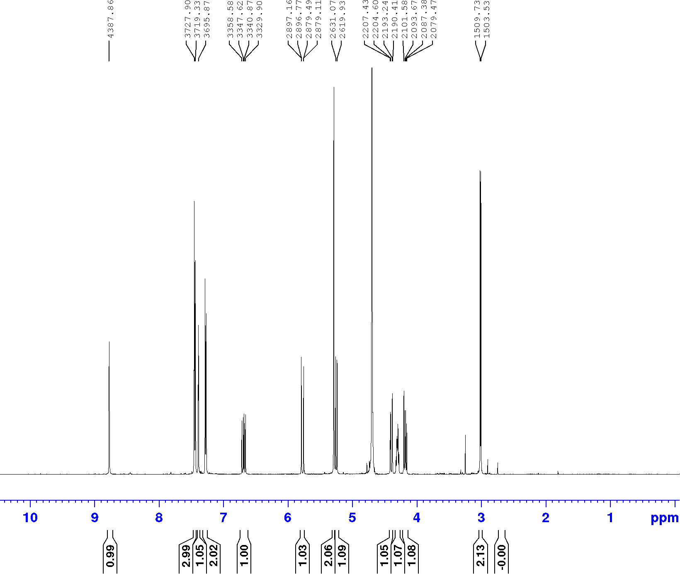

S1: ¹H NMR spectrum of monomer 2 recorded in D₂O.
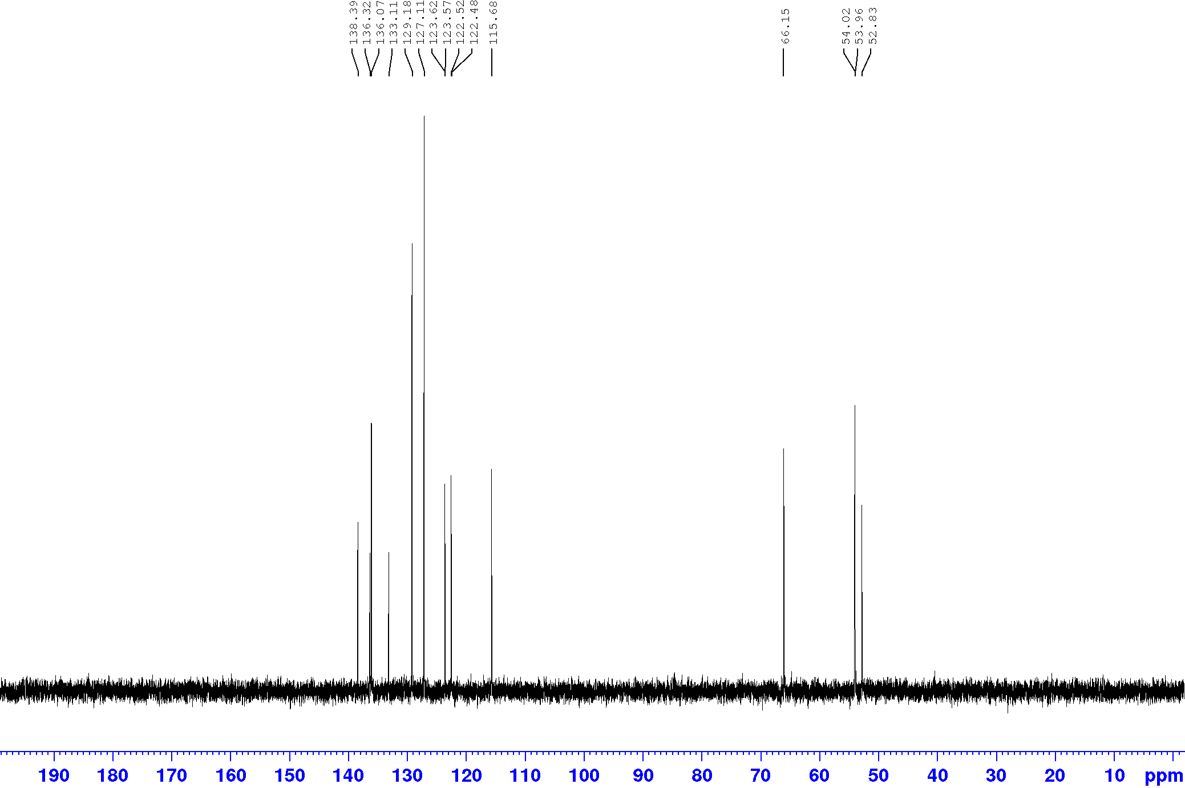

S2: ¹³C NMR spectrum of monomer 2 recorded in D₂O.
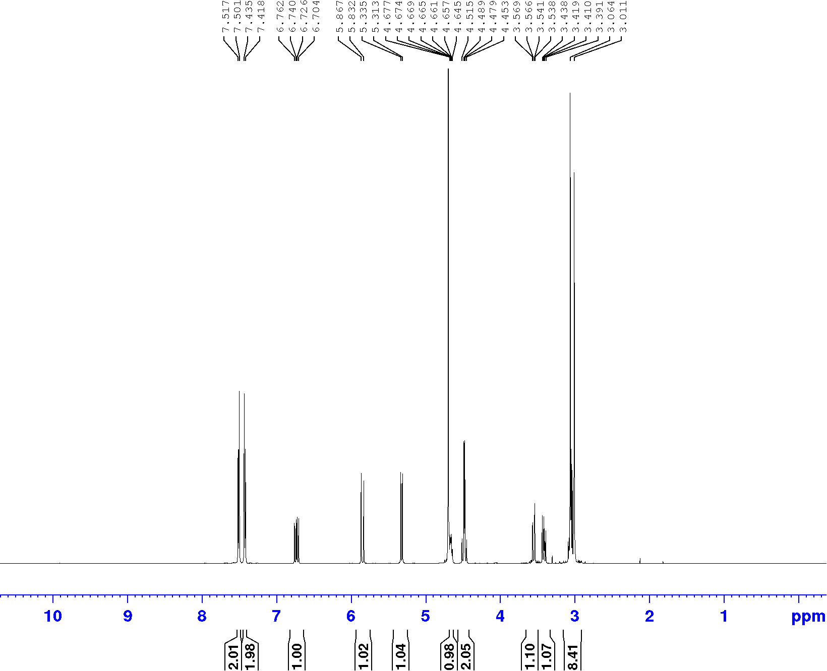
S3: ¹H NMR spectrum of monomer 4 recorded in D₂O.
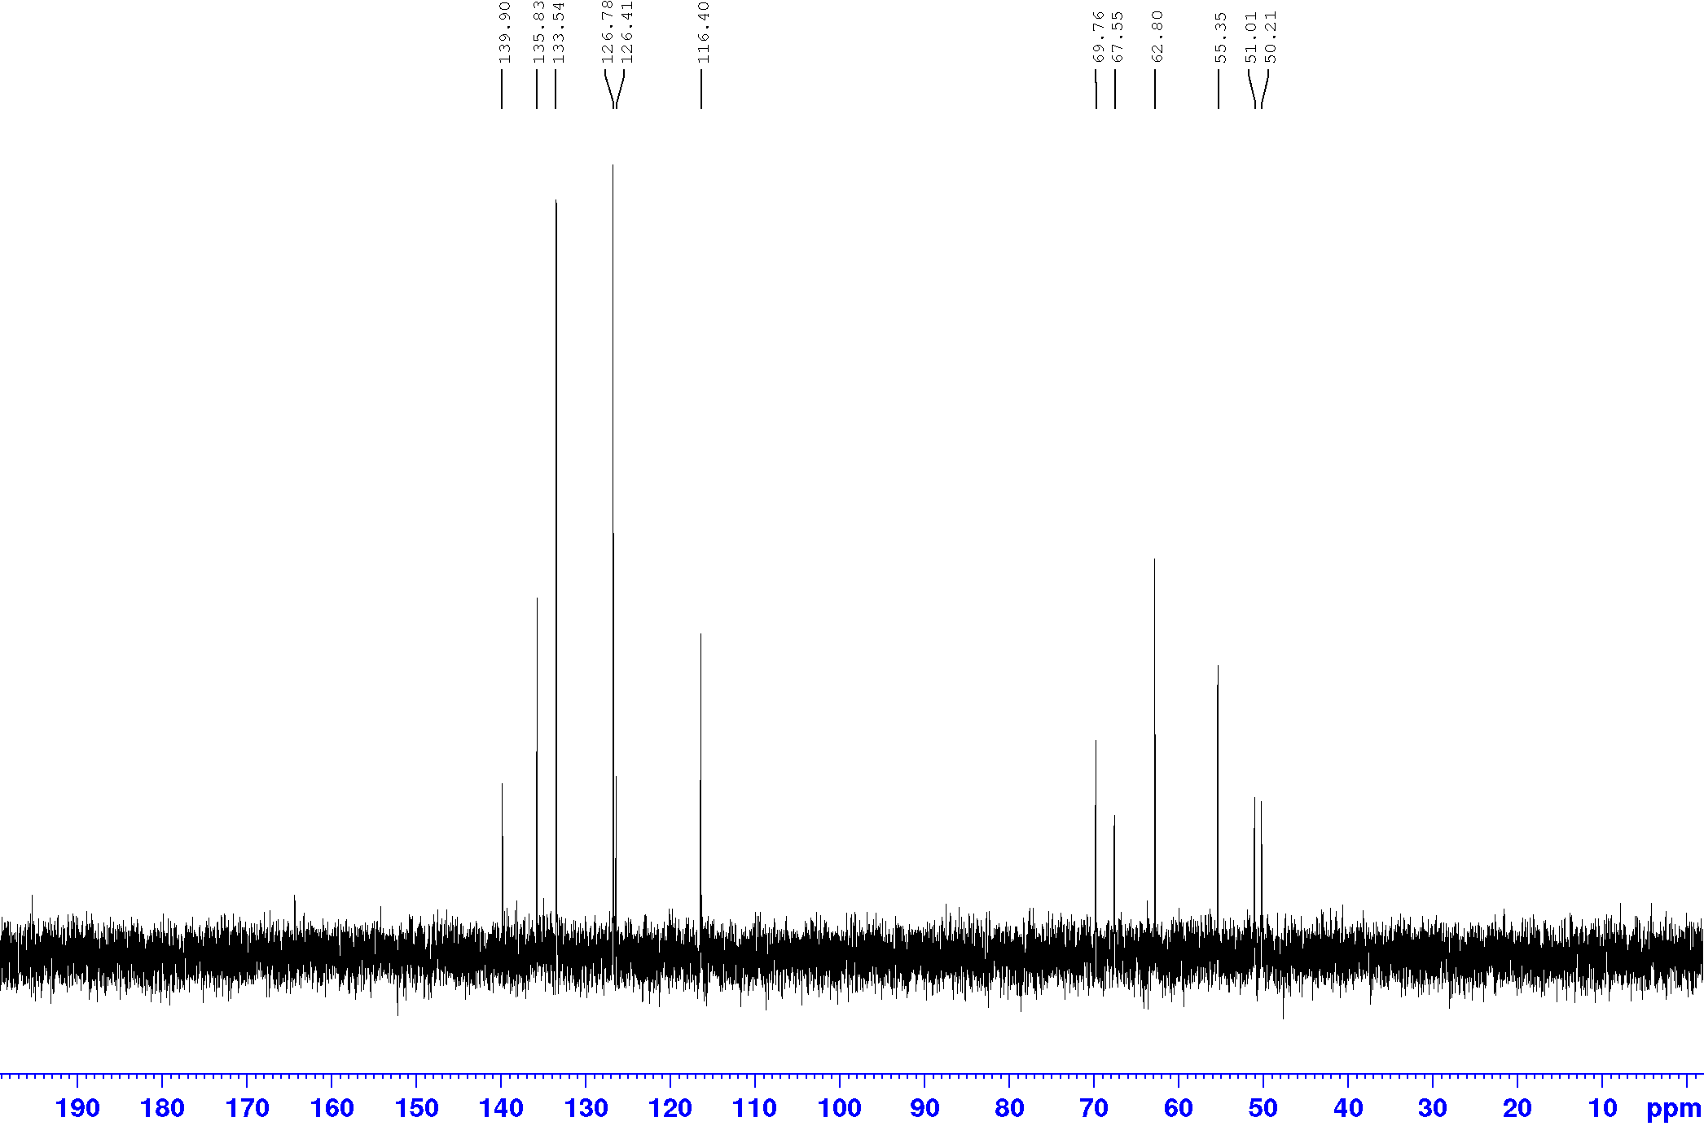
S4: ¹³C NMR spectrum of monomer 4 recorded in D₂O.

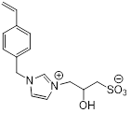
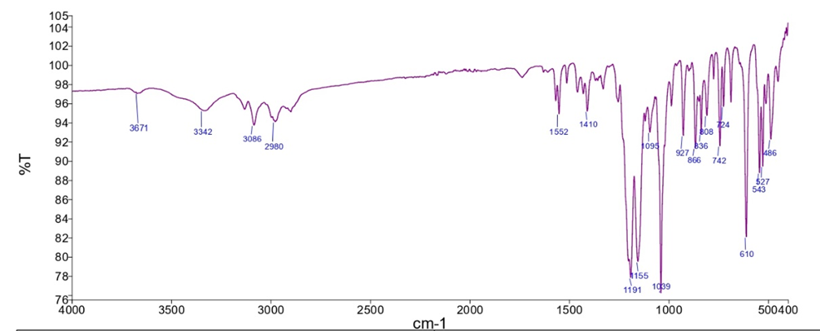

S5: FTIR spectrum of monomer 2

S6: FTIR spectrum of monomer 4

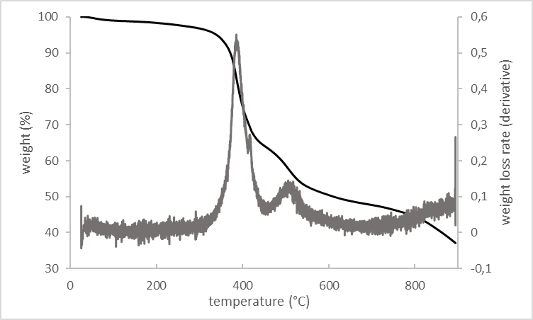
S7: Thermogravimetric analysis (TGA) and derivative thermogravimetric curves of monomer 2

