Supplementary Materials

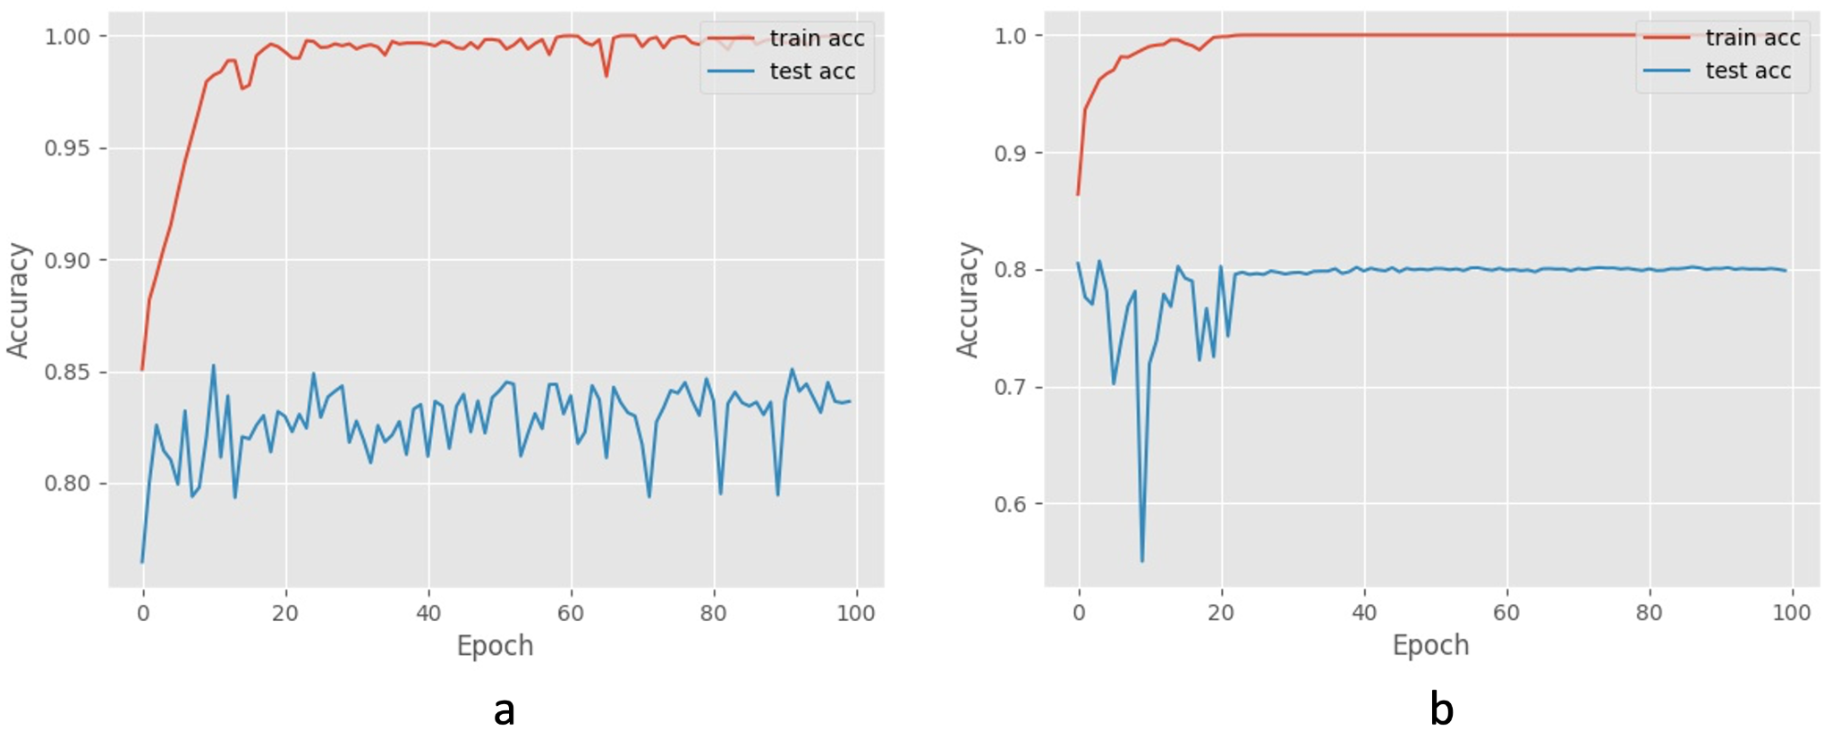Figure S1. Accuracy trend curves for training set and testing set. RustNet was trained with all data from Pullman, WA, USA (a) and tested with the data from Marquardt, Potsdam, Germany. RustNet was trained with all Marquardt’s data (b) and tested with the Pullman data.

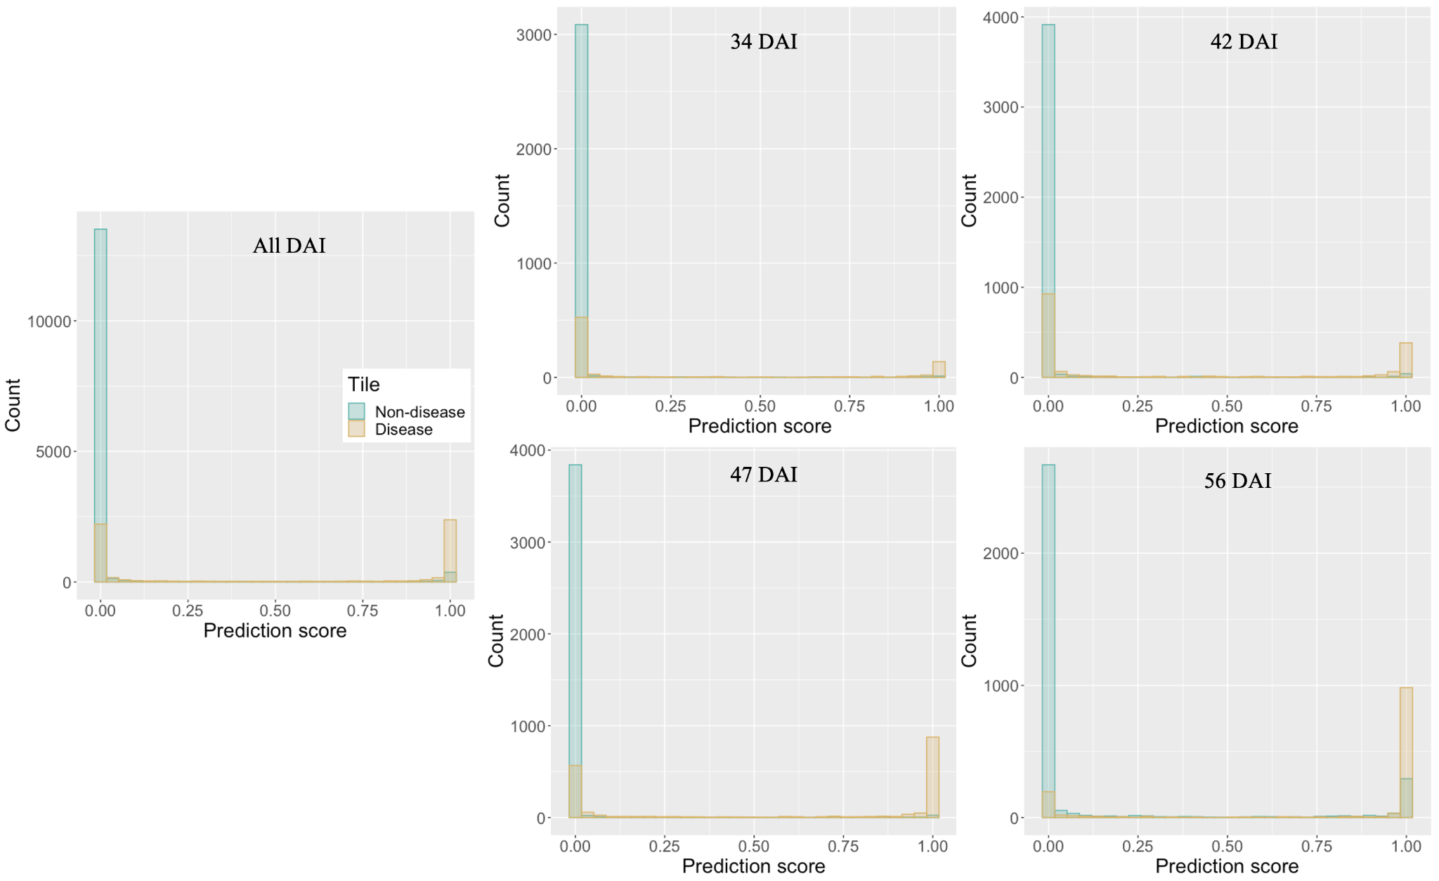

Figure S2. Distribution of prediction scores. RustNet was trained with all data from Pullman, WA, USA and tested with the data from different days (34, 42, 47 and 56 days after inoculation) in Marquardt, Potsdam. Majority of prediction scores for disease and non-disease tiles in different DAI distributed near zero or one.

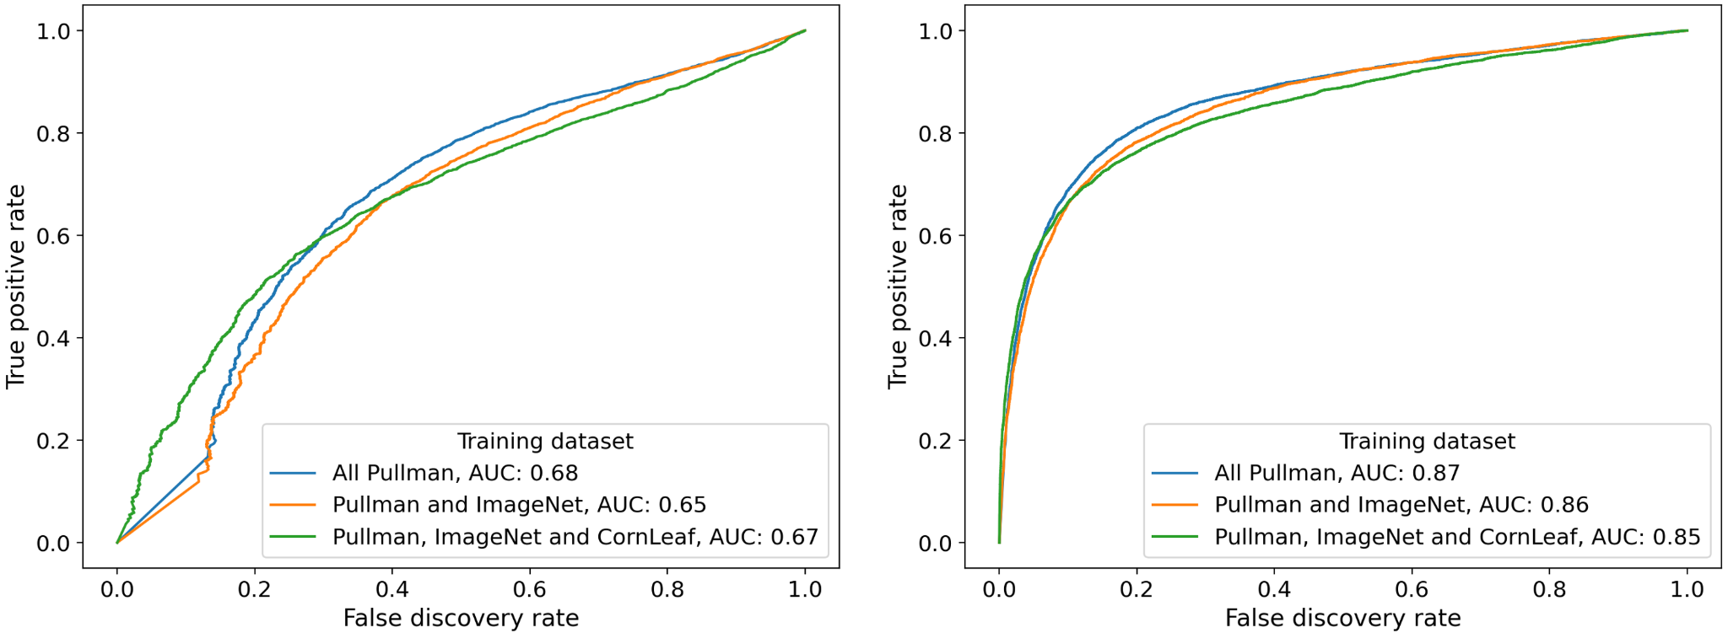

Figure S3. Receiver Operating Characteristic curves for adding negative control images into the training dataset. The RustNet was trained with all Pullman, WA (blue line), adding 80% false positive images of ImageNet (orange line) into the training dataset, and adding 80% false positive images of Corn leaf disease dataset (green line) into the training dataset. All three models were tested with the data from Marquardt, Potsdam, Germany.

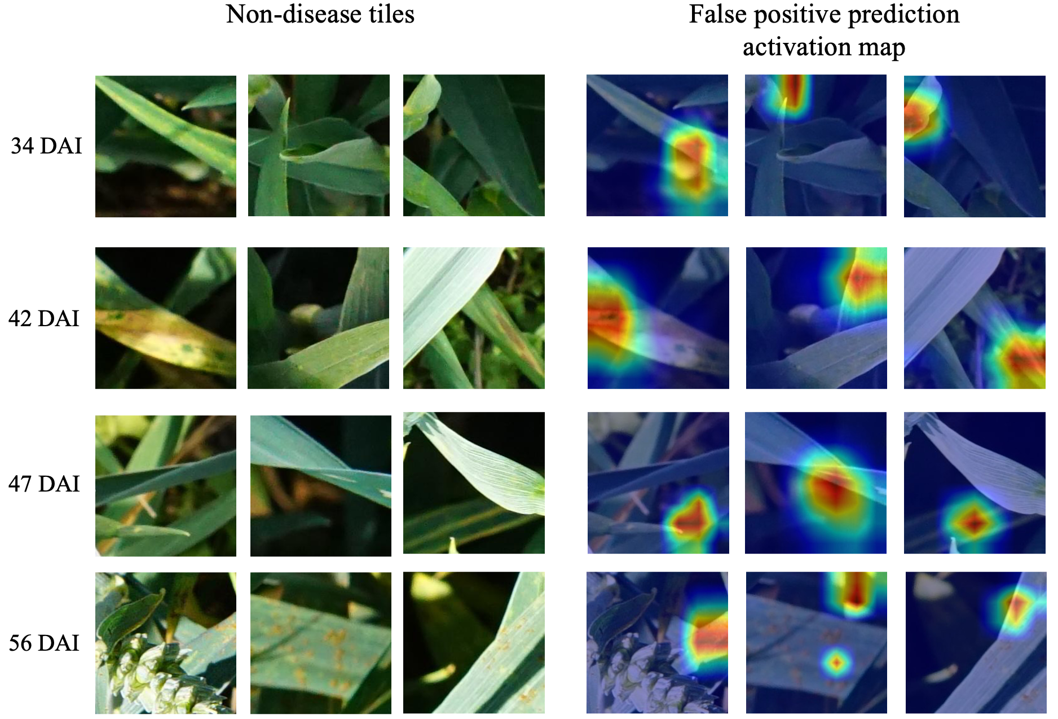

Figure S4. Example non-disease tiles with disease prediction. Non-disease tiles of different days (34, 42, 47 and 56 days after inoculation) in Marquardt, Potsdam were predicted as disease by RustNet that was trained with all data from Pullman, WA, USA. For disease predictions, activation maps tended to capture areas with similar symptoms of wheat stripe rust (false positive predictions).
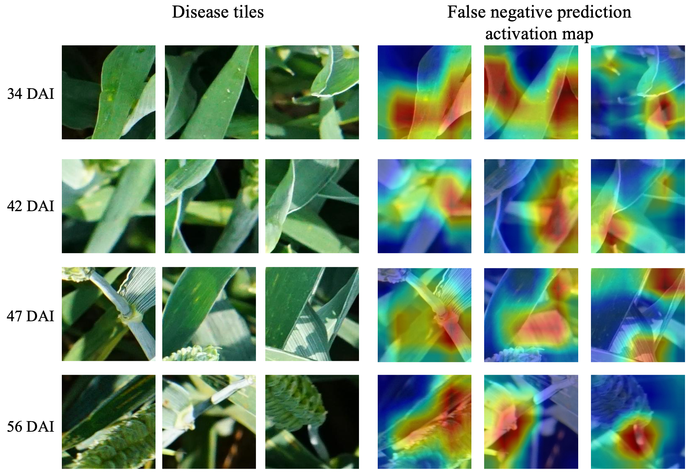

Figure S5. Example disease tiles with non-disease prediction. Disease tiles of different days (34, 42, 47 and 56 days after inoculation) in Marquardt, Potsdam were predicted as non-disease by RustNet that was trained with all data from Pullman, WA, USA. Activation map captured plant area for a non-disease prediction (false negative predictions).

Table S1. Summary of image tiles from Marquardt, Potsdam, Germany
DAI | Raw image (disease) | Raw image (non-disease) | Raw image  (disease %) | Tile image (disease) | Tile image (non-disease) | Tile image  (disease %)
34 | 180 | 679 | 20.95 | 850 | 3,163 | 21.18
42 | 321 | 715 | 30.98 | 1,735 | 4,115 | 29.66
47 | 298 | 642 | 31.70 | 1,852 | 3,964 | 31.84
56 | 234 | 582 | 28.68 | 1,381 | 3,300 | 29.50
Total | 1,033 | 2,618 | 28.29 | 5,818 | 14,542 | 28.58

Raw image size was 6000 × 4000 px. Tile size was 224 × 224 px. The numbers of tiles ranged from 1 to 48 per raw image. Disease and Non-disease tiles can be from the same raw image. DAI indicates the days after disease inoculation.

Table S2. Area under curve (AUC) of using Pullman images to test Marquardt images.
Training images | AUC with FPR | AUC with FDR
Stage 1 (200 non-diseased and 200 diseased) * | 0.64 | 0.23
Stage 2 (24 non-disease and 20 diseased) ** | 0.78 | 0.54
Stage 3 (stage 2 + 61 partially diseased) | 0.87 | 0.66
Images from videos (100) & Still images from UAV (100) | 0.85 | 0.63
Still images from phone (100) and UAV (100) | 0.86 | 0.66
Images from videos (100) & Still images from phone (100) | 0.86 | 0.67
Winter wheat (150) | 0.78 | 0.53
Spring wheat (150) | 0.85 | 0.65
All Pullman images (300) | 0.87 | 0.68

*Both images with non-diseased and diseased leaves were automatically labeled.
**The images with all leaves diseased were adjusted after prediction for all tiles.

