SUPPLEMENTARY MATERIAL
1 - PM1 mass and chemical composition - Daily samples characterization
Extractions were performed on sample punches of 1.5 cm2 by 30-min sonication using 5 mL of MilliQ water. Anions analysis was carried out using a solution of Na2CO3 and NaHCO2 as eluent, while cations analysis used MSA (methane-sulfonic acid) as eluent. During Levoglucosan analysis, NaOH was used as eluent. The instrument was periodically calibrated with standard solutions. Method detection limits are reported in the Supplementary Material (see Table X).
2- Ion chromatography
Ionic component and Levoglucosan content were determined via Ion Chromatography (ThermoFisher) analysis on daily quartz-fibre filters. Method detection limits are reported in Table X.
Table S1: MDL for species detected by Ion Cromatography.
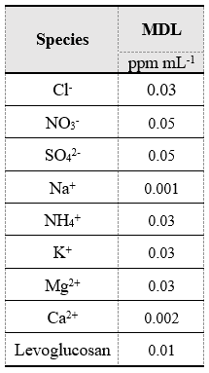

3 - Oxidative and reducing potential
OP^{DTT} was measured by using three aliquots of 0.7 mL for each sample solution incubated at 37 °C with 0.1 mL of DTT (1 mM) and 0.2 mL of potassium phosphate buffer (1 M). Then, 1 mL of trichloroacetic acid (10%TCA) was added to the mixture at different reaction times (0, 10 and 20 minutes) to stop DTT reaction. An aliquot of the reaction mixture (1 mL) was mixed with 2 mL of tris-buffer (0.08 M, containing EDTA 4 mM) and 50 µL of 5,5-dithiobis-2-nitrobenzoic acid (DTNB). The obtained solution was measured at 412 nm by using a UV-Vis spectrometer. OP^{AA} was determined by adding 300 µL of phosphate buffer (0.5 mM) and 100 µL of AA to 2.5 mL of sample solution. Then, the absorbance was measured at 265 nm at different reaction times (0, 10 and 20 minutes) by UV-Vis spectrometry. OP^{DCFH} was measured by dissolving 4.87 mg of 2’,7’-dichlorofluorescin diacetate (DCFH-DA) in 5 mL of ethanol (EtOH, 96%) with 20 mL NaOH (0.01M) and kept in the dark for 30 minutes. Then, 125 µL of DCFH (5 µM) and 5 mL of HRP (0.5 units mL-1) dissolved in a sodium phosphate buffer (pH 7.4; 25 mM) were added to 1.5 mL of the sample solution placed in a water bath at 37 ºC for 5 minutes. The concentration of dichlorofluorescin (DCF) upon reaction with ROS was measured by using fluorescent spectroscopy. RP^{DPPH} was determined using 2 mg of DPPH in 50 mL of ethanol (EtOH 96%). The mixture was shaken for 30 min under magnetic stirrer agitation and kept in the dark. The obtained solution was measured at 517 nm by UV-Vis spectrometry.
For the DTT analysis on quartz fibre filters, 2.5 ml of extract were added to 0.5 ml of potassium phosphate buffer (0.5 M, pH = 7.4) into an amber vial (primary vial). The obtained solution was heated at the temperature of 37°C using a water bath. When the temperature reached the desired value, 30 ml of the DTT solution, with a concentration of 10 mM, were added to the vial at the time zero. At the time of 5, 10, 15, 20 and 25 minutes an aliquot of 0.5 ml was removed from the vial and added to a second amber vial (secondary vial) containing 0.5 ml of 10% trichloroacetic acid to stop the reaction. After all solutions were collected, 50 ml of 10mM DTNB solution in phosphate buffer at pH 7.4 were added to all secondary vials, mixed adequately, and allowed to react for 5 minutes in the dark. Then, 2 ml of a solution of 0.4 M Tris-HCl buffer at the pH of 8.9 and EDTA 20 mM were added. The reaction between the residual DTT and DTNB forms 2-nitro-5-thiobenzoic acid (TNB), which was quantified at its maximum of absorption at 412 nm wavelength by a TIDAS E (J&M) UV-VIS spectrophotometer.
For both the total and soluble approaches, the kinetics of DTT oxidation was followed by measuring the decrease of the DTT concentration added to the sample (100 µmol) over the reaction course. The DTT depletion rate (nmolDTT min-1), which is proportional to the reactive oxygen species production, was computed as the slope of the straight line obtained by fitting the five experimental points of the DTT concentration as a function of the reaction time (5, 10, 15, 20 and 25 minutes). Slopes obtained by the field blank filters, following the same approach, were subtracted from the slopes of the samples, to compensate for signals coming from the filter matrix. The reproducibility of the method was determined on repeated tests of standard DTT-active organic compounds and resulted the uncertainty on the order of 15% and 30% for the water soluble and total OP, respectively.
4 - ChAMBRe instruments and online monitors
Several instruments and online monitors are connected to ChAMBRe (Table X), and controlled by a remote Ethernet connection and a NI Compact-RIO acquisition module (based on the NI cRIO-9064 controller). In the bottom of the structure, a fan is installed to favour the mixing of gas and aerosol species in the chamber volume. A composite pumping system is connected to ChAMBRe to clean up its volume at the end of each experiment, to avoid possible contamination in the further tests. The system consists of a rotary pump (model TRIVAC® D65B, Leybold Vacuum), followed by a root pump (model RUVAC WAU 251, Leybold Vacuum) and a turbo pump (Leybold Turbovac 1000); it can evacuate the total volume down to 10-5 mbar in about 15 minutes. Between the pumping system and ChAMBRe is collocated a safety valve (Leycon Secuvac DN 63, Oerlikon Leybold Vacuum) as a gate to prevent possible backwashes of the pumps oil inside the chamber. After the evacuation, ChAMBRe is refilled with ambient air filtered by several pollutant traps (including a HEPA filter and zeolite traps).
Table S2: ChAMBRe instrumentation summary.
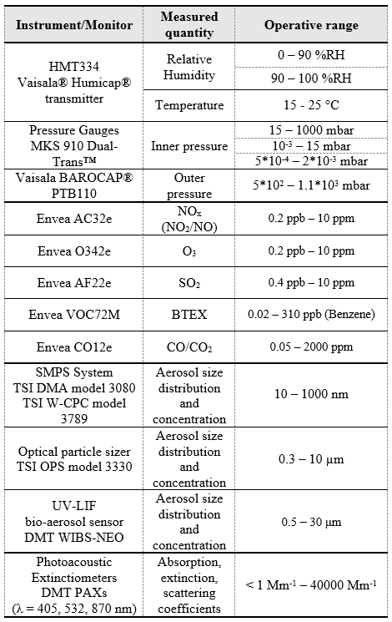

5- Quantification of polycyclic aromatic hydrocarbons (PAH)
Reagents and chemicals
Benzo(α)anthracene, chrysene, benzo(β)fluoranthene, benzo(α)pyrene and benzo(α)anthracene - D12 were purchased from SUPELCO 959 (North Harrison Road, PA, USA).
Acetonitrile (ACN) and dichloromethane (CH₂Cl₂) were bought from Carlo Erba Reagents s.r.l. (Cornaredo, Italy).
PAHs extraction protocol
The concentration of PAHs, such as benzo(α)anthracene, chrysene, benzo(β)fluoranthene and benzo(α)pyrene were evaluated in quartz filters previously exposed during the winter sampling in two different areas (i.e. Bologna and San Pietro Capofiume, Italy).
The samples were prepared according to [Terzopoulou et al., 2015; Gosetti et al., 2011] with some modifications.
Before the extraction, filters were weighted individually on analytical balance. For the quantitative analysis benz(α)anthracene-D12 was added as internal standard (200ng/sample) to all filters.
Every sample was dissolved in 7,0 mL of CH₂Cl₂ and the suspension was separated from its solid fraction through filter paper. Samples were dried under nitrogen gas flow (N₂) and 5,0 mL of ACN were added. After vortexing, samples were filtered by 0,45 µM regenerated cellulose membrane filters and each solution was concentrated until 1,0 mL under N₂ gas flow. Finally, samples were purified by 0,22µM regenerated cellulose membrane filters and dried under N₂ gas flow. The extracts were reconstituted in 20 µL of ACN before the injection.
Gas-Chromatography Mass Spectrometry (GC-MS)
The quantitative analysis was performed using gas chromatography (Varian 3900 GC) supplied by ion trap mass spectrometry (Varian Saturn 2100T). The chromatographic separation was achieved with TG-5SILMS column. The injector temperature was 280 °C, the flow rate was 1,0 ml/min and the gradient was as follow: 0-2.00 min 80°C, 2.00-22.00 min linear gradient to 300 °C (10 °C/min) and 22.00-38.00 min maintained at 300°C.
As concerned mass spectrometry conditions, electron impact ion source was set at 70 eV and detector ion trap mass range scan was 100-400 milli mass unit (mmu). Quantitative analysis was performed on the basis of calibration curves freshly prepared.
The following table shows the m/z ratio and retention time of the analytes and IS.

Table S3 : the m/z ratio and retention time of the analytes and IS
Analyte | m/z ratio | RT
Benzo(α)anthracene -D12 (IS) | 240 | 20,38
Benzo(α)anthracene | 228 | 20,43
Crysene | 228 | 20,52
Benzo(β)fluoranthene | 252 | 22,84
Benzo(α)pyrene | 252 | 23,50

FIGURES
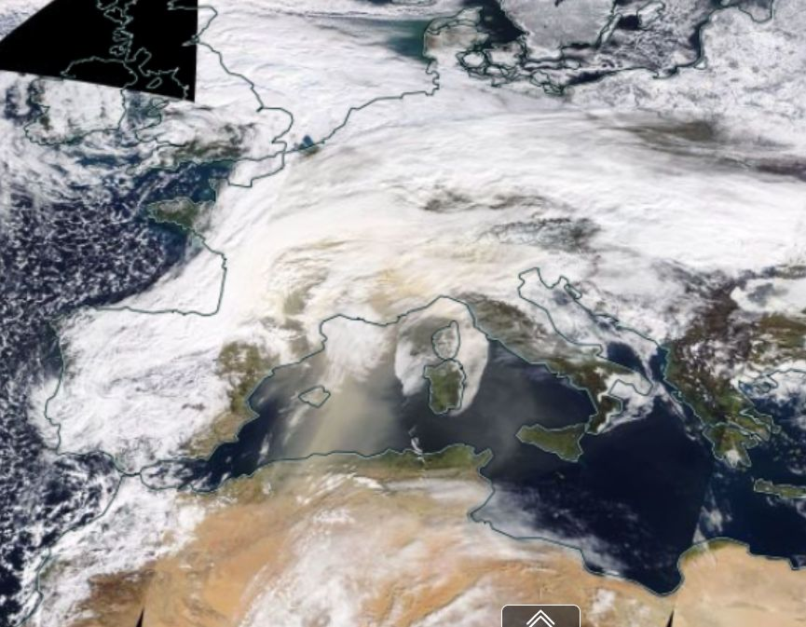
Figure S 1. MODIS/Terra true color image over Western Europe on 6 Feb 2021. A Saharan dust plume advected over the low-cloud deck covering Northern Italy is visible. Image from NASA WorldView.
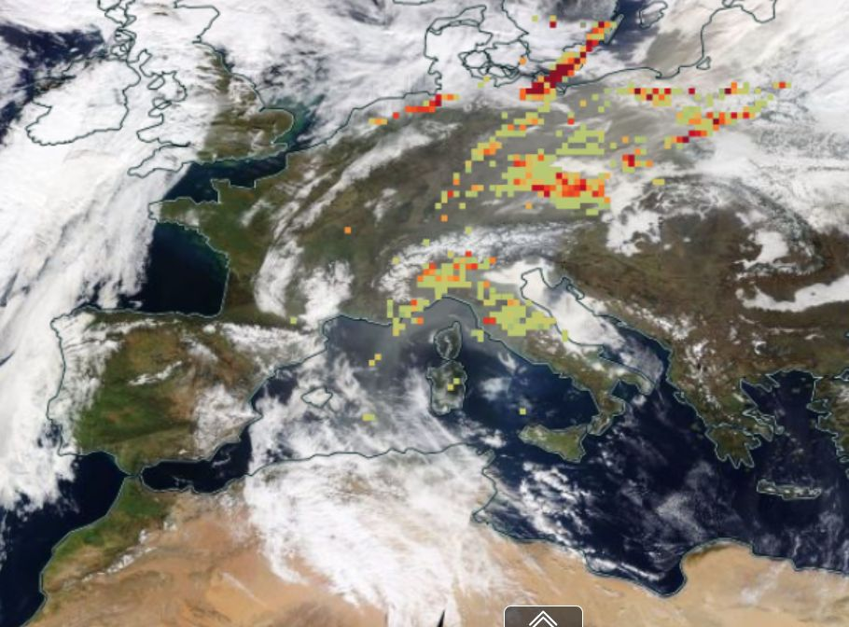
Figure S 2. MODIS/Terra true color image over Western Europe on 23 Feb 2021. Superimposed the Dust Index from AIRS/Aqua. A Saharan dust plume advected over Northern Italy is visible. Image from NASA WorldView.
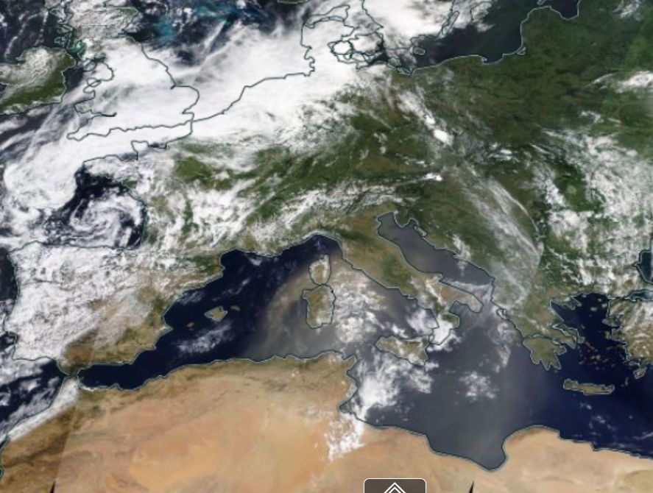
Figure S3. MODIS/Terra true color image over Western Europe on 21 Jun 2021. A dust plume is visible over Italy. Image from NASA WorldView.
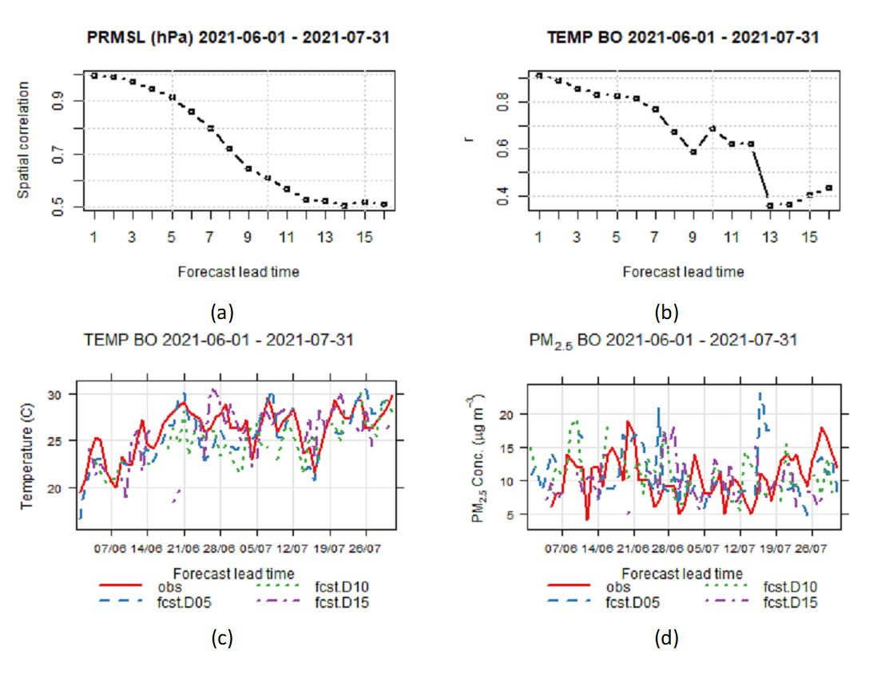
Figure S 4. Illustration of forecast system skills during summer campaign. (a) Spatial correlation of sea levels pressure at 00 UTC from NOAA/GFS simulation between analysis and forecast days from 1 to 16. (b) Temporal correlation of daily mean temperature in Bologna from WRF simulation between analysis and forecast days from 1 to 16. (c) Timeseries of daily mean temperature in Bologna during winter campaign from observations and WRF simulation on forecast days 5, 10, and 15. (d) Timeseries of daily mean PM2.5 concentration in Bologna during winter campaign from observations and CHIMERE simulation on forecast days 5, 10, 15.

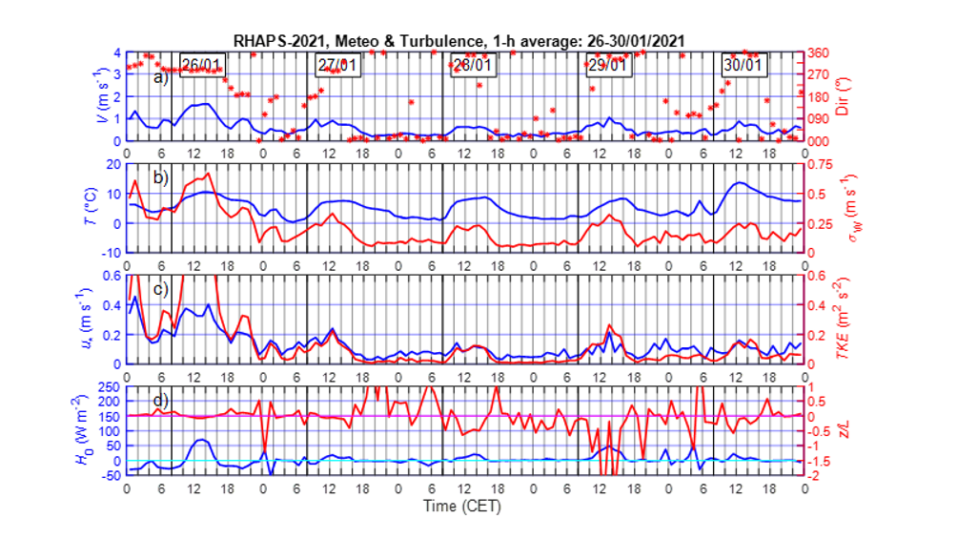Fig. S5 Time series of the wind speed (blue line) and direction (red line) (a), temperature (blue line) and variance of the vertical velocity (red line)(b) , friction velocity (blue line) and TKE(red line) (c), and heat flux (blue line) and Z/L (red line) (d) during the SIOP1 (26 to 30 January 2021).
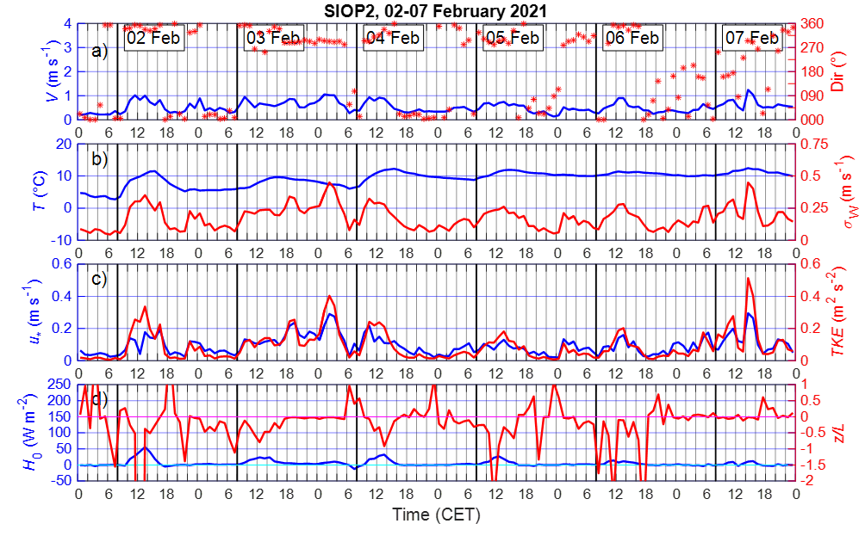
Fig. S6 Time series of the wind speed (blue line) and direction (red line) (a), temperature (blue line) and variance of the vertical velocity (red line)(b) , friction velocity (blue line) and TKE(red line) (c), and heat flux (blue line) and Z/L (red line) (d) during the SIOP2 (2 to 7 February 2021).
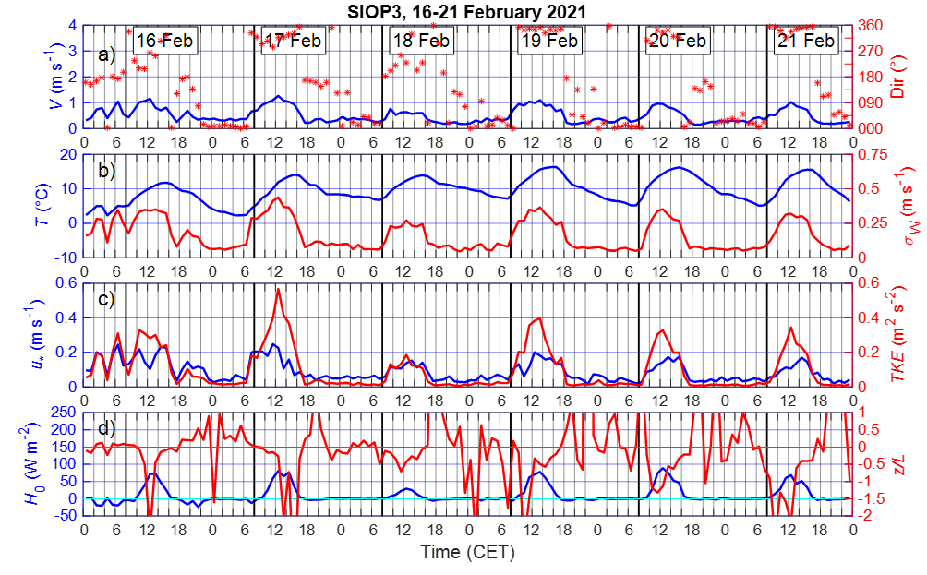Fig. S7 Time series of the wind speed (blue line) and direction (red line) (a), temperature (blue line) and variance of the vertical velocity (red line)(b) , friction velocity (blue line) and TKE(red line) (c), and heat flux (blue line) and Z/L (red line) (d) during the SIOP3 (16 to 21 February 2021).
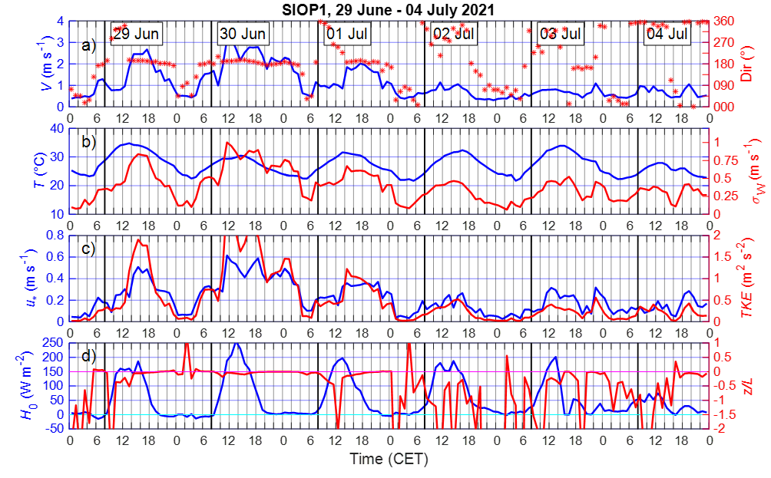
Fig. S8 Time series of the wind speed (blue line) and direction (red line) (a), temperature (blue line) and variance of the vertical velocity (red line)(b) , friction velocity (blue line) and TKE(red line) (c), and heat flux (blue line) and Z/L (red line) (d) during the summer SIOP (29 June to 4 July 2021).
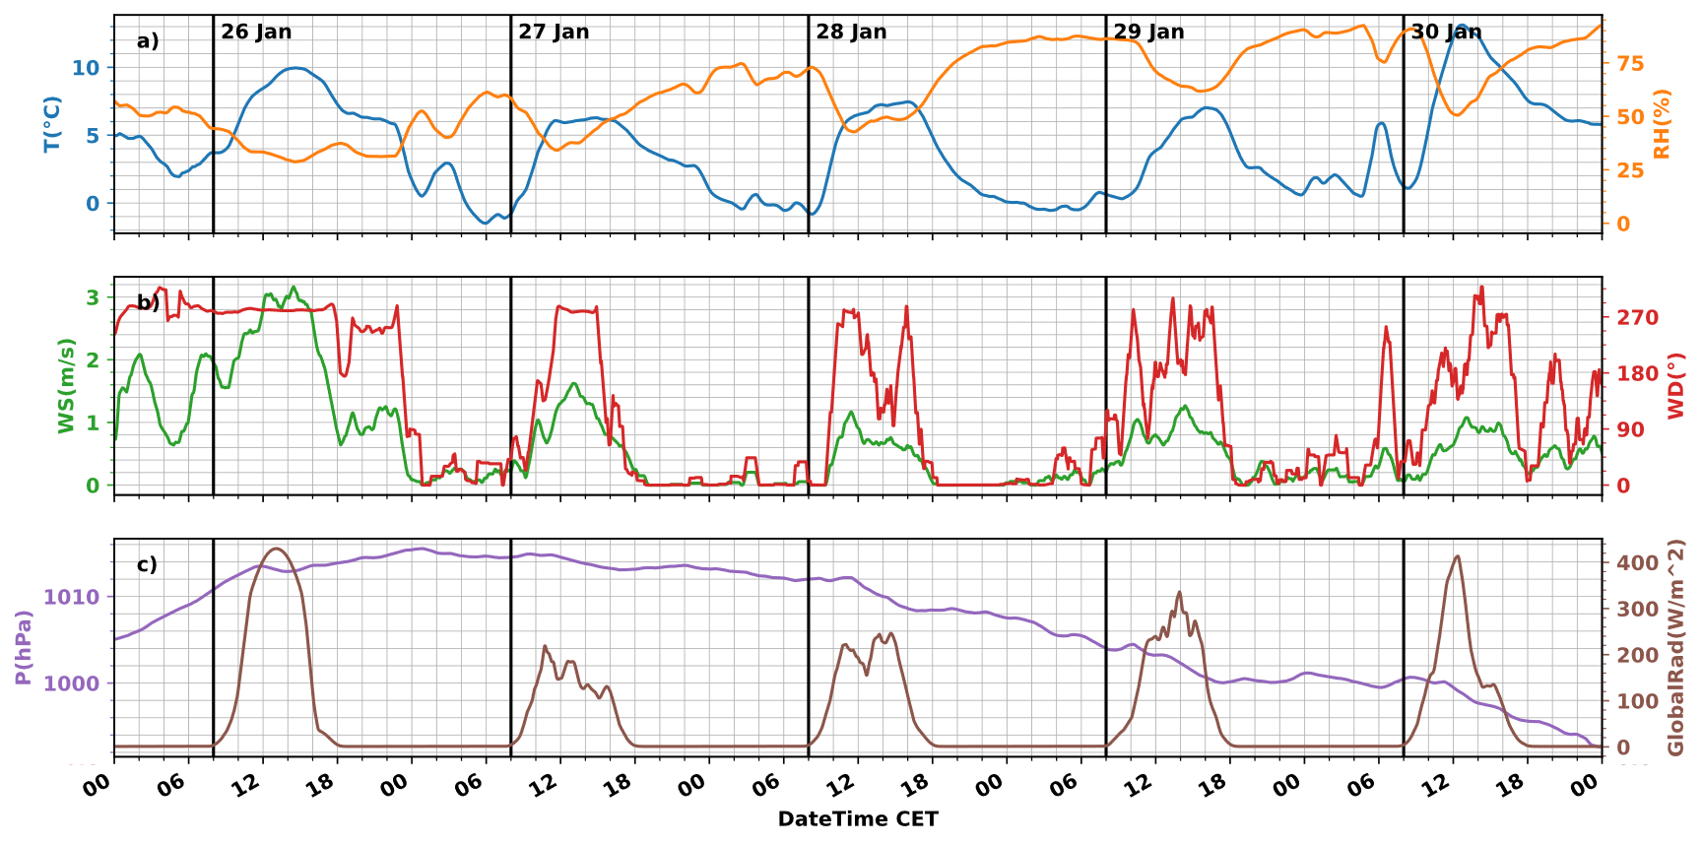
Fig. S9 : Meteorological variables during SIOP1
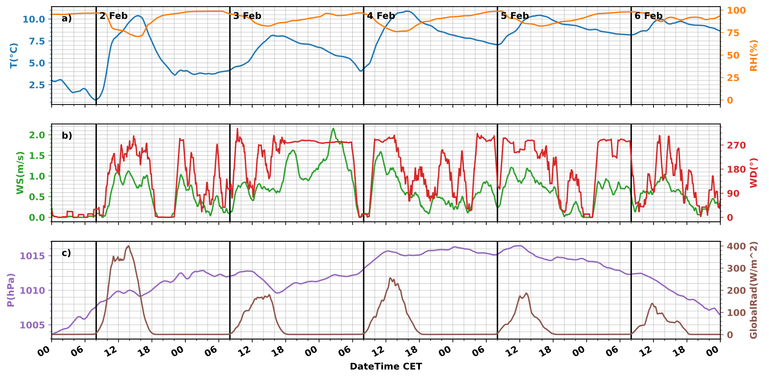
Fig. S10 : Meteorological variables during SIOP2
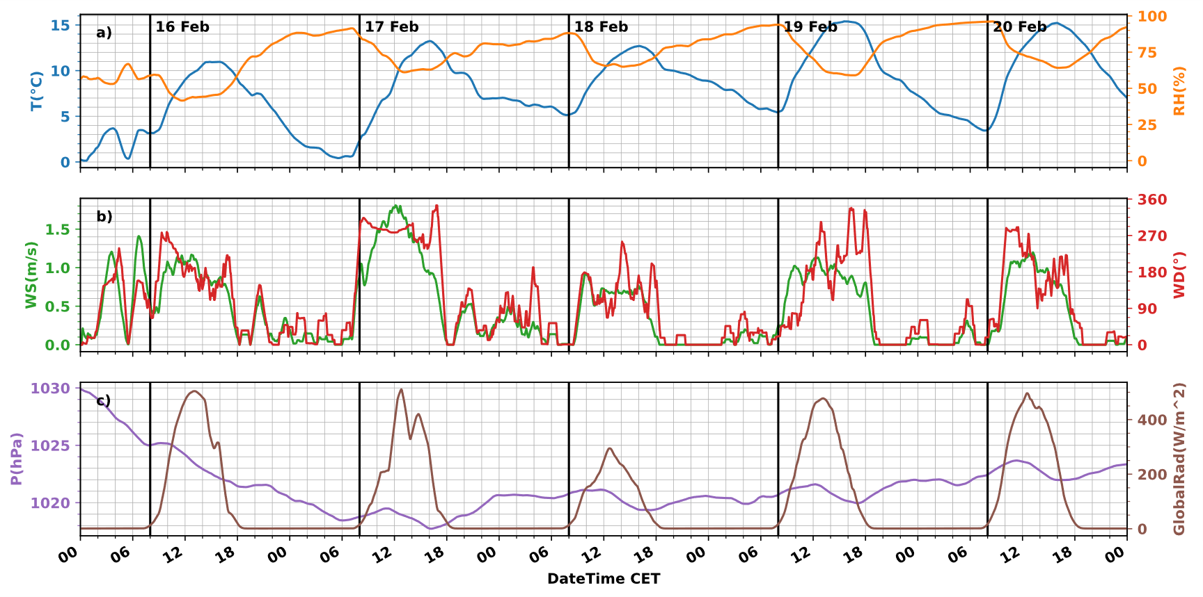
Fig. S11 : Meteorological variables during SIOP3
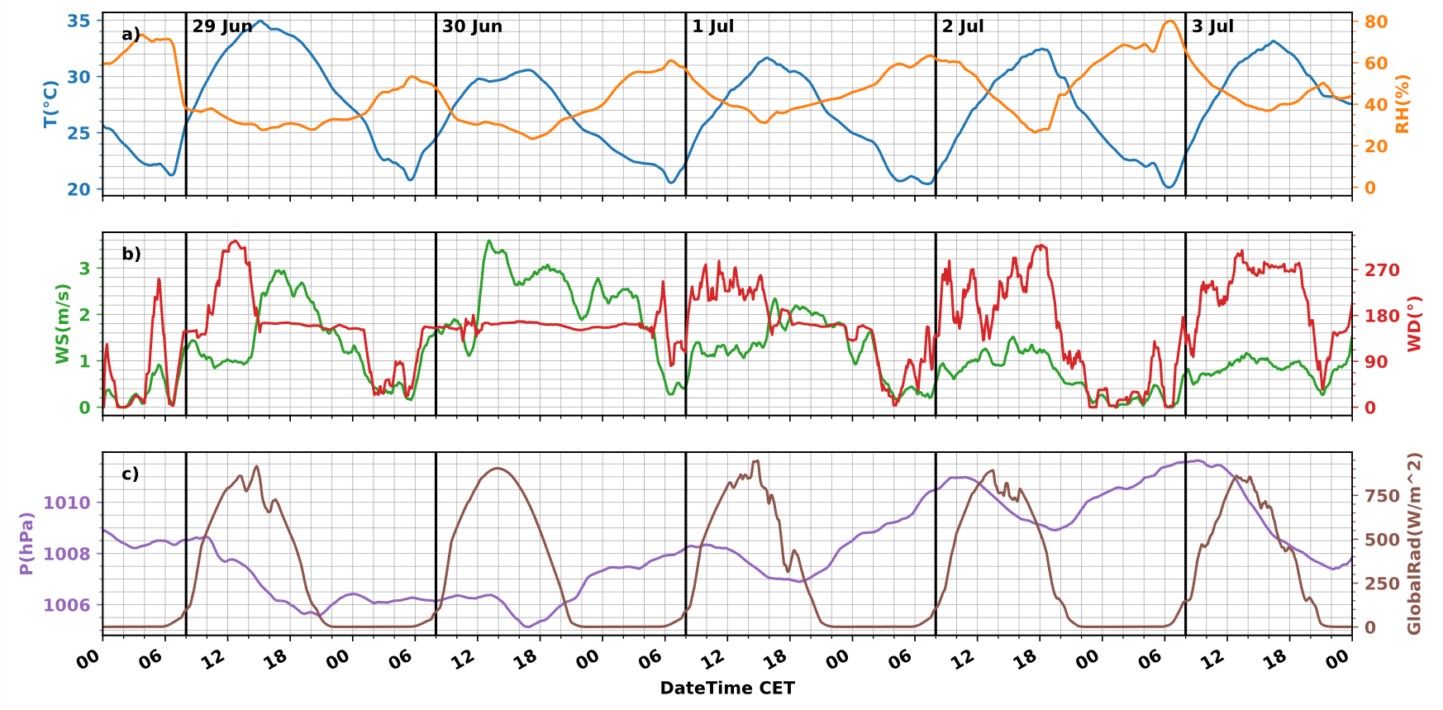
Fig. S12 : Meteorological variables during SIOP4
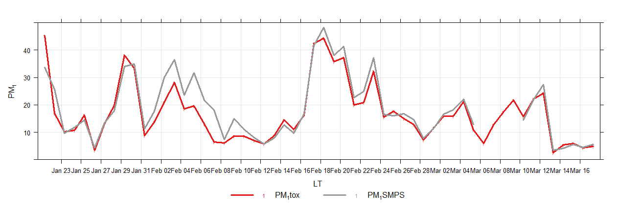
Fig. S13 : Trends of PM1 mass concentration from the reference instruments and reconstructed from the SMPS
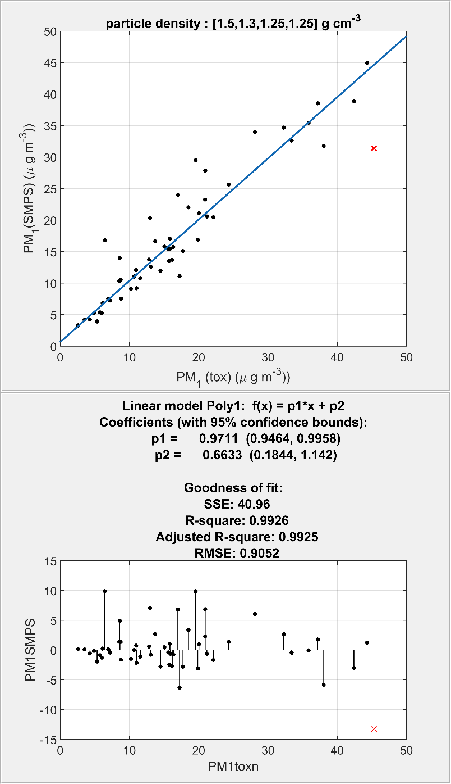
Fig. S13 : Goodness of the fit of the PM1 mass concentration from the reference instruments and reconstructed from the SMPS.

