Article

GASIFICATION OF SUGARCANE CUTTING RESIDUES IN THE CAPTURE OF CARBON DIOXIDE BY SIMULATION

SANDRA PEÑA1 *, CARMEN FORERO2, FRANCISCO VELASCO2, EDUARDO ARANGO2, JOSE BARREIRO3, MARCONIS CASTILLO4,*

|  |
| --- |
| **Citation:** Lastname, F.; Lastname, F.; Lastname, F. Title. *Atmosphere* **2022**, *13*, x. https://doi.org/10.3390/xxxxx  Academic Editor: Firstname Lastname  Received: date  Accepted: date  Published: date  **Publisher’s Note:** MDPI stays neutral with regard to jurisdictional claims in published maps and institutional affiliations.    **Copyright:** © 2022 by the authors. Submitted for possible open access publication under the terms and conditions of the Creative Commons Attribution (CC BY) license (https://creativecommons.org/licenses/by/4.0/). |

1 University of Guayaquil; sandra.penam@ug.edu.ec

2 University of Valley; [carmen.forero@correounivalle.edu.co](mailto:carmen.forero@correounivalle.edu.co); [Francisco.velasco@correounivalle.edu.co](mailto:Francisco.velasco@correounivalle.edu.co); [Eduardo.arango@correounivalle.edu.co](mailto:Eduardo.arango@correounivalle.edu.co)

3,4 University of Guayaquil; [jose.barreiro@ug.edu.ec](mailto:jose.barreiro@ug.edu.ec); marconis.castillo@ug.edu.ec

**\*** Correspondence: sandra.penam@ug.edu.ec; Tel.: 593999630391

**Abstract:** The gasification of sugarcane cutting residues (RAC) is a process that occurs in a gasifier where the transformation of this raw material into a solid state and a gasifying agent with a moderate calorific value occurs, thanks to the application of heat. , and under restricted oxygen levels we can say that there are several styles of gasifiers for air, steam, oxygen and hydrogen, all of which have a performance that can be analyzed and categorized by their performance to avoid damage to the environment. (1) The objective of this article is based on the mathematical development by means of simulation of the gasification of cane cutting residues. (2) In the methodology, the simulation of the gasification and CO2 capture process was developed, from the biomass residues of the sugarcane cutting residues, it was carried out as a transformation of the primary fuel into a gas stream whose main components are CO2 and H2, which can be separated relatively easily by their concentrations, available pressures and in some cases their temperatures; (3) According to the kinetic data obtained, the second order reaction in the transformation and improvement of the process was identified; applying to the optimization of development in the capture of CO2, contributing to the reduction of greenhouse gases. (4) The gasification simulation process results in a biomass conversion corresponding to 93% of its feed, the formation of volatiles whose molar fraction corresponds to 37% H2, 12% CH4, 37% CO and 12 % CO2.

**Keywords:** Greenhouse, biomass, carbon dioxide, capture carbon dioxide, gasification

**FIGURES**

3.1. Figures, Tables and Schemes

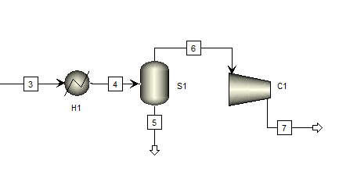

**Figure 1.** Stream 3, resulting from the gasification process

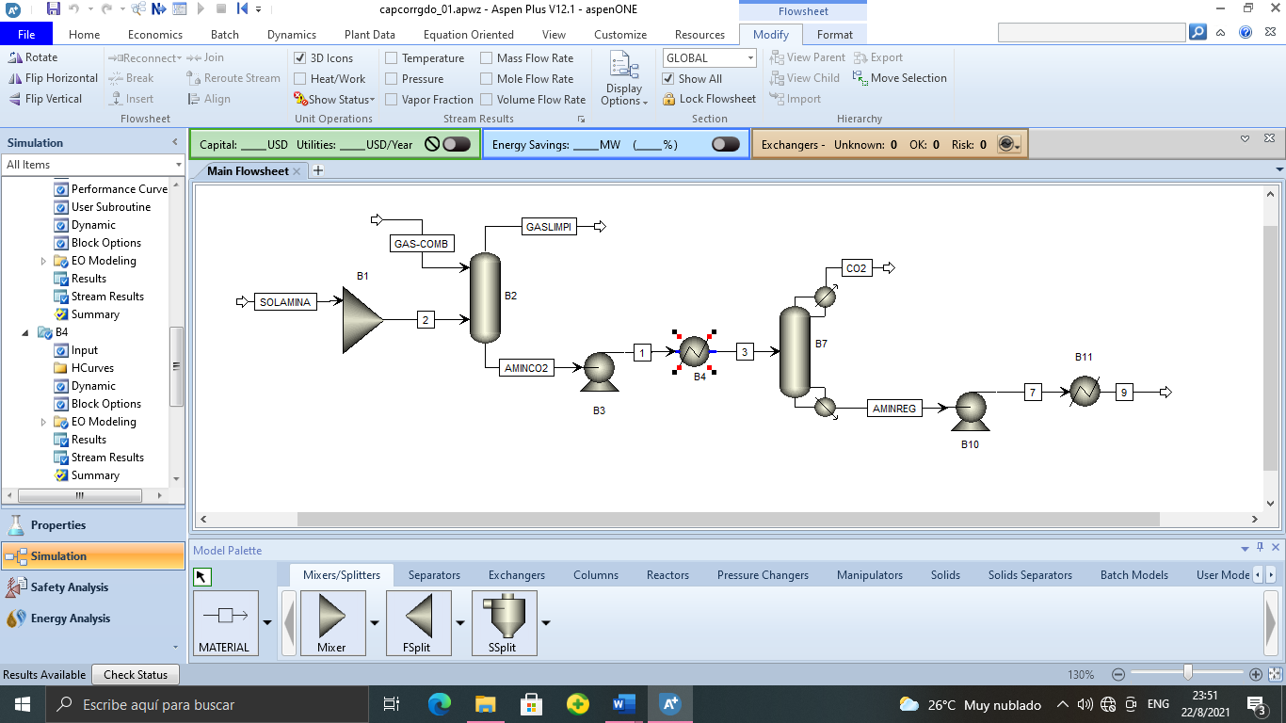

**Figure 2.** CO2 capture simulation procedure (absorption)

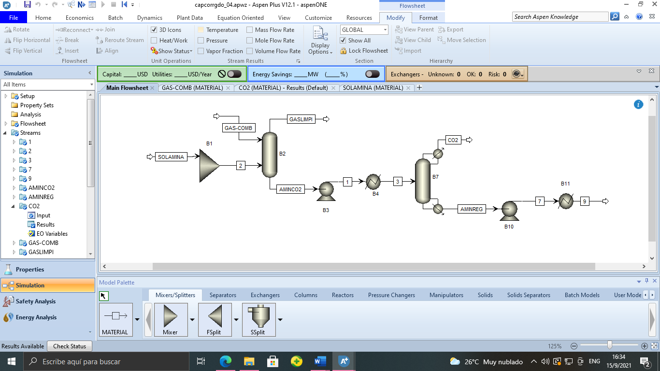

**Figure 3.** Basic Diagram of a capture and storage system CO2

**Table 1.** Operating Conditions.

|  |  |
| --- | --- |
| **OPERATING CONDITIONS** | |
| Flue gas temperature | 40oC |
| Flue gas pressure | 1.5 bar |
| Total inflow | 602874.4 kg/h |
| Co2 input flow | 48319.4 kg/h |
| The temperature of the amine solution is 30% of its weight | 40oC |
| Inlet pressure amine solution | 1.1bar |
| Inlet flow of the mine solution 30% of its weight | 554555.5kg/h |
| Number of stages in the absorber | 18 |
| Pressure in the absorber (upper stage) | 1.1bar |
| Flow ratio | 13 |
| Number of stages in the stripper | 40 |
| Reboiler energy | 5x107 cal/s |
| Stripper pressure (upper stage) | 2 bar |
| Discharge pressure | 2 bar |

**Table 2**. Gasification data the average of the three simulations d.

|  |  |  |
| --- | --- | --- |
| **Gasification simulation** | | |
| **Compound** | **Molar Fraction** | **Mass Flow** |
| CELLULOSE | 1.94E-22 | 3.56E-17 |
| CO | 0,373672851 | 11836,00044 |
| CO2 | 0,124282313 | 6185,187033 |
| H2O | 0,003786774 | 77,14441267 |
| H2 | 0,373731517 | 851,9586477 |
| CH4 | 0,124526546 | 2259,098378 |
| C | 3.37E-66 | 4.58E-62 |

**Table 3.** CO2 capture data

|  |  |  |
| --- | --- | --- |
| **SEPARATION DATA (CO2)** | | |
| **Compounds** | **Mass flows (kg/h)** | **Molar fraction** |
| C2H7NO | 43,375698 | 0,01063652 |
| CO2 | 1024,34624 | 0,25118858 |
| CO | 58,3290986 | 0,01430337 |
| H2 | 5.92E-06 | 1.45E-09 |
| H2O | 2877,01792 | 0,70549782 |
| N2 | 0 | 0 |
| CH4 | 0 | 0 |
| H2S | 70,4086294 | 0,01726549 |
| COS | 3,24480173 | 0,00079569 |
| H3N | 0,25488063 | 6.25E-05 |
| CHN | 1,01832761 | 0,00024971 |

**Table 4.** CO2 optimization data

|  |  |  |
| --- | --- | --- |
| **RECIRCULATING DATA (CO2 SEPARATION)** | | |
| **Compounds** | **Mass flows (kg/h)** | **Molar fraction** |
| C2H7NO | 155,816840 | 0,013358 |
| CO2 | 2798,521650 | 0,239925 |
| CO | 165,795452 | 0,014214 |
| H2 | 1.695754E-05 | 1.453818E-09 |
| H2O | 8332,250643 | 0,714347 |
| N2 | 0 | 0 |
| CH4 | 0 | 0 |
| H2S | 200,625294 | 0,017200 |
| COS | 9,385330 | 0,000804 |
| H3N | 0,724457 | 6.210978E-05 |
| CHN | 1,019191 | 8.737819E-05 |

3.2. Formatting of Mathematical Components

$1 {\left(C_{6}H_{10}O_{5}\right)}_{n}→1 CH_{4}+1 CO_{2}+3 CO+3$ Gasification process (1)

$\frac{dC_{x}}{dt}=-k∙{C_{x}}^{2}$ Kinetic calculus (2)

$\int_{C_{xo}}^{C_{x}}{\frac{dC_{x}}{d{C_{x}}^{2}}}=-\int_{t_{o}}^{t}{k∙t}$ (3)

$\frac{1}{C_{xo}}-\frac{1}{C_{x}}=-k∙t$ (4)

$\frac{1}{C_{x}}=k∙t+\frac{1}{C_{xo}}$ (5)