Immobilization and Characterization of L-Asparaginase over Carbon Xerogels
Rita A. M. Barros^{1,2,†}, Raquel O. Cristóvão^{1,2,†} , Sónia A. C. Carabineiro^{1,3}, Márcia C. Neves⁴, Mara G. Freire⁴, Joaquim L. Faria^{1,2}, Valéria C. Santos-Ebinuma⁵, Ana P. M. Tavares^{4,}*, Cláudia G. Silva^{1,2,}*
¹ LSRE-LCM - Laboratory of Separation and Reaction Engineering – Laboratory of Catalysis and Materials, Faculty of Engineering, University of Porto, Rua Dr. Roberto Frias, 4200-465 Porto, Portugal;
² ALiCE – Associate Laboratory in Chemical Engineering, Faculty of Engineering, University of Porto, Rua Dr. Roberto Frias, 4200-465 Porto, Portugal;
³ LAQV-REQUIMTE, Department of Chemistry, NOVA School of Science and Technology, Universidade NOVA de Lisboa, 2829-516 Caparica, Portugal;
⁴ CICECO-Aveiro Institute of Materials, Department of Chemistry, University of Aveiro, 3810-193 Aveiro, Portugal;
⁵ Department of Engineering Bioprocess and Biotechnology, School of Pharmaceutical Sciences, UNESP-University Estadual Paulista, Araraquara, Brazil;
* Correspondence: C. G. S: cgsilva@fe.up.pt; Tel.: +351 220 414 874; A. P. M. T: aptavares@ua.pt; Tel.: +351 234 401 520
† These authors contributed equally to this work.

Model Equations:

$Y(CX-4)=-363.27+0.17X_{1}+119.92X_{2}+447.25X_{3}+0.11X_{1}X_{2}-{0.83X}_{1}X_{3}+57.71X_{2}X_{3}-0.01X_{1}^{2}-10.47X_{2}^{2}-{1501.96X}_{3}^{2}$ (S1)

$Y(CX-13)=-440.42+2.56X_{1}+111.42X_{2}+922.57X_{3}-0.36X_{1}X_{2}-{3.94X}_{1}X_{3}+41.98X_{2}X_{3}-7.46X_{2}^{2}-{1790.42X}_{3}^{2}$ (S2)

$Y(CX-30)=110.83-4.80X_{1}+20.78X_{2}+573.48X_{3}-0.24X_{1}X_{2}-{0.17X}_{1}X_{3}+43.50X_{2}X_{3}-3.60X_{2}^{2}-{1564.96X}_{3}^{2}$ (S3)

Tables

Table S1. Factor levels for a central composite design to evaluate the ASNase immobilization over CX.

Factors | Parameters | Coded level
 |  | -1.68 | -1 | 0 | +1 | +1.68
X₁ | Time (min) | 9.6 | 30.0 | 60.0 | 90.0 | 110.4
X₂ | pH | 4.32 | 5.00 | 6.00 | 7.00 | 7.68
X₃ | ASNase Concentration (mg·mL⁻¹) | 0.02 | 0.09 | 0.20 | 0.31 | 0.38

Table S2. Central composite experimental design plan.
Run | X₁ | X₂ | X₃
1 | -1 | -1 | -1
2 | 1 | -1 | -1
3 | -1 | 1 | -1
4 | 1 | 1 | -1
5 | -1 | -1 | 1
6 | 1 | -1 | 1
7 | -1 | 1 | 1
8 | 1 | 1 | 1
9 | -1.68 | 0 | 0
10 | 1.68 | 0 | 0
11 | 0 | -1.68 | 0
12 | 0 | 1.68 | 0
13 | 0 | 0 | -1.68
14 | 0 | 0 | 1.68
15 | 0 | 0 | 0
16 | 0 | 0 | 0
17 | 0 | 0 | 0
18 | 0 | 0 | 0
19 | 0 | 0 | 0

Table S3. Central Composite design matrix with the experimental data (Exp.) and predicted (Pred.) values of RRA obtained after ASNase immobilization onto CX-4, CX-13 and CX-30, as a function of the coded factors X₁, X₂, X_{3,} respectively time (min), pH and enzyme concentration (mg·mL^{–1}).
Run | X₁  (min) | X₂ | X₃  (mg·mL⁻¹) | Relative Recovered Activity (%)
 |  |  |  | CX-4 |  | CX-13 |  | CX-30
 |  |  |  | Exp. | Pred. | Exp. | Pred. | Exp. | Pred.
1 | 30.0 | 5.00 | 0.09 | 43.0 | 42.1 | 33.3 | 29.6 | 70.0 | 96.9
2 | 90.0 | 5.00 | 0.09 | 42.4 | 29.3 | 47.9 | 55.3 | 74.1 | 45.9
3 | 30.0 | 7.00 | 0.09 | 51.2 | 48.0 | 49.5 | 59.3 | 52.6 | 74.6
4 | 90.0 | 7.00 | 0.09 | 52.3 | 48.9 | 41.3 | 41.5 | 62.4 | 53.0
5 | 30.0 | 5.00 | 0.31 | 56.8 | 66.3 | 83.7 | 95.2 | 110.9 | 134.3
6 | 90.0 | 5.00 | 0.31 | 33.3 | 42.6 | 66.9 | 68.9 | 93.6 | 85.5
7 | 30.0 | 7.00 | 0.31 | 78.4 | 97.6 | 139.0 | 143.3 | 89.0 | 131.2
8 | 90.0 | 7.00 | 0.31 | 80.6 | 87.6 | 58.1 | 73.5 | 124.6 | 111.7
9 | 9.6 | 6.00 | 0.20 | 95.7 | 84.0 | 126.4 | 119.0 | 242.2 | 180.8
10 | 110.4 | 6.00 | 0.20 | 61.9 | 64.9 | 91.1 | 81.9 | 80.1 | 121.7
11 | 60.0 | 4.32 | 0.20 | 42.0 | 42.1 | 68.9 | 64.3 | 83.6 | 82.0
12 | 60.0 | 7.68 | 0.20 | 93.5 | 84.8 | 105.0 | 93.0 | 103.5 | 85.3
13 | 60.0 | 6.00 | 0.02 | 0.0 | 15.3 | 0.0 | -2.5 | 0.0 | -0.01
14 | 60.0 | 6.00 | 0.38 | 91.9 | 68.1 | 93.7 | 79.6 | 100.5 | 80.8
15 | 60.0 | 6.00 | 0.20 | 82.4 | 93.0 | 94.6 | 99.7 | 110.5 | 93.8
16 | 60.0 | 6.00 | 0.20 | 91.8 | 93.0 | 93.4 | 99.7 | 95.5 | 93.8
17 | 60.0 | 6.00 | 0.20 | 65.8 | 93.0 | 110.8 | 99.7 | 91.3 | 93.8
18 | 60.0 | 6.00 | 0.20 | 140.3 | 93.0 | 105.8 | 99.7 | 94.8 | 93.8
19 | 60.0 | 6.00 | 0.20 | 83.2 | 93.0 | 90.9 | 99.7 | 73.5 | 93.8
X₁ – contact time (min); X₂ – pH; X₃ – ASNase concentration

Table S4. Analysis of variance (ANOVA) for the fitted quadratic polynomial models of RRA values obtained after ASNase immobilization onto CX-4, CX-13 and CX-30.
Source | Sum of Squares (SS) |  |  | df | Mean Square (MS) |  |  |  |  |  | F-value |  |  |  | p-value
 | CX-4 | CX-13 | CX-30 |  | CX-4 | CX-13 | CX-30 |  | CX-4 |  |  | CX-13 | CX-30 |  |  |  | CX-4 | CX-13 | CX-30
(1) X1 (L) | 440.36 | 1660.35 | 4224.52 | 1 | 440.36 | 1660.35 | 4224.52 |  | 0.7930 |  |  | 10.8903 | 3.2876 |  |  |  | 0.3964 | 0.0092 | 0.1032
X1 (Q) | 585.14 | 0.95 | 5634.08 | 1 | 585.14 | 0.95 | 5634.08 |  | 1.0538 |  |  | 0.0063 | 4.3845 |  |  |  | 0.3314 | 0.9387 | 0.0658
(2) X2 (L) | 2208.20 | 1000.83 | 12.99 | 1 | 2208.20 | 1000.83 | 12.99 |  | 3.9768 |  |  | 6.5645 | 0.0101 |  |  |  | 0.0773 | 0.0306 | 0.9221
X2 (Q) | 1490.42 | 757.37 | 175.92 | 1 | 1490.42 | 757.37 | 175.92 |  | 2.6841 |  |  | 4.9676 | 0.1369 |  |  |  | 0.1358 | 0.0528 | 0.7199
(3) X3 (L) | 3378.00 | 8133.37 | 7883.20 | 1 | 3378.00 | 8133.37 | 7883.20 |  | 6.0835 |  |  | 53.3469 | 6.1348 |  |  |  | 0.0358 | 0.0000 | 0.0352
X3 (Q) | 4494.57 | 6386.71 | 4879.48 | 1 | 4494.57 | 6386.71 | 4879.48 |  | 8.0943 |  |  | 41.8905 | 3.7973 |  |  |  | 0.0192 | 0.0001 | 0.0831
1L by 2L | 93.67 | 944.35 | 428.50 | 1 | 93.67 | 944.35 | 428.50 |  | 0.1687 |  |  | 6.1940 | 0.3335 |  |  |  | 0.6909 | 0.0345 | 0.5778
1L by 3L | 59.78 | 1351.57 | 2.42 | 1 | 59.78 | 1351.57 | 2.42 |  | 0.1077 |  |  | 8.8649 | 0.0019 |  |  |  | 0.7503 | 0.0155 | 0.9663
2L by 3L | 322.41 | 170.59 | 183.18 | 1 | 322.41 | 170.59 | 183.18 |  | 0.5806 |  |  | 1.1189 | 0.1426 |  |  |  | 0.4656 | 0.3177 | 0.7145
Error | 4997.48 | 1372.16 | 11564.92 | 9 | 555.28 | 152.46 | 1284.99
Total SS | 16963.41 | 21500.03 | 36806.00 | 18
CX-4: R² = 0.7054; CX-13: R² = 0.93618; CX-30: R² = 0.68579
X1: Time (min); X2: pH; X3: ASNase Concentration (mg·mL⁻¹)
Df, degrees of freedom; L, linear; Q, quadratic

Table S5. Experimental and predicted relative recovered activity (RRA) and immobilization yield (IY) maximum values at critical process conditions for the ASNase immobilization onto carbon xerogels with different pore sizes, namely 4, 13 and 30 nm (CX-4, CX-13 and CX-30, respectively).
Sample | Critical Value Conditions |  |  | Predicted Values |  | Experimental Values
 | Time (min) | pH | Enzyme Concentration (mg·mL⁻¹) | RRA (%) | IY (%) | RRA (%) | IY (%)
CX-4 | 49.0 | 6.73 | 0.26 | 100 | 100 | 97 ± 4 | 99.2 ± 0.4
CX-13 | 116 | 5.18 | 0.19 | 85 | 100 | 89 ± 2 | 99.9 ± 0.1
CX-30 | 67.8 | 6.90 | 0.28 | 100 | 1.5 | 100 ± 5 | 0 ± 8

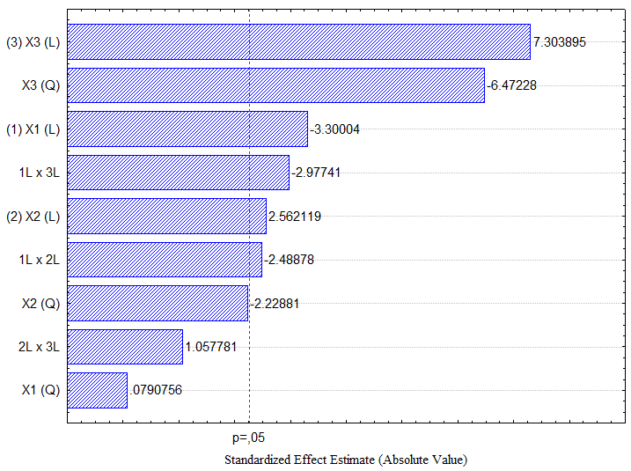
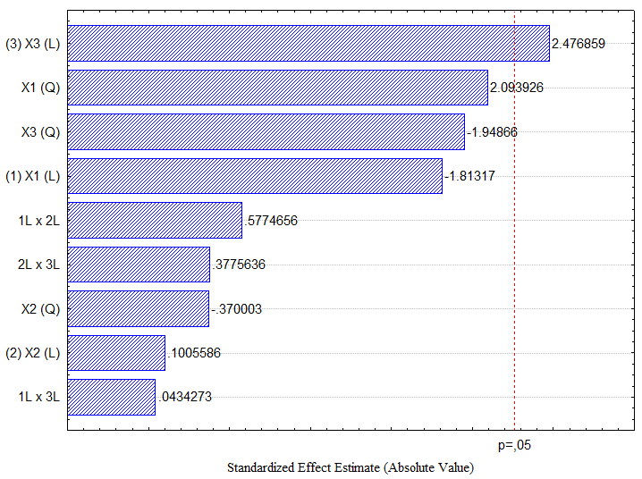
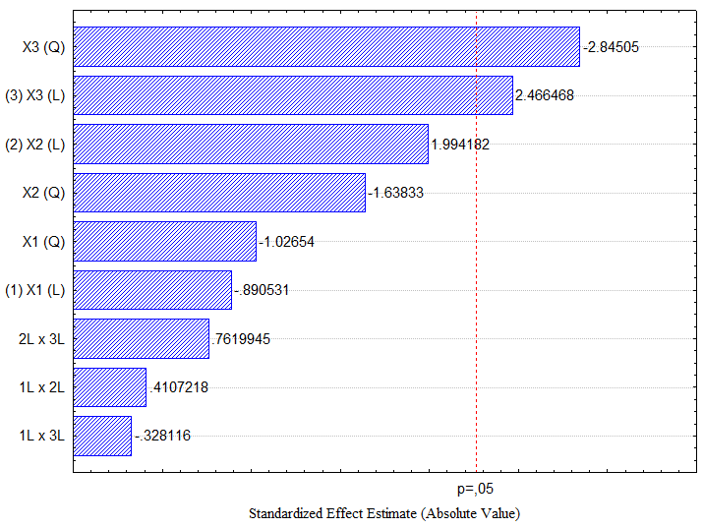
Figures
(b) – CX-13
(c) – CX-30
(a) – CX-4
Figure S1. Pareto chart of standardized effects for the Central Composite design for ASNase immobilization onto (a) CX-4, (b) CX-13 and (c) CX-30. (1) time; (2) pH; (3) enzyme concentration.
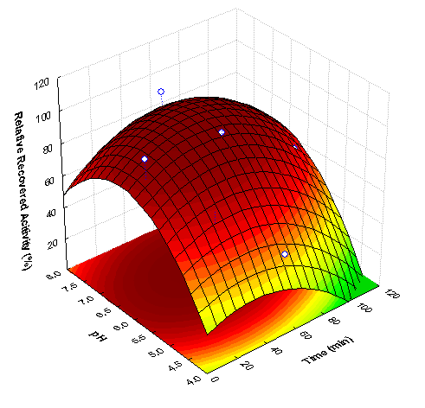
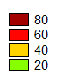
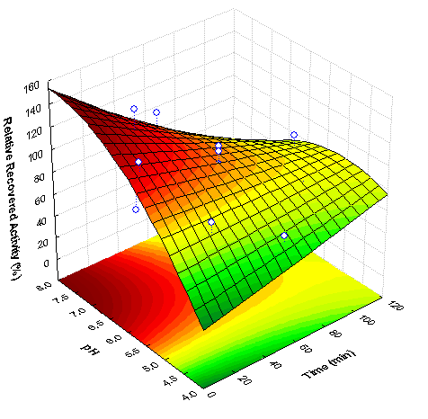
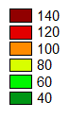
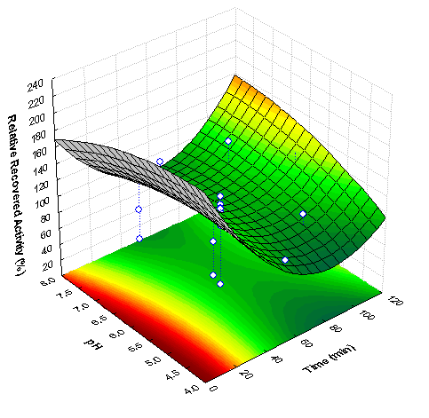
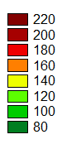
(a)
(b)
(c)
Figure S2. Response surface plots for RRA of immobilized ASNase over CX as a function of pH and time with an enzyme concentration of 0.2 mg·mL⁻¹. (a) CX-4; (b) CX-13; (c) CX-30.

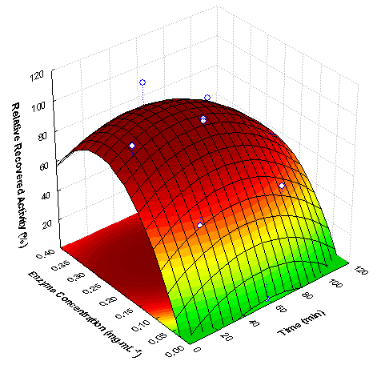
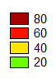
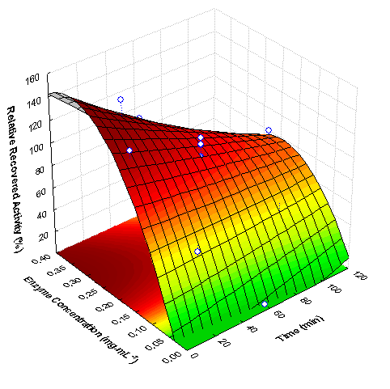
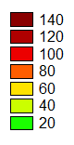
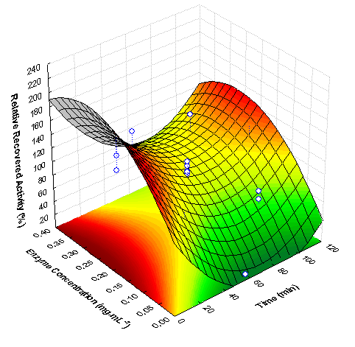
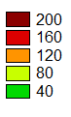
(a)
(b)
(c)

Figure S3. Response surface plots for RRA of immobilized ASNase over CX as a function of enzyme concentration and time, at pH 6. (a) CX-4; (b) CX-13; (c) CX-30.

Figure S4. Initial reaction rates (v₀) for free (♦) and immobilized ASNase (■) (0.26 mg·mL⁻¹) onto CX-4 by physical adsorption. The solid lines represent the experimental data fit to the Hill equation.

