Supplementary Material
Supplementary Table 1. Variables to be analyzed and information sources
Environmental Matrix |  | Variable |  | Data source |  | Period of time
Solid Waste |  | Conventional solid waste (Tons/month) generated in Bogota |  | Superintendency of Residential Public Service |  | January 2019-December 2020
 |  | Bio-sanitary hospital waste -Personal Protective Equipment produced in Bogota (kg/month) |  | Special Administrative Unit of Public Utilities -UAESP-. |  | January 2019-December 2020
Air Quality |  | Concentration of criteria air pollutants (carbon monoxide (CO), nitrogen oxides (NO2), particulate matter less than 10 microns (PM10) and fine particulate matter (PM2.5)) |  | Air quality monitoring network of Bogota - District Secretary of the Environment. |  | January 2019-December 2020
 |  | Perception of change in air quality |  | Citizen characterization survey. ITHACA Project* National Institute of Health. |  | February 2019-May 2021
Water Resource |  | Bogotá river water quality parameters (Organic matter,ammonioum,dissolved oxygen,manganese,turbidity and conductivity) |  | Bogota Water and Sewer System |  | Maximum values in 2019 and 2020
Transport |  | Change in the choice of mode of transport used |  | Citizen characterization survey. ITHACA Project National Institute of Health. |  | February 2019-May 2021
 |  | Use of Bogota's Rapid Transit System (BRT) |  | Company providing services: Transmilenio S.A. |  | January 2019-December 2020
Supplementary Table 2.Types of generators according to their production in kilograms per day and the frequency of waste collection.
Acronym | Type of Generator |  | Daily production (Kg/day) |  | Collection frequencies (days)
LP | Large Producer |  | > 100 |  | Daily (6/7 or 7/7)
MP | Medium Producer |  | ≥ 25 - < 100 |  | Three times a week (3/6)
PP | Small Producer |  | ≥ 3 - < 25 |  | Twice a week (2/6)
MA | Microproducer A |  | < 3 |  | Once a week (1/6)
MB | Microproducer B |  |  |  | Twice a month
MC | Microproducer C |  |  |  | Once a month

Supplementary Table 3. Sociodemographic characteristics of the survey participants ITHACA.
Variable |  |  |  | Ovelall |  | Female
Age | 15-20 |  |  | 140 |  | 86 (61.4%)
 | 21-30 |  |  | 603 |  | 394 (65.3%)
 | 31-40 |  |  | 497 |  | 303 (61%)
 | 41-50 |  |  | 292 |  | 172 (58.9%)
 | 51-60 |  |  | 134 |  | 61 (45.5%)
 | 61-70 |  |  | 28 |  | 5 (17.9%)
 | Missing |  |  | 127 |  | 50 (39.4%)
Date of the survey | Pandemic |  |  | 738 |  | 370 (50.1%)
 | Pre Pandemic |  |  | 1083 |  | 701 (64.7%)
Socioeconomic Strata | 1 |  |  | 19 |  | 13 (68.4%)
 | 2 |  |  | 298 |  | 184 (61.7%)
 | 3 |  |  | 771 |  | 484 (62.8%)
 | 4 |  |  | 476 |  | 263 (55.3%)
 | 5 |  |  | 147 |  | 87 (59.2%)
 | 6 |  |  | 60 |  | 40 (66.7%)
 | Missing |  |  | 50 |  | - (%)
Occupation | Unemployed |  |  | 24 |  | 20 (83.3%)
 | Student |  |  | 422 |  | 269 (63.7%)
 | Other |  |  | 5 |  | 2 (40%)
 | Employee |  |  | 1319 |  | 780 (59.1%)
 | Missing |  |  | 51 |  | 0%
Educational level | High School |  |  | 257 |  | 166 (64.6%)
 | Doctorate |  |  | 43 |  | 23 (53.5%)
 | Specialization |  |  | 446 |  | 268 (60.1%)
 | Master |  |  | 264 |  | 167 (63.3%)
 | Post-doctorate |  |  | 5 |  | 5 (100%)
 | Undergraduate |  |  | 544 |  | 318 (58.5%)
 | Technicians |  |  | 211 |  | 123 (58.3%)
 | Missing |  |  | 51 |  | 1 (2%)
Mode of transport | Walking |  |  | 113 |  | 68 (60.2%)
 | Bike |  |  | 189 |  | 71 (37.6%)
 | Bus |  |  | 159 |  | 115 (72.3%)
 | Vehicle |  |  | 208 |  | 113 (54.3%)
 | Motorcycle |  |  | 89 |  | 34 (38.2%)
 | Skaterboard |  |  | 2 |  | 2 (100%)
 | Zonal Bus |  |  | 413 |  | 273 (66.1%)
 | Taxi |  |  | 82 |  | 60 (73.2%)
 | BRT Bus |  |  | 515 |  | 317 (61.6%)
 | Missing |  |  | 51 |  | 18 (35.3%)
Supplementary Table 4. U-Mann Whitney test to total solid waste and biosanitary waste.
Variable |  | Units | 2019 |  | 2020 |  | Estimated |  | p-value
Total Solid Waste |  | Ton | 203751 |  | 188713.6 |  | 111 |  | <0.05
Biosanitary Waste |  | Ton | 975414.9 |  | 1063097.8 |  | 51 |  | 0.24

Supplementary Table 5. U-Mann Whitney and t-test to Air Quality data.
Variable | Units | 2019 | 2020 | Estimated | p-value
CO | ppm | 0,9 | 0,5 | 11.343 | 1,82E-13**
NO₂ | ppm | 38,6 | 16,8 | 982 | 3,41E-13**
PM₁₀ | µg m⁻³ | 33,8 | 22,4 | 828 | 1,01E-05**
PM_{2.5} | µg m⁻³ | 17,5 | 13,6 | 697 | 0.01253

Supplementary Figure 1. Solid waste disposal series at the Bogota sanitary landfill. The gray line with circular markers indicates the tons per month for 2019, the blue line with square markers indicates the tons disposed of in 2020, the year of the pandemic.
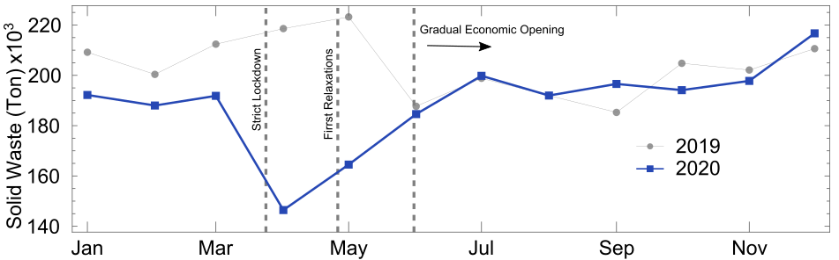

Supplementary Figure 2. Air quality perception: a) the air quality on house from job. b) Only pandemic answers about the existence of a relationship between air quality and usage of personal protection

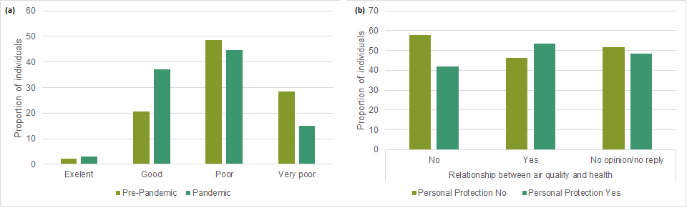

Supplementary Figure 3. BRT system admissions timeline. The light blue series shows moving concentrations in 2019 and the dark blue series shows concentrations in 2020.

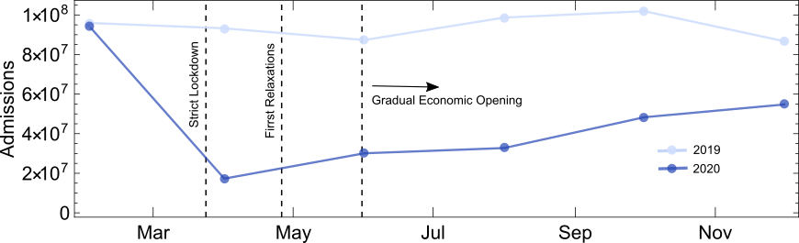

Supplementary Figure 4.Water Quality reported Bogota Water and Sewer Service 2019 – 2020.
