Supporting Information:
Table S1. Result summary of genome analysis of C. coralloides DSM2259 genome (NCBI accession # CP003389) with antiSMASH. NP = natural product, bp = base pairs, DB = database
Cluster ID | NP class | bp_{start} | bp_{end} | # bp | Predicted BGC | sequence similarity [%] | DB BGC | Origin of DB BGC
1 | Terpene | 913,294 | 930,557 | 17,263 | carotenoid | 100 | BGC0000648 | Myxococcus xanthus
2 | T1 PKS-NRPS | 1,032,294 | 1,080,211 | 47,917 | - | - | - | -
3 | Terpene | 2,119,082 | 2,141,484 | 22,402 | - | - | - | -
4 | T1 PKS-NRPS | 2,428,410 | 2,482,711 | 54,301 | chloromyxamide | 13 | BGC0001945 | Myxococcus sp.
5 | T1 PKS | 2,606,636 | 2,651,986 | 45,350 | chloromyxamide | 27 | BGC0001945 | Myxococcus sp.
6 | NRPS | 2,816,735 | 2,882,770 | 66,035 | - | - | - | -
7 | RiPP-like | 3,013,876 | 3,022,723 | 8,847 | - | - | - | -
8 | T1 PKS-NRPS | 3,103,725 | 3,257,110 | 153,385 | - | - | - | -
9 | NRPS, T1PKS | 3,442,275 | 3,494,934 | 52,659 | BE-43547A1/ BE-43547A2… | 10 | BGC0001330 | Micromonospora sp. RV43
10 | lanthipeptide | 4,030,200 | 4,051,486 | 21,286 | - | - | - | -
11 | T1 PKS-NRPS | 4,186,913 | 4,241,185 | 54,272 | - | - | - | -
12 | T1 PKS-NRPS | 4,412,963 | 4,485,151 | 72,188 | - | - | - | -
13 | lanthipeptide | 4,529,903 | 4,551,241 | 21,338 | - | - | - | -
14 | RiPP-like | 4,746,094 | 4,757,661 | 11,567 | - | - | - | -
15 | NRPS | 4,857,415 | 4,924,895 | 67,480 | - | - | - | -
16 | lanthipeptide | 5,052,309 | 5,073,083 | 20,774 | - | - | - | -
17 | T1 PKS-NRPS | 5,209,355 | 5,345,413 | 136,058 | myxoprincomide | 66 | BGC0000393 | Myxococcus xanthus
18 | T1 PKS-NRPS | 5,481,949 | 5,577,500 | 95,551 | myxochelin A/ B | 86 | BGC00001345 | Stigmatella aurantiaca
19 | NRPS | 5,625,043 | 5,674,634 | 49,591 | - | - | - | -
20 | RiPP-like | 5,680,374 | 5,690,671 | 10,297 | - | - | - | -
21 | RiPP-like, LAP, thiopeptide | 5,825,525 | 5,852,242 | 26,717 | ficellomycin | 5 | BGC0001593 | Streptomyces ficellus
22 | T1 PKS | 6,407,278 | 6,448,051 | 40,773 | puwainaphycin A/ B / C / D | 30 | BGC0001125 | Cylindrospermum alatosporum CCALA 988
23 | lanthipeptide | 6,566,995 | 6,592,859 | 25,864 | - | - | - | -
24 | terpene | 6,928,334 | 6,945,580 | 17,246 | - | - | - | -
25 | thiopeptide | 7,099,821 | 7,138,262 | 38,441 | - | - | - | -
26 | T1 PKS-NRPS | 7,184,802 | 7,246,797 | 61,995 | rakicidin A / B | 22 | BGC0001327 | Micromonospora purpureochromogenes
27 | NRPS, arylpolyene | 7,341,187 | 7,422,939 | 81,752 | APE-Ec | 36 | BGC0000836 | Escherichia coli CFT073
28 | lanthipeptide | 7,528,620 | 7,551,841 | 23,221 | - | - | - | -
29 | butyrolactone | 8,181,142 | 8,191,966 | 10,824 | - | - | - | -
30 | phenazine | 8,386,250 | 8,406,681 | 20,431 | streptobactin | 11 | BGC0000368 | Streptomyces sp. ATCC 700974
31 | T3 PKS | 9,028,261 | 9,069,358 | 41,097 | alkylpyrone-407/ alkylpyrone-393 | 34 | BGC0001964 | Cystobacterineae bacterium
32 | terpene | 9,239,314 | 9,261,572 | 22,258 | geosmin | 100 | BGC0000661 | Nostoc punctiforme PCC 73102
33 | RiPP-like, RRE-containing | 9,512,033 | 9,533,635 | 21,602 | -

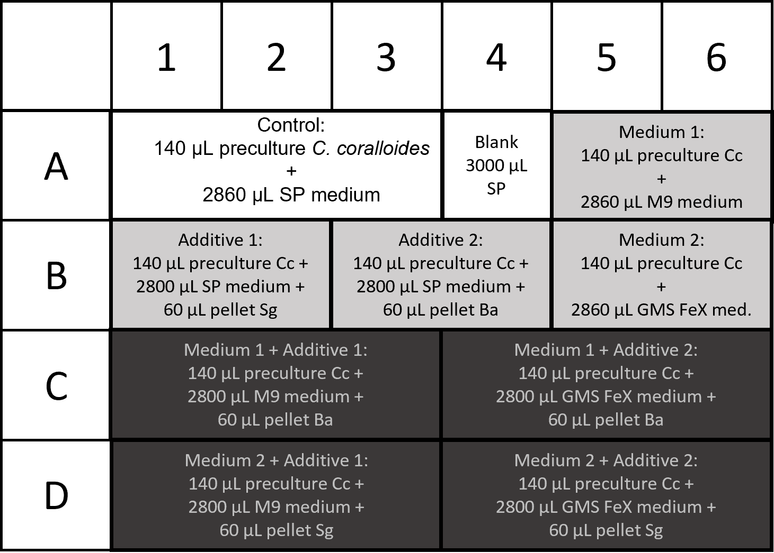
Figure S1. Inoculation plan for SD plate with added cell pellets. White = control and blank, grey = univariate experiments, black = bivariate experiments.
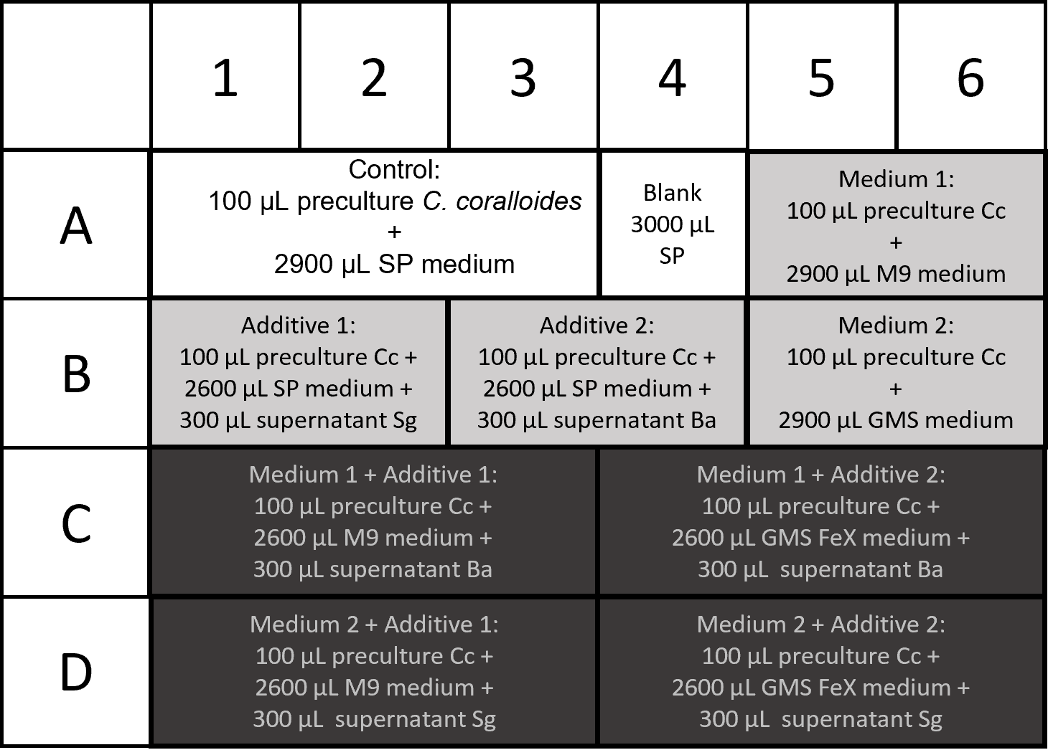
Figure S2. Inoculation plan for SD plate with added supernatants. White = control and blank, grey = univariate experiments, black = bivariate experiments.
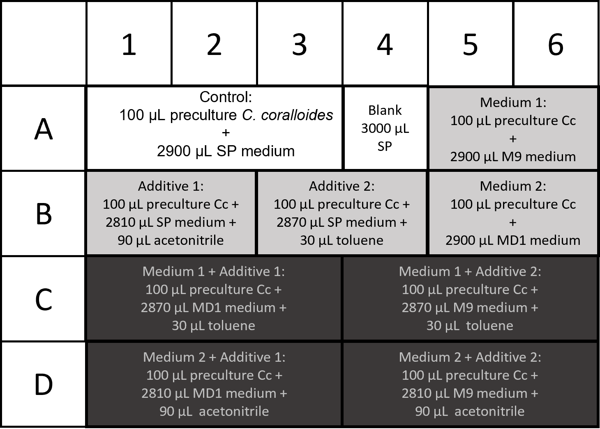
Figure S3. Inoculation plan for SD plate with added organic solvents. White = control and blank, grey = univariate experiments, black = bivariate experiments.
Table S2. List of chemicals, chemical formulae, and supplier. Chemicals were used in the purest form available.
Chemical | Chemical formula | Supplier | Chemical | Chemical formula | Supplier
BactoPeptone | - | Beckto Dickinson | magnesium sulfate heptahydrate | MgSO₄ x 7 H₂O | Carl Roth
meat extract | - | Fluka | dipotassium-phosphate | K₂HPO₄ | Carl Roth
raffinose D(+) pentahydrate | C₁₈H₃₂O₁₆ x 5 H₂O | Sigma Aldrich | calcium chloride dihydrate | CaCl₂ x 2 H₂O | Carl Roth
sucrose D(+) | C₁₂H₂₂O₁₁ | Carl Roth | vitamin B12 | C₆₃H₈₈CoN₁₄O₁₄P | Carl Roth
galactose D(+) | C₆H₁₂O₆ | Carl Roth | EDTA | C₁₀H₁₆N₂O₈ | Carl Roth
soluble starch | (C₆H₁₀O₅)n | Carl Roth | iron (II) sulfate heptahydrate | FeSO₄ x 7 H₂O | Carl Roth
BactoCasitone | - | Beckto Dickinson | zinc sulfate heptahydrate | ZnSO₄ x 7 H₂O | AppliChem
boric Acid | H₃BO₃ | Carl Roth | manganese (II) cloride tetrahydrate | MnCl₂ x 4 H₂O | Carl Roth
cobalt (II) chloride hexahydrate | CoCl₂ x 6 H₂O | Carl Roth | copper (II) chloride dihydrate | CuCl₂ x 2 H₂O | Carl Roth
nickel (II) chloride dihydrate | NiCl₂ x 6 H₂O | Alfa Aesar | sodium molybdate dihydrate | MoNa₂O₄ x 2 H₂O | Carl Roth
sodium chloride | NaCl | Carl Roth | D (+) glucose | C₆H₁₂O₆ | Carl Roth
malt extract | - | Carl Roth | Bacto yeast extract | - | Beckto Dickinson
potassium dihydrogen phosphate | KH₂PO₄ | Carl Roth | sodium nitrate | NaNO₃ | Carl Roth
manganese (II) sulfate hydrate | MnSO₄ x H₂O | Carl Roth | thiamine-HCl | C₁₂H₁₇ClN₄OS x HCl | Carl Roth
ethyl acetate | C₄H₈O₂ | VWR | L-proline | C₅H₉NO₂ | Carl Roth
acetonitrile | C₂H₃N | Carl Roth | disodium hydrogen phosphate | Na₂HPO₄ x 2 H₂O | AppliChem
toluene | C₇H₈ | Fisher Scientific | ammonium chloride | NH₄Cl | Carl Roth
methanol | CH₄O | Carl Roth

Table S3. Steps and settings used for raw data processing in MZmine 2.35.
Input | Step | Settings | Output
raw data, mzXML-format | Peak Detection -> Mass Detection | MS level: 1  Mass Detector: Centroid  Noise level: 1.0E4 | mass list
mass list | Peak Detection -> Chromatogram Builder | MS level: 1  Min time span: 0.01 min  Min height: 3.0E4  m/z tolerance: 0.0 m/z or 20 ppm | peak lists, suffix:  chromatograms

Table S4. Steps and settings used for peak list processing in MZmine 2.35.
Input | Step | Settings | Output
peak lists, suffix:  chromatograms | Peak Detection -> Chromatogram Deconvolution | Algorithm: Baseline cut-off | peak lists, suffix:  chromatograms deconvoluted
peak lists, suffix:  chromatograms deconvoluted | Isotopes -> Isotopic peaks grouper | m/z tolerance: 0.0 m/z or 20 ppm  RT tolerance: 0.1 min  Maximum charge: 3  Representative isotope: lowest m/z | peak lists, suffix:  chromatograms deconvoluted deisotoped
peak lists, suffix:  chromatograms deconvoluted deisotoped | Alignment -> Join Aligner | m/z tolerance: 0.0 m/z or 20 ppm  Weight for m/z: 75  RT tolerance: 0.1 min  Weight for RT: 25 | aligned peak list
aligned peak list | Filtering -> Peak list rows filter | Minimum peaks in a row: 2  remove rows that match all criteria | aligned peak list, suffix:  filtered
aligned peak list, suffix:  filtered | Filtering -> Peak list rows filter | RT: 1.0-11.0 min  keep rows that match all criteria | aligned peak list, suffix:  filtered filtered

Table S5. List of control groups and background samples for each univariate experiment with C. coralloides. The control group for all univariate experiments was C. coralloides grown on SP medium without any additives.
Univariate Experiments | Background samples to be subtracted
SP medium + P_{Ba} | SP medium and extracted P_{Ba}
SP medium + P_{Sg} | SP medium and extracted P_{Sg}
SP medium + Sup_{Ba} | SP medium and extracted Sup_{Ba}
SP medium + Sup_{Sg} | SP medium and extracted Sup_{Sg}
SP medium + 1% v/v Tol | SP medium with 1% v/v toluene
SP medium + 3% v/v ACN | SP medium with 3% v/v acetonitrile
M9 medium | M9 medium
MD1 medium | MD1 medium
GMS medium | GMS medium
GMS FeX medium | GMS FeX medium

.

Bivariate Experiments | Background samples to be subtracted | Univariate condition 1: additive (to be subtracted) | Univariate condition 2: medium (to be subtracted)
M9 medium + P_{Sg} | M9 medium and  extracted P_{Sg} | Cc on SP medium + P_{Sg} | Cc on M9 medium
M9 medium + P_{Ba} | M9 medium and  extracted P_{Ba} | Cc on SP medium + P_{Ba} | Cc on M9 medium
GMS FeX medium + P_{Sg} | GMS FeX medium and extracted P_{Sg} | Cc on SP medium + P_{Sg} | Cc on GMS FeX medium
GMS FeX medium + P_{Ba} | GMS FeX medium  and extracted P_{Ba} | Cc on SP medium + P_{Ba} | Cc on GMS FeX medium
M9 medium + Sup_{Sg} | M9 medium  and extracted Sup_{Sg} | Cc on SP medium + Sup_{Sg} | Cc on M9 medium
M9 medium + Sup_{Ba} | M9 medium and  extracted Sup_{Ba} | Cc on SP medium + Sup_{Ba} | Cc on M9 medium
GMS medium + Sup_{Sg} | GMS medium and  extracted Sup_{Sg} | Cc on SP medium + Sup_{Sg} | Cc on GMS medium
GMS medium + Sup_{Ba} | GMS medium and  extracted Sup_{Ba} | Cc on SP medium + Sup_{Ba} | Cc on GMS medium
M9 medium + 1% v/v Tol | M9 medium with 1% v/v Tol | Cc on SP medium + 1% v/v Tol | Cc on M9 medium
M9 medium + 3% v/v ACN | M9 medium with 3% v/v ACN | Cc on SP medium + 3% v/v ACN | Cc on M9 medium
MD1 medium + 1% v/v Tol | MD1 medium with 1% v/v Tol | Cc on SP medium + 1% v/v Tol | Cc on MD1 medium
MD1 medium + 3% v/v ACN | MD1 medium with 3% v/v ACN | Cc on SP medium + 3% v/v ACN | Cc on MD1 medium
Table S6. List of background samples and univariate samples for each bivariate experiment with C. coralloides (Cc). The control group for all bivariate experiments was C. coralloides grown on SP medium without any additives. A combined background sample was used for the experiments with organic solvents, i.e., the solvent (acetonitrile (ACN) or toluene (Tol)) was directly added to the respective medium which was then extracted.

Table S7. New mass features from univariate OSMAC experiments and culture conditions under which they were produced. # p.c. = number of producing conditions. P_{Ba} = B. amyloliquefaciens pellet, Sup_{Ba} = B. amyloliquefaciens supernatant, P_{Sg} = S. griseochromogenes pellet, Sup_{Sg} = S. griseochromogenes supernatant, ACN = acetonitrile, Tol = toluene. If adduct forms are not indicated, they could not be determined based on the obtained mass spectra.
Mass feature ID | m/z [-] | t_{R} [min] | # p.c. | univariate producing conditions
MF1 | 470.22 [M+H]⁺ | 6.23 | 1 | M9 medium
MF2 | 875.57 [M+H]⁺ | 11.04 | 2 | M9 medium, GMS medium
MF4 | 306.26 [M+H]⁺ | 5.51 | 2 | M9 medium, GMS medium
MF6 | 449.20 [M+H]⁺ | 6.64 | 1 | Sup_{Sg}
MF8 | 272.16 [M+H]⁺ | 4.65 | 1 | Sup_{Sg}
MF39 | 170.06  [M+H-H₂O]⁺ | 8.39 | 2 | GMS medium, Sup_{Ba}
MF54 | 295.15 [M+H]⁺ | 7.99 | 2 | P_{Ba}, Sup_{Ba}
MF107 | 290.27 [M+H]⁺ | 5.39 | 1 | M9 medium
MF120 | 164.11 [M+H]⁺ | 5.31 | 2 | Sup_{Ba}, Sup_{Sg}
MF127 | 269.16 [M+H]⁺ | 5.04 | 1 | Sup_{Ba}
MF128 | 227.16 [M+H]⁺ | 5.64 | 1 | Sup_{Ba}
MF129 | 422.22 | 7.84 | 1 | Sup_{Ba}
MF133 | 288.25 [M+H]⁺ | 5.42 | 1 | Sup_{Ba}
MF153 | 396.46 | 10.35 | 1 | M9 medium
MF197 | 227.16 [M+H]⁺ | 5.56 | 1 | MD1 medium
MF198 | 252.16 [M+H]⁺ | 5.95 | 1 | ACN
MF199 | 359.27 [M+H]⁺ | 8.43 | 1 | MD1 medium
MF202 | 313.14 [M+Na]⁺ | 8.02 | 1 | Tol

Table S8. New mass features from bivariate OSMAC experiments and culture condition sets under which they were produced. # p.c. = number of producing conditions. P_{Ba} = B. amyloliquefaciens pellet, Sup_{Ba} = B. amyloliquefaciens supernatant, P_{Sg} = S. griseochromogenes pellet, Sup_{Sg} = S. griseochromogenes supernatant, ACN = acetonitrile, Tol = toluene. If adduct forms are not indicated, they could not be determined based on the obtained mass spectra.
Mass feature ID | m/z [-] | t_{R} [min] | # p.c. | Producing conditions
CcSD10 | 366.29 | 7.75 | 1 | GMS FeX + P_{Ba}
CcSD56 | 292.22 | 7.55 | 2 | M9 + P_{Ba}, M9 + Sup_{Ba}
CcSD57 | 230.21  [M+H]⁺ | 6.5 | 2 | M9 + P_{Ba}, M9 + Sup_{Ba}
CcSD59 | 293.21 [M+H]⁺ | 8.46 | 1 | M9 + P_{Ba}
CcSD60 | 323.22 [M+H]⁺ | 7.06 | 2 | M9 + P_{Ba}, M9 + Sup_{Ba}
CcSD61 | 216.1921 [M+H]⁺ | 6.03 | 2 | M9 + P_{Ba}, M9 + Sup_{Ba}
CcSD62 | 252.23 [M+Na]⁺ | 7.55 | 1 | M9 + P_{Ba}
CcSD65 | 268.2248 [M+H]⁺ | 7.45 | 2 | M9 + P_{Ba}, M9 + Sup_{Ba}
CcSD66 | 322.2323 [M+H]⁺ | 6.37 | 2 | M9 + P_{Ba}, M9 + Sup_{Ba}
CcSD69 | 288.2379 [M+H]⁺ | 7.67 | 1 | M9 + Sup_{Ba}
CcSD73 | 257.13 [M+H]⁺ | 7.62 | 3 | GMS FeX + P_{Ba}, M9 + P_{Sg}, M9 + Sup_{Sg}
CcSD79 | 310.06 [M+H]⁺ | 6.79 | 1 | M9 + P_{Sg}
CcSD80 | 263.22 [M+H]⁺ | 6.01 | 1 | M9 + P_{Sg}
CcSD82 | 303.252 [M+H]⁺ | 10.37 | 1 | M9 + P_{Sg}
CcSD83 | 255.15 [M+H]⁺ | 7.92 | 1 | M9 + P_{Sg}
CcSD101 | 264.23 [M+Na]⁺ | 6.35 | 1 | M9 + Sup_{Ba}
CcSD102 | 317.2681 [M+H]⁺ | 10.89 | 2 | GMS FeX + P_{Sg}, M9 + Sup_{Sg}
CcSD134 | 318.3 [M+H]⁺ | 7.92 | 1 | M9 + Sup_{Sg}
CcSD136 | 230.2075 | 6.51 | 1 | GMS + Sup_{Sg}
CcSD139 | 330.2583 [M+H]⁺ | 6.14 | 1 | M9 + Sup_{Ba}
CcSD142 | 281.1 [M+H]⁺ | 3.86 | 1 | M9 + Sup_{Ba}
CcSD143 | 286.2328 | 5.95 | 1 | M9 + Sup_{Ba}
CcSD145 | 283.22 | 7.06 | 1 | M9+ Sup_{Ba}
CcSD151 | 279.13 [M+H]⁺ | 3.42 | 1 | GMS + Sup_{Ba}
CcSD205 | 265.14 [M+H]⁺ | 4.87 | 1 | MD1 + Tol
CcSD206 | 180.1038 [M+H]⁺ | 3.38 | 1 | MD1 + Tol

