Supplementary Figure 1. Principal components analysis (PCA) plots of the population ancestry of cases and controls. HapMap CEU individuals are plotted in blue circles, CHB+JPT are plotted in green circles, YRI individuals are plotted in red circles. Familial glioma cases, TCGA glioma cases and Controls are plotted as blue, orange and grey crosses respectively.
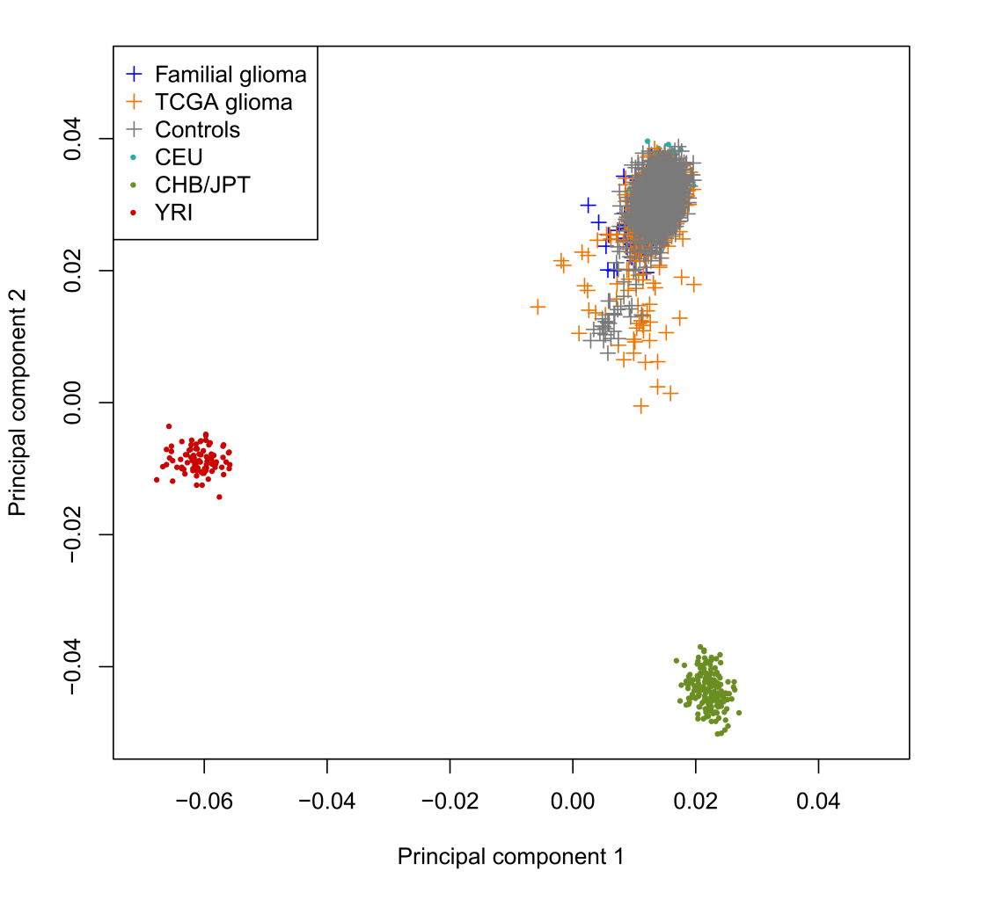

Supplementary Table 1. Details of glioma cases sequenced. Shown for each family sequenced are the proband’s personal history of cancer and any known details of relatives affected with brain tumours.*, sample sequenced; M, Male; F, Female; Mo, Mother; Fa, Father; m, maternal; p, paternal; B, brother; S, sister; A, aunt; U, uncle; C, cousin; GMo, Grandmother; GFa, Grandfather; GU, Great uncle; GA, Great aunt; GNe, Grandnephew; Ne, Nephew; Ni, Niece; GGMo, Great grandmother; D, Daughter; So, Son; H, Half; Cr, First cousin once removed; Cd, Double cousin; C2, Second cousin.
Family | Centre | Proband - sex, histology (age of diagnosis) | Brain tumours in family - relation (sex), histology (age of diagnosis) | N
FAM_1 | French | M, Grade II astrocytoma (31)* | B (M), Grade III anaplastic astrocytoma (48)* | 2
FAM_2 | French | F, Grade III anaplastic oligoastrocytoma (27)* | Fa (M), GBM (51)* | 2
FAM_3 | French | M, GBM (61)* | B (M), GBM (65)*; S (F), Astrocytoma; B (M), PBT, Mo (M), GBM, mC (F), GBM | 2
FAM_4 | French | M, Glioma medulla* | Mo (F), Anaplastic astrocytoma (61)*, mGMo (F), PBT | 2
FAM_5 | French | M, GBM (44)* | mC (M), GBM* | 2
FAM_6 | French | M, Grade II oligoastrocytoma (40)* | mC (M), glioma* | 2
FAM_7 | French | M, Grade II oligodendroglioma (30)* | pU (M), GBM*; Mo, Grade II Meningioma (50) | 2
FAM_8 | French | M, Grade III oligodendroglioma (46)* | B (M), Anaplastic oligoastrocytoma (56)/COAD*; B (M), head + neck | 2
FAM_9 | French | M, Grade II oligodendroglioma (45)* | S (F), GBM* | 2
FAM_10 | French | M, Brainstem glioma* | S (F), Grade II oligodendroglioma (41)*; B (M), Grade III oligodendroglioma | 2
FAM_11 | French | M, Ganglioma (36)* | B (M), GBM (51)*; pGMo (F), PBT | 2
FAM_12 | Danish | M, GBM (46)/Anaplastic astrocytoma (46) | fC (M), Anaplastic astrocytoma (58)* | 2
FAM_13 | Danish | F, Dysembroplastic neuroepithelial tumour (27)/Glioma, unclassified (27)* | Mo (F), Diffuse astrocytoma (46)*; mGMo (F), PBT (21); mU (M), Medulloblastoma (13) | 2
FAM_14 | Danish | F, Anaplastic oligodendroglioma (67)* | B (M), Anaplastic oligodendroglioma (63)*; mC (F), Breast (60)/Meningioma (62) | 2
FAM_15 | Danish | F, BCC (75)/GBM (77)* | S (F), GBM (78)* | 2
FAM_16 | Danish | M, GBM (73)* | S (F), Astrocytoma, juvenile pilocytic (41)*; mC (M), GBM (76)/Glioma unclassified*; mA (F), GBM (66); mU (M), PBT; mGNi (F), thyroid (40) | 3
FAM_17 | Danish | F, Diffuse astrocytoma (24)* | S (F), Diffuse astrocytoma (26)* | 2
FAM_18 | French | M, GBM* | B (M), GBM | 1
FAM_19 | French | M, Grade III anaplastic oligoastrocytoma (55)* | U (M), PBT | 1
FAM_20 | French | M, Grade III oligoastrocytoma (52)* | Mo (F), Brain-stem glioma | 1
FAM_21 | French | M, Grade III oligodendroglioma (54)* | mA (F), PBT | 1
FAM_22 | French | M, Oligodendroglioma* | Mo (F), GBM | 1
FAM_23 | French | M, Grade III oligodendroglioma (44)* | S (F), PBT | 1
FAM_24 | French | M, GBM (68)* | B (M), GBM | 1
FAM_25 | French | M, GBM* | Mo (F), PBT | 1
FAM_26 | French | M, Anaplastic oligoastrocytoma (31)* | GFa (M), Oligoastrocytoma/astrocytoma | 1
FAM_27 | French | F, Melanoma-glioma* |  | 1
FAM_28 | French | F, Grade II oligoastrocytoma* | S (F), Astrocytoma | 1
FAM_29 | French | F, Malignant neural glioma (26)* | pGMo (F), Astrocytoma; GGMo, Probable brain tumour | 1
FAM_30 | French | F, Anaplastic astrocytoma* | GA (F), PBT | 1
FAM_31 | French | F, Grade III oligodendroglioma* | S (F), Thalamic tumour | 1
FAM_32 | French | M, GBM* | S (F), PBT | 1
FAM_33 | French | F, Grade III oligodendroglioma* | B (M), PBT; S (F), PBT | 1
FAM_34 | French | F, GBM (65)* | Fa (M), PBT | 1
FAM_35 | French | M, GBMO-melanoma* |  | 1
FAM_36 | French | M, Grade III anaplastic astrocytoma (61)* | B (M), Grade III/IV gemistocytic astrocytoma | 1
FAM_37 | French | F, GBM* | S (F), GBM; | 1
FAM_38 | French | M, Grade II oligodendroglioma (54)* | pU (M), PBT | 1
FAM_39 | French | M, Ganglioma (32)* | mGFa (M), PBT; mC (M), PBT | 1
FAM_40 | French | F, Grade III oligodendroglioma (49)* | A (F), PBT | 1
FAM_41 | French | F, GBM (51)* | B (M), Cerebral lymphoma | 1
FAM_42 | French | M, Gemistocytic astrocytoma (28)* | Fa (M), Anaplastic astrocytoma (52); pA (F), PBT | 1
FAM_43 | French | F, GBM (53)* | Mo (F), GBM | 1
FAM_44 | French | M, Grade II oligodendroglioma (50)* | D (F), Medulloblastoma | 1
FAM_45 | French | F, Grade III oligodendroglioma* | Mo (F), PBT | 1
FAM_46 | French | F, GBMO-melanoma* |  | 1
FAM_47 | French | M, GBM* | C (F), Glioma unspecified | 1
FAM_48 | French | F, GBM (51)* | C (M), PBT; C (M), PBT | 1
FAM_49 | French | F, Glioma unspecified (29)* | U (M), PBT | 1
FAM_50 | French | M, Grade II astrocytoma (48)/colon cancer* | Suspected history of turcot syndrome | 1
FAM_51 | French | F, Grade II astrocytoma (43)* | GFa (M), PBT | 1
FAM_52 | French | F, GBM (50)/ breast (36)* | Fa (M), Malignant cerebellar astrocytoma (54) | 1
FAM_53 | French | F, Grade III oligodendroglioma (27) | mU (M), Glioma unspecified | 1
FAM_54 | French | F, GBMO-melanoma* |  | 1
FAM_55 | French | F, Grade II oligoastrocytoma (72)/Thyroid adenocarcinoma* |  | 1
FAM_56 | French | F, Gliomatosis cerebri-choroidal melanoma* |  | 1
FAM_57 | French | M, Gliomatose astrocytoma grade II/III (21)* | Multiple PBTs in family | 1
FAM_58 | French | F, GBM* | So (M), PBT | 1
FAM_59 | French | F, Malignant glioma* | B (M), GBM/renal cancer | 1
FAM_60 | French | F, GBM* | Mo (F), GBM | 1
FAM_61 | French | F, Oligoastrocytoma (26)* | Mo (F), GBM | 1
FAM_62 | French | M, Grade II ependymoma (27)* | Mo (F), Glioma unspecified; pU (M), PBT | 1
FAM_63 | French | M, Grade II astrocytoma (54)* | C (M), PBT | 1
FAM_64 | French | M, Oligoastrocytoma (35)* | Fa (M), Oligodendroglioma; B (M), Oligoastrocytoma (21) | 1
FAM_65 | French | F, Grade II oligodendroglioma (50)* | B (M), Pilocytic astrocytoma | 1
FAM_66 | French | F, Anaplastic oligodendroglioma* | C (M), PBT; A (F), PBT | 1
FAM_67 | French | M, GBM (68)* | B (M), PBT | 1
FAM_68 | French | M, Grade III anaplastic astrocytoma (57)* | Mo (F), PBT | 1
FAM_69 | French | M, Grade III oligodendroglioma (76)* | Fa (M), PBT | 1
FAM_70 | French | M, Anaplastic astrocytoma* | Fa (M), GBM; C (M), GBM | 1
FAM_71 | French | M, GBM (34)* | mGFa (M), Glioma unspecified | 1
FAM_72 | French | F, Oligoastrocytoma (30)* | Multiple PBTs | 1
FAM_73 | French | F, GBM-melanoma* |  | 1
FAM_74 | French | M, Grade III anaplastic astrocytoma (57)* | B (M), PBT (51) | 1
FAM_75 | French | M, GBM* | B (M), GBM | 1
FAM_76 | French | F, Grade III anaplastic oligoastrocytoma (37)* | Fa (M), GBM | 1
FAM_77 | French | M, GBM-melanoma* |  | 1
FAM_78 | French | F, Grade II oligodendroglioma-melanoma* |  | 1
FAM_79 | French | F, Grade II oligoastrocytoma (48)* | S (F), PBT | 1
FAM_80 | French | M, Grade III anaplastic astrocytoma (20)* | Fa (M), Glioma papilloma | 1
FAM_81 | French | M, Gliosarcoma (71)* | F (M), GBM | 1
FAM_82 | French | M, GBM (61)* | F (M), PBT | 1
FAM_83 | French | M, Grade II astrocytoma/colorectal polyps* | C (M), PBT (40) | 1
FAM_84 | French | M, GBM-melanoma* |  | 1
FAM_85 | French | M, Grade II oligodendroglioma (47)* | B (M), PBT | 1
FAM_86 | French | M, GBM with oligodendroglioma (32)* | C (M), Glioma unspecified | 1
FAM_87 | French | F, Gemistocytic astrocytoma* | mGMo (F), GBM | 1
FAM_88 | French | F, Grade II oligodendroglioma (38) / melanoma (34) | GFa (M), PBT | 1
FAM_89 | French | M, Xanthoastrocytoma* | Mo (F), PBT | 1
FAM_90 | French | F, GBM (48)* | mU (M), PBT | 1
FAM_91 | French | M, GBM (56)* | Mo (F), PBT | 1
FAM_92 | French | M, Glioma* | C (M), Oligodendroglioma (33); C (M), Medulloblastoma (11) | 1
FAM_93 | French | F, GBM (67)* | B (M), GBM (49) | 1
FAM_94 | French | M, GBM* | Fa (M), GBM | 1
FAM_95 | French | M, Grade II oligodendroglioma (46)* | B (M), PBT, Mo (F), PBT | 1
FAM_96 | French | M, Grade II oligodendroglioma-melanoma* |  | 1
FAM_97 | French | M, GBM (51)* | B (M), PBT | 1
FAM_98 | French | M, Grade II astrocytoma (37)* | Mo (F), PBT; A (F), PBT | 1
FAM_99 | French | M, Anaplastic oligoastrocytoma* | Mo (F), PBT; mU (M), PBT | 1
FAM_100 | French | F, Grade III oligodendroglioma (35)* | C (M), Grade II glioma | 1
FAM_101 | French | M, GBM-melnoma* |  | 1
FAM_102 | French | M, GBM (52)* | mGMo (F), GBM | 1
FAM_103 | French | M, GBM (62)* | B (M), GBM | 1
FAM_104 | French | M, Grade III anaplastic oligoastrytoma (40)* | Fa (M), PBT | 1
FAM_105 | French | F, Anaplastic astrocytoma (30)* | Mo (F), GBM; pC (F), PBT | 1
FAM_106 | French | M, GBM* | Ne (M), PBT | 1
FAM_107 | French | M, GBM* | So (M), Anaplastic astrocytoma | 1
FAM_108 | French | F, GBM (18)* | C (F), Cerebellar astrocytoma | 1
FAM_109 | French | M, GBM* | Mo (F), GBM | 1
FAM_110 | French | M, Anaplastic oligodendroglioma* | B (M), PBT | 1
FAM_111 | French | M, Glioma* | U (M), Cerebellar tumour | 1
FAM_112 | French | M, GBM (72)* | S (M), GBM | 1
FAM_113 | French | M, GBM (58)* | Fa (M), PBT | 1
FAM_114 | Danish | F, Diffuse astrocytoma (45, 50, 52)* | B (M), GBM (37) | 1
FAM_115 | Danish | M, Diffuse astrocytoma (25)* | Fa (M), Oligodendroglioma (39, 42, 46); pHA (F), GBM (60) | 1
FAM_116 | Danish | M, Anaplastic astrocytoma (58)* | Fa (M), Giant cell GBM (40) | 1
FAM_117 | Danish | F, Diffuse astrocytoma (51)* | B (M), Diffuse astrocytoma (41) | 1
FAM_118 | Danish | F, GBM (35)* | pGA (F), GBM (50) | 1
FAM_119 | Danish | M, GBM (64)* | Fa (M), Oligodendroglioma (61) | 1
FAM_120 | Danish | F, Thyroid (28)/GBM (47) | Fa (M), GBM (68) | 1
FAM_121 | Danish | F, GBM (69)* | B (M), GBM (65); B (M), Eye (45); pA (F), BCC (77)/Melanoma (81)/PBT (88) | 1
FAM_122 | Danish | F, Anaplastic oligoastrocytoma (55)* | So (M), Fibrillary astrocytoma (27)/Anaplastic astrocytoma (28); pGFa (M), PBT (48); mHC (M), Oligodendroglioma (42)/GBM (46); mHC (F), Meningioma (56) | 1
FAM_123 | Danish | F, Diffuse astrocytoma (29)/Diffuse astrocytoma (32)/Anaplastic astrocytoma (35)* | pC (F), Diffuse astrocytoma (29); pGA (F), Oligoastrocytoma (68); pCr (M), GBM (37)/GBM (38) | 1
FAM_124 | Danish | F, Anaplastic astrocytoma (57)* | S (F), GBM (45); Mo (F), Anaplastic astrocytoma (83) | 1
FAM_125 | Danish | M, GBM (80)* | Fa (M), Oligodendroglioma (59); pC (F), Meningioma (59); pCr (M), Diffuse astrocytoma (46) | 1
FAM_126 | Danish | M, Glioma unclassified (69)* | Mo (F), GBM (58) | 1
FAM_127 | Danish | M, GBM (77)* | B (F), GBM (69); mA (F), Diffuse astrocytoma (73) | 1
FAM_128 | Danish | F, GBM (53)* | Cd (M), Oligoastrocytoma (31), Anaplastic oligodendroglioma (34) | 1
FAM_129 | Danish | M, Anaplastic oligoastrocytoma (43)* | mC (M), GBM (39) | 1
FAM_130 | Danish | M, Oligodendroglioma (44)/oligodendroglioma (60)* | mGFa (F), Anaplastic oligodendroglioma (74) | 1
FAM_131 | Danish | F, GBM (43)* | pGFa (M), GBM (58) | 1
FAM_132 | Danish | F, Oligodendroglioma (38)/Oligodendroglioma (43)* | Fa (M), GBM (46) | 1
FAM_133 | Danish | F, Spinal cord paraganglioma (51)* | Mo (F), GBM (63) | 1
FAM_134 | Danish | F, GBM (53)* | pA (F), BCC (52)/GBM (71) | 1
FAM_135 | Danish | M, GBM (42)* | mA (F), Pilocytic astrocytoma (30) | 1
FAM_136 | Danish | M, GBM (60) | pU (M), Oligodendroglioma (60) | 1
FAM_137 | Danish | M, GBM (43)/GBM (44)* | Fa (M), Fibrillary astrocytoma (25); mC2 (M), GBM (29); mCr (M), Diffuse astrocytoma (28) | 1
FAM_138 | Danish | M, Anaplastic oligoastrocytoma (69)* | Fa (M), Diffuse astrocytoma (66) | 1
FAM_139 | Danish | F, Anaplastic oligodendroglioma (41)* | S (F), Meningioma (40); pC (F), Adrenal (30)/ | 1
FAM_140 | Danish | F, Ependymoma (51)* | Fa (M), GBM (63) | 1
FAM_141 | Danish | M, Diffuse astrocytoma (32)/Gemistocytic astrocytoma (33)* | Mo (F), Anaplastic astrocytoma (33) | 1
FAM_142 | Danish | M, Diffuse astrocytoma (37)* | S (F), Oligoastrocytoma (37)/Oligoastrocytoma (45)/Anaplastic oligodendroglioma (46) | 1
FAM_143 | Danish | F, GBM (73)* | B (M), GBM (63) | 1
FAM_144 | Danish | F, Diffuse astrocytoma (58)* | mA (F), GBM (F); mGU (M), Anaplastic oligodendroglioma (60) | 1
FAM_145 | Danish | M, GBM (76)* | Fa (M), Glioma (57); pA (F), Thyroid (67)/Skin unknown (78) | 1
FAM_146 | Danish | F, Glioma unclassified* | pC (M), GBM | 1
FAM_147 | Danish | F, GBM (53)* | Fa (M), GBM | 1
FAM_148 | Danish | F, GBM (63)* | Fa (M), GBM (64) | 1
FAM_149 | Danish | M, GBM (56)/GBM (56) | HB (M), Oligodendroglioma (40) | 1
FAM_150 | Danish | M, Anaplastic oligodendroglioma* | Fa (M), PBT; Mo (F), Meningioma | 1

Supplementary Table 2. Per-gene association analysis in glioma cases.The SKAT-O test was applied to protein altering variants (P_{non-syn}) and synonymous variants (P_{synon}). Shown are all genes with >1 protein altering variant and P_{non-syn} <1x10⁻⁴.

Gene | Ensembl gene | N | P_{non-syn} | P_{synon}
AMT | ENSG00000145020 | 8 | 2.21x10⁻⁵ | 0.070
HCP5 | ENSG00000206337 | 9 | 2.28 x10⁻⁵ | 1.00
MICA | ENSG00000204520 | 9 | 2.28 x10⁻⁵ | 1.00
TBC1D21 | ENSG00000167139 | 3 | 3.55 x10⁻⁵ | 1.00
ZNF577 | ENSG00000161551 | 13 | 4.29 x10⁻⁵ | 1.00
UBD | ENSG00000213886 | 5 | 4.80 x10⁻⁵ | 1.00
SEMA3A | ENSG00000075213 | 19 | 4.98 x10⁻⁵ | 0.092
EQTN | ENSG00000120160 | 8 | 5.60 x10⁻⁵ | -
DPH1 | ENSG00000108963 | 6 | 5.63 x10⁻⁵ | 1.00
GABRA2 | ENSG00000151834 | 2 | 5.86 x10⁻⁵ | 0.404
TET2 | ENSG00000168769 | 21 | 6.00 x10⁻⁵ | 0.060
CCDC113 | ENSG00000103021 | 11 | 6.26 x10⁻⁵ | 1.00
RIMS2 | ENSG00000176406 | 20 | 6.62 x10⁻⁵ | 0.29
WDR19 | ENSG00000157796 | 23 | 7.00 x10⁻⁵ | 0.34
N4BP2L2 | ENSG00000244754 | 28 | 8.23 x10⁻⁵ | 0.55
PDK4 | ENSG00000004799 | 11 | 8.53 x10⁻⁵ | 0.064
ZNF804B | ENSG00000182348 | 55 | 9.45 x10⁻⁵ | 0.053
ENPP2 | ENSG00000136960 | 17 | 9.67 x10⁻⁵ | 0.545

