Supplementary material
Supplementary Figure SF1 The ventilated test room with local exhaust ventilation (LEV) to allow air extraction between tests
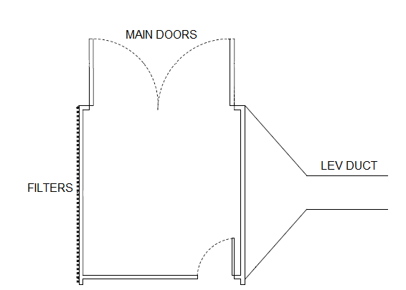

Supplementary Figure SF2 Measurements taken of each face shield with table of dimensions and comments on construction
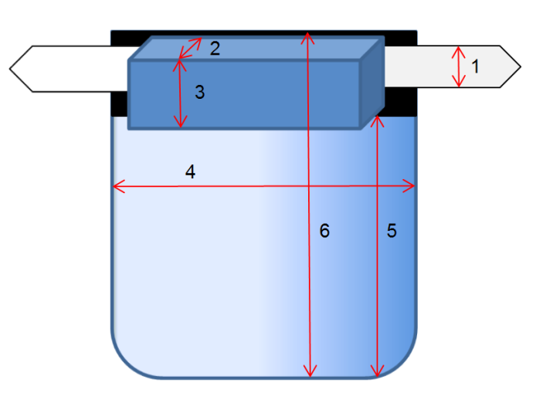

1. The thickness of the headband at the point that would be closest to the centre of the back of the head when worn.
2. The thickness of the foam i.e. the width of the side attached to the face shield, where applicable.
3. The depth of the foam or size of gap between the face shield and forehead.
4. The width of the visor (face shield window) at the top.
5. The length of the visor from the top to the bottom along the centre line.
6. Total length of the face shield including the headband.

Face Shield | Dimensions / mm |  |  |  |  |  |  | Comments
 | 1 | 2, 3 | 4 | 5 | 6 | Face shield to ear (large) | Face shield to ear (small)
PH20194/01 | 20 | 30, 35 | 320 | 148 | 190 | 29 | 23 | FH, ES, CE
PH20194/02 | 15 | 29, 35 | 311 | 182 | 221 | 31 | 35 | FH, ES, CE
PH20194/03 | 18 | 40, 35 | 329 | 149 | 190 | 24 | 30 | FH, ES, CE
PH20194/04 | 15 | 34, 36 | 330 | 175 | 220 | 34 | 35 | FH, ES, CE
PH20194/05 | 17 | 34, 34 | 330 | 183 | 219 | 36 | 31 | FH, ES, CE
PH20194/06 | 49 | 30, 24 | 333 | 149 | 230 | 9* | 8** | FH, SA, CS, CE
PH20194/07 | 29 | 31, 24 | 281 | 198 | 236 | 30* | 35** | FH, SA, PS, CE
PH20194/08 | 40 | N/A | 320 | 139 | 191 | 11** | 4 | CS. 25 mm and 23 mm gap between visor and forehead on large and small heads respectively. CE
PH20194/09 | 8 | 29, 42 | 319 | 153 | 191 | 14 | 12 | FH, ES, CE
PH20194/10 | 16 | N/A | 277 | 227 | 240 | 44 | 47 | PH, ES, SA
PH20194/11 | 75 | N/A | 361 | 196 | 271 | -13* | -25* | CS, CE
PH20194/12 | 21 | 39, 23 | 325 | 175 | 229 | 19* | 19 | FH, ES, CE
PH20194/13 | 25 | 29, 35 | 312 | 178 | 220 | 48 | 33 | FH, PS, CE
PH20194/14 | 3 | N/A | 240 | 310 | 310 | 72 | 70 | PH, SA, elastic bands for straps and gap at headband
FH = foam headband, PH = plastic shaped headband, ES = elastic strap, SA = self-assembly, CS = cardboard straps with slots for adjustment, PS = plastic straps as extension of visor with slots for adjustment, N/A = not applicable (no foam headband), *Visor touched or squashed nose, **Visor was close to nose, CE = product is CE marked according to the PPE stockpile database
Supplementary Figure SF3 Large (a) and small (b) manikin heads

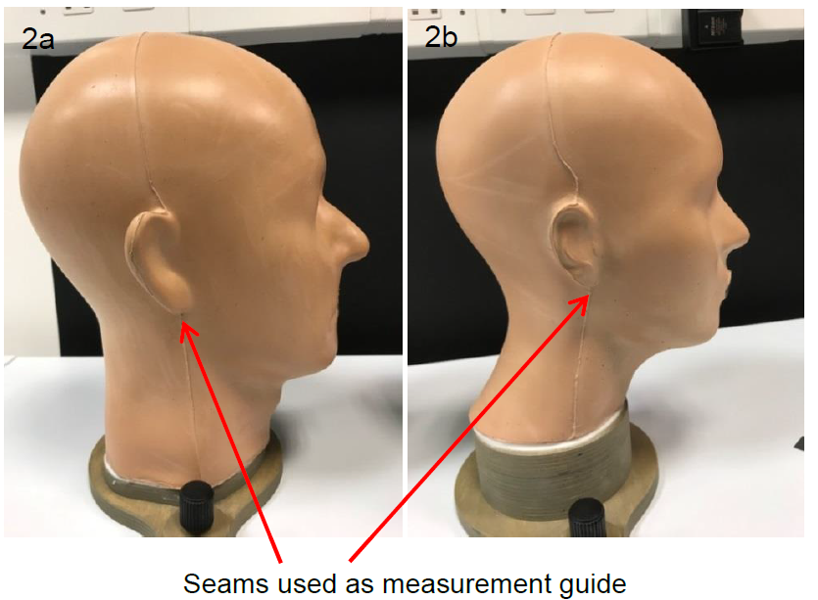

Supplementary Figure SF4 Schematic of the sampling templates when testing face shields on the (a) large and (b) small head (not to scale)
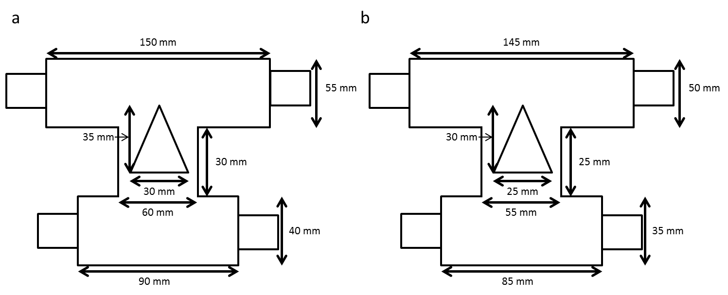

Supplementary Figure SF5 Schematic of the adapted sampling templates when testing goggles and safety glasses on the (a) large and (b) small head (not to scale)
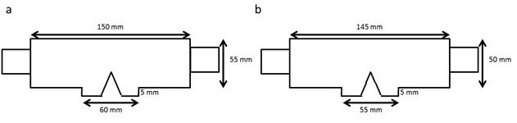

Supplementary Figure SF6 a) Blank sample on manikin head and contaminated samples representing b) low, c) medium and d) high levels of contamination. Areas of contamination were marked with a black pen for photographic purposes.
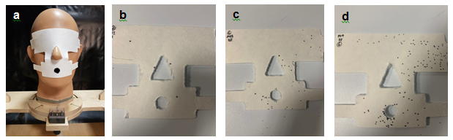

Supplementary Table ST1 Design of each pair of goggles and safety glasses with comments on wear-ability
Reference | Design summary | Wear-ability comments
G1 | Design: Goggles  Vents: Yes; 2 at top and 2 at side  Ease of assembly and adjustment: Good  Gaps at goggle periphery:  Gaps around the outer edges on a small head and the large head | Comfortable to wear with a good seal around the forehead and cheeks on the small head but not as comfortable on a larger head around the cheeks.  Product is CE marked.
G2 | Design: Goggles  Vents: No  Ease of assembly and adjustment: Good  Gaps at goggle periphery:  Fits well on both the small and the large heads even | Comfortable to wear with a good seal around the forehead and cheeks.  No vents so hot to work in and prone to lens fog.  Product is CE marked.
G3 | Design: Goggles  Vents: No  Ease of assembly and adjustment: Good  Gaps at goggle periphery:  Small gaps around the outer edges at the top and the bottom on a small head.  Small gaps at the outer edges at the top on the large head. | Fairly comfortable to wear with a good seal around the forehead and cheeks on the small head.  Not very giving on a large head creating some discomfort around the cheeks and forehead.  No vents so hot to work in and prone to lens fog.  Product is CE marked.
G4 | Design: Goggles  Vents: Yes; several small holes at top  Ease of assembly and adjustment: Good  Gaps at goggle periphery:  Large gaps around the bottom outer edges on a small head.  Large finger width gaps round the outer edges on the large head. | Uncomfortable to wear on both a large and small head as the plastic edges are quite inflexible, particularly where the goggles rest on the wearer’s cheeks.  A good seal around the forehead and cheeks on the small head.  Product is CE marked.
SG1 | Design: Safety glasses  Features: Hinged arms, clear plastic glasses | Fairly comfortable to wear but not compatible with prescription glasses. Don’t require a seal with the wearer’s face.  Product is CE marked.

