Supplementary Table 1 Summary of the bZIP transcription factor genes in Alfalfa
Ms_id | Gene name | Number of Amino Acid | Molecular weight (Daltons) | Theoretical pI | GRAVY* | Group
MsbZIP3 | lcl|MS.gene41906.t1 | 307 | 33939.79 | 6.42 | -0.812 | A
MsbZIP6 | lcl|MS.gene016376.t1 | 298 | 33179.15 | 6.94 | -0.833 | A
MsbZIP7 | lcl|MS.gene62322.t1 | 322 | 35758.99 | 8.65 | -0.791 | A
MsbZIP17 | lcl|MS.gene050328.t1 | 444 | 48261.27 | 8.62 | -0.814 | A
MsbZIP20 | lcl|MS.gene068056.t1 | 321 | 35733.82 | 6.85 | -0.870 | A
MsbZIP29 | lcl|MS.gene84330.t1 | 325 | 36736.53 | 9.44 | -0.783 | A
MsbZIP40 | lcl|MS.gene62039.t1 | 322 | 36099.44 | 6.21 | -0.836 | A
MsbZIP42 | lcl|MS.gene51984.t1 | 322 | 36116.47 | 6.14 | -0.799 | A
MsbZIP44 | lcl|MS.gene028382.t1 | 210 | 23886.42 | 6.39 | -1.078 | A
MsbZIP60 | lcl|MS.gene47208.t1 | 322 | 35758.99 | 8.65 | -0.791 | A
MsbZIP63 | lcl|MS.gene73966.t1 | 252 | 27993.34 | 6.11 | -0.692 | A
MsbZIP67 | lcl|MS.gene063953.t1 | 322 | 36029.55 | 8.41 | -0.793 | A
MsbZIP68 | lcl|MS.gene35404.t1 | 325 | 36707.49 | 9.37 | -0.775 | A
MsbZIP76 | lcl|MS.gene034461.t1 | 331 | 37146.95 | 9.26 | -0.764 | A
MsbZIP78 | lcl|MS.gene60690.t1 | 276 | 30685.68 | 5.43 | -0.670 | A
MsbZIP80 | lcl|MS.gene59225.t1 | 222 | 24404.29 | 4.92 | -0.705 | A
MsbZIP83 | lcl|MS.gene37622.t1 | 253 | 27755.27 | 7.87 | -0.562 | A
MsbZIP88 | lcl|MS.gene23905.t1 | 210 | 23886.42 | 6.39 | -1.078 | A
MsbZIP89 | lcl|MS.gene38710.t1 | 444 | 48236.24 | 8.9 | -0.668 | A
MsbZIP94 | lcl|MS.gene016887.t1 | 644 | 69760.21 | 8.39 | -0.391 | A
MsbZIP100 | lcl|MS.gene83996.t1 | 309 | 34112.16 | 8.98 | -0.731 | A
MsbZIP111 | lcl|MS.gene84329.t1 | 272 | 30665 | 5.93 | -0.918 | A
MsbZIP115 | lcl|MS.gene41866.t1 | 320 | 35513.58 | 6.85 | -0.845 | A
MsbZIP121 | lcl|MS.gene99362.t1 | 243 | 26616.98 | 8.69 | -0.593 | A
MsbZIP126 | lcl|MS.gene39793.t1 | 688 | 74994.38 | 8.73 | -0.371 | A
MsbZIP132 | lcl|MS.gene047841.t1 | 376 | 41550.91 | 9.47 | -0.689 | A
MsbZIP136 | lcl|MS.gene51703.t1 | 322 | 36044.34 | 5.96 | -0.789 | A
MsbZIP137 | lcl|MS.gene012975.t1 | 444 | 48236.24 | 8.9 | -0.668 | A
MsbZIP139 | lcl|MS.gene35405.t1 | 272 | 30618.93 | 5.93 | -0.929 | A
MsbZIP145 | lcl|MS.gene034460.t1 | 272 | 30636.95 | 6.04 | -0.945 | A
MsbZIP149 | lcl|MS.gene48512.t1 | 450 | 48815.85 | 8.9 | -0.677 | A
MsbZIP158 | lcl|MS.gene028384.t1 | 210 | 23886.42 | 6.39 | -1.078 | A
MsbZIP161 | lcl|MS.gene43043.t1 | 272 | 30671.99 | 6.04 | -0.937 | A
MsbZIP165 | lcl|MS.gene56338.t1 | 322 | 36014.37 | 6.14 | -0.777 | A
MsbZIP175 | lcl|MS.gene43044.t1 | 325 | 36693.42 | 9.3 | -0.774 | A
MsbZIP182 | lcl|MS.gene88920.t1 | 448 | 49000.08 | 5.75 | -0.556 | A
MsbZIP206 | lcl|MS.gene013906.t1 | 320 | 35575.67 | 6.85 | -0.860 | A
MsbZIP207 | lcl|MS.gene38353.t1 | 425 | 46264.85 | 8.8 | -0.718 | A
MsbZIP216 | lcl|MS.gene012973.t1 | 340 | 36504.19 | 8.55 | -0.540 | A
MsbZIP221 | lcl|MS.gene26446.t1 | 376 | 41550.91 | 9.47 | -0.689 | A
MsbZIP231 | lcl|MS.gene053517.t1 | 376 | 41532.88 | 9.47 | -0.682 | A
MsbZIP233 | lcl|MS.gene006156.t1 | 450 | 49171.23 | 5.75 | -0.562 | A
MsbZIP235 | lcl|MS.gene59798.t1 | 322 | 36039.64 | 8.41 | -0.768 | A
MsbZIP9 | lcl|MS.gene073045.t1 | 302 | 33286.8 | 5.62 | -0.594 | C
MsbZIP10 | lcl|MS.gene40352.t1 | 302 | 33286.8 | 5.62 | -0.594 | C
MsbZIP12 | lcl|MS.gene026022.t1 | 486 | 52905.74 | 5.82 | -0.521 | C
MsbZIP13 | lcl|MS.gene050464.t1 | 457 | 49719.98 | 5.33 | -0.558 | C
MsbZIP24 | lcl|MS.gene059104.t1 | 339 | 36947.77 | 5.33 | -0.571 | C
MsbZIP27 | lcl|MS.gene073012.t1 | 175 | 19697.22 | 9.37 | -0.598 | C
MsbZIP58 | lcl|MS.gene014698.t1 | 302 | 33286.8 | 5.62 | -0.594 | C
MsbZIP59 | lcl|MS.gene75758.t1 | 324 | 35854.64 | 5.8 | -0.638 | C
MsbZIP62 | lcl|MS.gene021509.t1 | 338 | 37010.83 | 5.23 | -0.589 | C
MsbZIP86 | lcl|MS.gene024569.t1 | 328 | 35446.85 | 7.68 | -0.574 | C
MsbZIP90 | lcl|MS.gene31590.t1 | 339 | 36991.78 | 5.23 | -0.581 | C
MsbZIP93 | lcl|MS.gene70820.t1 | 414 | 44458.48 | 5.67 | -0.651 | C
MsbZIP108 | lcl|MS.gene059481.t1 | 242 | 26730.52 | 5.36 | -0.713 | C
MsbZIP129 | lcl|MS.gene69936.t1 | 414 | 44440.44 | 5.67 | -0.645 | C
MsbZIP142 | lcl|MS.gene44006.t1 | 414 | 44458.48 | 5.67 | -0.651 | C
MsbZIP146 | lcl|MS.gene005138.t1 | 414 | 44458.48 | 5.67 | -0.651 | C
MsbZIP148 | lcl|MS.gene026023.t1 | 390 | 42279.97 | 6.94 | -0.737 | C
MsbZIP162 | lcl|MS.gene63163.t1 | 557 | 62453.65 | 7.63 | -0.229 | C
MsbZIP170 | lcl|MS.gene062546.t1 | 557 | 62370.51 | 7.12 | -0.221 | C
MsbZIP180 | lcl|MS.gene073047.t1 | 302 | 33286.8 | 5.62 | -0.594 | C
MsbZIP188 | lcl|MS.gene050529.t1 | 457 | 49833.1 | 5.42 | -0.584 | C
MsbZIP204 | lcl|MS.gene050528.t1 | 363 | 39197.39 | 6.94 | -0.767 | C
MsbZIP220 | lcl|MS.gene050463.t1 | 391 | 42338.99 | 6.94 | -0.743 | C
MsbZIP234 | lcl|MS.gene024570.t1 | 391 | 42338.99 | 6.94 | -0.743 | C
MsbZIP5 | lcl|MS.gene059700.t1 | 288 | 32618.22 | 5.46 | -0.291 | D
MsbZIP22 | lcl|MS.gene90011.t1 | 519 | 58286.77 | 8.95 | -0.770 | D
MsbZIP36 | lcl|MS.gene045075.t1 | 363 | 41305.96 | 6.57 | -0.510 | D
MsbZIP39 | lcl|MS.gene88455.t1 | 466 | 51781.56 | 6.4 | -0.662 | D
MsbZIP45 | lcl|MS.gene70341.t1 | 358 | 40958.62 | 5.91 | -0.431 | D
MsbZIP52 | lcl|MS.gene38759.t1 | 453 | 50062.09 | 6.7 | -0.592 | D
MsbZIP54 | lcl|MS.gene66761.t1 | 468 | 51778.28 | 6.72 | -0.484 | D
MsbZIP55 | lcl|MS.gene04594.t1 | 414 | 46675.96 | 7.8 | -0.585 | D
MsbZIP61 | lcl|MS.gene39037.t1 | 384 | 42607.79 | 7.04 | -0.594 | D
MsbZIP65 | lcl|MS.gene017751.t1 | 403 | 44986.64 | 8.13 | -0.543 | D
MsbZIP66 | lcl|MS.gene88240.t1 | 496 | 54943.72 | 6.36 | -0.495 | D
MsbZIP70 | lcl|MS.gene03842.t1 | 496 | 55044.91 | 6.45 | -0.495 | D
MsbZIP72 | lcl|MS.gene072378.t1 | 414 | 46691.91 | 7.26 | -0.585 | D
MsbZIP85 | lcl|MS.gene76274.t1 | 427 | 47653.32 | 6.24 | -0.452 | D
MsbZIP87 | lcl|MS.gene030750.t1 | 309 | 35271.4 | 6.2 | -0.351 | D
MsbZIP91 | lcl|MS.gene053893.t1 | 462 | 51931.35 | 6.52 | -0.547 | D
MsbZIP97 | lcl|MS.gene43041.t1 | 493 | 55118.93 | 6.48 | -0.570 | D
MsbZIP99 | lcl|MS.gene28123.t1 | 358 | 40958.62 | 5.91 | -0.431 | D
MsbZIP110 | lcl|MS.gene063783.t1 | 466 | 51587.45 | 6.4 | -0.620 | D
MsbZIP112 | lcl|MS.gene59677.t1 | 464 | 52186.56 | 6.52 | -0.557 | D
MsbZIP130 | lcl|MS.gene97682.t1 | 424 | 47464.86 | 8.51 | -0.572 | D
MsbZIP144 | lcl|MS.gene067733.t1 | 496 | 55014.88 | 6.45 | -0.486 | D
MsbZIP147 | lcl|MS.gene059702.t1 | 358 | 40901.47 | 5.79 | -0.429 | D
MsbZIP151 | lcl|MS.gene030746.t1 | 309 | 35271.4 | 6.2 | -0.351 | D
MsbZIP157 | lcl|MS.gene017958.t1 | 414 | 46733.95 | 6.94 | -0.592 | D
MsbZIP159 | lcl|MS.gene014002.t1 | 453 | 50077.06 | 6.7 | -0.608 | D
MsbZIP160 | lcl|MS.gene059698.t1 | 299 | 34600.78 | 9.12 | -0.451 | D
MsbZIP168 | lcl|MS.gene029373.t1 | 427 | 47695.36 | 6.15 | -0.457 | D
MsbZIP172 | lcl|MS.gene61762.t1 | 466 | 51795.63 | 6.4 | -0.650 | D
MsbZIP174 | lcl|MS.gene042636.t1 | 462 | 51858.19 | 6.5 | -0.546 | D
MsbZIP185 | lcl|MS.gene75437.t1 | 363 | 41286.91 | 6.36 | -0.506 | D
MsbZIP187 | lcl|MS.gene016556.t1 | 466 | 51587.45 | 6.4 | -0.620 | D
MsbZIP189 | lcl|MS.gene034458.t1 | 494 | 55169.9 | 6.21 | -0.563 | D
MsbZIP190 | lcl|MS.gene84947.t1 | 479 | 53619.44 | 7.69 | -0.762 | D
MsbZIP208 | lcl|MS.gene018793.t1 | 437 | 48738.25 | 8.21 | -0.553 | D
MsbZIP212 | lcl|MS.gene017753.t1 | 453 | 50077.06 | 6.7 | -0.608 | D
MsbZIP215 | lcl|MS.gene066070.t1 | 361 | 40338.47 | 6.14 | -0.431 | D
MsbZIP225 | lcl|MS.gene065104.t1 | 427 | 47709.42 | 6.31 | -0.455 | D
MsbZIP227 | lcl|MS.gene030748.t1 | 309 | 35271.4 | 6.2 | -0.351 | D
MsbZIP230 | lcl|MS.gene96525.t1 | 462 | 51973.37 | 6.52 | -0.553 | D
MsbZIP232 | lcl|MS.gene84327.t1 | 493 | 54960.69 | 6.29 | -0.551 | D
MsbZIP11 | lcl|MS.gene006667.t1 | 331 | 37648.56 | 5.55 | -1.007 | E
MsbZIP43 | lcl|MS.gene031633.t1 | 306 | 34804.22 | 5.38 | -1.032 | E
MsbZIP51 | lcl|MS.gene043474.t1 | 335 | 38453.42 | 5.46 | -1.134 | E
MsbZIP53 | lcl|MS.gene31409.t1 | 331 | 37900.83 | 5.64 | -1.119 | E
MsbZIP56 | lcl|MS.gene28919.t1 | 306 | 34804.22 | 5.38 | -1.032 | E
MsbZIP107 | lcl|MS.gene055759.t1 | 331 | 37900.83 | 5.64 | -1.119 | E
MsbZIP114 | lcl|MS.gene045518.t1 | 306 | 34804.22 | 5.38 | -1.032 | E
MsbZIP125 | lcl|MS.gene31407.t1 | 289 | 33146.4 | 5.34 | -1.170 | E
MsbZIP152 | lcl|MS.gene58381.t1 | 171 | 18840.09 | 6.08 | -0.577 | E
MsbZIP166 | lcl|MS.gene031632.t1 | 306 | 34804.22 | 5.38 | -1.032 | E
MsbZIP179 | lcl|MS.gene062584.t1 | 320 | 35452.04 | 5.88 | -0.784 | E
MsbZIP186 | lcl|MS.gene059751.t1 | 320 | 35452.04 | 5.88 | -0.784 | E
MsbZIP15 | lcl|MS.gene66809.t1 | 219 | 24228.25 | 5.72 | -0.653 | F
MsbZIP38 | lcl|MS.gene000056.t1 | 187 | 20957.39 | 7.13 | -0.861 | F
MsbZIP122 | lcl|MS.gene003566.t1 | 267 | 28998.45 | 6.15 | -0.706 | F
MsbZIP124 | lcl|MS.gene85094.t1 | 182 | 20575.91 | 6.83 | -0.829 | F
MsbZIP141 | lcl|MS.gene63627.t1 | 187 | 20983.43 | 7.13 | -0.879 | F
MsbZIP181 | lcl|MS.gene070434.t1 | 187 | 20975.45 | 7.1 | -0.856 | F
MsbZIP202 | lcl|MS.gene057769.t1 | 267 | 28998.53 | 6.32 | -0.676 | F
MsbZIP229 | lcl|MS.gene062998.t1 | 267 | 29024.62 | 6.32 | -0.658 | F
MsbZIP21 | lcl|MS.gene85199.t1 | 217 | 23821.4 | 9.71 | -0.656 | G
MsbZIP25 | lcl|MS.gene98174.t1 | 419 | 44861.55 | 6.16 | -0.850 | G
MsbZIP35 | lcl|MS.gene027976.t1 | 402 | 43063.33 | 6.32 | -0.912 | G
MsbZIP46 | lcl|MS.gene026383.t1 | 309 | 34719.62 | 6.21 | -0.954 | G
MsbZIP48 | lcl|MS.gene93037.t1 | 397 | 42714.07 | 6.15 | -0.926 | G
MsbZIP49 | lcl|MS.gene050619.t1 | 421 | 45228.1 | 8.72 | -0.851 | G
MsbZIP84 | lcl|MS.gene28487.t1 | 340 | 36428.98 | 5.66 | -1.009 | G
MsbZIP92 | lcl|MS.gene040816.t1 | 309 | 34564.31 | 5.57 | -0.946 | G
MsbZIP102 | lcl|MS.gene025418.t1 | 255 | 28626.94 | 5.45 | -0.904 | G
MsbZIP103 | lcl|MS.gene025938.t1 | 421 | 45301.17 | 8.42 | -0.860 | G
MsbZIP105 | lcl|MS.gene59612.t1 | 422 | 45110.76 | 6.23 | -0.853 | G
MsbZIP113 | lcl|MS.gene49498.t1 | 397 | 42783.19 | 6.15 | -0.941 | G
MsbZIP116 | lcl|MS.gene87408.t1 | 340 | 36428.98 | 5.66 | -1.009 | G
MsbZIP123 | lcl|MS.gene92139.t1 | 422 | 45266.85 | 5.85 | -0.862 | G
MsbZIP133 | lcl|MS.gene95700.t1 | 397 | 42724.11 | 6.15 | -0.928 | G
MsbZIP135 | lcl|MS.gene22824.t1 | 421 | 45228.1 | 8.72 | -0.851 | G
MsbZIP138 | lcl|MS.gene062050.t1 | 178 | 20012.13 | 5.02 | -1.110 | G
MsbZIP150 | lcl|MS.gene98408.t1 | 277 | 31153.98 | 5.56 | -0.792 | G
MsbZIP153 | lcl|MS.gene98482.t1 | 400 | 42926.29 | 6.43 | -0.912 | G
MsbZIP154 | lcl|MS.gene061696.t1 | 309 | 34604.44 | 5.73 | -0.933 | G
MsbZIP155 | lcl|MS.gene97758.t1 | 367 | 39240.31 | 7.2 | -0.860 | G
MsbZIP176 | lcl|MS.gene024473.t1 | 421 | 45228.1 | 8.72 | -0.851 | G
MsbZIP192 | lcl|MS.gene011938.t1 | 340 | 36443.01 | 5.66 | -1.009 | G
MsbZIP193 | lcl|MS.gene69637.t1 | 400 | 42850.19 | 6.28 | -0.906 | G
MsbZIP195 | lcl|MS.gene068933.t1 | 255 | 28652.94 | 5.43 | -0.922 | G
MsbZIP200 | lcl|MS.gene056509.t1 | 397 | 42724.11 | 6.15 | -0.928 | G
MsbZIP210 | lcl|MS.gene76383.t1 | 340 | 36428.98 | 5.66 | -1.009 | G
MsbZIP213 | lcl|MS.gene061085.t1 | 309 | 34614.48 | 5.73 | -0.937 | G
MsbZIP226 | lcl|MS.gene79717.t1 | 422 | 45173.85 | 6.16 | -0.857 | G
MsbZIP79 | lcl|MS.gene22247.t1 | 323 | 35401.9 | 6.68 | -1.063 | H
MsbZIP197 | lcl|MS.gene019128.t1 | 300 | 32967.28 | 6.95 | -1.068 | H
MsbZIP205 | lcl|MS.gene46980.t1 | 300 | 33015.32 | 6.95 | -1.064 | H
MsbZIP222 | lcl|MS.gene92043.t1 | 300 | 32967.28 | 6.95 | -1.068 | H
MsbZIP14 | lcl|MS.gene019804.t1 | 310 | 34969.18 | 7.91 | -0.875 | I
MsbZIP16 | lcl|MS.gene26260.t1 | 293 | 32255.69 | 5.67 | -0.788 | I
MsbZIP18 | lcl|MS.gene41497.t1 | 371 | 40411.53 | 5.9 | -0.740 | I
MsbZIP19 | lcl|MS.gene052006.t1 | 430 | 46813.72 | 5.96 | -0.877 | I
MsbZIP32 | lcl|MS.gene003636.t1 | 514 | 56625.51 | 6.33 | -0.918 | I
MsbZIP37 | lcl|MS.gene64121.t1 | 253 | 28137.51 | 5.4 | -0.700 | I
MsbZIP64 | lcl|MS.gene010137.t1 | 252 | 28006.32 | 5.4 | -0.711 | I
MsbZIP71 | lcl|MS.gene049545.t1 | 371 | 40352.51 | 5.84 | -0.726 | I
MsbZIP95 | lcl|MS.gene64187.t1 | 553 | 61571.25 | 7.82 | -0.986 | I
MsbZIP98 | lcl|MS.gene013429.t1 | 312 | 34775.53 | 5.78 | -0.727 | I
MsbZIP118 | lcl|MS.gene009667.t1 | 293 | 32265.73 | 5.67 | -0.791 | I
MsbZIP119 | lcl|MS.gene049400.t1 | 312 | 34775.53 | 5.78 | -0.727 | I
MsbZIP120 | lcl|MS.gene06529.t1 | 312 | 34775.53 | 5.78 | -0.727 | I
MsbZIP128 | lcl|MS.gene050047.t1 | 253 | 28137.51 | 5.4 | -0.700 | I
MsbZIP134 | lcl|MS.gene010139.t1 | 143 | 15766.54 | 5.7 | -0.709 | I
MsbZIP143 | lcl|MS.gene24194.t1 | 553 | 61567.26 | 7.82 | -0.987 | I
MsbZIP156 | lcl|MS.gene50698.t1 | 525 | 58046.99 | 6.45 | -0.963 | I
MsbZIP167 | lcl|MS.gene06773.t1 | 312 | 34775.53 | 5.78 | -0.727 | I
MsbZIP178 | lcl|MS.gene062934.t1 | 452 | 49634.86 | 6.33 | -0.859 | I
MsbZIP183 | lcl|MS.gene008480.t1 | 371 | 40401.47 | 5.67 | -0.756 | I
MsbZIP191 | lcl|MS.gene032183.t1 | 430 | 46813.72 | 5.96 | -0.877 | I
MsbZIP194 | lcl|MS.gene48176.t1 | 291 | 32746.59 | 8.69 | -0.900 | I
MsbZIP196 | lcl|MS.gene98730.t1 | 430 | 46857.73 | 5.85 | -0.890 | I
MsbZIP203 | lcl|MS.gene63982.t1 | 553 | 61514.19 | 7.38 | -0.971 | I
MsbZIP209 | lcl|MS.gene23361.t1 | 519 | 57394.45 | 6.64 | -0.945 | I
MsbZIP211 | lcl|MS.gene38438.t1 | 365 | 40234.49 | 6.12 | -0.756 | I
MsbZIP218 | lcl|MS.gene043876.t1 | 252 | 27996.28 | 5.4 | -0.708 | I
MsbZIP223 | lcl|MS.gene000218.t1 | 310 | 34923.11 | 7.91 | -0.884 | I
MsbZIP224 | lcl|MS.gene67397.t1 | 310 | 34953.14 | 7.91 | -0.892 | I
MsbZIP228 | lcl|MS.gene27036.t1 | 518 | 57461.4 | 6.85 | -0.987 | I
MsbZIP236 | lcl|MS.gene85271.t1 | 431 | 46941.85 | 5.96 | -0.883 | I
MsbZIP237 | lcl|MS.gene017232.t1 | 293 | 32298.72 | 5.67 | -0.806 | I
MsbZIP1 | lcl|MS.gene011104.t1 | 190 | 22028.55 | 5.91 | -0.904 | S
MsbZIP2 | lcl|MS.gene050407.t1 | 151 | 17409.56 | 9.45 | -1.049 | S
MsbZIP4 | lcl|MS.gene033030.t1 | 217 | 24669.69 | 8.95 | -0.724 | S
MsbZIP8 | lcl|MS.gene37156.t1 | 200 | 23451.92 | 5.78 | -0.991 | S
MsbZIP23 | lcl|MS.gene66480.t1 | 145 | 17093.42 | 9.29 | -0.803 | S
MsbZIP26 | lcl|MS.gene22502.t1 | 151 | 17409.56 | 9.45 | -1.049 | S
MsbZIP28 | lcl|MS.gene072700.t1 | 151 | 17379.53 | 9.45 | -1.032 | S
MsbZIP30 | lcl|MS.gene022030.t1 | 163 | 18860.08 | 6.2 | -0.904 | S
MsbZIP31 | lcl|MS.gene62014.t1 | 163 | 18874.11 | 6.2 | -0.899 | S
MsbZIP34 | lcl|MS.gene07286.t1 | 152 | 17092.26 | 5.94 | -0.672 | S
MsbZIP41 | lcl|MS.gene43521.t1 | 157 | 18400.77 | 10.1 | -0.889 | S
MsbZIP50 | lcl|MS.gene060074.t1 | 191 | 22253.84 | 5.91 | -0.874 | S
MsbZIP69 | lcl|MS.gene20855.t1 | 152 | 17062.23 | 5.94 | -0.655 | S
MsbZIP74 | lcl|MS.gene20805.t1 | 119 | 13659.47 | 5.24 | -0.574 | S
MsbZIP75 | lcl|MS.gene36596.t1 | 190 | 22083.63 | 5.91 | -0.905 | S
MsbZIP81 | lcl|MS.gene75985.t1 | 192 | 22152.72 | 5.95 | -0.896 | S
MsbZIP82 | lcl|MS.gene44768.t1 | 191 | 22043.64 | 5.95 | -0.869 | S
MsbZIP96 | lcl|MS.gene00525.t1 | 145 | 17063.33 | 9.29 | -0.821 | S
MsbZIP104 | lcl|MS.gene038814.t1 | 187 | 21182.75 | 9.44 | -0.751 | S
MsbZIP109 | lcl|MS.gene07054.t1 | 151 | 17409.56 | 9.45 | -1.049 | S
MsbZIP117 | lcl|MS.gene28809.t1 | 151 | 17409.56 | 9.45 | -1.049 | S
MsbZIP127 | lcl|MS.gene24498.t1 | 145 | 17063.33 | 9.29 | -0.821 | S
MsbZIP131 | lcl|MS.gene050405.t1 | 151 | 17409.56 | 9.45 | -1.049 | S
MsbZIP140 | lcl|MS.gene36705.t1 | 190 | 22030.56 | 5.78 | -0.857 | S
MsbZIP163 | lcl|MS.gene79191.t1 | 191 | 22218.84 | 5.98 | -0.837 | S
MsbZIP169 | lcl|MS.gene018226.t1 | 200 | 23451.92 | 5.78 | -0.991 | S
MsbZIP173 | lcl|MS.gene063525.t1 | 217 | 24741.75 | 8.62 | -0.736 | S
MsbZIP201 | lcl|MS.gene62516.t1 | 193 | 22386.99 | 5.86 | -0.840 | S
MsbZIP214 | lcl|MS.gene072178.t1 | 190 | 22028.55 | 5.91 | -0.904 | S
MsbZIP217 | lcl|MS.gene044486.t1 | 208 | 23685.65 | 9.38 | -0.718 | S
MsbZIP219 | lcl|MS.gene005517.t1 | 148 | 16804.04 | 6.62 | -0.676 | S
MsbZIP33 | lcl|MS.gene03935.t1 | 226 | 25698.35 | 10.06 | -0.866 | M
MsbZIP47 | lcl|MS.gene03266.t1 | 226 | 25581.22 | 9.97 | -0.894 | M
MsbZIP57 | lcl|MS.gene80415.t1 | 253 | 28968.26 | 9.72 | -0.896 | M
MsbZIP73 | lcl|MS.gene03937.t1 | 222 | 25317.75 | 9.37 | -0.922 | M
MsbZIP77 | lcl|MS.gene048528.t1 | 217 | 24815.17 | 9.44 | -0.912 | M
MsbZIP101 | lcl|MS.gene05749.t1 | 225 | 25380.85 | 9.06 | -0.761 | M
MsbZIP106 | lcl|MS.gene008661.t1 | 222 | 25332.77 | 9.48 | -0.840 | M
MsbZIP164 | lcl|MS.gene67973.t1 | 216 | 24516.08 | 9.96 | -0.897 | M
MsbZIP171 | lcl|MS.gene008657.t1 | 226 | 25623.2 | 9.96 | -0.867 | M
MsbZIP177 | lcl|MS.gene85685.t1 | 216 | 24526.16 | 10 | -0.852 | M
MsbZIP184 | lcl|MS.gene048529.t1 | 194 | 22408.72 | 9.87 | -0.843 | M
MsbZIP198 | lcl|MS.gene05750.t1 | 267 | 30349.96 | 10.14 | -0.775 | M
MsbZIP199 | lcl|MS.gene019718.t1 | 226 | 25665.35 | 9.91 | -0.869 | M

Supplementary Table 2 Meme motif sequences in predicted bZIP proteins
Motif | E-value | Width | Top scoring sequence
1 | 0.00E+00 | 32 | TVERRQKRMIKNRESAARSRARKQAYTQELEI
2 | 0.00E+00 | 41 | HYDEIFRLKGVAAKADVFHLLSGMWKTPAERCFLWLGGFRS
3 | 0.00E+00 | 50 | FIRQADNLRQQTLQQMHRILTTRQSARALLAIHDYFSRLRALSSLWLARP
4 | 0.00E+00 | 41 | SELLKLLVSHLEPLTEQQLMGIYNLQQSSQQAEDALSQGMD
5 | 0.00E+00 | 29 | NGAMAFDAEYARWLEEHNRQTNELRAAIN
6 | 0.00E+00 | 29 | KVQTLQTEATTLSAQLTLYQRDTTGLSTE
7 | 0.00E+00 | 19 | NTELKLRLQAMEQQAHLRD
8 | 0.00E+00 | 29 | MGGSGKDFGSMNMDELLKNIWSAEEVQTM
9 | 0.00E+00 | 21 | SRLKLTQLEQELQRARQQGVF
10 | 0.00E+00 | 21 | RVLKADVETLRAKVKMAEETV
11 | 0.00E+00 | 29 | SPNPSGASGNVANYMGQMAMAMGKLGTLE
12 | 0.00E+00 | 29 | EKQQTLGEMTLEDFLVKAGVVGESFHNNK
13 | 0.00E+00 | 29 | AISNHLQRQGSLTLPRTLSQKTVDEVWKD
14 | 0.00E+00 | 21 | FGEIMDAKKAMPPDKLAELWT
15 | 1.70E-224 | 15 | SHISDIELRMLVDGM
16 | 5.00E-223 | 15 | PYVAMYPHGGIYAHP
17 | 2.50E-214 | 15 | HTPHPYMWGPPQHMM
18 | 0.00E+00 | 50 | FRSWQPSWKSIDLGKQEASSSGVKATPQDKKTNNISVPKSNLGHAEKNHI
19 | 0.00E+00 | 41 | SFTTSLNNQFLHNQRQMSTTPQLNMTTSIRRMPHVSPTINV
20 | 0.00E+00 | 41 | ANQSSASKHNRDGTSMRAAGGSKRSTDGDQDDSNKDYPSSM
21 | 4.50E-203 | 15 | LVRQNSVYSLTLDEV
22 | 4.90E-218 | 21 | MKGIPKRMTGTNMLHTEEGPG
23 | 2.80E-217 | 21 | GNDVTTPRTRHRHSCSVDGST
24 | 6.30E-186 | 21 | WAAMQAYYGPRVAMPPYYNSP
25 | 1.60E-251 | 29 | QVVWLRNENHQLLDKLNNFCETHDKVVQE

https://drive.google.com/file/d/1OkLAoMt0hphslOPQdnfCOYfjH981cL3C/view?usp=sharing
Supplementary Figure 1: Multiple Sequence Alignment of complete (237) bZIP sequences. The alignment was performed using MUSCLE 3.8.31 and visualized using Unipro UGENE v.33. A consensus sequence is provided at the top of the figure (in bold). The bars above the consensus sequence present the percentage of consensus amino acid base between the aligned sequences. The ruler below the consensus sequence provides the position of the amino acid base on the aligned sequences. The color changes from light to dark with dark color indicating highly conserved amino acid bases. The consensus sequence at the top indicates the level of conservation with a capital letter indicating high conservation and a small letter with low conservation. The highly conserved bZIP domain (N-x(7)-[RK]-x(9)-L-x(6)-L-x(6)-L), between 590 to 622, is presented in dark color.

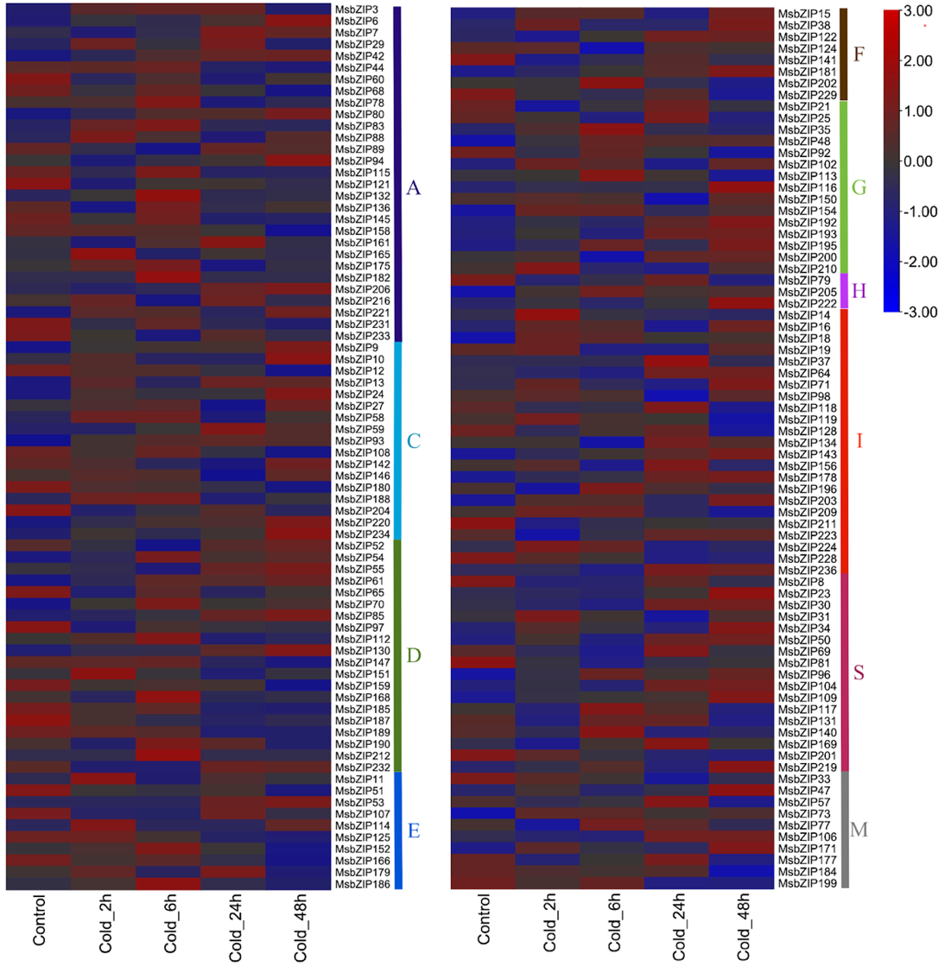

Supplementary Figure 2. Expression profile of 152 alfalfa bZIP genes in response to cold stress. Most of the genes were highly expressed during the initial 2-hour cold treatment and as the duration of treatment increased, the number of highly expressed genes decreased. Few genes that were highly expressed during initial cold treatment of 2 hours were also active during 24 hours of cold treatment. At a duration of 2 hours, 6 hours and 48 hours of cold treatment, different genes were highly expressed suggesting differential gene expression of the bZIP genes. Different groups are represented to the side of the genes by the respective group name along with the color as represented in the phylogenetic tree.
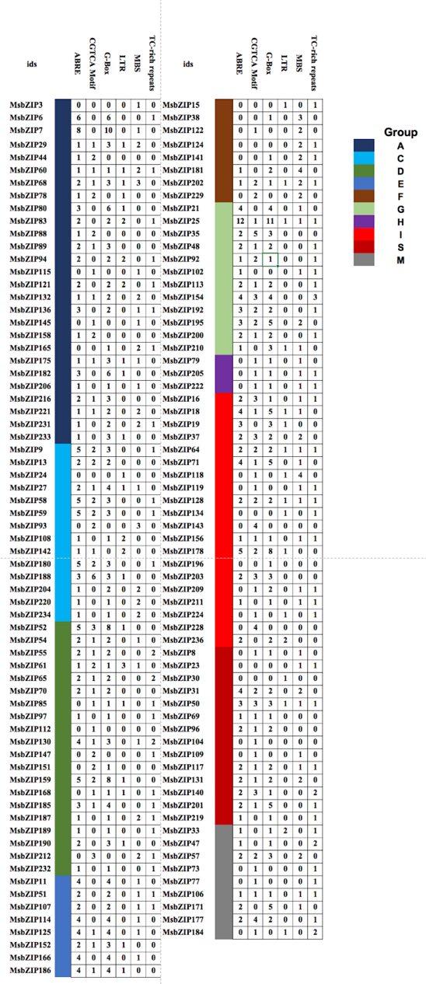

Supplementary Figure 3. Cis-regulatory elements in the promoter regions of MsbZIP genes. The numbers inside blocks represent the numbers of cis-element identified in the analyzed promoter region of indicated bZIP genes. The cis-element investigated are abscisic acid responsive (ABRE), methyl jasmonate responsive (CGTCA-motif), light inducible G-box motif, low-temperature responsive (LTR), drought responsive (MBS binding site) and defense and stress responsive (TC-rich repeats). The different color represents different groups based on the phylogeny.

https://drive.google.com/file/d/1dIEnSGCp13JSmv317tTw3A2T0Rq473du/view?usp=sharing

Supplementary Figure 4. Representation of motifs identified among 237 bZIP proteins using the “MEME” motif searching tools. The motifs are indicated by different colors. The alphabet adjacent to the rightmost lines is the name of the group for the sequences and motif. MEME-suite version 5.1.1 was used online for generating the motif location figure. The 25 different motifs are represented by different colors. As the groups are formed based on the similarity of motifs between sequences, the sequences showed high group specificity and were in consensus with the groups from phylogenetic analysis. The sequence for the motif is presented in supplemental information S5. The basic region and the leucine zipper region are represented by motif 1 and motif 6.

https://drive.google.com/file/d/1LKbUzHZSLV7nlGUud0CzxNoZsu_PUrbM/view?usp=sharing

Supplementary Figure 5. Detailed gene information for Phylogenetic analysis and group classification of Alfalfa and other model species (Arabidopsis thaliana, Lotus japonicus, Medicago truncatula, Oryza sativa).

