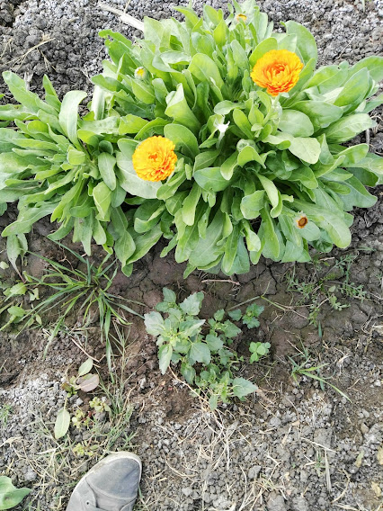
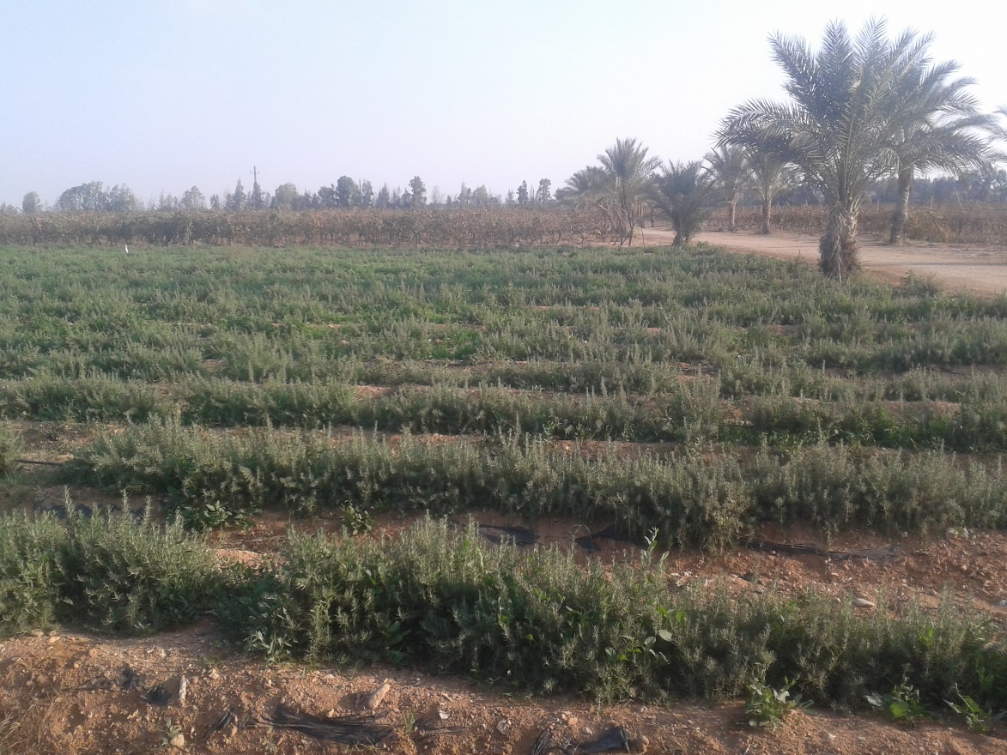
Appendix 1. Rosemary plot, with interaction with weeds, SEKEM farm.

Appendix 2. Calendula and weeds, Shampoliah farm.

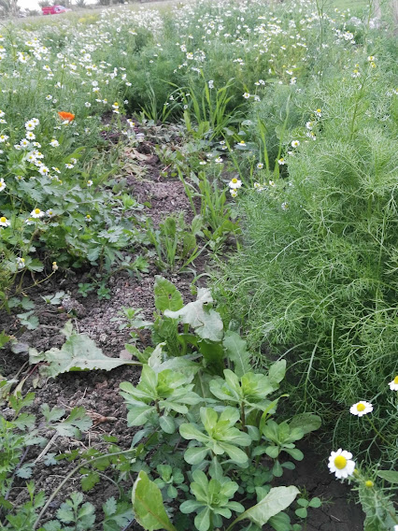
Appendix 3. Chamomile field with different weed plants, Shampoliah farm.

