Home-field advantage of litter decomposition faded 5-10 years after spruce forest clearcutting
Liyan Zhuang¹, Andrea Schnepf¹, Kirsten Unger², Ziyi Liang^{1, 3, *} and Roland Bol¹
¹ Forschungszentrum Jülich, Agrosphäre (IBG-3), 52428 Jülich, Germany
² Institute of Crop Science and Resource Conservation (INRES), Soil Science and Soil Ecology, University of Bonn, Nussallee 13, 53115 Bonn, Germany
³ Long-term Research Station of Alpine Forest Ecosystems, Key Laboratory of Ecological Forestry Engineering, Institute of Ecology and Forestry, Sichuan Agricultural University, Chengdu 611130, China
* Corresponding author. chn_liangzy@163.com.

Supplementary and Materials
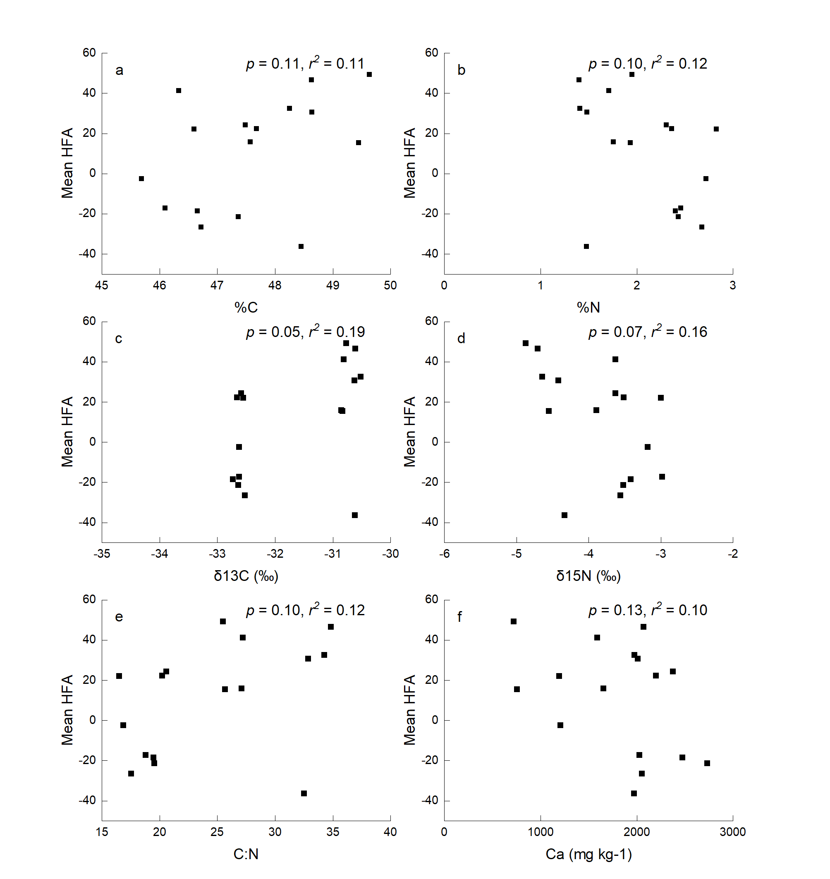Fig. S1 the relationship between total C, N concentrations, δ¹³C, δ¹⁵N, C:N ratios, Ca and mean HFA

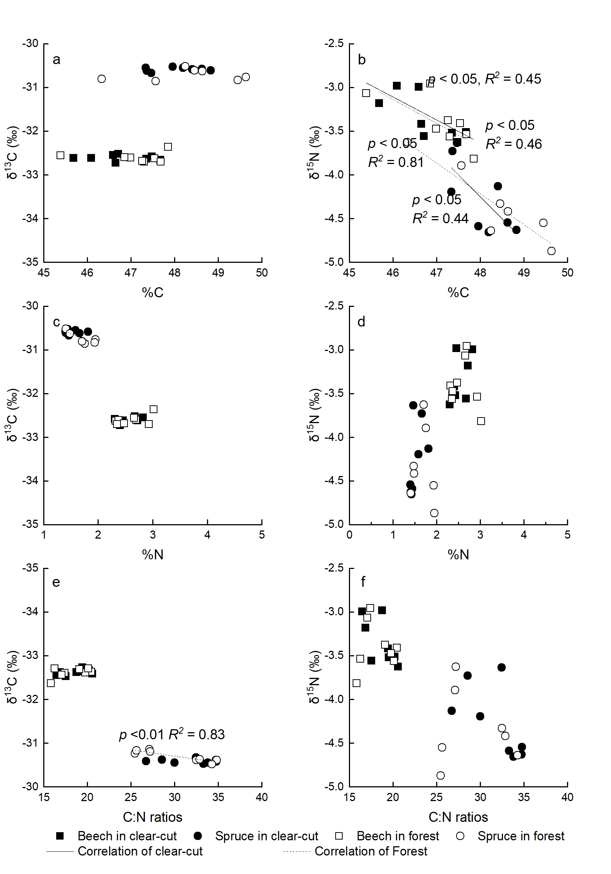
Fig. S2 the relationship between the initial litter C, N and C:N ratios on the isotopic ¹³C and δ¹⁵N value

