Electronic Supplementary Material (ESI)

Multilayered curcumin-loaded hydrogel microcarriers with antimicrobial function
Weronika Szczęsna¹, Marta Tsirigotis-Maniecka¹, Łukasz Lamch¹, Lilianna Szyk-Warszyńska², Ewa Zboińska³, Piotr Warszyński^{2,*}, Kazimiera A. Wilk^{1,*}
¹ Department of Engineering and Technology of Chemical Processes, Faculty of Chemistry, Wrocław University of Science and Technology, 50-370 Wrocław, Poland; weronika.szczesna@pwr.edu.pl; marta.tsirigotis@pwr.edu.pl; lukasz.lamch@pwr.edu.pl; kazimiera.wilk@pwr.edu.pl
² Jerzy Haber Institute of Catalysis and Surface Chemistry, Polish Academy of Sciences, 30-239 Kraków, Poland; ncszyk@cyf-kr.edu.pl; ncwarszy@cyf-kr.edu.pl
³ Department of Organic and Medicinal Chemistry, Faculty of Chemistry, Wrocław University of Science and Technology, 50-370 Wrocław, Poland; ewa.zboinska@pwr.edu.pl
* Correspondence: ncwarszy@cyf-kr.edu.pl; kazimiera.wilk@pwr.edu.pl

Table of Contents
Figure S1. FTIR spectra of CUR-loaded microparticles decorated with A-QAS-PEs: CHIT system (a) and PAH system (b).
Figure S2. FTIR spectra of CUR, CU, CC, and CP.
Figure S3. Adsorption kinetic measurements of polyelectrolyte multilayers monitored by QCM-D: (a) PEI/CUR/ALG/CHIT/1; (b) PEI/CUR/ALG/CHIT/2;
(c) PEI/CUR/ALG/CHIT/3; (d) PEI/CUR/ALG/CHIT/4; (e) PEI/CUR/ALG/CHIT/PAA; (f) PEI/CUR/ALG/PAH/PAA; (g) PEI/CUR/ALG/PAH/1; (h) PEI/CUR/ALG/PAH/2; (i) PEI/CUR/ALG/PAH/3; (j) PEI/CUR/ALG/PAH/4. Blue lines illustrate frequency shifts (Δf), while red lines illustrate dissipation shifts (ΔD) of polyelectrolyte multilayers. Resonance frequency variations and dissipation variations are recorded as functions of time.
Figure S4. CUR release profiles from CU (squares), CC (circles), and CP (triangles) microparticles. The lines correspond to the fitting curves of the hybrid model to the payload release profiles.
Table S1. Film thickness characterization by spectroscopic ellipsometry.

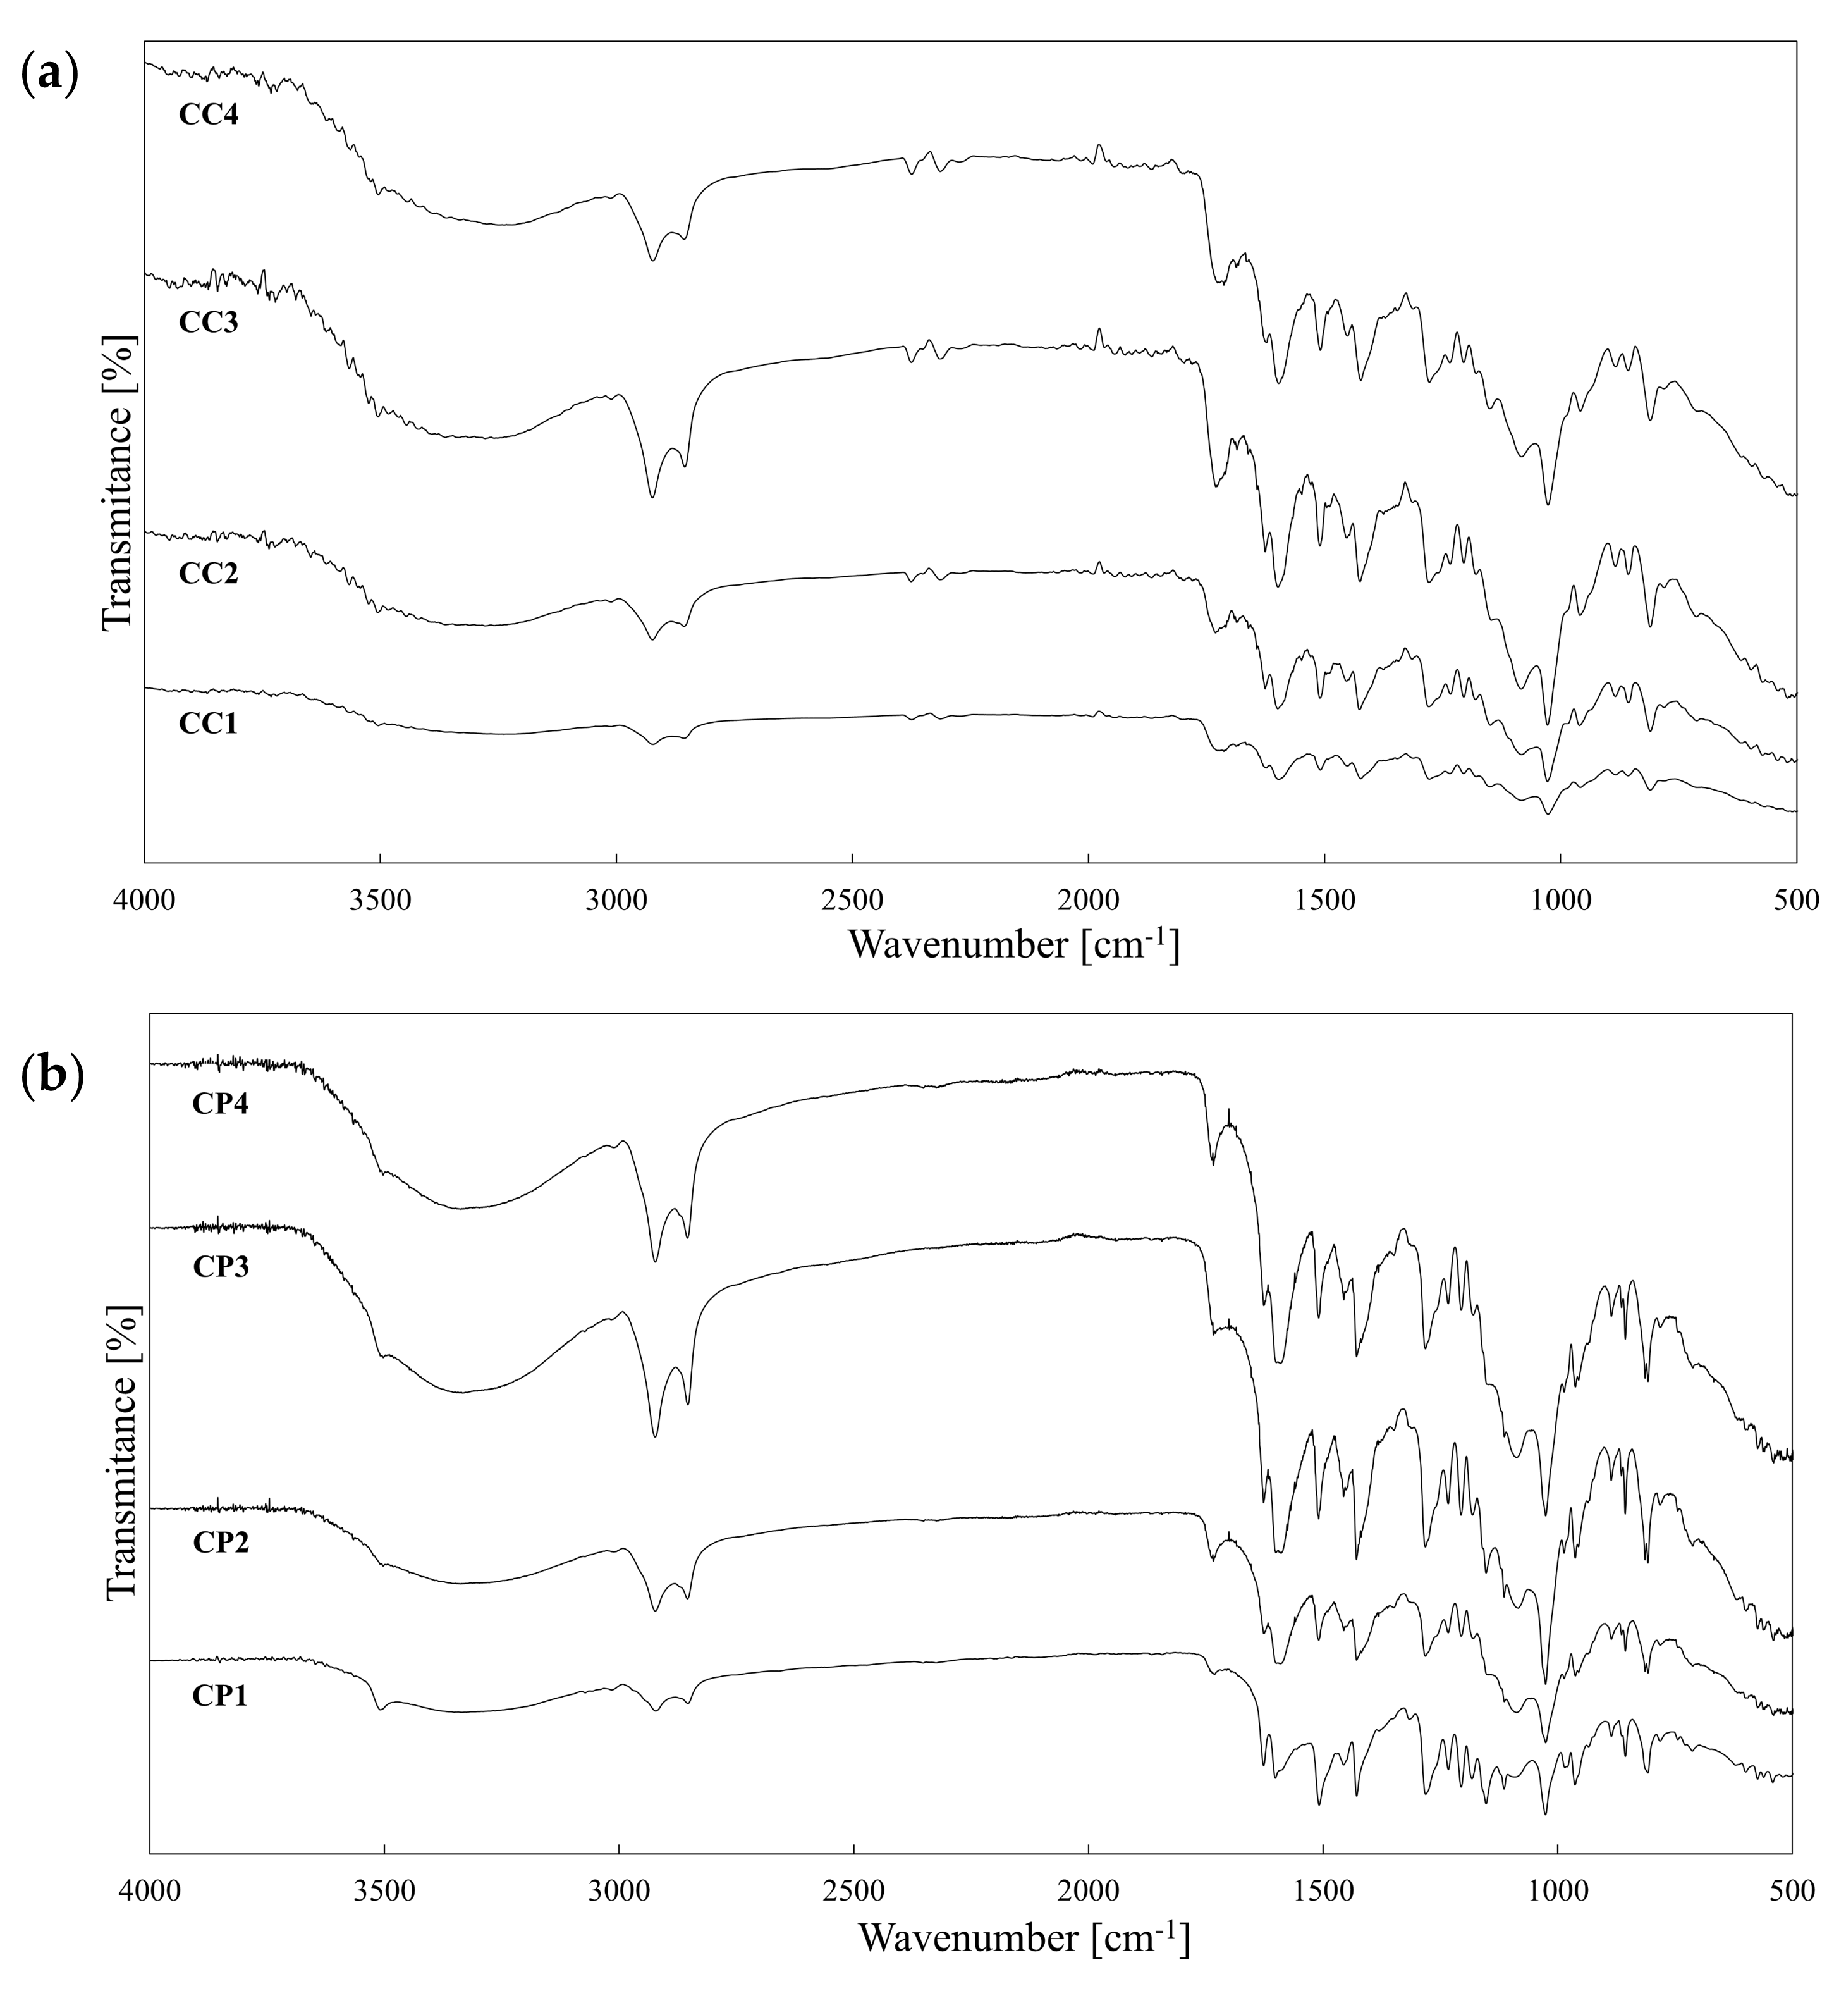

Figure S1. FTIR spectra of CUR-loaded microparticles decorated with A-QAS-PAAs: CHIT system (a) and PAH system (b).
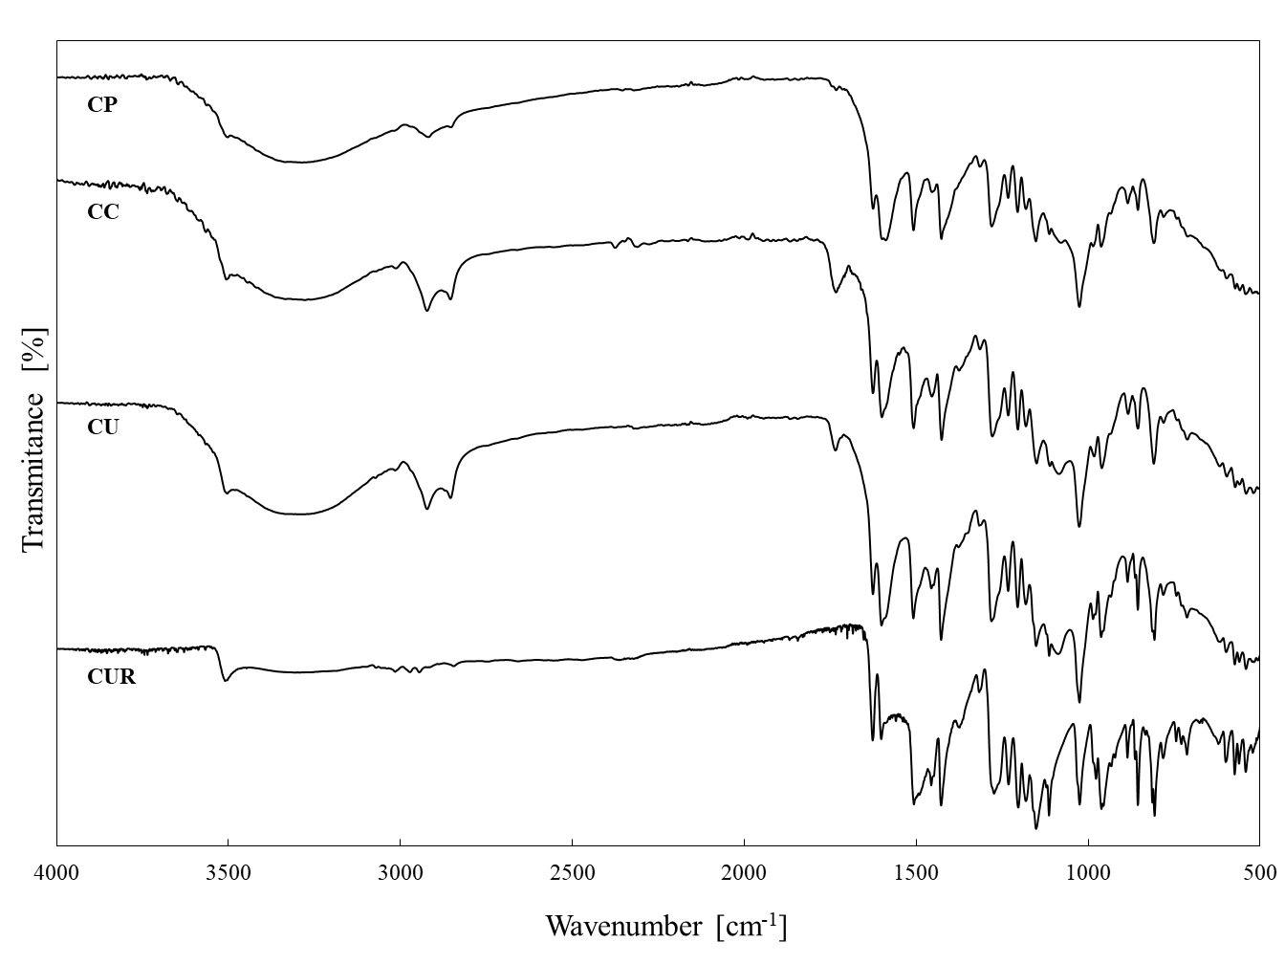
Figure S2. FTIR spectra of CUR, CU, CC and CP.
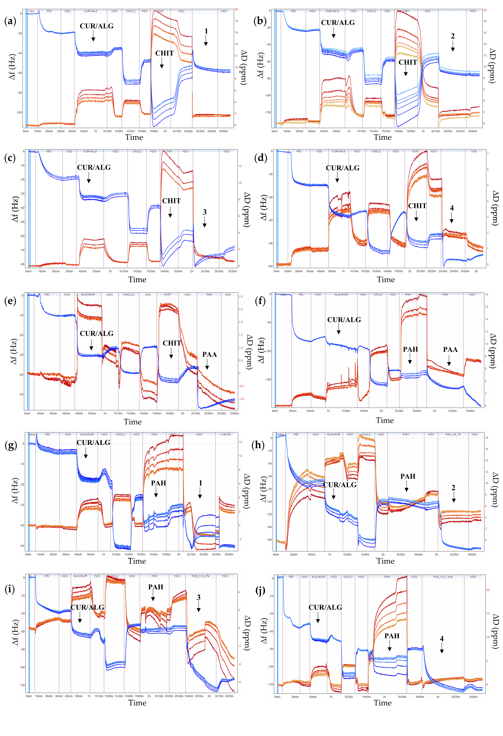
Figure S3. Adsorption kinetic measurements of polyelectrolyte multilayers monitored by QCM-D: (a) PEI/CUR/ALG/CHIT/1; (b) PEI/CUR/ALG/CHIT/2;
(c) PEI/CUR/ALG/CHIT/3; (d) PEI/CUR/ALG/CHIT/4; (e) PEI/CUR/ALG/CHIT/PAA; (f) PEI/CUR/ALG/PAH/PAA; (g) PEI/CUR/ALG/PAH/1; (h) PEI/CUR/ALG/PAH/2; (i) PEI/CUR/ALG/PAH/3; (j) PEI/CUR/ALG/PAH/4. Blue lines illustrate frequency shifts (Δf), while red lines illustrate dissipation shifts (ΔD) of polyelectrolyte multilayers. Resonance frequency variations and dissipation variations are recorded as functions of time.
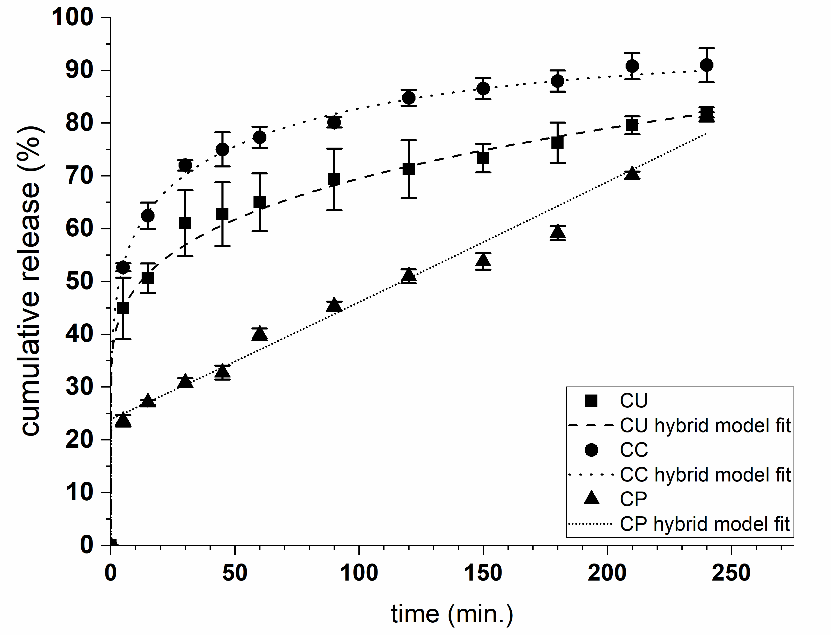
Figure S4. Release profiles of CUR from CU (squares), CC (circles), and CP (triangles) microparticles. Lines correspond to the fitting curves of the hybrid model to the payload release profiles.
Table S1. Film thickness characterization by spectroscopic ellipsometry.
 | PE layer | thickness  [nm] |  | PE layer | thickness  [nm]
 | CUR/ALG | 1.6±0.1 |  | CUR/ALG | 1.6±0.1
CHIT system | CHIT | 1.4±0.1 | PAH system | PAH | 2.2±0.2
 | PAA | 0.8±0.2 |  | PAA | 1.3±0.2
 | PAA-C(O)O-(CH₂)₆-N⁺(CH₃)₃-8% | 4.7±0.2 |  | PAA-C(O)O-(CH₂)₆-N⁺(CH₃)₃-8% | 7.2±0.7
 | PAA-C(O)O-(CH₂)₆-N⁺(CH₃)₃-10% | 6.4±1.4 |  | PAA-C(O)O-(CH₂)₆-N⁺(CH₃)₃-10% | 7.6±0.3
 | PAA-C(O)O-(CH₂)₁₂-N⁺(CH₃)₃-8% | 1.1±0.2 |  | PAA-C(O)O-(CH₂)₁₂-N⁺(CH₃)₃-8% | 1.0±0.3
 | PAA-C(O)O-(CH₂)₁₂-N⁺(CH₃)₃-14% | 1.0±0.4 |  | PAA-C(O)O-(CH₂)₁₂-N⁺(CH₃)₃-14% | 0.8±0.3

