Quantitative Determination and Fingerprint of Phenolic Compounds with Anti-inflammatory Activities for the Quality Control of Mangosteen Extract

Doudou Xu ^{1, 2}, Zhu Li ³, Mudan Guo ², Bo Jiang ², En Zhang ^{2,}* and Xinchuan Zheng ^{4,}*

- Key Laboratory of Biorheological Science and Technology, Ministry of Education, College of Bioengineering, Chongqing University, Chongqing 400044, China; xudoudou@cqifdc.org.cn
- Chongqing Institute for Food and Drug Control, Chongqing 401121, China; guomudan@cqifdc.org.cn (M.G.); jiangbo@cqifdc.org.cn (B.J.); zhangen@cqifdc.org.cn (E.Z.)
- Department of Emergency, Children’s Hospital of Chongqing Medical University, Chongqing 400014, China; lizhu_198528@163.com
- Chongqing Institute of Green and Intelligent Technology, Chinese Academy of Sciences, Chongqing 400714, China; zhengxinchuan@cigit.ac.cn
* Correspondence: zhengxinchuan@cigit.ac.cn (X.Z.); zhangen@cqifdc.org.cn (E.Z.); Tel.: +86-23-65935203 (X.Z.); +86-23-86072705 (E.Z.)

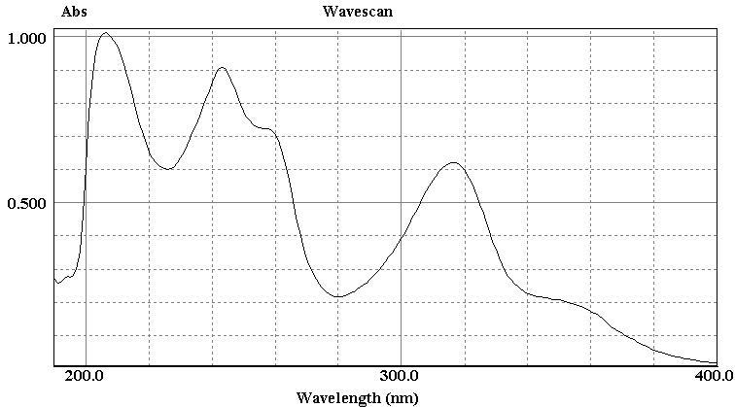
Figure S1. The UV spectrum of α-mangostin

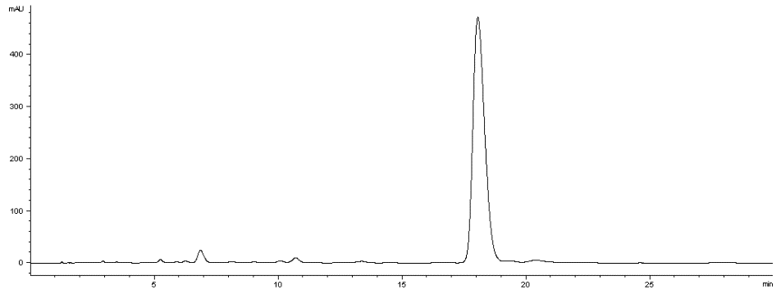
Figure S2. The HPLC chromatogram of α-mangostin

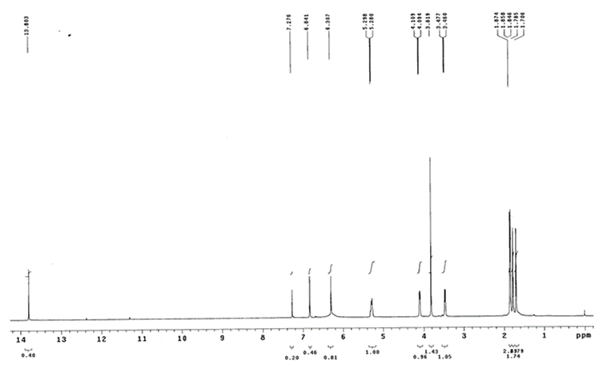
Figure S3. The ¹H NMR spectrum of α-mangostin

Table S1. The evaluation of different methods of extraction
Methods of extraction | Peak area
 | Catechin | Epicatechin | Procyanidin B2
Ultrasound | 125.7 | 1505.9 | 628.6
Reflux | 23.4 | 449.4 | 161
Maceration | 15.9 | 100.7 | 44.5

Table S2. The evaluation of different solvents of extraction
Solvents of extraction | Peak area
 | Catechin | Epicatechin | Procyanidin B2
Methanol | 125.7 | 1505.9 | 628.6
Ethyl acetate | 86.6 | 592 | 254.1

Table S3. The evaluation of different extraction time
Time of extraction | Peak area
 | Catechin | Epicatechin | Procyanidin B2
0.5 h | 95.5 | 1226.7 | 522.2
1.0 h | 125.7 | 1505.9 | 628.6
1.5 h | 115.5 | 1474.3 | 659.3

Table S4. The linear relationship of catechin
Amount (ng) | 50 | 100 | 150 | 200 | 250
Peak area | 94.2 | 194.5 | 285.4 | 383.4 | 491.3

Table S5. The linear relationship of epicatechin
Amount (ng) | 250 | 500 | 750 | 1000 | 1250
Peak area | 453.9 | 939.2 | 1517.8 | 2076.7 | 2604.2

Table S6. The linear relationship of procyanidin B2
Amount (ng) | 250 | 500 | 750 | 1000 | 1250
Peak area | 220.3 | 425.2 | 657.5 | 861.7 | 1068.4

Table S7. The result of precision
Compounds | Average peak area | RSD
Catechin | 2957.6±66.72 | 2.26%
Epicatechin | 2472.2±46.46 | 1.88%
Procyanidin B2 | 1031.1±21.39 | 2.07%

Table S8. The result of stability
Compounds | Average peak area | RSD
Catechin | 107.28±2.13 | 1.99%
Epicatechin | 1643.88±28.45 | 2.84%
Procyanidin B2 | 741.54±21.07 | 1.73%

Table S9. The result of repeatability
Compounds | Average amount | RSD
Catechin | 0.006±0.0001% | 1.99%
Epicatechin | 0.081±0.0012% | 1.45%
Procyanidin B2 | 0.086±0.0026% | 2.96%

Table S10. The result of recovery
Compounds | Pre-spike (mg) | Spiked (mg) | Post-spike (mg) | Recovery | Average recovery | RSD
Catechin | 0.29 | 0.25 | 0.53 | 96.6% | 99.3% | 2.8%
 | 0.28 | 0.25 | 0.52 | 96.1%
 | 0.28 | 0.25 | 0.53 | 100.9%
 | 0.28 | 0.25 | 0.53 | 98.9%
 | 0.29 | 0.25 | 0.55 | 103.4%
 | 0.29 | 0.25 | 0.54 | 99.8%
Epicatechin | 4.10 | 3.50 | 7.48 | 96.5% | 99.5% | 2.7%
 | 4.11 | 3.50 | 7.56 | 98.5%
 | 3.99 | 3.50 | 7.62 | 103.6%
 | 4.02 | 3.50 | 7.48 | 98.9%
 | 3.97 | 3.50 | 7.53 | 101.8%
 | 4.04 | 3.50 | 7.46 | 97.9%
Procyanidin B2 | 4.11 | 3.50 | 7.55 | 98.3% | 99.8% | 2.7%
 | 4.35 | 3.50 | 7.77 | 97.6%
 | 4.31 | 3.50 | 7.91 | 102.9%
 | 4.31 | 3.50 | 7.79 | 99.5%
 | 4.45 | 3.50 | 7.85 | 97.1%
 | 4.46 | 3.50 | 8.08 | 103.3%

Table S11. The results of quantitative determination of catechin, epicatechin, and procyanidin B2
Batches | Content
 | Catechin | Epicatechin | Procyanidin B2
2090526 | 0.007% | 0.074% | 0.073%
2100624 | 0.006% | 0.082% | 0.082%

Table S12. The result of precision (relative retention time of common peaks)
Number of common peaks | 1 | 2 | 3 | 4 (S) | 5 | RSD
1 | 0.3377 | 0.3372 | 0.3371 | 0.3373 | 0.3373 | 0.07%
2 | 0.4839 | 0.4904 | 0.4899 | 0.4901 | 0.4896 | 0.56%
3 | 0.5497 | 0.5499 | 0.5497 | 0.5500 | 0.5500 | 0.03%
4 (S) | 1.0000 | 1.0000 | 1.0000 | 1.0000 | 1.0000 | /
5 | 1.5130 | 1.5113 | 1.5109 | 1.5119 | 1.5120 | 0.05%
6 | 1.6050 | 1.6035 | 1.6030 | 1.6042 | 1.6045 | 0.05%
7 | 1.8623 | 1.8607 | 1.8601 | 1.8615 | 1.8621 | 0.05%
S: reference substance (α-mangostin)

Table S13. The result of precision (peak area ratio of common peaks)
Number of common peaks | 1 | 2 | 3 | 4 (S) | 5 | RSD
1 | 0.0168 | 0.0175 | 0.0174 | 0.0174 | 0.0173 | 1.61%
2 | 0.1154 | 0.1173 | 0.1140 | 0.1138 | 0.1116 | 1.84%
3 | 0.0253 | 0.0271 | 0.0266 | 0.0266 | 0.0266 | 2.55%
4 (S) | 1.0000 | 1.0000 | 1.0000 | 1.0000 | 1.0000 | /
5 | 0.0073 | 0.0078 | 0.0078 | 0.0077 | 0.0077 | 2.71%
6 | 0.0202 | 0.0208 | 0.0208 | 0.0207 | 0.0206 | 1.21%
7 | 0.0039 | 0.0040 | 0.0041 | 0.0041 | 0.0040 | 2.08%
S: reference substance (α-mangostin)

Table S14. The result of stability (relative retention time of common peaks)
Number of common peaks | 1 | 2 | 3 | 4 (S) | 5 | RSD
1 | 0.3375 | 0.3371 | 0.3373 | 0.3366 | 0.3371 | 0.10%
2 | 0.4894 | 0.4888 | 0.4899 | 0.4896 | 0.4916 | 0.21%
3 | 0.5504 | 0.5497 | 0.5495 | 0.5474 | 0.5479 | 0.23%
4 (S) | 1.0000 | 1.0000 | 1.0000 | 1.0000 | 1.0000 | /
5 | 1.5139 | 1.5115 | 1.5220 | 1.5147 | 1.5150 | 0.26%
6 | 1.6066 | 1.6040 | 1.6161 | 1.6068 | 1.6068 | 0.29%
7 | 1.8647 | 1.8619 | 1.8778 | 1.8656 | 1.8652 | 0.33%
S: reference substance (α-mangostin)

Table S15. The result of stability (peak area ratio of common peaks)
Number of common peaks | 1 | 2 | 3 | 4 (S) | 5 | RSD
1 | 0.0144 | 0.0143 | 0.0148 | 0.0149 | 0.0149 | 1.94%
2 | 0.1174 | 0.1120 | 0.1147 | 0.1129 | 0.1121 | 2.00%
3 | 0.0181 | 0.0183 | 0.0186 | 0.0180 | 0.0185 | 1.41%
4 (S) | 1.0000 | 1.0000 | 1.0000 | 1.0000 | 1.0000 | /
5 | 0.0077 | 0.0077 | 0.0077 | 0.0080 | 0.0080 | 1.81%
6 | 0.0208 | 0.0207 | 0.0199 | 0.0195 | 0.0200 | 2.63%
7 | 0.0030 | 0.0031 | 0.0030 | 0.0032 | 0.0030 | 2.92%
S: reference substance (α-mangostin)

Table S16. The result of reproducibility (relative retention time of common peaks)
Number of common peaks | 1 | 2 | 3 | 4 (S) | 5 | RSD
1 | 0.3376 | 0.3372 | 0.3372 | 0.3370 | 0.3372 | 0.07%
2 | 0.4867 | 0.4896 | 0.499 | 0.4899 | 0.4906 | 0.31%
3 | 0.5501 | 0.5498 | 0.5496 | 0.5487 | 0.5490 | 0.10%
4 (S) | 1.0000 | 1.0000 | 1.0000 | 1.0000 | 1.0000 | /
5 | 1.5135 | 1.5114 | 1.5165 | 1.5133 | 1.5135 | 0.12%
6 | 1.6058 | 1.6038 | 1.6096 | 1.6055 | 1.6057 | 0.13%
7 | 1.8635 | 1.8613 | 1.8690 | 1.8636 | 1.8637 | 0.15%
S: reference substance (α-mangostin)

Table S17. The result of reproducibility (peak area ratio of common peaks)
Number of common peaks | 1 | 2 | 3 | 4 (S) | 5 | RSD
1 | 0.0156 | 0.0159 | 0.0161 | 0.0161 | 0.0161 | 1.43%
2 | 0.1164 | 0.1146 | 0.1143 | 0.1134 | 0.1118 | 1.47%
3 | 0.0217 | 0.0227 | 0.0226 | 0.0223 | 0.0226 | 1.77%
4 (S) | 1.0000 | 1.0000 | 1.0000 | 1.0000 | 1.0000 | /
5 | 0.0075 | 0.0078 | 0.0078 | 0.0078 | 0.0078 | 1.77%
6 | 0.0205 | 0.0207 | 0.0204 | 0.0201 | 0.0203 | 1.13%
7 | 0.0035 | 0.0035 | 0.0036 | 0.0037 | 0.0035 | 2.08%
S: reference substance (α-mangostin)

