Supplement

Table 1. Prediction performance of ML model during 2020/08-2020/10. Prediction performance was inferior between probability 0.4-0.48.
 | Probability<0.40 | 0.4-0.48 | >0.48
accuracy | 0.9857 | 0.88 | 0.94

Figure 1. Illustration of grey zone definition in this study. Probability range between 0.40 to 0.48 was defined as grey zone.
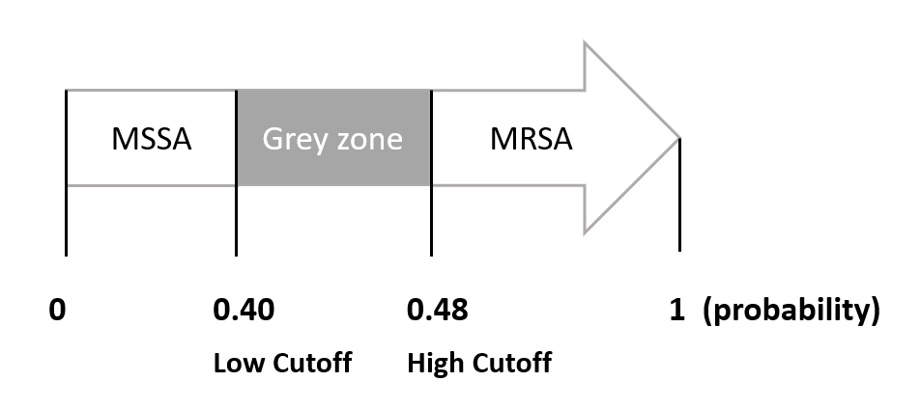

Table 2. Detailed peak numbers of the MALDI-TOF mass spectra in different groups.
 | Minimum | First Quartile | Median | Third Quartile | Maximum
MRSA, correct | 96 | 116 | 124.00 | 134.00 | 190
Grey zone | 101 | 118.5 | 126 | 133.75 | 166
MSSA, correct | 87 | 113 | 120 | 130 | 166
MRSA, incorrect | 106 | 115 | 124 | 130 | 152
MSSA, incorrect | 95 | 120 | 127.5 | 137.75 | 192

Table 3. Literature review of molecular typing of S. aureus in Taiwan.
Time | Research | Strain | Population | Sample size | Top 5 MLST |  | Other MLST
2012 | Chen et al¹ | MSSA | - Community-onset infection  - 2 medical centers (Tri-Service General Hospital and Kaohsiung Medical University Hospital).  - a four-month collection period in 2006. | 34 | ST188  ST7  ST97  ST12  ST15 | 7 (20.6%)  6 (17.6%)  4 (11.8%)  4 (11.8%)  3 (8.8%) | 10 (29.4%)
2019 | Chen et al² | MSSA | - Infected children (< 18y/o), excluding neonate  - Chang Gung Memorial Hospital, Linkou  - January 1, 2015 to December 31, 2015 | 59 | ST15  ST188  ST7  ST508  ST5 | 6 (10.2%)  5 (8.5%)  4 (6.8%)  3 (5.1%)  2 (3.4%) | 39(66.1%)
2014 | Ho et al³ | MSSA | - Blood culture of different patients  - China Medical University Hospital, Taiwan  - July 2008 to December 2009 for MSSA  - July to December 2008 for MRSA | 14 | ST15  ST59  ST188  ST12  ST6 | 4(28.6%)  3(21.4%)  3(21.4%)  2(14.3%)  2(14.3%) | -
 |  | MRSA |  | 22 | ST5  ST239  ST59 | 10(45.4%)  7(31.8%)  5(22.7%) | -
2019 | Wu et al⁴ | MRSA | - Nasal swabs from patients >18y/o visiting the emergency department and health care workers in the ED and intensive care unit (ICU)  - 2 regional hospitals in Changhua  - February to June 2015 | 36 | ST59  ST45  ST239  ST508  ST5 | 16(44.4%)  11(30.5%)  3(8.3%)  3(8.3%)  1(2.7%) | 2 (5.5%)
2019 | Peng et al⁵ | MRSA | - MRSA isolates from cellulitis and from osteomyelitis patients.  - Chang Gung Memorial Hospital, Chiayi  - 2016 to 2018 | 221 | ST59  ST8  ST239  ST45  ST30 | 91(41.2%)  46(20.8%)  35(15.8%)  13(5.9%)  11(5.0%) | 25(11.3%)
2012 | Wang et al⁶ | MRSA | - blood culture of different patients  - 9 medical centers, including in northern (hospitals N1, N2, N3), central (hospitals C1, C2, C3), and southern (hospitals S1, S3) and one in eastern (hospital E1) part of Taiwan.  - March to August, 2003 | 157 | ST239  ST59  ST241  ST5  ST573 | 99(63.0%)  27(17.2%)  12(7.6%)  9(5.7%)  4(2.5%) | 6 (3.8%)

Reference
1. Chen FJ, Siu LK, Lin JC, Wang CH and Lu PL. Molecular typing and characterization of nasal carriage and community-onset infection methicillin-susceptible Staphylococcus aureus isolates in two Taiwan medical centers. BMC Infect Dis. 2012; 12: 343.
2. Chen YJ, Chen PA, Chen CJ and Huang YC. Molecular characteristics and clinical features of pediatric methicillin-susceptible Staphylococcus aureus infection in a medical center in northern Taiwan. BMC Infect Dis. 2019; 19: 402.
3. Ho CM, Lin CY, Ho MW, Lin HC, Peng CT and Lu JJ. Concomitant genotyping revealed diverse spreading between methicillin-resistant Staphylococcus aureus and methicillin-susceptible Staphylococcus aureus in central Taiwan. J Microbiol Immunol Infect. 2016; 49: 363-70.
4. Wu TH, Lee CY, Yang HJ, et al. Prevalence and molecular characteristics of methicillin-resistant Staphylococcus aureus among nasal carriage strains isolated from emergency department patients and healthcare workers in central Taiwan. J Microbiol Immunol Infect. 2019; 52: 248-54.
5. Peng KT, Huang TY, Chiang YC, et al. Comparison of Methicillin-Resistant Staphylococcus aureus Isolates from Cellulitis and from Osteomyelitis in a Taiwan Hospital, 2016-2018. J Clin Med. 2019; 8.
6. Wang WY, Chiueh TS, Sun JR, Tsao SM and Lu JJ. Molecular typing and phenotype characterization of methicillin-resistant Staphylococcus aureus isolates from blood in Taiwan. PLoS One. 2012; 7: e30394.

