Supplementary Information

Photocatalytic degradation of fluoroquinolone antibiotics in solution
Abniel Machín^{1*}, Kenneth Fontánez², José Duconge³, María Cotto³, Florian I. Petrescu⁴, Carmen Morant⁵, Francisco Márquez^{3*}
¹ Arecibo Observatory, Universidad Ana G. Méndez-Cupey Campus, 00926PR, United States
² Department of Chemistry, University of Puerto Rico, Rio Piedras Campus, San Juan, 00925PR, United States
³ Nanomaterials Research Group, School of Natural Sciences and Technology, Universidad Ana G. Méndez-Gurabo Campus, 00778PR, United States
⁴ IFToMM-ARoTMM, Bucharest Polytechnic University, Bucharest, (CE), Romania
⁵ Department of Applied Physics, Autonomous University of Madrid and Instituto de Ciencia de Materiales Nicolas Cabrera, 28041, Spain

* Correspondence: fmarquez@uagm.edu (FM), machina1@uagm.edu (AM)

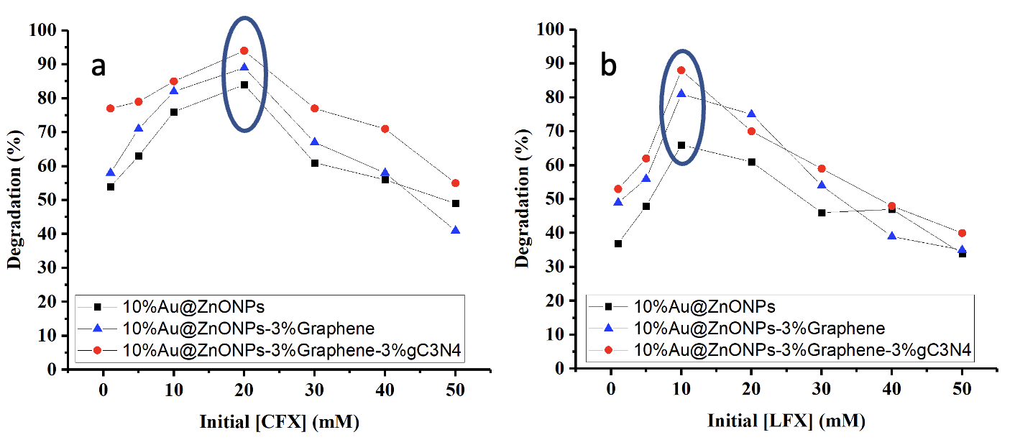

Figure S1. Evaluation of the initial concentration of CFX (a) and LFX (b) on the catalytic efficiency of 10%Au@ZnONPs, 10%Au@ZnONPs-3%rGO, and 10%Au@ZnONPs-3%rGO-3%gC₃N₄ in the photodegradation reaction.

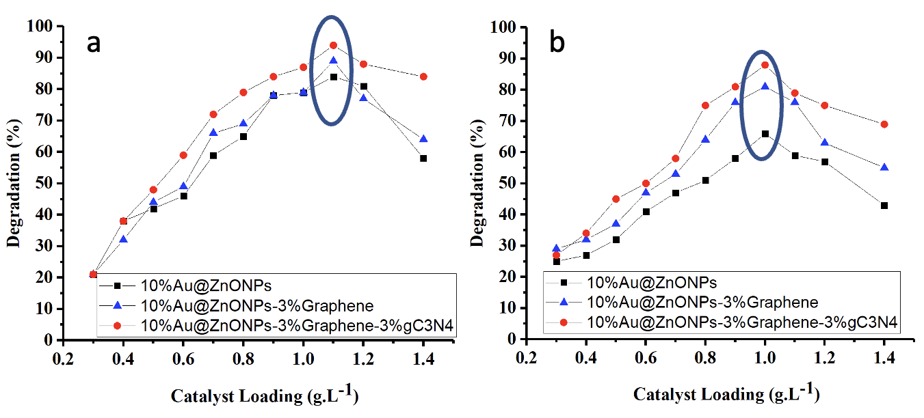

Figure S2. Evaluation of the initial concentration of 10%Au@ZnONPs, 10%Au@ZnONPs-3%rGO, and 10%Au@ZnONPs-3%rGO-3%gC₃N₄ on the efficiency of the photodegradation reaction of CFX (a) and LFX (b).

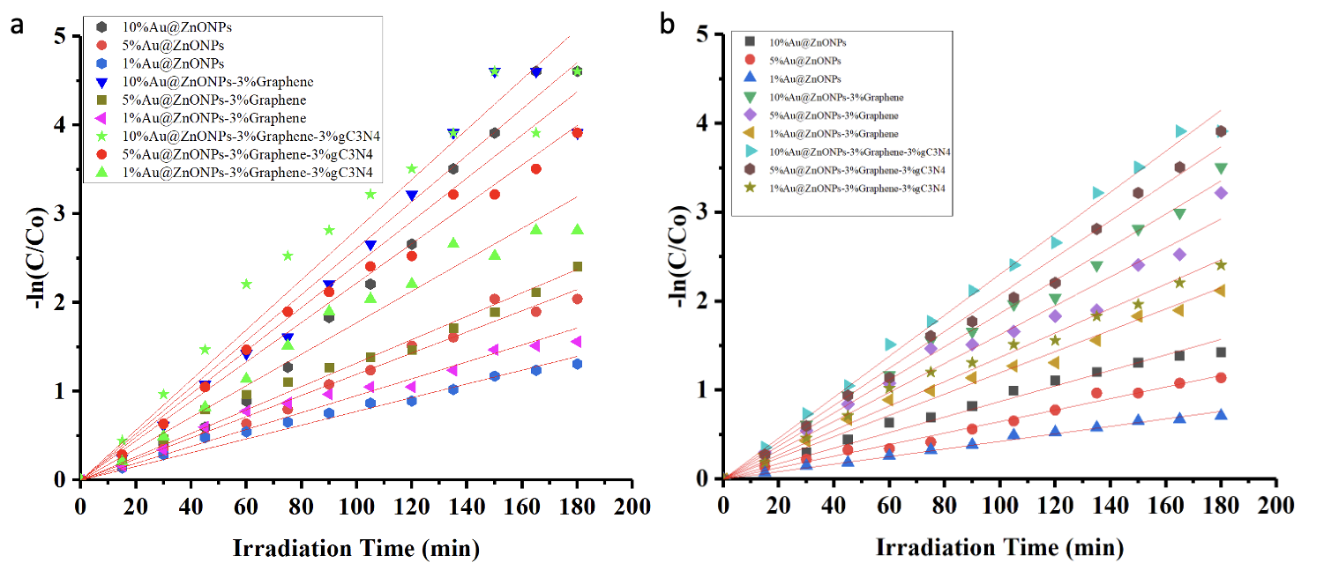

Figure S3. Pseudo-first order kinetics of photodegradation of CFX (a) and LFX (b) using different catalysts.

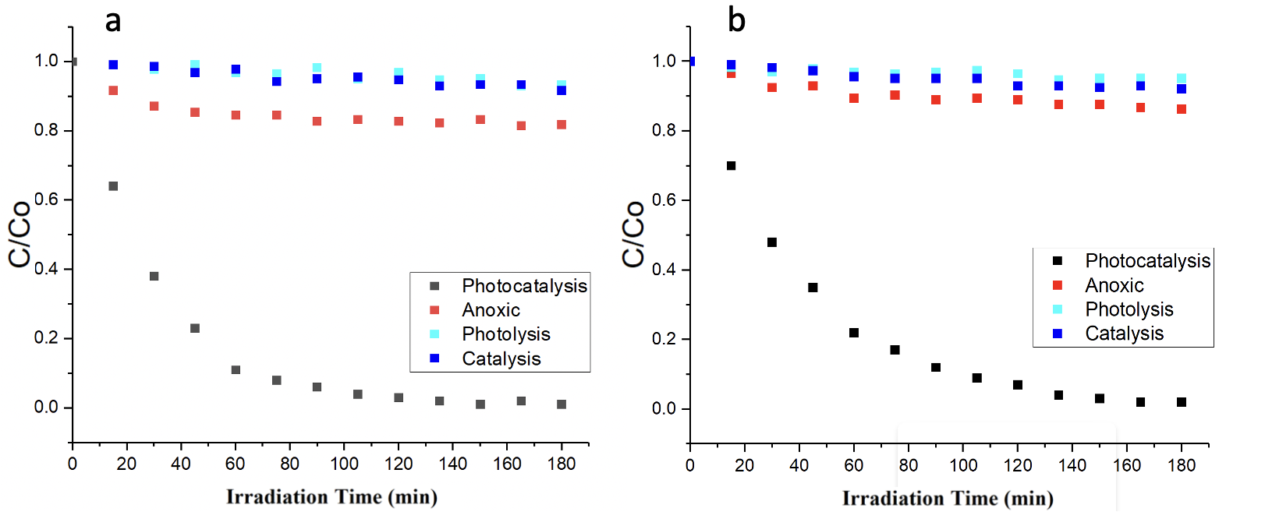

Figure S4. Control experiments for 10%Au@ZnONPs-3%rGO-3%gC₃N₄ with CFX (a) and LFX (b), under visible radiation.

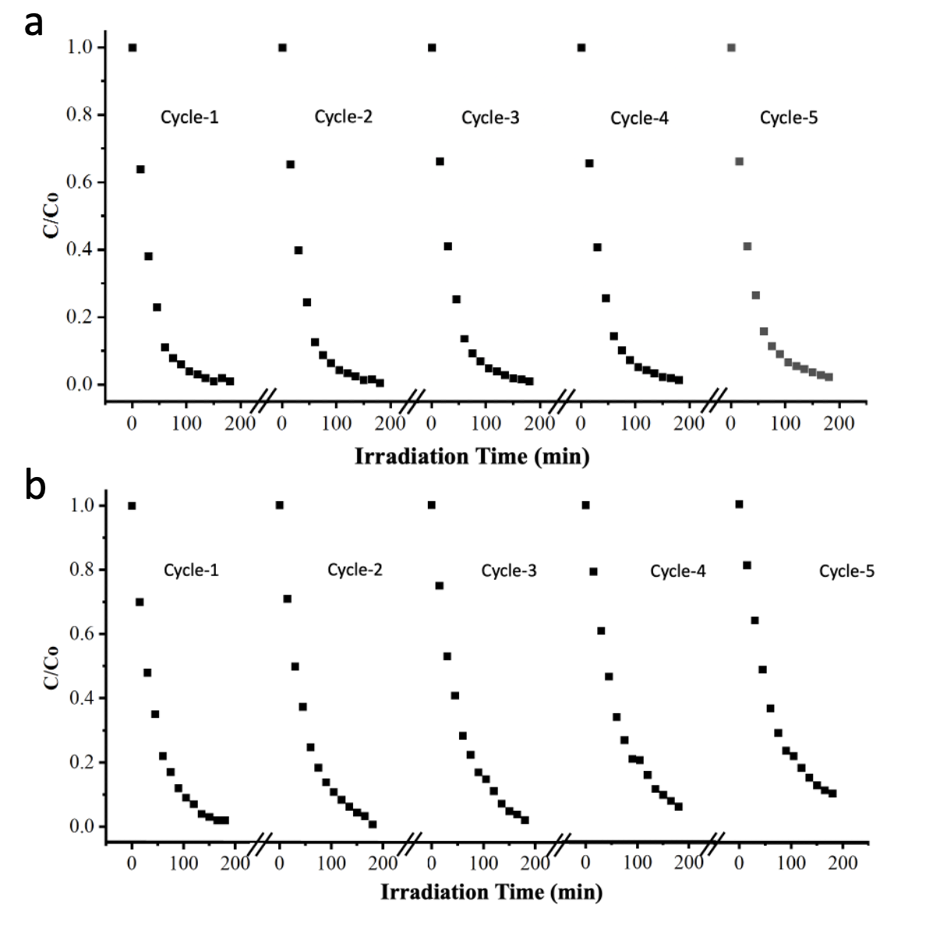
Figure S5. Recyclability of 10%Au@ZnONPs-3%rGO-3%gC₃N₄ after five consecutive catalytic cycles of photodegradation of CFX (a) and LFX (b) under visible radiation.

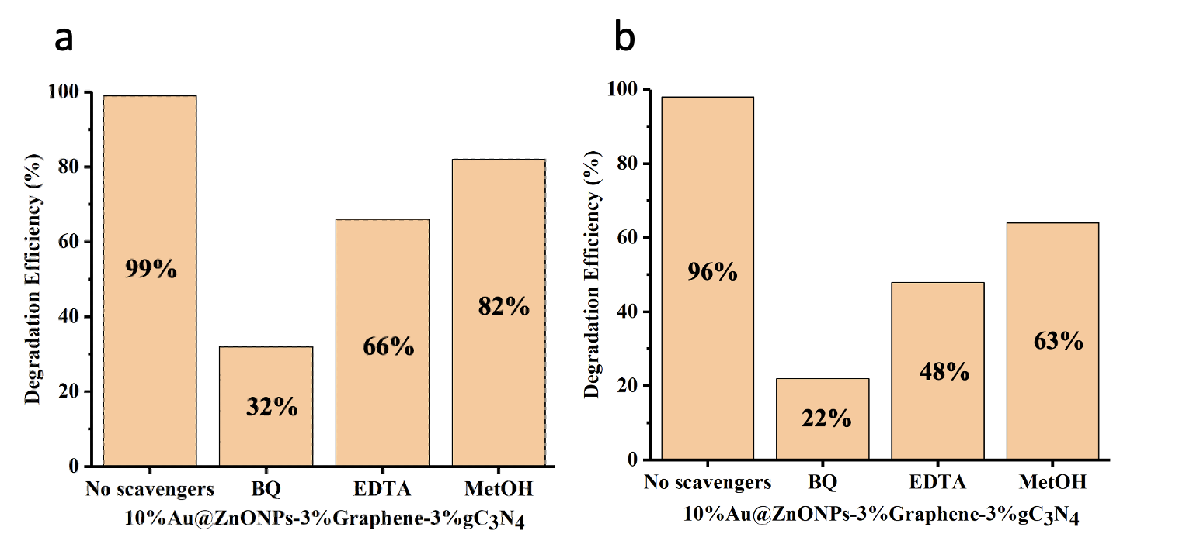

Figure S6. Photocatalytic activity of 10%Au@ZnONPs-3%rGO-3%gC₃N₄ on the degradation of CFX (a) and LFX (b) in the presence of various scavengers under visible radiation.

Table S1. The pseudo-first-order kinetics constants for the photodegradation of CFX and LFX.

Material | Apparent rate CFX¹ | Apparent rate LFX¹
1%Au@ZnONPs  5%Au@ZnONPs  10%Au@ZnONPs  1%Au@ZnONPs-3%rGO  5%Au@ZnONPs-3%rGO  10%Au@ZnONPs-3%rGO  1%Au@ZnONPs-3%rGO-3%gC₃N₄  5%Au@ZnONPs-3%rGO-3%gC₃N₄  10%Au@ZnONPs-3%rGO-3%gC₃N₄ | 0.008 0.004  0.012 0.006  0.026 0.009  0.009 0.011  0.013 0.016  0.024 0.019  0.018 0.014  0.022 0.021  0.028 0.023

¹(k, min⁻¹)

