Negative mpMRI rules out extra-prostatic extension before robot assisted radical prostatectomy.

Supplementary Online Material

S1. Exclusion and Inclusion Criteria for the NeuroSAFE PROOF Trial (NCT 03317990).

Inclusion criteria:
1. Men opting to undergo RALP for organ confined prostate cancer.
2. Potent men (IIEF 22‐25 not using PDE5i or other medications or
devices).
3. Men who are continent of urine (no self‐reported urinary
incontinence).
4. Has given written informed consent.
5. Ability to read English sufficiently to answer questionnaires and
understand PIS.

Exclusion criteria:
1. Unable to undergo robotic prostatectomy.
2. Known overactive bladder.
3. Previous treatment for prostate cancer.
4. Previous/current hormone treatment for prostate cancer.
5. Nerve sparing deemed futile due to locally advanced disease by
surgeon and radiologist.
Figure S2. Locations of MRI Scanners and corresponding numbers of mpMRI Scans Performed

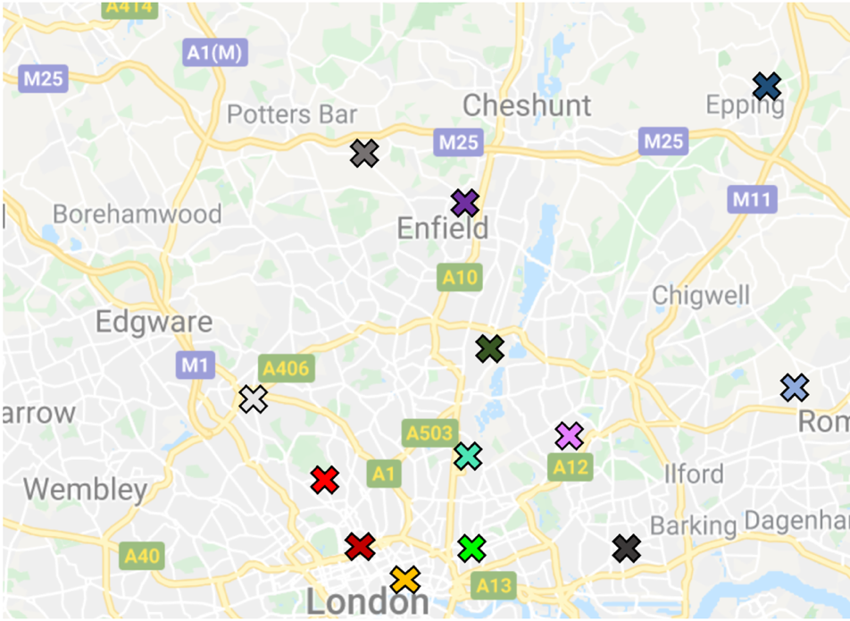

Legend and numbers of scans performed in brackets; UCLH, University College London Hospitals (31); RFH, Royal Free London NHS Foundation Trust (10); Barts, St Bartholomew’s Hospitals part of Barts Health NHS Trust; Royal Ldn, Royal London Hospitals part of Barts Health NHS Foundation Trust; NMUH, North Middlesex University Hospital; Homerton, Homerton University Hospital NHS Foundation Trust, King George (BHR), King George Hospital part of Barking, Havering and Redbridge University Hospitals NHS Trust; St Margs (PAH), St Margaret’s Hospital part of The Princess Alexandra Hospital NHS Trust; Whipps X, Whipps Cross Hospital part of Barts Health NHS Trust; Enfield, Enfield Alliance MRI Centre performed on behalf of Chase Farm Hospital part of Royal Free London NHS Foundation Trust; Barnet, Barnet Hospital part of Royal Free London NHS Foundation Trust; Chase Farm, Chase Farm Hospital part of Royal Free London NHS Foundation Trust; Newham, Newham University Hospital part of Barts Health NHS Trust.

Figure S3. Study Case Reporting Form

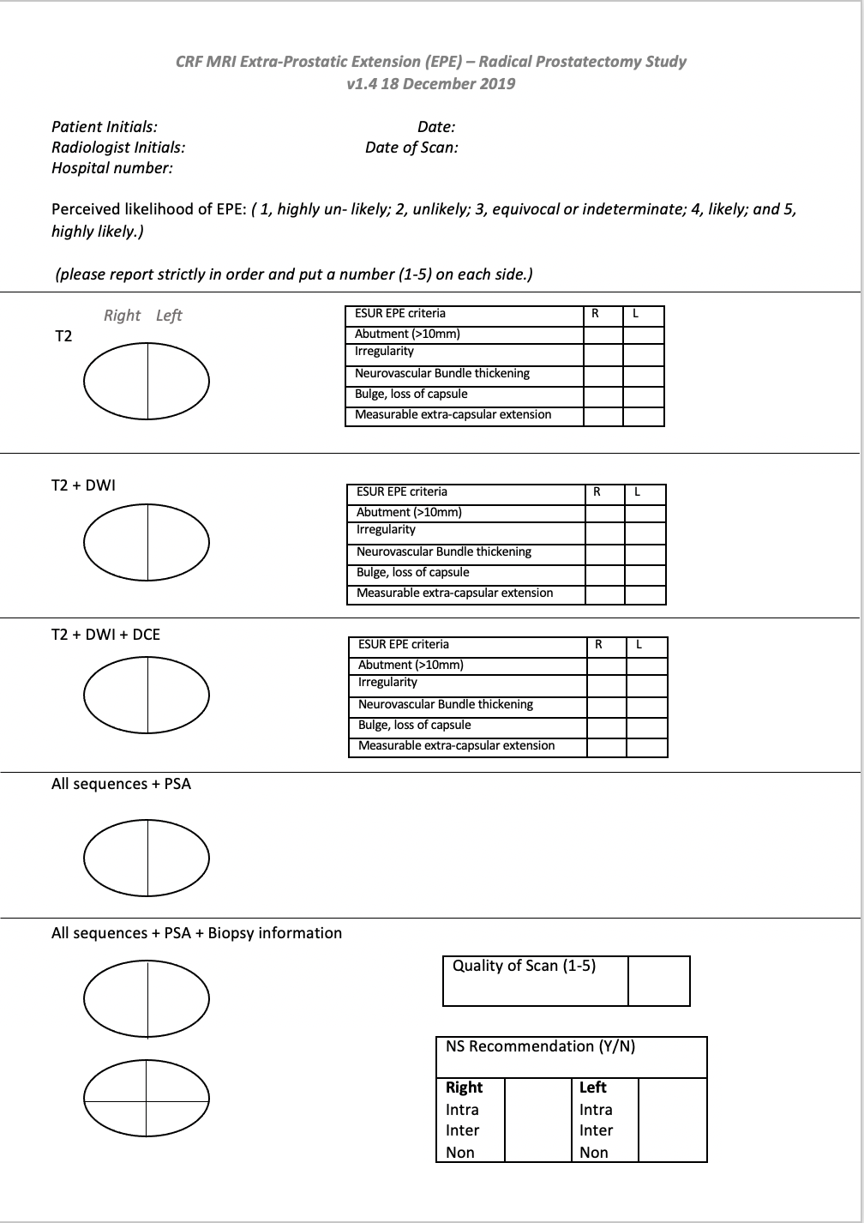

Table S4. Summary for Assessment of the diagnostic quality of mpMRI scans using the PI-QUAL score

PI-QUAL SCORE | Criteria | Clinical Implications
1 | All mpMRI sequences are below the minimum standard for diagnostic quality | It is NOT possible to rule in all significant lesions.  It is NOT possible to rule out all significant lesions.
2 | Only one mpMRI sequence is of acceptable diagnostic quality.
3 | At least two mpMRI sequences taken together are of acceptable diagnostic quality. | It is possible to rule in all significant lesions.  It is NOT possible to rule out all significant lesions.
4 | Two or more mpMRI sequences are independently of optimal diagnostic quality. | It is possible to rule in all significant lesions.  It is possible to rule out all significant lesions.
5 | All mpMRI sequences are of optimal diagnostic quality.

Figure S5. Scoring sheet for assessing the quality of mpRMI using the PI_QUL scoring system. T2-WI=T2-weighted imaging; DWI=diffusion-weighted imaging; DCE=dynamic contrast-enhanced; ADC=apparent diffusion coefficient.

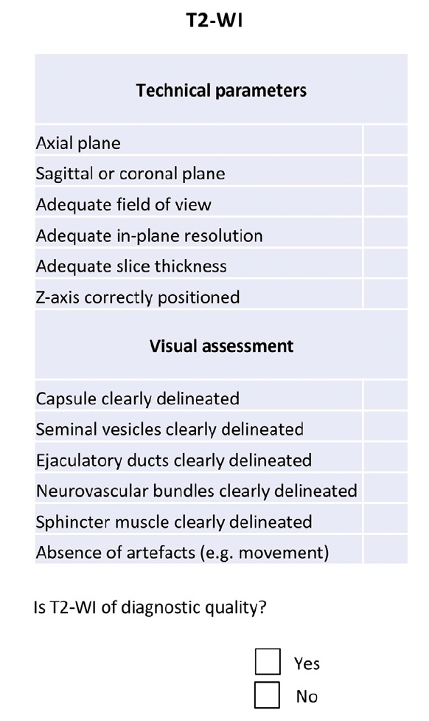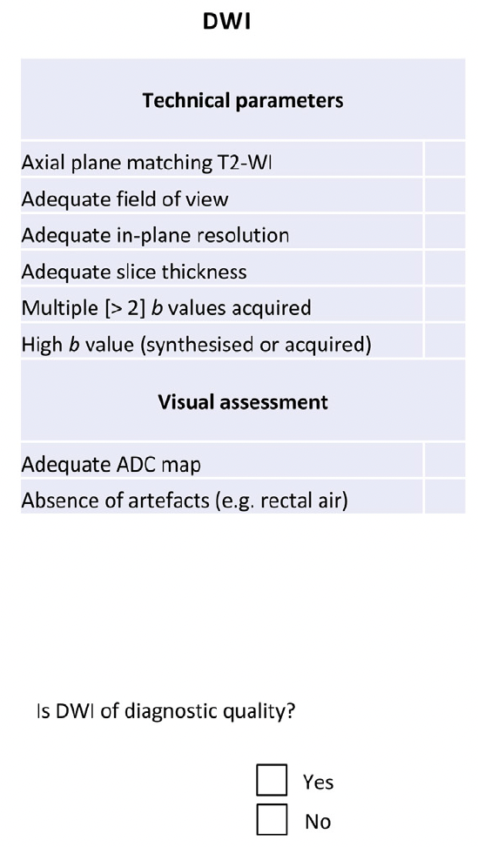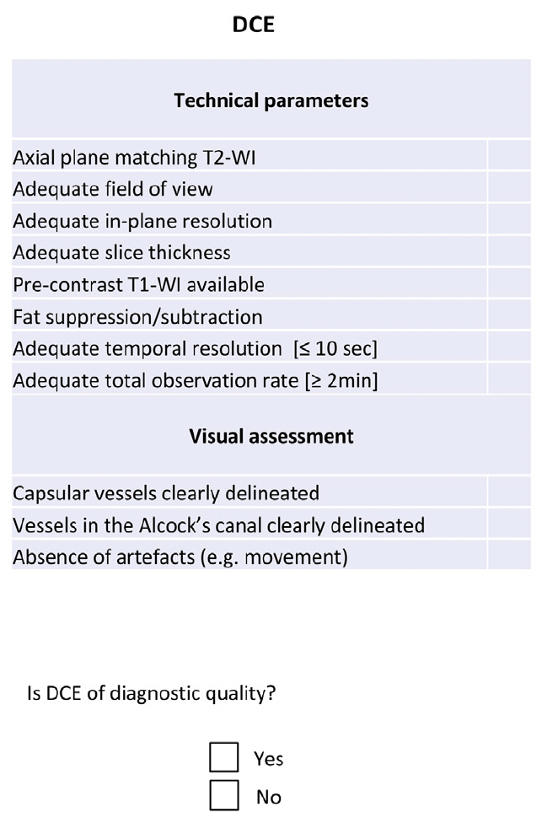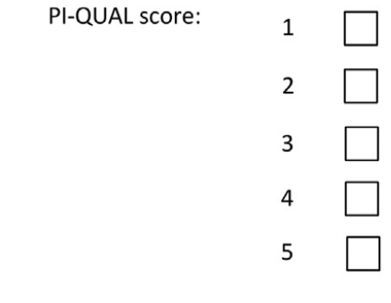

*Reproduced with permission of Giganti, et al. Prostate Imaging Quality (PI-QUAL): A New Quality Control Scoring System for Multiparametric Magnetic Resonsnce Imaging of the Prostate from the PRECISION trial. Eur Urol Onc; 3(202): 615-619.
Table S6. Clinical and Radiological features of the 9 men who had mpMRI repeated following prostate biopsy.

Age, years (mean (IQR)) | 57.6 (50 - 59)
Reason repeat scan  ‘Previous scan poor quality’  ‘For RP planning’  ‘Repeat staging/old scan’  ‘suitable for focal therapy?’ | 2  3  3  1
Time since previous scan, days (mean (IQR)) | 233 (76 - 353)
Time since biopsy, days (mean (IQR)) | 164 (63 - 475)
Time until RARP, days (mean (IQR)) | 13 (4 - 24)
Pathological stage  pT2a  pT2c  pT3a  pT3b | 1  4  3  1
PI-QUAL score  3  4 | 3  6
Sensitivity, % (95% CI) | 100 (73.5 - 100)
Specificity, % (95% CI) | 63.2 (46 - 78.2)
AUC (95% CI) | 0.93 (0.85 - 0.1)
*All repeat scans were performed at the academic hospital where RARP and MRI reporting was performed.

Table S7. Pathological EPE according to final Likert score by individual radiologist per prostate lobe.

 | Reader 1 (%) | Reader 2† (%) | Reader 3‡ (%)
Likert 1 | 0/0 (0) | 0/8 (0) | 0/13 (0)
Likert 2 | 5/121 (4.1) | 3/68 (4.4) | 4/92 (4.3)
Likert 3 | 7/50 (14) | 11/90 (12.2) | 11/68 (16.2)
Likert 4 | 16/38 (42.1) | 19/50 (38) | 18/40 (45)
Likert 5 | 15/22 (68.2) | 7/9 (77.8) | 9/11 (81.8)
Total | 43/231 | 40/225 | 42/224
†Reader 2, 6 scores missing. ‡Reader 3, 7 scores missing.

Table S8. Per patient analysis of Sensitivity (SE), specificity (SP), positive predictive value (PPV), negative predictive value (NPV) and area under the curve (AUC) by individual radiologist and combined where Likert score 3≥ was positive scan for pathological.

 | Reader 1 | Reader 2 | Reader 3 | Readers Combined
SE* | 97.5  (88.6-99.9) | 100  (90.8-100) | 94.9  (82.7-99.4) | 97.4  (92.7-99.5)
SP* | 40.5  (21.9-51.8) | 8.5  (3.5-16.8) | 23.5  (13.8-38.2) | 24.4  (19.2-30.3)
PPV* | 44.3  (33.7-55.3) | 33.6  (25-43.1) | 37.4  (27.9-47.7) | 38  (32.5-43.8)
NPV* | 97.1  (85.1-99.3) | 100  (59-100) | 90.5  (69.6-98.8) | 95.2  (86.7-99)
AUC* | 0.69  (0.6-0.78) | 0.54  (0.44-0.65) | 0.59  (0.49-0.7) | 0.61  (0.55-0.67)
*95% confidence intervals in parentheses.

Figure S9. Stacked bar charts showing proportion clinical detection of EPE per lobe according to Final Likert score for biparametric scans (A), PI-QUAL score 1-3 scans (B), and PI-QUAL score 4-5 scans (C), respectively.
- Biparametric MRI scans.

- PI-QUAL score 1-3 mpMRI scans.
- PI-QUAL score 1-3 mpMRI scans.

Figure S10. ROC curves for prediction of pathologic EPE using mpMRI for all 3 readers with additional imaging and information in sequence.

Area under the Curve (AUC) (with 95% CI), T2WI 0.62 (0.56, 0.69); +DWI 0.69 (0.64, 0.75); +DCE 0.76 (0.71, 0.82); +PSA 0.79 (0.74, 0.84); Final 0.82 (0.77, 0.86). Legend: T2WI, T2 weighted-imaging; DWI, diffusion-weighted imaging; DCE, dynamic contrast enhanced; PSA, prostate specific antigen; Final (including biopsy information).
Table S11. Visual features according to radiological interpretation of positive scan for EPE (Likert ≥3).

 | Abutment | Irregularity | NVB Thickening | Bulge | Measurable ECE
Likert ≥3 | 57.9% | 36% | 5% | 20.1% | 6.6%
Likert 1-2 | 17.2% | 5.3% | 0% | 4.6% | 0.3%
Overall | 39.9% | 21.9% | 2.7% | 13.1% | 3.7%
Abbreviations: EPE=extra-prostatic extension, NVB=neurovascular bundle, ECE=extra-capsular extension.

Table S12. Visual features according to EPE on final pathological assessment of RP specimen.

 | Abutment | Irregularity | NVB Thickening | Bulge | Measurable ECE
EPE present | 64.3% | 40.5% | 6.3% | 30.2% | 11.1%
No EPE | 34.6% | 18.1% | 1.9% | 9.3% | 2.1%
Overall | 39.9% | 21.9% | 2.7% | 13.1% | 3.7%
Abbreviations: EPE=extra-prostatic extension, RP=radical prostatectomy, NVB=neurovascular bundle, ECE=extra-capsular extension.

Table S13. Diagnostic Performance of mpMRI when Likert score ≥4 for final read indicates positive diagnostic test.

 | Reader 1 (%) | Reader 2 (%) | Reader 3 (%) | Readers combined (%)
SE | 72.1 (56.3 - 84.6) | 65 (48.3 - 79.4) | 64.3 (48 - 78.5) | 67.2 (58.2-75.3)
SP | 84.6 (78.6 - 89.4) | 82.2 (75.9 - 87.4) | 86.8 (81 - 91.4) | 84.5 (81.2-87.4)
PPV | 51.7 (38.4 - 64.8) | 44.1 (31.2 - 57.6) | 52.9 (38.5 - 67.1) | 49.4 (41.7 - 57.2)
NPV | 93 (88.1 - 96.3) | 91.6 (86.3 - 95.3) | 91.3 (86.1 - 95.1) | 92 (89.3 - 94.2)
95% confidence intervals in brackets.

