Supporting Information

AZOLO[1,5-a]PYRIMIDINES AND THEIR CONDENSED ANALOGS WITH ANTICOAGULANT ACTIVITY

Konstantin V. Savateev*[a], Victor V. Fedotov[a], Vladimir L. Rusinov[a], Svetlana K. Kotovskaya[a], Alexandr A. Spasov[b], Aida F. Kucheryavenko[b], Pavel M. Vasiliev[b], Vadim A. Kosolapov[b], Victor S. Sirotenko[b], Kseniya A. Gaidukova[b], Georgiy M. Uskov[b]

[a] Department of organic and biomolecular chemistry, Ural Federal University named after the First President of Russia B.N. Eltsin, Mira st. 19, Yekaterinburg, 620002, Russian Federation; E-mail: i-krafttt@yandex.ru

[b] Department of Pharmacology and Bioinformatics, Volgograd State Medical University, Pavshikh Bortsov Sq. 1, Volgograd, 400131, Russian Federation

Table of contents
Spectra of compounds 2

Spectra of compounds
2,6-Diethoxycarbonyl-1,2,4-triazolo[1,5-a]pyrimidin-7-one (3а)
DMSO
DMSO
Figure S1. ¹H NMR (400 MHz, DMSO-d₆) and ¹³C NMR (100 MHz, DMSO-d₆) spectra of 3a
2,6-Diethoxycarbonyl-1,2,4-triazolo[1,5-a]pyrimidin-7-one (3а)
Figure S2. IR spectra of 3a

2-(Thien-2-yl)-6-ethoxycarbonyl-1,2,4-triazolo[1,5-a]pyrimidin-7-one (3f)
DMSO
DMSO
Figure S3. ¹H NMR (400 MHz, DMSO-d₆) and ¹³C NMR (100 MHz, DMSO-d₆) spectra of 3f
2-(Thien-2-yl)-6-ethoxycarbonyl-1,2,4-triazolo[1,5-a]pyrimidin-7-one (3f)
Figure S4. IR spectra of 3f
2-(Pyridin-3-yl)-6-nitro-1,2,4-triazolo[1,5-a]pyrimidin-7-one (3g)
H₂O
DMSO
DMSO
Figure S5. ¹H NMR (400 MHz, DMSO-d₆) and ¹³C NMR (100 MHz, DMSO-d₆) spectra of 3g
2-(Pyridin-3-yl)-6-nitro-1,2,4-triazolo[1,5-a]pyrimidin-7-one (3g)
Figure S6. IR spectra of 3g
2-phenyl-6-nitro-1,2,4-triazolo[1,5-a]pyrimidin-7-one pyridinium (3h)
DMSO
DMSO
Figure S7. ¹H NMR (400 MHz, DMSO-d₆) and ¹³C NMR (100 MHz, DMSO-d₆) spectra of 3h
2-phenyl-6-nitro-1,2,4-triazolo[1,5-a]pyrimidin-7-one pyridinium (3h)
Figure S8. IR spectra of 3h
2-(fur-2-yl)-6-nitro-1,2,4-triazolo[1,5-a]pyrimidin-7-one pyridinium (3i)
DMSO
Figure S9. ¹H NMR (400 MHz, DMSO-d₆) and ¹³C NMR (100 MHz, DMSO-d₆) spectra of 3i
DMSO
2-(fur-2-yl)-6-nitro-1,2,4-triazolo[1,5-a]pyrimidin-7-one pyridinium (3i)
Figure S10. IR spectra of 3i
2-(thien-2-yl)-6-nitro-1,2,4-triazolo[1,5-a]pyrimidin-7-one pyridinium (3j)
DMSO
DMSO
Figure S11. ¹H NMR (400 MHz, DMSO-d₆) and ¹³C NMR (100 MHz, DMSO-d₆) spectra of 3j
2-(thien-2-yl)-6-nitro-1,2,4-triazolo[1,5-a]pyrimidin-7-one pyridinium (3j)
Figure S12. IR spectra of 3j

2-(5-nitrofur-2-yl)-6-nitro-1,2,4-triazolo[1,5-a]pyrimidin-7-one pyridinium (3k)
DMSO
DMSO
Figure S13. ¹H NMR (400 MHz, DMSO-d₆) and ¹³C NMR (100 MHz, DMSO-d₆) spectra of 3k

2-(5-nitrofur-2-yl)-6-nitro-1,2,4-triazolo[1,5-a]pyrimidin-7-one pyridinium (3k)
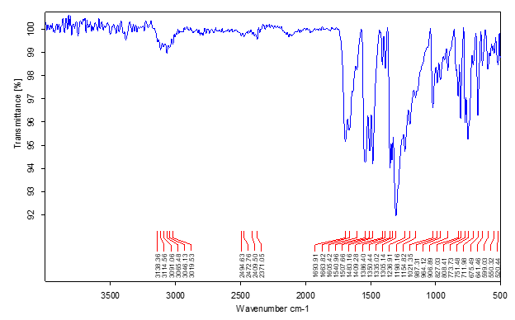
Figure S14. IR spectra of 3k
2-phenyl-3-cyano-6-nitropyrazolo[1,5-a]pyrimidin-7-one pyridinium (3l)
DMSO
DMSO
Figure S15. ¹H NMR (400 MHz, DMSO-d₆) and ¹³C NMR (100 MHz, DMSO-d₆) spectra of 3l
2-phenyl-3-cyano-6-nitropyrazolo[1,5-a]pyrimidin-7-one pyridinium (3l)
Figure S16. IR spectra of 3l
2-(5-nitrofur-2-yl)-5-methyl-6-nitro-1,2,4-triazolo[1,5-a]pyrimidin-7-one (3m)
DMSO

DMSO
Figure S17. ¹H NMR (400 MHz, DMSO-d₆) and ¹³C NMR (100 MHz, DMSO-d₆) spectra of 3m

2-(5-nitrofur-2-yl)-5-methyl-6-nitro-1,2,4-triazolo[1,5-a]pyrimidin-7-one (3m)

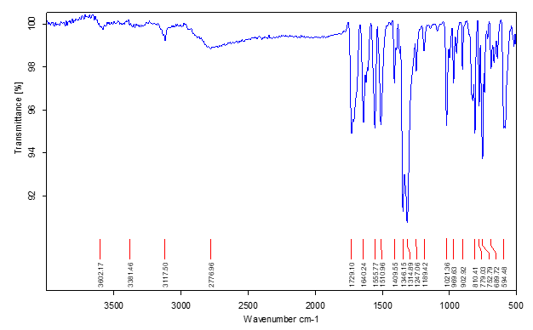
Figure S18. IR spectra of 3m

2-(fur-2-yl)-6-nitro-1,2,4-triazolo[1,5-a]pyrimidin-7-one sodium salt (3n)
H₂O
DMSO
DMSO

Figure S19. ¹H NMR (400 MHz, DMSO-d₆) and ¹³C NMR (100 MHz, DMSO-d₆) spectra of 3n

2-(fur-2-yl)-6-nitro-1,2,4-triazolo[1,5-a]pyrimidin-7-one sodium salt (3n)
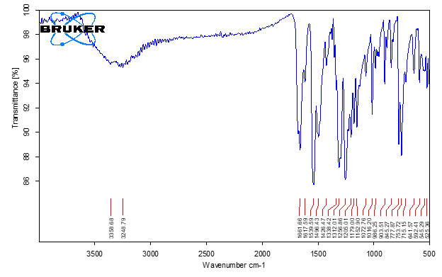
Figure S20. IR spectra of 3n

2-(fur-2-yl)-6-nitro-1,2,4-triazolo[1,5-a]pyrimidin-7-one ammonium salt (3o)
DMSO
H₂O

DMSO

Figure S21. ¹H NMR (400 MHz, DMSO-d₆) and ¹³C NMR (100 MHz, DMSO-d₆) spectra of 3o
2-(fur-2-yl)-6-nitro-1,2,4-triazolo[1,5-a]pyrimidin-7-one ammonium salt (3o)
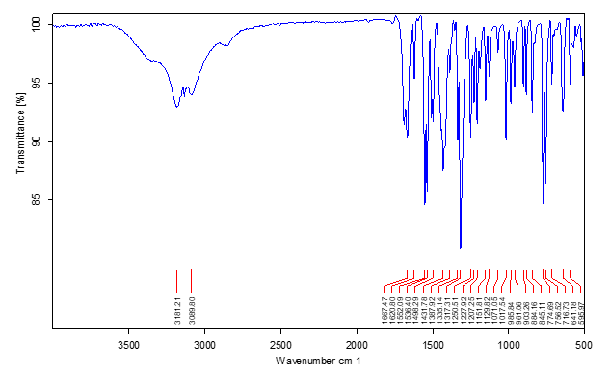

Figure S22. IR spectra of 3o

2-(fur-2-yl)-6-nitro-1,2,4-triazolo[1,5-a]pyrimidin-7-one morpholinic salt (3p)
DMSO
H₂O

DMSO

Figure S23. ¹H NMR (400 MHz, DMSO-d₆) and ¹³C NMR (100 MHz, DMSO-d₆) spectra of 3p
2-(fur-2-yl)-6-nitro-1,2,4-triazolo[1,5-a]pyrimidin-7-one morpholinic salt (3p)
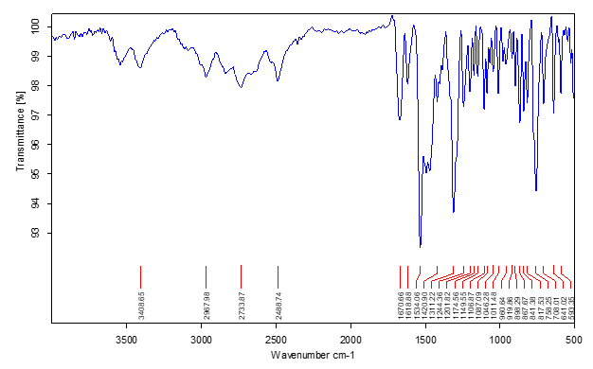
Figure S24. IR spectra of 3p

2-(fur-2-yl)-6-nitro-1,2,4-triazolo[1,5-a]pyrimidin-7-one L-argininium salt (3q)
DMSO
DMSO
Figure S25. ¹H NMR (400 MHz, DMSO-d₆) and ¹³C NMR (100 MHz, DMSO-d₆) spectra of 3q
2-(fur-2-yl)-6-nitro-1,2,4-triazolo[1,5-a]pyrimidin-7-one L-argininium salt (3q)
Figure S26. IR spectra of 3q
3-(4-Hydroxyphenylethyl)-[1,3,4]thiadiazolo[3,2-a]purin-8-one (6a)
DMSO
DMSO
Figure S27. ¹H NMR (400 MHz, DMSO-d₆) and ¹³C NMR (100 MHz, DMSO-d₆) spectra of 6b
3-(4-Hydroxyphenylethyl)-[1,3,4]thiadiazolo[3,2-a]purin-8-one (6a)
Figure S28. IR spectra of 6a

3-(Cyclopropyl)-[1,3,4]thiadiazolo[3,2-a]purin-8-one (6b)
H₂O
DMSO
DMSO

Figure S29. ¹H NMR (400 MHz, DMSO-d₆) and ¹³C NMR (100 MHz, DMSO-d₆) spectra of 6b

3-(Cyclopropyl)-[1,3,4]thiadiazolo[3,2-a]purin-8-one (6b)
Figure S30. IR spectra of 6b

5-[4-(diethoxymethyloxy)butyl]thiadiazolo[3,2-a]purin-8-one (6c)
H₂O
DMSO
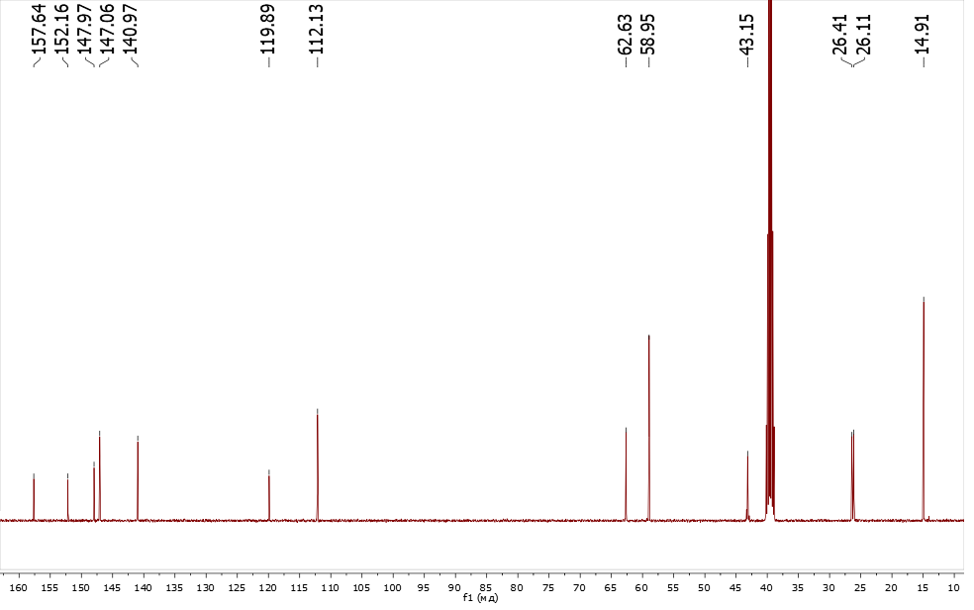
DMSO
Figure S31. ¹H NMR (400 MHz, DMSO-d₆) and ¹³C NMR (100 MHz, DMSO-d₆) spectra of 6c

5-[4-(diethoxymethyloxy)butyl]thiadiazolo[3,2-a]purin-8-one (6c)
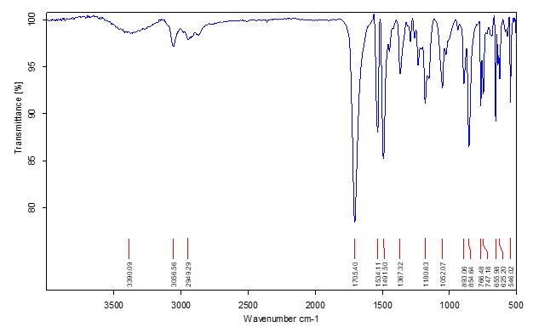
Figure S32. IR spectra of 6c
3-nitrobenz[4,5]imidazo[1,2-a]pyrimidin-4(1H)-one sodium salt (9)
H₂O
DMSO
DMSO
Figure S33. ¹H NMR (400 MHz, DMSO-d₆) and ¹³C NMR (100 MHz, DMSO-d₆) spectra of 9
3-nitrobenz[4,5]imidazo[1,2-a]pyrimidin-4(1H)-one sodium salt (9)
Figure S34. IR spectra of 9
2-(p-Tolyl)-4-(2,3,4-trimethoxyphenyl)-2H-benz[4,5]imidazo[1,2-a][1,2,3]triazolo[4,5-e]pyrimidine (13a)
H₂O
CHCl₃
CHCl₃
Figure S35. ¹H NMR (400 MHz, DMSO-d₆) and ¹³C NMR (100 MHz, CDCl₃) spectra of 13a
2-(p-Tolyl)-4-(2,3,4-trimethoxyphenyl)-2H-benz[4,5]imidazo[1,2-a][1,2,3]triazolo[4,5-e]pyrimidine (13a)
Figure S36. IR spectra of 13a

2-(p-Tolyl)-4-(3,4-trimethoxyphenyl)-2H-benz[4,5]imidazo[1,2-a][1,2,3]triazolo[4,5-e]pyrimidine (13b)
H₂O
CHCl₃
Figure S37. ¹H NMR (400 MHz, DMSO-d₆) and ¹³C NMR (100 MHz, CDCl₃) spectra of 13b
CHCl₃
2-(p-Tolyl)-4-(3,4-trimethoxyphenyl)-2H-benz[4,5]imidazo[1,2-a][1,2,3]triazolo[4,5-e]pyrimidine (13b)
Figure S38. IR spectra of 13b
2-(p-Tolyl)-4-(thien-2-yl)-2H-benz[4,5]imidazo[1,2-a][1,2,3]triazolo[4,5-e]pyrimidine (13c)
CHCl₃
H₂O
Figure S39. ¹H NMR (400 MHz, DMSO-d₆) and ¹³C NMR (100 MHz, CDCl₃) spectra of 13c
CHCl₃
2-(p-Tolyl)-4-(thien-2-yl)-2H-benz[4,5]imidazo[1,2-a][1,2,3]triazolo[4,5-e]pyrimidine (13c)
Figure S40. IR spectra of 13c

2-(p-Tolyl)-4-(1-Methyl-1H-pyrrol-2-yl)-2H-benz[4,5]imidazo[1,2-a][1,2,3]triazolo[4,5-e]pyrimidine (13d)
CHCl₃
H₂O
CHCl₃
Figure S41. ¹H NMR (400 MHz, DMSO-d₆) and ¹³C NMR (100 MHz, CDCl₃) spectra of 13d
2-(p-Tolyl)-4-(1-Methyl-1H-pyrrol-2-yl)-2H-benz[4,5]imidazo[1,2-a][1,2,3]triazolo[4,5-e]pyrimidine (13d)
Figure S42. IR spectra of 13c

2-(p-Tolyl)-4-(1-naphthalene-2-ol)-2H-benz[4,5]imidazo[1,2-a][1,2,3]triazolo[4,5-e]pyrimidine (13e)
Figure S43. ¹H NMR (400 MHz, DMSO-d₆) and ¹³C NMR (100 MHz, CDCl₃) spectra of 13d
CHCl₃
CHCl₃
H₂O
2-(p-Tolyl)-4-(1-naphthalene-2-ol)-2H-benz[4,5]imidazo[1,2-a][1,2,3]triazolo[4,5-e]pyrimidine (13e)
Figure S44. IR spectra of 13c

8,9-Difluor-2-(p-Tolyl)-4-(2,3,4-trimethoxyphenyl)-2H-benz[4,5]imidazo[1,2-a][1,2,3]triazolo[4,5-e]pyrimidine (14a)
Figure S43. ¹H NMR (400 MHz, DMSO-d₆) and ¹³C NMR (100 MHz, CDCl₃) spectra of 14a
8,9-Difluor-2-(p-Tolyl)-4-(2,3,4-trimethoxyphenyl)-2H-benz[4,5]imidazo[1,2-a][1,2,3]triazolo[4,5-e]pyrimidine (14a)
Figure S44. IR spectra of 14a

