SUPPLEMENTARY MATERIALS

Potential of hydroxybenzoic acids fraction from Graptopetalum paraguayense E. Walter leaves for inhibiting Herpes Simplex virus DNA polymerase – metabolome profiling, molecular docking and quantum-chemical analysis
Nadezhda Todorova¹, Miroslav Rangelov ², Ivayla Dincheva³, Ilian Badjakov³, Venelin Enchev⁴, Nadezhda Markova²*

¹ Institute of Biodiversity and Ecosystem Research, Bulgarian Academy of Sciences, 1113 Sofia, Bulgaria, nadeshda@abv.bg
² Institute of Organic Chemistry with Centre of Phytochemistry, Bulgarian Academy of Sciences, 1113 Sofia, Bulgaria, nadya@orgchm.bas.bg, marangelov@gmail.com
³ Department of Agrobiotechnologies, Agrobioinstitute, Agricultural Academy, 1164 Sofia, Bulgaria, ivadincheva@yahoo.com, ibadjakov@gmail.com
⁴ Institute of General and Inorganic Chemistry, Bulgarian Academy of Sciences, 1113 Sofia, Bulgaria, venelin@svr.igic.bas.bg

Table S1. Polar metabolites fraction from G. Paraguayense determined by GC-MS analysis.

# | # | Name | RT | RI_{lit} | RI_{calc} | µg/g DW
Amino acids
Essential amino acids
1 | 1 | L-Valine (2TMS) | 4.89 | 1223.5 | 1223.7 | 67.25
2 | 2 | L-Leucine (2TMS) | 5.45 | 1280.9 | 1281.1 | 92.04
3 | 3 | L-Isoleucine (2TMS) | 5.67 | 1302.6 | 1302.8 | 80.74
5 | 5 | L-Threonine (3TMS) | 6.59 | 1395.7 | 1395.9 | 38.61
4 | 4 | L-Methionine (2TMS) | 7.77 | 1523.1 | 1523.2 | 25.78
6 | 6 | L-Phenylalanine (2TMS) | 8.93 | 1636.4 | 1636.6 | 82.72
Non-essential amino acids
7 | 1 | L-Alanine (2TMS) | 4.55 | 1102.3 | 1102.5 | 29.06
8 | 2 | L-Proline (2TMS) | 5.72 | 1305.6 | 1305.8 | 33.28
9 | 3 | L-Glycine (3TMS) | 5.81 | 1311.1 | 1311.3 | 34.89
10 | 4 | L-Serine (3TMS) | 6.33 | 1370.6 | 1370.8 | 26.93
11 | 5 | 4-Aminobutyric acid (3TMS); [GABA]; non-protein amino acid | 7.86 | 1533.6 | 1533.7 | 27.24
12 | 6 | L-Tyrosine (3TMS) | 13.18 | 1942.2 | 1942.4 | 37.75
Total amino acids |  |  |  |  |  | 576.30
Organic and inorganic acids
13 | 1 | Phosphoric acid (3TMS) | 5.50 | 1277.0 | 1277.1 | 25.40
14 | 1 | Succinic acid (2TMS) | 5.85 | 1314.5 | 1322.6 | 26.97
15 | 2 | Fumaric acid (2TMS) | 6.15 | 1358.4 | 1358.5 | 25.05
16 | 3 | Malic acid (3TMS) | 7.48 | 1488.3 | 1488.4 | 1830.54
17 | 4 | Citric acid (4TMS) | 11.52 | 1821.6 | 1821.7 | 110.94
Total organic acids |  |  |  |  |  | 2018.90
Mono- and dicarbohydrates
18 | 1 | D-Ribose methoxyamine (4TMS) isomer | 9.46 | 1666.1 | 1666.2 | 160.25
19 | 2 | D-Ribose methoxyamine (4TMS) isomer | 9.65 | 1681.9 | 1682.0 | 52.42
20 | 3 | D-Fructose methoxyamine (5TMS) isomer | 12.43 | 1871.1 | 1871.2 | 609.90
21 | 4 | D-Fructose methoxyamine (5TMS) isomer | 12.58 | 1877.8 | 1885.9 | 515.45
22 | 5 | D-Galactose methoxyamine (5TMS) isomer | 12.72 | 1885.5 | 1885.6 | 347.01
23 | 6 | D-Mannose methoxyamine (5TMS) | 12.82 | 1894.9 | 1895.0 | 1335.38
24 | 7 | D-Galactose methoxyamine (5TMS) isomer | 13.04 | 1906.1 | 1906.2 | 82.42
25 | 8 | D-Glucose methoxyamine (5TMS) | 13.09 | 1914.4 | 1914.5 | 200.05
26 | 9 | Sedoheptulose methoxyamine (6TMS) isomer | 16.63 | 2150.1 | 2150.2 | 803.77
27 | 10 | Sedoheptulose methoxyamine (6TMS) isomer | 16.72 | 2156.2 | 2156.3 | 646.86
28 | 11 | Sucrose (8TMS); [alpha-D-Glc-(1,2)-beta-D-Fru (8TMS)] | 24.62 | 2640.2 | 2640.4 | 473.52
29 | 12 | Maltose (8TMS); [alpha-D-Glc-(1,4)-D-Glc (8TMS)] | 25.39 | 2741.6 | 2741.8 | 34.88
Total mono- and dicarbohydrates |  |  |  |  |  | 5261.90
Sugar alcohols
30 | 1 | Glycerol (3TMS) | 5.47 | 1284.3 | 1284.4 | 329.58
31 | 2 | D-Threitol (4TMS) | 7.63 | 1498.6 | 1498.7 | 23.94
32 | 3 | D-Erythritol (4TMS) | 7.71 | 1510.4 | 1510.5 | 32.39
33 | 4 | myo-Inositol (6TMS) | 15.81 | 2091.3 | 2091.4 | 37.59
Total sugar alcohols |  |  |  |  |  | 423.50

Table S2. Main saturated fatty acids fraction from G. Paraguayense determined by GC-MS analysis.

# | Name | Simplified abbreviation | RT | RI_{lit} | RI_{calc} | µg/g DW
Fatty acids
1 | n-Tetradecanoic acid methyl ester; [Myristic acid] | 14:0 | 9.77 | 1694.1 | 1694.2 | 95.97
2 | n-Hexadecenoic acid methyl ester; [Palmitoleic acid]; ω-7 | 16:1 n-7 | 10.56 | 1884.9 | 1885.0 | 89.12
3 | n-Hexadecanoic acid methyl ester; [Palmitic acid] | 16:0 | 12.74 | 1907.9 | 1908.0 | 432.87
4 | all cis-9,12-Octadecadienoic acid methyl ester; [Linoleic acid]; ω-6 | 8:2 n-6 | 15.34 | 2071.9 | 2072.0 | 2522.25
5 | cis-Octadecenoic acid methyl ester; [Oleic acid]; ω-9 | 18:1 | 15.44 | 2077.3 | 2077.4 | 459.56
6 | all cis-9,12,15-Octadecatrienoic acid methyl ester; [α-Linolenic acid]; ω-3 | 8:3 n-3 | 15.45 | 2078.3 | 2078.4 | 2842.50
7 | n-Octadecanoic acid methyl ester; [Stearic acid] | 18:0 | 15.95 | 2111.1 | 2111.2 | 122.24
8 | cis-11-E-Eicosenoic acid methyl ester | 20:1 n-9 | 24.06 | 2289.8 | 2289.9 | 173.73
9 | n-Eicosanoic acid methyl ester; [Arachidic acid] | 20:0 | 24.85 | 2302.6 | 2302.7 | 93.76
10 | n-Docosanoic acid methyl ester; [Behenic acid ] | 22:0 | 27.51 | 2475.2 | 2475.3 | 119.56
Total fatty acids |  |  |  |  |  | 6951.55

Table 3S. Sterol fraction from G. Paraguayense determined by GC-MS analysis.

# | Name | RT | RI_{lit} | RI_{calc} | µg/g DW
Sterols, terpenoids and tocopherols
1 | γ-Tocopherol (TMS) | 20.72 | 2999.6 | 2999.7 | 97.80
2 | α-Tocopherol (TMS) | 30.52 | 3142.7 | 3142.8 | 1447.18
3 | Campesterol (TMS) | 31.92 | 3263.1 | 3263.2 | 625.33
4 | Stigmasterol (TMS) | 32.28 | 3286.3 | 3286.4 | 707.60
5 | β-Sitosterol (TMS) | 32.99 | 3375.4 | 3375.5 | 2010.41
6 | β-Amyrin (TMS) | 33.12 | 3385.2 | 3385.3 | 2080.86
7 | A'-Neogammacer-22(29)-en-3-one; Hopenone b | 33.31 | 3394.7 | 3394.8 | 488.10
8 | Lanosterol (TMS) | 33.48 | 3401.3 | 3401.4 | 537.06
9 | A'-Neogammacer-22(29)-ene; Hopene b | 33.72 | 3429.9 | 3430.0 | 664.40
Total sterols |  |  |  |  | 8658.75

DW- dried weight, RT-retention time, RI-Kovats retention indices, TMS-trimethylsilyl derivatives

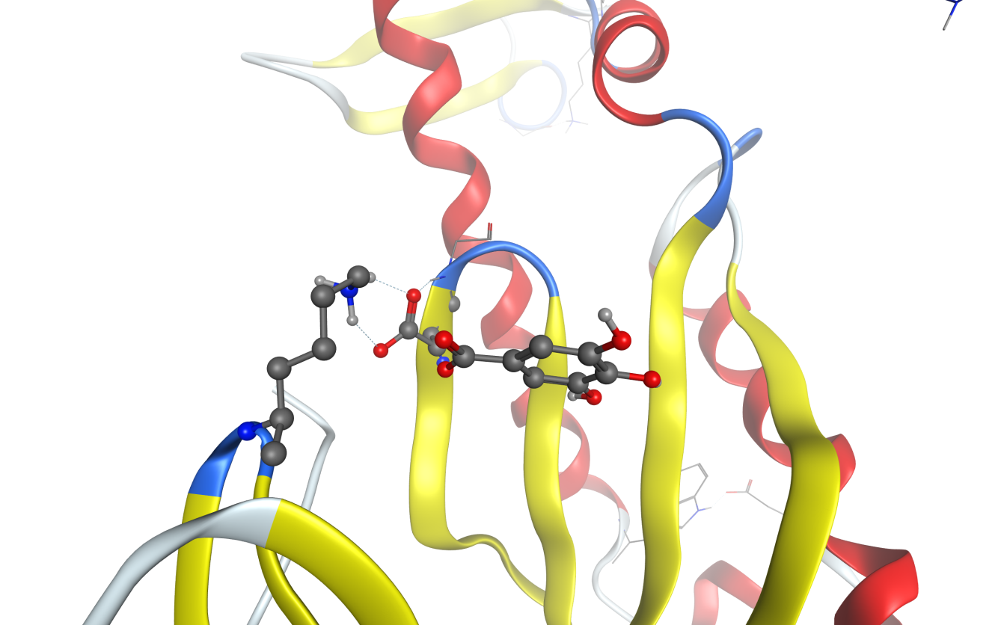

Figure S1. Gallic acid and its vicinity after docking procedure.

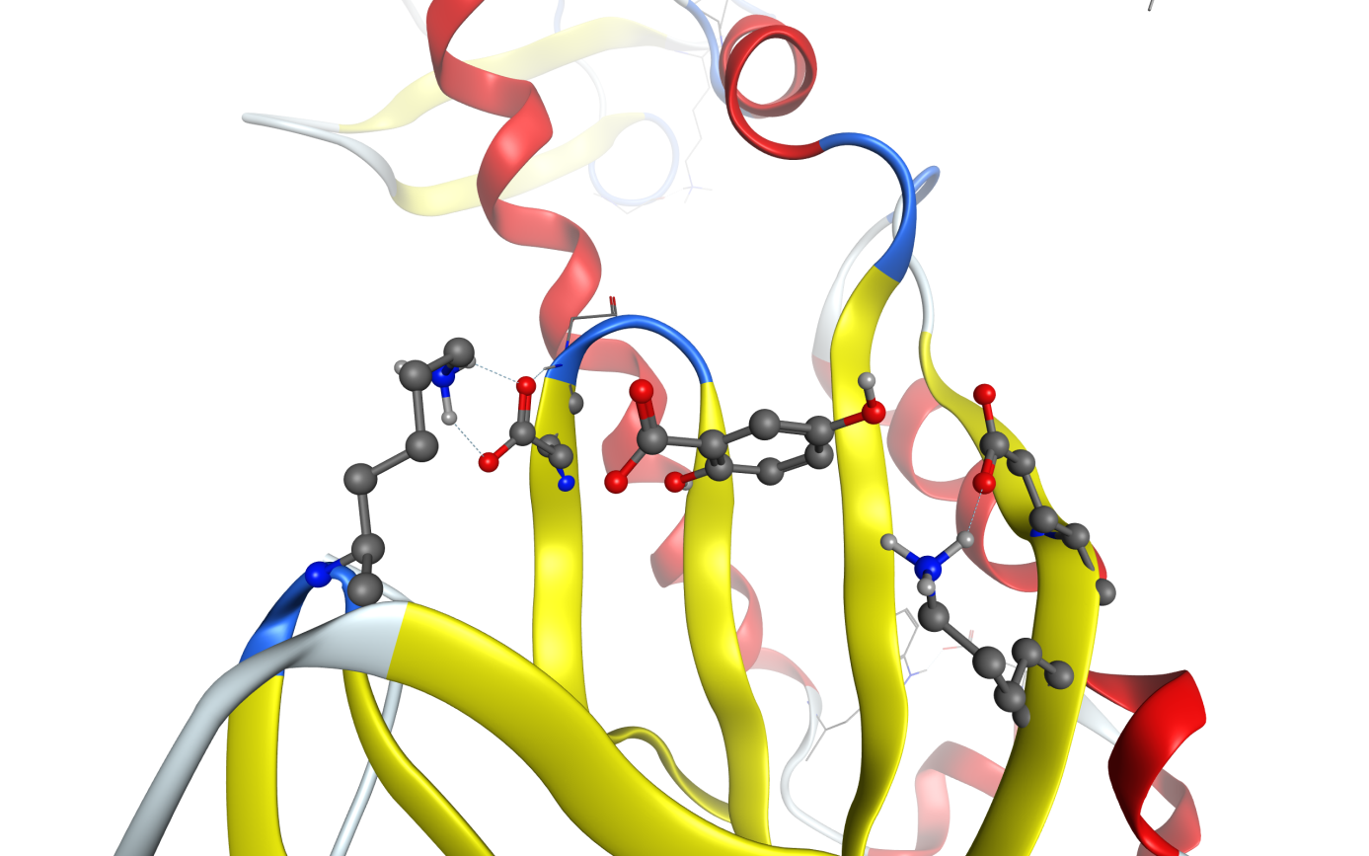

Figure S2. Gentisic acid and its vicinity after docking procedure.

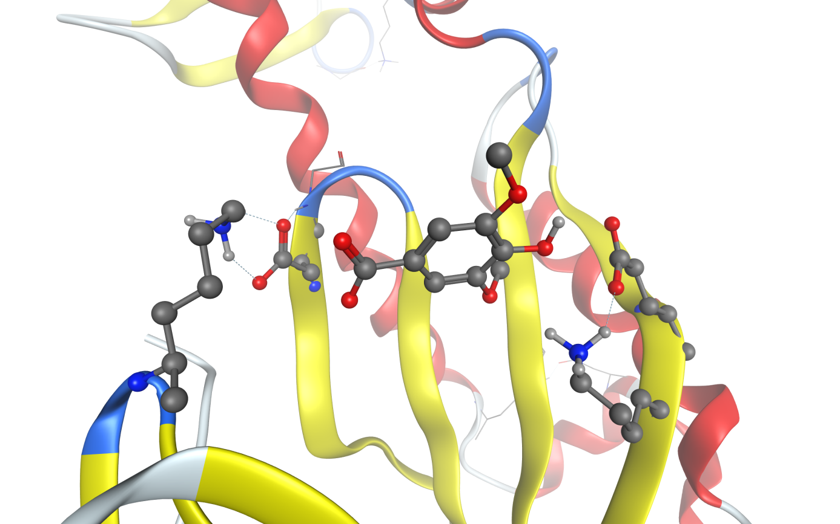

Figure S3. Syringic acid and its vicinity after docking procedure.

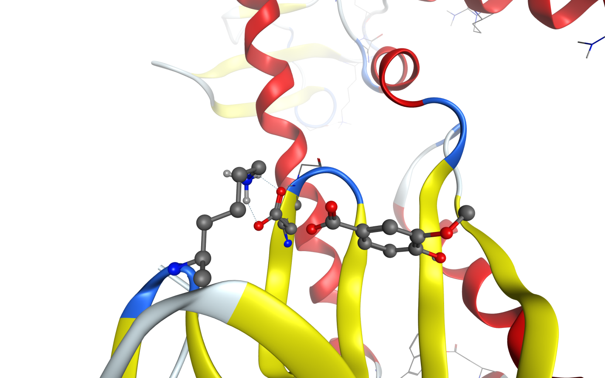

Figure S4. Vanillic acid and its vicinity after docking procedure.

