**REGIONAL PRECIPITATION TRENDS SINCE 1500 CE, RECONSTRUCTED FROM CALCITE SUBLAYERS OF A VARVED MEDITERRANEAN LAKE RECORD (CENTRAL PYRENEES).**

Teresa Vegas-Vilarrúbia, Juan Pablo Corella, Javier Sigró, Valentí Rull, Isabel Dorado-Liñan, Blas Valero-Garcés, Emilia Gutiérrez.

ª Corresponding autor: [tvegas@ub.edu](mailto:tvegas@ub.edu)

**SUPPLEMENTARY MATERIAL**

|  |  |  |
| --- | --- | --- |
| **Frequency** | **PERIOD** | **F values** |
| 0.026367 | 37.926 | 4.8872 |
| 0.064453 | 15.515 | 6.4833 |
| 0.094727 | 10.557 | 6.7499 |
| 0.10254 | 9.752 | 10.795 |
| 0.13672 | 7.314 | 5.2184 |
| 0.17773 | 5.627 | 7.014 |
| 0.22266 | 4.491 | 5.5724 |
| 0.24414 | 4.096 | 8.0651 |
| 0.30566 | 3.272 | 8.5663 |
| 0.31543 | 3.170 | 10.865 |

Table S1.- Significant periods and oscillation frequencies of the series CaL67 between 1500-2002 CE. F-values > 4.5 are significant with p < 0.05.



Table S2.- Summary of the significant cross correlation coefficients (Cxy (k)) between CaL67 (X) and climatic series (Y): rainfall and average maximum (Tx) and minimum (Tn) temperatures at seasonal and annual resolution. Only lags of k = 0 to k = ± 5 are shown. p-values in italics and if significant (p <0.05) in yellow.



Table S3.- Significant oscillation periods (F-value> 4.5, p <0.05 and F-value> 9.8, p <0.01) from the spectral analysis of each series for the period 1910-2002. P, total precipitation; Tx, mean maximum temperature; Tn, mean minimum temperature; spSP, spring; suSU, summer; wiWI, winter; PPT-SON, total precipitation of September, October and November

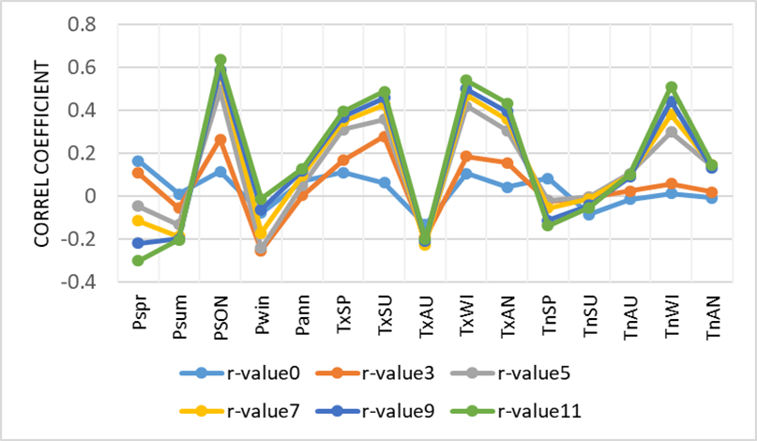

Figure S1.- Representation of the correlation coefficients between the calcite series, CaL67, and the seasonal and annual climatic variables of precipitation (P), maximum (Tx) and minimum (Tn) temperatures smoothed with moving averages of 3 to 11 years. Period of analysis 1910-2002. P-value < 0,05 for r-values > 0,3520. The correlation coefficients were computed with using CorrelWindows (see Methods) (Macias-Fauria et al. 2012).

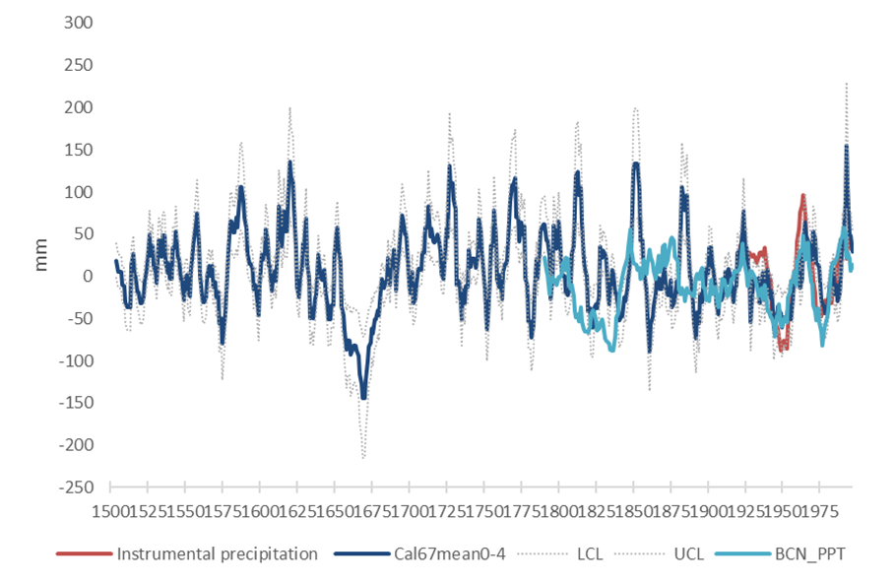

Figure S2.- Comparison for the 1500–2002 period between the historical autumn precipitation (SON) at Barcelona (blue line), the reconstructed precipitation at Montcortès (dark blue line), and the autumn precipitation data of the instrumental series (red line)

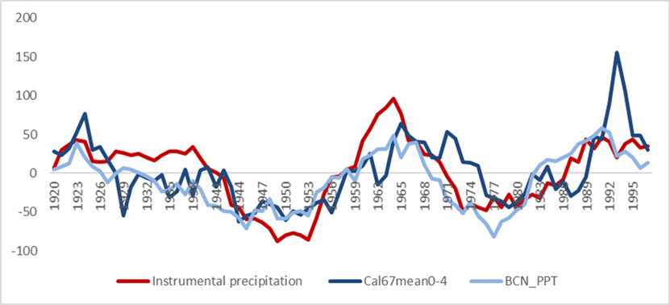

Figure S3.- Comparison for the 20th century between the historical autumn precipitation (SON) at Barcelona (blue line), the reconstructed precipitation at Montcortès (dark blue line), and the autumn precipitation data of the instrumental series (red line).