Supplementary File

Supplementary Figure S1:
Fatty acids and methyl esters identified in GC-MS of bioactive compounds of Aspergillus giganteus
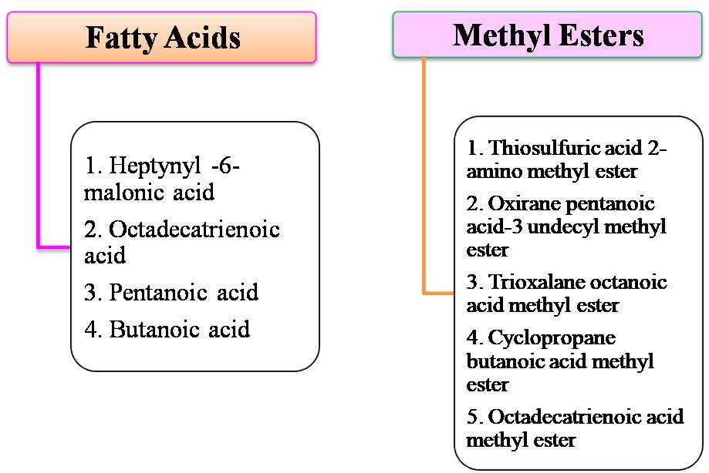

Supplementary Table S1:
Profile description of sarcin, thionin, chitinase and its derivatives of Aspergillus giganteus
Selected derivatives | Compound | PubChem ID | Molecular Weight | Log P | Rotatable bonds | Acceptors | Donors | Surface area
Standard Drug | Fluconazole | 3365 | 306.276 | 0.7358 | 5 | 7 | 1 | 123.419
Sarcin | 1-Methylthioguianine | 3032391 | 181.224 | 0.60809 | 0 | 5 | 2 | 73.255
 | 3-Imino-3H-phenothiazin-7-amine | 65044 | 227.292 | 2.46277 | 0 | 4 | 2 | 96.045
Thionin | Thionine cation | 462371 | 228.3 | 0.6431 | 0 | 3 | 2 | 96.045
 | 3-Methyl-2-[[(8E)-7-methylidene-5-(trifluoromethyl)-3,4,5,6-tetrahydro-2H-thionin-8-yl]methyl]-7-(4-methylimidazol-1-yl)-3,4-dihydropyrido[1,2-a]pyrazine-1,6-dione | 122678533 | 492.567 | 4.72242 | 3 | 6 | 0 | 199.708
 | N,N-Dimethyl-4-[(Z)-[(3Z,6Z,8Z)-2H-thionin-5-ylidene]methyl]aniline | 88094842 | 269.413 | 4.5089 | 2 | 2 | 0 | 119.564
Chitinase | Chitinase-IN-2 | 86223064 | 395.488 | 2.45152 | 6 | 7 | 1 | 166.525
 | Chitinase-IN-1 | 86223063 | 352.419 | 2.38552 | 5 | 6 | 1 | 148.035
 | Chitin from Shrimp cells | 6857375 | 221.209 | -3.0776 | 2 | 6 | 5 | 86.290

