**Appendix A**



Figure S1. Timeline depicting the clinical course prior to hospitalization



The data shown are the total number of reported cases, in parentheses by year. The 2002-2003 data were obtained from Lewis et. al. Scrub typhus re-emergence in the Maldives, Emerging Infectious Diseases 2003.

Figure S2. Past and recent, epidemiology of scrub typhus in atolls of the Maldives



The graph shows the reported cases of scrub typhus to the Health Protection Agency, Ministry of Health, from 2012 through 2021. Shown in green is when scrub typhus re-emerged in the Maldives, sixty decades later since the first reporting in 1942.

Figure S3. Two decades of sentinel reporting of scrub typhus in the Maldives.

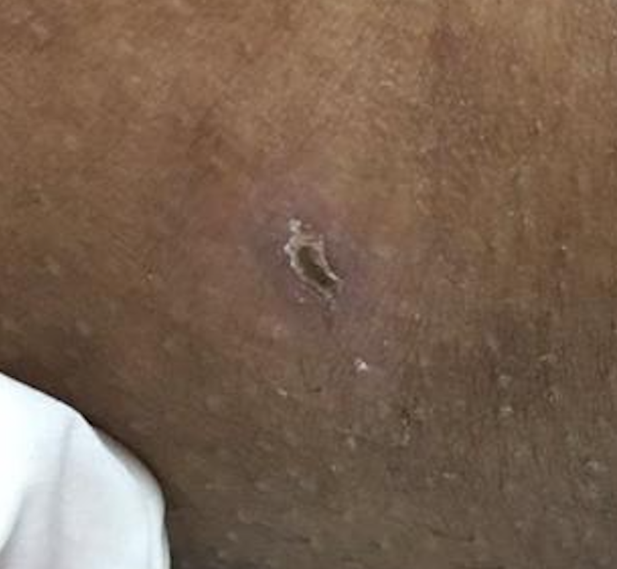

Figure S4. Eschar lesion on the medial aspect of thigh.



The graph shows the heart rate and temperature measured during the course of the hospitalization, ‡ Time doxycycline was initiated, † Time fever subsided and the shaded area in green is the fever clearance time after administration of doxycycline.

Figure S5. Clinical course during hospitalization.