Table 1. Odds ratio (OR) and 95% confidence intervals (CI) of metabolic syndrome (MetS) according to quartiles of energy intake
 |  |  | Men (n = 43 850) |  |  |  |  |  |  | Women (n = 86 573)
 | Q 1 | Q 2 |  | Q 3 | Q4 | P-value |  | Q 1 | Q 2 |  | Q3 | Q 4 | P-value
Total energy intake (kcal/day, median) | 1351 | 1654 |  | 1931 | 2416 | <0.001 |  | 1144 | 1509 |  | 1786 | 2237 | <0.001
Age (years, median) | 55.0 | 54.0 |  | 53.0 | 51.0 | <0.001 |  | 53.0 | 53.0 |  | 52.0 | 50.0 | <0.001
Body mass index (kg/m², median) | 24.1 | 24.2 |  | 24.4 | 24.6 | <0.001 |  | 23.2 | 23.3 |  | 23.4 | 23.4 | <0.001
Marital status (yes, %) | 92.8 | 94.4 |  | 95.3 | 94.4 | <0.001 |  | 83.2 | 85.9 |  | 88.3 | 89.8 | <0.001
Education (≥12 years, %) | 41.3 | 42.1 |  | 44.9 | 47.2 | <0.001 |  | 21.2 | 21.4 |  | 24.6 | 29.5 | <0.001
Family income (≥$3,000/month, %) | 46.3 | 47.5 |  | 51.6 | 53.3 | <0.001 |  | 40.8 | 41.1 |  | 44.9 | 49.1 | <0.001
Occupied (yes, %) | 77.1 | 79.9 |  | 82.7 | 85.4 | <0.001 |  | 37.3 | 39.3 |  | 40.2 | 41.7 | <0.001
Current smoker (yes, %) | 30.6 | 30.5 |  | 31.1 | 35.3 | <0.001 |  | 3.01 | 2.20 |  | 2.15 | 1.98 | <0.001
Current drinker (yes, %) | 69.8 | 72.7 |  | 74.1 | 74.8 | <0.001 |  | 30.0 | 28.7 |  | 30.8 | 33.0 | <0.001
Regular exercise (yes, %)  Hypertension (yes, %)  Diabetes (yes, %)  Dyslipidemia (yes, %) | 53.6  53.2  35.5  40.45 | 56.9  52.7  35.2  40.00 |  | 58.7  52.3  33.9  40.11 | 59.3  51.0  32.9  40.05 | <0.001  <0.001  <0.001  0.610 |  | 49.2  38.1  20.5  28.41 | 48.7  39.2  20.2  28.28 |  | 52.3  36.7  19.2  27.30 | 54.5  33.6  17.6  25.80 | <0.001  <0.001  <0.001  <0.001
Macronutrient intake (% of energy)
Carbohydrate | 74.4 | 74.1 |  | 71.4 | 68.8 | <0.001 |  | 72.8 | 73.6 |  | 71.8 | 69.2 | <0.001
Protein | 12.3 | 12.4 |  | 13.2 | 13.9 | <0.001 |  | 13.4 | 12.9 |  | 13.5 | 14.3 | <0.001
Fat | 11.6 | 11.7 |  | 14.0 | 16.4 | <0.001 |  | 12.9 | 12.2 |  | 13.8 | 16.1 | <0.001
Comparisons were made by Mantel-Haenszel chi-square test for categorical variables, and general linear regression for continuous variables.
Table 2. Median macronutrient intake according to MetS and its components stratified by age group
 | MetS |  |  | Abdominal obesity | High triglyceride | Low HDL-c | High blood pressure |  | Hyperglycemia
 | case/controlª |  |  | case/controlª | case/controlª | case/controlª | case/controlª |  | case/controlª
Men
Energy (kcal/day)
40-49 | 1875 (1590,2241)/  1846 (1568,2217) |  |  | 1904 (1614,2285)/  1836 (1559,2203) | 1860 (1576,2226)/  1851 (1571,2225) | 1854 (1568,2215)/  1855 (1574,2230) | 1865 (1570,2234)/  1844 (1574,2217) |  | 1851 (1566,2225)/  1856 (1575,2226)
50-59 | 1778 (1525,2111)/  1774 (1511,2096) |  |  | 1809 (1541,2152)/  1763 (1505,2081) | 1778 (1522,2112)/  1774 (1511,2089) | 1772 (1518,2106)/  1777 (1515,2098) | 1770 (1516,2091)/  1783 (1515,2110) |  | 1769 (1514,2093)/  1780 (1517,2105)
60-69 | 1727 (1473,2032)/  1711 (1471,2013) |  |  | 1751 (1500,2069)/  1700 (1459,1994) | 1720 (1473,2017)/  1714 (1470,2019) | 1709 (1463,1997)/  1719 (1474,2025) | 1716 (1473,2021)/  1716 (1470,2014) |  | 1710 (1467,2011)/  1721 (1474,2024)
Carbohydrate (g/day)
40-49 | 327 (280,386)/  324 (279,382) |  |  | 330 (282,394)/  322 (278,379) | 324 (279,383)/  324 (280,383) | 327 (279,383)/  324 (279,383) | 325 (279,383)/  324 (279,383) |  | 322 (277,381)/  325 (280,383)
50-59 | 316 (277,368)/  317 (276,366) |  |  | 321 (278,375)/  315 (275,364) | 317 (276,370)/  317 (276,365) | 318 (279,369)  /316 (275,366) | 315 (276,364)/  318 (276,370) |  | 314 (276,364)/  318 (276,369)
60-69 | 312 (274,359)/  311 (273,356) |  |  | 315 (276,364)/  310 (272,354) | 312 (275,358)/  312 (273,356) | 313 (275,358)/  311 (273,356) | 311 (273,357)/  312 (273,356) |  | 309 (272,355)/  313 (274,359)
Protein (g/day)
40-49 | 63.1 (51,79)/  61.4 (49,78) |  |  | 64.3 (52,81)/  60.7 (49,77) | 62.0 (49,78)/  61.6 (49,78) | 61.2 (49,77)/  61.9 (49,78) | 62.5 (50,78)/  61.3 (49,78) |  | 62.5 (50,78)/  61.5 (49,78)
50-59 | 59.3 (47,74)/  58.3 (46,73) |  |  | 60.3 (48,76)/  57.8 (46,72) | 58.9 (47,73)/  58.3 (46,73) | 57.6 (46,72)/  58.9 (47,74) | 58.8 (47,73)/  58.4 (47,73) |  | 59.0 (47,73)/  58.4 (47,73)
60-69 | 56.4 (45,71)/  55.1 (44,70) |  |  | 57.5 (46,73)/  54.6 (44,69) | 55.9 (44,70)/  55.3 (44,70) | 54.8 (44,69)/  55.7 (45,70) | 55.7 (44,70)/  55.2 (45,70) |  | 55.9 (45,70)/  55.3 (44,70)
Fat (g/day)
40-49 | 31.5 (23,43)/  30.7 (22,42) |  |  | 32.5 (23,45)/  30.3 (22,42) | 31.1 (22,43)/  30.8 (22,42) | 30.4 (22,41)/  31.1 (22,43) | 30.9 (22,42)/  30.9 (22,43) |  | 31.0 (22,43)/  30.9 (22,42)
50-59 | 26.8 (19,37)/  26.8 (19,37) |  |  | 27.7 (20,39)/  26.4 (18,37) | 26.8 (19,37)/  26.8 (19,37) | 25.6 (18,36)/  27.1 (19,38) | 26.6 (19,37)/  26.9 (19,37) |  | 26.6 (19,37)/  26.9 (19,37)
60-69 | 24.4 (17,35)/  23.9 (17,34) |  |  | 25.5 (18,36)/  23.4 (16,33) | 24.3 (17,34)/  23.9 (17,34) | 23.0 (16,33)/  24.4 (17,34) | 24.0 (16,34)/  24.2 (17,34) |  | 24.2 (17,34)/  24.0 (16,34)
Women
Energy (kcal/day)
40-49 |  | 1699 (1404,2044)/  1703 (1393,2039) | 1722 (1418,2062)/  1693 (1386,2030) |  | 1700 (1393,2051)/  1703 (1395,2038) | 1709 (1407,2043)/  1699 (1388,2039) |  | 1685 (1392,2021)/  1707 (1396,2044) | 1691 (1395,2023)/  1704 (1395,2042)
50-59 |  | 1632 (1367,1937)/  1635 (1342,1947) | 1649 (1377,1958)/  1621 (1329,1935) |  | 1629 (1352,1940)/  1635 (1350,1946) | 1623 (1357,1929)/  1640 (1346,1954) |  | 1630 (1356,1937)/  1636 (1346,1949) | 1627 (1347,1939)/  1636 (1351,1945)
60-69 |  | 1564 (1310,1842)/  1571 (1308,1865) | 1573 (1318,1861)/  1560 (1292,1850) |  | 1567 (1307,1854)/  1569 (1308,1857) | 1553 (1298,1834)/  1581 (1316,1869) |  | 1568 (1311,1848)/  1568 (1303,1863) | 1557 (1288,1830)/  1573 (1316,1865)
Carbohydrate (g/day)
40-49 |  | 307 (252,359)/  305 (246,358) | 309 (252,361)/  303 (244,357) |  | 307 (248,362)/  305 (246,357) | 308 (253,361)/  303 (244,357) |  | 305 (248,357)/  305 (246,358) | 303 (247,355)/  305 (246,358)
50-59 |  | 302 (253,349)/  299 (243,349) | 303 (253,350)/  297 (240,347) |  | 301 (249,350)/  299 (244,348) | 300 (250,347)/  299 (243,349) |  | 300 (248,349)/  299 (244,349) | 300 (246,347)/  300 (245,349)
60-69 |  | 295 (247,339)/  293 (242,338) | 295 (248,340)/  292 (239,337) |  | 295 (247,341)/  293 (243,337) | 293 (245,337)/  294 (244,340) |  | 294 (246,339)/  293 (243,338) | 292 (241,335)/  295 (246,340)
Protein (g/day)
40-49 |  | 55.7 (44,71)/  56.1 (44,71) | 57.2 (45,72)/  55.7 (44,70) |  | 55.6 (44,71)/  56.2 (44,71) | 55.9 (44,71)/  56.2 (44,71) |  | 55.3 (44,70)/  56.3 (44,71) | 56.1 (44,71)/  56.1 (44,71)
50-59 |  | 52.4 (42,67)/  53.3 (42,68) | 53.5 (42,68)/  52.7 (41,67) |  | 52.2 (41,66)/  53.3 (42,68) | 52.1 (41,66)/  53.5 (42,68) |  | 52.7 (42,67)/  53.3 (42,68) | 52.6 (41,67)/  53.1 (42,67)
60-69 |  | 49.3 (39,62)/  50.0 (40,64) | 49.7 (39,63)/  49.6 (39,63) |  | 49.4 (39,62)/  49.8 (39,63) | 48.9 (39,61)/  50.5 (40,64) |  | 49.6 (39,63)/  49.7 (39,63) | 49.2 (39,62)/  49.9 (39,63)
Fat (g/day)
40-49 |  | 25.3 (18,36)/  26.5 (19,37) | 26.7 (19,37)/  26.3 (19,37) |  | 25.3 (17,36)/  26.5 (19,37) | 25.5 (18,36)/  26.8 (19,37) |  | 25.2 (18,36)/  26.7 (19,37) | 26.2 (18,37)/  26.4 (19,37)
50-59 |  | 21.2 (15,30)/  22.8 (16,32) | 22.3 (15,32)/  22.4 (16,32) |  | 21.4 (15,31)/  22.8 (16,32) | 21.2 (14,30)/  23.1 (16,33) |  | 21.8 (15,31)/  22.8 (16,32) | 21.8 (15,31)/  22.5 (16,32)
60-69 |  | 18.4 (12,27)/  19.6 (14,29) | 18.9 (13,27)/  19.4 (13,28) |  | 18.7 (12,27)/  19.3 (13,28) | 18.0 (12,26)/  19.9 (14,29) |  | 19.0 (13,27)/  19.3 (13,28) | 18.7 (13,27)/  19.3 (13,28)
HDL-c: High density lipoprotein cholesterol
ª Median (Interquartile range, Q1,Q3).
- Energy B. Carbohydrate
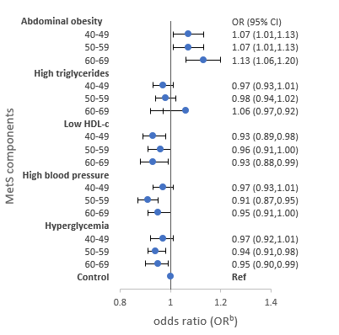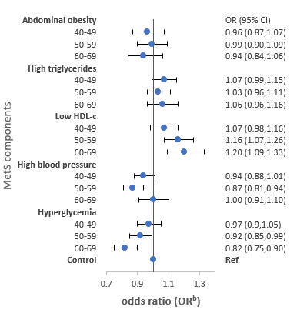
C. Protein D. Fat
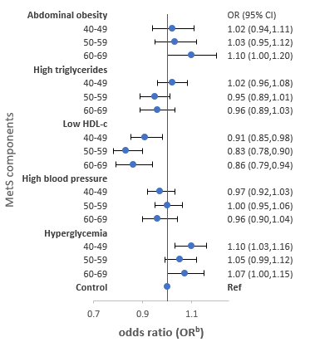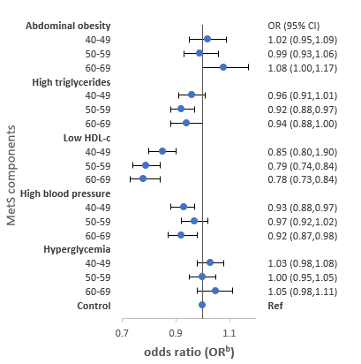

HDL-c: High density lipoprotein cholesterol.
b Adjusted for for age, body mass index, marital status, education, family income, occupation, smoking, drinking, regular exercise and energy intake.
Figure 1a. Odds ratios and 95% CI of MetS components stratified by age group in men

- Energy B. Carbohydrate
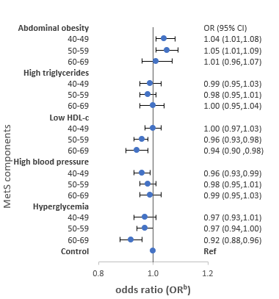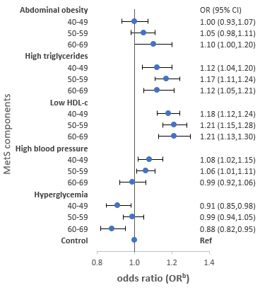

C. Protein D. Fat
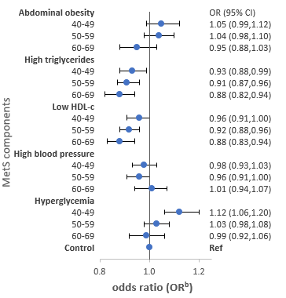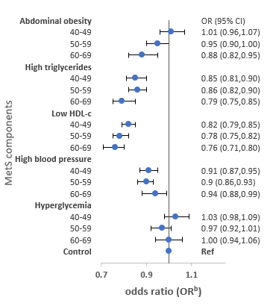

HDL-c: High density lipoprotein cholesterol.
b Adjusted for for age, body mass index, marital status, education, family income, occupation, smoking, drinking, regular exercise, energy intake and menopausal status.
Figure 1b. Odds ratios and 95% CI of MetS components stratified by age group in women

Table 3. Median macronutrient intake according to MetS and its components stratified by macronutrient source
 | MetS | Abdominal obesity | High triglyceride | Low HDL-c | High blood pressure | Hyperglycemia
 | Case/controlª | Case/controlª | Case/controlª | Case/controlª | Case/controlª | Case/controlª
Men
Carbohydrate (g/day)
Plant | 309 (270,358)/  308 (269,356) | 312 (272,364)/  306 (268,353) | 309 (270,359)/  307 (269,355) | 309 (271,358)/  307 (269,356) | 307 (269,354)/  309 (269,358) | 306 (268,353)/  309 (270,358)
Animal | 6.2 (2,14)/  7.2 (3,15) | 6.7 (2,15)/  7.0 (2,15) | 6.4 (2,14)/  7.2 (3,15) | 6.5 (2,14)/  7.0 (2,15) | 6.5 (2,14)/  7.4 (3,15) | 6.3 (2,14)/  7.2 (3,15)
Protein (g/day)
Plant | 36.9 (31,44)/  36.5 (31,44) | 37.4 (31,45)/  36.3 (31,43) | 36.9 (31,44)/  36.4 (31,43) | 36.5 (31,44)/  36.6 (31,44) | 36.7 (31,44)/  36.5 (31,44) | 36.5 (31,44)/  36.6 (31,44)
Animal | 21.3 (14,32)/  21.0 (13,32) | 22.3 (14,33)/  20.6 (13,31) | 21.2 (14,32)/  20.9 (13,32) | 20.1 (13,31)/  21.3 (14,32) | 20.9 (13,31)/  21.2 (14,32) | 21.1 (13,32)/  21.0 (13,32)
Fat (g/day)
Plant | 10.8 (8,15)/  10.9 (8,15) | 11.1 (8,16)/  10.7 (8,15) | 11.0 (8,15)/  10.7 (8,15) | 10.6 (8,15)/  10.9 (8,15) | 10.7 (8,15)/  11.0 (8,15) | 10.4 (7,15)/  11.1 (8,15)
Animal | 15.4 (10,24)/  15.5 (10,24) | 16.2 (10,25)/  15.2 (9,23) | 15.5 (10,24)/  15.4 (10,24) | 14.4 (9,23)/  15.7 (10,24) | 15.2 (9,23)/  15.7 (10,24) | 15.3 (10,24)/  15.5 (10,24)
Women
Carbohydrate (g/day)
Plant | 290 (241,334)/  290 (232,337) | 292 (241,336)/  288 (230,336) | 290 (238,336)/  290 (234,336) | 291 (240,336)/  289 (231,336) | 289 (237,333)/  290 (233,337) | 288 (234,332)/  290 (235,337)
Animal | 7.8 (3,16)/  9.8 (4,19) | 8.7 (3,17)/  9.8 (4,19) | 8.6 (3,17)/  9.7 (4,18) | 8.2 (3,16)/  9.9 (4,19) | 8.8 (3,17)/  9.8 (4,18) | 8.6 (3,17)/  9.7 (3,18)
Protein (g/day)
Plant | 33.7 (28,40)/  33.8 (28,41) | 34.0 (28,41)/  33.7 (27,41) | 33.7 (28,40)/  33.8 (28,41) | 33.7 (28,40)/  33.8 (28,41) | 33.6 (28,40)/  33.9 (28,41) | 33.5 (27,40)/  33.8 (28,41)
Animal | 17.5 (11,27)/  19.6 (12,29) | 18.7 (12,28)/  19.4 (12,29) | 17.8 (11,27)/  19.5 (12,29) | 18.0 (11,28)/  19.7 (13,30) | 18.0 (11,28)/  19.7 (13,29) | 18.3 (11,28)/  19.3 (12,29)
Fat (g/day)
Plant | 8.3 (6,12)/  9.3 (7,13) | 8.7 (6,13)/  9.3 (6,13) | 8.6 (6,12)/  9.2 (6,13) | 8.6 (6,12)/  9.4 (7,13) | 8.6 (6,12)/  9.4 (7,14) | 8.5 (6,12)/  9.2 (6,13)
Animal | 11.7 (7,19)/  13.7 (8,21) | 12.7 (8,20)/  13.6 (8,21) | 11.9 (7,19)/  13.6 (8,21) | 12.2 (7,19)/  13.8 (9,21) | 12.2 (7,19)/  13.8 (9,21) | 12.4 (7,20)/  13.4 (8,21)
HDL-c: High density lipoprotein cholesterol
ª Median (Interquartile range, Q1,Q3).

