Figure S1. Process of scanning and renaming transponders using the RFID unit’s computer. A) shows the interface of the MultiReader software with scanned tags (red color). The display of blue dots indicates the active connection between the unit and software for both antennas and the reader. B) visualization of the new window for tag renaming prompted by right-clicking on the transponder’s name (EPC Value). A confirmation message must be displayed to ensure proper name recording in the transponder’s internal memory.

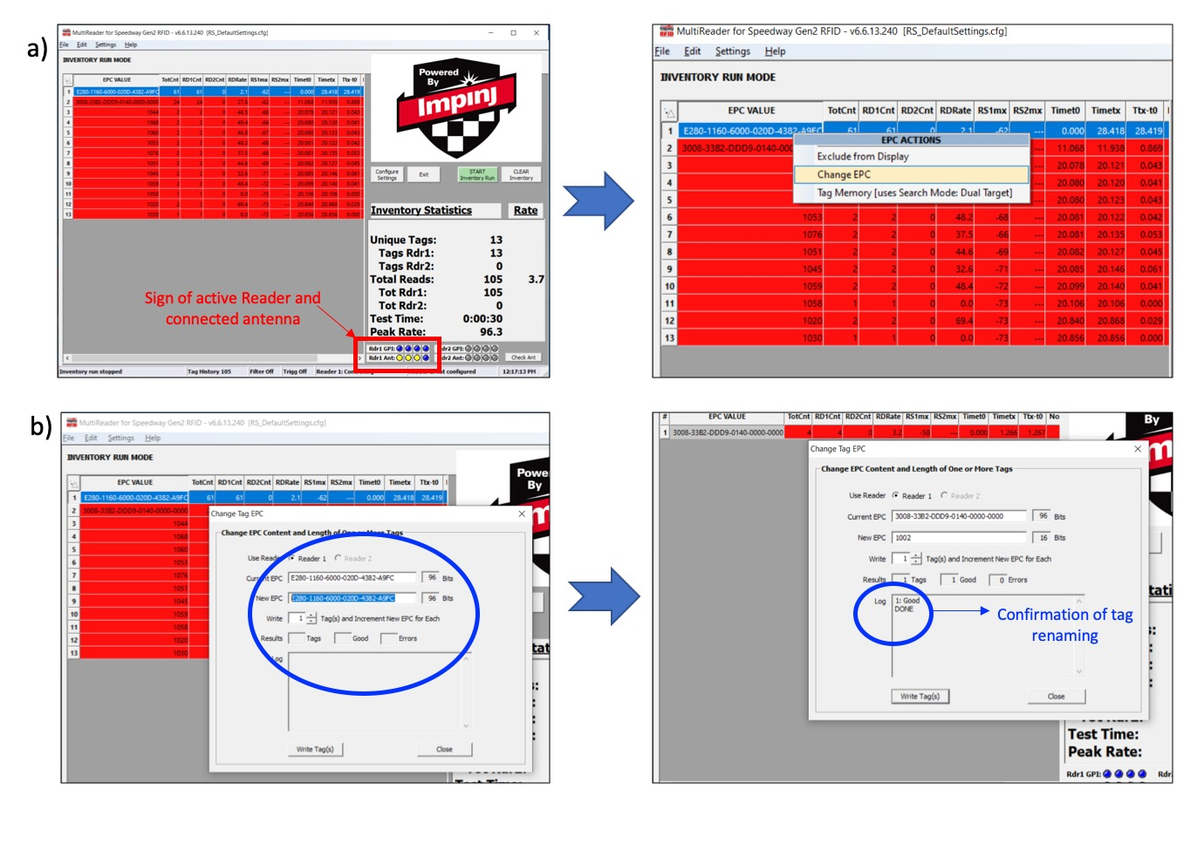

Figure S2. Basic operation of the ItemTest software running on a laptop connected to the RFID unit. A) Active connection of the unit to the software for data transfer and communication. B) Results of tag inventory obtained by clicking the “Play” button (top left) to initiate tag scanning (highlighted in gray). C) Final output generated by ItemTest as an excel file (.cvs), which comprises the date and time of the bee activity (Timestamp), name of the bee (EPC) and its hive (Antenna).

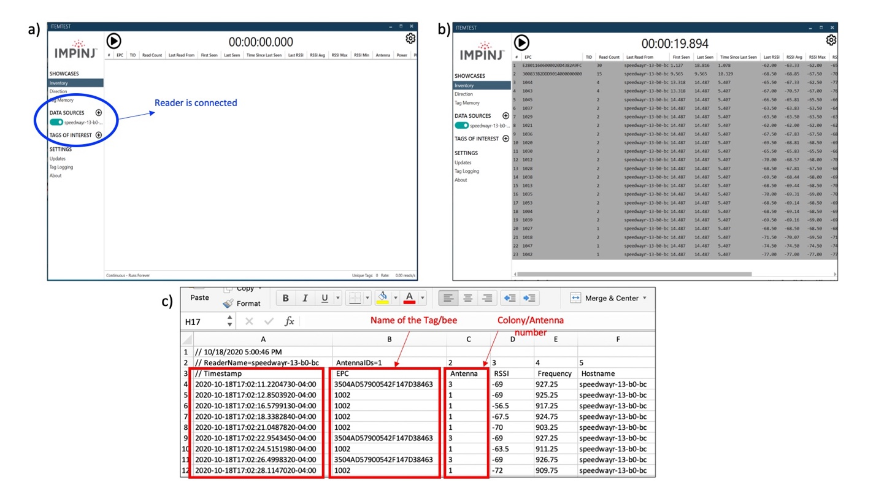

Figure S3. Interface of the preferred software for this unit (Speedway Connect). A) shows accessing the software through a webpage using the reader address (https://speewayr-xx-xx-xx.local). The red tag indicates the software is not running. B) run the software by pressing the “Status” button followed by “Apply.” C) Software running when the “Status” tag is green and flashing lights on both hubs and reader are observed. The software interface comprises additional parameters that were not discussed in this study.

