Supplementary material for Interindividual and intraindividual differences in orangutans drawings
Marie Pelé¹, Gwendoline Thomas², Alaïs Liénard², Shimada Masaki³, Cédric Sueur^{4,5}
1: Anthropo-Lab, ETHICS EA7446, Lille Catholic University, Lille, France
2 : Université Sorbonne Paris Nord - UFR LLSHS, Paris, France
3 : Department of Animal Sciences, Teikyo, University of Science, Uenohara, Yamanashi, Japan
4: Université de Strasbourg, CNRS, IPHC UMR 7178, Strasbourg, France
4 : Institut Universitaire de France, Paris, France

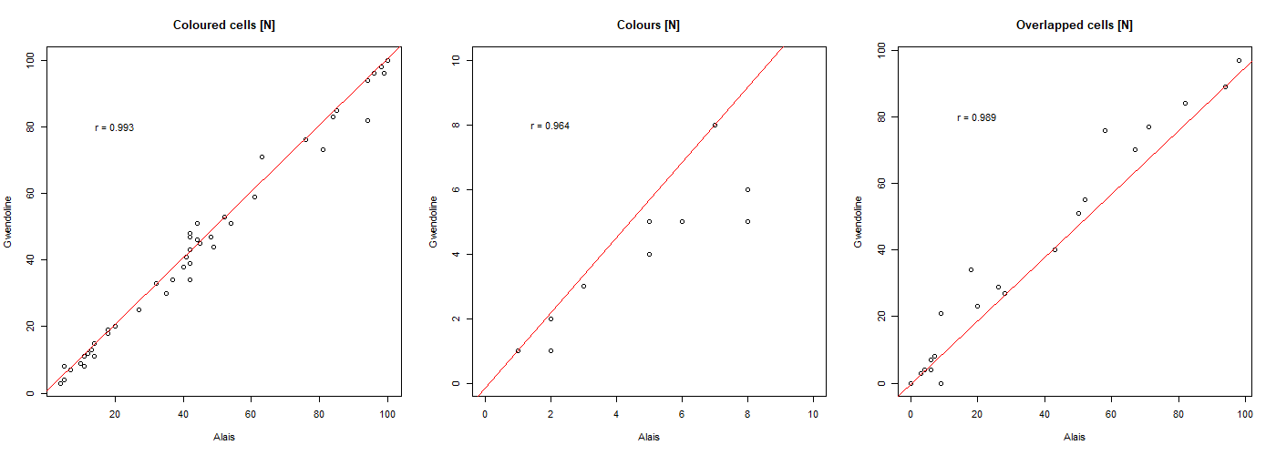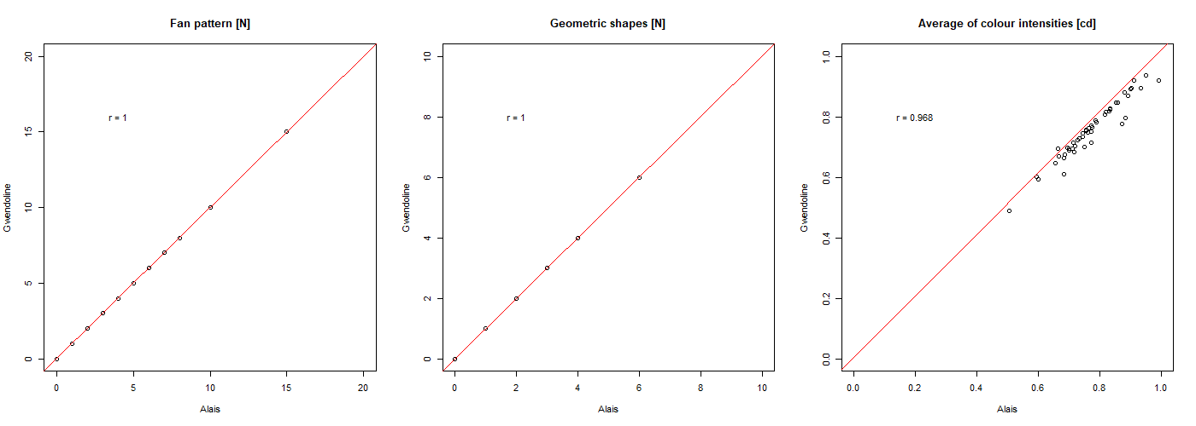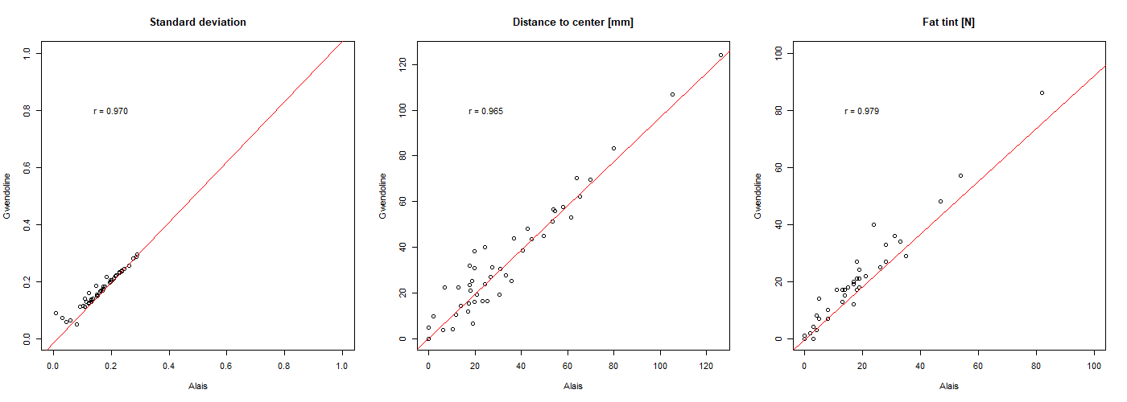
Figure S1. Inter-observer correlations for quantitative variables in the classical analysis.

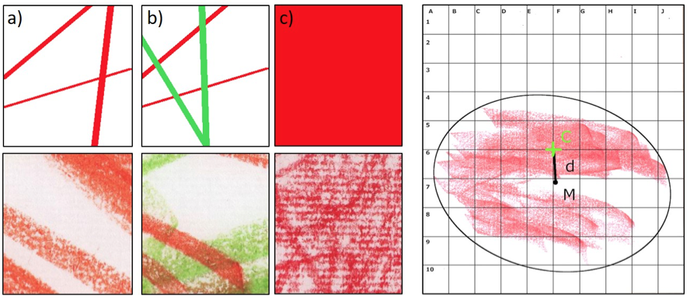
Figure S2: On the left, schematic (top) and actual (bottom) examples of a) a covered cell, b) an overlapped cell and c) solid colour rate. On the right, calculation of the distance to the centre. C is the centre of the paper sheet, M is the centre of the drawing ellipse, and d is the diameter.

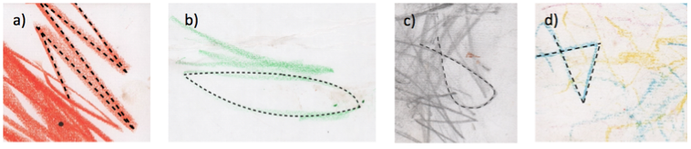
Figure S3: examples of a) a fan pattern, b) a circle, c) a loop and d) a triangle.

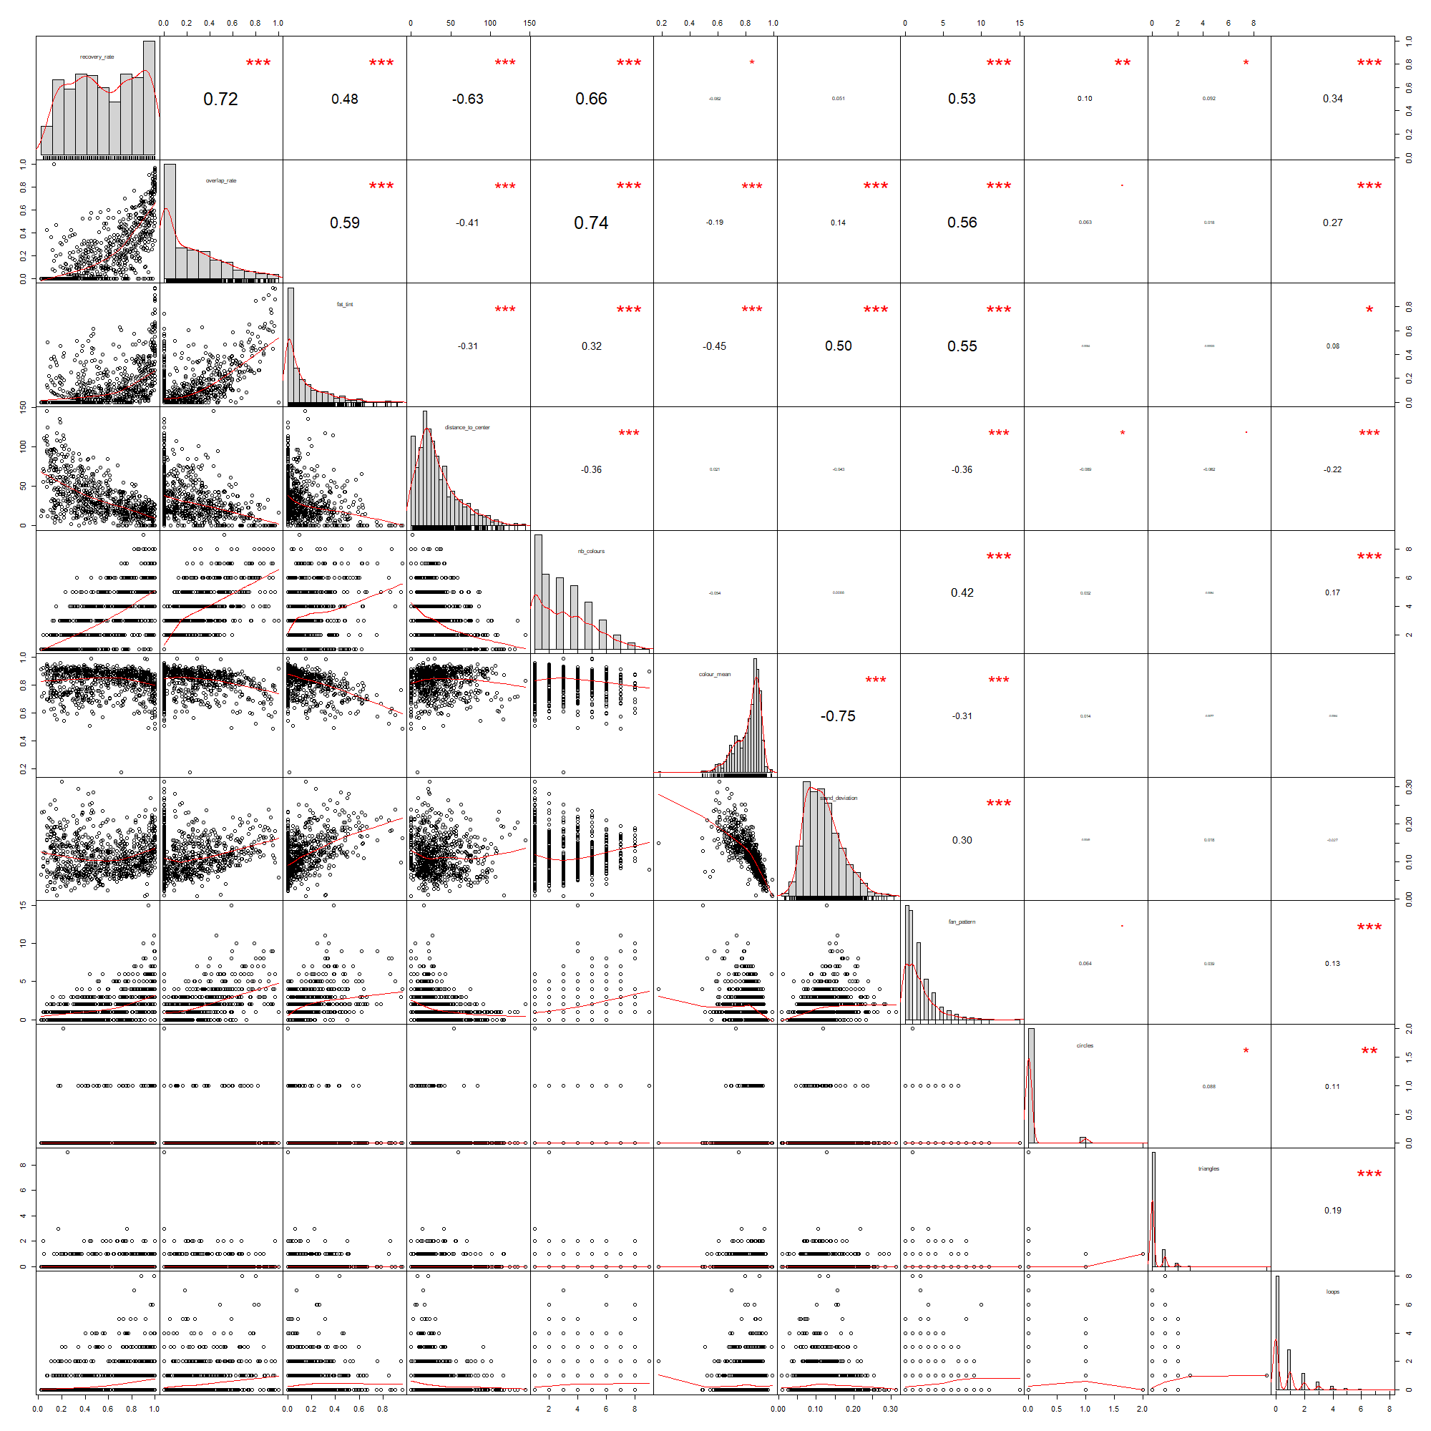
Figure S4. Correlation chart of our quantitative variables. *:p<0.05, **p<0.01,***:p<0.001. The number indicates the correlation.

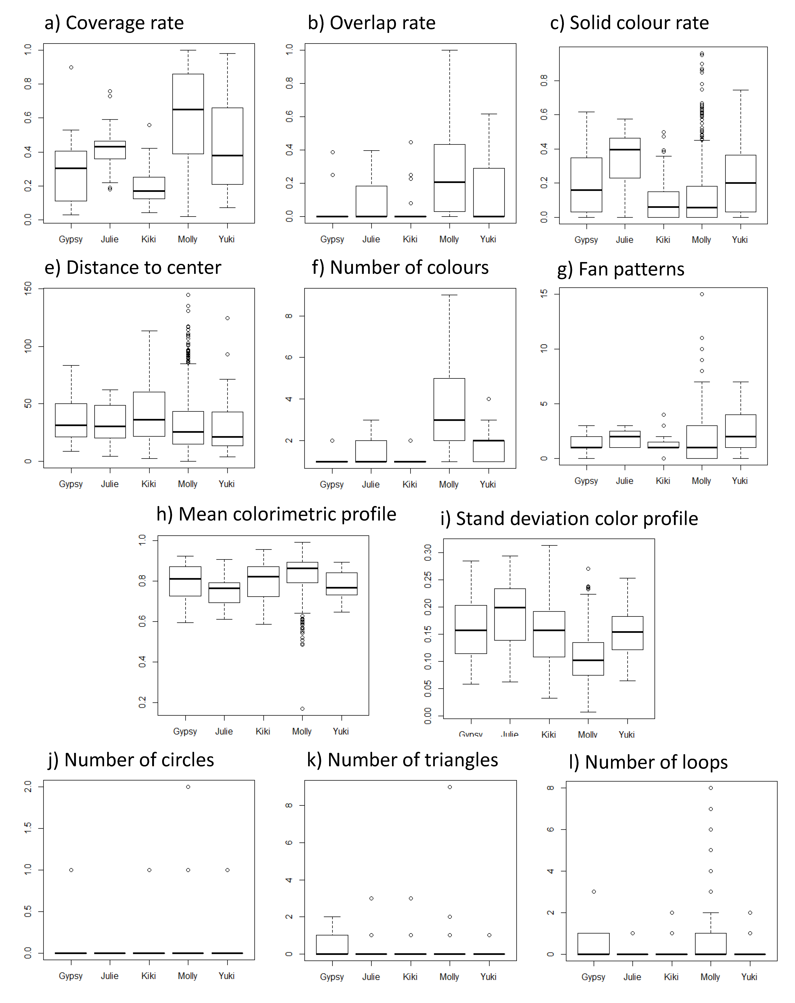
Figure S5: Boxplots of each drawing metric per individual
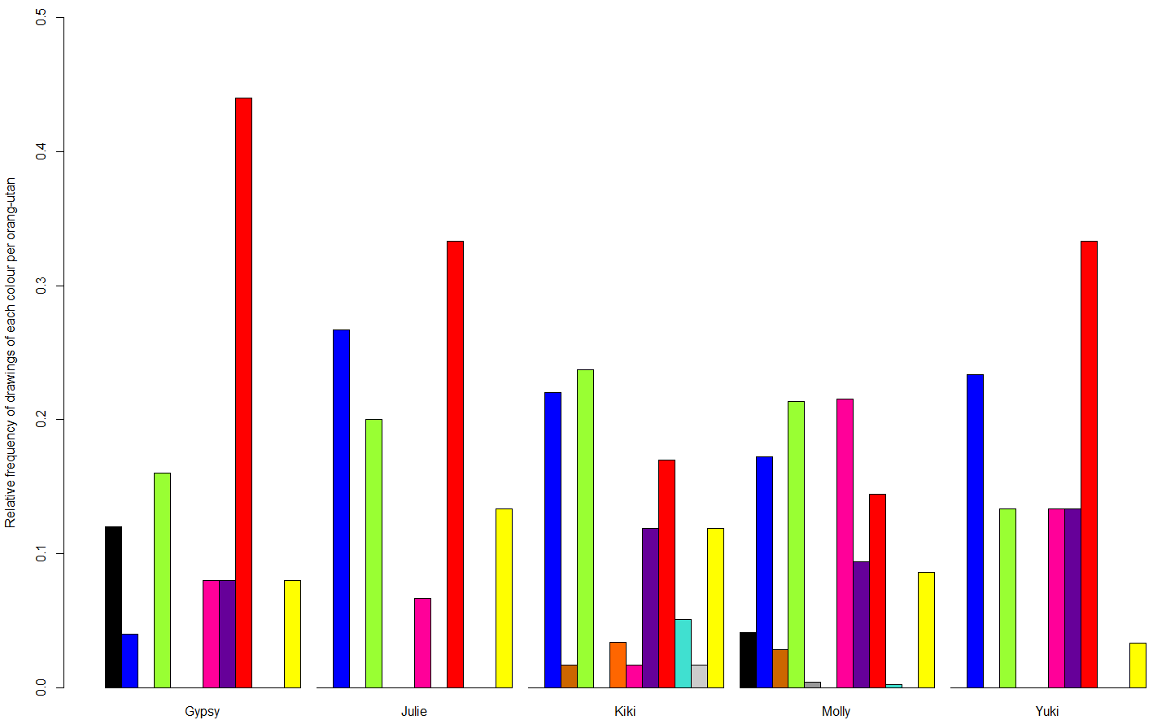
Figure S6. Frequency of drawings per main colour per individual.
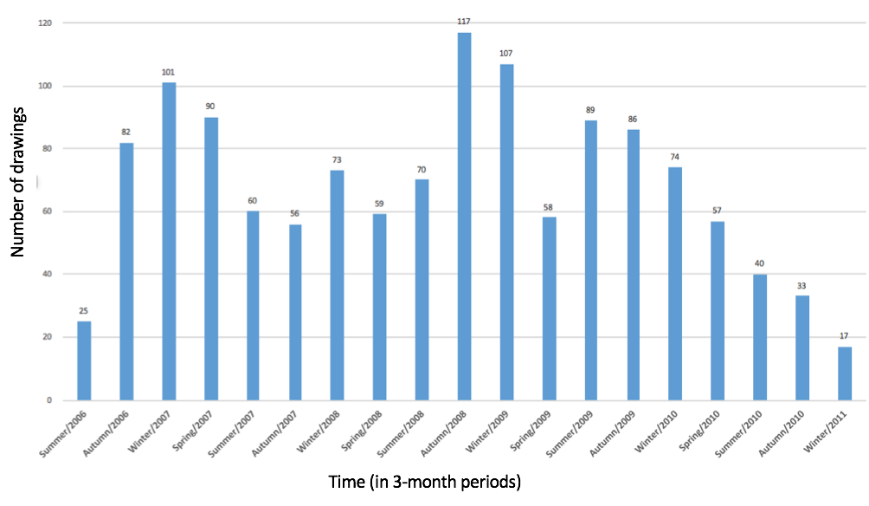

Figure S7: Number of drawings according to the seasons over the years. The exact number is specified above the bars.

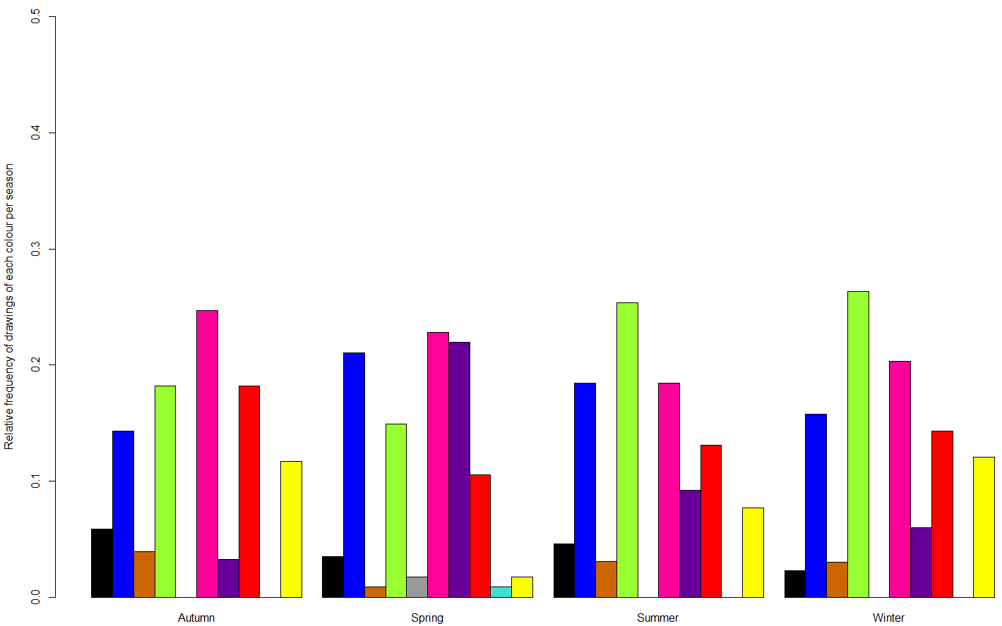
Figure S8. Frequency of Molly's drawings per main colour per season.
Table S1: pairwise comparisons tests (p-values) for each dimension between the five individuals
Dim1 | Gypsy | Julie | Kiki | Molly
Julie | 0.1844 | - | - | -
Kiki | 0.3149 | 0.0152 | - | -
Molly | 0.016 | 0.9006 | 3.60E-09 | -
Yuki | 0.1525 | 0.9006 | 0.0025 | 0.8234
Dim2 | Gypsy | Julie | Kiki | Molly
Julie | 0.081 | - | - | -
Kiki | 0.932 | 0.045 | - | -
Molly | 4.80E-11 | 8.30E-14 | < 2e-16 | -
Yuki | 0.907 | 0.045 | 0.907 | 5.00E-12
Dim3 | Gypsy | Julie | Kiki | Molly
Julie | 0.643 | - | - | -
Kiki | 0.301 | 0.643 | - | -
Molly | 0.041 | 0.301 | 0.301 | -
Yuki | 0.301 | 0.601 | 0.643 | 0.643

Table S2: pairwise comparisons tests (p-values) for each metric of Dimension 1
Coverage rate | Gypsy | Julie | Kiki | Molly
Julie | 0.13059 | - | - | -
Kiki | 0.17047 | 0.00479 | - | -
Molly | 1.50E-08 | 0.01076 | < 2e-16 | -
Yuki | 0.07067 | 0.99024 | 0.00029 | 0.0004
Overlap rate | Gypsy | Julie | Kiki | Molly
Julie | 0.482 | - | - | -
Kiki | 0.869 | 0.372 | - | -
Molly | 8.40E-06 | 0.018 | 5.60E-13 | -
Yuki | 0.112 | 0.549 | 0.032 | 0.018
Number of colours | Gypsy | Julie | Kiki | Molly
Julie | 0.541 | - | - | -
Kiki | 0.931 | 0.541 | - | -
Molly | 1.30E-10 | 1.90E-05 | < 2e-16 | -
Yuki | 0.146 | 0.541 | 0.093 | 2.10E-06
Fan patterns | Gypsy | Julie | Kiki | Molly
Julie | 0.5247 | - | - | -
Kiki | 0.8489 | 0.346 | - | -
Molly | 0.329 | 0.9918 | 0.0406 | -
Yuki | 0.0406 | 0.3048 | 0.0044 | 0.0406
Distance to centre | Gypsy | Julie | Kiki | Molly
Julie | 0.911 | - | - | -
Kiki | 0.714 | 0.668 | - | -
Molly | 0.714 | 0.912 | 0.035 | -
Yuki | 0.714 | 0.912 | 0.271 | 0.912
Solid colour rate | Gypsy | Julie | Kiki | Molly
Julie | 0.0212 | - | - | -
Kiki | 0.0189 | 3.50E-06 | - | -
Molly | 0.0287 | 3.50E-06 | 0.319 | -
Yuki | 0.5568 | 0.0461 | 0.0015 | 0.0015

Table S3: pairwise comparisons tests (p-values) for each metric of Dimension 2
Colour mean | Gypsy | Julie | Kiki | Molly
Julie | 0.2651 | - | - | -
Kiki | 0.8763 | 0.2651 | - | -
Molly | 0.1266 | 0.0057 | 0.0057 | -
Yuki | 0.5863 | 0.5263 | 0.5863 | 0.0059
Standard deviation of mean colour | Gypsy | Julie | Kiki | Molly
Julie | 0.0335 | - | - | -
Kiki | 0.5064 | 0.0022 | - | -
Molly | 1.40E-07 | 1.20E-11 | 5.60E-11 | -
Yuki | 0.7355 | 0.0135 | 0.6962 | 9.40E-08

Table S4: pairwise comparisons tests (p-values) for each metric of Dimension 3
Circles | Gypsy | Julie | Kiki | Molly
Julie | 0.88 | - | - | -
Kiki | 0.88 | 0.88 | - | -
Molly | 0.88 | 0.88 | 0.88 | -
Yuki | 0.89 | 0.88 | 0.88 | 0.88
Triangles | Gypsy | Julie | Kiki | Molly
Julie | 1 | - | - | -
Kiki | 0.45 | 0.45 | - | -
Molly | 0.45 | 0.54 | 0.45 | -
Yuki | 0.45 | 0.45 | 0.89 | 0.65
Loops | Gypsy | Julie | Kiki | Molly
Julie | 0.5006 | - | - | -
Kiki | 0.5006 | 0.835 | - | -
Molly | 0.5006 | 0.1012 | 0.0022 | -
Yuki | 0.5542 | 0.835 | 0.835 | 0.079

Table S5: Loadings of the metrics on the three PCA dimensions of our dataset for Molly. Bold values indicate the dimension in which each variable is retained.
 | Dim.1 | Dim.2 | Dim.3
coverage rate | 0.83259466 | 0.35898791 | -0.03754139
Overlap rate | 0.86645016 | 0.11386246 | -0.15141994
Solid colour rate | 0.82093692 | -0.20890006 | -0.06820954
distance to centre | -0.59224515 | -0.4847952 | 0.0366672
Number of colours | 0.70657478 | 0.21081542 | -0.29585089
Colour mean | -0.5250608 | 0.71138628 | -0.22231713
Standard deviation of mean colour | 0.59217275 | -0.65153752 | 0.21292017
fan pattern | 0.75009581 | -0.06012067 | -0.05905462
circles | 0.09579288 | 0.18189447 | 0.50532385
triangles | 0.07651598 | 0.16002544 | 0.70546716
loops | 0.30038742 | 0.37499276 | 0.49370317

