Supplementary file
Figure S1. Patterns of extensor tendons and their connecting fibrous bands on the dorsum of the hand.
A) The most common pattern, where the index finger has a single extensor digitorum communis tendon (in dark gray) and a single extensor indices tendon (in lighter gray) that inserts at the MCP-joint ulnar to the extensor digitorum communis. The middle finger has a single extensor digitorum communis. The ring finger originates as a single extensor digitorum communis tendon that diverges into two tendons midsubstance that again merge into one right before insertion at the MCP-joint. The little finger has a single extensor digitorum communis and a double extensor digiti minimi with double insertion at the MCP-joint. The fibrous bands are present in the 2nd, 3rd and 4th intermetacarpal spaces. B) Figure B portrays one of the many variations of extensor tendons and connecting fibrous bands that can be found. In this variation the index finger has a single extensor digitorum communis tendon and a double extensor indices tendon (in lighter gray) that inserts at the MCP-joint ulnar to the extensor digitorum communis. The middle finger has a double extensor digitorum communis and the ring finger a single extensor digitorum communis tendon The little finger has a single extensor digiti minimi and an absent extensor digitorum communis. The fibrous band in the second intermetacarpal space is absent and in the third and fourth intermetaracpal space have a Y-shape (y-subtype).
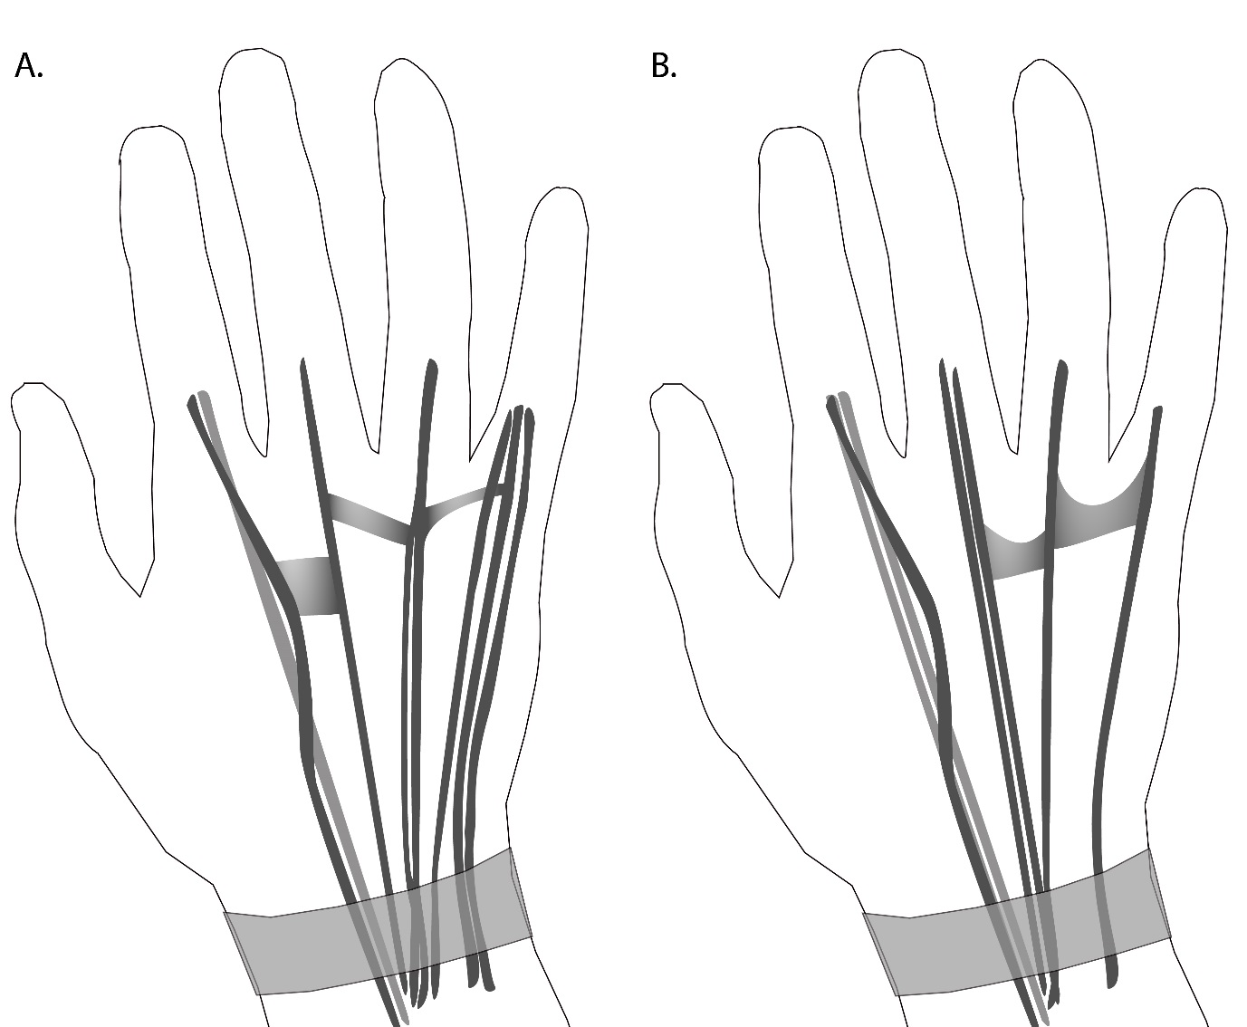
Figures A & B present a summary of the literature that is presented in more detail in Tables S1 and S2.
Table S1. Patterns of extensor tendons on the dorsum of the hand according to the literature.
 | Tendon | Number of tendons in dissection studies, mean % of specimen (range)*
 |  | Single tendon | Double tendons | Triple tendons | Quadruple tendons | Absent | Other
Index finger | Extensor indices | 88 (77-98) | 11 (2-18) | 1 (0-7) | 0 (0) | 0.4 (0-4)
 | Extensor digitorum communis | 96 (82-100) | 4 (0-8) | 0 (0) | 0 (0) | 0 (0)
Middle finger | Extensor digitorum communis | 63 (51-93) | 30 (4-39) | 7 (0-19) | 0.4 (0-5) | 0 (0)
Ring finger | Extensor digitorum communis | 43 (12-96) | 43 (2-63) | 10 (0-22) | 3 (0-9) | 0 (0)
Little finger | Extensor digitorum communis | 26 (2-66) | 8 (0-25) | 1 (0-3) | 0 (0) | 20 (1-69) | Common ring- and little finger: 45 (0-93)**
 | Extensor digiti minimi | 15 (0-35) | 81 (63-89) | 4 (2-9) | 0.7 (0-10) | 0 (0)
These numbers are based upon the results and summarizing tables of Zilber et al, Dass et al and Celik et al and are from 1176 specimen in total. *Number should be interpreted as follows: an average of 88% of specimen had a single extensor indices tendon (range 77-98%). The large variation between studies is mostly due to differences in definitions and methodology. **Some but not all articles define a common extensor digitorum communis between the ring- and little-finger.

Table S2. Frequency of intermetacarpal fibrous bands.
Location | Present, mean % of specimen (range)
Second intermetacarpal space | 79 (61-87)
Third intermetacarpal space | 99 (96-100)
Forth intermetacarpal space | 100 (100)*

These numbers are based upon the results and summarizing tables of Zilber et al, Dass et al and Celik et al and are from 204 specimen in total. Fibrous bands are also referred to as juncturae tendinae. *One study did not mention the frequency of presence of the fibrous bands at this location. It stated that analyses of the fibrous bands in the fourth intermetacarpal space is difficult because of their appearance, particularly close to the tendons, and because they often insert on the extensor apparatus of the little finger at a distant level (level of MCP-joint). As reported in literature, the fibrous bands can be classified into 3 types according to their consistency and shape (Dass et al): we have not elaborated on this.
The most common pattern of extensor tendons and fibrous bands is illustrated in supplementary Figure S1A, Supplementary Figure S1B illustrates a variation to this pattern. These figures are based upon Tables S1 and S2.

