Article
Appendix A - Data entry forms for SM geodatabase of
MzS Tools: GIS methods and tools for seismic microzonation mapping
Giuseppe Cosentino ^{1,} *, Francesco Pennica ², Emanuele Tarquini ², Giuseppe Cavuoto³ and Francesco Stigliano ²
¹ Institute of Geosciences and Earth Resources (IGG) of National Research Council of Italy (CNR), 56124 Pisa; giuseppe.cosentino@igg.cnr.it;
² Institute of Environmental Geology and Geoengineering (IGAG) of National Research Council of Italy (CNR); 00010 Montelibretti, Roma; francesco.pennica@igag.cnr.it; emanuele.tarquini@igag.cnr.it; francesco.stigliano@igag.cnr.it
³ Institute of Heritage Sciences of National Research Council of Italy, 80134 Napoli; giuseppe.cavuoto@cnr.it

* Correspondence: giuseppe.cosentino@igg.cnr.it; Tel: +39 3398352827

Abstract: This Appendix A, of article MzS Tools: GIS methods and tools for seismic microzonation mapping, describes the functions of the 23 forms of the QGIS project for data entry of the SM database. The exact data entry is very important for the drawing up of the maps as the values of the attribute codes are linked to the symbology of the cartographic project.

Table A1 shows the summary below is a list and description of the forms divided by theme.
Table A1. Data entry Forms for the data entry of the SM geodatabase divided by cartographic theme
Map |  | Data entry Form
Geological surveys Map ( Carta delle Indagini) | Sito puntuale (punctual site)
 | Indagini puntuali (punctual surveys)
Parametri puntuali (punctual parameters)
Curve di riferimento (reference diagram)
Indagini a stazione singola - HVSR (HVSR surveys)
Sito lineare (linear site)
Indagini lineari (linear surveys)
Parametri lineari (linear parameters)
Geological-technical Map (Carta geologico tecnica per la microzonazione sismica) | Elementi geologici e idrogeologici puntuali ( Geological and hydrogeological elements)
Elementi puntuali (punctual elements)
Elementi lineari (linear elements)
Instabilità di versante (landslides)
Forme (geomorphologic landforms)
Unità geologico-tecniche (Geological-technical Units)
SM level 1 Map (Carta delle microzone omogenee in prospettiva sismica MOPS) | Isobate liv 1 (Isobaths of level 1)
 | Zone instabili liv1 (Unstable zones of level 1)
 | Zone stabili liv1 (Stable zones of level 1)
SM level 2 Map (Carta di microzonazione sismica di livello 2) | Isobate liv 2 (Isobaths of level 2)
Zone instabili liv. 2 (Unstable zones of level 2)
Zone stabili liv. 2 (Stable zones of level 2)
SM level 3 Map (Carta di microzonazione sismica di livello 3) | Isobate liv. 3 (Isobaths of level 3)  Zone Instabili liv. 3 (Unstable zones of level 3)  Zone stabili liv.3 (Stable zones of level 3)

Further information on the subject is contained in the on line user manual (https://mzs-tools.readthedocs.io/it/latest/) and in the video tutorials in the section Supplementary Materials of this Article.
- Geological surveys Map
  - Punctual geological surveys
Punctual geological surveys have five data entry forms (Figure A1). Table A2 lists the punctual surveys Geological survey map.
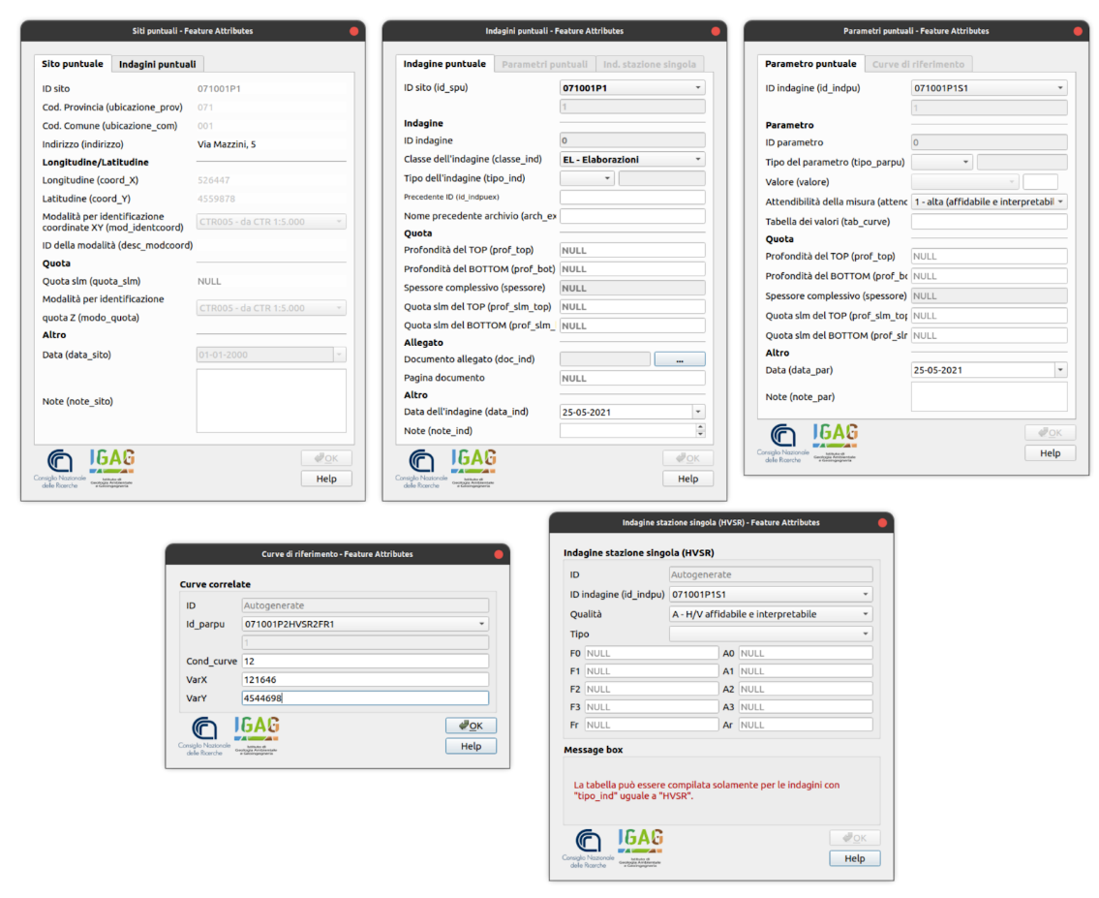
Figure A1. Data entry Forms for the attributes of punctual geological surveys: Siti puntuali, Indagini puntuali, Parametri puntuali, Curve di riferimento e Indagine a Stazione singola (HVSR).
- Sit puntuale the data of the site ID sito, the Code of the Municipality (Cod. Comune), the Code of the Province (Cod. Provincia), of the Geographic Coordinates in WGS84UTM33N (Longitudine - Latitudine) are compiled; these elements are automatically recorded thanks to the action of a trigger that is executed when saving the digitization of the point representing the survey. Other data to be entered manually are the Topographic elevation a.s.l. (Quota slm), the Date and the Notes.
- Indagini Puntuali by selecting the Site ID Code from the drop-down list of "Punctual sites'' registered, you can to data entry of the attributes relating to the Survey class (Classe d’indagine) (Elaborations, Geo-electrical, Geophysics, Geology, Laboratory geotechnics, Geotechnics in situ, Hydrogeology) based on the chosen Survey Class, the list of Survey Types (Tipo dell’indagine) is activated for data entry the related numerical parameters. Other data to add are the Depths (above sea level) of the TOP and the BOTTOM of the test, the Thickness (Spessore) automatically calculated, the Attachment that loads the original document, the Date and Notes. Thanks to the action of a trigger, ID indagine is automatically recorded at the time of saving
- Parametri puntuali by selecting the survey registered by the ID Indagine, you proceed to data entry of the Parameter Type (Tipo del parametro), which is activated specifically by type of Survey previously entered in "Survey Types ''; the Numerical value (Valore) of the parameter and the Reliability (Attendibilità) of the measurement (high, medium or low); of the name of the Curve Value Table (Tabella dei valori). Other data to be entered are the Depths (Profondità) of the TOP and the BOTTOM of the parameter value meters above sea level (ma.s.l.) and the topography, the Thickness (automatically calculated) of the parameter value, the Date and the Notes. Thanks to the action of a trigger, the primary key ID parametro is automatically registered at the time of saving.
- Curve di riferimento by selecting the previously registered ID_parpu code, the Cartesian values of the parameter curve can be loaded (data entry). Thanks to the action of a trigger, the primary key ID_curva is automatically recorded at the time of saving.
- Indagini a stazione singola (HVSR) This form allows you to upload data relating to HVSR measurements. such as the Quality (Qualità) of the test (reliable, suspect, poor), the Type (Tipo) (at least one clear peak, no clear peaks) and the numerical values of the Peak Frequencies (Picchi di frequenza) (F0, F1, F2, F3, Fr) and their Amplitude (Ampiezza)(A0, A1, A2, A3, Ar).

Table A2. List of point geological surveys represented in the Map
Code | Description
S  SS  SD  SDS  SC  SP  SI  T  TP  GEO  PI  SMS  SPT  CPT  CPTU  CPTE  DTM  DS  DP  DN  DL  VT  PTL  PP  DH  CH  UH  SPAC_ESAC  SR  GM  ACC  HVSR  SCPT  SDMT  SL  ERT  PA | Continuous core drilling borehole  Continuous core drilling borehole that intersects the bedrock  Core destruction perforation borehole  Core destruction perforation borehole that intersects the bedrock  Borehole with geological sampling  Borehole with piezometer  Borehole with inclinometer  Dugout or exploratory well  Paleo seismological dugout  Geomechanical station  Hydrocarbon well  Microzone stratigraphy  Standard penetration test  Cone Penetration Test  Cone Penetration Test with pore water pressure measurement  Cone Penetration Test with electric cone  Flat Dilatometer Test  Dynamic probing heavy  Dynamic probing super heavy  Dynamic probing medium  Dynamic probing light  Vane test  Plate load test  Pressuremeter test  Down-Hole  Cross-Hole  Up-Hole  Seismic Array  Vertical Refraction test  Gravimetric station  Accelerometric / seismometric station  Horizontal to Vertical Spectral Ratio  Seismic Cone Penetration Test  Seismic Dilatometer Test  Vertical Reflection test  Vertical Electrical Resistivity Tomography  Hydro Well
  - Linear geological surveys
Linear geological surveys have three data entry forms (Figure A2). Table A3 lists the linear surveys Geological survey map.

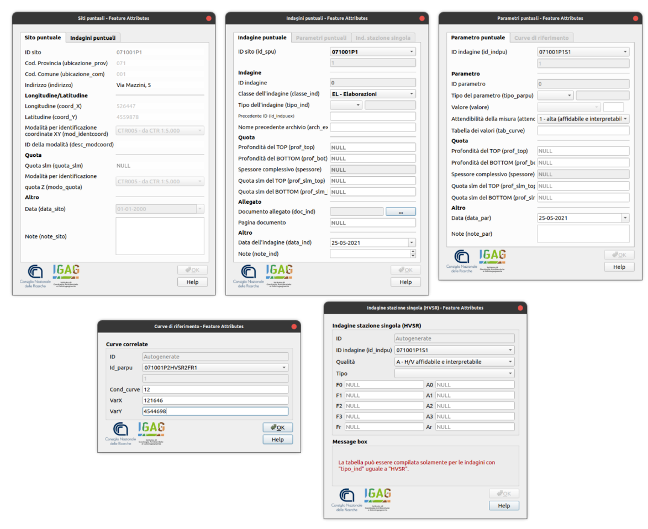
Figure A2. Data entry Forms for the attributes of linear geological surveys: Sito lineare, Indagini lineari e Parametri lineari.
- Sito lineare the data of the ID sito, the Code of the Municipality (Cod. Comune), the Code of the Province, the Geographical Coordinates (WGS84UTM33N) of the initial and final points of the segment are compiled (XaYa, XbYb); these elements are automatically recorded thanks to the action of a trigger that is executed when saving the digitization of the points representing the survey. Other data to be entered manually are the Topographic elevation (above sea level) of the starting and ending point of the segment, the Date and the Notes.

Table A3. List of linear geological surveys represented in the Map
Code | Description
SL  SSR  RAD  SASW  MASW  REMI  FTAN  ERT  SEV  SEO  PR | Reflection seismic profile
 | Refraction seismic profile
 | Radar Profile
 | Spectral Analysis of Surface Waves
 | Multichannel Analysis of Surface Waves
 | Refraction Microtremor profile
 | Frequency Time Analysis
 | Electrical Resistivity Tomography
 | Vertical electrical surveys
 | Horizontal electrical surveys
 | Resistivity profile

- Indagini lineari by selecting the Site ID Code from the drop-down list of "Punctual sites'' registered, you can to data entry of the attributes relating to the Survey class (Classe d’indagine) (Elaborations, Geo-electrical, Geophysics, Geology, Laboratory geotechnics, Geotechnics in situ, Hydrogeology) based on the chosen Survey Class, the list of Survey Types (Tipo dell’indagine) is activated for data entry the related numerical parameters. Other data to add are the Attachment that loads the original document, the Date and Notes. Thanks to the action of a trigger, ID indagine is automatically recorded at the time of saving.
- Parametri lineari by selecting the survey registered by the ID Indagine, you proceed to data entry of the Parameter Type (Tipo del parametro), which is activated specifically by type of Survey previously entered in "Survey Types " ; the Numerical value (Valore) of the parameter and the Reliability (Attendibilità) of the measurement (high, medium or low). Other data to be entered are the Depths (Profondità) of the TOP and the BOTTOM of the parameter value meters above sea level (meters a.s.l.) and the topography, the Thickness (automatically calculated) of the parameter value, the Date and the Notes. Thanks to the action of a trigger, the primary key ID parametro is automatically registered at the time of saving.
- Geological-technical Map
Geological-technical Map has six data entry forms (Figure A3).
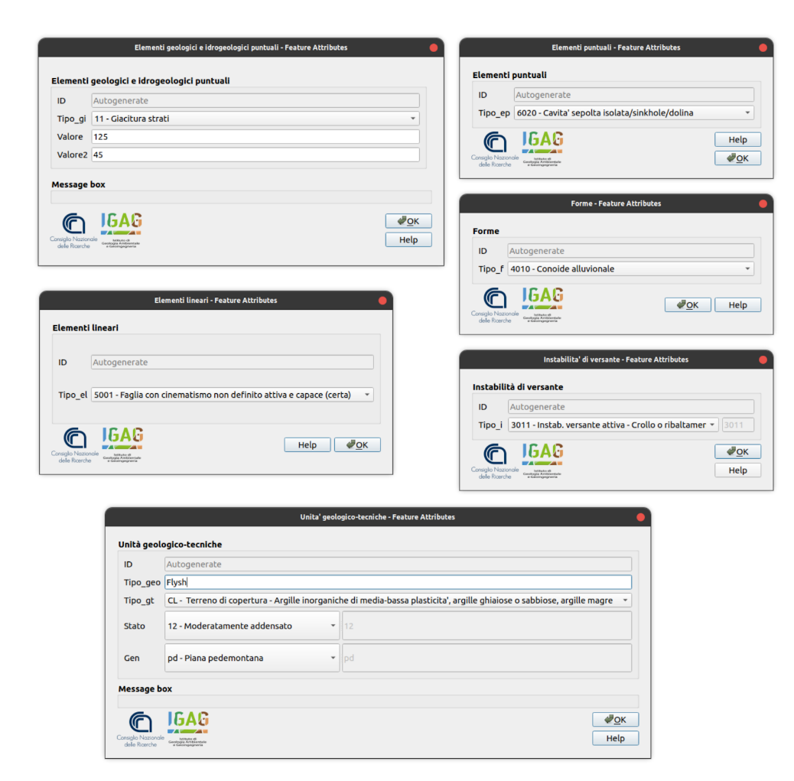
Figure A3. Data entry Forms for the attributes of Geological-Technical Map: Elementi geologici ed idrogeologici puntuali, Elementi puntuali, Elementi lineari, Instabilità di versante e Unità geologico-tecniche
- Elementi geologici e idrogeologici puntuali. Table A4 shows the encoding of the objects of the layer. Each object based on the identification code activates the data entry of specific attributes through the form. For example, for “strike/dip sedimentary layers” the form activates the insertion of the relative strike and dip.

Table A4. Objects of the layer “Elementi geologici e idrogeologici puntuali”
Code | Description
11 | Data strike / dip sedimentary layers
21 | well or boreholes that intersects the bedrock
22 | well or boreholes that do not intersects bedrock
31 | depth of the water table in areas with sand / gravel

- Elementi puntuali form for the data entry of the objects shown in the Table A5.

Table A5. Objects of the layer “Elementi puntuali”
Code | Description
6010 | isolated peak
6020 | isolated buried cavity / sinkhole

- Elementi lineari form for the data entry of the objects shown in the Table A6.

Table A6. Objects of the layer “Elementi lineari”
Code | Description
5001  5002  5011  5012  5021  5022  5031  5032  5041  5042  5051  5052  5060  5070  5071  5081  5082  5111  5112  5121  5122  5131  5132  5141  5142  5201  5301  7011  7012  7021  7022  7031  7032  7041  7042  8001  8002 | active and capable fault with undefined kinematics  active and capable fault with undefined kinematics – uncertain  active and capable normal fault  active and capable direct fault - uncertain  active and capable reverse fault  active and capable reverse fault - uncertain  active and capable strike-dip fault  active and capable strike-dip fault – uncertain  natural or artificial morphological cliff edge (10-20m)  natural or artificial morphological cliff edge (>20m)  river terrace edge (10-20m)  river terrace edge (>20m)  ridge  buried cliff  limit of buried slope with inclination between 15 ° and 45 °  narrow buried valley axis (C≥ 0.25)  wide buried valley axis (C <0.25)  potentially active and capable normal fault  potentially active and capable normal fault – uncertain  potentially active and capable reverse fault  potentially active and capable reverse fault - uncertain  potentially active and capable strike-dip fault  potentially active and capable strike-dip fault – uncertain  fault with undefined kinematics potentially active and capable  fault with undefined kinematics potentially active and capable – uncertain  lava field limit (volcanic environment)  Paleo-bed axis  normal fault not active  normal fault not active – uncertain  reverse fault not active  reverse fault not active – uncertain  strike-dip fault not active  strike-dip fault not active - uncertain  syncline  anticline  geological profile  topographic profile

- Instabilità di versante form for the data entry of slope instabilities (Table A7, from instability code 3011 to 3045).

Table A7. Objects of the layer “Zone instabili”. Stable zones susceptible to local amplification have codes ranging from 2001 to 2099
ID | Instab Code | Stable zones susceptible to local amplification CODE | Description | SM level
1 | 3001  3002  3052  3053  3061  3062  3011  3012  3013  3014  3015  3021  3022  3023  3024  3025  3031  3032  3033  3034  3035  3041  3042  3043  3044  3045  3050  3060  3070  3080 | 2000 +1n | Slope instability susceptibility zone | 3  3  3  3  3  3  1 / 2  1 / 2  1 / 2  1 / 2  1 / 2  1 / 2  1 / 2  1 / 2  1 / 2  1 / 2  1 / 2  1 / 2  1 / 2  1 / 2  1 / 2  1 / 2  1 / 2  1 / 2  1 / 2  1 / 2  1 / 2  1 / 2  1 / 2  1 / 2
2 |  | 2000 +1n | Respect zone for landslide
3 |  | 2000 +1n | Susceptibility zone for liquefaction
4 |  | - | Respect zone for liquefaction
5 |  | 2000 +1n | Susceptibility Zone for active and capable faults
6 |  | 2000 +1n | Respect Zone for active and capable faults
7 |  | 2000 +1n | Attention zone for Active landslide / collapse
8 |  | 2000 +1n | Attention zone for Active landslide / sliding
9 |  | 2000 +1n | Attention zone for Active landslide / flow
10 |  | 2000 +1n | Attention zone for Active landslide / complex
11 |  | 2000 +1n | Attention zone for Active landslide / undefined
12 |  | 2000 +1n | Attention zone for Quiescent landslide / collapse
13 |  | 2000 +1n | Attention zone for Quiescent landslide / sliding
14 |  | 2000 +1n | Attention zone for Quiescent landslide / flow
15 |  | 2000 +1n | Attention zone for Quiescent landslide / complex
16 |  | 2000 +1n | Attention zone for Quiescent landslide / undefined
17 |  | 2000 +1n | Attention zone for Inactive landslide / collapse
18 |  | 2000 +1n | Attention zone for Inactive landslide / sliding
19 |  | 2000 +1n | Attention zone for Inactive landslide / flow
20 |  | 2000 +1n | Attention zone for Inactive landslide / complex
21 |  | 2000 +1n | Attention zone for Inactive landslide / undefined
22 |  | 2000 +1n | Attention zone for Undefined landslide / collapse
23 |  | 2000 +1n | Attention zone for Undefined landslide / sliding
24 |  | 2000 +1n | Attention zone for Undefined landslide / flow
25 |  | 2000 +1n | Attention zone for Undefined landslide / complex
26 |  | 2000 +1n | Attention zone for Undefined landslide / undefined
27 |  | 2000 +1n | Attention zone for liquefaction
28 |  | -
29 |  | - | Attention zone for overlapping of different instabilities
30 |  | - | Attention zone for differential settlement / cavity collapse / sinkhole

- Forme form for the data entry of the objects shown in the Table A8.

Table A8. Objects of the layer “Forme”
Code | Description
4010  4020  4030  4040  4050  4060  4070  4080 |  | alluvial fan
 |  | debris areas
 |  | area with buried cavities / sinkholes
 |  | fan of lava at the foot of slopes or buried escarpments
 |  | buried sub-horizontal surface
 |  | buried volcanoclastic structure
 |  | buried incoherent sedimentary deposits
 |  | seismic fracturing area

• Unità geologico-tecniche Table A9 shows the substrate types and recent sedimentary coverings. For these, the encodings of the genetic-depositional environments (Table A10) and of the state of recent sedimentary covers are also established (Table A11).

Table A9. Objects of the layer “Unità geologico-tecniche” from ID 1 to ID 16 are recent sediments covering; from ID 17 to ID 37 are geological bedrock.
ID | CODE | Description
1 | RI | Backfill soil
2 | GW | Well-graded gravels and gravels mixtures, little or no fines
3 | GP | Poorls-graded gravels and gravels mixtures, little or no fines
4 | GM | Silty gravels, gravel-sand-clay mixtures
5 | GC | Clayes gravels, gravel-sand-clay mixtures
6 | SW | Well-graded sands and gravelly sands, little or no fines
7 | SP | Poorls-graded sands and gravelly sands, little or no fines
8 | SM | Silty sands, and silt mixtures
9 | SC | Clayey sand, sand-clay mixtures
10 | ML | Inorganic silts, very fine sands, rock flour, silty or clayey fine sands
11 | CL | Inorganic clays, or low to medium plasticity, gravelly, clays, sand clays, lean clays
12 | OL | Organic silts and organic silty clays of loow plasticity
13 | OH | Inorganic silts, micaceous or diatomaceous fine sands or silts, elastic silts
14 | CH | Inorganic clays of high plasticity, fat clays
15 | OH | Organic clays of medium to high plasticity
16 | Pt | Peat, muck and other highy organic soils
17 | LC | Cover lithoid
18 | LP | Stone geological bedrock
19 | GR | Cemented granular geological bedrock
20 | CO | Over-consolidated cohesive geological bedrock
21 | AL | Geological bedrock alternation of lithotypes
22 | IS | Incoherent or poorly consolidated geological bedrock
23 | LPS | Stone stratified geological bedrock
24 | GRS | Cemented granular stratified geological bedrock
25 | COS | Over-consolidated cohesive stratified geological bedrock
26 | ALS | Geological stratified bedrock alternation of lithotypes
27 | ISS | Incoherent or poorly consolidated stratified geological bedrock
28 | SFLP | Fractured / altered stone geological substrate
29 | SFGR | Fractured / altered cemented granular geological bedrock
30 | SFCO | Fractured / altered over-consolidated cohesive geological bedrock
31 | SFAL | Fractured / altered geological bedrock alternation of lithotypes
32 | SFIS | Fractured / altered Incoherent or poorly consolidated geological bedrock
33 | SFLPS | Fractured / altered stone stratified geological bedrock
34 | SFGRS | Fractured / altered cemented granular stratified geological bedrock
35 | SFCOS | Fractured / altered over-consolidated cohesive stratified geological bedrock
36 | SFALS | Fractured / altered geological stratified bedrock alternation of lithotypes
37 | SFISS | Fractured / altered incoherent or poorly consolidated stratified geological bedrock

Table A10. Depositional genetic environments of the geological-technical Unit Types.
Code | Description
la | Flows / spreads / domes / dikes / lava cones
pc | Pyroclasts
sc | Lavic scoriae
ig | Ignimbrite cover
lh | Lahar
ep | Epiclastic deposits
fd | Talus deposits
cd | Detrital cones
cz | Dejection cone
ec | Eluvium/Colluvium
es | Embankment / bars / channels
dl | Delta plain
pd | Plain foothills
in | Basin between mountains
ca | Alluvial fan
tf | River terrace
va | Varve
lc | Lacustrine
pa | Marshy
pi | Flood plain
do | Dolina / karren / sinkhole filling
so | Forms built near springs
cy | Forms built in karst canyons
cc | Limestone crusts
mr | Maraine

Table A11. State of recent sedimentary covers.
Code | State description
11 | Thickened
12 | Moderately thickened
13 | Slightly thickened
14 | Loose
21 | Extremely consistent cohesive
22 | Very consistent cohesive
23 | Consistent cohesive
24 | Moderately consistent cohesive
25 | Loosely-bound cohesive
26 | Cohesive without consistency

- SM level 1 Map
SM level 1 Map has three data entry forms (Figure A4).
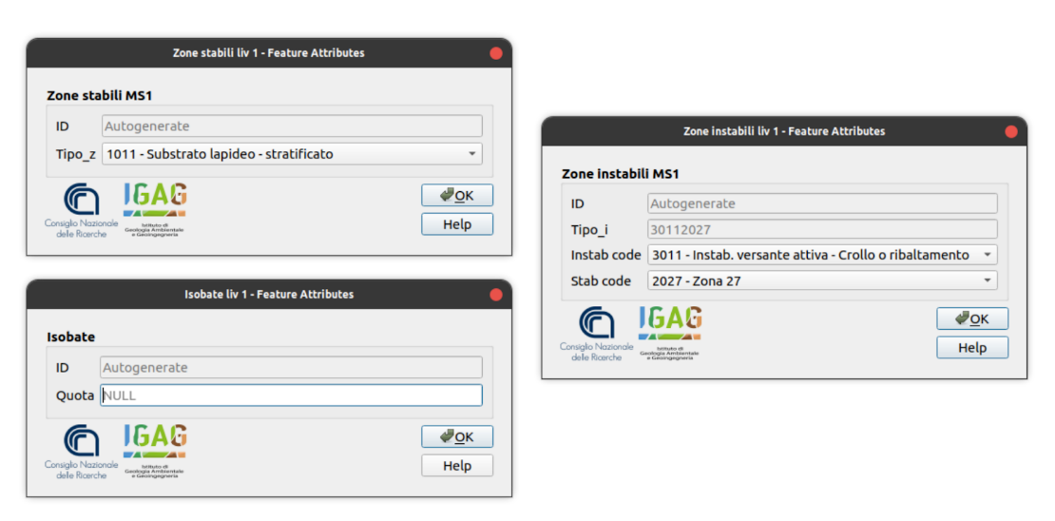
Figure A4. Data entry Forms for the attributes of SM Level 1 Map: Zone stabili MS1, Zone instabili MS1 and Isobate liv1.
- Isobate liv 1 form for data entry of the depth quotas meters above sea level (m a.s.l.) of the seismic bedrock isolines (SM level 1).
- Zone Instabili (Table A7) This form is used for the data entry of the instability codes (Type_i) that are self-compiling by inserting the Instab code and the corresponding microzone code (Stab code).
- Zone stabili this module compiles the codes shown in Table A12 through a special drop-down menu containing the descriptions of the codes of the Stable Zones and of the Stable zones susceptible to local amplification.

Table A12. Objects of the layer “Zone Stabili MS1” shown in the Map of homogeneous microzones in a seismic perspective (SM level 1). Stable zones susceptible to local amplification range from code 2001 to 2099. The stable zones range from the 1011 code to 1042. Stable zones susceptible to local amplification have codes ranging from 2001 to 2099.
Code | Description
1011 |  | Stone stratified geological bedrock
1012 |  | Stone unstratified geological bedrock
1021 |  | Cemented granular stratified geological bedrock
1022 |  | Cemented granular unstratified geological bedrock
1031 |  | Over-consolidated cohesive stratified geological bedrock
1032 |  | Over-consolidated cohesive unstratified geological bedrock
1041 |  | Geological stratified bedrock alternation of lithotypes
1042 |  | Geological unstratified bedrock alternation of lithotypes
2099 |  | Fractured / altered geological bedrock
2000+1n |  | Stable zones susceptible to local amplification

- SM level 2 Map
SM level 2 Map has three data entry forms (Figure A5).
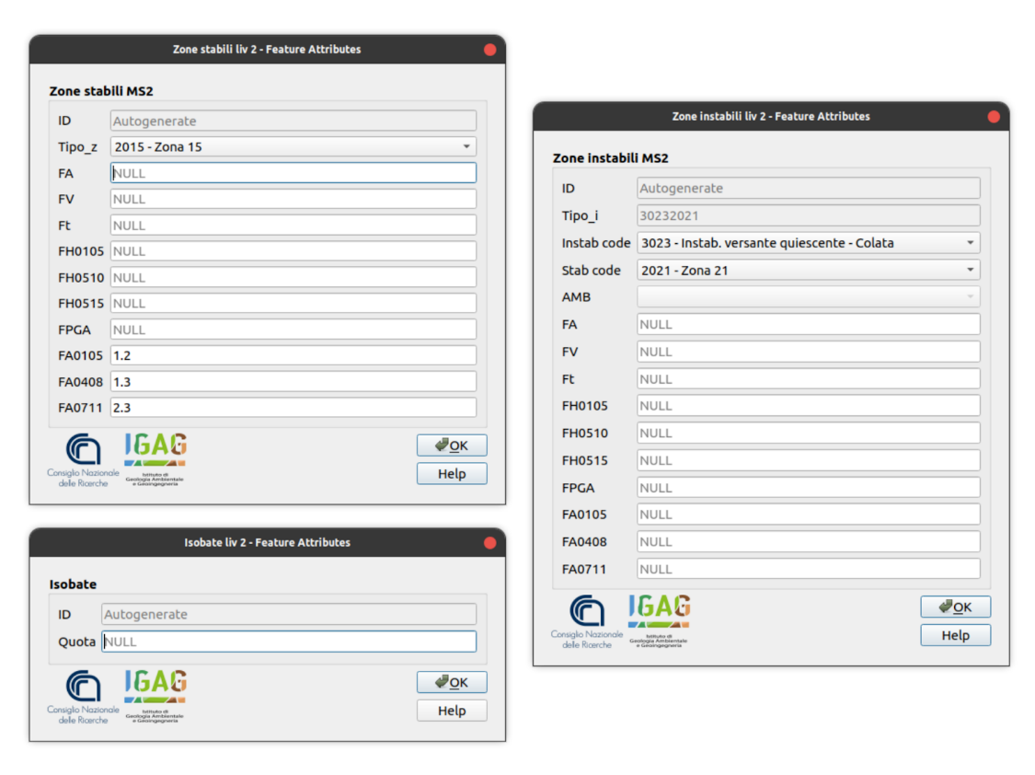
Figure A5. Data entry Forms for the attributes of SM Level 2 Map: Zone stabili MS2, Zone instabili MS2 and Isobate liv.2

- Isobate liv 2 form for data entry of the depth quotas meters above sea level (m a.s.l.) of the seismic bedrock isolines (SM level 2).
- Zone Instabili liv 2 form for the data entry of the instability codes (Type_i) (Table A7 from ID n.7 to ID n.30) which are self-filled by entering the Instab code and the corresponding microzone code (Stab code). Other data that can be entered are the Environmental and Age Indices of the deposits affected by potential liquefaction (AMB) (Table A13) and the Amplification Factors (FA, FV, Ft, FH0105, FH0510, FH0515, FPGA, FA0105, FA0408, FA0711). Table A14 shows classes of amplification values related to the symbology of level 2 Maps.

Table A13. Indices of the depositional environment and the age of deposits affected by potential liquefaction.
ID | CODE | Description
1 | A1 | Continental deposits - river beds - (<500 years)
2 | A2 | Continental deposits - river beds - (Olocene)
3 | A3 | Continental deposits - river beds - (Pleistocene)
4 | A4 | Continental deposits - river beds - (Pliocene)
5 | B1 | Continental deposits – floodplains - (<500 years)
6 | B2 | Continental deposits - floodplains - (Olocene)
7 | B3 | Continental deposits - floodplains - (Pleistocene)
8 | B4 | Continental deposits - floodplains - (Pliocene)
9 | C1 | Continental deposits – conoids - (<500 years)
10 | C2 | Continental deposits - conoids - (Olocene)
11 | C3 | Continental deposits - conoids - (Pleistocene)
12 | C4 | Continental deposits - conoids - (Pliocene)
13 | D1 | Continental deposits - flat and marine terraces - (<500 years)
14 | D2 | Continental deposits - flat and marine terraces - (Olocene)
15 | D3 | Continental deposits - flat and marine terraces - (Pleistocene)
16 | D4 | Continental deposits - flat and marine terraces - (Pliocene)
17 | E1 | Continental deposits - delta - (<500 years)
18 | E2 | Continental deposits - delta - (Olocene)
19 | E3 | Continental deposits - delta - (Pleistocene)
20 | E4 | Continental deposits - delta - (Pliocene)
21 | F1 | Continental deposits - beach lacustrine - (<500 years)
22 | F2 | Continental deposits - beach lacustrine - (Olocene)
23 | F3 | Continental deposits - beach lacustrine - (Pleistocene)
24 | F4 | Continental deposits - beach lacustrine - (Pliocene)
25 | G1 | Continental deposits - colluvium - (<500 years)
26 | G2 | Continental deposits – colluvium - (Olocene)
27 | G3 | Continental deposits – colluvium - (Pleistocene)
28 | G4 | Continental deposits – colluvium - (Pliocene)
29 | H1 | Continental deposits - rock debris - (<500 years)
30 | H2 | Continental deposits - rock debris - (Olocene)
31 | H3 | Continental deposits - rock debris - (Pleistocene)
32 | H4 | Continental deposits - rock debris - (Pliocene)
33 | K1 | Continental deposits - dunes - (<500 anni)
34 | K2 | Continental deposits - dunes - (Olocene)
35 | K3 | Continental deposits - dunes - (Pleistocene)
36 | K4 | Continental deposits - dunes - (Pliocene)
37 | L1 | Continental deposits - loess - (<500 years)
38 | L2 | Continental deposits - loess - (Olocene)
39 | L3 | Continental deposits - loess - (Pleistocene)
40 | L4 | Continental deposits - loess - (Pliocene)
41 | M1 | Continental deposits - glacial debris - (<500 years)
42 | M2 | Continental deposits - glacial debris - (Olocene)
43 | M3 | Continental deposits - glacial debris - (Pleistocene)
44 | M4 | Continental deposits - glacial debris - (Pliocene)
45 | N1 | Continental deposits - tefra - (<500 years)
46 | N2 | Continental deposits - tefra - (Olocene)
47 | N3 | Continental deposits - tefra - (Pleistocene)
48 | N4 | Continental deposits - tefra - (Pliocene)
49 | O1 | Continental deposits - residual soils - (<500 years)
50 | O2 | Continental deposits - residual soils - (Olocene)
51 | O3 | Continental deposits - residual soils - (Pleistocene)
52 | O4 | Continental deposits - residual soils - (Pliocene)
53 | P1 | Continental deposits - brackish marsh - (<500 years)
54 | P2 | Continental deposits - brackish marsh - (Olocene)
55 | P3 | Continental deposits - brackish marsh - (Pleistocene)
56 | P4 | Continental deposits - brackish marsh - (Pliocene)
57 | Q1 | Coastal Zone - delta - (<500 years)
58 | Q2 | Coastal Zone - delta - (Olocene)
59 | Q3 | Coastal Zone - delta - (Pleistocene)
60 | Q4 | Coastal Zone - delta - (Pliocene)
61 | R1 | Coastal Zone - estuaries - (<500 years)
62 | R2 | Coastal Zone - estuaries - (Olocene)
63 | R3 | Coastal Zone - estuaries - (Pleistocene)
64 | R4 | Coastal Zone - estuaries - (Pliocene)
65 | S1 | Coastal Zone - beach - (<500 years)
66 | S2 | Coastal Zone - beach - (Olocene)
67 | S3 | Coastal Zone - beach - (Pleistocene)
68 | S4 | Coastal Zone - beach - (Pliocene)
69 | T1 | Coastal Zone - lagune - (<500 years)
70 | T2 | Coastal Zone - lagune - (Olocene)
71 | T3 | Coastal Zone - lagune - (Pleistocene)
72 | T4 | Coastal Zone - lagune - (Pliocene)
73 | U1 | Coastal Zone - intertidal zone - (<500 years)
74 | U2 | Coastal Zone - intertidal zone - (Olocene)
75 | U3 | Coastal Zone - intertidal zone - (Pleistocene)
76 | U4 | Coastal Zone - intertidal zone - (Pliocene)
77 | V1 | Loose backfill - (<500 years)
78 | V2 | Loose backfilli - (Olocene)
79 | V3 | Loose backfill - (Pleistocene)
80 | V4 | Loose backfill - (Pliocene)
81 | Z1 | Backfill well constipated - (<500 years)
82 | Z2 | Backfill well constipated - (Olocene)
83 | Z3 | Backfill well constipated - (Pleistocene)
84 | Z4 | Backfill well constipated - (Pliocene)

- Zone stabili liv. 2 this form compiles the codes shown in Table A12 through a special drop-down menu containing the descriptions of the codes of the geological substrates and the recent sedimentary coverings and the values of the amplification factors (FA, FV, Ft, FH0105, FH0510, FH0515) are entered, FPGA, FA0105, FA0408, FA0711). The classes of symbology-related amplification factor (FA) values are shown in Table A14.
Table A14. Classes of amplification values related to the symbology of level 2 and 3 SM Maps.
Class | Range amplification factor (FA) for SM level 2/3
1 | 1
2 | 1.1 | 1.2
3 | 1.3 | 1.4
4 | 1.5 | 1.6
5 | 1.7 | 1.8
6 | 1.9 | 2.0
7 | 2.1 | 2.2
8 | 2.3 | 2.4
9 | 2.5 | 3.0
10 | 3.1 | 3.5
11 | >3.5

- SM level 3 Map
SM level 3 Map has three data entry forms (Figure A6).
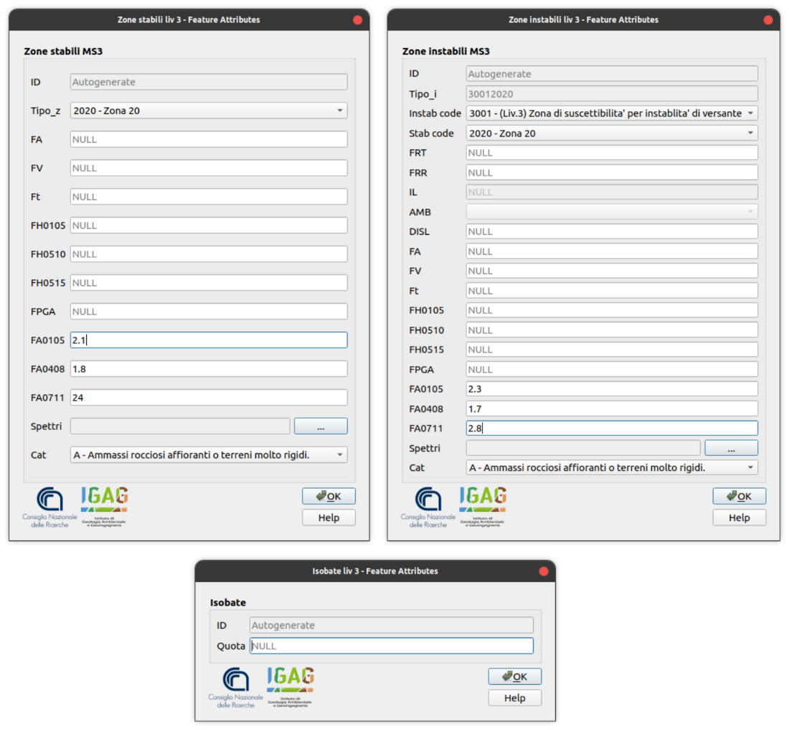
Figure A6. Data entry Forms for the attributes of SM Level 3 Map: Zone stabili MS3, Zone instabili MS3 e Isobate liv.3.
- Isobate liv 3 form for data entry of the depth quotas meters above sea level (m a.s.l.) of the seismic bedrock isolines (SM level 3).
- Zone Instabili liv 3 form for the data entry of the instability codes (Tipo_i) (Table A7 from ID n.1 to ID n.6) which are self-filled by entering the Instab code and the corresponding microzone code (Stab code). Table A14 shows the classes of amplification factor values (FA) that correspond to the symbology colors of level 3 SM maps. The unstable microzones are divided into zones of susceptibility and zones of respect for active and capable faults, landslides and liquefaction. The liquefaction zones and the slope instabilities are characterized by further parameters shown in Tables A15 and Table A16 that distinguish the symbolism of the instabilities in the SM level 3 maps with particular cartographic patterns. Other data that can be entered are the Environmental and Age Indices of the deposits affected by potential liquefaction (AMB) (Table A13); the Amplification Factors (FA, FV, Ft, FH0105, FH0510, FH0515, FPGA, FA0105 , FA0408, FA0711); The Soil categories (Cat.) shown in Table A17 and Attachment for loading the seismic spectra (Spettri).

Table A15. Values of the liquefaction index in the instability zones: Susceptible (ZS) and Respect (ZR). The symbol "|| "In the codes it has the meaning of" concatenate”.
Unstable zones (Z): susceptible (S), respect (R) | ZS _{LQ} |  | ZR _{LQ}
Liquefaction index (IL) | 2 < IL ≤ 5 | 5 < IL ≤1 5 | IL > 15
Instability Code || Stable zones susceptible to local amplification CODE | 3052||2000+1n | 3052||2000+1n | 3053||2000+1n

Table A16. Values of the shift of slope instability in the susceptible zones (ZS) and in the respect zones (ZR) . The symbol “|| "In the codes it has the meaning of" concatenate”
Zones of slope Instability | ZS_{FR} |  |  | ZS_{FR}
Estimated cumulative displacement in landslide | 0<FRT≤ 0.15 m | 1<FRT≤ 1 m | FRT>1m | Calculated displacement
Estimated cumulative displacement in rockslide | 0<FRR≤ 10 m | 1<FRR≤ 50 m | FRR>50m | Calculated displacement
Instability Code || Stable zones susceptible to local amplification CODE | 3001||2000+1n | 3001||2000+1n | 3001||2000+1n | 3002||2000+1n

Code | Description
A | Surface rock masses or very rigid soils
B | Soft rocks and very thickened coarse-grained soil deposits or very consistent fine-grained soils
C | Deposits of medium-thickened coarse-grained soils or medium-fine-grained soils
D | Deposits of poorly densified coarse-grained soils or poorly consistent fine-grained soils
E | Soils with characteristics and velocity values (Vs) equivalent to those defined for categories C or D
Table A17. This is a table. Tables should be placed in the main text near to the first time they are cited.

- Zone stabili liv. 3 this form compiles the codes shown in Table 12 through a special drop-down menu containing the descriptions of the codes of the geological substrates and the recent sedimentary coverings and the values of the amplification factors (FA, FV, Ft, FH0105, FH0510, FH0515) are entered, FPGA, FA0105, FA0408, FA0711). The classes of symbology-related amplification factor (FA) values are shown in Table A14. Other data that can be entered are the Environmental and Age Indices of the deposits affected by potential liquefaction (AMB) (Table A13); the Amplification Factors (FA, FV, Ft, FH0105, FH0510, FH0515, FPGA, FA0105 , FA0408, FA0711); The Soil categories (Cat.) shown in Table A17 and Attachment for loading the seismic spectra (Spettri).

