- Appendix A
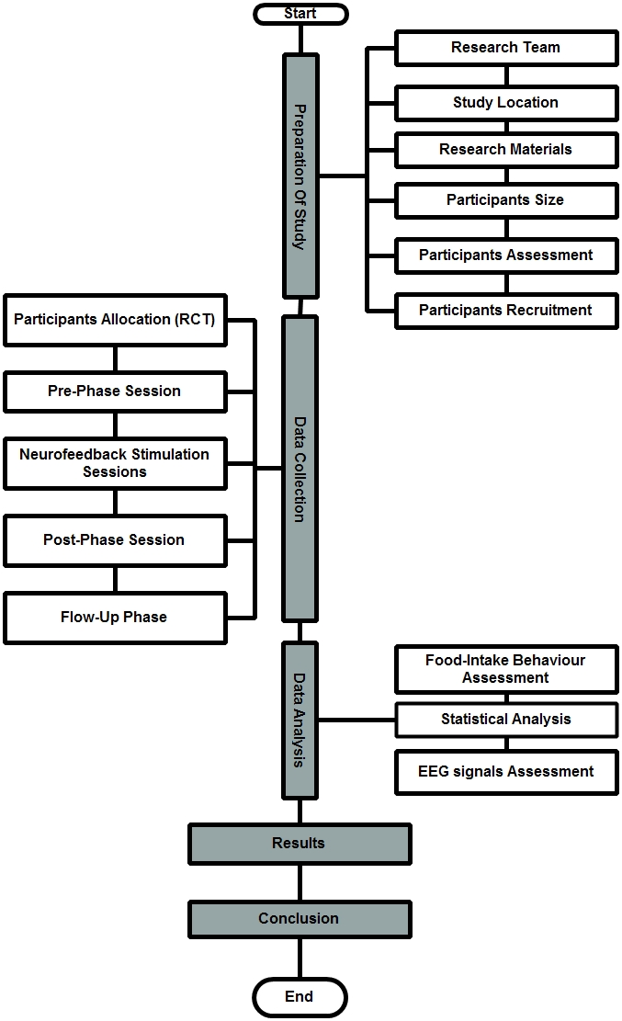
Figure 1. Study Structure

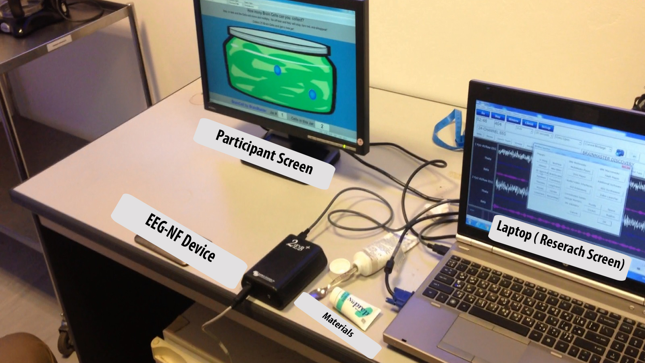
Figure 2. Overview of EEG-NF setup

- Appendix B

Participants Size Calculation
The ideal number of participants to be involved in this study is calculated by using the Hypothesis testing method[1]. The null hypothesis defined is that food intake behavior is not different among groups. The alternative hypothesis defined is that the food intake behavior is significantly different among groups.
Consequently, the food intake behavior is selected as the test variable and the impact of EEG-NF stimulation on this behavior has been extracted from a previous study [2]. The formula (1) for the sample size calculation:
 | $$N =\frac{{2 SD}^{2}{\left\lfloor z_{1-\frac{α}{2}}+ z_{1-β}\right\rfloor }^{2}}{{\left(μ_{1}-μ_{2}\right)}^{2}}$$ | (1)
Where N: sample size in each group; Z_{1-α/2}: represents the desired level of significant level (1.64); Z1_{-β}: represents the desired power (1.96); µ1- µ2: Effect Size (the difference in means); SD: Standard deviation.
Table 1. Participant’s size calculation
Previous study | WLG (N₁) | NFG (N₂) | µ₁₋ µ₂ | SD | Sample Size
[2] | 13 | 14 | 2.51 | 1.73 | 12

NFG: Neurofeedback Group (intervention); WLG: Wait List Group (non-intervention)
The satisfactory figure of power test in biomedical researches statistics is 80%, while above 80 statistical power will give good study design, therefore, the power test of 90% has been selected in this study and significance level for rejecting a null hypothesis is 5%. The sample size is calculated as follows:
 | $N=\frac{{2 (1.73)}^{2}{\left\lfloor 1.64+ 1.96\right\rfloor }^{2}}{{\left(2.51\right)}^{2}}$ = 12 | (2)
Therefore, the suitable target number of participants per group is 12 or more. However, in this study the total number of participants recruited is 24.

- Appendix C (Questionnaire A & B)
Food Intake Behaviour- Questionnaire A
- How many times did you eat per day last week?

- Which kind of food you intake a lot :
□Fast food □ Snack food □Home food □ All of them
- How did you feel your food intake behaviour (FIB):
□Normal □ Neither Normal nor Abnormal □Abnormal
Please read the each question carefully and only choose one answer for each one:
- When you eat what you are craving , you won't be able to stop once you start (CA) :
□disagree □ neither disagree nor agree □agree
- You find yourself preoccupied with food (PWF):
□disagree □ neither disagree nor agree □agree
- You want to eat when you feel bored , angry or sad (Feeling):
□disagree □ neither disagree nor agree □agree

- Once you start eating , you have trouble stopping (TSE):
□disagree □ neither disagree nor agree □agree
- The emotions often make you want to eat (Emotions):
□disagree □ neither disagree nor agree □agree

Thank you …..
Food Intake Behavior- Questionnaire B

Question 1 : How did you feel during sessions? (circle your response)
- Excellent
- Very good
- Good
- Average
- Bad
- Very bad
- Terrible
Question 2 : After 8 sessions , How did you feel your food intake behavior (FIB):
□Normal □ Neither Normal nor Abnormal □Abnormal
**Please read each question carefully and only choose one answer for each one (the answers should be accordance to your feeling in last week):
- When you eat what you are craving , you won't able to stop once you start (CA):
□disagree □ neither disagree nor agree □agree
- You find yourself preoccupied with food (PWF):
□disagree □ neither disagree nor agree □agree
- You want to eat when you feel bored , angry or sad (Feeling):
□disagree □ neither disagree nor agree □agree
- Once you start eating , you have trouble stopping (TSE):
□disagree □ neither disagree nor agree □agree
- The emotions often make you want to eat (Emotions):
□disagree □ neither disagree nor agree □agree

Reference

[1] B. Sathian, J. Sreedharan, S. N. Baboo, and et al, “Relevance of Sample Size Determination in Medical Research,” Nepal J. Epidemiol., vol. 1, no. 1, pp. 4–10, 2010.
[2] J. Schmidt and A. Martin, “Neurofeedback Reduces Overeating Episodes in Female Restrained Eaters: A Randomized Controlled Pilot-Study,” Appl. Psychophysiol. Biofeedback, vol. 40, no. 4, pp. 283–295, 2015.

