Supplementary Information
Intelligent Image Classification for Grading Egyptian Cotton Lint
Oliver J. Fisher¹, Ahmed Rady¹, Aly A. A. El-Banna², Nicholas J. Watson1^{1*}, Haitham H. Emaish³
¹ Food, Water, Waste Research Group, Faculty of Engineering, University of Nottingham, Nottingham, UK; olivert.fisher@nottingham.ac.uk; ahmed.rady@nottingham.ac.uk
² Department of Plant Production, Faculty of Agriculture, Saba Basha, Alexandria University, Egypt; aly-elsawy@alexu.edu.eg
³ Department of Soils and Agricultural Chemistry, Faculty of Agriculture, Saba Basha, Alexandria University, Egypt; drhaitham1976@alexu.edu.eg
* nicholas.watson@nottingham.ac.uk

Table of Contents
Figure S1 Distribution of the cultivar Giza 87 extracted features (a) L*, (b) a*, (c) b* and (d) impurity data across the Egyptian cotton lint grades 2
Figure S2 Distribution of the cultivar Giza 90 extracted features (a) L*, (b) a*, (c) b* and (d) impurity data across the Egyptian cotton lint grades 2
Figure S3 Distribution of the cultivar Giza 94 extracted features (a) L*, (b) a*, (c) b* and (d) impurity data across the Egyptian cotton lint grades 3
Figure S4 Distribution of the cultivar Giza 96 extracted features (a) L*, (b) a*, (c) b* and (d) impurity data across the Egyptian cotton lint grades 3
Figure S5 The feature impurity plotted against L* (a.b), a* (c,d) and b* (e,f) features and labelled using the actual cotton lint labels (a, c and e) and the K-means clusters (b, d and f) for cultivar Giza 87 4
Figure S6 The feature impurity plotted against L* (a.b), a* (c,d) and b* (e,f) features and labelled using the actual cotton lint labels (a, c and e) and the K-means clusters (b, d and f) for cultivar Giza 90 5
Figure S7 The feature impurity plotted against L* (a.b), a* (c,d) and b* (e,f) features and labelled using the actual cotton lint labels (a, c and e) and the K-means clusters (b, d and f) for cultivar Giza 94 6
Figure S8 The feature impurity plotted against L* (a.b), a* (c,d) and b* (e,f) features and labelled using the actual cotton lint labels (a, c and e) and the K-means clusters (b, d and f) for cultivar Giza 96 7

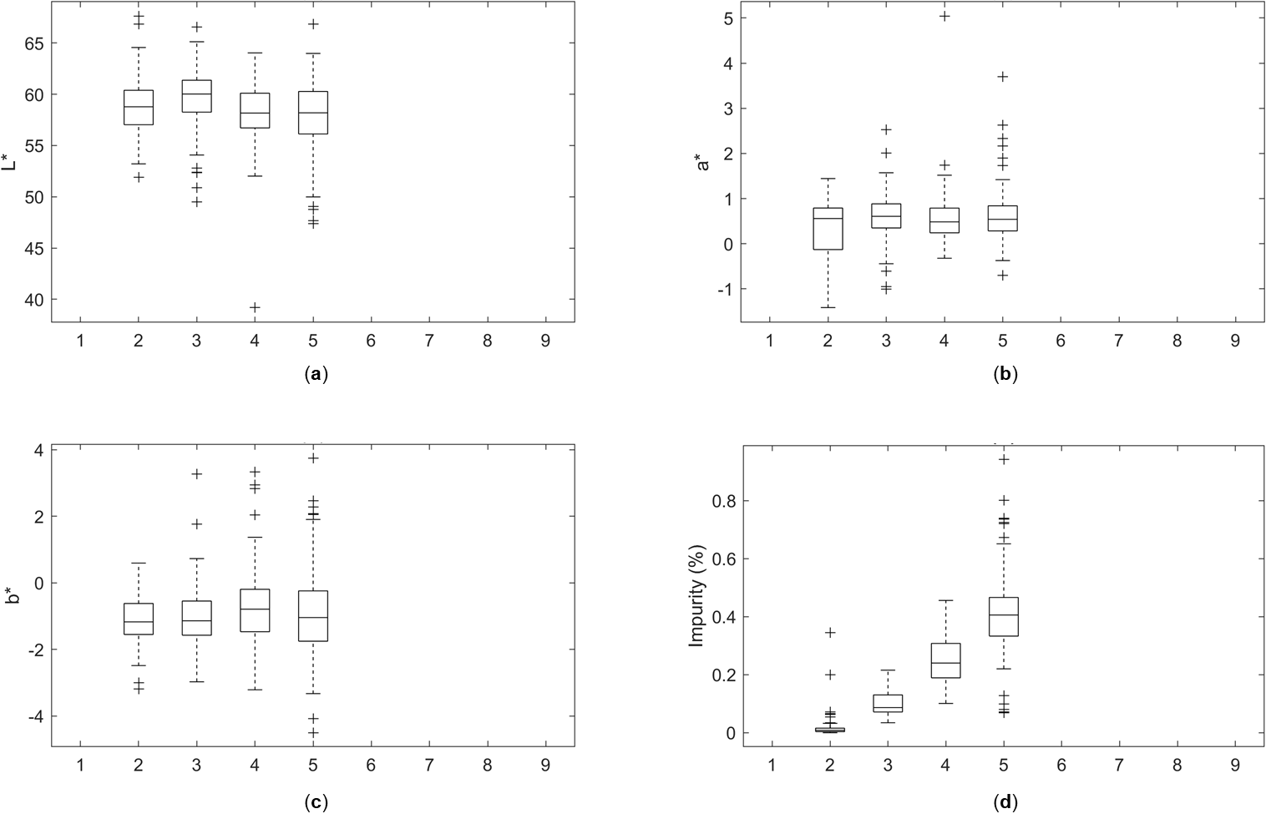
Figure S1 Distribution of the cultivar Giza 87 extracted features (a) L*, (b) a*, (c) b* and (d) impurity data across the Egyptian cotton lint grades
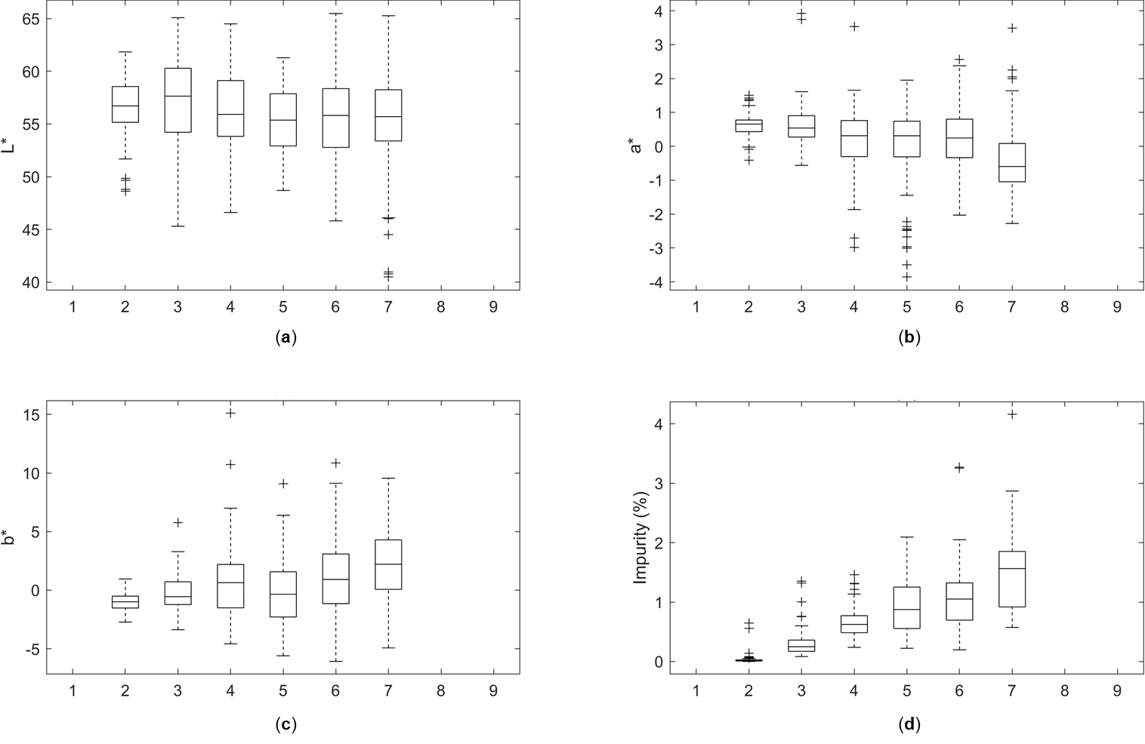
Figure S2 Distribution of the cultivar Giza 90 extracted features (a) L*, (b) a*, (c) b* and (d) impurity data across the Egyptian cotton lint grades
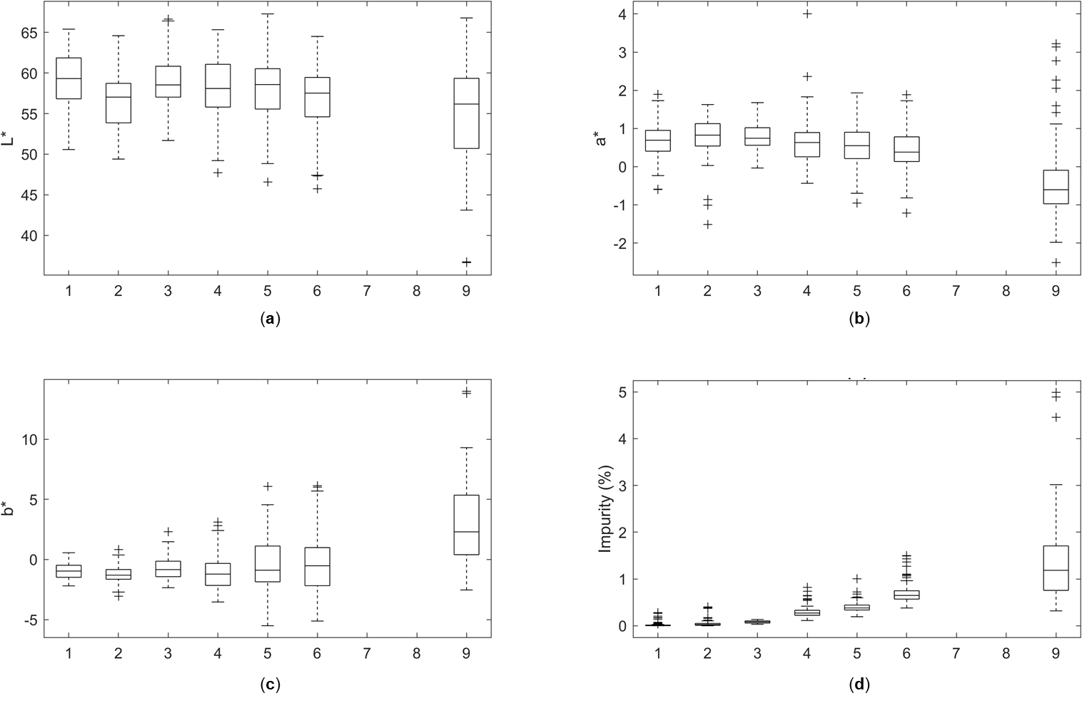
Figure S3 Distribution of the cultivar Giza 94 extracted features (a) L*, (b) a*, (c) b* and (d) impurity data across the Egyptian cotton lint grades
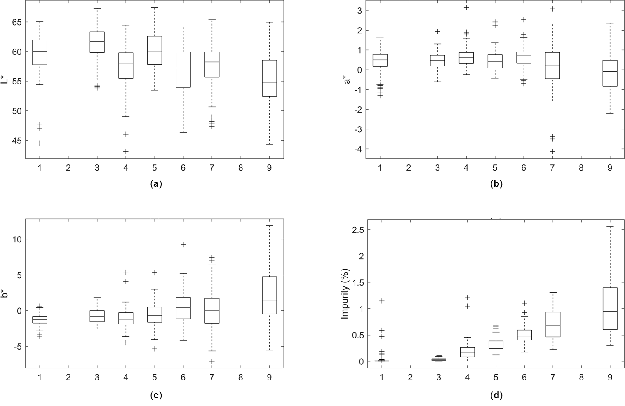
Figure S4 Distribution of the cultivar Giza 96 extracted features (a) L*, (b) a*, (c) b* and (d) impurity data across the Egyptian cotton lint grades

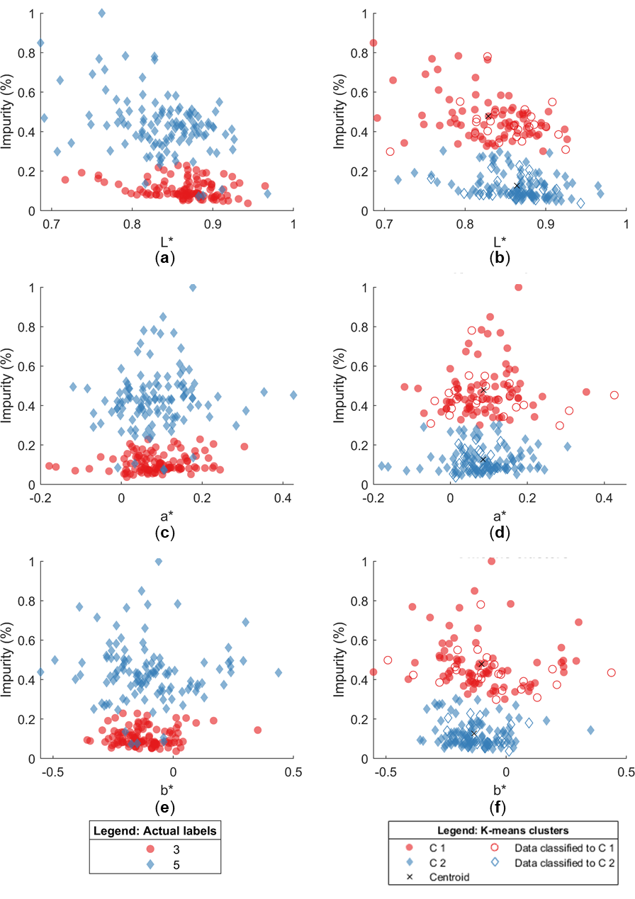
Figure S5 The feature impurity plotted against L* (a.b), a* (c,d) and b* (e,f) features and labelled using the actual cotton lint labels (a, c and e) and the K-means clusters (b, d and f) for cultivar Giza 87.

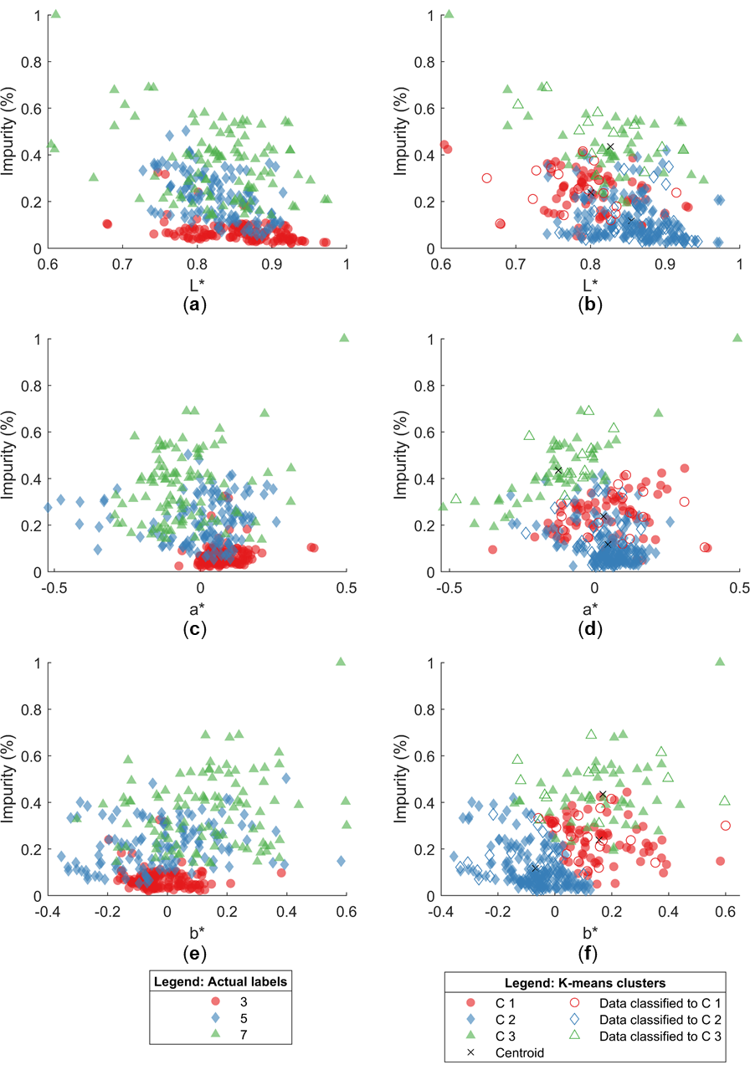
Figure S6 The feature impurity plotted against L* (a.b), a* (c,d) and b* (e,f) features and labelled using the actual cotton lint labels (a, c and e) and the K-means clusters (b, d and f) for cultivar Giza 90.
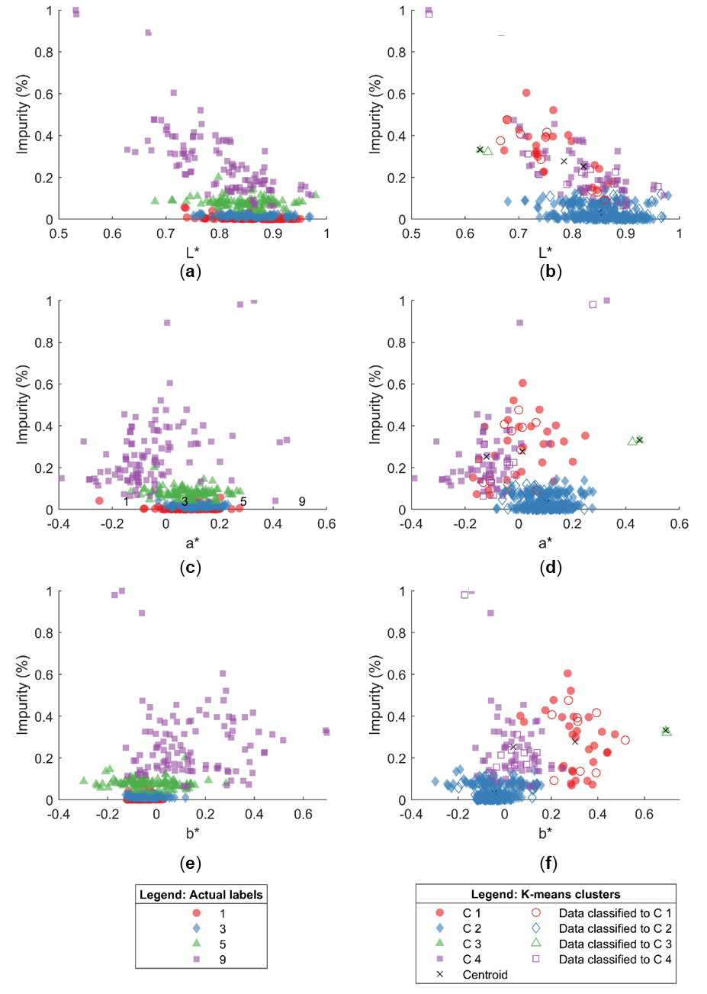
Figure S7 The feature impurity plotted against L* (a.b), a* (c,d) and b* (e,f) features and labelled using the actual cotton lint labels (a, c and e) and the K-means clusters (b, d and f) for cultivar Giza 94.
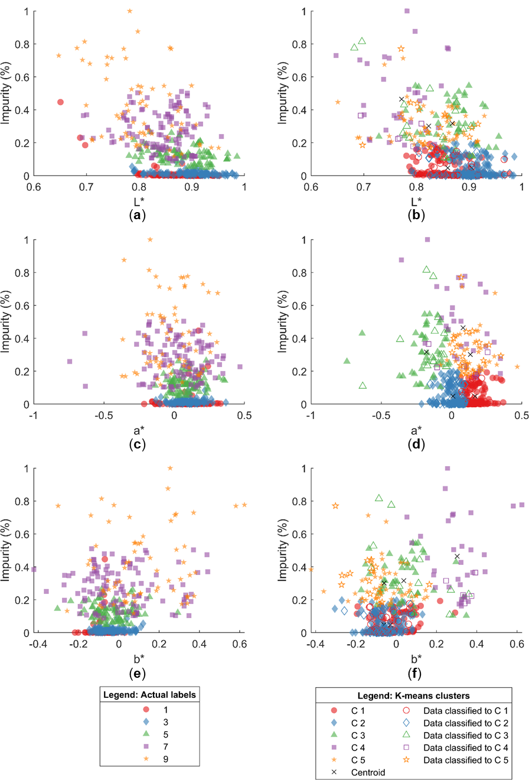
Figure S8 The feature impurity plotted against L* (a.b), a* (c,d) and b* (e,f) features and labelled using the actual cotton lint labels (a, c and e) and the K-means clusters (b, d and f) for cultivar Giza 96.

