Supplementary Information

Stratigraphy

Figure S1. Photograph of core REM3A, collected adjacent REM3B, and stratigraphic log as documented in Vinnepand et al. (2020).

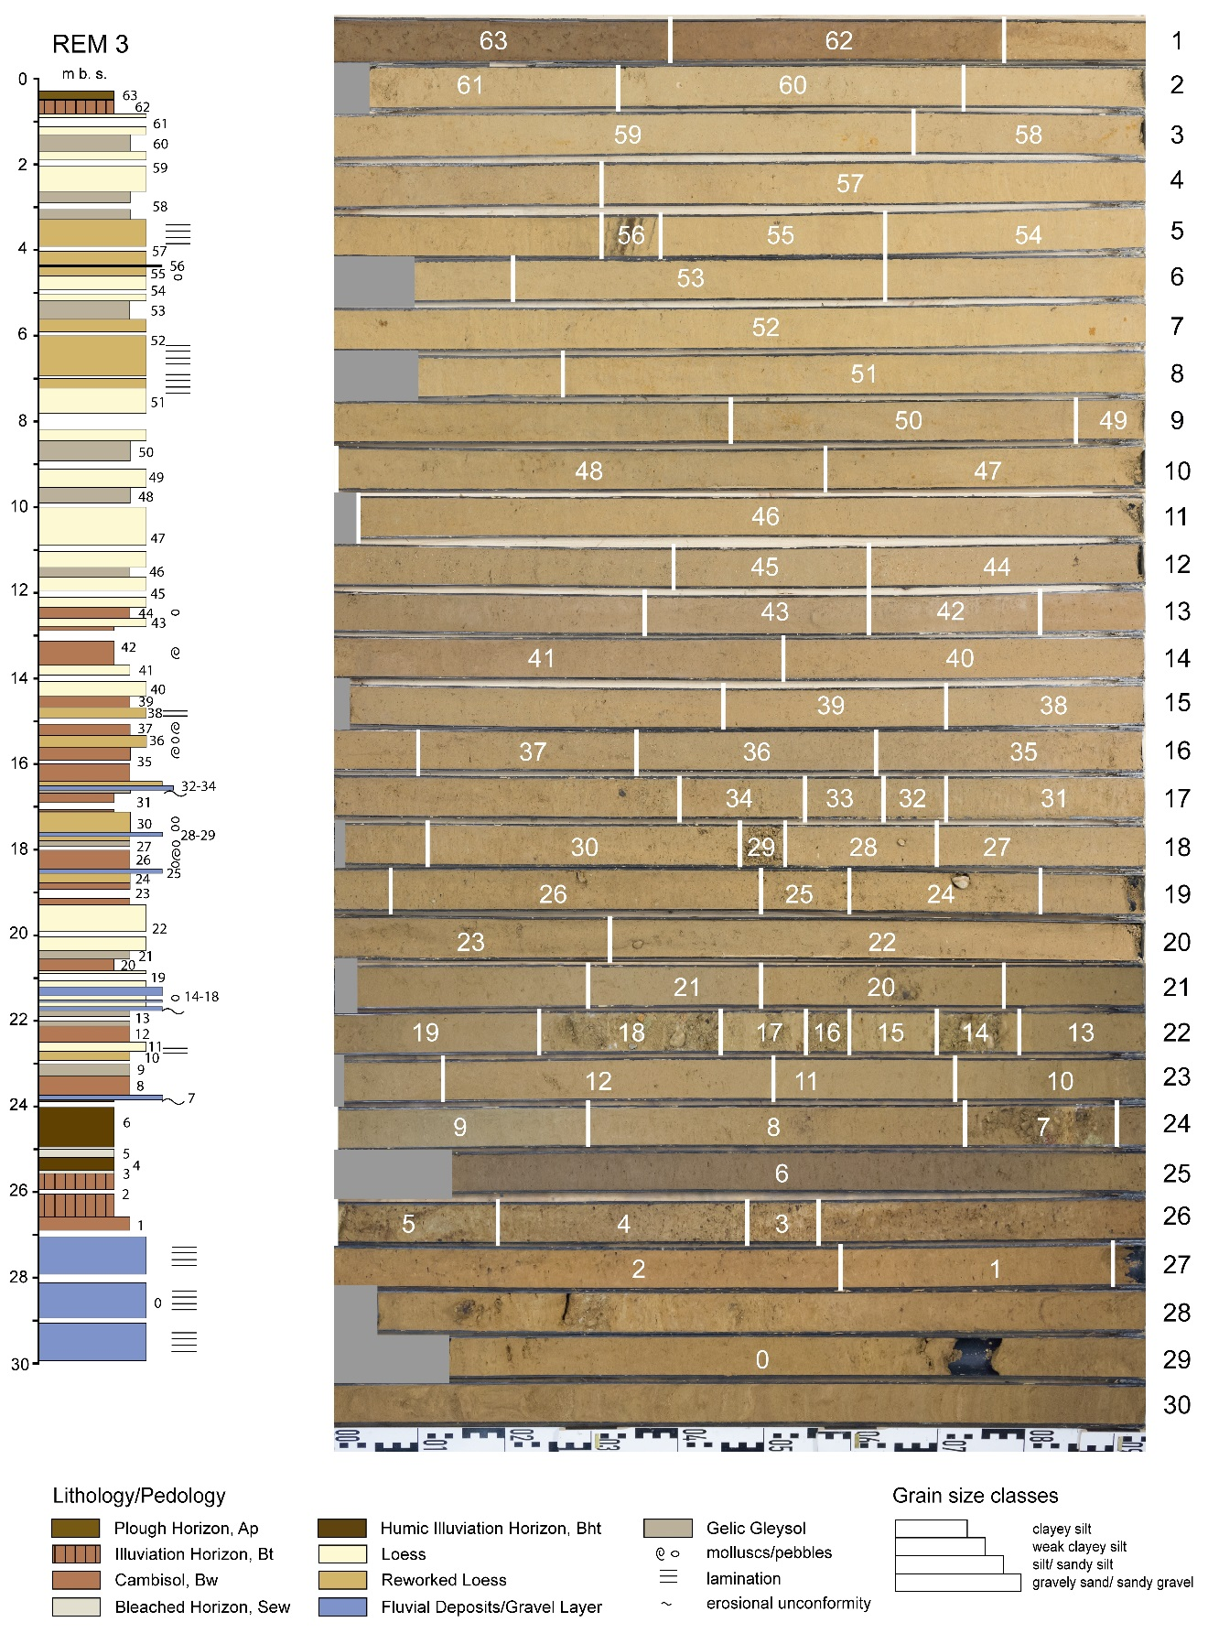

Luminescence Measurements

Equivalent dose measurements, profile RP1
Table S1. Overview of luminescence samples collected from the profile RP1. The number of aliquots measured for each size and mineral fraction, determined by availability, is provided in the respective columns. Equivalent dose is given as the mean of the accepted aliquots.
Sample | Depth (m) | Approx. D_{e} (Gy) | Stratigraphic description | Luminescence sensitivity measurements (number of aliquots)
 |  |  |  | Quartz |  | Polymineral
 |  |  |  | 63-100 µm | 100-200 µm | 4-11 µm
MAL10349 | 3.50 ± 0.05 | 80 | Primary loess (MIS2) | 21 | 0 | 18
MAL10348 | 4.25 ± 0.05 | 80 | Primary loess (MIS3) | 24 | 18 | 18
MAL10347 | 4.95 ± 0.05 | 80 | Weak paleosol (MIS3) | 24 | 14 | 18
MAL10346 | 6.35 ± 0.05 | 96 | Primary loess (MIS3) | 24 | 24 | 18

Table S2. Summary of equivalent dose values for the different mineral and grain-size fractions measured for profile RP1 (see Fischer et al. 2021 for more details). The number of aliquots measured for each sample is given as n.
Sample | Depth from surface (m) | Quartz D_{e} (Gy) |  |  |  | Polymineral D_{e} (Gy)
 |  | 100-200 µm | n | 63-100 µm | n | 4-11 µm | n
MAL10349 | 3.50 ± 0.05 | - | - | 59.3 ± 2.4 | 21 | 77.7 ± 1.1 | 17
MAL10348 | 4.25 ± 0.05 | 72.8 ± 3.3 | 9 | 70.2 ± 2.7 | 18 | 80.4 ± 1.8 | 17
MAL10347 | 4.95 ± 0.05 | 91.7 ± 5.6 | 4 | 79.3 ± 4.4 | 20 | 81.4 ± 1.4 | 13
MAL10346 | 6.35 ± 0.05 | 81.2 ± 6.0 | 18 | 86.0 ± 3.5 | 21 | 100 ± 1.3 | 18

Figure S2. Equivalent dose vs. depth for the different mineral and grain-size fractions measured for profile RP1. Uncertainties shown are for 1σ.

Equivalent dose measurements, REM3B core

Table S3. Overview of samples from core REM3B measured for this study with respect to measurement protocol, mineral and grain-size fraction. From a total of 102 samples collected from the core, 83 were measured for unprocessed IRSL₅₀, 10 for 63-90 µm polymineral pIR₂₀₀IR₂₉₀, 8 for 63-90 µm K-feldspar pIR₅₀IR₂₉₀, 5 for 63-90 µm quartz OSL and 10 for 4-11 µm quartz OSL.
Sample | Depth (m) | IRSL₅₀ (bulk) | pIR₅₀IR₂₉₀ (63-90 µm, polymineral) | pIR₂₀₀IR₂₉₀ (63-90 µm, K-feldspar) | OSL (63-90 µm, quartz) | OSL (4-11 µm, quartz)
A0164 | 29.80 ± 0.05 |  |  |  |  | X
A0166 | 28.85 ± 0.05 |  |  |  |  | X
A0167 | 28.45 ± 0.05 |  |  |  |  | X
A0168 | 27.75 ± 0.05 |  |  |  |  | X
A0171 | 26.35 ± 0.05 | X |  |  |  | X
A0172 | 25.30 ± 0.05 |  |  |  |  | X
A0174 | 24.25 ± 0.05 | X |  |  |  | X
A0175 | 23.65 ± 0.05 | X |  |  |  | X
A0176 | 23.45 ± 0.05 | X |  |  |  | X
A0177 | 23.20 ± 0.05 | X |  |  |  | X
A0179 | 22.55 ± 0.05 | X
A0180 | 22.35 ± 0.05 | X
A0181 | 22.15 ± 0.05 | X
A0182 | 21.85 ± 0.05 | X
A0183 | 21.65 ± 0.05 | X
A0184 | 21.35 ± 0.05 | X
A0185 | 21.15 ± 0.05 | X
A0186 | 20.80 ± 0.05 | X
A0187 | 20.55 ± 0.05 | X
A0188 | 20.35 ± 0.05 | X
A0189 | 20.10 ± 0.05 | X
A0190 | 19.80 ± 0.05 | X
A0191 | 19.45 ± 0.05 | X
A0192 | 19.15 ± 0.05 | X
A0193 | 18.80 ± 0.05 | X
A0194 | 18.55 ± 0.05 | X
A0195 | 18.15 ± 0.05 | X
A0196 | 17.80 ± 0.05 | X
A0197 | 17.60 ± 0.05 | X
A0198 | 17.35 ± 0.05 | X
A0199 | 17.15 ± 0.05 | X
A0200 | 16.80 ± 0.05 | X
A0201 | 16.55 ± 0.05 | X |  | X
A0202 | 16.35 ± 0.05 | X
A0203 | 16.15 ± 0.05 | X
A0204 | 15.80 ± 0.05 | X
A0205 | 15.45 ± 0.05 | X
A0206 | 15.15 ± 0.05 | X
A0207 | 14.85 ± 0.05 | X
A0208 | 14.65 ± 0.05 | X
A0209 | 14.35 ± 0.05 | X
A0210 | 14.15 ± 0.05 | X
A0211 | 13.85 ± 0.05 | X
A0212 | 13.65 ± 0.05 | X
A0213 | 13.45 ± 0.05 | X
A0214 | 13.20 ± 0.05 | X
A0215 | 12.85 ± 0.05 | X
A0216 | 12.65 ± 0.05 |  |  | X
A0217 | 12.45 ± 0.05 | X
A0218 | 12.25 ± 0.05 | X
A0219 | 12.10 ± 0.05 | X
A0220 | 11.80 ± 0.05 |  |  | X
A0221 | 11.50 ± 0.05 | X
A0222 | 11.30 ± 0.05 | X
A0223 | 11.10 ± 0.05 | X
A0347 | 10.80 ± 0.05 | X
A0348 | 10.50 ± 0.05 |  |  | X
A0349 | 10.30 ± 0.05 | X
A0350 | 10.10 ± 0.05 | X
A0351 | 9.80 ± 0.05 | X
A0352 | 9.60 ± 0.05 | X
A0353 | 9.40 ± 0.05 | X
A0354 | 9.20 ± 0.05 |  |  | X
A0355 | 8.75 ± 0.05 | X
A0356 | 8.55 ± 0.05 | X
A0357 | 8.35 ± 0.05 | X
A0358 | 8.15 ± 0.05 | X
A0359 | 7.80 ± 0.05 | X
A0360 | 7.60 ± 0.05 |  |  | X
A0361 | 7.40 ± 0.05 | X
A0362 | 7.15 ± 0.05 | X
A0363 | 6.85 ± 0.05 | X
A0364 | 6.65 ± 0.05 | X
A0365 | 6.45 ± 0.05 |  |  | X | X
A0366 | 6.25 ± 0.05 | X
A0367 | 6.10 ± 0.05 | X
A0368 | 5.81 ± 0.05 | X
A0369 | 5.65 ± 0.05 | X
A0370 | 5.45 ± 0.05 |  |  | X | X
A0371 | 5.25 ± 0.05 | X
A0372 | 5.10 ± 0.05 | X
A0373 | 4.80 ± 0.05 | X
A0374 | 4.60 ± 0.05 | X
A0375 | 4.45 ± 0.05 |  |  | X | X
A0376 | 4.25 ± 0.05 |  |  | X | X
A0377 | 4.10 ± 0.05 | X
A0378 | 3.75 ± 0.05 | X
A0379 | 3.45 ± 0.05 |  | X | X | X
A0380 | 3.15 ± 0.05 | X | X
A0381 | 2.85 ± 0.05 | X | X
A0382 | 2.55 ± 0.05 | X | X
A0383 | 2.35 ± 0.05 | X | X
A0384 | 2.15 ± 0.05 | X | X
A0385 | 1.80 ± 0.05 | X | X
A0386 | 1.50 ± 0.05 | X
A0387 | 1.25 ± 0.05 | X | X
A0388 | 0.75 ± 0.05 | X

Table S4. Dose recovery and residual dose results for selected samples from core REM3B measured using the pIR₂₀₀IR₂₉₀ protocol. Three aliquots were measured for the dose recovery test, and six each for the residual dose tests.
Sample | Dose recovery |  |  | Residual dose
 | Applied dose (Gy) | Measured dose (Gy) | Ratio | Bleaching method | Dose (Gy)
A0375 | 104 | 107 ± 5 | 1.02 | 60 days direct sunlight | 6.75 ± 0.3
A0376 | - |  |  | 300 hours LED lamp | 32.7 ± 4.0

Table S5. Summary of depths and averaged D_{e} values and test dose sensitivity values for the ten fine-grained (4-11µm) and five very fine sand (63-90 µm) quartz OSL samples measured in this study. Three aliquots were measured for each sample, using a measurement protocol involving three regenerative dose steps, preheat/cutheat temperatures of 260/240°C and a test dose of c. 37 Gy. Minimum equivalent doses are assumed to represent signal saturation.
Sample | Depth (m) | Grain-size fraction (µm) | Averaged D_{e} (Gy)
A0164 | 29.80 ± 0.05 | 4-11 | No signal
A0166 | 28.85 ± 0.05 |  | >290
A0167 | 28.45 ± 0.05 |  | >290
A0168 | 27.75 ± 0.05 |  | >290
A0171 | 26.35 ± 0.05 |  | >102
A0172 | 25.30 ± 0.05 |  | >474
A0174 | 24.25 ± 0.05 |  | >239
A0175 | 23.65 ± 0.05 |  | 191 ± 9
A0176 | 23.45 ± 0.05 |  | 209 ± 18
A0177 | 23.20 ± 0.05 |  | 78.1 ± 38.6
A0365 | 6.45 ± 0.05 | 63-90 | 55.1 ± 8.3
A0370 | 5.45 ± 0.05 |  | 51.0 ± 12.1
A0375 | 4.45 ± 0.05 |  | 63.5 ± 9.9
A0376 | 4.25 ± 0.05 |  | 135 ± 94
A0379 | 3.45 ± 0.05 |  | 50.0 ± 7.0

Table S6. Summary of depths, number of aliquots measured, measurement protocol and averaged uncorrected D_{e} values for the 18 very fine sand (63-90µm) feldspar samples measured in this study using pIR-IR protocols. The D_{e} uncertainty is given as the standard error.
Sample | Depth (m) | Number of aliquots measured | Measurement protocol | Averaged D_{e} (Gy) ± se
A0201 | 16.60 ± 0.05 | 6 | pIR₂₀₀IR₂₉₀ | 174 ± 3
A0216 | 12.65 ± 0.05 | 6 |  | 133 ± 3
A0220 | 11.80 ± 0.05 | 6 |  | 114 ± 3
A0348 | 10.50 ± 0.05 | 6 |  | 120 ± 4
A0354 | 9.20 ± 0.05 | 6 |  | 116 ± 8
A0360 | 7.60 ± 0.05 | 6 |  | 117 ± 3
A0365 | 6.45 ± 0.05 | 12 |  | 122 ± 11
A0370 | 5.45 ± 0.05 | 12 |  | 131 ± 6
A0375 | 4.45 ± 0.05 | 12 |  | 112 ± 4
A0376 | 4.25 ± 0.05 | 6 |  | 113 ± 4
A0379 | 3.45 ± 0.05 | 6 | pIR₂₀₀IR₂₉₀ | 113 ± 4
 |  | 24 | pIR₅₀IR₂₉₀ | 85.8 ± 1.0
A0380 | 3.45 ± 0.05 | 24 | pIR₅₀IR₂₉₀ | 77.0 ± 1.5
A0381 | 3.15 ± 0.05 | 24 |  | 81.7 ± 3.4
A0382 | 2.85 ± 0.05 | 24 |  | 87.8 ± 2.6
A0383 | 2.55 ± 0.05 | 24 |  | 87.7 ± 1.1
A0384 | 2.15 ± 0.05 | 24 |  | 84.1 ± 4.1
A0385 | 1.80 ± 0.05 | 24 |  | 83.4 ± 1.8
A0387 | 1.25 ± 0.05 | 24 |  | 77.5 ± 0.9

Figure S3. Differences in equivalent dose vs. depth for the different mineral and grain size fractions down the REM3B core, using pIR-IRSL equivalent dose values uncorrected for residual dose. The IRSL50 results are based on bulk, unprocessed sample.

Sensitivity measurements

Table S7. Summary of depths, averaged D_{e} values and test dose sensitivity values for the bulk IRSL₅₀ measurements from the REM3B core. Three aliquots were measured for each sample, applying a test dose of c. 37 Gy following measurement of the natural IRSL signal at 50°C. Equivalent dose is given as the mean of the accepted aliquots.
Sample | Depth (m) | Approximate D_{e} (Gy) | Sensitivity (cts/s/Gy) ± 1σ
A0171 | 26.35 ± 0.05 | 108 | 2980 ± 1513
A0174 | 24.25 ± 0.05 | 67 | 1259 ± 1027
A0175 | 23.65 ± 0.05 | 61 | 3088 ± 2115
A0176 | 23.45 ± 0.05 | 55 | 4855 ± 562
A0177 | 23.20 ± 0.05 | 60 | 6411 ± 3140
A0179 | 22.55 ± 0.05 | 62 | 5769 ± 2067
A0180 | 22.35 ± 0.05 | 57 | 6285 ± 1133
A0181 | 22.15 ± 0.05 | 54 | 10016 ± 3149
A0182 | 21.85 ± 0.05 | 55 | 9768 ± 2240
A0183 | 21.65 ± 0.05 | 61 | 6512 ± 1368
A0184 | 21.35 ± 0.05 | 56 | 4339 ± 3224
A0185 | 21.15 ± 0.05 | 55 | 6414 ± 1583
A0186 | 20.80 ± 0.05 | 59 | 5892 ± 1191
A0187 | 20.55 ± 0.05 | 65 | 5473 ± 985
A0188 | 20.35 ± 0.05 | 56 | 6189 ± 2591
A0189 | 20.10 ± 0.05 | 60 | 6577 ± 465
A0190 | 19.80 ± 0.05 | 61 | 6901 ± 1349
A0191 | 19.45 ± 0.05 | 59 | 5811 ± 1405
A0192 | 19.15 ± 0.05 | 59 | 3574 ± 972
A0193 | 18.80 ± 0.05 | 64 | 4632 ± 2671
A0194 | 18.55 ± 0.05 | 59 | 5932 ± 2793
A0195 | 18.15 ± 0.05 | 57 | 3871 ± 2123
A0196 | 17.80 ± 0.05 | 53 | 5014 ± 1927
A0197 | 17.60 ± 0.05 | 55 | 3988 ± 1972
A0198 | 17.35 ± 0.05 | 56 | 4087 ± 130
A0199 | 17.15 ± 0.05 | 56 | 4612 ± 496
A0200 | 16.80 ± 0.05 | 50 | 5673 ± 1201
A0201 | 16.55 ± 0.05 | 53 | 7767 ± 676
A0202 | 16.35 ± 0.05 | 48 | 4067 ± 10
A0203 | 16.15 ± 0.05 | 46 | 4411 ± 4525
A0204 | 15.80 ± 0.05 | 43 | 4252 ± 1835
A0205 | 15.45 ± 0.05 | 44 | 4984 ± 1475
A0206 | 15.15 ± 0.05 | 44 | 6868 ± 2365
A0207 | 14.85 ± 0.05 | 42 | 10013 ± 2312
A0208 | 14.65 ± 0.05 | 44 | 12048 ± 2868
A0209 | 14.35 ± 0.05 | 43 | 10922 ± 526
A0210 | 14.15 ± 0.05 | 40 | 7022 ± 2306
A0211 | 13.85 ± 0.05 | 41 | 5656 ± 2103
A0212 | 13.65 ± 0.05 | 42 | 4356 ± 825
A0213 | 13.45 ± 0.05 | 41 | 5881 ± 1798
A0214 | 13.20 ± 0.05 | 42 | 3795 ± 2393
A0215 | 12.85 ± 0.05 | 41 | 2859 ± 1380
A0217 | 12.45 ± 0.05 | 40 | 4004 ± 99
A0218 | 12.25 ± 0.05 | 40 | 6024 ± 1844
A0219 | 12.10 ± 0.05 | 36 | 9457 ± 4669
A0221 | 11.50 ± 0.05 | 36 | 7505 ± 674
A0222 | 11.30 ± 0.05 | 34 | 10127 ± 5499
A0223 | 11.10 ± 0.05 | 37 | 6342 ± 1475
A0347 | 10.80 ± 0.05 | 35 | 8559 ± 4055
A0349 | 10.30 ± 0.05 | 33 | 8615 ± 2753
A0350 | 10.10 ± 0.05 | 32 | 7136 ± 5420
A0351 | 9.80 ± 0.05 | 32 | 7380 ± 3412
A0352 | 9.60 ± 0.05 | 32 | 7048 ± 1114
A0353 | 9.40 ± 0.05 | 30 | 7890 ± 3359
A0355 | 8.75 ± 0.05 | 31 | 6132 ± 1365
A0356 | 8.55 ± 0.05 | 33 | 7086 ± 507
A0357 | 8.35 ± 0.05 | 31 | 6025 ± 2173
A0358 | 8.15 ± 0.05 | 31 | 7388 ± 982
A0359 | 7.80 ± 0.05 | 33 | 7378 ± 2956
A0361 | 7.40 ± 0.05 | 31 | 10536 ± 3801
A0362 | 7.15 ± 0.05 | 30 | 12860 ± 1520
A0363 | 6.85 ± 0.05 | 32 | 14730 ± 5158
A0364 | 6.65 ± 0.05 | 32 | 11213 ± 3898
A0366 | 6.25 ± 0.05 | 33 | 9223 ± 2026
A0367 | 6.10 ± 0.05 | 33 | 10675 ± 483
A0368 | 5.81 ± 0.05 | 35 | 10879 ± 2010
A0369 | 5.65 ± 0.05 | 34 | 11195 ± 3145
A0371 | 5.25 ± 0.05 | 32 | 20821 ± 3144
A0372 | 5.10 ± 0.05 | 33 | 23798 ± 4648
A0373 | 4.80 ± 0.05 | 31 | 19008 ± 4645
A0374 | 4.60 ± 0.05 | 32 | 22835 ± 650
A0377 | 4.10 ± 0.05 | 33 | 21749 ± 2602
A0378 | 3.75 ± 0.05 | 32 | 29515 ± 3227
A0380 | 3.15 ± 0.05 | 30 | 4946 ± 1244
A0381 | 2.85 ± 0.05 | 28 | 6511 ± 2459
A0382 | 2.55 ± 0.05 | 29 | 7640 ± 3245
A0383 | 2.35 ± 0.05 | 29 | 4509 ± 404
A0384 | 2.15 ± 0.05 | 28 | 5855 ± 1399
A0385 | 1.80 ± 0.05 | 27 | 6400 ± 431
A0386 | 1.50 ± 0.05 | 26 | 6982 ± 2741
A0387 | 1.25 ± 0.05 | 26 | 9499 ± 2552
A0388 | 0.75 ± 0.05 | 27 | 8169 ± 2899

Table S8. Summary of depths, average and standard deviation of test dose sensitivity values for the different mineral and grain-size fractions measured for profile RP1.
Sample | Depth from surface (m) | Sensitivity (cts/s/Gy) ± 1σ
 |  | 100-200 µm quartz | 63-100 µm quartz | 4-11 µm polymineral
MAL10349 | 3.50 ± 0.05 | - | 87.8 ± 83.6 | 756 ± 67.2
MAL10348 | 4.25 ± 0.05 | 102 ± 103 | 76.6 ± 45.8 | 549 ± 44.7
MAL10347 | 4.95 ± 0.05 | 84.4 ± 55.2 | 98.3 ± 71.7 | 514 ± 35
MAL10346 | 6.35 ± 0.05 | 77.47 ± 117 | 65.3 ± 37.5 | 713 ± 55

Figure S4. Test dose sensitivity for the different mineral and grain-size samples measured for profile RP1, expressed as dot plots. The median of each set of values is marked by a black line. A logarithmic scale in (A) highlights differences between the quartz sensitivities, and a linear scale in (B) highlights differences between the polymineral fine-grained sensitivities.

A. B.

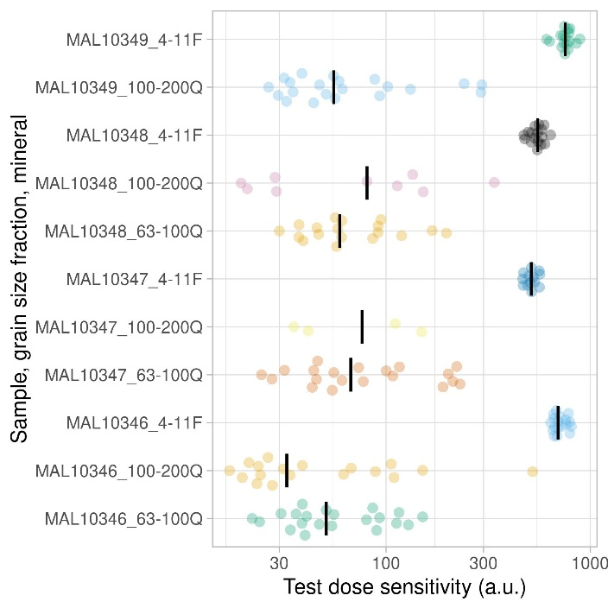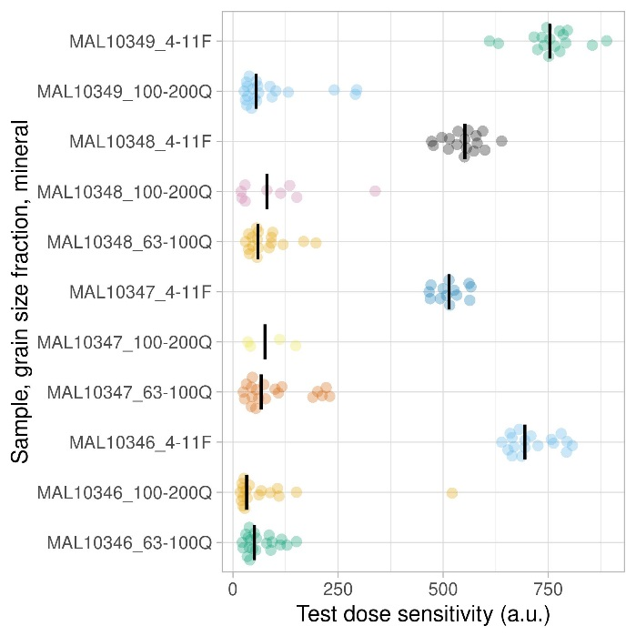

Figure S5. Test dose sensitivity for the very fine sand (63-90 µm) K-feldspar samples measured from RP1 in this study expressed as violin plot distributions.

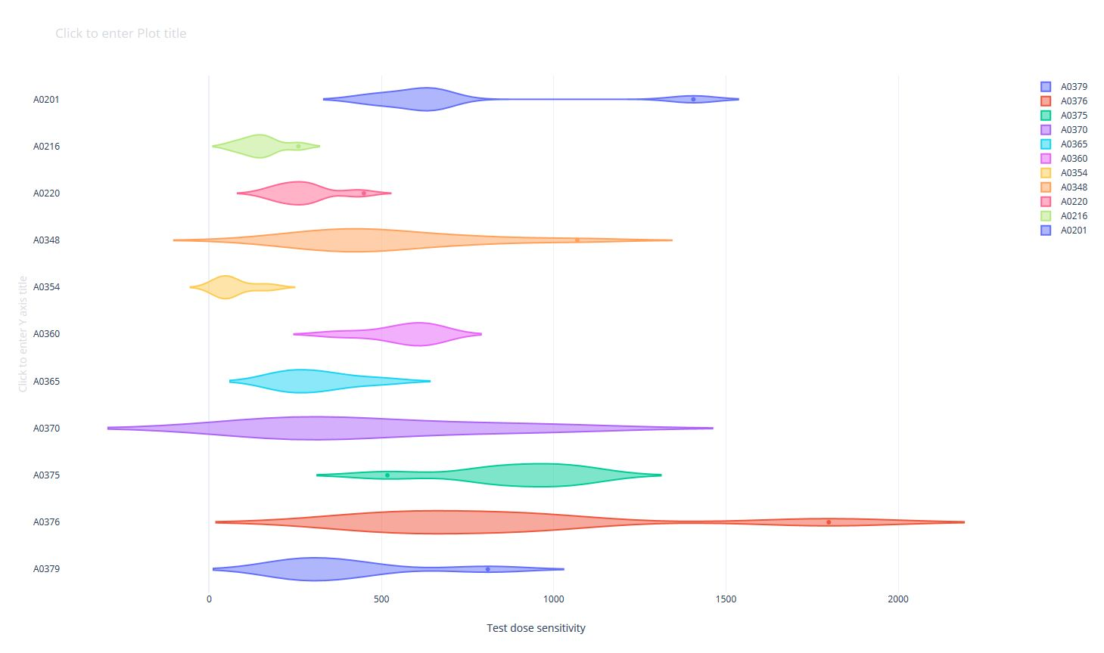

Figure S6. Test dose sensitivity for the very fine sand (63-90 µm) K-feldspar samples measured from RP1 in this study expressed as box plots with A) linear and B) logarithmic scale on the x-axis.

A

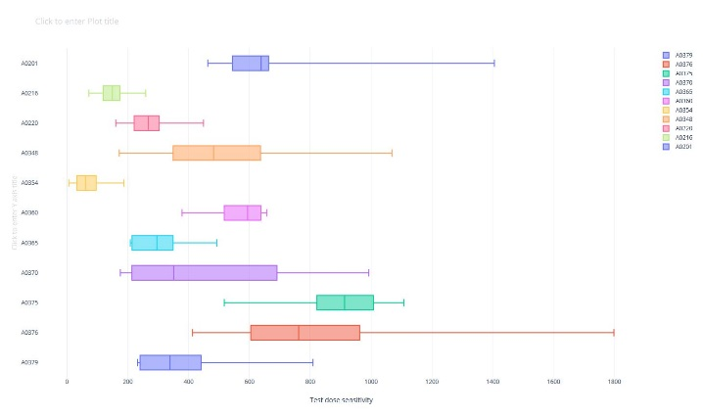

B

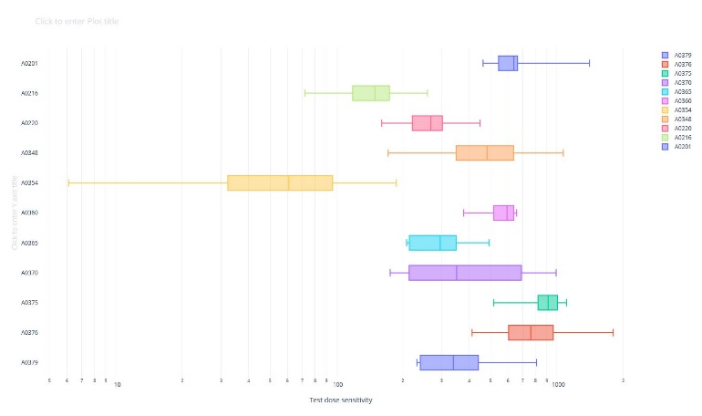

Figure S7. Box-plots of test-dose sensitivity for the A) 100-200 µm and B) 63-100 µm quartz fraction of samples measured from profile RP1, using a logarithmic scale.

A

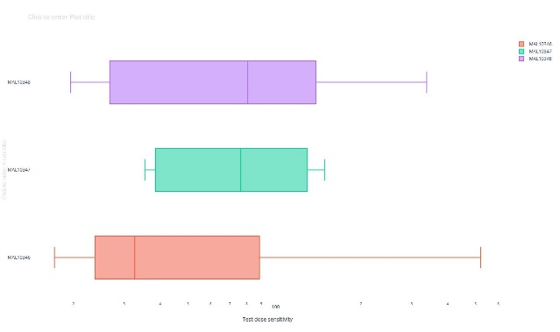

B

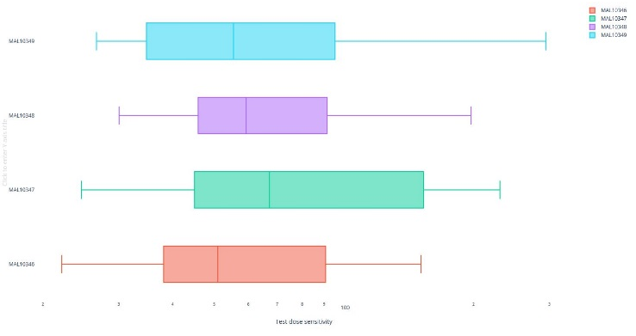

Figure S8. Box-plots of test-dose sensitivity for the 4-11 µm polymineral fraction of samples measured from profile RP1, using a logarithmic scale.

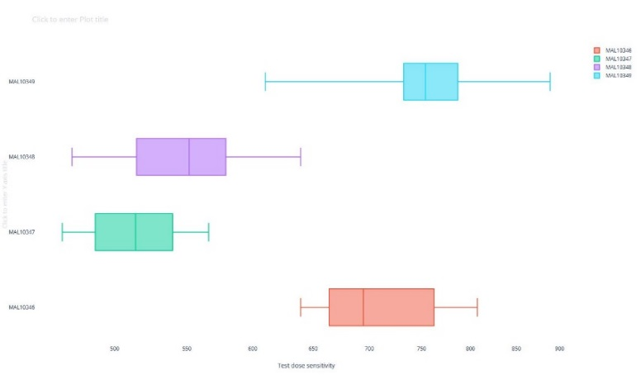

Table S9. Summary of depths, averaged D_{e} values and test dose sensitivity values for the ten fine-grained (4-11µm) quartz OSL samples measured in this study. Three aliquots were measured for each sample, using a measurement protocol involving three regenerative dose steps, preheat/cutheat temperatures of 260/240°C and a test dose of c. 37 Gy. Minimum equivalent doses are assumed to represent signal saturation.
Sample | Depth (m) | Averaged D_{e} (Gy) | Sensitivity (cts/s/Gy) ± 1σ
A0164 | 29.80 ± 0.05 | No signal | 26.9 ± 11.4
A0166 | 28.85 ± 0.05 | >290 | 222 ± 75
A0167 | 28.45 ± 0.05 | >290 | 646 ± 456
A0168 | 27.75 ± 0.05 | >290 | 460 ± 27
A0171 | 26.35 ± 0.05 | >102 | 405 ± 69
A0172 | 25.30 ± 0.05 | >474 | 1698 ± 672
A0174 | 24.25 ± 0.05 | >239 | 859 ± 139
A0175 | 23.65 ± 0.05 | 191 ± 9 | 1321 ± 239
A0176 | 23.45 ± 0.05 | 209 ± 18 | 719 ± 88
A0177 | 23.20 ± 0.05 | 78.1 ± 38.6 | 1621 ± 2613

Table S10. Summary of depths, averaged D_{e} values and test dose sensitivity values for the five very fine sand (63-90 µm) quartz OSL samples measured in this study. Three aliquots were measured for each sample, using a measurement protocol involving two regenerative dose steps, preheat/cutheat temperatures of 260/240°C and a test dose of c. 37 Gy.
Sample | Depth (m) | Averaged D_{e} (Gy) | Sensitivity (cts/s/Gy) ± 1σ
A0365 | 6.45 ± 0.05 | 55.1 ± 8.3 | 86.2 ± 15.9
A0370 | 5.45 ± 0.05 | 51.0 ± 12.1 | 221 ± 84
A0375 | 4.45 ± 0.05 | 63.5 ± 9.9 | 195 ± 153
A0376 | 4.25 ± 0.05 | 135 ± 94 | 573 ± 132
A0379 | 3.45 ± 0.05 | 50.0 ± 7.0 | 275 ± 214

Table S11. Summary of depths, averaged uncorrected D_{e} values and test dose sensitivity values for the 11 very fine sand (63-90µm) K-feldspar samples measured in this study using the pIR-IR protocols. The number of aliquots measured for each sample is listed and the D_{e} uncertainty is given as the standard error.
Sample | Depth (m) | Number of aliquots measured | Measurement protocol | Averaged D_{e} (Gy) ± se | Sensitivity (cts/s/Gy) ± 1σ
A0201 | 16.60 ± 0.05 | 6 | pIR₂₀₀IR₂₉₀ | 174 ± 3 | 400 ± 216
A0216 | 12.65 ± 0.05 | 6 |  | 133 ± 3 | 884 ± 492
A0220 | 11.80 ± 0.05 | 6 |  | 114 ± 3 | 880 ± 208
A0348 | 10.50 ± 0.05 | 6 |  | 120 ± 4 | 462 ± 317
A0354 | 9.20 ± 0.05 | 6 |  | 116 ± 8 | 309 ± 107
A0360 | 7.60 ± 0.05 | 6 |  | 117 ± 3 | 563 ± 103
A0365 | 6.45 ± 0.05 | 12 |  | 122 ± 11 | 72.7 ± 56.4
A0370 | 5.45 ± 0.05 | 12 |  | 131 ± 6 | 512 ± 248
A0375 | 4.45 ± 0.05 | 12 |  | 112 ± 4 | 277 ± 85
A0376 | 4.25 ± 0.05 | 6 |  | 113 ± 4 | 726 ± 154
A0379 | 3.45 ± 0.05 | 6 | pIR₂₀₀IR₂₉₀ | 113 ± 4 | 168 ± 63
 |  | 24 | pIR₅₀IR₂₉₀ | 85.8 ± 1.0 | 4762 ± 2501
A0380 | 3.45 ± 0.05 | 24 | pIR₅₀IR₂₉₀ | 77.0 ± 1.5 | 2243 ± 1533
A0381 | 3.15 ± 0.05 | 24 |  | 81.7 ± 3.4 | 780 ± 426
A0382 | 2.85 ± 0.05 | 24 |  | 87.8 ± 2.6 | 9478 ± 4034
A0383 | 2.55 ± 0.05 | 24 |  | 87.7 ± 1.1 | 11098 ± 5365
A0384 | 2.15 ± 0.05 | 24 |  | 84.1 ± 4.1 | 4939 ± 7907
A0385 | 1.80 ± 0.05 | 24 |  | 83.4 ± 1.8 | 5662 ± 2908
A0387 | 1.25 ± 0.05 | 24 |  | 77.5 ± 0.9 | 3876 ± 2000

References
Fischer, P., Jöris, O., Fitzsimmons, K.E., Vinnepand, M., Prud’homme, C., Schulte, P., Hatté, C., Hambach, U., Lindauer, S., Zeeden, C., Peric, Z., Lehmkuhl, F., Wunderlich, T., Wilken, D., Schirmer, W., Vött, A., 2021. T Millennial-scale terrestrial ecosystem responses to Upper Pleistocene climatic changes: 4D-reconstruction of the Schwalbenberg Loess-Paleosol-Sequence (Middle Rhine valley, Germany). Catena 196, 104913.
Vinnepand, M., Fischer, P., Fitzsimmons, K., Thornton, B., Fiedler, S., Vött, A., 2020. Combining Inorganic and Organic Carbon Stable Isotope Signatures in the Schwalbenberg Loess-Palaeosol-Sequence Near Remagen (Middle Rhine Valley, Germany). Frontiers in Earth Science 8.

