Supporting Information

Heterogeneous double metal cyanide catalyzed synthesis of poly(ε-caprolactone) polyols for the preparation of thermoplastic elastomers

Chinh Hoang Tran, Min Woong Lee, Sang Woo Park, Jae Eon Jeong, Soo Jeong Lee, Wenliang Song, PilHo Huh*, and Il Kim*

Department of Polymer Science and Engineering, Pusan National University, Busandaehag-ro 63-2, Geumjeong-gu, Busan 46241, Republic of Korea.
* Correspondence: IK: ilkim@pusan.ac.kr; PH: pilho.huh@pusan.ac.kr

Table of Contents
Table of Contents S2
1. Supplementary figures S6
1.1 Characterization of DMC catalysts S6
Fig. S1 Characterization of the DMC catalysts used in this work. (a) FTIR spectra, (b) XPS spectra, and (c) XRD patterns. S6
1.2 Polymerization of lactones S7
Fig. S2 ¹H NMR spectrum (400 MHz, CDCl₃) of the crude reaction mixture of CL without using initiator after 24 h. Conditions: DMC-EAA = 10 mg ([Zn]₀ = 30 × 10⁻³ M), [CL]₀ = 9 M, T_{p} = 120 °C. S7
Fig. S3 ¹H NMR spectrum (400 MHz, CDCl₃) of the crude reaction mixture of CL polymerization using PPG400 initiator (run 1 of Table 1). Conditions: DMC-EAA = 10 mg ([Zn]₀ = 30 × 10⁻³ M), [CL]₀ = 9 M, [CL]₀/[PPG400]₀ = 10, T_{p} = 120 °C. S7
Fig. S4 ¹H NMR spectrum (400 MHz, CDCl₃) of the crude reaction mixture of CL polymerization using EG initiator (run 2 of Table 1). Conditions: DMC-EAA = 10 mg ([Zn]₀ = 30 × 10⁻³ M), [CL]₀ = 9 M, [CL]₀/[EG]₀ = 10, T_{p} = 120 °C. S8
Fig. S5 ¹H NMR spectrum (400 MHz, CDCl₃) of the crude reaction mixture of CL polymerization using PG initiator (run 3 of Table 1). Conditions: DMC-EAA = 10 mg ([Zn]₀ = 30 × 10⁻³ M), [CL]₀ = 9 M, [CL]₀/[PG]₀ = 10, T_{p} = 120 °C. S8
Fig. S6 ¹H NMR spectrum (400 MHz, CDCl₃) of the crude reaction mixture of CL polymerization using GL initiator (run 4 of Table 1). Conditions: DMC-EAA = 10 mg ([Zn]₀ = 30 × 10⁻³ M), [CL]₀ = 9 M, [CL]₀/[GL]₀ = 10, T_{p} = 120 °C. S9
Fig. S7 ¹H NMR spectrum (400 MHz, CDCl₃) of the crude reaction mixture of CL polymerization using EG initiator (run 6 of Table 1). Conditions: DMC-TBA = 10 mg ([Zn]₀ = 30 × 10⁻³ M), [CL]₀ = 9 M, [CL]₀/[I]₀ = 10, T_{p} = 160 °C. S9
Fig. S8 ¹H NMR spectrum (400 MHz, CDCl₃) of the crude reaction mixture of CL polymerization using EG initiator (run 7 of Table 1). Conditions: DMC-IBN = 10 mg ([Zn]₀ = 30 × 10⁻³ M), [CL]₀ = 9 M, [CL]₀/[I]₀ = 10, T_{p} = 160 °C. S10
Fig. S9 ¹H NMR spectrum (400 MHz, CDCl₃) of the PCL produced by SB initiator (run 10 of Table 1). Conditions: DMC-EAA = 10 mg ([Zn]₀ = 30 × 10⁻³ M), [CL]₀ = 9 M, [CL]₀/[I]₀ = 10, T_{p} = 120 °C. S10
Fig. S10 GPC curves of the resultant PCLs using different initiators (run 1–4 of Table 1). Conditions: DMC-EAA = 10 mg ([Zn]₀ = 30 × 10⁻³ M), [M]₀ = 9 M, [M]₀/[I]₀ = 10, T_{p} = 120 °C. S11
Fig. S11 MALDI-TOF MS spectrum of PG-PCL (Table 1, run 5). Conditions: DMC-EAA = 10 mg ([Zn]₀ = 30 × 10⁻³ M), [M]₀ = 9 M, [M]₀/[PG]₀ = 10, T_{p} = 160 °C. S11
Fig. S12 MALDI-TOF MS spectrum of GL-PCL (Table 1, run 6). Conditions: DMC-EAA = 10 mg ([Zn]₀ = 30 × 10⁻³ M), [M]₀ = 9 M, [M]₀/[GL]₀ = 10, T_{p} = 160 °C. S12
Fig. S13 MALDI-TOF MS spectrum of SB-PCL (Table 1, run 7). Conditions: DMC-EAA = 10 mg ([Zn]₀ = 30 × 10⁻³ M), [M]₀ = 9 M, [M]₀/[SB]₀ = 10, T_{p} = 160 °C. S12
Fig. S14 Recycling experiment of the ROP of CL using DMC-EAA catalyst. S13
Fig. S15 GPC curves of the PCLs obtained using various amount of PG initiator. Condition: DMC-EAA = 10 mg ([Zn]₀ = 30 × 10⁻³ M), [CL]₀ = 9 M, reaction temperature: 160 °C. S13
Fig. S16 GPC curves of the PCLs obtained using various amount of GL initiator. Condition: DMC-EAA = 10 mg ([Zn]₀ = 30 × 10⁻³ M), [CL]₀ = 9 M, reaction temperature: 160 °C. S14
Fig. S17 GPC curves of the resultant PCLs using different ILs. Conditions: DMC-EAA = 10 mg ([Zn]₀ = 30 × 10⁻³ M), [CL]₀ = 9 M, [CL]₀/[GL]₀ = 10, [IL]₀/[Zn]₀ = 2.5, T_{p} = 160 °C. S14
Fig. S18 GPC curves of the resultant PCLs using various amount of PG in the presence of BMIMCl (IL). Conditions: DMC-EAA = 10 mg [Zn]₀ = 30 × 10⁻³ M), [CL]₀ = 9 M, [IL]₀/[Zn]₀ = 2.5, T_{p} = 160 °C. S15
Fig. S19 GPC curves of the resultant PCLs using various amount of GL in the presence of BMIMCl (IL). Conditions: DMC-EAA = 10 mg ([Zn]₀ = 30 × 10⁻³ M), [CL]₀ = 9 M, [IL]₀/[Zn]₀ = 2.5, T_{p} = 160 °C. S15
Fig. S20 GPC curves of the resultant PCLs using various amount of BMIMCl (IL). Conditions: DMC-EAA = 10 mg ([Zn]₀ = 30 × 10⁻³ M), [CL]₀ = 9 M, [CL]₀/[PG]₀ = 10, T_{p} = 160 °C. S16
1.3 Kinetic Studies S17
Fig. S21 ¹H NMR (400 MHz, CD₃OD) spectra of the PCL collected at different intervals. Conditions: DMC-EAA = 10 mg ([Zn]₀ = 30 × 10−3 M), [CL]₀ = 9 M, [CL]₀/[GL]₀ = 20, T_{p} = 130 °C. Dashed lines denote the monomer signals. S17
Fig. S22 ¹H NMR (400 MHz, CD₃OD) spectra of the PCL collected at different intervals. Conditions: DMC-EAA = 10 mg ([Zn]₀ = 30 × 10⁻³ M), [CL]₀ = 9 M, [CL]₀/[GL]₀ = 20, T_{p} = 140 °C. Dash lines denote the monomer signals. S17
Fig. S23 ¹H NMR (400 MHz, CDCl₃) spectra of the PCL collected at different intervals. Conditions: DMC-EAA = 10 mg ([Zn]₀ = 30 × 10⁻³ M), [CL]₀ = 9 M, [CL]₀/[GL]₀ = 20, T_{p} = 150 °C. Dash lines denote the monomer signals. S18
Fig. S24 ¹H NMR (400 MHz, CDCl₃) spectra of the PCL collected at different intervals. Conditions: DMC-EAA = 10 mg ([Zn]₀ = 30 × 10⁻³ M), [CL]₀ = 9 M, [CL]₀/[GL]₀ = 20, T_{p} = 160 °C. Dash lines denote the monomer signals. S18
Fig. S25 ¹H NMR (400 MHz, CDCl₃) spectra of the PCL collected at different intervals. Conditions: DMC-EAA = 10 mg ([Zn]₀ = 30 × 10⁻³ M), [CL]₀ = 9 M, [CL]₀/[SB]₀ = 20, T_{p} = 160 °C. Dash lines denote the monomer signals. S19
Fig. S26 GPC curves of PCL collected at different intervals. Conditions: DMC-EAA = 10 mg ([Zn]₀ = 30 × 10⁻³ M), [CL]₀ = 9 M, [CL]₀/[GL]₀ = 20, T_{p} = 140 °C. S20
Fig. S27 Plots of M_{n} and Ð versus (a) monomer conversion (x_{p}) and (b) polymerization time in Fig. S26. S20
Fig. S28 GPC curves of PCL collected at different intervals. Conditions: DMC-EAA = 10 mg ([Zn]₀ = 30 × 10⁻³ M), [CL]₀ = 9 M, [CL]₀/[GL]₀ = 20, T_{p} = 150 °C. S21
Fig. S29 Plots of M_{n} and Ð versus (a) monomer conversion (x_{p}) and (b) polymerization time in Fig. S28. S21
Fig. S30 GPC curves of PCL collected at different intervals. Conditions: DMC-EAA = 10 mg ([Zn]₀ = 30 × 10⁻³ M), [CL]₀ = 9 M, [CL]₀/[GL]₀ = 20, T_{p} = 160 °C. S22
Fig. S31 Plots of M_{n} and Ð versus (a) monomer conversion (x_{p}) and (b) polymerization time in Fig. S30. S22
1.4 Copolymerization of CL with Glycidol S23
Fig. S32 ¹H NMR spectrum (400 MHz, CDCl₃) of the copolymerization of CL with glycidol (G) in CDCl₃. Condition: DMC-EAA = 10 mg ([Zn]₀ = 30 × 10⁻³ M), [CL]₀ = 9 M, [CL]₀/[G]₀ = 7 : 3, T_{p} = 160 °C. S23
Fig. S33 ¹H NMR spectrum (400 MHz, CDCl₃) of the copolymerization of CL with glycidol (G) in CDCl₃. Condition: DMC-EAA = 10 mg ([Zn]₀ = 30 × 10⁻³ M), [CL]₀ = 9 M, [CL]₀/[G]₀ = 6 : 4, T_{p} = 160 °C. S23
Fig. S34 ¹H NMR spectrum (400 MHz, CDCl₃) of the copolymerization of CL with glycidol (G) in CDCl₃. Condition: DMC-EAA = 10 mg ([Zn]₀ = 30 × 10⁻³ M), [CL]₀ = 9 M, [CL]₀/[G]₀ = 5 : 5, T_{p} = 160 °C. S24
Fig. S35 2D NMR spectra (400 MHz, CDCl₃) of the copolymerization of CL with glycidol (G) in CDCl₃. Condition: DMC-EAA = 10 mg ([Zn]₀ = 30 × 10⁻³ M), [CL]₀ = 9 M, [CL]₀/[G]₀ = 6 : 4, T_{p} = 160 °C. S24
Fig. S36 ¹³C NMR spectra (400 MHz, CDCl₃) of the PCL (top) and branched PCL (bottom) obtained from the copolymerization of CL with glycidol (G). Condition: DMC-EAA = 10 mg ([Zn]₀ = 30 × 10⁻³ M), [CL]₀ = 9 M, [CL]₀/[G]₀ = 7 : 3, T_{p} = 160 °C. S25
Fig. S37 ¹H NMR (400 MHz, CDCl₃) spectra of the copolymerization of CL with glycidol (G) collected at different intervals. Conditions: DMC-EAA = 10 mg ([Zn]₀ = 30 × 10⁻³ M), [CL]₀ = 9 M, [CL]₀/[G]₀ = 5/5, T_{p} = 160 °C. S25
Fig. S38 GPC curves of the resultant copolymers obtained from the copolymerization of CL and glycidol (G). Condition: DMC-EAA = 10 mg ([Zn]₀ = 30 × 10⁻³ M), [CL]₀ = 9 M, T_{p} = 160 °C. S26
1.5 Synthesis of TPEs and TPUs S27
Fig. S39 ¹H-NMR spectrum of the PCL-TPE-1 produced by EG-PCL-1000 diol. S27
Fig. S40 ¹H-NMR spectrum of the PCL-TPE-3 produced by PG-PCL-1000 diol. S27
Fig. S41 ¹H-NMR spectrum of the TPEE produced by PTMEG-1000 diol. S28
Fig. S42 ¹H-NMR spectrum of the PCL-TPU produced by PG-PCL-1000 diol. S28
Fig. S43 ¹H-NMR spectrum of the TPU produced by PTMEG-1000 diol. S29
Fig. S44 FTIR spectra of the TPU and PCL-TPU produced by PTMEG-1000 and PG-PCL-1000 diols, respectively. S29
Fig. S45 (a) TGA and (b) DTG curves for TPEE, PCL-TPE-1, and PCL-TPE-3 produced by PTMEG-1000, EG-PCL-1000, and PG-PCL-1000 diols, respectively. S30
Fig. S46 (a) TGA and (b) DTG curves for TPU and PCL-TPU produced by PTMEG-1000 and PG-PCL-1000 diols, respectively. S30
Fig. S47 DSC curves for TPEE, PCL-TPE-1, and PCL-TPE-3 produced by PTMEG-1000, EG-PCL-1000, and PG-PCL-1000 diols, respectively: (a) during cooling from melt, (b) during second heating run. S31
Fig. S48 DSC curves for TPU and PCL-TPU produced by PTMEG-1000 and PG-PCL-1000 diols, respectively during second heating run. S31
Fig. S49 Stress–strain curves for PCL-TPEs produced by PG-PCL diols with different molecular weights conducted at a crosshead speed of 100 mm min⁻¹ (Table 5). S32
2. Supplementary Schemes S33
Scheme S1 Proposed mechanism for the copolymerization of CL and glycidol using DMC catalyst. S33
Scheme S2 Synthesis of PCL-TPEs using PCL diols. S33
Scheme S3 Synthesis of PCL-TPU using PG-PCL diol. S34
3. Supplementary tables S35
Table S1 Results of the batch ROP of CL by DMC catalyst using various amount of PG and BMIMCl (IL)ª S35
Table S2 Results of the batch ROP of CL in IL by DMC catalyst using various amount of GLª S36

1. Supplementary figures

1.1 Characterization of DMC catalysts

Fig. S1 Characterization of the DMC catalysts used in this work. (a) FTIR spectra, (b) XPS spectra, and (c) XRD patterns.

1.2 Polymerization of lactones

Fig. S2 ¹H NMR spectrum (400 MHz, CDCl₃) of the crude reaction mixture of CL without using initiator after 24 h. Conditions: DMC-EAA = 10 mg ([Zn]₀ = 30 × 10⁻³ M), [CL]₀ = 9 M, T_{p} = 120 °C.

Fig. S3 ¹H NMR spectrum (400 MHz, CDCl₃) of the crude reaction mixture of CL polymerization using PPG400 initiator (run 1 of Table 1). Conditions: DMC-EAA = 10 mg ([Zn]₀ = 30 × 10⁻³ M), [CL]₀ = 9 M, [CL]₀/[PPG400]₀ = 10, T_{p} = 120 °C.

Fig. S4 ¹H NMR spectrum (400 MHz, CDCl₃) of the crude reaction mixture of CL polymerization using EG initiator (run 2 of Table 1). Conditions: DMC-EAA = 10 mg ([Zn]₀ = 30 × 10⁻³ M), [CL]₀ = 9 M, [CL]₀/[EG]₀ = 10, T_{p} = 120 °C.

Fig. S5 ¹H NMR spectrum (400 MHz, CDCl₃) of the crude reaction mixture of CL polymerization using PG initiator (run 3 of Table 1). Conditions: DMC-EAA = 10 mg ([Zn]₀ = 30 × 10⁻³ M), [CL]₀ = 9 M, [CL]₀/[PG]₀ = 10, T_{p} = 120 °C.

Fig. S6 ¹H NMR spectrum (400 MHz, CDCl₃) of the crude reaction mixture of CL polymerization using GL initiator (run 4 of Table 1). Conditions: DMC-EAA = 10 mg ([Zn]₀ = 30 × 10⁻³ M), [CL]₀ = 9 M, [CL]₀/[GL]₀ = 10, T_{p} = 120 °C.

Fig. S7 ¹H NMR spectrum (400 MHz, CDCl₃) of the crude reaction mixture of CL polymerization using EG initiator (run 6 of Table 1). Conditions: DMC-TBA = 10 mg ([Zn]₀ = 30 × 10⁻³ M), [CL]₀ = 9 M, [CL]₀/[I]₀ = 10, T_{p} = 160 °C.

Fig. S8 ¹H NMR spectrum (400 MHz, CDCl₃) of the crude reaction mixture of CL polymerization using EG initiator (run 7 of Table 1). Conditions: DMC-IBN = 10 mg ([Zn]₀ = 30 × 10⁻³ M), [CL]₀ = 9 M, [CL]₀/[I]₀ = 10, T_{p} = 160 °C.

Fig. S9 ¹H NMR spectrum (400 MHz, CDCl₃) of the PCL produced by SB initiator (run 10 of Table 1). Conditions: DMC-EAA = 10 mg ([Zn]₀ = 30 × 10⁻³ M), [CL]₀ = 9 M, [CL]₀/[I]₀ = 10, T_{p} = 120 °C.

Fig. S10 GPC curves of the resultant PCLs using different initiators (run 1–4 of Table 1). Conditions: DMC-EAA = 10 mg ([Zn]₀ = 30 × 10⁻³ M), [M]₀ = 9 M, [M]₀/[I]₀ = 10, T_{p} = 120 °C.
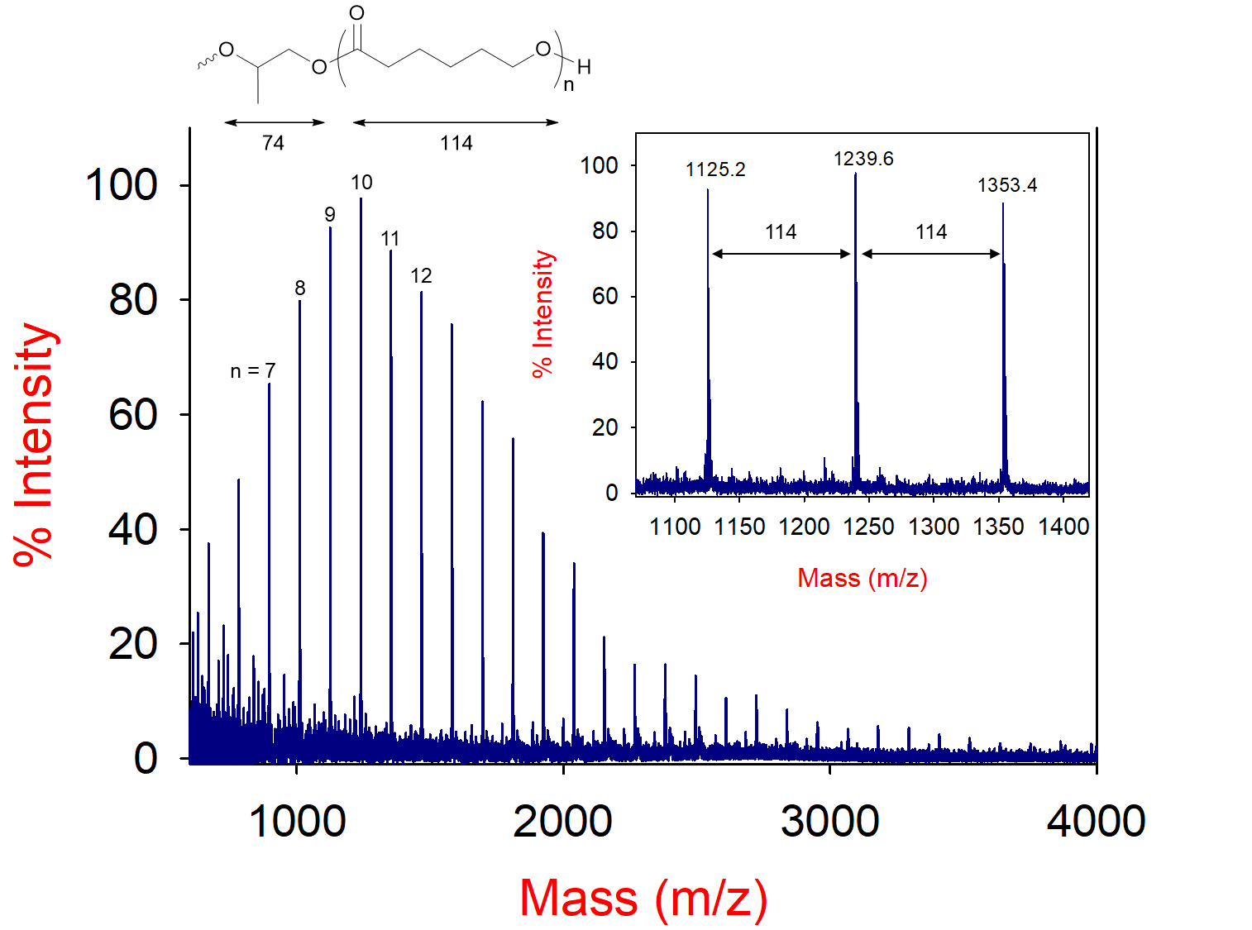

Fig. S11 MALDI-TOF MS spectrum of PG-PCL (Table 1, run 5). Conditions: DMC-EAA = 10 mg ([Zn]₀ = 30 × 10⁻³ M), [M]₀ = 9 M, [M]₀/[PG]₀ = 10, T_{p} = 160 °C.
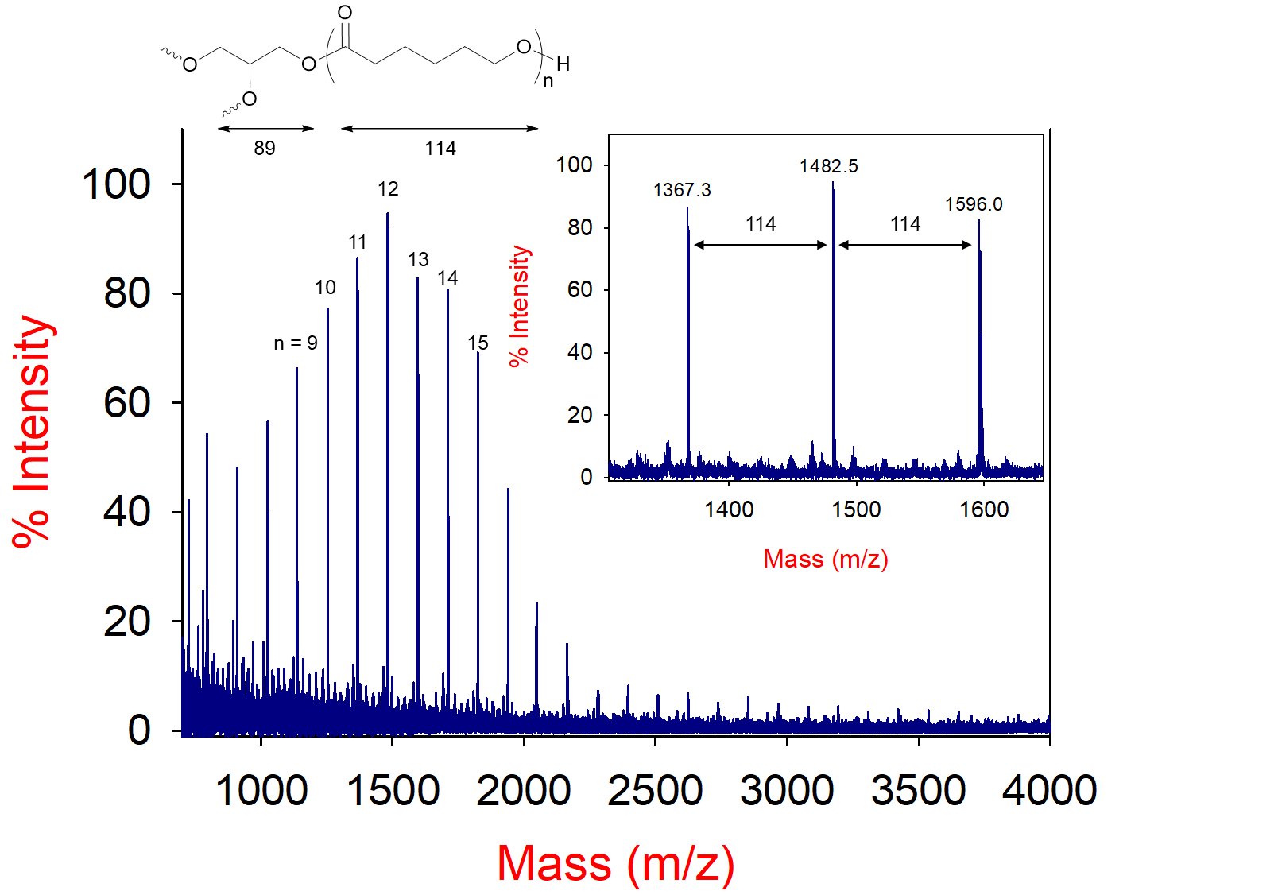

Fig. S12 MALDI-TOF MS spectrum of GL-PCL (Table 1, run 6). Conditions: DMC-EAA = 10 mg ([Zn]₀ = 30 × 10⁻³ M), [M]₀ = 9 M, [M]₀/[GL]₀ = 10, T_{p} = 160 °C.
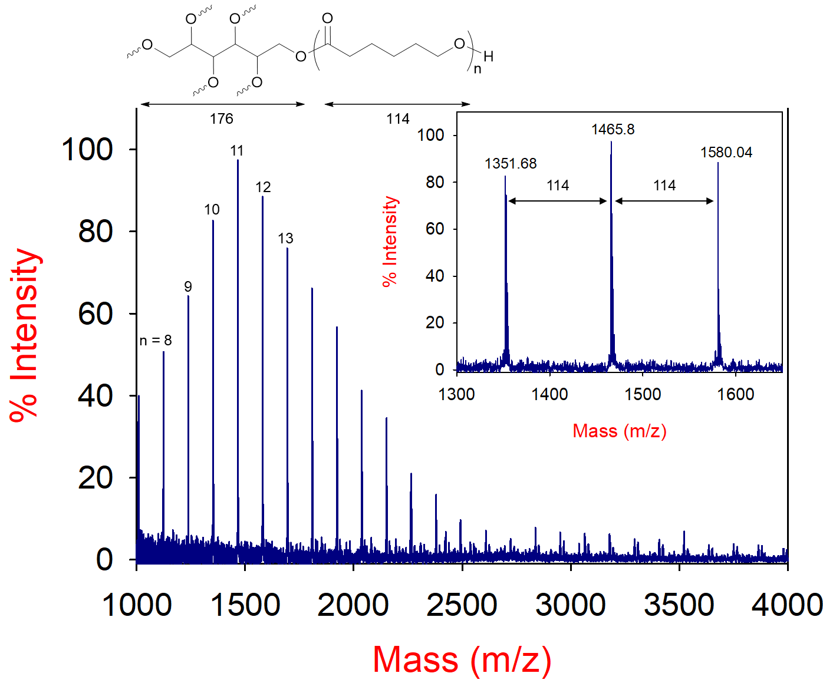

Fig. S13 MALDI-TOF MS spectrum of SB-PCL (Table 1, run 7). Conditions: DMC-EAA = 10 mg ([Zn]₀ = 30 × 10⁻³ M), [M]₀ = 9 M, [M]₀/[SB]₀ = 10, T_{p} = 160 °C.

Fig. S14 Recycling experiment of the ROP of CL using DMC-EAA catalyst.

Fig. S15 GPC curves of the PCLs obtained using various amount of PG initiator. Condition: DMC-EAA = 10 mg ([Zn]₀ = 30 × 10⁻³ M), [CL]₀ = 9 M, reaction temperature: 160 °C.

Fig. S16 GPC curves of the PCLs obtained using various amount of GL initiator. Condition: DMC-EAA = 10 mg ([Zn]₀ = 30 × 10⁻³ M), [CL]₀ = 9 M, reaction temperature: 160 °C.

Fig. S17 GPC curves of the resultant PCLs using different ILs. Conditions: DMC-EAA = 10 mg ([Zn]₀ = 30 × 10⁻³ M), [CL]₀ = 9 M, [CL]₀/[GL]₀ = 10, [IL]₀/[Zn]₀ = 2.5, T_{p} = 160 °C.

Fig. S18 GPC curves of the resultant PCLs using various amount of PG in the presence of BMIMCl (IL). Conditions: DMC-EAA = 10 mg [Zn]₀ = 30 × 10⁻³ M), [CL]₀ = 9 M, [IL]₀/[Zn]₀ = 2.5, T_{p} = 160 °C.

Fig. S19 GPC curves of the resultant PCLs using various amount of GL in the presence of BMIMCl (IL). Conditions: DMC-EAA = 10 mg ([Zn]₀ = 30 × 10⁻³ M), [CL]₀ = 9 M, [IL]₀/[Zn]₀ = 2.5, T_{p} = 160 °C.

Fig. S20 GPC curves of the resultant PCLs using various amount of BMIMCl (IL). Conditions: DMC-EAA = 10 mg ([Zn]₀ = 30 × 10⁻³ M), [CL]₀ = 9 M, [CL]₀/[PG]₀ = 10, T_{p} = 160 °C.

1.3 Kinetic Studies

Fig. S21 ¹H NMR (400 MHz, CD₃OD) spectra of the PCL collected at different intervals. Conditions: DMC-EAA = 10 mg ([Zn]₀ = 30 × 10−3 M), [CL]₀ = 9 M, [CL]₀/[GL]₀ = 20, T_{p} = 130 °C. Dashed lines denote the monomer signals.

Fig. S22 ¹H NMR (400 MHz, CD₃OD) spectra of the PCL collected at different intervals. Conditions: DMC-EAA = 10 mg ([Zn]₀ = 30 × 10⁻³ M), [CL]₀ = 9 M, [CL]₀/[GL]₀ = 20, T_{p} = 140 °C. Dash lines denote the monomer signals.

Fig. S23 ¹H NMR (400 MHz, CDCl₃) spectra of the PCL collected at different intervals. Conditions: DMC-EAA = 10 mg ([Zn]₀ = 30 × 10⁻³ M), [CL]₀ = 9 M, [CL]₀/[GL]₀ = 20, T_{p} = 150 °C. Dash lines denote the monomer signals.

Fig. S24 ¹H NMR (400 MHz, CDCl₃) spectra of the PCL collected at different intervals. Conditions: DMC-EAA = 10 mg ([Zn]₀ = 30 × 10⁻³ M), [CL]₀ = 9 M, [CL]₀/[GL]₀ = 20, T_{p} = 160 °C. Dash lines denote the monomer signals.

Fig. S25 ¹H NMR (400 MHz, CDCl₃) spectra of the PCL collected at different intervals. Conditions: DMC-EAA = 10 mg ([Zn]₀ = 30 × 10⁻³ M), [CL]₀ = 9 M, [CL]₀/[SB]₀ = 20, T_{p} = 160 °C. Dash lines denote the monomer signals.

Fig. S26 GPC curves of PCL collected at different intervals. Conditions: DMC-EAA = 10 mg ([Zn]₀ = 30 × 10⁻³ M), [CL]₀ = 9 M, [CL]₀/[GL]₀ = 20, T_{p} = 140 °C.

Fig. S27 Plots of M_{n} and Ð versus (a) monomer conversion (x_{p}) and (b) polymerization time in Fig. S26.

Fig. S28 GPC curves of PCL collected at different intervals. Conditions: DMC-EAA = 10 mg ([Zn]₀ = 30 × 10⁻³ M), [CL]₀ = 9 M, [CL]₀/[GL]₀ = 20, T_{p} = 150 °C.

Fig. S29 Plots of M_{n} and Ð versus (a) monomer conversion (x_{p}) and (b) polymerization time in Fig. S28.

Fig. S30 GPC curves of PCL collected at different intervals. Conditions: DMC-EAA = 10 mg ([Zn]₀ = 30 × 10⁻³ M), [CL]₀ = 9 M, [CL]₀/[GL]₀ = 20, T_{p} = 160 °C.

Fig. S31 Plots of M_{n} and Ð versus (a) monomer conversion (x_{p}) and (b) polymerization time in Fig. S30.

1.4 Copolymerization of CL with Glycidol
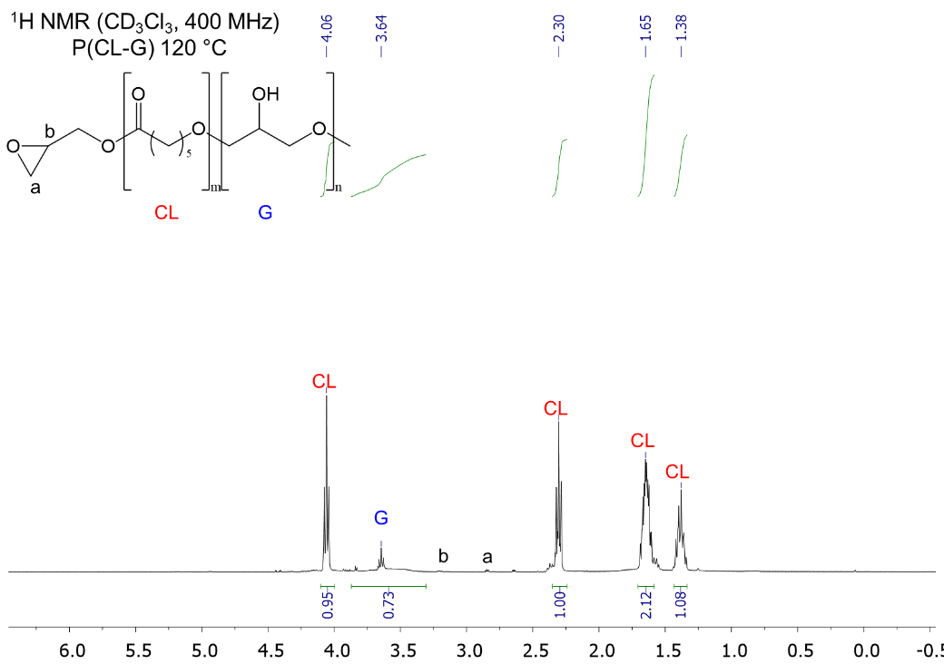

Fig. S32 ¹H NMR spectrum (400 MHz, CDCl₃) of the copolymerization of CL with glycidol (G) in CDCl₃. Condition: DMC-EAA = 10 mg ([Zn]₀ = 30 × 10⁻³ M), [CL]₀ = 9 M, [CL]₀/[G]₀ = 7 : 3, T_{p} = 160 °C.
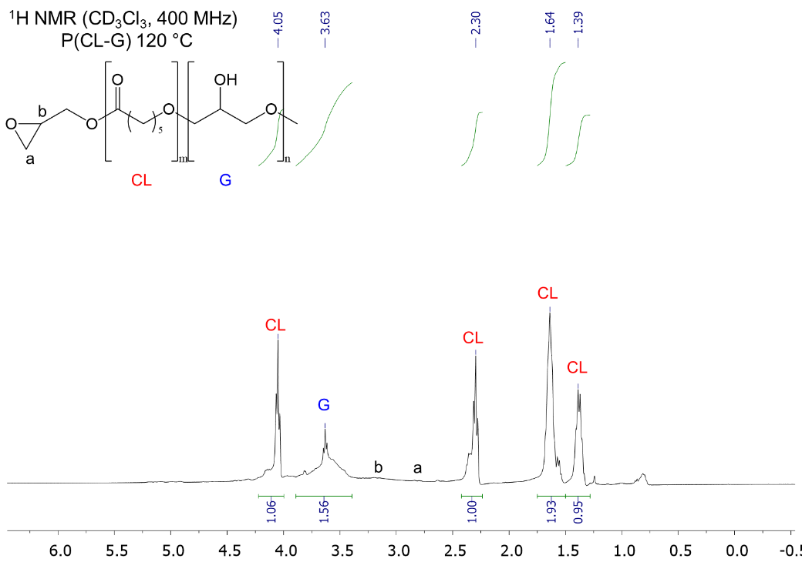

Fig. S33 ¹H NMR spectrum (400 MHz, CDCl₃) of the copolymerization of CL with glycidol (G) in CDCl₃. Condition: DMC-EAA = 10 mg ([Zn]₀ = 30 × 10⁻³ M), [CL]₀ = 9 M, [CL]₀/[G]₀ = 6 : 4, T_{p} = 160 °C.
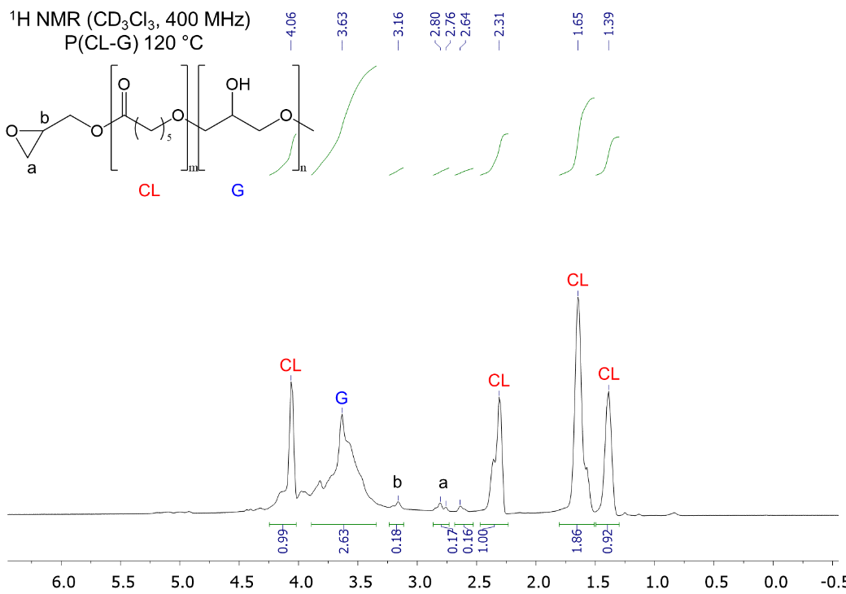

Fig. S34 ¹H NMR spectrum (400 MHz, CDCl₃) of the copolymerization of CL with glycidol (G) in CDCl₃. Condition: DMC-EAA = 10 mg ([Zn]₀ = 30 × 10⁻³ M), [CL]₀ = 9 M, [CL]₀/[G]₀ = 5 : 5, T_{p} = 160 °C.

Fig. S35 2D NMR spectra (400 MHz, CDCl₃) of the copolymerization of CL with glycidol (G) in CDCl₃. Condition: DMC-EAA = 10 mg ([Zn]₀ = 30 × 10⁻³ M), [CL]₀ = 9 M, [CL]₀/[G]₀ = 6 : 4, T_{p} = 160 °C.
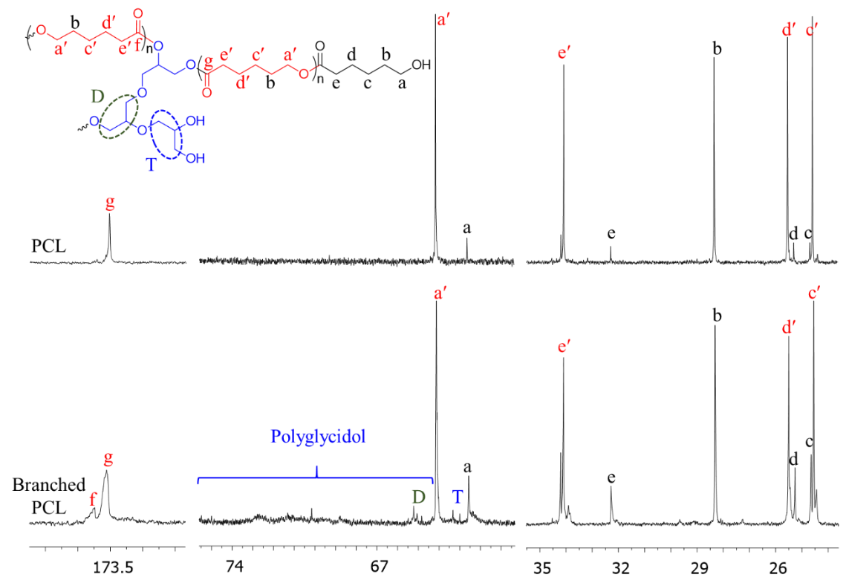

Fig. S36 ¹³C NMR spectra (400 MHz, CDCl₃) of the PCL (top) and branched PCL (bottom) obtained from the copolymerization of CL with glycidol (G). Condition: DMC-EAA = 10 mg ([Zn]₀ = 30 × 10⁻³ M), [CL]₀ = 9 M, [CL]₀/[G]₀ = 7 : 3, T_{p} = 160 °C.
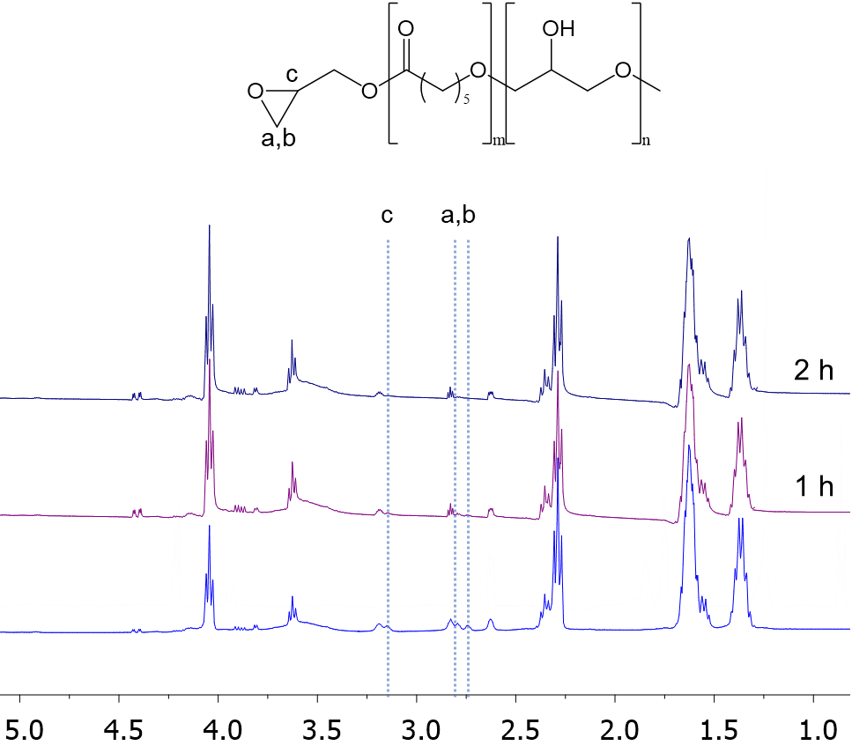

Fig. S37 ¹H NMR (400 MHz, CDCl₃) spectra of the copolymerization of CL with glycidol (G) collected at different intervals. Conditions: DMC-EAA = 10 mg ([Zn]₀ = 30 × 10⁻³ M), [CL]₀ = 9 M, [CL]₀/[G]₀ = 5/5, T_{p} = 160 °C.
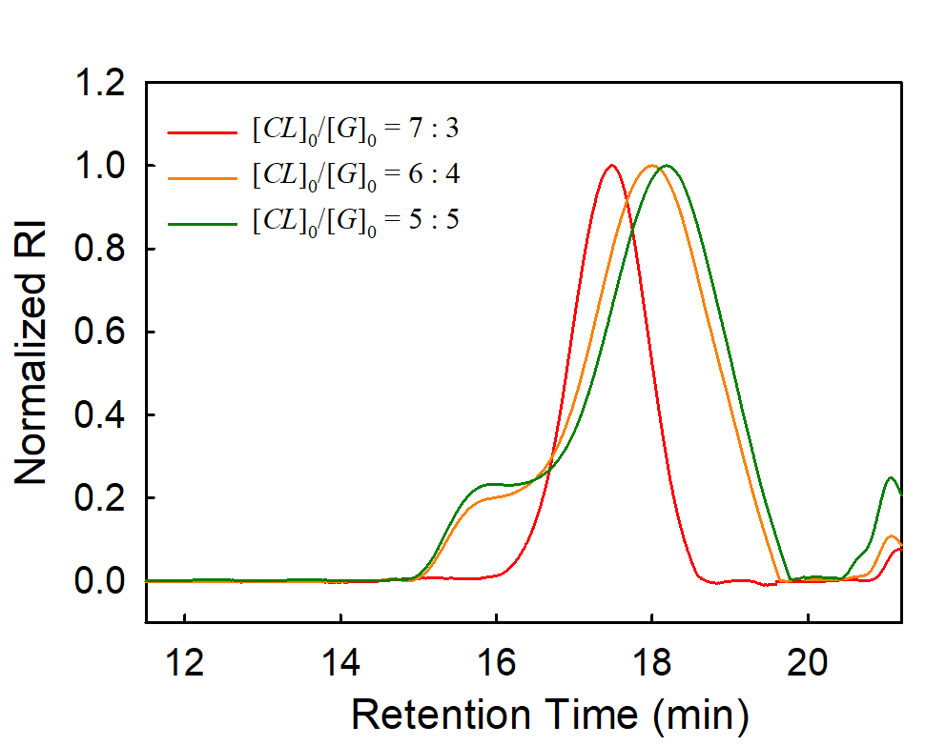

Fig. S38 GPC curves of the resultant copolymers obtained from the copolymerization of CL and glycidol (G). Condition: DMC-EAA = 10 mg ([Zn]₀ = 30 × 10⁻³ M), [CL]₀ = 9 M, T_{p} = 160 °C.

1.5 Synthesis of TPEs and TPUs

Fig. S39 ¹H-NMR spectrum of the PCL-TPE-1 produced by EG-PCL-1000 diol.

Fig. S40 ¹H-NMR spectrum of the PCL-TPE-3 produced by PG-PCL-1000 diol.

Fig. S41 ¹H-NMR spectrum of the TPEE produced by PTMEG-1000 diol.

Fig. S42 ¹H-NMR spectrum of the PCL-TPU produced by PG-PCL-1000 diol.

Fig. S43 ¹H-NMR spectrum of the TPU produced by PTMEG-1000 diol.

Fig. S44 FTIR spectra of the TPU and PCL-TPU produced by PTMEG-1000 and PG-PCL-1000 diols, respectively.

Fig. S45 (a) TGA and (b) DTG curves for TPEE, PCL-TPE-1, and PCL-TPE-3 produced by PTMEG-1000, EG-PCL-1000, and PG-PCL-1000 diols, respectively.

Fig. S46 (a) TGA and (b) DTG curves for TPU and PCL-TPU produced by PTMEG-1000 and PG-PCL-1000 diols, respectively.

Fig. S47 DSC curves for TPEE, PCL-TPE-1, and PCL-TPE-3 produced by PTMEG-1000, EG-PCL-1000, and PG-PCL-1000 diols, respectively: (a) during cooling from melt, (b) during second heating run.

Fig. S48 DSC curves for TPU and PCL-TPU produced by PTMEG-1000 and PG-PCL-1000 diols, respectively during second heating run.

Fig. S49 Stress–strain curves for PCL-TPEs produced by PG-PCL diols with different molecular weights conducted at a crosshead speed of 100 mm min⁻¹ (Table 5).

2. Supplementary Schemes

Scheme S1 Proposed mechanism for the copolymerization of CL and glycidol using DMC catalyst.

Scheme S2 Synthesis of PCL-TPEs using PCL diols.

Scheme S3 Synthesis of PCL-TPU using PG-PCL diol.

3. Supplementary tables

Table S1 Results of the batch ROP of CL by DMC catalyst using various amount of PG and BMIMCl (IL)ª
Run | [IL]₀/[Zn]₀ | [CL]₀/[PG]₀ | t^{b}  (h) | x_{p}^{c}  (%) | GPC
 |  |  |  |  | M_{n} | Ð
1 | 2.5 | 100 | 12 | 17 | 3740 | 1.05
2 | 2.5 | 50 | 10 | 56 | 2500 | 1.07
3 | 2.5 | 20 | 8 | 62 | 1700 | 1.03
4 | 2.5 | 10 | 8 | 91 | 1400 | 1.11
5 | 2.5 | 5 | 8 | 86 | 1100 | 1.01
6 | 1.25 | 10 | 8 | 58 | 1220 | 1.02
7 | 3.0 | 10 | 8 | 61 | 1240 | 1.01
8 | 4.0 | 10 | 8 | 58 | 1310 | 1.02
9 | 5.0 | 10 | 8 | 84 | 1470 | 1.08
10 | [IL]₀^{d} | 10 | 12 | < 3 | – | –
ª Conditions: DMC-EAA = 10 mg ([Zn]₀ = 30 × 10⁻³ M); [CL]₀ = 9 M; T_{p} = 160 °C. ^{b} Reaction time. ^{c} Monomer conversion determined by ¹H NMR. ^{d} The polymerization was performed in the absence of DMC catalyst.

Table S2 Results of the batch ROP of CL in IL by DMC catalyst using various amount of GLª
Run | IL^{b} | [CL]₀/[GL]₀ | t^{c}  (h) | x_{p}^{d}  (%) | GPC
 |  |  |  |  | M_{n} | Ð
1 | BMIMCl | 100 | 12 | 31 | 4050 | 1.01
2 | BMIMCl | 50 | 10 | 65 | 2750 | 1.02
3 | BMIMCl | 20 | 8 | 89 | 2520 | 1.07
4 | BMIMCl | 10 | 8 | 95 | 1730 | 1.11
5 | BMIMCl | 5 | 8 | 95 | 1280 | 1.06
6 | TMAP | 10 | 8 | 24 | 1900 | 1.16
7 | TEAB | 10 | 8 | 29 | 2340 | 1.32
8 | TDAB | 10 | 8 | 29 | 2510 | 1.26
ª Conditions: DMC-EAA = 10 mg ([Zn]₀ = 30 × 10⁻³ M); [CL]₀ = 9 M; T_{p} = 160 °C. ^{b} Ionic liquid: [IL]₀/[Zn]₀ = 2.5. ^{c} Reaction time. ^{d} Monomer conversion determined by ¹H NMR.

