The protein-protein interaction network of first episode psychosis and schizophrenia reveals possible trigger factors and new drug targets among intracellular signal transduction pathways and neurotoxicity processes.

Michael Maes, M.D., Ph.D. ^{a,b,c}, Kitiporn Plaimas, Dr.rer.nat. ^{d}, Apichat Suratanee, Dr.rer.nat. ^{e}, Cristiano Noto, M.D. ^{f,g}, Buranee Kanchanatawan, M.D. ª

ª Department of Psychiatry, Faculty of Medicine, Chulalongkorn University, Bangkok, Thailand
^{b} Department of Psychiatry, Medical University of Plovdiv, Plovdiv, Bulgaria
^{c} IMPACT Strategic Research Center, Deakin University, Geelong, Australia
^{d} Advanced Virtual and Intelligent Computing (AVIC) Center, Department of Mathematics and Computer Science, Faculty of Science, Chulalongkorn University, Bangkok, 10330, Thailand
^{e} Department of Mathematics, Faculty of Applied Science, King Mongkut’s University of Technology North Bangkok, Bangkok 10800, Thailand
^{f} GAPi (Early Psychosis Group), Universidade Federal de São Paulo (UNIFESP), São Paulo, Brazil.
^{g} Schizophrenia Program (PROESQ), Department of Psychiatry, Universidade Federal de São Paulo (UNIFESP), São Paulo, Brazil

Corresponding author:
Prof. Dr. Michael Maes, M.D., Ph.D.
IMPACT Strategic Research Center
Barwon Health
Deakin University
Geelong, Vic
Australia
dr.michaelmaes@hotmail.com
https://scholar.google.co.th/citations?user=1wzMZ7UAAAAJ&hl=th&oi=ao

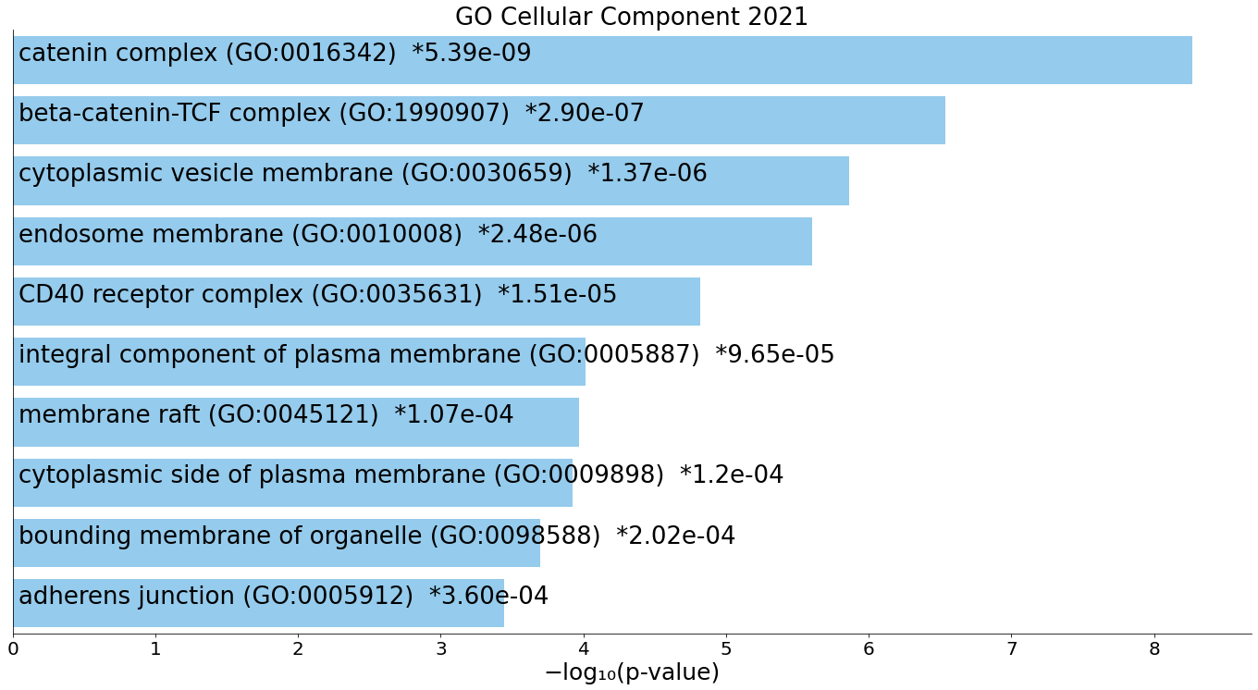
ESF Figure 1. Heatmap (top-10) of enriched GO cellular component terms accumulated in the differently expressed proteins in first episode psychosis and schizophrenia.
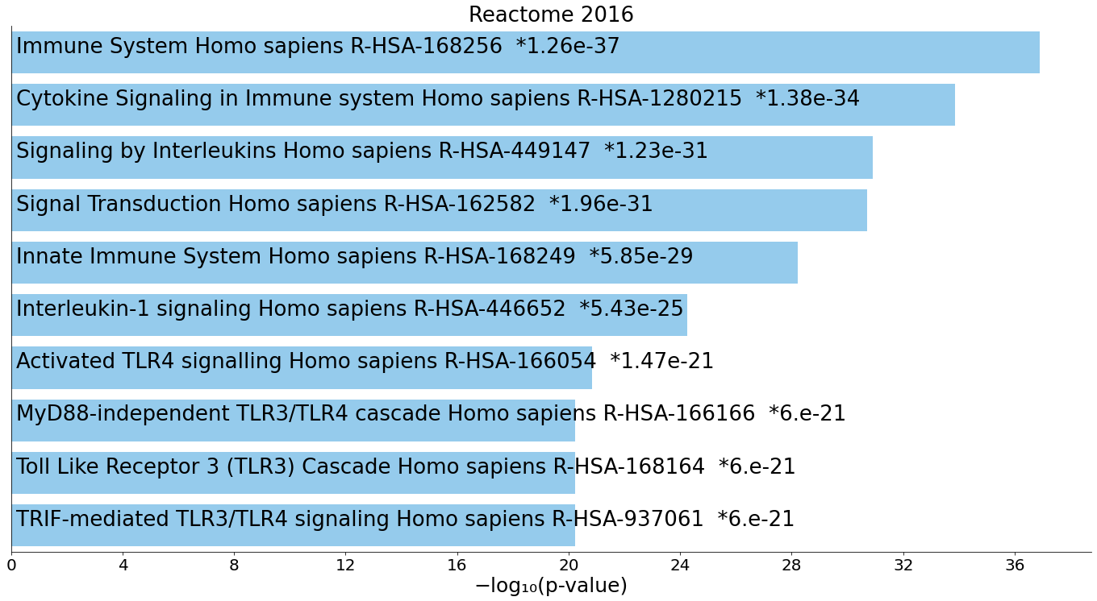
ESF Figure 2. Heatmap (top-10) of enriched Reactome terms over-represented in the differently expressed proteins in first episode psychosis and schizophrenia.
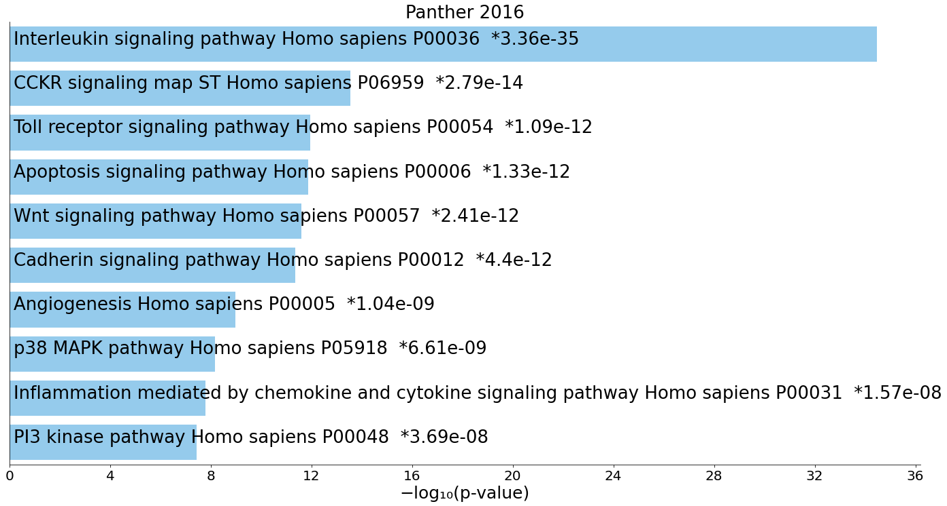
ESF Figure 3. Heatmap (top-10) of enriched Panther Pathways that were over-represented in the differently expressed proteins in first episode psychosis and schizophrenia.
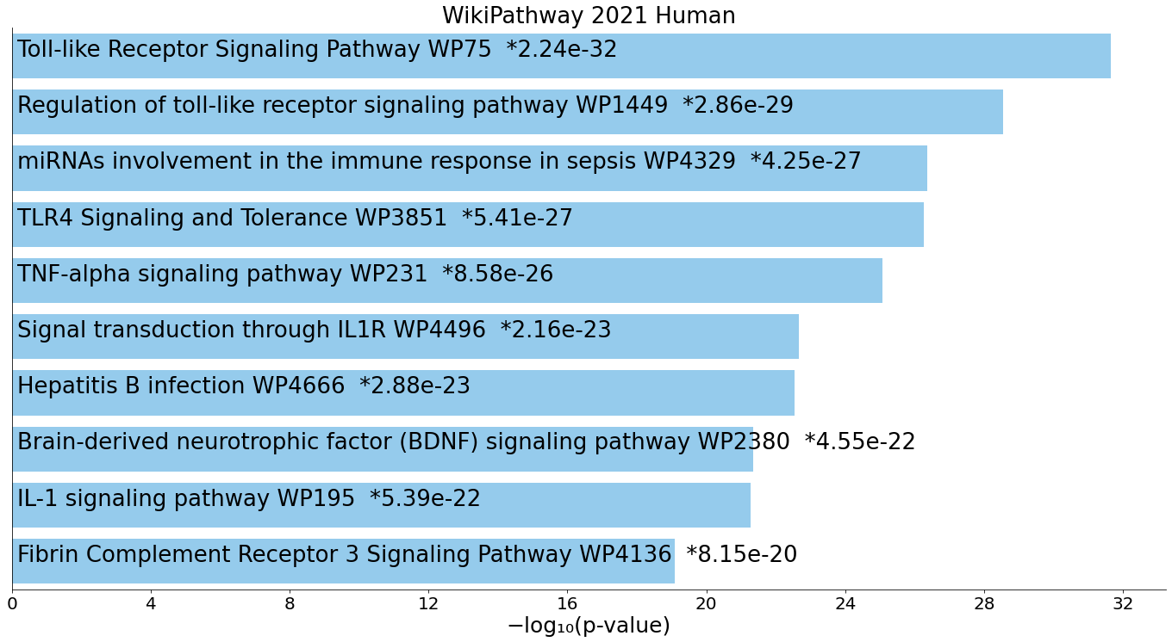
ESF Figure 4. Heatmap (top-10) of enriched WikiPathways that were over-represented in the differently expressed proteins in first episode psychosis and schizophrenia.

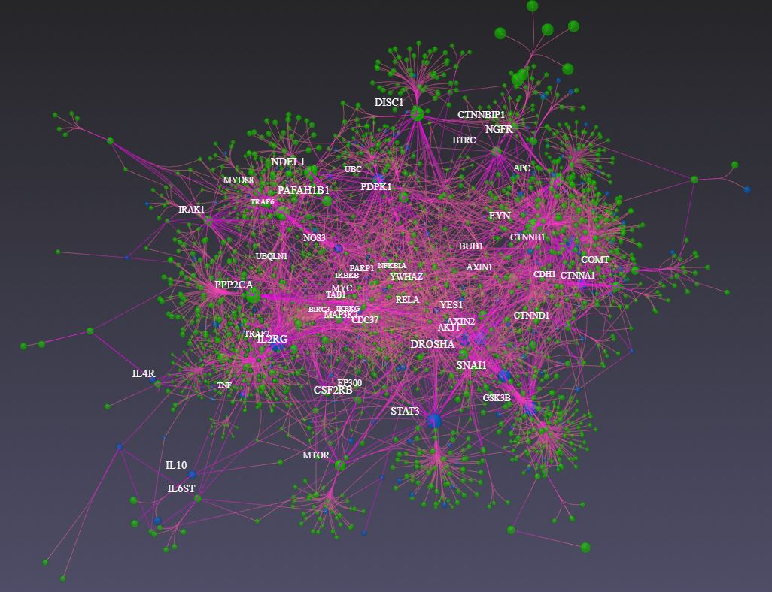
ESF Figure 5. Protein-protein interaction network (built with OmicsNet and IntAct) of first episode psychosis and schizophrenia. The top-3 transcriptional factors are shown as blue spots (SP1, NFκB1, and RELA). Proteins in green and bundles in pink.
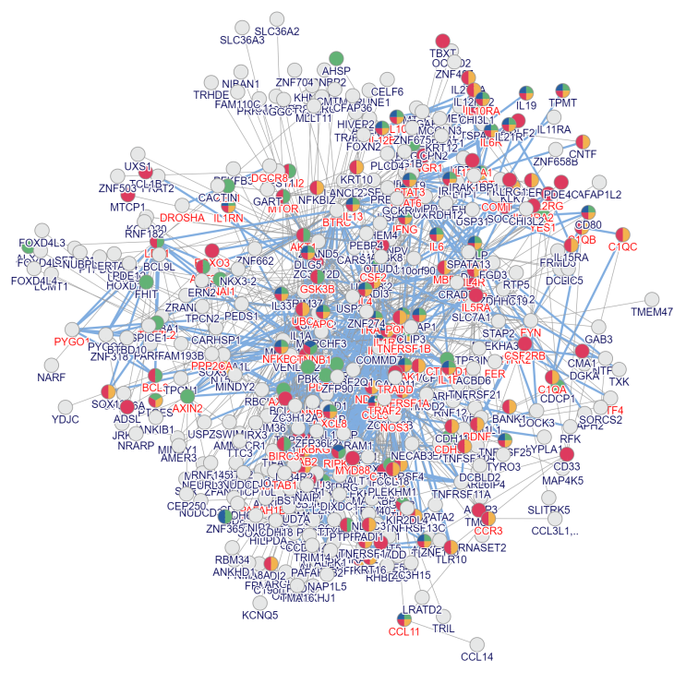
ESF Figure 6. Protein-protein interaction network (built with inBio Discover) of differently expressed proteins in first episode psychosis and schizophrenia. Shown are 4 top annotations that are over-represented in the gene list, namely: red color: immune system disease (DOID:2914); blue color: inflammatory bowel disease (DOID:0050589); green color: intestinal disease (DOID:5295); yellow color: autoimmune disease (DOID:417)
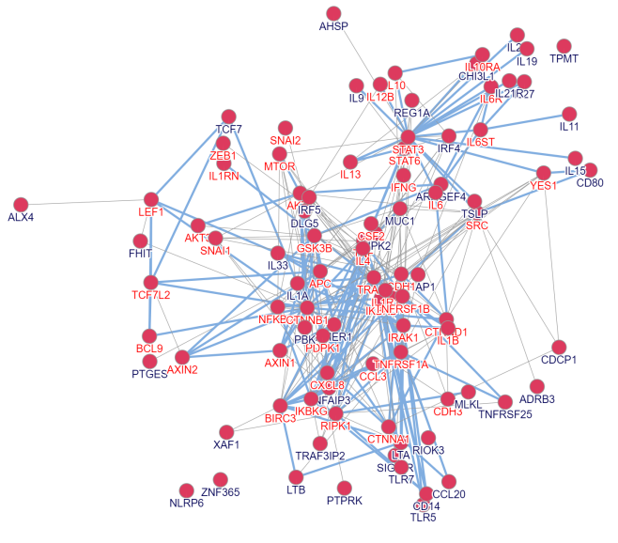
ESF Figure 7. Differently expressed proteins in the extended protein-protein interaction network that accumulated in intestinal disease (DOID:5295).

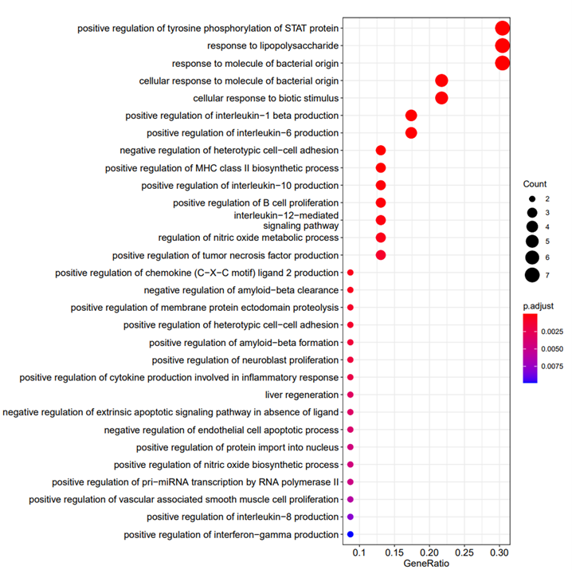
ESF Figure 8. GO functional enrichment analysis of all differently expressed proteins in first episode psychosis and schizophrenia using R package ClusterProfiler. Only annotated GO term leaves are shown in this figure. The x-axis shows the gene ratio and the y-axis the annotated GO biological terms. The size of the dots is proportional to the gene number; p-values of all GO terms are colored as indicated in the figure.

