Extreme climatic events to intensify in the Lake Victoria Basin under global warming
Obed M. Ogega^{a,b}, Enrico Scoccimarro^{c}, Herbert Misiani^{d}, and James Mbugua^{e}
Supplementary information

List of figures
Fig. S 1: Climatology of the study domain for the period 1985-2014 3
Fig. S 2: Annual (ANN) climatology differences between model data and MSWEP data, for the period 1985-2014. Stippling shows significant values at 99% confidence level. All units are in mm/month 4
Fig. S 3: As in Fig. S 2 but for MAM 5
Fig. S 4: As in Fig. S 2 but for JJA 6
Fig. S 5: As in Fig. S 2 but for OND 7
Fig. S 6: Changes in mean annual (ANN) precipitation climatology for the period 2040-2069 (MID-CTLl) and 2070-2099 (FUT-CTL) relative to the 1985-2014 period (CTL), for all models and an ensemble mean for the top-five models identified in subsection 3.1 (ENStop5). Stippling shows significant values (at 99% confidence level). All units are in mm/month 8
Fig. S 7: As in Fig. S 6 but for MAM 9
Fig. S 8: As in Fig. S 6 but for JJA 10
Fig. S 9: As in Fig. S 6 but for OND 11
Fig. S 10: Changes in the maximum 5-day precipitation (Rx5day) climatology for the period 2040-2069 (MID-CTLl) and 2070-2099 (FUT-CTL) relative to the 1985-2014 period (CTL), for all models and an ensemble mean for the top-five models (ENStop5). Stippling shows significant values at 99% confidence level. All units are in mm 12
Fig. S 11: As in Fig. S 10 but for SDII 13
Fig. S 12: As in Fig. S 10 but for 99p90p. Units are in mm 14

List of tables
Table S 1: NEX-GDDP-CMIP6 datasets used in the study. All the data have a spatial resolution of 0.25 degrees x 0.25 degree and are based on SSP5-8.5. More information about the models is available at https://esgf-node.llnl.gov/search/cmip6/ 1

Methodology
Table S 1: NEX-GDDP-CMIP6 datasets used in the study. All the data have a spatial resolution of 0.25 degrees x 0.25 degree and are based on SSP5-8.5. More information about the models is available at https://esgf-node.llnl.gov/search/cmip6/
Model ID (Variant)  [Hereinafter] | Institution | Main reference
CMCC-ESM2 (r1i1p1f1)  [CMCC] | Centro Euro-Mediterraneo sui Cambiamenti Climatici (CMCC), Italy | ¹
CNRM-ESM2-1 (r1i1p1f2)  [CNRM] | Centre National de Recherches Météorologiques (CNRM) and Centre Européen de Recherche et de Formation Avancée en Calcul Scientifique (CERFACS), France | ²
EC-Earth3 (r1i1p1f1)  [EC] | Consortium Europe | ³
FGOALS-g3 (r3i1p1f1)  [FGOALS] | Chinese Academy of Sciences (CAS), China | ⁴
GFDL-ESM4 (r1i1p1f1)  [GFDL] | National Oceanic and Atmospheric Administration, Geophysical Fluid Dynamics Laboratory (NOAA), USA | ⁵
IPSL-CM6A-LR (r1i1p1f1)  [IPSL] | Institut PierreSimon Laplace (IPSL), France | ⁶
KACE-1-0-G (r1i1p1f1)  [KACE] | National Institute of Meteorological Sciences, Korea Meteorological Administration (NIMS-KMA), Republic of Korea | ⁷
MIROC-ES2L (r1i1p1f2)  [MIROC] | Japan Agency for Marine-Earth Science and Technology, Atmosphere and Ocean Research Institute, Japan | ⁸
MIROC6 (r1i1p1f1)  [MIROC6] |  | ⁹
MPI-ESM1-2-HR (r1i1p1f1)  [MPI_HR] | Max Planck Institute for Meteorology (MPI), Germany | ¹⁰
MPI-ESM1-2-LR (r1i1p1f1)  [MPI_LR] |  | ¹¹
MRI-ESM2-0 (r1i1p1f1)  [MRI] | Meteorological Research Institute (MRI), Japan | ¹²
NESM3 (r1i1p1f1)  [NESM3] | Nanjing University of Information Science and Technology (NUIST), China | ¹³
NorESM2-LM (r1i1p1f1)  [NorESM2_LM] | NorESM Climate Modelling Consortium (NCC), Norway | ¹⁴
NorESM2-MM (r1i1p1f1)
[NorESM2_MM]

TaiESM1 (r1i1p1f1)  [TaiESM1] | Research Center for Environmental Changes, Academia Sinica Taiwan (AS-RCEC), China | ¹⁵
UKESM1-0-LL (r1i1p1f2)  [UKESM1] | Met Office-NERC, United Kingdom | ¹⁶

Results and discussion
Fig. S 1: Climatology of the study domain for the period 1985-2014
Fig. S 2: Annual (ANN) climatology differences between model data and MSWEP data, for the period 1985-2014. Stippling shows significant values at 99% confidence level. All units are in mm/month
Fig. S 3: As in Fig. S 2 but for MAM
Fig. S 4: As in Fig. S 2 but for JJA
Fig. S 5: As in Fig. S 2 but for OND
Fig. S 6: Changes in mean annual (ANN) precipitation climatology for the period 2040-2069 (MID-CTLl) and 2070-2099 (FUT-CTL) relative to the 1985-2014 period (CTL), for all models and an ensemble mean for the top-five models identified in subsection 3.1 (ENStop5). Stippling shows significant values (at 99% confidence level). All units are in mm/month
Fig. S 7: As in Fig. S 6 but for MAM
Fig. S 8: As in Fig. S 6 but for JJA
Fig. S 9: As in Fig. S 6 but for OND
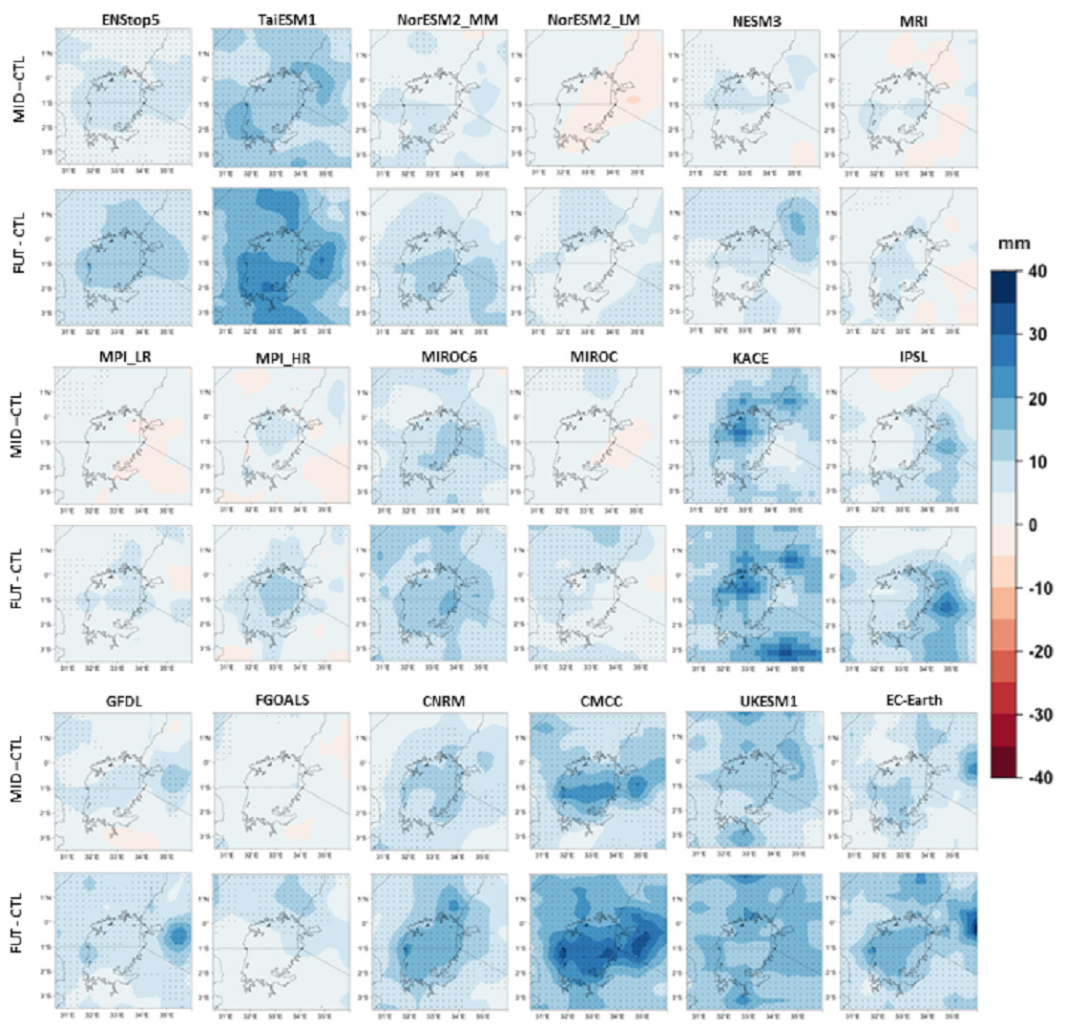
Fig. S 10: Changes in the maximum 5-day precipitation (Rx5day) climatology for the period 2040-2069 (MID-CTLl) and 2070-2099 (FUT-CTL) relative to the 1985-2014 period (CTL), for all models and an ensemble mean for the top-five models (ENStop5). Stippling shows significant values at 99% confidence level. All units are in mm
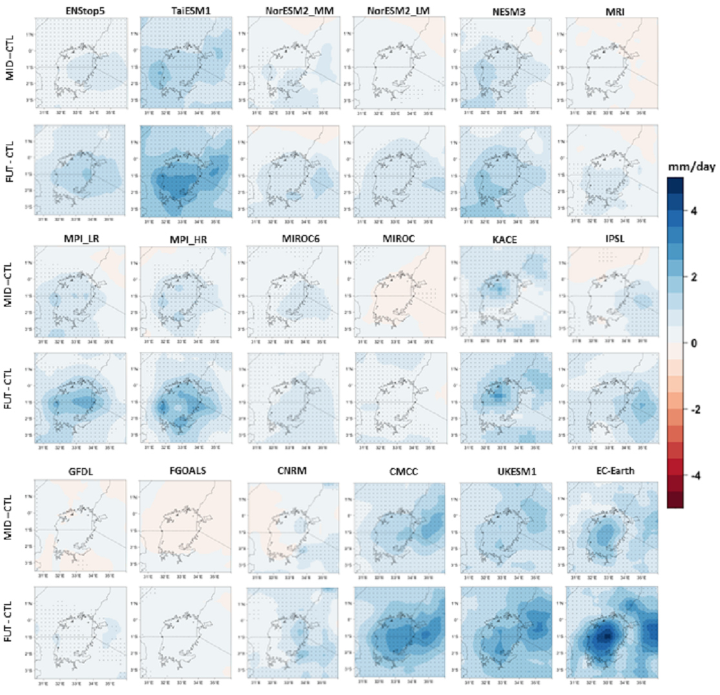
Fig. S 11: As in Fig. S 10 but for SDII
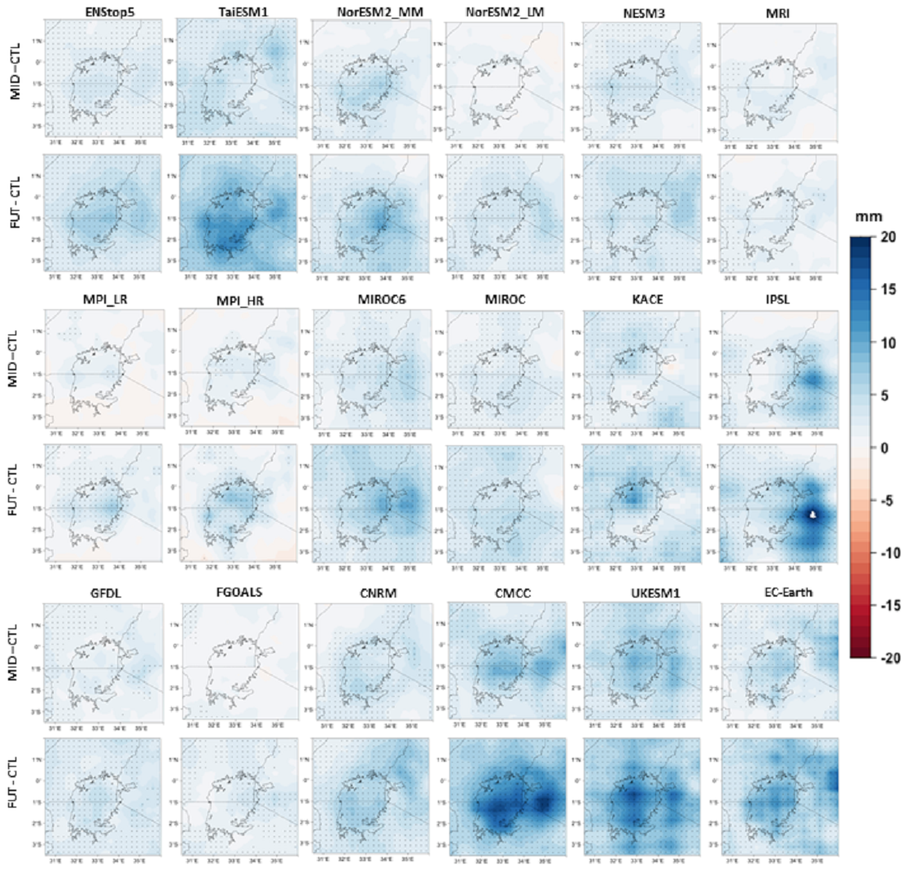
Fig. S 12: As in Fig. S 10 but for 99p90p. Units are in mm

References
1. Cherchi, A. et al. Global mean climate and main patterns of variability in the CMCC‐CM2 coupled model. J Adv Model Earth Syst 2018MS001369 (2018) doi:10.1029/2018MS001369.
2. Voldoire, A. et al. Evaluation of CMIP6 DECK Experiments With CNRM‐CM6‐1. J Adv Model Earth Syst 11, 2177–2213 (2019).
3. Döscher, R. et al. The EC-Earth3 Earth system model for the Coupled Model Intercomparison Project 6. Geosci Model Dev 15, 2973–3020 (2022).
4. Li, L. et al. The Flexible Global Ocean‐Atmosphere‐Land System Model Grid‐Point Version 3 (FGOALS‐g3): Description and Evaluation. J Adv Model Earth Syst 12, (2020).
5. Dunne, J. P. et al. The GFDL Earth System Model Version 4.1 (GFDL‐ESM 4.1): Overall Coupled Model Description and Simulation Characteristics. J Adv Model Earth Syst 12, (2020).
6. Boucher, O. et al. Presentation and Evaluation of the IPSL‐CM6A‐LR Climate Model. J Adv Model Earth Syst 12, (2020).
7. Lee, J. et al. Evaluation of the Korea Meteorological Administration Advanced Community Earth-System model (K-ACE). Asia Pac J Atmos Sci 56, 381–395 (2020).
8. Hajima, T. et al. Development of the MIROC-ES2L Earth system model and the evaluation of biogeochemical processes and feedbacks. Geosci Model Dev 13, 2197–2244 (2020).
9. Tatebe, H. et al. Description and basic evaluation of simulated mean state, internal variability, and climate sensitivity in MIROC6. Geosci Model Dev 12, 2727–2765 (2019).
10. Müller, W. A. et al. A Higher‐resolution Version of the Max Planck Institute Earth System Model (MPI‐ESM1.2‐HR). J Adv Model Earth Syst 10, 1383–1413 (2018).
11. Mauritsen, T. et al. Developments in the MPI‐M Earth System Model version 1.2 (MPI‐ESM1.2) and Its Response to Increasing CO ₂. J Adv Model Earth Syst 11, 998–1038 (2019).
12. Yukimoto, S. et al. The Meteorological Research Institute Earth System Model Version 2.0, MRI-ESM2.0: Description and Basic Evaluation of the Physical Component. Journal of the Meteorological Society of Japan. Ser. II 97, 931–965 (2019).
13. Cao, J. et al. The NUIST Earth System Model (NESM) version 3: description and preliminary evaluation. Geosci Model Dev 11, 2975–2993 (2018).
14. Seland, Ø. et al. Overview of the Norwegian Earth System Model (NorESM2) and key climate response of CMIP6 DECK, historical, and scenario simulations. Geosci Model Dev 13, 6165–6200 (2020).
15. Lee, W.-L. et al. Taiwan Earth System Model Version 1: description and evaluation of mean state. Geosci Model Dev 13, 3887–3904 (2020).
16. Sellar, A. A. et al. UKESM1: Description and Evaluation of the U.K. Earth System Model. J Adv Model Earth Syst 11, 4513–4558 (2019).

