Supplementary Figure S1. Forest plot comparing lenvatinib and HAIC group which representing hazard ratio, p-value, and median OS in each subgroup

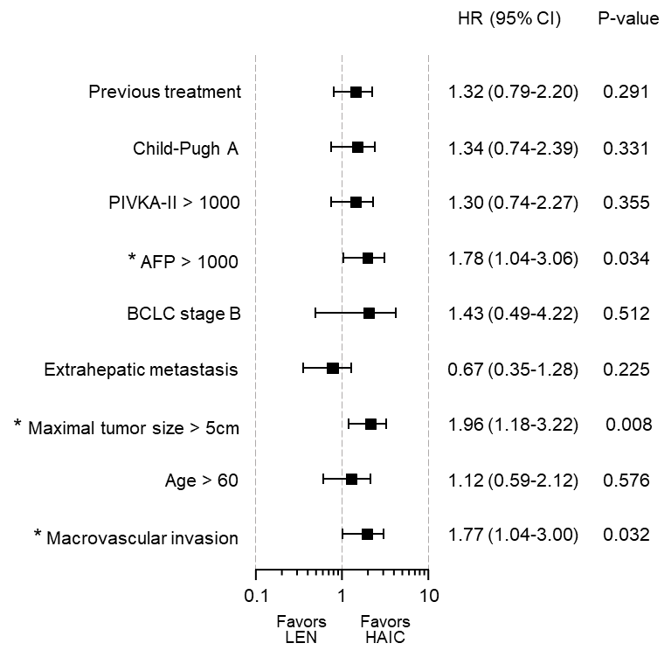

Supplementary Figure S2. Forest plot comparing lenvatinib and HAIC group which representing hazard ratio, p-value, and median PFS in each subgroup

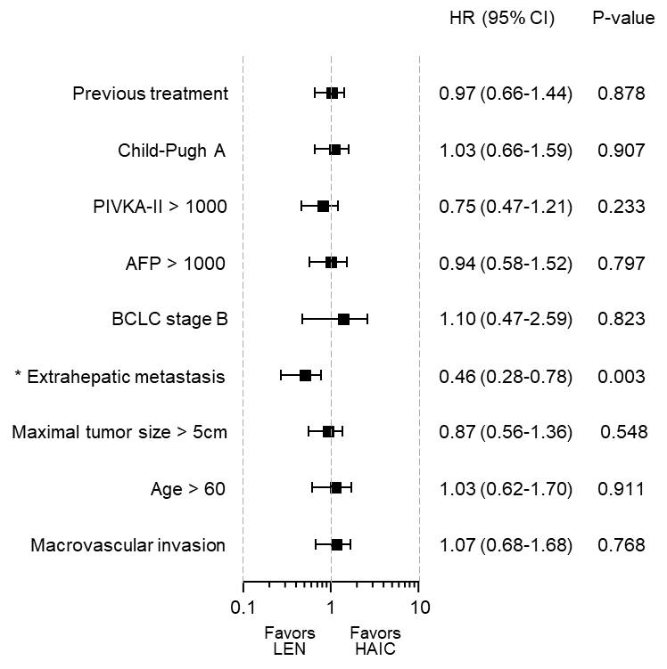

Supplementary Figure S3. Kaplan-Meier curve representing survival difference between patients with salvage therapy and without salvage therapy at the end of HAIC or lenvatinib treatment, in PSM cohort.

Supplementary Table S1. Salvage therapy following lenvatinib or HAIC
 | Lenvatinib (n = 46) | HAIC (n = 47) | P
Salvage therapy | 14 (30.4) | 26 (55.3) | 0.015
Sorafenib | 1 | 11
Lenvatinib | - | 5
Nivolumab | 4 | 1
Regorafenib | 2 | 0
Ramucirumab | 0 | 1
Atezolizumab-Bevacizumab | 0 | 1
TACE | 3 | 6
HAIC | 1 | -
TARE | 0 | 1
Systemic cytotoxic chemotherapy | 3 | 0

Data are given as n (%). HAIC, hepatic arterial infusion chemotherapy; TACE, transarterial chemoembolization; TARE, transarterial radioembolization.

