Melatonin/nanoclay hybrids for skin delivery
Ana Borrego-Sánchez^{1,2,3,}*, Daniel Muñoz-Santiburcio⁴, César Viseras^{1,2,*}, Alfonso Hernández-Laguna¹ and C. Ignacio Sainz-Díaz^{1,*}

¹ Instituto Andaluz de Ciencias de la Tierra (Consejo Superior de Investigaciones Científicas-University of Granada). Av. de las Palmeras 4, 18100 Armilla, Granada (Spain); a.h.laguna@csic.es (A.H.-L); ignacio.sainz@iact.ugr-csic.es (C.I.S.-D.)
² Department of Pharmacy and Pharmaceutical Technology. Faculty of Pharmacy (University of Granada). Campus de Cartuja s/n, 18071 Granada (Spain); cviseras@ugr.es (C.V.)
³ Center for Human Technologies (Italian Institute of Technology). Via Enrico Melen 83, 16152 Genoa (Italy); ana.borrego@iit.it (A.B.-S.)
⁴ CIC Nanogune BRTA. Tolosa Hiribidea 76, 20018 San Sebastian (Spain); d.munoz@nanogune.eu (D.M.-S.)

* Correspondence: Correspondence: ana.borrego@iit.it (A.B.-S.); ignacio.sainz@iact.ugr-csic.es (C.I.S.-D.); cviseras@ugr.es (C.V.)

Table of Contents
1. Methodology
1.1. Atomistic Simulation Models Figure S1
2. Results
2.1. Stability of pristine melatonin in organic solvents
2.2. Calculated X-ray diffraction Figure S2
2.3. Optimized melatonin molecular structure Figure S3
2.4. Main geometrical features of the optimized melatonin molecule Table S1
2.5. Main geometrical features of the optimized melatonin crystal Table S2
2.6. Experimental FTIR spectroscopy Figure S4

1. Methodology
  - Atomistic Simulation Models
Figure S1. MEL-Montmorillonite-Water model used in the AIMD runs (side (a) and top (b) views). The simulation cell is shown in blue lines. Colour code: O in red, H in white, N in blue, C in cyan, Na in green, Si in yellow, Al in pink, Mg in light blue.

2. Results and Discussion
2.1. Stability of pristine melatonin in organic solvents
Due to the low solubility of MEL in water and the high affinity of clays to water, other solvents in which the drug is soluble were tested. Therefore, preliminary explorations related with the stability of MEL in different organic solvents were performed for the preparation of hybrid materials (MEL-clay) and also for setting up an analytical protocol. Firstly, the stability of MEL in ethanol 96% and 99% were studied. After dissolving the MEL in ethanol 96% and 99% at zero time, the solutions were measured in HPLC and the degradation of the drug was observed. The results obtained allow us to know that ethanol could not be used for the dissolution of MEL, since ethanol produces an immediate degradation of MEL, despite previous studies used ethanol as a solvent for MEL [1–4]. The same results were obtained by dissolving MEL in methanol, isopropanol and acetone. Therefore, these organic solvents could not be used to dissolve the drug. On the contrary, the stability of MEL in acetonitrile was observed until one month later, and the solubility of MEL in acetonitrile was approximately 41 mg/mL. Since the solubility of the drug in acetonitrile is high and MEL is stable in acetonitrile, this organic solvent was chosen to solubilize MEL in the rest of experimental tests.
2.2. Calculated X-ray diffraction
The X-ray diffraction of the melatonin crystal[5] was calculated with the Reflex Powder Diffraction module [6]. In Figure S2, the main melatonin peaks appeared at 16.5°, 19.0°, 24.5°, 25.5° and 26.5° 2θ according with the experimental results (Figure 1) and others spectrum previously reported [7] with the only differences are in the relative intensity of peaks.
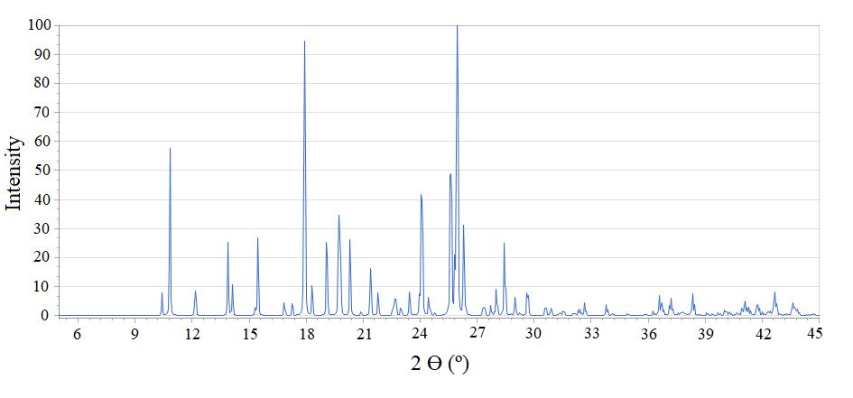
Figure S2. Calculated powder X-ray diffraction of crystal structure of melatonin.

2.3. Optimized melatonin molecular structure
Figure S3. The MEL molecular structure optimized with Dmol³ (a) and INTERFACE FF (b). Two orientations are shown.

2.4. Main geometrical features of the optimized melatonin molecule
Table S1. Main bond lengths (Å) and angles (°) values of the optimized MEL molecular structure.^{[a]}
Features | EXP | UF | CF | INTERFACE | DFT
d(H₃C-CO) | 1.492 | 1.497 | 1.507 | 1.511 | 1.528
d(C=O) | 1.239 | 1.220 | 1.218 | 1.228 | 1.237
d(OC-NH) | 1.329 | 1.371 | 1.344 | 1.327 | 1.376
d(HN-CH₂) | 1.445 | 1.465 | 1.466 | 1.476 | 1.468
d(H₂C-CH₂) | 1.504 | 1.534 | 1.515 | 1.515 | 1.534
d(H₂C-C=C) | 1.497 | 1.507 | 1.491 | 1.532 | 1.508
d(HC-NH) | 1.364 | 1.352 | 1.380 | 1.411 | 1.388
d(C=C-O) | 1.382 | 1.410 | 1.385 | 1.396 | 1.387
d(O-CH₃) | 1.416 | 1.427 | 1.424 | 1.448 | 1.433
H₃C-O-C | 117.3 | 118.2 | 117.5 | 123.7 | 117.4
O=C-N | 121.2 | 120.4 | 122.3 | 124.1 | 122.2
H₃CO-C-C=C | 0.1 | 0.0 | 2.1 | 1.5 | 0.4
O=C-N-H | 179.0 | 180.0 | 178.0 | 179.8 | 179.7
H-N-C-C | 4.1 | 0.0 | 96.9 | 3.8 | 0.0
C-C-C=CN | 5.5 | 0.0 | 90.1 | 98.9 | 9.5
[a] EXP: experimental data in crystal lattice [5]; UF: calculated with Universal FF using Forcite code; CF: calculated with COMPASS and FORCITE code; INTERFACE: calculated with INTERFACE FF and DISCOVER code; DFT: calculated with DMol³.

2.5. Main geometrical features of the optimized melatonin crystal
Table S2. Main bond lengths (Å) and angles (°) values of the crystal structure of melatonin optimized at variable volume.^{[a]}
Features | EXP | UF | CF | INTERFACE | CA | CA_TS | CA_G
d(H₃C-CO) | 1.492 | 1.495 | 1.487 | 1.518 | 1.508 | 1.507 | 1.507
d(C=O) | 1.239 | 1.219 | 1.217 | 1.207 | 1.255 | 1.256 | 1.257
d(OC-NH) | 1.329 | 1.371 | 1.328 | 1.336 | 1.345 | 1.339 | 1.337
d(HN-CH₂) | 1.445 | 1.464 | 1.474 | 1.471 | 1.457 | 1.452 | 1.453
d(H₂C-CH₂) | 1.504 | 1.533 | 1.521 | 1.511 | 1.525 | 1.523 | 1.522
d(H₂C-C=C) | 1.497 | 1.508 | 1.514 | 1.504 | 1.500 | 1.495 | 1.492
d(HC-NH) | 1.364 | 1.350 | 1.376 | 1.381 | 1.377 | 1.376 | 1.377
d(C=C-O) | 1.382 | 1.409 | 1.377 | 1.385 | 1.377 | 1.376 | 1.377
d(O-CH₃) | 1.416 | 1.426 | 1.420 | 1.423 | 1.424 | 1.423 | 1.426
H₃C-O-C | 117.3 | 118.6 | 116.2 | 117.9 | 117.3 | 116.8 | 116.5
O=C-N | 121.2 | 120.4 | 119.8 | 124.6 | 122.0 | 121.8 | 121.8
H₃CO-C-C=C | 0.1 | 10.8 | 4.9 | 0.6 | 2.5 | 0.8 | 3.6
O=C-N-H | 179.0 | 179.1 | 179.1 | 168.7 | 175.1 | 174.9 | 173.1
H-N-C-C | 4.1 | 1.0 | 11.3 | 24.8 | 15.9 | 11.2 | 6.4
C-C-C=CN | 5.5 | 4.6 | 5.2 | 12.1 | 12.4 | 6.2 | 6.5
=NH···OC | 2.035 | 2.897 | 2.079 | 1.847 | 1.939 | 1.832 | 1.814
NH···OC | 2.157 | 2.654 | 2.364 | 1.995 | 2.016 | 1.904 | 1.849
H₃CO···HC= | 2.612 | 2.517 | 2.948 | 2.574 | 2.750 | 2.361 | 2.387
H₃CO···H₂C | 2.861 | 2.935 | 3.160 | 3.031 | 3.072 | 2.745 | 2.641
[a] EXP: experimental data [5]; UF: calculated with the Universal FF; CF: calculated with Compass FF; INTERFACE: calculated with INTERFACE FF; CA: calculated with CASTEP; CA_TS: calculated with CASTEP and Tkatchenko-Scheffler dispersion correction; CA_G: with CASTEP and Grimme dispersion correction.

2.6. Experimental FTIR spectroscopy
For a better visualization of the infrared bands, the zoom of the experimental spectrum has been shown (Figure S4). The results were described in the manuscript.
Figure S4. Zoom views of the experimental FTIR spectrum of melatonin (Figure 6).

References
1. Gulcin, I.; Buyukokuroglu, M.E.; Oktay, M.; Kufrevioglu, O.I. On the in Vitro Antioxidative Properties of Melatonin. Journal of Pineal Research 2002, 33, 167–171, doi:10.1034/j.1600-079X.2002.20920.x.
2. El-Sherif, Y.; Tesoriero, J.; Hogan, M. v.; Wieraszko, A. Melatonin Regulates Neuronal Plasticity in the Hippocampus. Journal of Neuroscience Research 2003, 72, 454–460, doi:10.1002/jnr.10605.
3. Molska, A.; Nyman, A.K.G.; Sofias, A.M.; Kristiansen, K.A.; Hak, S.; Widerøe, M. In Vitro and in Vivo Evaluation of Organic Solvent-Free Injectable Melatonin Nanoformulations. European Journal of Pharmaceutics and Biopharmaceutics 2020, 152, 248–256, doi:10.1016/j.ejpb.2020.05.003.
4. Robertson, N.J.; Lingam, I.; Meehan, C.; Martinello, K.A.; Avdic-Belltheus, A.; Stein, L.; Tachrount, M.; Price, D.; Sokolska, M.; Bainbridge, A.; et al. High-Dose Melatonin and Ethanol Excipient Combined with Therapeutic Hypothermia in a Newborn Piglet Asphyxia Model. Scientific Reports 2020, 10, 1–13, doi:10.1038/s41598-020-60858-x.
5. Mostad, A.; Romming, C. The Crystal and Molecular Structure of N-Acetyl-5-Methoxy-Tryptamine (Melatonin). Acta Chemica Scandinavica B 1974, 28, 564–572.
6. Biovia; Materials Studio; 2018; Accelrys Inc.; San Diego; USA Biovia, Materials Studio, 2018. Accelrys Inc., San Diego, USA.
7. Al-Omary, F.A.M. Melatonin. Comprehensive Profile. In Profiles of Drug Substances, Excipients and Related Methodology; Academic Press Inc., 2013; Vol. 38, pp. 159–226.

