Enhancing the cell-free expression of native membrane proteins by in-silico optimisation of the coding sequence – an experimental study of the human voltage-dependent anion channel
Sonja Zayni, Samar Damiati, Susana Moreno-Flores*, Fabian Amman*, Ivo Hofacker and Eva-Kathrin Ehmoser

SUPPORTING INFORMATION
Table of Contents
Experimental Details 1
Cloning and purification of plasmids – Primer templates. 1
Cloning and purification of plasmids - PCR cycle program for the amplification of the VDAC-encoding gene. 2
RNA detection and quantitative PCR (qPCR) – RNA isolation, qPCR experimental conditions. 2
Matrix-Assisted Laser Desorption Ionization - Time-of-Flight Mass Spectrometry (MALDI-TOF MS) and MS/MS. 2
MALDI-TOF MS and MS/MS – Protein purification, sample preparation. 3
In-cell expression of VDAC proteins 3
Simulated annealing and construct optimization 4
Calculation of accessibility profiles for single constructs and sets of constructs (ΔE_{open} (i)) 4
Results 5
MALDI-TOF MS and MS/MS 5
In-cell expression of VDAC protein 6
Coomassie and Western Blots – VDAC-I and VDAC-II 7
SDS-page and Western Blot – bands at lower Mw 8
Accessibility profiles (ΔE_{open} (i)) – H. sapiens and E. coli transcripts 9

Experimental Details

Cloning and purification of plasmids – Primer templates.
Primer were purchased from Invitrogen (Thermo Fisher, Waltham, USA). The forward primers are schematically listed in the main text (figures 1 and 2), and obey the following design:
5’GGGG-attB1-GC-SD-spacer nucleotides-ATG-(downstream box)-3’
where “attB1” is the one-side flanking sequence required for creating the Gateway® entry clone (BP reaction), SD refers to the Shine-Dalgarno sequence forming part of the RBS together with additional nucleotides. Downstream box refers to the nucleotide sequence preceding the protein coding sequence in the translated region (TR). The sequence of the reverse primer, common to all constructs, is the following:
GGGG-attB2-T-TTA-CTCGAGTGCTTGAAATTCCAGTCC
where “attB2” is the second one-side flanking sequence for the Gateway® entry clone.
Name of construct | Primer sequence (5´to 3´)
VDAC-I-0, II-0 | gc gaa gga gat aga acc ATG GCT GTG CCA CCC ACG TAT G
VDAC-I-A, II-A | gc gaa gga gat aga ATG GCT GTG CCA CCC ACG TAT G
VDAC-I-B, II-B | gc ATG GCT GTG CCA CCC ACG TAT G
VDAC-II-C | gc gaa gga gat ata cat ATG GCT GTG CCA CCC ACG TAT G
VDAC-II-D | gc gaa gga gat ata cat ATG TCG TAC TAC GCT GTG CCA CCC ACG TAT G
VDAC-II-E | gc gaa gga gat ata cat ATG GAG AAA AAA ATC GCT GTG CCA CCC ACG TAT G
VDAC-I-C, II-F | gc gaa gga gat aga ATG GAG AAA AAA ATC GCT GTG CCA CCC ACG TAT G
VDAC-II-G | gc gaa gga gat aga ATG GCA GTA CCA CCA ACA TAC GCA GAC
Table S1. List of primer sequences used in this study. Sequences of untranslated (UTR) and translated (TR) regions are in lowercase and uppercase letters, respectively. UTRs may contain Shine-Dalgarno (red), the Kozak sequence (grey), and spacer sequences (blue and light blue, respectively). The start codon ATG in green. TRs may contain downstream PDEST-17-codons (brown), the CAT enhancer sequence (orange), in addition to the VDAC sequence (black). Single-nucleotide mutations (synonymous mutations) are depicted in pink (Original first-nine-codon sequence: GCT GTG CCA CCC ACG TAT GCC GAC).

Cloning and purification of plasmids - PCR cycle program for the amplification of the VDAC-encoding gene.
Denaturation: 98°C, 10s ; Annealing: 56°C, 10s; Elongation: 72°C, 20s.

RNA detection and quantitative PCR (qPCR) – RNA isolation, qPCR experimental conditions.
RNA isolation was carried out with 35 µl of the cell-free reaction mixture and the Aurum Total RNA Mini Kit (Bio-Rad, Hercules, USA), following the protocol for bacterial cells with the exception of adding lysozyme. The isolation procedure includes a DNA digestion step and elution was performed with 40 µl elution buffer before spectrophotometric measurements and reverse transcription into cDNA for qPCR.
qPCR experiments were performed with cDNA at a starting concentration of 500 nM, and three VDAC-specific primer pairs for amplicons of varying lengths, as the table below shows:
Primer pair | Forward primer | Reverse primer | Amplicon Length (bp)
1 | CCAAGGGCTATGGATTTGG | TACTTGGTTTCCAGACTGCC | 130
2 | ACACTAGGCACCGAGATTAC | GCTTGTACCCTGTCTTGATT | 120
3 | ACGTGGACTGAAGCTGAC | GCTTGTACCCTGTCTTGATT | 80
Table S2. qPCR VDAC specific primer pairs
The PCR reaction mixture was subjected to the following multi-step treatment: 95°C for 180s (step 1), 95°C for 10s (step 2); 60°C for 30s (step 3); 95°C for 10s (step 4); temperature sweep from 65 to 95°C (melt curve with 5°C temperature steps every 5s, step 5). Steps 2 and 3 were repeated 40 times, plate reading was done after steps 3 and 5. Lid temperature was 100°C. Sample with primers but no cDNA was used as non-template control (NTC).

Matrix-Assisted Laser Desorption Ionization - Time-of-Flight Mass Spectrometry (MALDI-TOF MS) and MS/MS.
MALDI-TOF MS was conducted on in-gel digested protein expressed from VDAC-I-0. The sample was purified from the cell-free reaction mixture prior to in-gel digestion as described below. The tryptic peptides were isolated, dried, and resuspended in acetonitrile-trifluoroacetic acid before being analysed in an Autoflex MALDI TOF/TOF mass spectrometer (Bruker, Billerica, USA). Peptide matching was performed by comparing the experimental tryptic profile with those from the theoretical profile of VDAC. VDAC-based peptide sequences and comparison were carried out using the MS-Digest and MS-Tag algorithms of ProteinProspector (http://prospector.ucsf.edu), respectively. Peptide fragments giving out matching peaks were chosen as parent ions for partial sequencing via MS/MS.

MALDI-TOF MS and MS/MS – Protein purification, sample preparation.
HIS-Tagged VDAC was purified using the MagneHisTM Protein Purification Kit (Promega) according to manufacturer’s instructions, and eluted from nickel beads in two fractions. Attempts to filter the eluted fractions with Amicon ultra-0.5 mL centrifugal filters (Millipore) or D-tubeTM dialyzer Mini (MWCO 12-14 kDa, Novagen) led to considerable loss of sample, and hence fractions were not filtered after elution. The first fraction eluted by 3 M NaCl and the second by 3 M NaCl, 500 mM imidazole in 10 mM HEPES (1:1). The second fraction, of higher purity, was used for MS analysis.
In-gel digestion of HIS-tagged VDAC protein for MS analysis was performed as follows. After excising the VDAC band, the gel fragments were distained and dehydrated thrice at room temperature for 15 min, twice with 50% acetonitrile (AcCN) and once with 100% AcCN, before being further treated with 0.1 M NH₄HCO₃ and 100 % AcCN. Gel bands were then dried in a Speed Vac (Thermo Scientific) and then reduced and allowed to swell with 10 mM dithiothreitol (DTT) in 0.1 M NH₄HCO₃ at room temperature for 5 min. The swollen pieces were incubated at 56°C for 45 min, and alkylated with 55 mM iodoacetamide in 0.1 M NH₄HCO₃ in the dark for another 30 min. Gel bands were then washed as detailed above, and dried in AcCN before trypsin-digested in 0.1 M NH₄HCO₃. Trypsin cleaves at the carboxyl sites of positively-charged Lys and Arg side chains. After digestion, the pieces were reswollen for 5 min, then incubated overnight in 0.1 M NH₄HCO₃ at 37°C and the supernatant transferred into a clean tube. Peptide traces still lodged in the gel were extracted thrice with AcCN: H₂O: trifluoroacetic acid (TFA) (660:330:1), incubated at room temperature for 15 min and at 1400 rpm, and added to the tube. The extracted peptides were then dried in the Speed-Vac at low or zero heat, and resuspended in 5 µl 50% AcCN and 0.1% TFA, before dispensed onto the MALDI-target plate and air dried at room temperature. The masses of minimum and maximum digest fragment masses were found to be 500 (5 amino acids) and 4000 Da, respectively.
Database search was carried out with one missing trypsin cleavage, carbamidomethylation and methionine oxidation. Mass tolerances were 0.1% for precursor and product ions. The variable search parameters were Acetyl (Protein N-term), Gln-pyro-Glu (N term Q), Met-loss (Protein N-term M), Met-loss+Acetyl (Protein N-term M), and Oxidation (M).

In-cell expression of VDAC proteins
VDAC-I-0 and VDAC-II-0 plasmids were transformed into E. coli BL21 via heat-shock transformation. Cells were then regenerated by incubation in SOC broth at 37°C for 1h. Transformed cells were allowed to grow overnight on LB agar plates supplemented with 50 µm/ml ampicillin at 37°C. Single colonies were inoculated in 5 ml LB medium containing ampicillin. After overnight growth, 100 µl of the start culture was transferred to 5 ml of fresh LB medium containing ampicillin, and further incubated at 37°C for 3h. 5 µl of 1 M isopropyl-β-D-thiogalactopyranosid (iPTG), were then added to the culture to induce over expression of VDAC protein, and further incubated at 37°C for another 3 hours. 100 µl of sample were collected every hour and checked for protein expression via SDS-PAGE and Western Blot.

Simulated annealing and construct optimization
The procedure starts with the characterization of the source sequence, the RNA transcript of a reference construct. δ is computed with the equation in the main text, with ΔE_{tRNA} set constant and equal to -1.19 kcal/mol for the AUG start codon. ΔE_{SD} is calculated between a 30-nucleotide-long segment upstream the start codon of the source sequence and and the anti-SD sequence in the 16S-ribosomal RNA (CACCTCCTTA), for the most energetically favourable location of the SD sequence in the source, which is obtained with RNAduplex. ΔE_{open} is calculated with the program RNAup.
δ is then maximised by allowing single-nucleotide mutations in the TR of source sequences that encode the same amino acid (synonymous). The simulated annealing algorithm randomly swaps codons with synonymous mutations and the resulting sequence is characterized as described above. Mutations are accepted as long as they decrease ΔE_{open}; otherwise they are accepted with a probability p that in turn depends on the change in ΔE_{open} brought about by the mutation, and a virtual temperature t that is iteratively decreased from 2 to 0:
$$p≤e^{{\left({∆E}_{open}^{after}-{∆E}_{open}^{before}\right)}/t}$$
Where ${∆E}_{open}^{before}$ and ${∆E}_{open}^{after}$ are the opening energies before and after introducing the mutation, respectively. Hence the probability of accepting a detrimental mutation is reduced in the course of the iterative process. This allows to widely explore the energy landscape before fine searching for local energy minima. Finding mutations that are accepted is accomplished by setting 300 iteration steps with up to 25 tries per step.

Calculation of accessibility profiles for single constructs and sets of constructs (ΔE_{open} (i))
For the constructs such as those displayed in Figure 4a and b, ΔE_{open}(i) is calculated using RNAplfold with the parameters -W 120 -L 70 -u 30. All coding sequences (4,294) from the K12 strain of E. Coli, including the 100 nucleotide long upstream region, were obtained from microbes.uscs.edu. The cDNA sequence of all human protein transcripts (57,982 sequences) as well as all protein coding transcripts associated with the GO-term “integral component of the membrane” (GO:0016021, 8,270 sequences with an annotated 5’UTR of 100 nucleotides at least) were obtained from ensemble_biomart. The UTRs of these transcripts were replaced with the sequence of the pDEST14 vector to generate the pDEST14-based constructs, and the respective sequences of the CAT enhancer (GAGAAAAAAATC) and the embedded HIS-tag (TCGTACTACCATCACCATCACCATCACCTCGAATCAACAAGTTTGTACAAA
AAAGCAGGCTGCGAAGGAGATAGAACC) inserted right after the start codon. For the purpose of visualization, ΔE_{open} (i) data were smoothed by a generalized additive model (Wood, S.N. J. R. Stat. Soc. B: Statistical Methodology 2001, 73, 3-36).

Results

MALDI-TOF MS and MS/MS
1 | MAVPPTYADL | GKSARDVFTK | GYGFGLIKLD | LKTKSENGLE | FTSSGSANTE | TTKVTGSLET | KYRWTEYGLT | FTEKWNTDNT
81 | LGTEITVEDQ | LARGLKLTFD | SSFSPNTGKK | NAKIKTGYKR | EHINLGCDMD | FDIAGPSIRG | ALVLGYEGWL | AGYQMNFETA
161 | KSRVTQSNFA | VGYKTDEFQL | HTNVNDGTEF | GGSIYQKVNK | KLETAVNLAW | TAGNSNTRFG | IAAKYQIDPD | ACFSAKVNNS
241 | SLIGLGYTQT | LKPGIKLTLS | ALLDGKNVNA | GGHKLGLGLE | FQALE

Figure S1. MALDI-TOF-MS spectrum of VDAC showing the tryptic peptides. The theoretical masses, intensity and signal-to-noise ratio (S/N) are shown in the box. Peaks corresponding to matching peptide sequences (in red below) are shown in bold type. Below, the complete VDAC amino acid sequence, showing the matching peptide sequences in red and the sites of cleavage by trypsin (_).The matched peptides cover 34% of the protein with 98 identical residues of 285 aminoacids for VDAC.
Figure S2. MS/MS spectra of two parent ions corresponding to the two highest peaks of the MS spectrum (figure S1). Upper graph: Spectrum of the peptide 1945.934 m/z with sequence KLETAVNLAWTAGNSNTR (matched intensity: 48.1%). Lower graph: Spectrum of the peptide 2175.956 m/z with sequence EHINLGCDMDFDIAGPSIR (matched intensity: 34.8%).

In-cell expression of VDAC protein
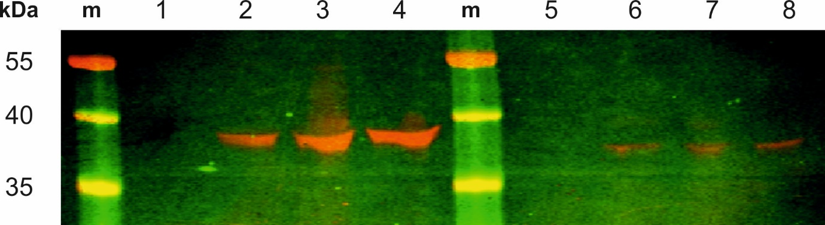
Figure S3. Western Blots of VDAC expression in E. coli. Lanes 1-4: Expression levels using VDAC-I-0 before (1), and 2h (2), 3h (3), and an overnight (4) after the addition of IPTG. Lanes 5-8: Expression levels using VDAC-II-0 construct before (5), and 2h (6), 3h (7), and an overnight (8) after the addition of iPTG.). m stands for marker.

Coomassie and Western Blots – VDAC-I and VDAC-II
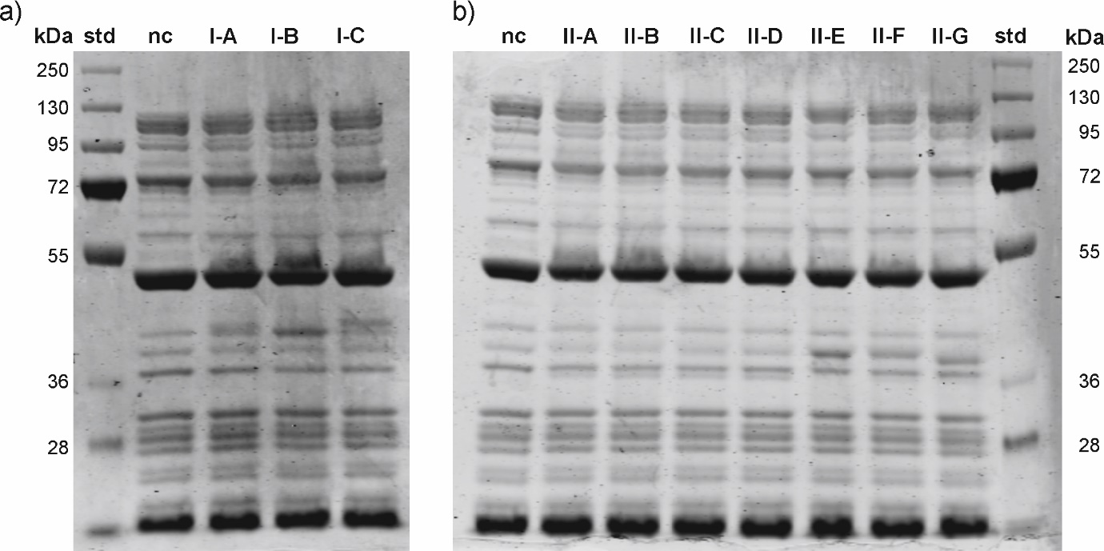
Figure S4. Coomassie stainings of the constructs VDAC-I (A,B,C) (a) and VDAC-II (A-G) (b). Fluorescence scans on the same gel are shown in the main text as figures 1 and 2, respectively. (std: standard; nc: negative control)
Figure S5. Western Blot showing the level of protein expression for the constructs VDAC-I (I-A, I-B, I-C) and VDAC-II (II-A, II-B, II-C, II-D, II-E, II-F, II-G).

Construct | Number of amino acids  of the coding protein | Calculated MW  of the coding protein (kDa)
IA | 311 | 34.12
IB | 307 | 33.66
IC | 315 | 34.12
IIA-IIC | 285 | 31.01
IID | 288 | 31.43
IIE | 289 | 31.51
IIF | 289 | 31.51
IIG | 285 | 31.01
Table S3. Number of amino acids and the corresponding molecular weight (MW) of the resulting protein, based on the construct´s coding sequence.

SDS-page and Western Blot – bands at lower Mw
Worth mentioning is the presence in both the SDS-page gel and Western Blot of an additional band at approximately 36 kDa. This band of weak intensity appears only when the intensity of the 39k Da band is either low or non-detectable; in other words, in the case of plasmids II-A to II-D or of low to no VDAC expression.
Protein expression in the absence of natural or good templates is not unheard of in in-vitro synthesis with bacterial systems, [1] and may be symptomatic of mRNA transcription re-initiation events. Resuming transcription initiation results in shorter mRNA transcripts, and hence to the expression of proteins of lower molecular weight. In this case, the underlying mechanism may not be different from that reported for DNA replication in the presence of non-replicating polymerases, whereby nascent RNA transcripts act as primers to re-initiate DNA replication. [2]

[1] A. Arslan Yildiz, In-vitro synthesis and reconstitution of cytochrome bo3 ubiquinol oxidase in artificial membranes, PhD Disssertation, 2010.
[2] S. Bo, A. Singh, S. Sultana, J. T. Inman, S. S. Patel and M. D. Wang, Nature Comm., 2018, 9, 2306-2314.

Accessibility profiles (ΔE_{open} (i)) – H. sapiens and E. coli transcripts
Native human mRNA transcripts are less accessible than E. coli´s, which is reflected in higher values of ΔE_{open} at the optimal location of the ribosome docking site (RDS), i.e. at i = -11 for E. coli. The disparity in profiles indicates the existence of structural differences in the translation-initiation region between prokaryotes and eukaryotes.
Figure S6. Average opening energies as a function of i, the RDS location for the E. coli (brown curve) and the H. sapiens (orange curve) genomes. Note that at i = -11 the value of ΔE_{open} is a local minimum only in the prokaryotic case.

