Supporting Information
Paper-supported WS₂ strain gauges
Wenliang Zhang¹, Riccardo Frisenda¹, Qinghua Zhao^{1,2,3}, Felix Carrascoso¹, Abdullah M. Al-Enizi⁴, Ayman Nafady⁴, Andres Castellanos-Gomez^{1,*}
¹Materials Science Factory. Instituto de Ciencia de Materiales de Madrid (ICMM-CSIC), Madrid, E-28049, Spain.
² State Key Laboratory of Solidification Processing. Northwestern Polytechnical University. Xi'an, 710072, P. R. China
³ Key Laboratory of Radiation Detection Materials and Devices. Ministry of Industry and Information Technology Xi'an, 710072, P. R. China
⁴ Department of Chemistry, College of Science, King Saud University, Riyadh 11451, Saudi Arabia.

Andres.castellanos@csic.es

Extra datasets of some WS₂-on-paper strain gauge devices
Electrical characteristics of a pencil-on-paper strain gauge upon strain
Electrical characteristics of several nanographite-on-paper strain gauge upon strain
Figure S1. Extra datasets of some WS₂-on-paper strain gauge devices. (a) Resistance change vs. strain measured on 5 different devices. (b) to (f) Individual datasets of the different devices. The gauge factor has been obtained from a linear fit.
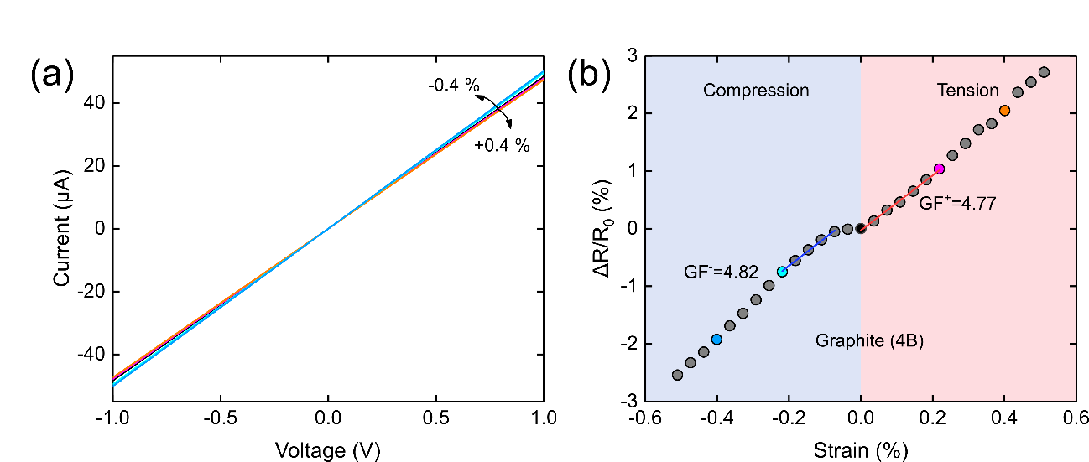
Figure S2. Electrical characteristics of a pencil-on-paper strain gauge upon strain. (a) Current vs. voltage characteristics of a pencil (4B) based strain gauge on paper for different strain values. (b) Extracted resistance change as a function of the applied strain load. The gauge factor has been obtained from a linear fit.

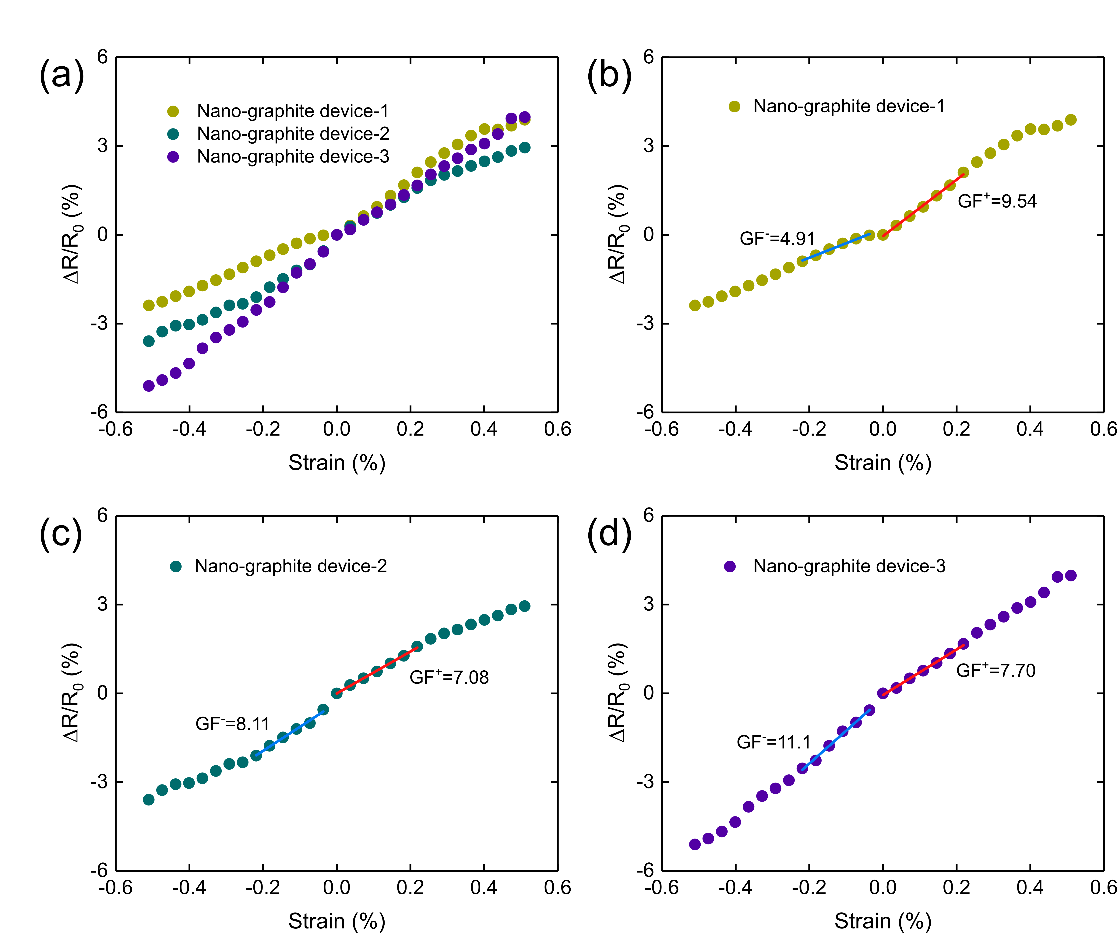
Figure S3. Electrical characteristics of several nanographite-on-paper strain gauge upon strain. (a) Summary of the resistance change upon strain of three nanographite based strain gauge on paper. (b) to (d) Individual datasets for each device. The gauge factor has been obtained from a linear fit.

