Alessia Mazzarotta¹, Tania Mariastella Caputo¹, Luca Raiola¹, Edmondo Battista², Filippo Causa^{1,2,3}, Paolo Antonio Netti^{1,2,3}
¹ Center for Advanced Biomaterials for Healthcare@CRIB, Istituto Italiano di Tecnologia (IIT), Largo Barsanti e Matteucci 53, 80125 Naples, Italy
²InterdisciplinaryResearch Centre on Biomaterials (CRIB), Università degli Studi di Napoli "Federico II", Piazzale Tecchio 80, 80125 Naples, Italy
³Dipartimento di Ingegneria Chimica del Materiali e della Produzione Industriale (DICMAPI), University “Federico II”, Piazzale Tecchio 80, 80125 Naples, Italy

Preliminary NMR studies
For NMR studies, we reduced the total reaction volume to 1 mL of deuterated water (Table 3.1). Polymerization was performed directly in special NMR tubes designed for gel samples. Hydrogel samples were than expelled from the NMR tube and put in a solution of D2O for the next 24h to remove all the unreacted materials. Hydrogels were dried in oven at 30°C for few hours, swelled with 1 mL of probe solution and finally put in the NMR tube for the measurement. In Figure S-1, ¹H-NMR spectra of PEGDA/darocur solution before polymerization is shown. Very intense peaks at 3.73 (f), 3.85 (e) and 4.38 (d) ppm are typical of PEG main chain methylene group while peaks a, b and c in the olefinic region (6.0 to 6.6 ppm) refer to PEGDA terminals acrylic protons. Peaks in the aromatic region (a’, b’ and c’ from 7.5 to 8.2 ppm) and singlet at 1.45 ppm (d’) become, respectively, from aromatic and methyl groups protons of darocur. Broad peak at 4.65 ppm is the H₂O residual signal. Peak integrations demonstrate chemical structures of solution components and their related amount in the mixture.
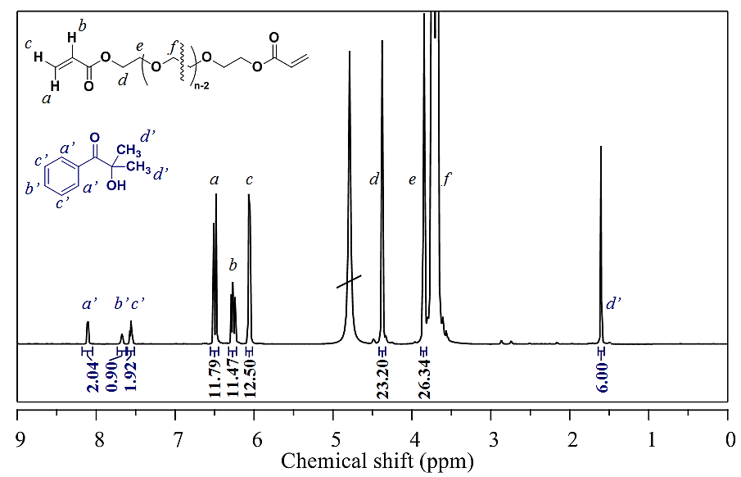
Figure S- 1:¹H-NMR spectrum of PEGDA/DAROCUR 1173 solution before polymerization
with signal attribution and related peak integration.

Moreover, signals attribution was confirmed by ¹H-NMR spectra of individual components, reported in Figure S- 2.
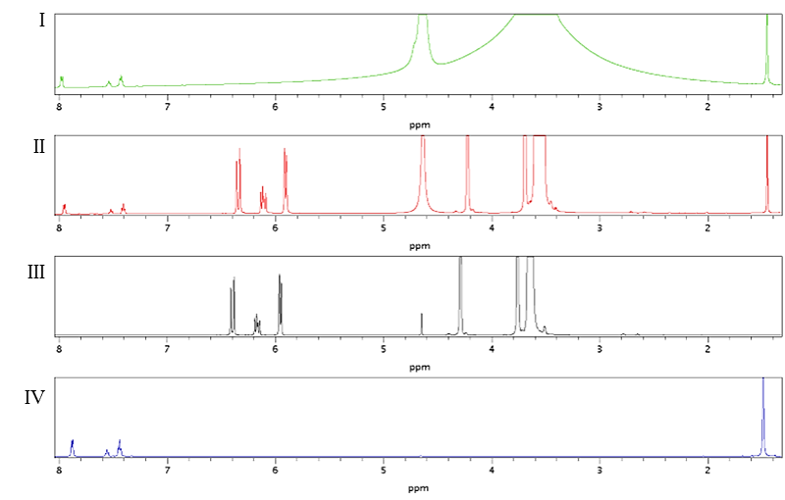
Figure S- 2: ¹H-NMR spectra of individual components darocur (IV) and PEGDA (III)
and mixture pre (II) and post- polymerization (I).

Molecular parameters of the three-dimensional network

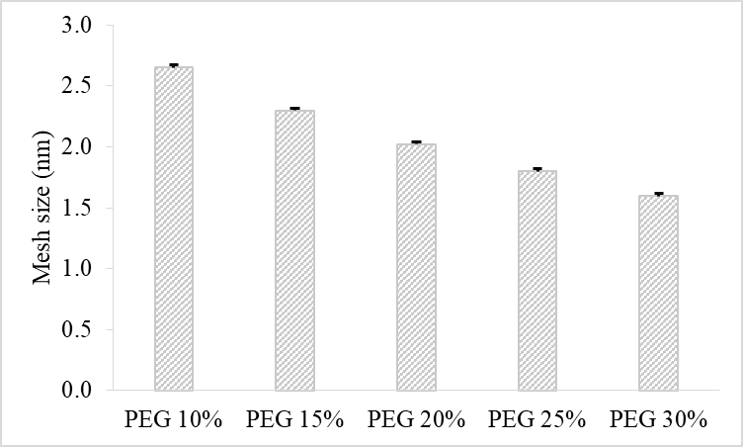

Figure S3: Mesh size values for different bulk-PEGDA concentrations

PFG-NMR
Interpolation curves fitting NMR- DOSY for water diffusion in PEGDA 10-15-20% (w/v), respectively.

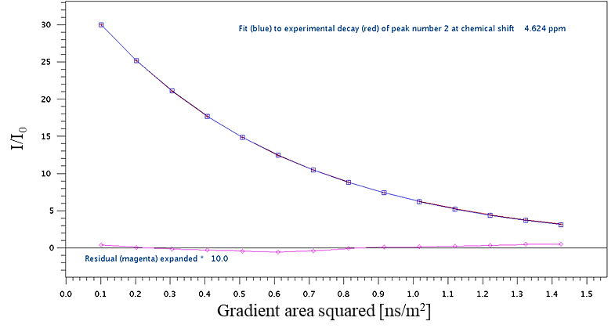
Figure S4: NMR- DOSY for water diffusion in PEGDA 10%

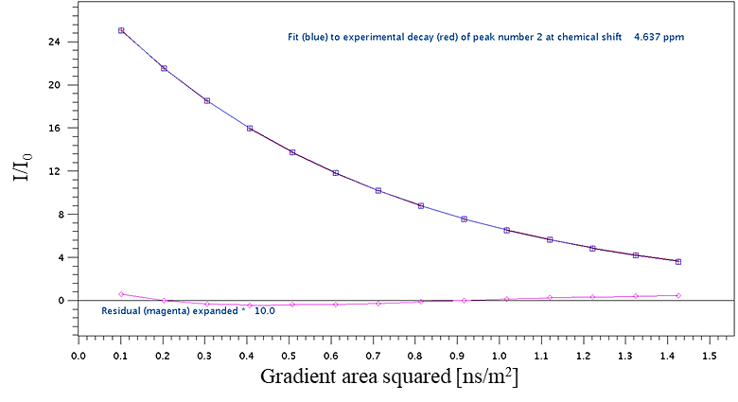
Figure S5: NMR- DOSY for water diffusion in PEGDA 15%

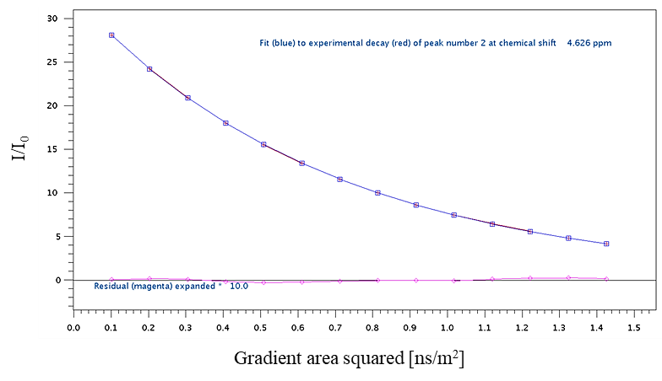
Figure S6: NMR- DOSY for water diffusion in PEGDA 20%

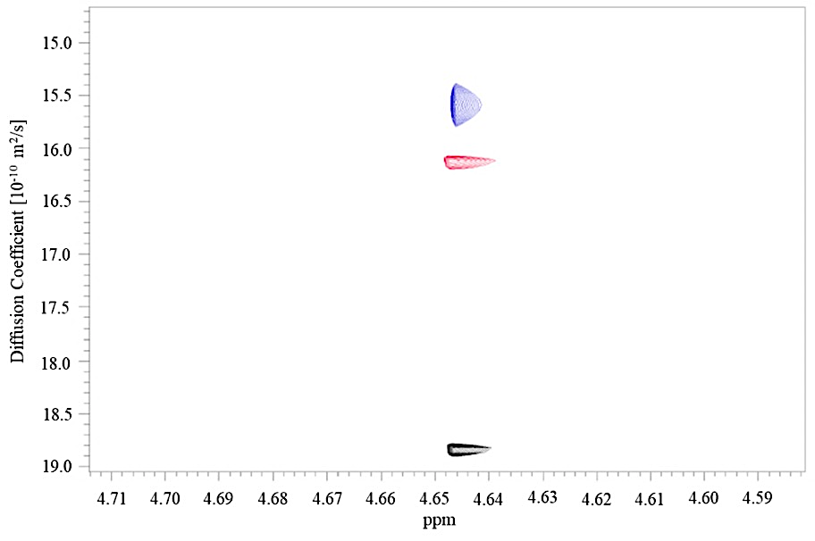
Figure S7: 2D DOSY of water (4.645 ppm) in hydrogels bulk with different PEGDA concentrations (20% in blue, 15% in red and 10% in black).

Probe optimization
For our studies, we used three DNA-sequences as reported in
fluorescent T-DNA that was covalently bounded with polymer network; complementary sequence (C) for the hybridization studies and non-complementary sequence (N) as control.

Table S1 Sequence and thermodynamic parameters
of the DNA probes used in this study.
probe | sequence (5'-3') | length (nt)
Fluorescent T-DNA (F-DNA-Tail) | TG AAA TCG GTT A | 12
Complementary sequence (C) | T AAC CGA TTT CG ATG GTG CTA | 21
Non-complementary sequence (N) | GAG CUA CAG UGC UUC AUC UCA | 21

In order to check the quenching efficiency of fluorescent tail with quencher strand, we firstly studied this system in 10 mM PBS solution. We tested different tail concentrations (5 μM - 0.1 μM) and BHQ-strand was added 1:1 respect to the tail. Results showed a quenching percentage from ~93% to 88%. (Figure S8).
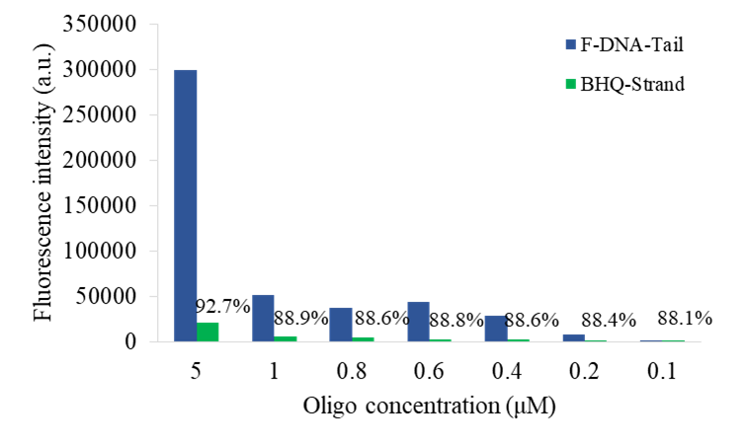
Figure S-8: Quenching percentage in solution for different oligonucleotide concentrations.

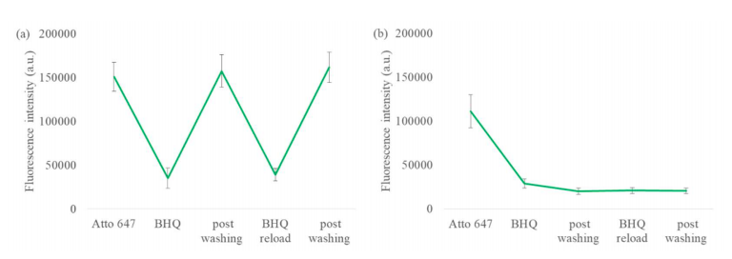

Figure S9: Fluorescence intensity of ATTO-BHQ in PEGDA 20% (a) and 10% (b).

