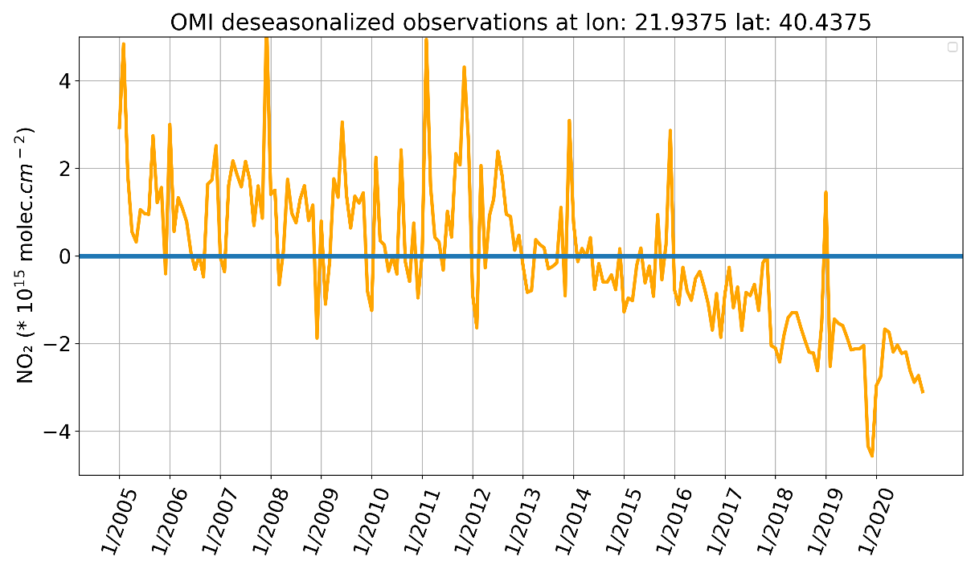
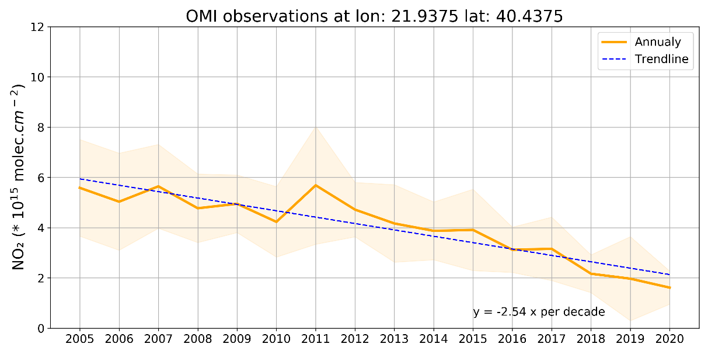
Figure S1 Top: Time series of deseasonalized mothly NO₂ columns from OMI/AURA for the period between 2005 and 2020 at the pixel where Ag. Dimitrios is located. Bottom: Time series of mean annual NO₂ columns from OMI/AURA at the same location. The shaded area denotes the standard deviation of the mean values and the trend is shown in blue.

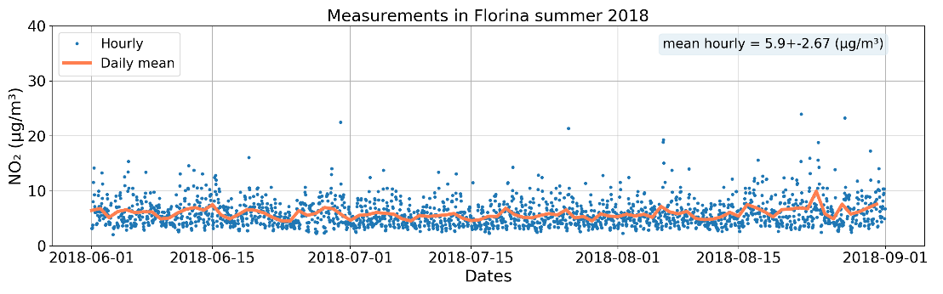
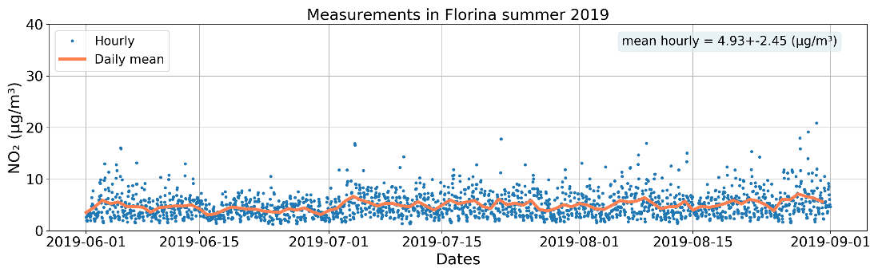
Figure S2. Timeseries of NO₂ hourly measurements (blue dots) in the station of Florina and the daily mean NO₂ (orange line) for the summer of 2018 (top) and 2019 (bottom).

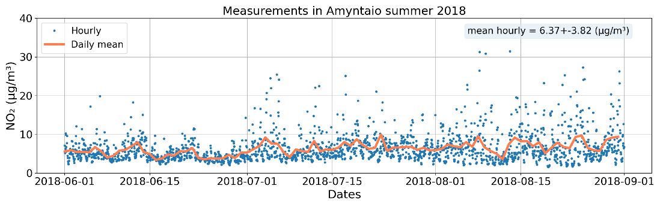
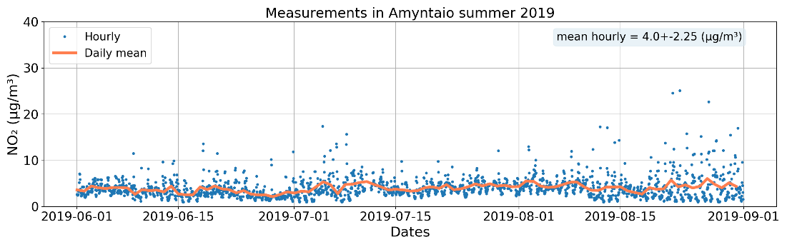
Figure S3. Timeseries of NO₂ hourly measurements (blue dots) in the station of Amyntaio and the daily mean NO₂ (orange line) for the summer of 2018 (top) and 2019 (bottom).

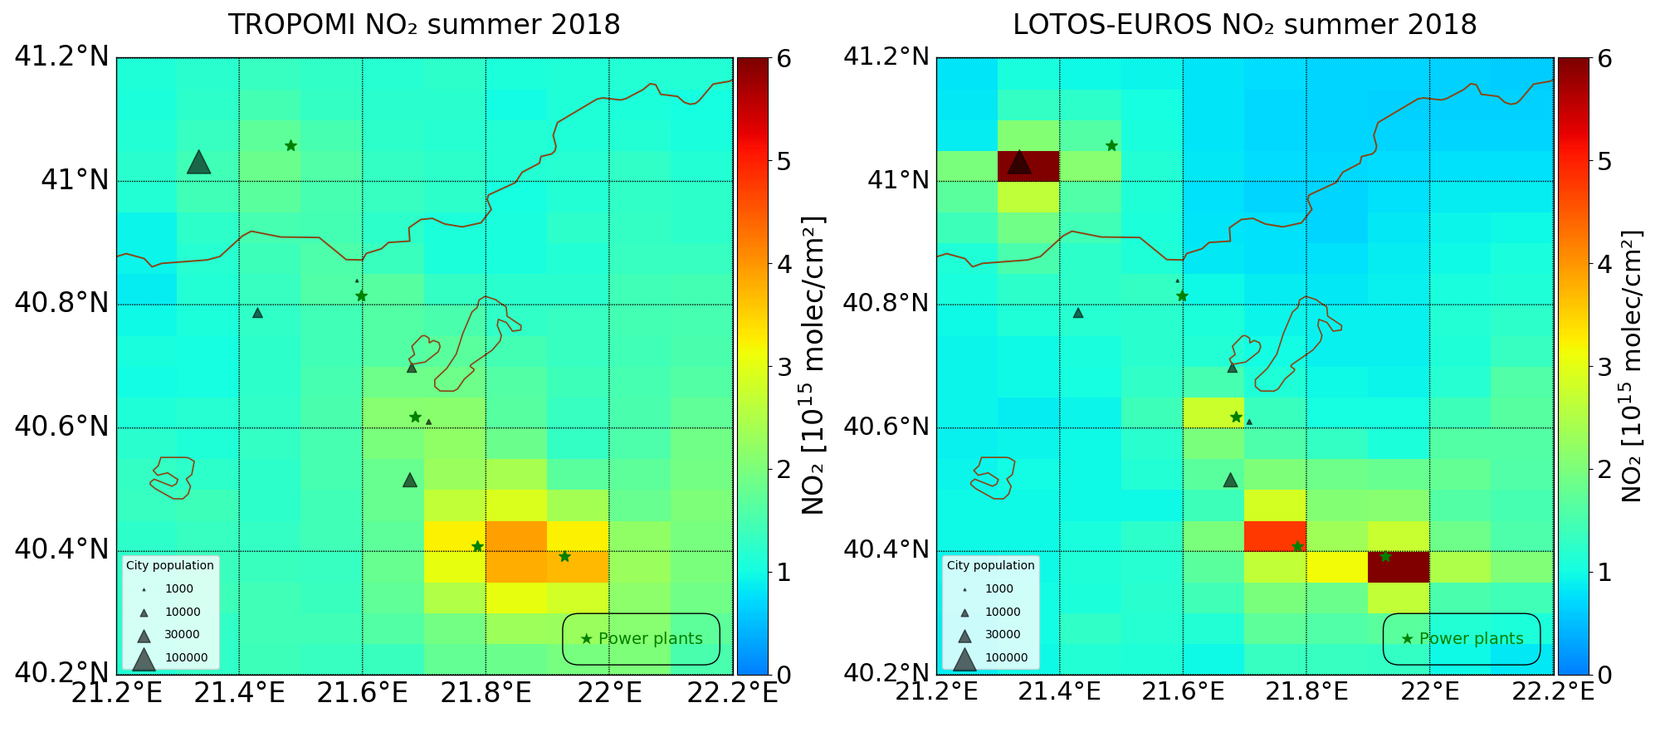
Figure S4 (a) Seasonal averaged NO₂ tropospheric columns in summer 2018 from S5P/TROPOMI retrieval; (b) LOTOS-EUROS NO₂ tropospheric simulation in summer 2018 after the averaging kernels of the satellite product are applied.

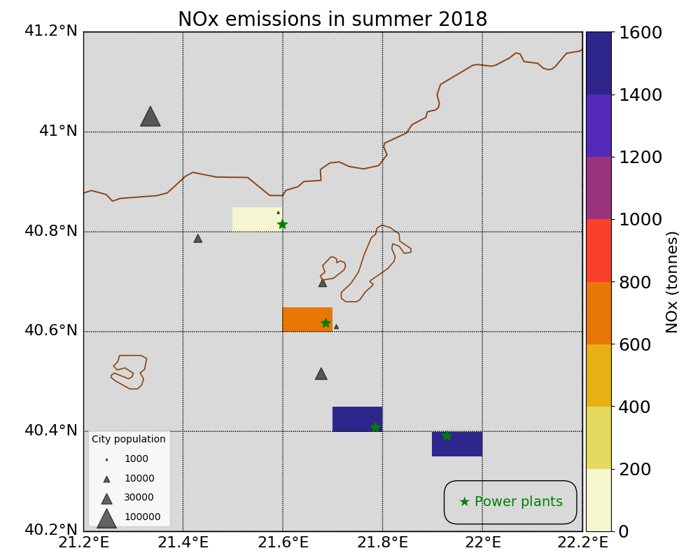 | 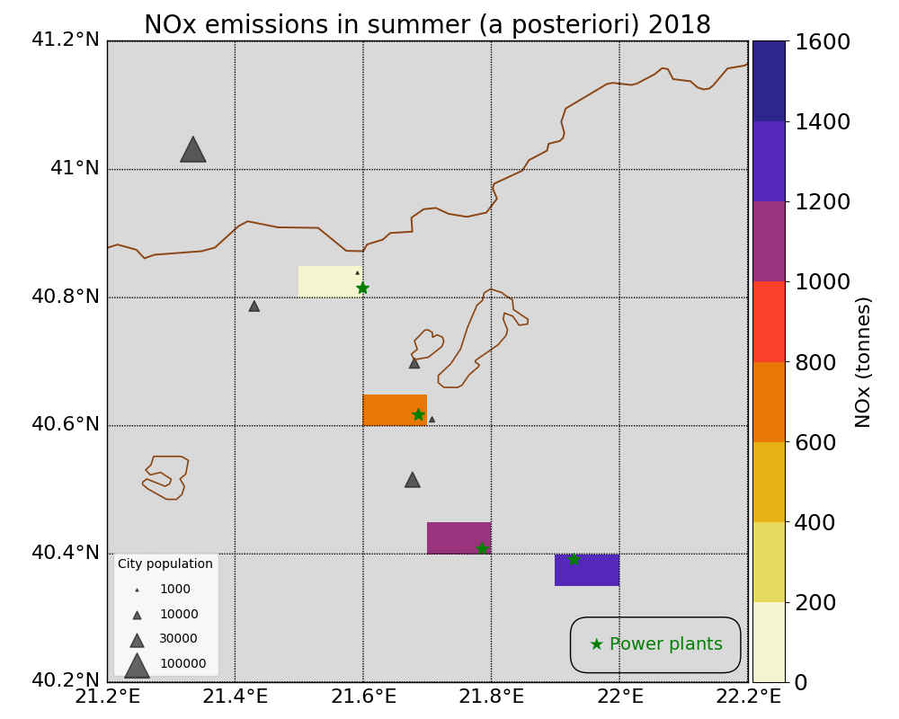
Figure S5 (a) Aggregated NOx a priori emissions over the four grid pixels in Northwest Greece in summer 2018 used for the base run; (b) Aggregated NOx a posteriori emissions assimilated using S5P/TROPOMI observations over the four grid pixels in Northwest Greece as in summer 2018.

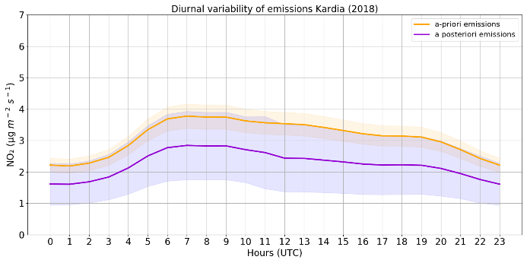 | 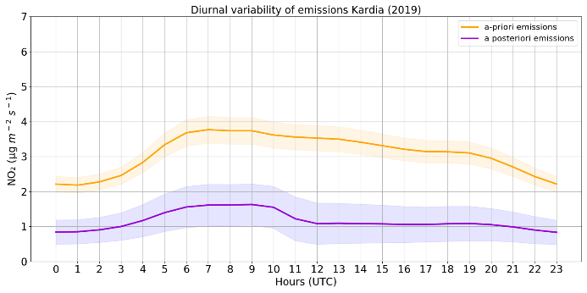
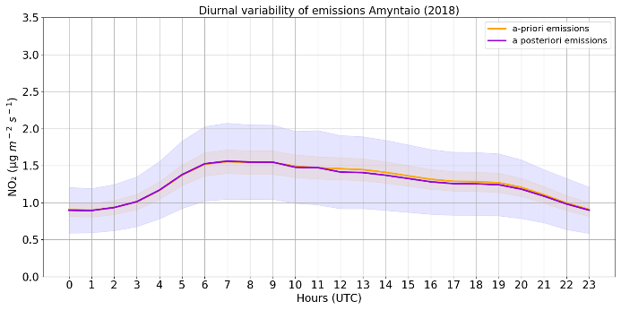 | 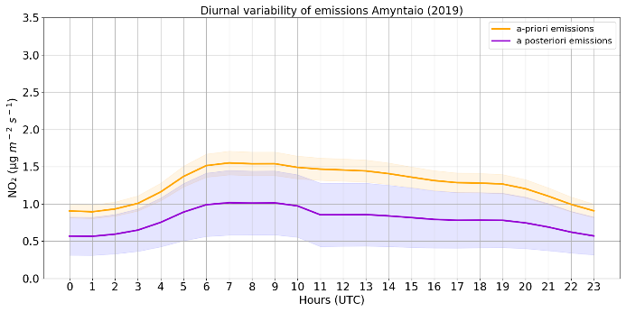
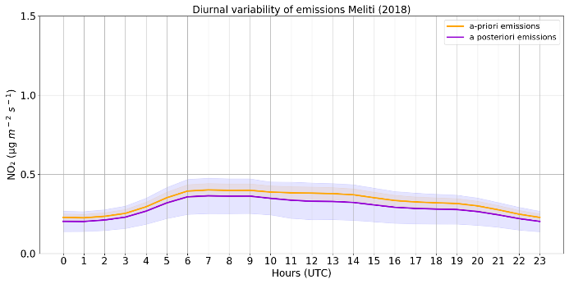 | 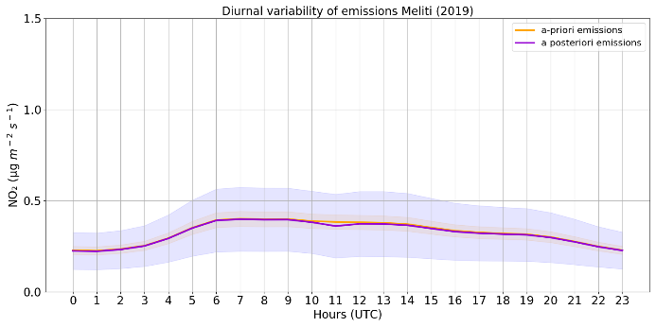
Figure S6 (a) Diurnal variability of NOx a priori emissions and a posteriori NOx emissions derived from TROPOMI assimilation over the grid pixel the power plants of Kardia (top), Amyntaio (middle) and Meliti (bottom) are located in summer 2018; (b) the same for summer 2019.

Table S1. Statistics of the comparison of LOTOS-EUROS surface simulations with the a priori emissions (base run) and the simulations with the a posteriori emissions (assimilated) with in situ surface measurements in summer 2018. P.P. refers to power plant.
Air Quality stations | Emission sources | Seasonal mean (μg/m3) ±std |  |  | Bias (μg/m3)
 |  | Measurements | Base run | Assimilated | Base run | Assimilated
Koilada | P.S. Ag. Dimitrios | 6.22±3.93 | 14.68±10.70 | 9.05±6.98 | 8.46 | 2.83
Filotas | Town of Filotas/ P.P. Amyntaio | 5.05±3.74 | 5.46±4.65 | 4.93±4.43 | 0.40 | -0.13
Amyntaio | Town of Amyntaio/ P.S. Amyntaio | 6.37±3.82 | 7.50±7.35 | 7.22±7.55 | 1.13 | 0.85
Meliti | Town of Meliti/P.P. Meliti/ P.P. Bitola | 10.93±11.05 | 6.38±5.53 | 5.30±4.94 | -4.54 | -5.63
Florina | Town of Florina | 5.90±2.67 | 6.49±6.13 | 4.74±4.81 | 0.59 | -1.15

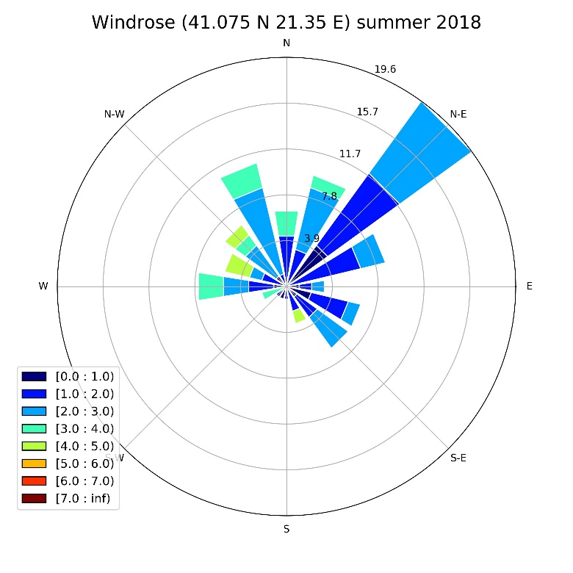 | 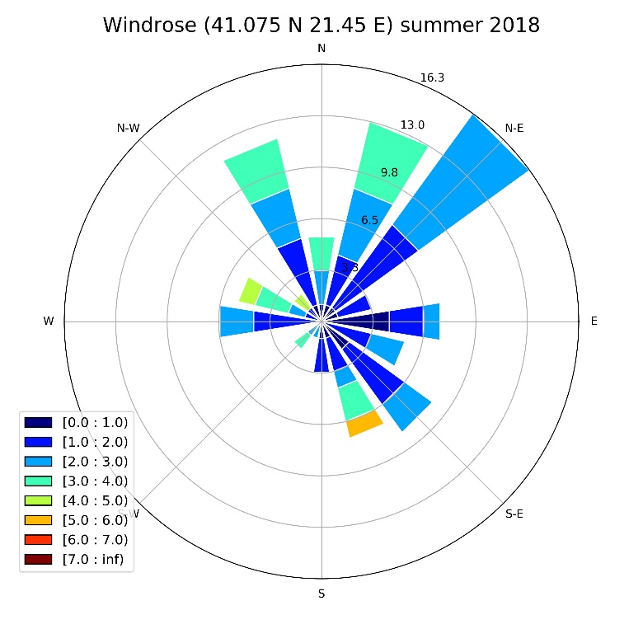
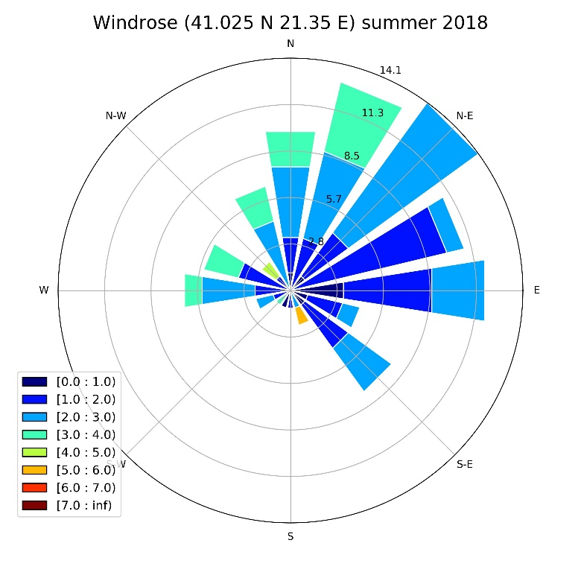 | 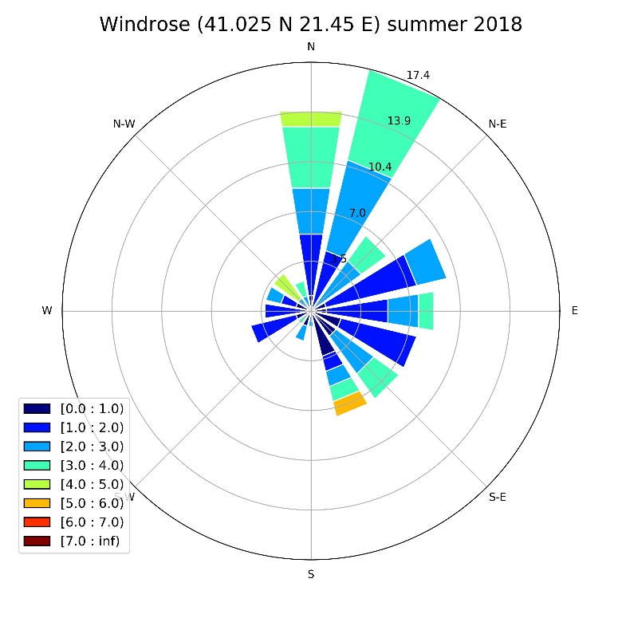
Figure S 7 Windroses for the pixels around around the power plant and city of Bitola in summer 2018.

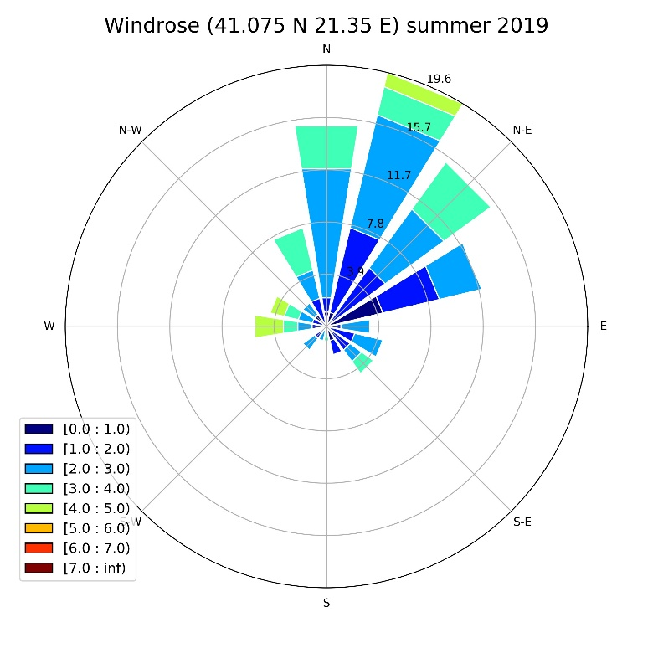 | 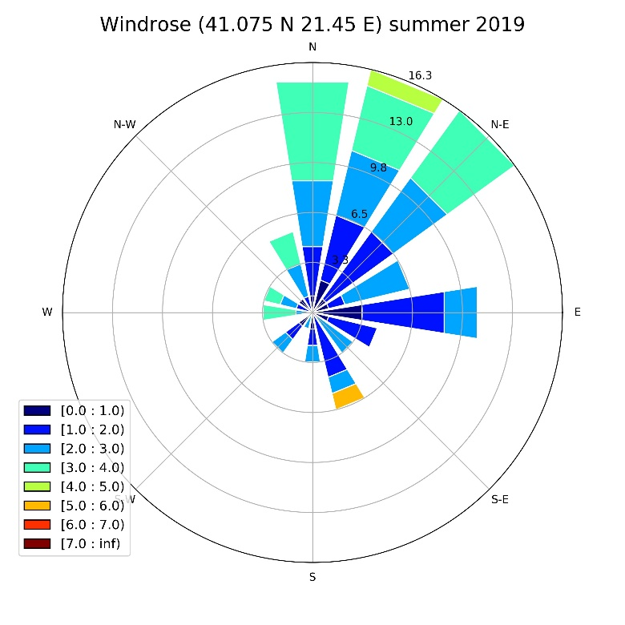
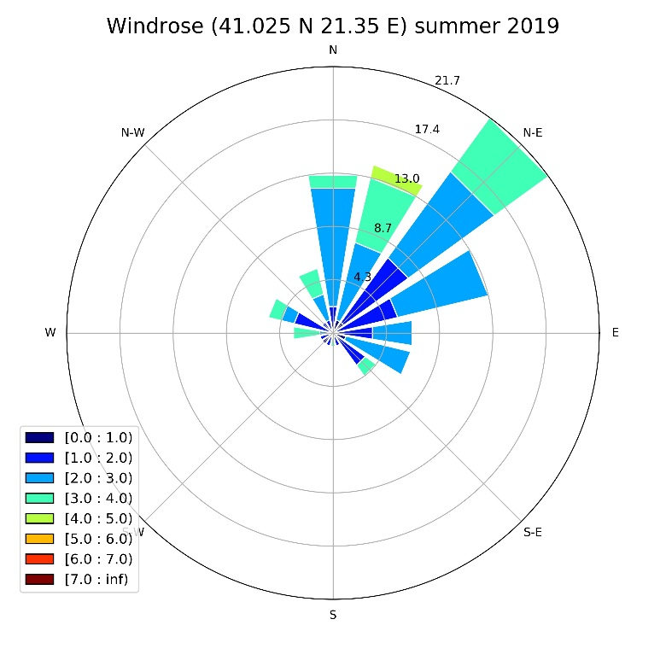 | 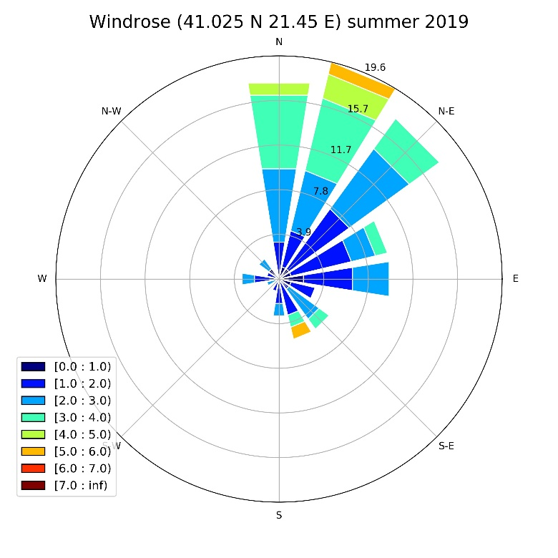
Figure S 8 Windroses for the pixels around around the power plant and city of Bitola in summer 2019.

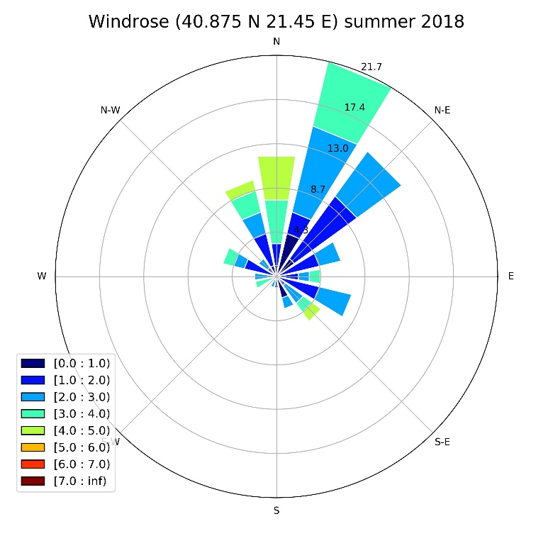 | 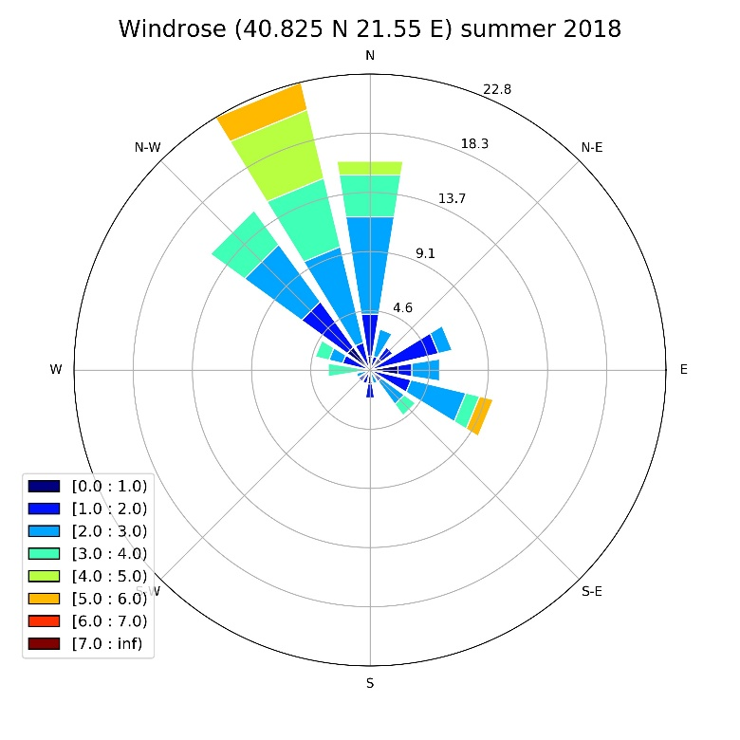
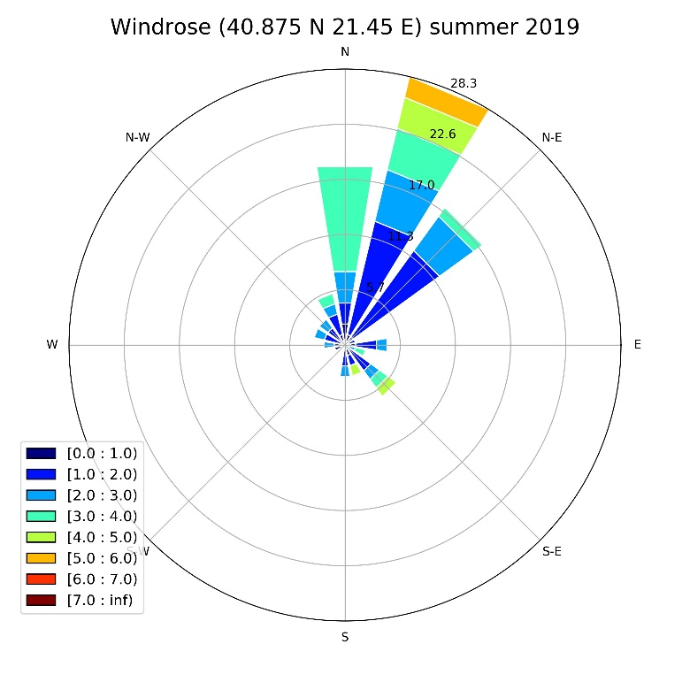 | 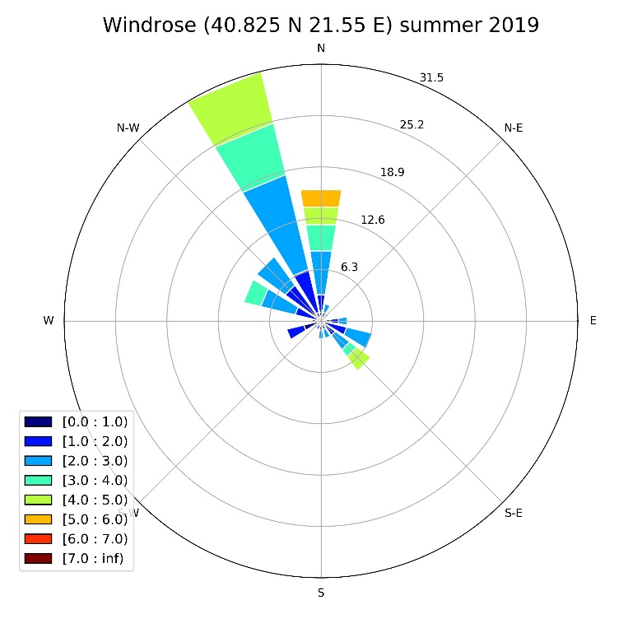
Figure S 9 Windroses for the pixels around the power plant and city of Meliti in summer 2018 (top) and 2019 (bottom).

