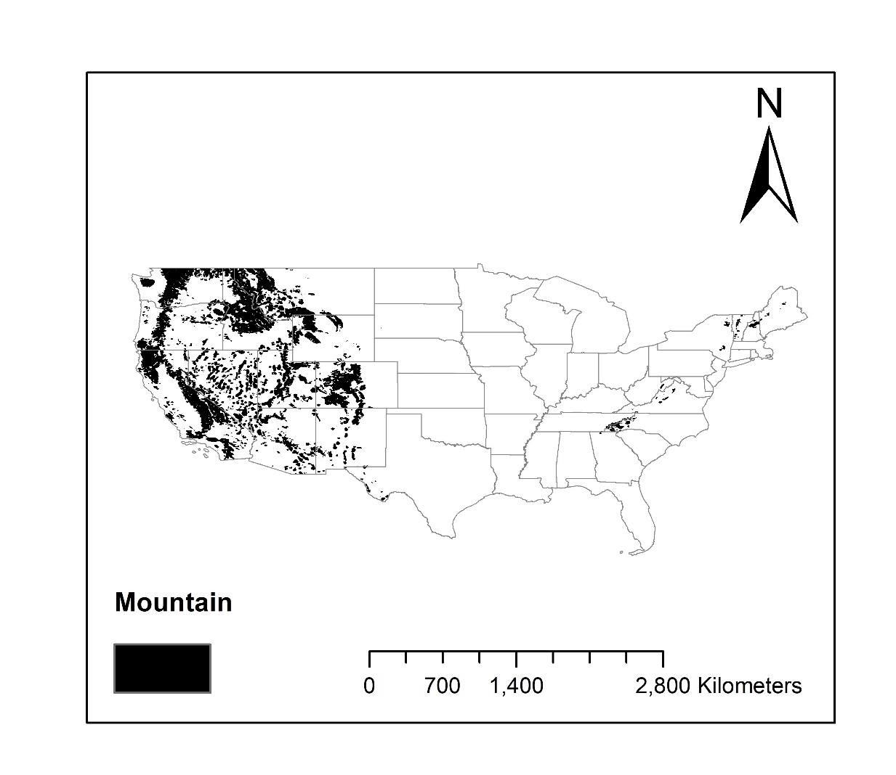
Figure S1. Mask of high and high-scatter mountains based on K3 mountain maps

