Original Research Article
Influence of Heart Rate Variability on abstinence-related changes in brain state in everyday drinkers
Hope Peterson ^{1,2} *, Rhiannon E. Mayhugh ³, Mohsen Bahrami ¹, W. Jack Rejeski ^{1,4}, Sean L. Simpson ^{1,5}, Keri Heilman ⁶, Steven W. Porges ^{6,7}, and Paul J. Laurienti ^{1,8}
Citation: Lastname, F.; Lastname, F.; Lastname, F. Title. Brain Sci. 2021, 11, x. https://doi.org/10.3390/xxxxx
Academic Editor: Firstname Lastname
Received: date
Accepted: date
Published: date
Publisher’s Note: MDPI stays neutral with regard to jurisdictional claims in published maps and institutional affiliations.
Copyright: © 2021 by the authors. Submitted for possible open access publication under the terms and conditions of the Creative Commons Attribution (CC BY) license (https://creativecommons.org/licenses/by/4.0/).
¹ Laboratory for Complex Brain Networks, Wake Forest University Health Sciences, Winston-Salem, NC, USA
² Graduate Program, Wake Forest School of Medicine, Neuroscience, Winston-Salem, NC, USA
³ Johns Hopkins University School of Medicine, Baltimore, MD, USA
⁴ Wake Forest University, Health and Exercise Sciences, Winston-Salem, NC, USA
⁵ Wake Forest School of Medicine, Biostatistics and Data Science, Winston-Salem, NC, USA
⁶ University of North Carolina School of Medicine, Department of Psychiatry, Chapel Hill, NC, USA
⁷ University of Illinois, Department of Psychiatry, Chicago, IL, USA
⁸ Wake Forest School of Medicine, Radiology, Winston-Salem, NC, USA
* Correspondence: hpeterso@wakehealth.edu, +1 (336) 716-0473

Supplementary Material

1. Supplementary Methods
1.1 Heart Rate Assessment and Data Processing for PB_{RSA} Calculation
In addition to assessment of PB_{RSA} data collected while participants were seated (PB_{RSA}-rest), PB_{RSA} was also calculated on heart rate data collected following a postural shift (seated to standing; PB_{RSA}-react). The main outcomes for PB_{RSA}-react data were negative, and as such were excluded from discussion of primary results. Using the ECG 3-electrode set up, data was collected for 5 minutes while participants were seated comfortably, and for 2 minutes following the postural shift. CardioEdit and CardioBath Plus software were used to inspect the data and calculate heart rate as described in the paper methods. To calculate PB_{RSA}-react scores, the average 5 minute seated PB_{RSA} value (PB_{RSA}-rest) was subtracted from the PB_{RSA} recorded during the standing 2 minutes.

1.2 Statistical Analysis and Mixed-Effects Modeling Framework
A mixed-effects regression was used to assess the relationship between whole brain connectivity, participants’ drinking state (normal vs. abstain), continuous measure of HRV (PB_{RSA}), and possible confounding variables [1, 2]. This framework was able to account for correlations between network connections within the individual participants and between the normal and abstained drinking states, as well as allow for the analysis of both network and non-network variables. This two-part regression models the probability of network connections (binary; presence vs. absence) and the strength of connections, if they exist. The multivariate regression captures the relationship between brain connections (probability and strength) as outcome (dependent) variables and network/non-network covariates as the independent variables. For all analyses, significant results were determined by a critical p-value < 0.05. All p-values were adjusted for multiple comparisons using the adaptive False Discovery Rate procedures detailed by Benjamini and Hochberg [3]. Analyses were conducted using the WFU_MMNET toolbox [4], Matlab (R2016b), and SAS v9.4 software.
Figures were generated from the resulting fits of the mixed effects regression model. For visualization purposes, the upper and lower bounds of the PB_{RSA} relationships were used in the regression equations in conjunction with the dichotomous drinking state variable to depict graphs. It should be remembered when interpreting these figures that they are intended for visualization, and that the statistical analyses are based on continuous functions that span the region between the upper and lower bounds.

1.3 Covariates
The primary variables of interest in this model were drinking state and HRV. Because fMRI time series data from both drinking states were included in the statistical model, a dichotomous variable was coded to differentiate the two conditions (normal drinking = 0, abstinence = 1). This allowed for the examination of the effects of drinking state between and within subjects, as well as the interaction of drinking state with network properties and other covariates. The complete model included interactions of all covariates and network features with both PB_{RSA}-rest and PB_{RSA}-react, but no 4-way interactions (i.e. probability/strength* PB_{RSA}-rest* PB_{RSA}-react*network feature) were significant, and were subsequently remove from the model to focus on significant 3-way interactions.
The network topology [5] from each individual participant was summarized with standard graph theory variables computed from each node pair, including average clustering coefficient (local specialization), average global efficiency (global integration), differences in degree (number of connections) between each nodal pair, and overall network modularity (the extent to which the network subdivides into densely interconnected communities that are scarcely connected to the rest of the network) [6]. Each of these summary variables was included as covariates in the model.
Age, sex, and BMI were included in the model due to previous associations with alcohol use and HRV [7-9]. The spatial Euclidean distance and square of the spatial distance between network nodes (brain regions) were also included as confounding variables to account for participants’ inter/intra-hemispheric asymmetries [10]. These metrics were included as covariates in the model to control for any associations with network organization. Measures that capture variance in drinking behavior and alcohol exposure were entered in a secondary post hoc model as additional covariates. These included average number of drinks consumed per day when participants chose to drink, the percent of days that they reported drinking at least one serving of alcohol in the last three months (via the TLFB), and the total number of years they had been consuming alcohol.

2. Supplementary Results
2.1 Primary Findings
The two-part mixed-model test the hypothesis that the effects of drinking state on brain network topology are dependent on HRV, measured via PB_{RSA}. This model separately evaluated connection strength and probability. Results for the connection strength model are presented here, and results for the connection probability model did not achieve significance for the stated hypothesis, and there were no significant interactions between PB_{RSA}-react and drinking state. The full probability model and results for PB_{RSA}-react are presented in the following section, covering the full model findings.
Degree, modularity, clustering coefficient, and global efficiency were included in the model as network covariates. No meaningful relationships with drinking state were found with modularity or degree. All four network features network features remained in the full model, but are only presented in the full model findings. The full model also included age, sex, and BMI to control for confounding effects. None of the demographic variables were significantly associated with connection strength. To control for differences in long vs. short distance brain connections, the spatial distance and square of the spatial distance between brain regions were included in this model. Distance variables were significant (Spatial Distance β = -0.05132, p < 0.0001, Spatial Distance² β = 0.02890, p < 0.0001).
Two 3-way interactions were associated with the main study hypothesis. The most robust interaction from the connection strength model was between drinking state, PB_{RSA}-rest, and clustering (β = 0.01186, p = 0.0004). This 3-way interaction can be visualized by examining the slope of the relationship between connection strength and clustering across drinking state and the upper and lower bounds of PB_{RSA}-rest values (Supp. Fig. 1). At the upper bound of PB_{RSA}-rest values large differences were found in the relationship between connection strength and clustering coefficient across drinking states, while at the lower bound only small differences were present. To understand these differences in the relationship between clustering and connection strength, we examined the strength values that would be expected for each condition at high clustering values. At the lower PB_{RSA}-rest bound we observe weaker network connections between highly clustered nodes during abstinence compared to normal drinking, while at the upper PB_{RSA}-rest bound we observe stronger connections between highly clustered nodes following abstinence.
Although it did not reach statistical significance, a notable corresponding trend was evident in the relationship between drinking state, PB_{RSA}-rest, and global efficiency (β = -0.00518, p = 0.1087, Supp. Fig. 2). The difference in the relationship between connection strength and global efficiency change in opposite directions across drinking state between the upper and lower bounds of PB_{RSA}-rest. At the lower bound the difference in slope increased as global efficiency increased, with greater strength at more globally efficient nodes observed in abstinence compared to normal drinking. At the upper bound the difference in slope decreased as global efficiency increased, and greater strength in highly globally efficient nodes was again observed n abstinence compared to normal drinking.
Suppl. Table 1 provides the key results for the connection strength mixed-model. There was a significant main effect of drinking state on connection strength, such that greater average connection strength was found during normal dinking compared to abstinence (β = 1.2340, p < 0.0001). The significant main effects of PB_{RSA}-rest indicated that, on average, participants with higher PB_{RSA}-rest had lower network connection strength (β = -0.00994, p = 0.0220). There was an interaction between drinking state and PB_{RSA}-rest that did not reach statistical significance, but exhibited a notable positive trend (β = 0.01180, p = 0.0553). Clustering (β = 0.06825, p < 0.0001) and global efficiency (β = 0.02923, p < 0.0001) were both statistically significant positive predictors of connection strength. Interactions between drinking state and these network topological features were not statistically significant. There was an interaction of PB_{RSA}-rest with clustering (β = -0.00532, p = 0.0004), but not with global efficiency.

2.2 Full Findings
Full results for the connection strength model can be found in Supp. Table 2. All four network features of interest associated significantly with connection strength. Clustering (β = 0.06825, p < 0.0001) and global efficiency (β = 0.02923, p < 0.0001) were positively associated with connection strength, while degree (β = -0.04430, p < 0.0001) and modularity (β = -0.01518, p < 0.0001) were negatively associated with connection strength. The relationship between PB_{RSA}-react scores and connection strength approached significance (β = 0.007051, p < 0.0898), in the inverse direction of the relationship between connection strength and PB_{RSA}-rest.
Significant interactions between connection strength and PB_{RSA}-rest and react were seen with clustering (β = -0.05132, p = 0.0406) and global efficiency (β = -0.05132, p = 0.0440), although the relationship between PB_{RSA}-rest and react was not significant. When examining the clustering relationship (Supp. Fig. 3), participants at the lower bound of PB_{RSA}-rest but the upper-bound of PB_{RSA}-react showed the strongest relationship between clustering and connection strength. Participants at the lower bound of PB_{RSA}-react, both with high and low PB_{RSA}-rest, showed similar relationships between clustering and connection strength. The weakest connections between highly clustered nodes was observed in participants at the upper bound of PB_{RSA}-rest and react. For the global efficiency relationship (Supp. Fig. 4), participants at the lower bound of both PB_{RSA}-rest and react, as well as those at the upper-bound of both PB_{RSA}-rest and react showed the strongest relationship between global efficiency and connections strength. The weakest connections between highly globally efficient nodes were observed in at the upper PB_{RSA}-rest bound, but the lower PB_{RSA}-react bound.
Full results for the probability model can be found in Supp. Table 3. Clustering (β = 0.3214, p < 0.0001) and degree (β = 0.1480, p < 0.0001) showed significant positive associations with connection probability, while global efficiency showed a significant negative relationship with connection probability (β = -0.3050, p < 0.0001). Spatial Distance (β = 0.3597, p < 0.0001) and Spatial Distance² (β = -0.1346, p < 0.0001) were significantly associated with connection probability. Drinking state was positively associated with probability (β = 0.1803, p < 0.0001), indicating greater average probability of connection was found during normal drinking compared to abstinence. Finally, a significant interaction was found between degree and PB_{RSA}-rest with connection probability (β = 0.04649, p = 0.0389), such that the higher degree observed with greater probability of connections was even greater at higher PB_{RSA}-rest values.

3. Supplementary Tables and Figures
3.1 Supplementary Tables
Supplementary Table 1. Relevant mixed-model strength results. Significant effects and interactions are bolded.
Effect | Estimate | Standard  Error | p-value
Drinking State | 0.2340 | 0.004659 | <0.0001
PB_{RSA}-rest | -0.00994 | 0.004340 | 0.0220
Drinking State*PB_{RSA}-rest | 0.01180 | 0.006157 | 0.0553
Clustering Coefficient | 0.06825 | 0.002450 | <0.0001
Global Efficiency | 0.02923 | 0.002528 | <0.0001
Drinking State*Clustering Coefficient | 0.001887 | 0.003163 | 0.5509
Drinking State*Global Efficiency | -0.00456 | 0.003046 | 0.1344
PB_{RSA}-rest*Clustering Coefficient | -0.00532 | 0.002651 | 0.0449
PB_{RSA}-rest*Global Efficiency | 0.000041 | 0.002713 | 0.9879
Drinking State*PB_{RSA}-rest*Clustering Coefficient | 0.01186 | 0.003357 | 0.0004
Drinking State*PB_{RSA}-rest*Global Efficiency | -0.00518 | 0.003357 | 0.1087
Spatial Distance | -0.05132 | 0.001100 | <0.0001
Spatial Distance² | 0.02890 | 0.000537 | <0.0001
Age | -0.00116 | 0.003233 | 0.7187
Sex | -0.00012 | 0.005968 | 0.9843
BMI | -0.00348 | 0.003519 | 0.3221
Supplementary Table 2. Full mixed-effects model results – strength. Significant effects and interactions are bolded.
Effect | Estimate | Standard  Error | p-value
Drinking State | 0.2340 | 0.004659 | <0.0001
PB_{RSA}-rest | -0.00994 | 0.004340 | 0.0220
PB_{RSA}-react | 0.007051 | 0.004156 | 0.0898
Clustering Coefficient | 0.06825 | 0.002450 | <0.0001
Global Efficiency | 0.02923 | 0.002528 | <0.0001
Degree | -0.04430 | 0.001256 | <0.0001
Modularity | -0.01518 | 0.003053 | <0.0001
Age | -0.00116 | 0.003233 | 0.7187
Sex | -0.00012 | 0.005968 | 0.9843
BMI | -0.00348 | 0.003519 | 0.3221
Spatial Distance | -0.05132 | 0.001100 | <0.0001
Spatial Distance² | 0.02890 | 0.000537 | <0.0001
Clustering Coefficient*PB_{RSA}-rest*PB_{RSA}-react | -0.00223 | 0.001092 | 0.0406
Global Efficiency*PB_{RSA}-rest*PB_{RSA}-react | 0.001999 | 0.000993 | 0.0440
Degree*PB_{RSA}-rest* PB_{RSA}-react | -0.00051 | 0.000561 | 0.3639
Modularity*PB_{RSA}-rest*PB_{RSA}-react | -0.00570 | 0.004092 | 0.1637
Clustering Coefficient*Drinking State*PB_{RSA}-rest | 0.01186 | 0.003357 | 0.0004
Global Efficiency*Drinking State* PB_{RSA}-rest | -0.00518 | 0.003226 | 0.1087
Degree*Drinking State*PB_{RSA}-rest | -0.00120 | 0.001734 | 0.4897
Modularity*Drinking State*PB_{RSA}-rest | -0.00138 | 0.007352 | 0.8511
Clustering Coefficient*Drinking State*PB_{RSA}-react | -0.00329 | 0.003343 | 0.3245
Global Efficiency*Drinking State*PB_{RSA}-react | 0.002779 | 0.003215 | 0.3874
Degree*Drinking State*PB_{RSA}-react | 0.001632 | 0.001730 | 0.3456
Modularity*Drinking State*PB_{RSA}-react | -0.01339 | 0.008060 | 0.0967
Clustering Coefficient*PB_{RSA}-rest | -0.00532 | 0.002651 | 0.0449
Global Efficiency*PB_{RSA}-rest | 0.000041 | 0.002713 | 0.9879
Degree*PB_{RSA}-rest | -0.00049 | 0.001351 | 0.7183
Modularity*PB_{RSA}-rest | 0.003155 | 0.003607 | 0.3817
Clustering Coefficient*PB_{RSA}-react | 0.000271 | 0.002731 | 0.9209
Global Efficiency*PB_{RSA}-react | 0.001526 | 0.002783 | 0.5835
Degree*PB_{RSA}-react | -0.00154 | 0.001399 | 0.2701
Modularity*PB_{RSA}-react | 0.006400 | 0.005891 | 0.2773
Clustering Coefficient*Drinking State | 0.001887 | 0.003163 | 0.5509
Global Efficiency* Drinking State | -0.00456 | 0.003046 | 0.1344
Degree* Drinking State | 0.000871 | 0.001643 | 0.5961
Modularity* Drinking State | -0.00044 | 0.005495 | 0.9367
Drinking State*PB_{RSA}-rest | 0.01180 | 0.006157 | 0.0553
Drinking State*PB_{RSA}-react | -0.00886 | 0.005583 | 0.1124
PB_{RSA}-rest*PB_{RSA}-react | -0.00021 | 0.002646 | 0.9366
Supplementary Table 3. Full mixed-effects model results – probability. Significant effects and interactions are bolded.
Effect | Estimate | Standard  Error | p-value
Drinking State | 0.1803 | 0.03493 | <0.0001
PB_{RSA}-rest | 0.01808 | 0.03219 | 0.5744
PB_{RSA}-react | 0.01719 | 0.03085 | 0.5773
Clustering Coefficient | 0.3214 | 0.03876 | <0.0001
Global Efficiency | -0.3050 | 0.03331 | <0.0001
Degree | 0.1480 | 0.02094 | <0.0001
Modularity | -0.02212 | 0.02264 | 0.3284
Age | -0.00487 | 0.02465 | 0.8433
Sex | 0.05779 | 0.04574 | 0.2065
BMI | -0.02645 | 0.02686 | 0.3249
Spatial Distance | 0.3597 | 0.01672 | <0.0001
Spatial Distance² | -0.1346 | 0.006994 | <0.0001
Clustering Coefficient*PB_{RSA}-rest*PB_{RSA}-react | -0.01740 | 0.01504 | 0.2474
Global Efficiency*PB_{RSA}-rest* PB_{RSA}-react | 0.002055 | 0.01414 | 0.8843
Degree*PB_{RSA}-rest*PB_{RSA}-react | 0.007776 | 0.01001 | 0.4373
Modularity*PB_{RSA}-rest*PB_{RSA}-react | 0.02905 | 0.03159 | 0.3578
Clustering Coefficient*Drinking State*PB_{RSA}-rest | 0.06127 | 0.04924 | 0.2133
Global Efficiency*Drinking State*PB_{RSA}-rest | -0.02835 | 0.04439 | 0.5229
Degree*Drinking State*PB_{RSA}-rest | -0.03306 | 0.03066 | 0.2808
Modularity*Drinking State*PB_{RSA}-rest | -0.02421 | 0.06190 | 0.6957
Clustering Coefficient*Drinking State*PB_{RSA}-react | 0.01006 | 0.04920 | 0.8380
Global Efficiency*Drinking State*PB_{RSA}-react | -0.00360 | 0.04436 | 0.9354
Degree*Drinking State*PB_{RSA}-react | -0.01732 | 0.03065 | 0.5719
Modularity*Drinking State*PB_{RSA}-react | -0.02421 | 0.06190 | 0.6957
Clustering Coefficient*PB_{RSA}-rest | 0.002834 | 0.04147 | 0.9455
Global Efficiency*PB_{RSA}-rest | -0.01805 | 0.03568 | 0.6129
Degree*PB_{RSA}-rest | 0.04649 | 0.02251 | 0.0389
Modularity*PB_{RSA}-rest | -0.03168 | 0.02663 | 0.2341
Clustering Coefficient*PB_{RSA}-react | -0.02664 | 0.04265 | 0.5323
Global Efficiency*PB_{RSA}-react | 0.02381 | 0.03693 | 0.5190
Degree*PB_{RSA}-react | 0.005685 | 0.02352 | 0.8090
Modularity*PB_{RSA}-react | 0.008284 | 0.04362 | 0.8494
Clustering Coefficient*Drinking State | -0.05450 | 0.04664 | 0.2426
Global Efficiency* Drinking State | 0.04794 | 0.04207 | 0.2545
Degree* Drinking State | 0.01711 | 0.02907 | 0.5562
Modularity* Drinking State | -0.01087 | 0.04291 | 0.8000
Drinking State*PB_{RSA}-rest | -0.03600 | 0.04742 | 0.4477
Drinking State*PB_{RSA}-react | -0.01412 | 0.04311 | 0.7432
PB_{RSA}-rest*PB_{RSA}-react | 0.007958 | 0.01986 | 0.6887
Supplementary Table 4. Differences in average survey responses preceding MRI scanning across drinking states.
 | Normal  Drinking | Abstinence | t-value | p-value
Alcohol Craving Experience (ACE) Questionnaire | 14.1 (13.5) | 14.5 (10.9) | -0.247 | 0.806
Perceived Stress Scale (PSS) | 30.8 (2.8) | 30.3 (2.3) | 1.404 | 0.168
State Trait Anxiety Inventory (STAI) | 45.9 (3.9) | 45.9 (3.4) | 0.092 | 0.927
Mindful Attention Awareness Scale (MAAS) | 7.8 (5.2) | 7.6 (5.6) | 0.272 | 0.787
Freiburg Mindfulness Scale | 40.7 (5.6) | 41.5 (5.9) | -1.548 | 0.130

3.2 Supplementary Figures
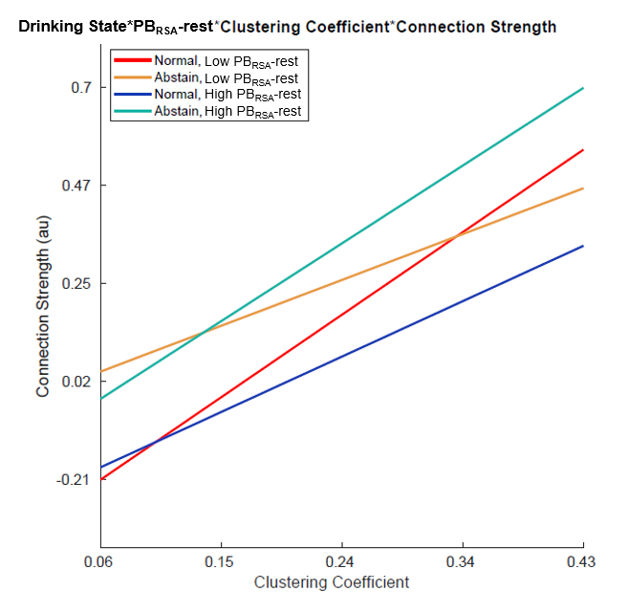
Figure 1. Graphical representation of the relationship between connection strength and clustering coefficient across drinking states, divided by the upper and lower bounds of PB_{RSA}-rest values, meant only for illustrative purposes. Because PB_{RSA} is a continuous variable, the 3-way interactions form 3-dimentional planes and cannot easily be graphed. For visualization purposes, the upper and lower bounds of PB_{RSA}-rest values were used in the regression equations in conjunction with the dichotomous drinking state variable to create this graph.

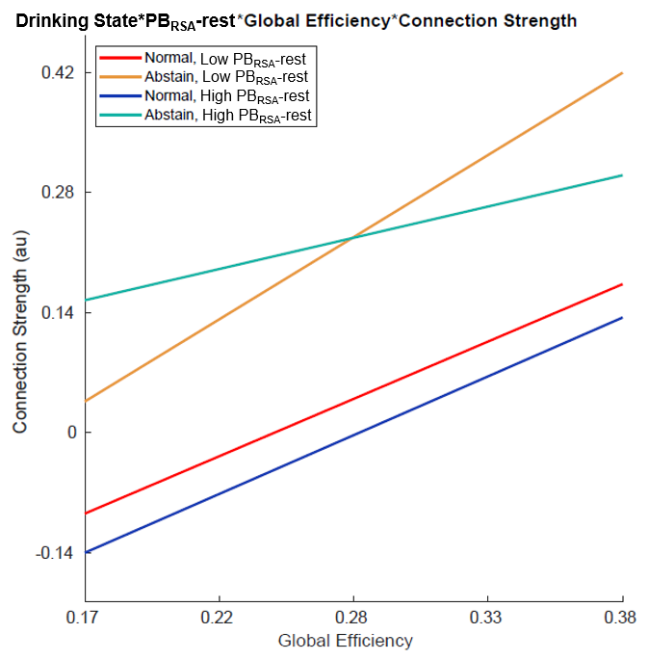
Figure 2. Graphical representation of the relationship between connection strength and global efficiency across drinking states, divided by PB_{RSA}-rest values (approaching significance), meant only for illustrative purposes. Because PB_{RSA} is a continuous variable, the 3-way interactions form 3-dimentional planes and cannot easily be graphed. For visualization purposes, the upper and lower bounds of PB_{RSA}-rest values were used in the regression equations in conjunction with the dichotomous drinking state variable to create this graph.
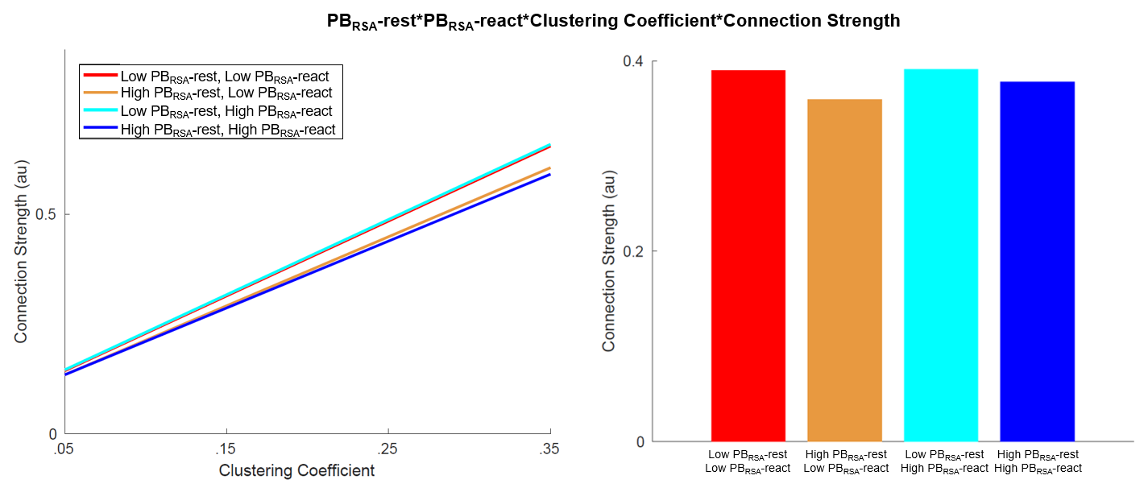
Figure 3. Graphical representation of the relationship between connection strength and clustering coefficient when accounting for both resting and reactive PB_{RSA,} meant only for illustrative purposes. Because PB_{RSA} is a continuous variable, the 3-way interactions form 3-dimentional planes and cannot easily be graphed. For visualization purposes, the upper and lower bounds of PB_{RSA}-rest and PB_{RSA}-react values were used in the regression equations to create this graph. A depiction of the regression equation (as included in Supplementary Figures 1 and 2) as well as the slopes of the four conditions (as seen in the main body of the manuscript) are included.

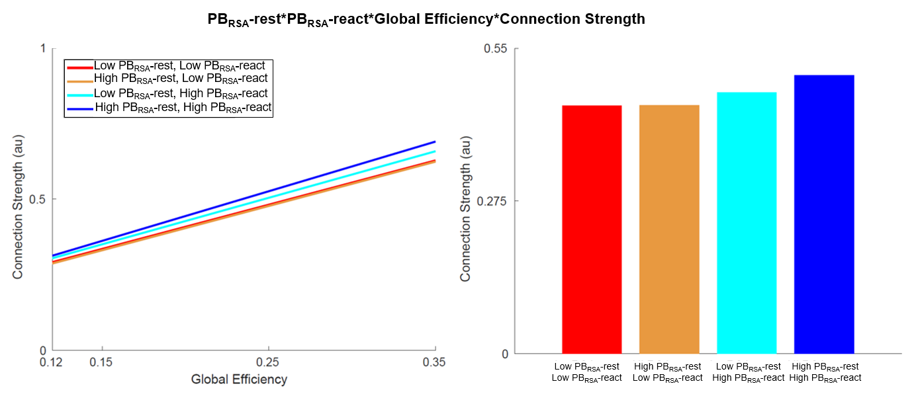
Figure 4. Graphical representation of the relationship between connection strength and global efficiency when accounting for both resting and reactive PB_{RSA,} meant only for illustrative purposes. Because PB_{RSA} is a continuous variable, the 3-way interactions form 3-dimentional planes and cannot easily be graphed. For visualization purposes, the upper and lower bounds of PB_{RSA}-rest and PB_{RSA}-react values were used in the regression equations to create this graph. A depiction of the regression equation (as included in Supplementary Figures 1 and 2) as well as the slopes of the four conditions (as seen in the main body of the manuscript) are included.

References
[1] 56. Simpson, S.L. and P.J. Laurienti, A two-part mixed-effects modeling framework for analyzing whole-brain network data. Neuroimage, 2015. 113: p. 310-319.
[2] 57. Simpson, S.L., M. Bahrami, and P.J. Laurienti, A mixed-modeling framework for analyzing multitask whole-brain network data. Network Neuroscience, 2019. 3(2): p. 307-324.
[3] 59. Benjamini, Y. and Y. Hochberg, On the adaptive control fo the false discovery rate in multiple testing with independent statistics. J Educ Behav Stat, 2000. 25(1): p. 60-83.
[4] 55. Bahrami, M., P.J. Laurienti, and S.L. Simpson, A MATLAB toolbox for multivariate analysis of brain networks. Human Brain Mapping, 2018. 40(1): p. 175-186.
[5] 81. Rubinov, M. and O. Sporns, Complex network measures of brain connectivity: uses and interpretations. Neuroimage, 2010. 52(3): p. 1059-69.
[6] 60. Newman, M.E. and M. Girvan, Finding and evaluating community structure in networks. Phys Rev E Stat Nonlin Soft Matter Phys, 2004. 69(2): p. 026113.
[7] 61. Demeersman, R.E., Aging as a moderator of respiratory sinus arrhythmia. Journals of Gerontology, 1993. 48(2): p. B74-78.
[8] 62. Seo, D., et al., Sex differences in neural responses to stress and alcohol context cues. Human Brain Mapping, 2011. 32(11): p. 1998-2013.
[9] 39. Wang, M.Q., et al., Acute alcohol intoxication, body composition, and pharmacokinetics. Pharmacology Biochemistry and Behavior, 1992. 43(2): p. 641.
[10] 82. Friedman, E.J., et al., Stochastic geometric network models for groups of functional and structural outcomes. Neuroimage, 2014. 101: p. 473-484.

