Diverse Transformers (Trf) protein family in the sea urchin Paracentrotus lividus act through collaboration between cellular and humoral immune effector arms

Iryna Yakovenko¹, Asaf Donnyo¹, Or Ioscovich¹, Benyamin Rosental², Matan Oren^{1*}
Affiliations:
¹ Department of Molecular Biology, Ariel University, Science Park, Ariel 40700, Israel
² The Shraga Segal Department of Microbiology, Immunology and Genetics, Regenerative Medicine, and Stem Cell Research Center, Ben-Gurion University of the Negev, Beer Sheva 84105, Israel
* Correspondence to: matanor@ariel.ac.il

Supplementary material
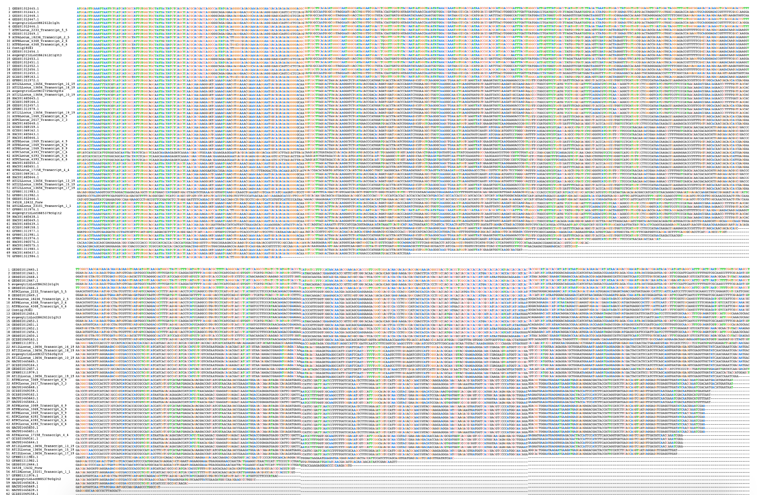
Fig. S1 Unique Trf sequences obtained from publicly available databases.

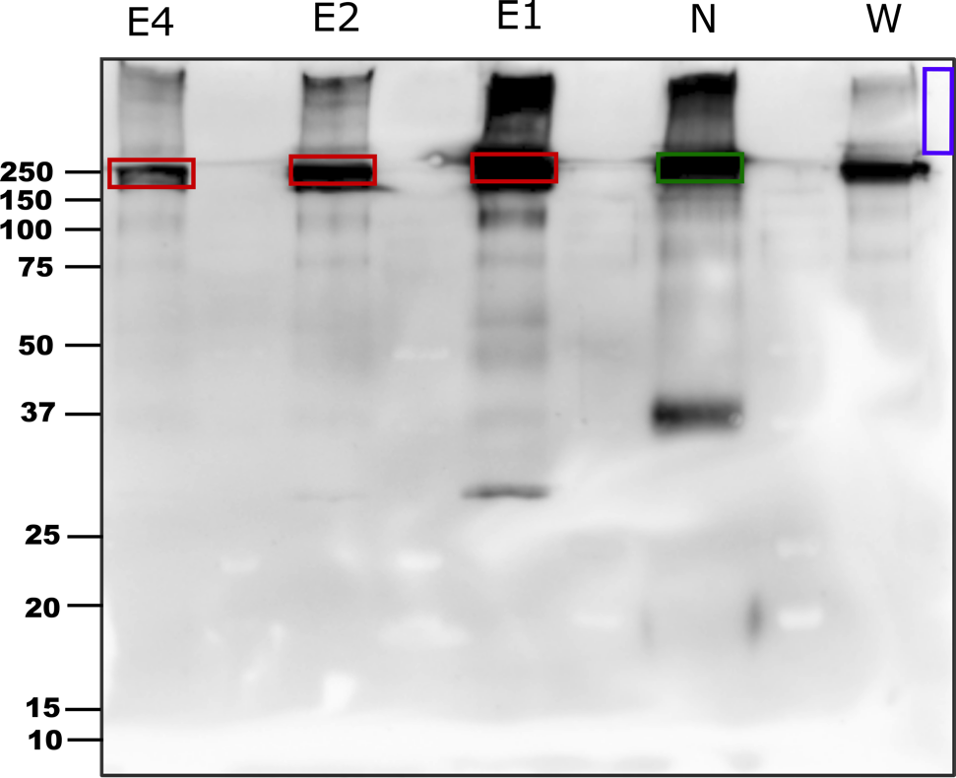
Fig. S2 Western blot of the gel that was used for the mass spectrometry. E1, E2, E4 – elution fractions, N – untreated native whole coelomic fluid protein, W – wash fraction. Inside boxes are the bands that were cut from PAGE gel. In red – elution fractions, in green – native protein from the same animal, in blue – the background control that was cut from the side of the gel.

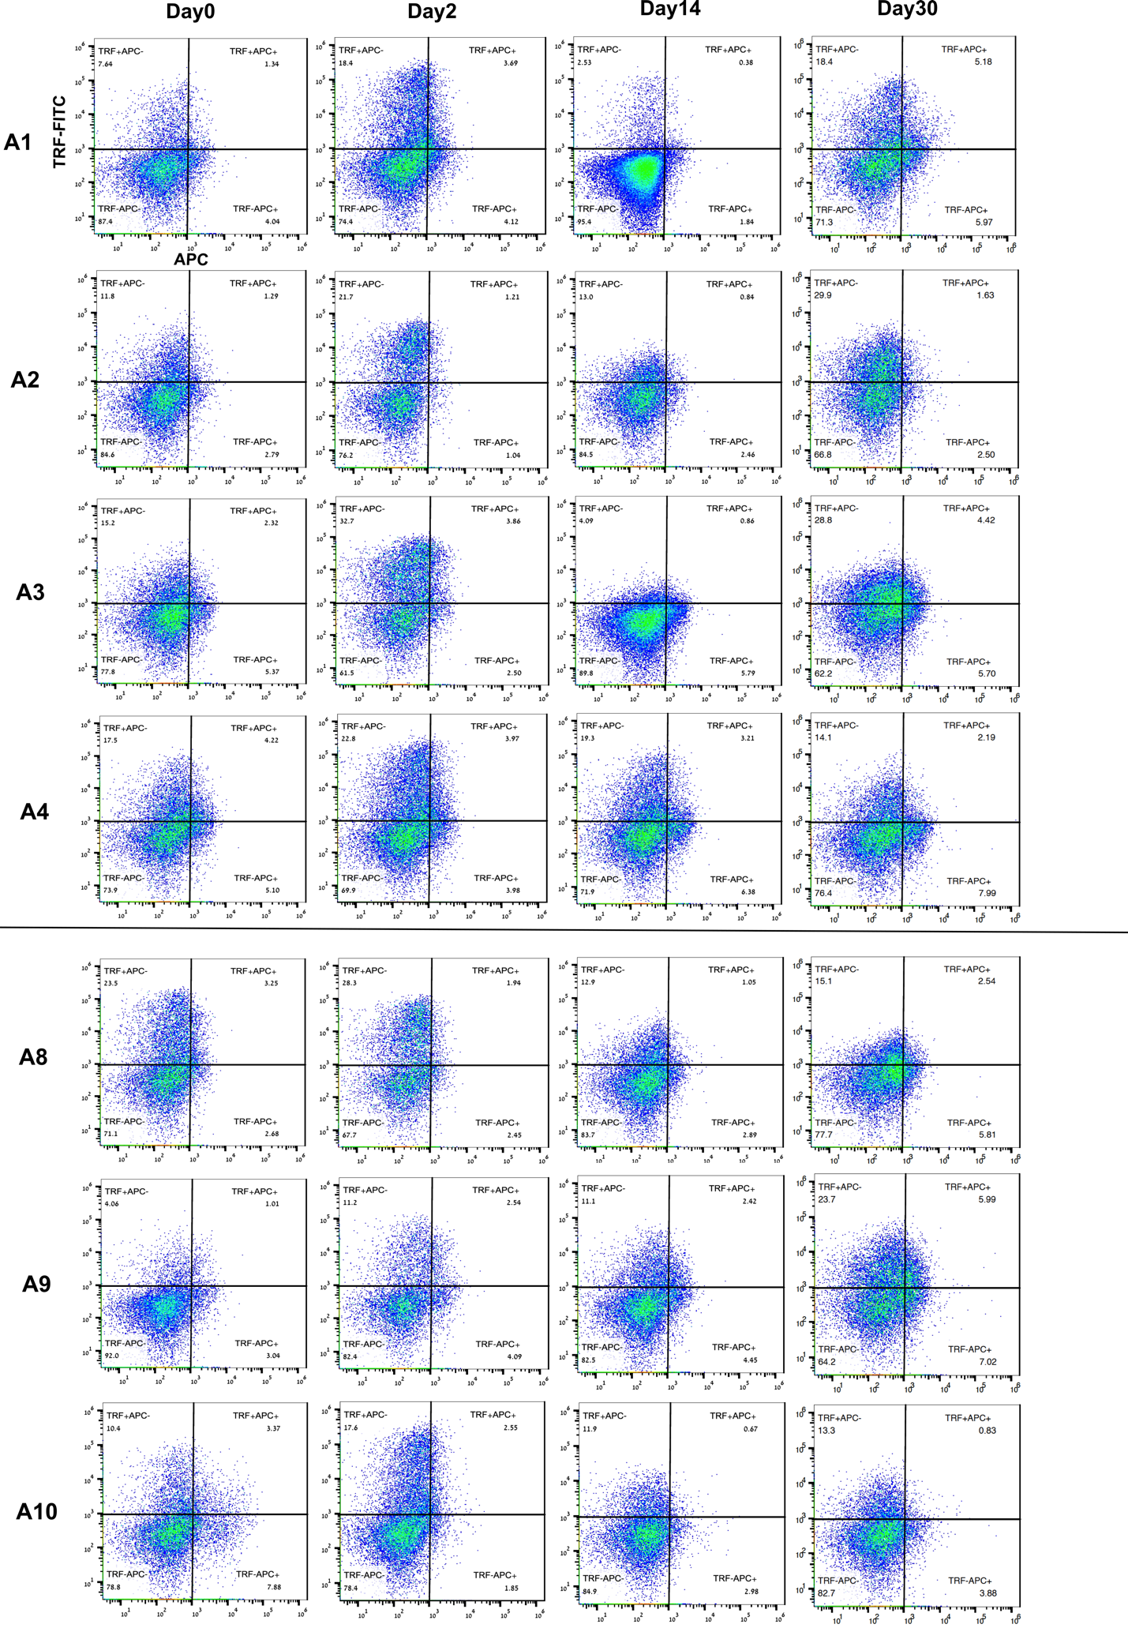
Fig. S3 Trf-positive cell population change over time after injection of either V. penaeicida or Acf. A1-A4 – animals challenged with heat-killed V. penaeicida, A8-A10 - control animals injected with sterile aCF. Y-axis Trf labeled with AF488, X-axis autofluorescence in APC channel indicates red spherule cells.
Table S1 accessions of the Trf sequences used to build the phylogenetic tree.
H. erythrogramma* |  | S. purpuratus*s |  | P. lividus**
JX245053.1 | HE001 | KJ408453.1 | SP001 | HACU01465650.1 | PL001
JQ780274.1 | HE002 | KJ408451.1 | SP002 | HACU01465648.1 | PL002
JX245045.1 | HE003 | KJ408450.1 | SP003 | HACU01465646.1 | PL003
JQ780273.1 | HE004 | KJ408449.1 | SP004 | HACU01465645.1 | PL004
JX245024.1 | HE005 | EF607775.1 | SP005 | HACU01465644.1 | PL005
JX245021.1 | HE006 | EF607759.1 | SP006 | HACU01465643.1 | PL006
JQ780304.1 | HE007 | EF607755.1 | SP007 | GFRN01311981.1 | PL007
JX245020.1 | HE008 | EF607753.1 | SP008 | GFRN01311979.1 | PL008
JQ780312.1 | HE009 | EF607742.1 | SP009 | GFRN01311974.1 | PL009
JQ780311.1 | HE010 | EF607719.1 | SP010 | GFRN01311972.1 | PL010
JQ780305.1 | HE011 | EF607717.1 | SP011 | GEDS01012457.1 | PL011
JQ780303.1 | HE012 | EF607713.1 | SP012 | GEDS01012456.1 | PL012
JQ780287.1 | HE013 | EF066272.1 | SP013 | GEDS01012454.1 | PL013
JQ780284.1 | HE014 | EF066267.1 | SP014 | GEDS01012453.1 | PL014
JQ780276.1 | HE015 | EF066259.1 | SP015 | GEDS01012452.1 | PL015
JQ780275.1 | HE016 | EF066253.1 | SP016 | GEDS01012451.1 | PL016
JQ780271.1 | HE017 | EF066219.1 | SP017 | GEDS01012450.1 | PL017
JQ780270.1 | HE018 | EF066159.1 | SP018 | GEDS01012448.1 | PL018
JQ780269.1 | HE019 | EF065743.1 | SP019 | GEDS01012447.1 | PL019
JQ780268.1 | HE020 | EF065742.1 | SP020 | GEDS01012446.1 | PL020
JQ780266.1 | HE021 | EF065733.1 | SP021 | GEDS01012445.1 | PL021
JQ780265.1 | HE022 | DQ183180.1 | SP022 | GEDS01012443.1 | PL022
JQ780262.1 | HE023 | DQ183182.1 | SP023 | GCZS01069164.1 | PL023
JQ780244.1 | HE024 | DQ183168.1 | SP024 | GCZS01069162.1 | PL024
JQ780233.1 | HE025 | DQ183167.1 | SP025 | GCZS01069159.1 | PL025

* P. lividus, S. purpuratus and H. erythrogramma Trf sequence accession numbers from NCBI protein database
**P. lividus sequences from TSA NCBI databases (HACU01, GCZS01, GEDS01, GFRN01)

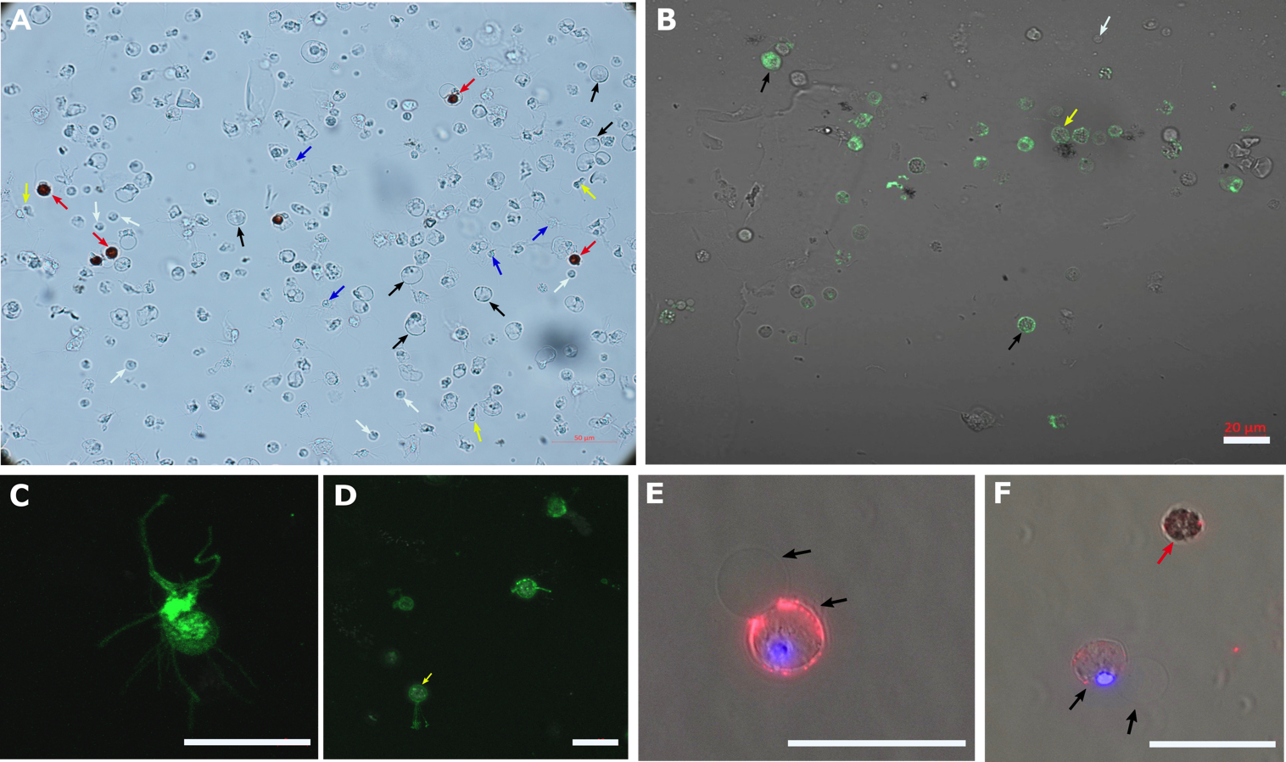

Fig S4. P. lividus coelomocyte types and sorted Trf-positive coelomocytes. A. P. lividus unsorted coelomocytes in whole CF shown in a bright field. B. Sorted Trf-positive cells - petaloid phagocytes and a vibratile cell labeling is clearly seen, other coelomocyte types have a weaker signal. C. Trf protein expression on the cell surface and filopodia of a filopodial phagocyte (confocal microscopy) D. Trf-positive P. lividus vibratile cell (yellow arrow) (confocal microscopy). E and F. Membranal interactions of Trf-positive and Trf-negative petaloid phagocytes (black arrows). Scale bars = 20 μm. Blue arrows - filopodial phagocytes. Red arrows- red spherule cells. Yellow arrows - vibratile cells. Green fluorophore — 2nd Ab AlexaFluor 488. Red fluorophore - 2nd Ab AlexaFluor 567. Blue is DAPI.

