Supplement Table. 1. HeLa cells were transiently transfected with an emerin expression vector and subjected to transcriptional profiling. Data from two independent experiments were normalized to GAPDH expression and are presented as emerin/control ratios.
Supplement Table 1. Transcription factor profiling analysis with emerin transfected HeLa cells
Gene name | Emerin/Control | Gene name | Emerin/Control | Gene name | Emerin/Control
E2F6 | 0.01 | PPARA | 0.18 | DR1 | 0.53
ELK1 | 0.02 | RELA | 0.21 | HAND2 | 0.54
FOXA2 | 0.02 | Catenin, beta | 0.22 | NFATC4 | 0.56
STAT1 | 0.02 | SMAD5 | 0.22 | ATF3 | 0.58
TFAP2A | 0.02 | TBP | 0.23 | ETS2 | 0.58
POU2AF1 | 0.03 | NR3C1 | 0.24 | HNF4A | 0.59
TGIF1 | 0.03 | CREB1 | 0.27 | NFKB1 | 0.6
NFYB | 0.04 | RB1 | 0.27 | ATF2 | 0.65
PAX6 | 0.04 | CEBP, gamma | 0.29 | SMAD1 | 0.68
STAT5B | 0.04 | TCF7L2 | 0.29 | GATA2 | 0.74
JUN | 0.05 | JUND | 0.3 | ARNT | 0.76
FOXO1 | 0.06 | GATA1 | 0.32 | GTF2B | 0.76
MYOD1 | 0.06 | STAT2 | 0.32 | NFATC1 | 0.77
STAT3 | 0.06 | MAX | 0.36 | CEBP, alpha | 0.81
JUNB | 0.09 | ATF4 | 0.37 | GATA3 | 0.82
E2F1 | 0.1 | IRF1 | 0.37 | MEF2A | 0.82
SP3 | 0.1 | NFATC3 | 0.37 | MEF2C | 0.83
YY1 | 0.11 | SP1 | 0.37 | HAND1 | 0.84
CREBBP | 0.12 | NFATC2 | 0.38 | AR (Androgen receptor) | 0.85
NFAT5 | 0.12 | FOXG1 | 0.45 | ATF1 | 0.86
STAT6 | 0.12 | HSF1 | 0.46 | FOS | 0.86
PPARG | 0.13 | ETS1 | 0.47 | CEBP, beta | 0.89
SMAD4 | 0.13 | HDAC1 | 0.48 | GTF2F1 | 0.95
HOXA5 | 0.14 | STAT4 | 0.48 | MYB | 0.97
MYC | 0.15 | TP53 | 0.48 | EGR1 | 0.98
STAT5A | 0.16 | ESR1 | 0.49 | HIF1A | 1.17
SMAD9 | 0.17 | MYF5 | 0.5 | RELB | 1.53
HNF1A | 0.18 | REL | 0.52 | ID1 | 1.83

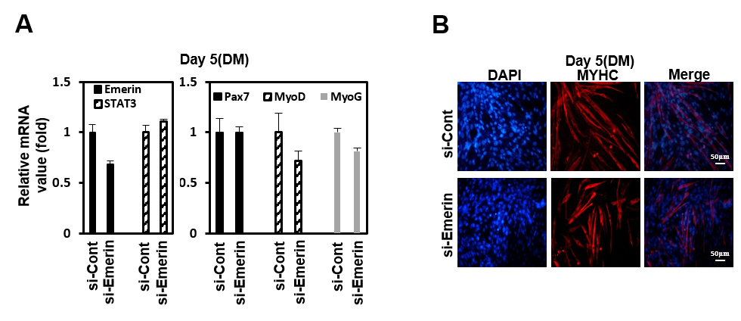
Supplement Fig. 1. (A) C2C12 cells were treated with siRNA (100 nM) against Emerin, or control for 48 hours in 6 well plates. After 48 hours, cells were treated with differentiation media (DM) for 5 days. The total RNA was isolated and subjected to a qRT-PCR analysis. Data were normalized to β-Actin. The results represent the mean ±S.D. of three independent experiments performed in triplicate. *, P < 0.05, ** P < 0.001. (B) C2C12 cells were treated with siRNA (100 nM) against Emerin, or control for 48 hours in 6 well plates. After 48 hours, cells were treated with differentiation media (DM) for 5 days. Immunocytochemistry image stained with anti-Myosin Heavy Chain (MYHC) antibody from emerin-depleted C2C12 cells at day 5 of differentiation. DAPI (blue) was used to visualize nucleus. Scale bar=50 μm

