Self-disclosure to a Robot or on Paper (Technical Report)

Euphie Y. Duan, Ji M. Yoon, Edison Z. Liang, and Johan F. Hoorn
The Hong Kong Polytechnic University

Contents
Author Note 2
Acknowledgements 2
Abstract 2
1 Introduction 2
2 Method 2
2.1 Participants and Design 2
2.2 Procedure 3
2.3 Apparatus and Materials 3
2.3.1 Video materials 3
2.3.2 Robot embodiment 3
2.3.3 Self-disclosure chatbot 4
2.4 Measures 15
3 Results 20
3.1 Demographics 20
3.2 Manipulation check: Emotional effects after negative-mood induction and after treatment 21
3.3 Effect of Media (robot vs. writing) on Valence and Relevance 21
3.3.1 Effects on general Valence and Relevance 22
3.3.2 Effects on Positive Valence, Negative Valence, and Relevance 22
3.4 Effect of Media on Valence and Relevance for those who felt most negative 23
3.4.1 Valence as a bipolar scale in high-negative subjects 24
3.4.2 Positive and Negative Valence as two unipolar scales in high-negative subjects 25
3.4 Exploratory analysis: Gender and Novelty 25
References 26
Appendix 1 27
1.1 Robot Chinese 27
1.2 Robot English 31
2. 1 Writing Chinese 35
2.2 Writing English 39

Author Note
Euphie Y. Duan, Ji M. Yoon, Edison Z. Liang, and Johan F. Hoorn (ORCID: 0000-0002-3427-5681) are with The Hong Kong Polytechnic University, Hong Kong. Correspondence concerning this article should be addressed to Johan F. Hoorn, School of Design and Department of Computing, The Hong Kong Polytechnic University, Hung Hom, Kowloon, Hong Kong. Contact: johan.f.hoorn@polyu.edu.hk

Acknowledgements
PAL AiDLab RP2-3 Grant. The authors have no competing interests to declare.

Abstract With the rapid development of interactive technologies, social robots are an innovative method to improve the well-being of individuals. Earlier research showed that people easily self-disclose to a social robot even in cases where that was unintended by the designers. We report the technicalities of an experiment of self-disclosing in a diary journal or to a social robot after negative mood induction. In terms of negative-mood reduction, we found that people who felt strongly negatively affected after being exposed to shocking earthquake footage also benefitted the most from talking to a robot rather than writing their feelings down. For people less affected by the treatment, a confidential robot chat or writing a journal page did not differ significantly.

Keywords Self-disclosure ⋅ Social robots ⋅ Diary ⋅ Emotion theory ⋅ Relevance ⋅ Valence

1 Introduction
Our research question is whether social robots offer an alternative to traditional diary writing to ‘let off steam,’ particularly in coming to terms with negatively valenced emotions. Based on the literature (e.g., Pu, Moyle, Jones, & Todorovic, 2019), we expect that social robots will do better than writing down ones feelings because the robot more closely resembles talking to a person (i.e. a virtual therapist).
We propose (H1) that a social robot that invites self-disclosure from its user decreases the level of negative emotions more than pencil-and-paper approaches do. As a medium (H2), a social robot that invites self-disclosure will be regarded as more relevant to the user’s goals and concerns than pencil-and-paper approaches.

2 Method

2.1 Participants and Design
Voluntary participants (N = 45; M_{age} = 24.9, SD_{age} = 3.29, 55.6% female, Chinese nationality) were randomly assigned to a between-subjects experiment of self-disclosure after negative-mood induction in a Robot (n = 24; 54.2% female) versus Writing condition (n = 21; 57.1% female), not receiving any credits or monetary rewards. All participants had university training at the master level, except for four doctorate degrees, three bachelors, and one with a diploma degree. Informed consent was obtained formally from all participants.

2.2 Procedure
Participants were brought in a dimly lit and shielded-off section of the experimenter room and were seated in front of a laptop. The experiment consisted of negative-mood induction and self-disclosure, after which participants filled out an online questionnaire in the Qualtrics environment for administration of surveys and experiments.
In the induction part, participants were confronted with a 10m. and 6s. video compilation of three documentaries about a serious earthquake incident that happened in Sichuan, China in 2008. Research has shown that viewing negative media, including videos, images, and texts effectively induces negative emotions with an increasing activation of the aversive system (Bolls, Potter, & Lang, 2001; Lang, Shin, & Lee, 2005). In accordance with the review conducted by Siedlecka and Denson (2019) that video is the most effective means of mood induction, we prepared a video on earthquakes that actually took place in Sichuan, China, which made the contents culturally related to our participants and brought relevance and realness to the experience.
After the video, participants were asked to either talk to a robot about their experiences during the video or to write them down on a paper. This instruction took 30-40s. The robot nor writing utensils were visible before self-disclosure - for which the participants had 10 minutes. The movements of the robot and text input were handled in remote control (Wizard of Oz), the conversation was handled autonomously by our inhouse developed AI chatbot (next section).
After the self-disclosure session ended, participants were asked to fill out a 30-item structured questionnaire (Appendix 1) and report on their assessment of the video clip and talking to the robot or writing the journal page. Items on the questionnaire were presented in blocks with pseudo-random sequences of items within blocks, different for each participant. We ended the questionnaire inquiring about demographic information. Upon completion, participants were thanked for their participation and debriefed.

2.3 Apparatus and Materials

2.3.1 Video materials
The video materials for negative-mood induction were 10 minutes and 6 seconds long and were composed of video excerpts from the following three Sichuan earthquake Internet documentaries:

无声也有情 (2018, May 7). 谨以此视频纪念四川汶川大地震十周年 (cut at 00:02-01:19) [Internet video in memory of the Wenchuan Sichuan earthquake tenth anniversary]. Available from https://www.bilibili.com/video/av23087386/
Dazzz2009 (2008, December 31). 512地震纪实 都江堰 实拍 四川大地震 (cut at 01:20-01:59) [internet video record of 512 earthquake in Dujiangyan]. Available from https://www.youtube.com/watch?v=Vz0nGbl81fM&list=PLf2PpWDjsx1d6rVUW0vaGFzhvIr_nRo_8&index=2
Lantian777 (2008, May 16). 汶川县城地震后10分钟画面曝光 (in full) [internet video ten minutes after Wenchuan Sichuan earthquake]. Available from https://www.youtube.com/watch?v=PI5KL7nvU28

2.3.2 Robot embodiment
The robot was a Robotis DARwIn Mini, a 3D printable, programmable, and customizable miniature humanoid robot of 27 cm tall with Bluetooth connection to a laptop (Figure 1). The robot could stand up and move its arms while speaking through an AI chatbot.
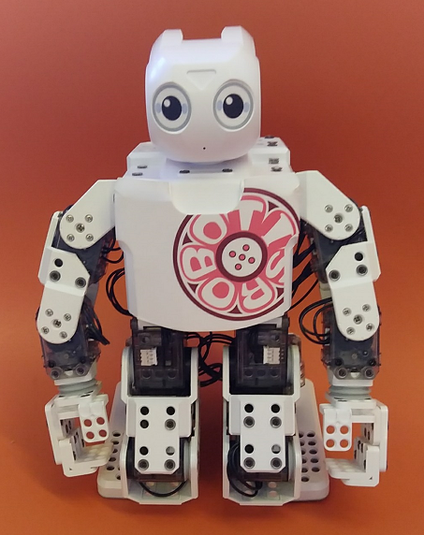

Figure 1. Robotis DARwIn Mini as the humanoid embodiment of our self-disclosure chatbot.

DARwIn Mini requires OS Android 2.3.3 (Gingerbread or greater), a 1.2 GHz Dual Core or greater, RAM 1GB or greater, iOS 6 or higher with a BT-410 Wireless Communication Module for iOS use. The actions DARwIn could execute during the experiment are tabulated in Table 1 and were controlled remotely.

Table 1. Action set of DARwIn Mini in the experiment.
Action code | Type | Description
1 | Greets | Wave two hands when conversation starts
2 | Left hand | Wave left hand
3 | Right hand | Wave right hand
4 | Up | Raise hand
5 | Down | Put down hand

2.3.3 Self-disclosure chatbot
The DARwIn Mini cannot speak, therefore, we created our own chatbot, using DARwIn Mini as the humanoid embodiment of our self-disclosure AI chatbot. Next, we report on the development of both the hardware and software.
Hardware development. Two main components made up the hardware of our self-disclosure AI chatbot: the core board Raspberry Pi Zero (WH) (Figure 2) and the extension board that was connected to the speaker and camera. These two boards we engineered into an integrated circuit (Figure 3). In the actual experiment, we did not use the camera due to the long processing time of voice in combination with image. Hardware details are summarized in Table 2. Figure 4 offers an impression of the hardware prototype chatbot.

Table 2. Hardware components of the self-disclosure chatbot.
Component | Description
Raspberry Pi Zero WH | Core board
Internal cardboard frame | Internal frame with speaker, Raspberry Pi, and other parts
Extension board (designed by ourselves) | Integrated with internal cardboard frame and camera
Speaker | Audio devices
Display screen | Display devices
Transparent plastic shell | Chatbot casing
Battery | Power supply
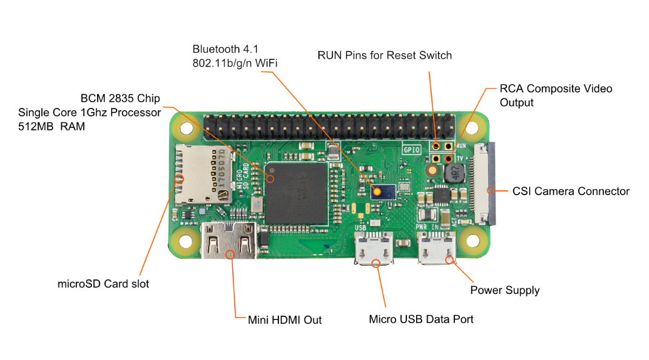
Figure 2. Raspberry Pi Zero (WH).
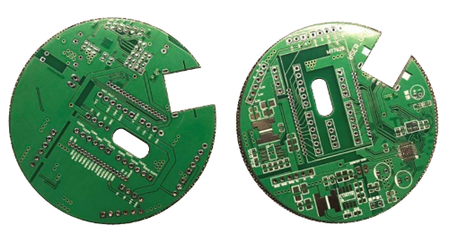
Figure 3. Inhouse-engineered integrated board.

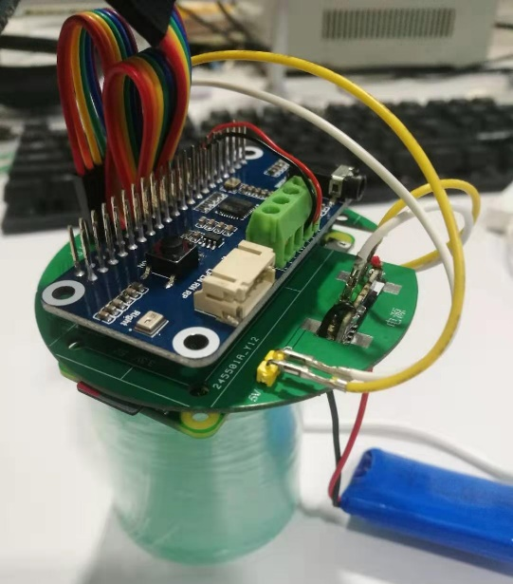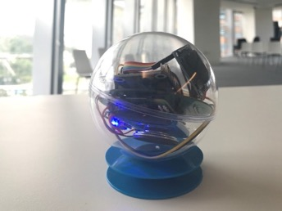
Figure 4. Hardware prototype of the chatbot.

Software development. To create a chatbot adjacent to the DARwIn Mini, we set up a homepage for test subjects to assess the chatbot system. For website development, we used Semantic UI as the front-end framework, and Node.js as the back-end. We tentatively called the chatbot Meme and invited test subjects to share their secrets with Meme in our test environment (Figure 5). The chatbot on the website had speech recognition in Putonghua, Cantonese, and English, using a Turing robot API. We submitted the code to the GitHub repository. Due to the size limitations of GitHub, the corpus is upload to Google drive. Readers can find the download address if they search for the readme.md file under the model folder.

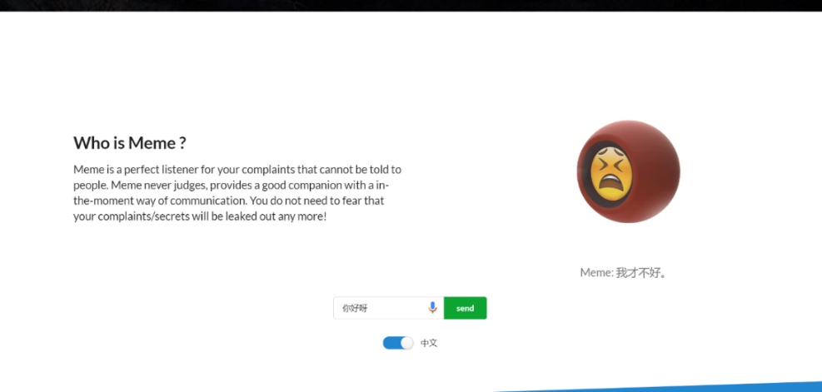
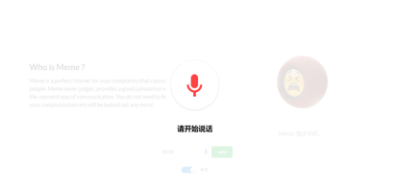

Figure 5. Chatbot test environment.

To increase the traffic on our website, we also created an official WeChat account and used Python to run a server in Google Cloud. Figure 6 shows two screenshots of the app.

Figure 6. WeChat official account.

On WeChat, we used Chill chat with the Xiaohuangji corpus for information retrieval and as an extra, we could generate poetry through LSTM. An example of such poem:

《江南》
凉雨好阿兄，东风撼碎蝉。
美人缝落尽，袖里认眠时。
枫叶攒纤手，残花落玉池。
朝朝千里去，飞雪戏烟台。

Ours was a hierarchical chatting system, consisting of three layers: (1) A rule-based layer that focused on certain specific chatting tasks (Figure 7), (2) an information retrieval-system that searched the answer from a corpus built from Weibo conversations and conversations about movies (Figure 8), and (3) a generation layer that used the general-purpose encoder seq2seq as well as Generative Adversarial Network, a machine-learning tool, to generate a response. We adopted the k-means algorithm in sentence vector clustering. After many iterations of improvement, the final model could effectively answer a question.

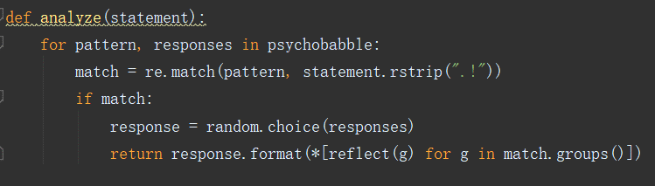
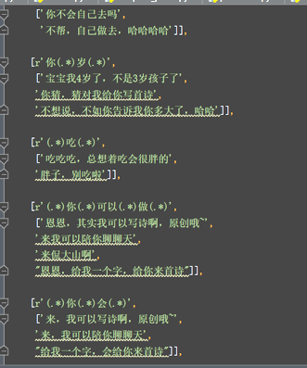

Figure 7. Rule-based: Eliza.py and regular expressions.

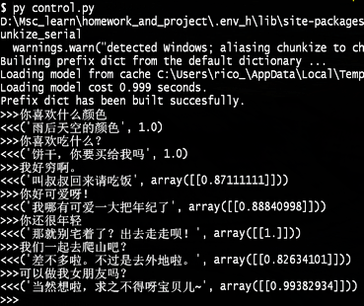

Figure 8. Information retrieval from Xiaohuangji corpus.

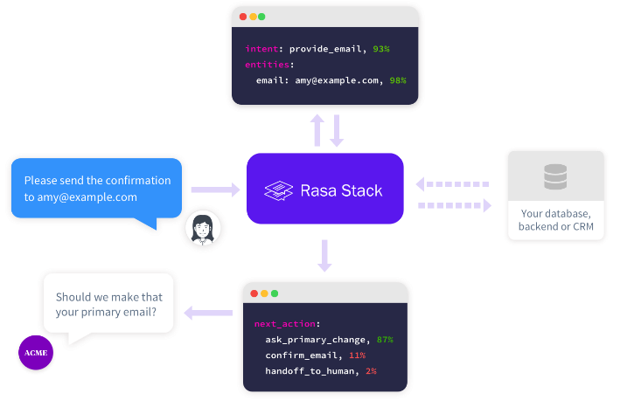

Figure 9. Framework for Natural Language Understanding (NLU).

For Natural Language Understanding (NLU), we installed a Rasa stack and so made the conversation somewhat more contextualized (Figure 9). For Rasa to estimate what a user means to say, we classified a number of conversational topics that had to do with negative experiences. Therefore, we analyzed the contents of a complaining website and ran a spider program to catch the users’ comments (Figure 10). Then we did data mining for hot topics (Figure 11). A screenshot of the training set is shown in Figure 12.

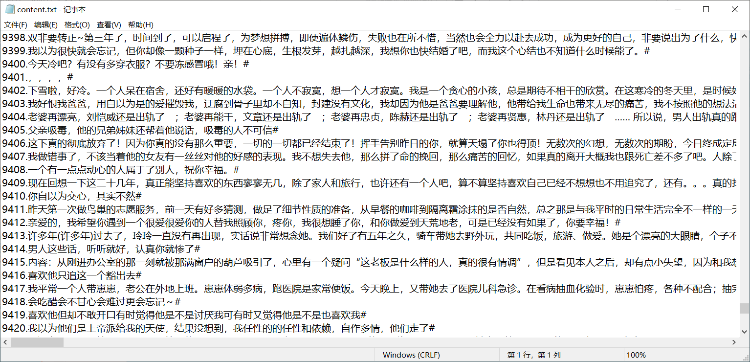

Figure 10. Users’ comments and complaints.

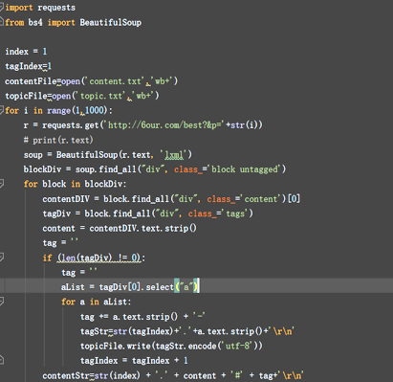

Figure 11. Data mining for hot topics.

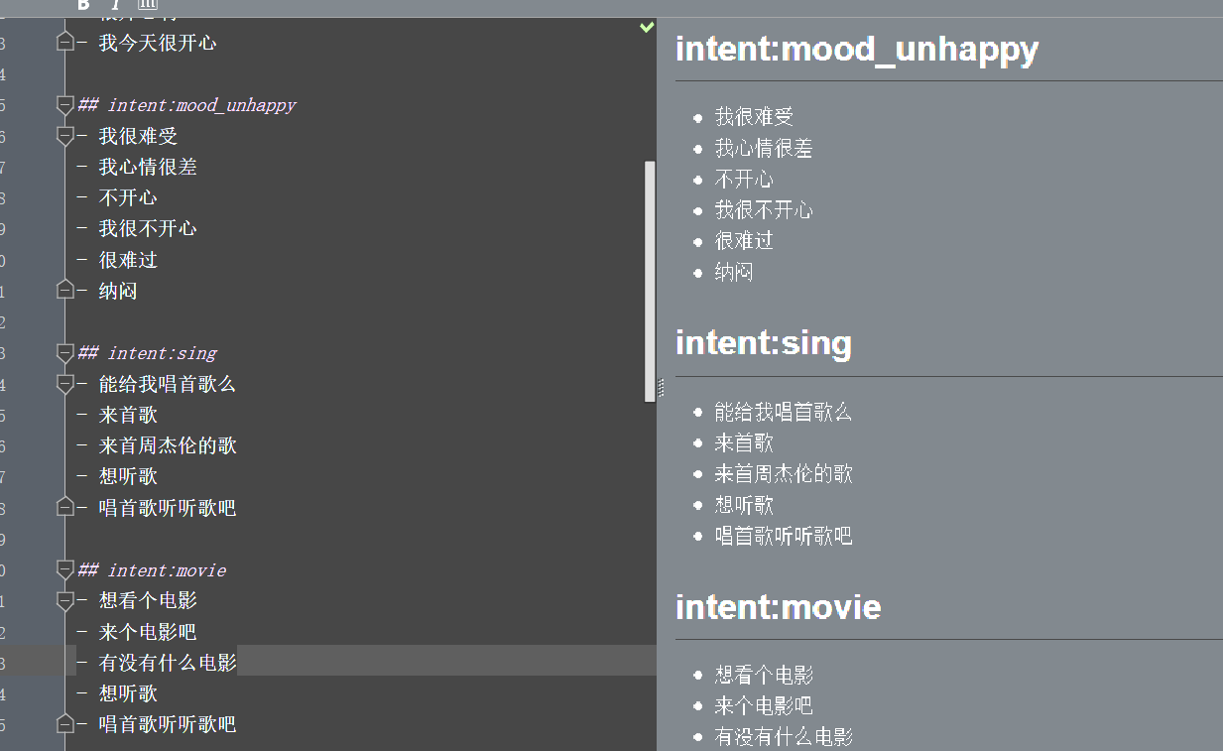

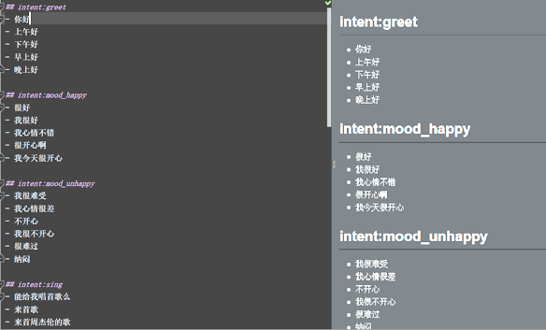

Figure 12. Training dataset for the Rasa system.

For training, we sampled a 2 years’ record of almost 500 pages and nearly 10,000 comments. Then we tokenized these utterances and identified the high-frequency items (‘hot topics’). An impression of the results is depicted in Figure 13: People worried most about unrequited love, emotions, relationship, family, love, homosexual love, cheating, love crush, self, life, work, making love (sex), being disappointed in live, only one, feelings, lost, life, cheer up, marriage, trouble and worry, loneliness, depression, study, entry exam to university and college, secrets, love relationships.

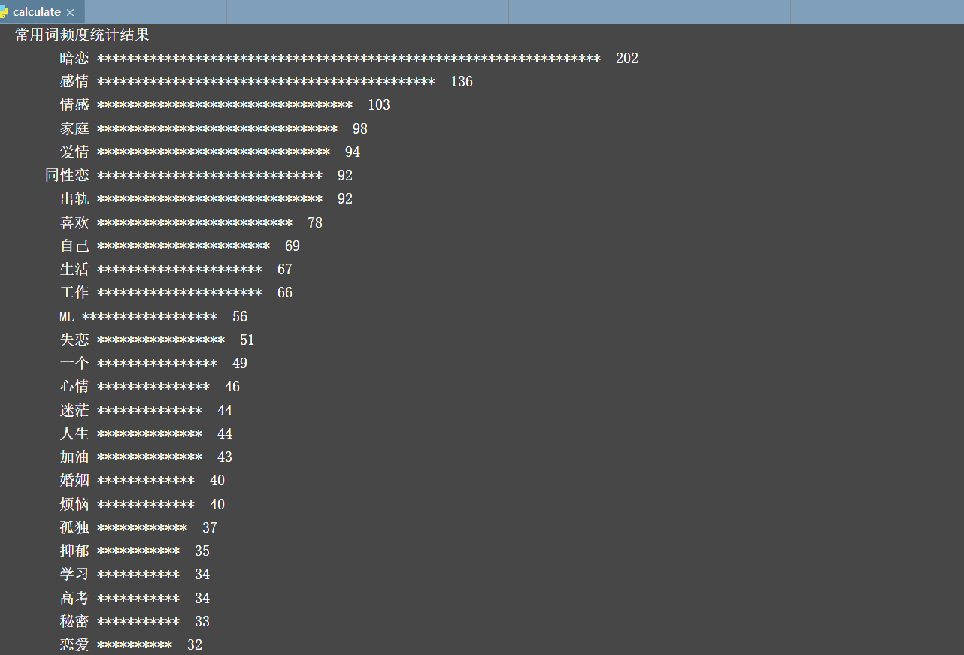

Figure 13. Frequency statistics for hot topics to complain about.

The complete set-up of the self-disclosure AI chatbot is shown in Figure 14. The sing, movie, poem, and weather options were not used in the actual experiment.
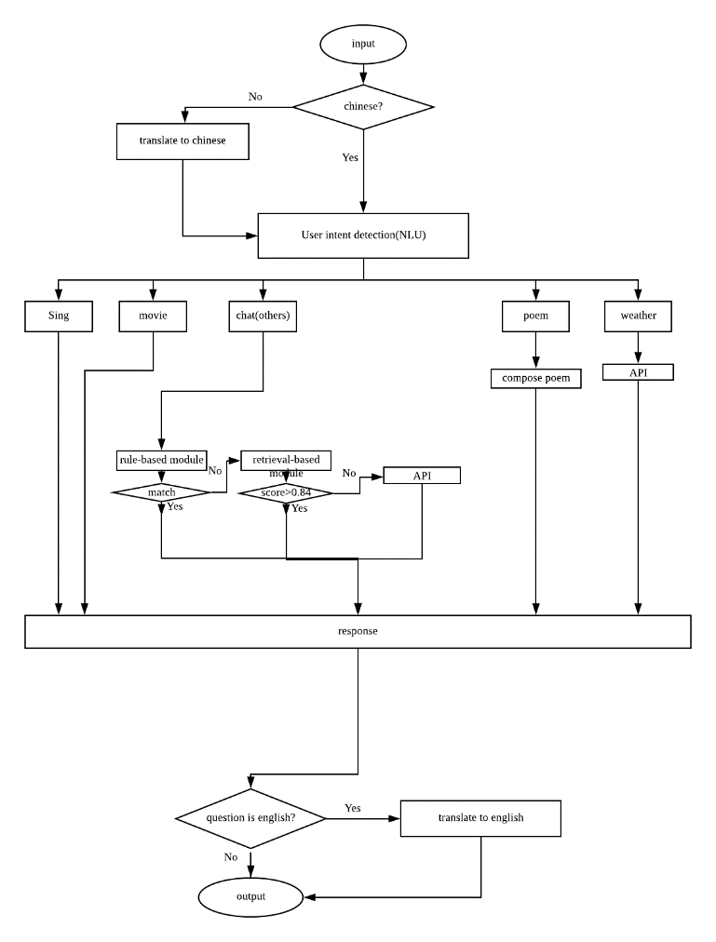

Figure 14. Flowchart for our self-disclosure AI chatbot.

For the experiment, we installed our chatbot system in a voice kit that stood behind the DARwIn Mini (Figure 15). We did not install voice-recognition software because of its inefficiency (i.e. slow and inaccurate). Therefore, a confederate not visible to the participant inputted the participant’s utterances.

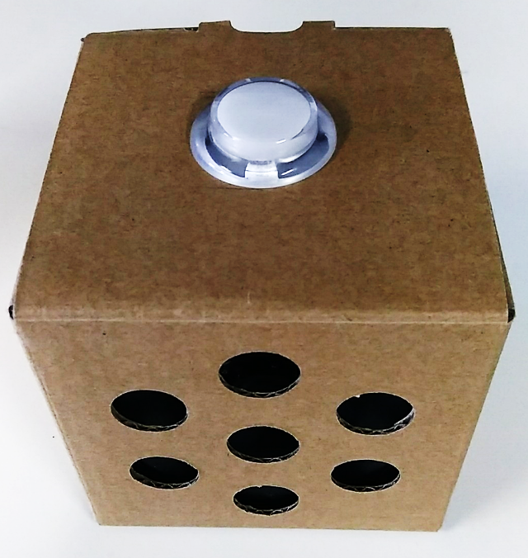

Figure 15. Voice kit vocalizing the ‘thoughts and feelings’ of DARwIn Mini.

Information processing and replying to the participants was done autonomously by our AI. Figure 16 exhibits the interaction flow.
The robot first introduced itself (translation from the Chinese): “Hi, I am MEME. I am a social robot. Nice to meet you. I want to help people. Please forgive my slow response because I am still learning to be a good robot. How do you feel today?” Depending on what the participant said, the robot chose from the following questions that were embedded in the chatbot program. To personalize the responses, not all questions were asked with each partcipant and not all participants were asked the exact same questions:

1. What troubles you? You can talk to me.
2. Can you say more about it?
3. What is the happiest thing in your life?
4. Imagine you can go anywhere tomorrow, where will you go?
5. What is your favourite thing?
6. Can you tell me the most interesting experience you had?
7. What can I do to make you happy?
8. Do you want to talk about something else?
9. What do you think?
10. What do you think is the most beautiful thing in the world?
11. How do you think about that?
12. Can I know why?

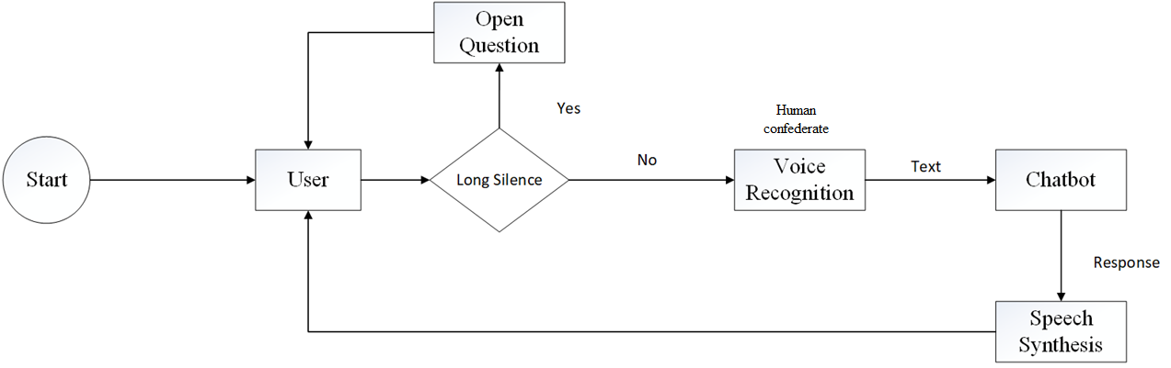

Figure 16. Human-robot interaction flowchart.

Together, the DARwIn Mini standing in front of the voice kit carrying our self-disclosure AI chatbot made up the ‘robot condition’ in our experiment. Figure 17 shows the final set-up.

Figure 17. DARwIn Mini was placed in front of the voice kit with self-disclosure AI chatbot.

2.4 Measures
Two versions of a structured questionnaire were used as appropriate to one of two conditions: Talking with the robot or journal writing on a piece of paper (Appendix 1). The questionnaire was constructed from emotion literature (e.g., Scherer, 2013; Frijda, 2007; Russell, 2003) and ran four measurement scales: Valence after the movie but before treatment (robot or writing), Valence after treatment, Relevance, and Novelty as a control variable. We also inquired about demographics.
Items were Likert-type statements followed by a 6-point rating scale (1 = strongly disagree, 6 = strongly agree). One half of the items on each measurement scale consisted of four indicative statements and the other half of counter-indications. Blocks of related items were offered in pseudo-random order, different for each participant. Items within blocks also were pseudo-randomly presented to each participant.
The measurement scale ‘Valence before treatment’ (ValB) consisted of four indicative items (Vb1i, Vb2i, Vb3i, and Vb4i), for example, “I feel good” (Vb1i) and of four counter-indicative items (Vb5c, Vb6c, Vb7c, and Vb8c), for example, “I feel bad” (Vb5c). We used the same items for measurement of Valence after talking to the robot or writing on paper but adjusted the wording to the situation. Thus, ‘Valence after treatment’ (ValA) also had four indicative and four counter-indicative items (Va1i, Va2i, Va3i, Va4i, Va5c, Va6c, Va7c, Va8c). Relevance of robot or writing to goals and concerns (i.e. personal emotion regulation) was measured with two indicative items (e.g., ‘… is useful’) (Re1i, Re2i) and two counter-indicative items (e.g., ‘… is meaningless’) (Re3c, Re4c).
To control for a possible confound of the robot as a novel means to regulate emotions, a Novelty scale was composed of three indicative items (e.g., ‘… is new’) (No1i, No2i, No3i) and three counter-indicative items (e.g., ‘… is commonplace’) (No4c, No5c, No6c).
Demographics included information about the participant’s Gender (De1), Age (De2), Education level (De3), and Country (De4). At the end of the questionnaire, participants could leave their comments. The raw scores to items are tabulated in Table 3.

Table 3. Raw scores to the items on the measurement scales (not reverse-coded) (N = 45).

R/W Vb1i Vb2i Vb3i Vb4i Vb5c Vb6c Vb7c Vb8c Va1i Va2i Va3i Va4i Va5c Va6c Va7c Va8c Re1i Re2i Re3c Re4c No1i No2i No3i No4c No5c No6c
R 2 2 1 1 5 4 6 5 4 4 3 4 1 1 1 1 4 4 4 4 4 4 2 6 4 3
R 1 1 2 1 6 6 6 6 4 4 5 2 2 5 2 5 4 4 4 4 5 5 3 4 4 2
R 3 3 4 3 4 4 4 4 5 5 5 5 2 2 2 2 4 4 2 3 4 4 4 4 5 3
R 2 2 2 1 5 5 4 4 4 3 3 3 3 4 4 3 4 3 4 4 4 4 4 4 4 3
R 2 3 3 3 2 2 2 2 2 2 3 2 2 2 2 2 4 4 4 3 4 5 3 4 3 2
R 3 2 4 2 4 4 3 3 4 4 4 4 2 2 3 2 4 4 2 2 4 4 2 5 4 4
R 2 2 3 2 4 4 4 4 4 4 4 4 2 2 3 3 3 3 4 4 4 4 3 4 3 2
R 2 2 4 4 5 3 5 5 4 4 4 4 3 3 3 3 4 4 3 3 4 5 4 3 2 3
R 5 6 5 6 2 1 2 2 5 5 6 5 2 1 2 1 5 4 1 1 5 6 5 3 3 1
R 2 2 2 2 5 4 6 5 5 5 5 5 2 2 2 2 5 6 2 2 6 6 6 2 2 2
R 2 1 1 1 5 5 5 4 5 4 5 4 1 1 1 1 4 4 3 1 5 5 4 3 3 1
R 1 1 1 1 5 5 4 4 5 4 4 4 2 3 2 2 6 6 1 1 5 6 5 1 2 3
R 1 1 2 1 5 5 5 5 5 5 5 4 1 2 2 2 5 5 3 3 5 5 3 4 3 1
R 5 4 4 4 2 2 2 2 5 5 4 5 2 2 2 1 4 4 2 2 4 5 3 4 3 3
R 4 1 1 1 3 3 4 2 4 5 5 4 3 2 2 1 6 6 2 1 5 5 5 4 2 1
R 1 1 1 1 6 6 6 6 5 5 5 5 2 2 2 2 5 4 2 2 4 4 5 3 3 2
R 5 6 5 5 1 1 5 1 5 5 6 6 1 1 1 1 5 5 2 5 4 3 3 4 5 3
R 1 1 1 1 6 5 6 5 4 4 4 4 2 1 3 3 2 2 5 5 2 2 1 6 5 5
R 5 5 4 3 1 1 1 1 6 1 5 6 1 1 1 1 5 5 1 2 5 3 4 4 5 3
R 2 2 2 2 5 4 5 4 5 4 4 4 2 1 2 1 5 4 2 2 5 6 4 3 1 2
R 1 1 1 3 4 5 4 3 2 1 3 2 4 4 2 2 2 2 4 5 4 4 2 4 3 4
R 3 3 3 3 2 3 5 4 3 2 3 4 2 4 3 3 4 2 4 2 4 4 2 4 3 2
R 2 1 1 1 5 6 5 4 4 4 4 4 2 3 3 4 4 4 3 3 4 4 3 4 5 4
R 3 2 2 3 3 3 5 4 4 4 4 4 3 3 4 3 4 4 2 3 5 5 4 3 3 2
W 2 2 1 1 4 3 5 5 4 4 4 4 2 2 3 3 4 5 3 3 2 1 4 3 5 3
W 2 1 1 1 6 6 6 6 4 4 4 4 3 3 3 3 4 4 3 3 4 2 5 3 4 1
W 3 1 5 1 5 5 5 4 2 1 2 1 2 1 5 4 5 5 3 3 2 3 2 2 2 2
W 2 2 2 2 4 4 5 3 2 2 3 4 5 4 5 3 4 5 2 4 2 2 2 5 5 2
W 1 1 1 2 5 4 5 5 3 3 4 4 2 2 3 2 6 6 1 1 3 2 2 4 5 1
W 2 1 4 4 6 5 4 5 4 4 5 4 2 2 2 4 5 5 1 1 4 4 5 1 2 3
W 2 1 5 4 4 4 4 4 3 2 4 2 2 2 2 4 5 4 2 2 2 2 3 3 4 2
W 2 2 2 2 5 4 5 5 3 5 3 2 2 2 4 3 4 3 4 2 4 3 5 3 2 2
W 3 2 5 5 3 2 2 2 3 3 5 4 1 2 2 2 6 5 1 2 5 4 3 2 2 1
W 2 2 1 1 2 4 1 1 1 1 1 1 1 1 1 1 2 2 5 5 2 2 4 3 5 3
W 5 2 2 2 2 2 5 5 4 2 1 1 2 1 3 2 3 2 3 3 2 2 5 1 4 2
W 3 3 3 3 4 4 3 4 4 4 4 4 3 3 3 4 4 4 3 3 3 3 4 4 4 3
W 3 2 6 1 4 1 3 3 4 5 4 3 2 2 2 2 1 1 6 6 2 4 2 2 4 4
W 3 3 3 3 4 4 4 4 4 4 4 4 3 3 3 3 3 3 4 4 3 1 4 3 6 4
W 1 2 6 2 2 4 1 4 3 6 3 3 1 1 1 1 4 4 2 2 1 2 5 1 2 1
W 3 2 3 1 6 5 6 6 2 2 2 1 5 5 5 6 2 2 5 5 2 1 4 2 5 3
W 3 3 3 3 3 3 3 3 4 3 4 4 3 3 3 3 4 4 2 2 3 3 4 2 5 3
W 1 1 1 1 5 4 5 5 3 1 3 2 4 4 4 4 2 2 5 5 3 3 3 3 5 4
W 2 2 4 5 4 5 5 3 4 5 6 4 3 2 2 4 5 5 1 1 3 3 5 3 1 1
W 1 1 5 4 5 4 4 4 3 4 4 5 2 3 2 2 5 5 2 2 5 4 4 2 2 1
W 2 2 3 3 5 4 5 4 4 4 5 5 3 3 4 3 4 4 3 2 3 2 4 3 4 3
Note: R = robot, W = writing.

Before reliability analysis, we reverse-coded (1→6, …, 6→1) the counter-indicative items on the two Valence scales (Vb5cr, Vb6cr, Vb7cr, and Vb8cr) and (Va5cr, Va6cr, Va7cr, and Va8cr), Relevance (Re3cr and Re4cr), and Novelty (No4cr, No5cr, and No6cr). For the variables of theoretical interest, all measurement scales with all items included, achieved good to very good reliability in the first run (Cronbach’s α ≥ .82). This was so for the separate subscales of Valence (4 items each) and for their combination (ValB and ValA, 8 items each) as well as for Relevance (4 items). The control variable of Novelty had Cronbach’s α = .75 in the first run (all items). Yet, we found that if we removed No4cr, we could increase the reliability to Cronbach’s α = .77. No4cr stated that “talking to robot/writing is predictable.” However, in the writing condition, it was peculiar to the participants to ask for ‘predictability’ of the blank sheet in front of them. Therefore, we removed No4cr from the scale (5 items remaining). Results are compiled in Table 4.

Table 4. Results of the reliability tests.
Scale | # Items | Alpha | Standardized Alpha | Scale mean | SD
MValBi | 4 | .82 | .82 | 2.40 | 1.08
MValBc | 4 | .90 | .90 | 4.00 | 1.22
MValB_all | 8 | .91 | .91 | 2.70 | 1.07
MValAi | 4 | .87 | .88 | 3.75 | 1.04
MValAc | 4 | .87 | .88 | 2.43 | 0.93
MValA_all | 8 | .88 | .86 | 4.16 | 0.81
MRel | 4 | .94 | .94 | 4.09 | 1.16
MNov | 5 | .77 | .77 | 3.78 | 0.88

Table 5 shows a PCA with varimax rotation on Valence after, Relevance, and Novelty. It seems that indicative items formed a positive-Valence subscale as the counter-indicative items clustered into a negative-Valence subscale. Only Va7cr (“I have negative feelings”) had a balanced spread between the two subscales. Because of its theoretical importance, however, we keep this item and place it in the negative-Valence subscale. Items on the Relevance scale neatly fell in line as intended. Novelty showed some spread over both Valence and Relevance. However, because this was a control variable, we kept the scale intact and will observe in the Results section its tendency to coalesce with variables of theoretical interest.

Table 5. Principal Components Analysis with rotated factor loadings (varimax).

Standardized loadings (pattern matrix) based upon correlation matrix
RC1 RC2 RC3 h2 u2 com
Va1i 0.79 -0.07 0.21 0.68 0.32 1.2
Va2i 0.71 -0.02 -0.09 0.51 0.49 1.0
Va3i 0.76 0.15 0.12 0.61 0.39 1.1
Va4i 0.78 0.03 0.30 0.69 0.31 1.3
Va5cr 0.20 0.22 0.80 0.73 0.27 1.3
Va6cr -0.07 0.10 0.84 0.72 0.28 1.0
Va7cr 0.62 0.18 0.53 0.70 0.30 2.1
Va8cr 0.49 0.18 0.61 0.64 0.36 2.1
Re1i 0.19 0.85 0.26 0.83 0.17 1.3
Re2i 0.33 0.74 0.22 0.71 0.29 1.6
Re3cr 0.25 0.78 0.30 0.76 0.24 1.5
Re4cr 0.10 0.82 0.09 0.69 0.31 1.1
No1i 0.76 0.42 -0.11 0.76 0.24 1.6
No2i 0.58 0.36 -0.13 0.49 0.51 1.8
No3i 0.29 0.47 -0.51 0.56 0.44 2.6
No4cr -0.25 0.66 -0.37 0.64 0.36 1.9
No6cr -0.02 0.74 0.03 0.55 0.45 1.0

RC1 RC2 RC3
SS loadings 4.24 4.23 2.79
Proportion Var 0.25 0.25 0.16
Cumulative Var 0.25 0.50 0.66
Proportion Explained 0.38 0.38 0.25
Cumulative Proportion 0.38 0.75 1.00

Mean item complexity = 1.5
Test of the hypothesis that 3 components are sufficient.

The root mean square of the residuals (RMSR) is 0.09
with the empirical chi square 72.64 with prob < 0.88

Fit based upon off diagonal values = 0.94> fs <- factor.scores(y,fit)
> fs
$scores
RC1 RC2 RC3
0 0.18162334 -1.2541913 1.8488756
0 0.55555323 -0.5247723 -1.4982430
0 1.08475670 -0.5126924 0.1873716
0 -0.15704623 -0.7837692 -1.3523288
0 0.12415988 -0.6327407 0.6745548
0 0.34674253 -0.2378908 -1.0453941
0 1.51253607 1.0558962 -0.7329299
0 0.74655918 0.4370271 0.9105045
0 0.71722149 1.5544635 -0.6225180
0 0.91880382 0.1260751 0.5799294
0 0.92909158 -0.3821653 0.5287668
0 0.85381069 1.2332883 -0.2918666
0 1.29787874 -0.7105512 1.6193620
0 -0.26971222 -2.9434996 1.1483241
0 0.72582113 0.2579284 1.7760812
0 0.64681097 0.4826684 0.4554635
0 -0.57841083 -0.2718089 0.2810230
0 -0.02445907 0.1386890 -1.0179596
0 -3.03036506 0.8179739 0.5804690
0 -1.11675828 1.2004502 1.1805388
0 0.08178814 1.1959045 -0.4865028
0 -1.62465786 0.5586195 0.5852824
0 -0.73279760 0.1052427 -0.7468910
0 -0.34978531 1.4583869 0.8074416
0 -2.06861791 0.1004976 0.2717079
0 -0.01707449 -0.5140845 -0.8245002
0 -0.07761579 -1.2989444 -0.7630102
0 -1.16197005 -1.6265014 -1.7080094
0 0.11365187 1.0716555 -0.2947409
0 0.05563341 -0.2736703 -0.8136524
0 0.31682794 0.1725157 -1.2371493

$weights
RC1 RC2 RC3
Va1i 0.216842845 -0.094162941 0.008811844
Va2i 0.218713670 -0.065061643 -0.106819000
Va3i 0.196193085 -0.027922199 -0.031062582
Va4i 0.195685001 -0.067994648 0.041819338
Va5cr -0.041995576 0.023918223 0.297957507
Va6cr -0.114764008 0.012332600 0.345606740
Va7cr 0.113190718 -0.018526123 0.146479238
Va8cr 0.064809567 -0.007897466 0.194263491
Re1i -0.044746623 0.208034100 0.063971477
Re2i 0.009402136 0.167073776 0.037712315
Re3cr -0.026438381 0.180800701 0.079702937
Re4cr -0.050806384 0.210455702 0.006664050
No1i 0.195631093 0.050186436 -0.130058904
No2i 0.152992537 0.050227085 -0.121693927
No3i 0.093767431 0.114725558 -0.245368652
No4cr -0.095496026 0.210095813 -0.138304949
No6cr -0.072682230 0.201078937 -0.004489390

$r.scores
RC1 RC2 RC3
RC1 1.000000e+00 2.389582e-15 4.198166e-15
RC2 2.282896e-15 1.000000e+00 3.926547e-15
RC3 4.199332e-15 3.845882e-15 1.000000e+00

We then calculated the means across the items on a scale (Table 4) and performed an outlier analysis for Valence, Relevance, and Novelty. We found that participant 9 was an outlier in MValB, participant 39 in MValA. Participant 5 and 21 were outliers for MValAi. Participants 39, 27, 38, and 33 were outliers in MValAc (see Figure 18). There were no outliers in MNov, MRel, MValBc, and MValBi. We will perform our effects analysis with and without those outliers.

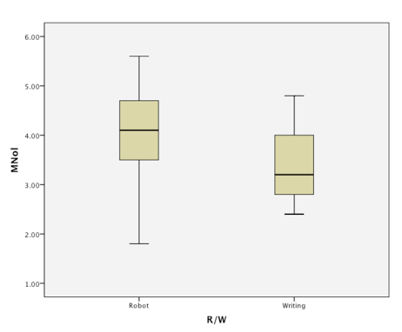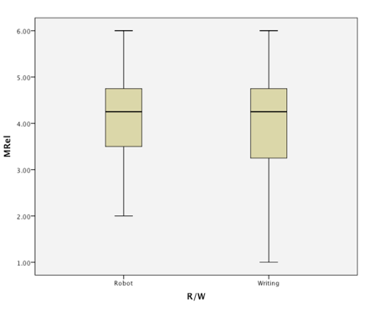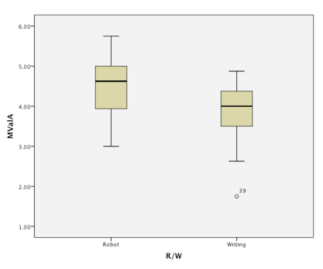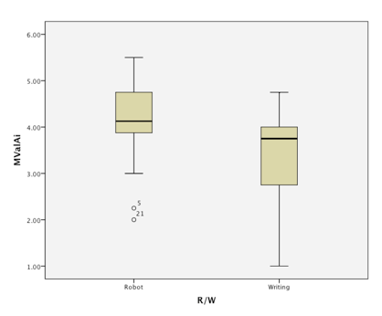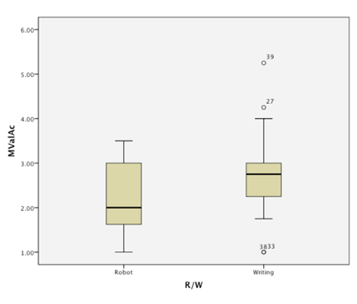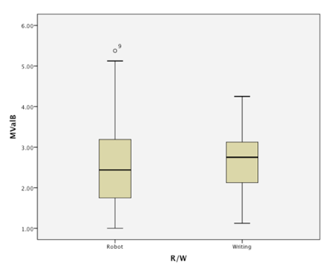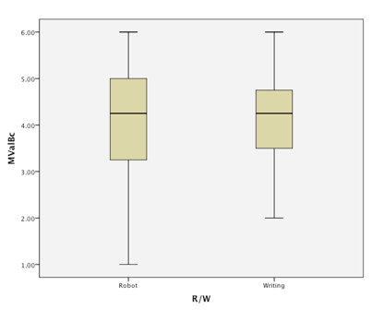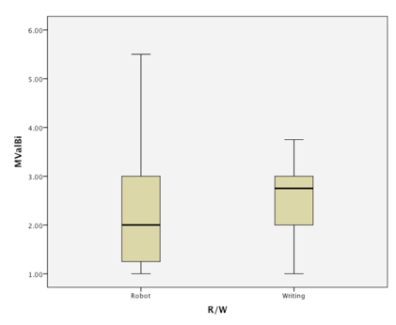

Figure 18. Outliers for mean scale values: MValB, MValA, MValAi, and MValAc.

3 Results

3.1 Demographics
We checked the country that participants came from (De4). Only participant 31 reported she was from Africa; the rest were from China. Inspection of the scatter plot, however, showed that number 31 was not in the zone of outliers. Therefore, we decided to treat this person as one of the same sample and not treat her differently in the analysis.
Next, we checked whether Age (De2) was correlated with the eight dependent variables (MRel, MNov, MValB, MValA, MValBi, MValBc, MValAi, and MValAc). We calculated Pearson bivariate correlations (two-tailed) and found no significant relations Age with MRel, MNov, MValB, MValA, MValAi, MValAc, and MValBc (Table 6). Age did have a near-significant weak negative correlation with MValBi (sig.= .08). In all, we concluded that Age did not have effect on the variables of theoretical interest, except maybe for MValBi, indicating that with higher age, people became less positive.

Table 6. Bivariate Pearson correlations with Age.
r sig.

MRel .09 .55
MNov .04 .80
MValB -.23 .13
MValA -.08 .62
MValBi -.27 .08
MValBc .17 .28
MValAi .02 .91
MValAc .15 .32

Next, we examined whether Gender (De1) was influential for the eight dependent variables (MRel, MNov, MValB, MValA, MValBi, MValBc, MValAi, and MValAc). We ran a MANOVA (Pillai’s Trace) to check the effect of Gender but we found no significant effects (V = .11, F_{(7,37)} = .68, p = .688).
Interestingly, Gender did exact an effect on the experience of Novelty (F_{(1,41)} = 4.18, p = .047, η_{p}² = .09). Throughout, females experienced more Novelty (M = 4.03, SD = .83) than did males (M = 3.50, SD = .87). However, Novelty was a control variable in our experiment and not of theoretical interest. Therefore, we concluded that Gender did not have a significant effect on the variables theoretically related to our hypotheses.
Among all participants, there were four with doctorate degrees, three with bachelor’s degrees and one with a diploma degree. The rest were all master’s degrees. We found participant 39 with a doctorate degree also to be one of the outliers to the scale means. Thus, we excluded this participant from the effect analysis of educational background.
We put the seven participants with a degree other than master in one group and randomly chose seven other participants (who were not outliers) with a master degree in the other group. We performed an independent samples t-test to check whether education had effect on the eight dependent variables that related to our theoretical hypothesis. We ran this test five times, each time with a different set of masters and found that in certain group comparisons, educational background did have effect on MValBc, MValA, MValAi, MValAc, and MNov. Therefore, we made two data sets, one with all 45 participants (24 in the robot group and 21 in the writing group) and the other with 31 participants (17 in the robot group and 14 in the writing group), excluding the outliers and the participants with a non-master degree as educational background. These separate sets were used to confront our hypotheses with.

3.2 Manipulation check: Emotional effects after negative-mood induction and after treatment
We wanted to control whether any emotion at all was provoked by the shocking video footage of the earthquake and whether the treatment (robot or writing) evoked any change in emotion at all. Or did everything remain at level 1 (no emotions reported)?
For N = 45, we ran a one-sample t-test (two-tailed) with 1 as the test value to see if any negative (or positive) emotions occurred after mood induction as well as after treatment. For positive valence after the earthquake clips, MValBi showed that t = 8.67, p < .00001. For negative valence after the earthquake clips, MValBc resulted in t = 16.44, p < .00001. For positive valence with n = 31, MValBi was t = 7.00, p < .00001. For negative valence with n = 31, MValBc resulted in t = 15.38, p < .00001. Thus, more negative than positive mood was induced by the clips, as intended.
For N = 45, after treatment (robot or writing), positive valence MValAi obtained t = 17.83, p < .00001 while for negative valence MValAc, t = 10.35, p < .00001. For n = 31, positive valence MValAi was t = 18.65, p < .00001 and negative valence MValAc, t = 9.39, p < .00001. In other words, more positive than negative emotions were felt after either talking to a robot or writing a diary page, as intended.
To check whether before-after effects of treatment actually occurred, we also ran paired-samples t-tests (two-tailed) in both data sets N = 45 and n = 31. Note that these are no tests of our hypotheses but a mere inspection if anything happened at all.
For the difference between MValBc – MValAc with N = 45, t = 9.34, p < .00001. For the difference between MValBc – MValAc with n = 31, t = 9.42, p < .00001, so that we may conclude that participants after treatment became less negative (MValBc was significantly larger than MValAc).
For the difference between MValBi – MValAi with N = 45, t = -7.16, p < .00001. For the difference between MValBi – MValAi with n = 31, t = -7.24, p < .00001, so that we may conclude that participants after treatment became more positive. Whether through a robot or through writing, treatment had effect into the expected direction.

3.3 Effect of Media (robot vs. writing) on Valence and Relevance
To analyze the changes in Valence after talking to a robot or writing a diary page, we computed three mean difference scores: For overall Valence, ΔVal = MValA – MValB; for Positive Valence, ΔValP = MValAi – MValBi; and for Negative Valence, ΔValN = MValAc – MValBc. In Table 7, ΔVal, ΔValP, ΔValN, MRel, and MNov are shown for the two conditions (robot vs. writing). Top half of Table 7 shows the averages for the entire sample (N = 45), the bottom half with suspected cases excluded (n = 31).

Table 7. Valence, Relevance, and Novelty for robot and writing.
 | Robot |  |  | Writing
 | Mean | SD | n | Mean | SD | n
∆Val | 1.77 | 1.26 | 24 | 1.11 | 0.81 | 21
∆ValP | 1.75 | 1.31 | 24 | 0.89 | 1.06 | 21
∆ValN | 1.78 | 1.30 | 24 | 1.32 | 0.84 | 21
MRel | 4.19 | 0.99 | 24 | 3.98 | 1.33 | 21
MNov | 4.10 | 0.86 | 24 | 3.42 | 0.77 | 21
N = 45
∆Val | 1.98 | 1.11 | 17 | 1.33 | 0.83 | 14
∆ValP | 1.99 | 1.08 | 17 | 1.05 | 1.17 | 14
∆ValN | 1.97 | 1.27 | 17 | 1.61 | 0.76 | 14
MRel | 4.35 | 0.96 | 17 | 4.27 | 1.08 | 14
MNov | 4.13 | 0.95 | 17 | 3.53 | 0.78 | 14
n = 31

3.3.1 Effects on general Valence and Relevance
Next we performed a General Linear Model (GLM) Multivariate analysis of Media (2: robot vs. writing) on ∆Val and MRel (grand mean scores) with MNov as a covariate. We did this for N = 45 and n = 31 separately.
For the data set (N = 45), with Novelty as a covariate, we did not find significant multivariate effects (V = .09, F_{(2,41)} = 1.98, p = .151, η_{p}² = .09). Therefore, no significant effect of Media was found on ∆Val (F_{(1,42)} = 2.04, p = .161, η_{p}² = .05) and neither on MRel (F_{(1,42)} = 1.64, p = .207, η_{p}² = .04). However, we did find multivariate effects for MNov (V = .39, F_{(2,41)} = 12.92, p = .000, η_{p}² = .39), which covaried quite strongly with MRel (F_{(1,42)} = 25.91, p < .001, η_{p}² = .38).
With Novelty excluded from the analysis, the pattern of multivariate effects was similar as before (V = .09, F_{(2,42)} = 2.09, p = .136, η_{p}² = .09). Officially, we should stop our scrutiny here. Yet, when we looked into the main effect of Media on ∆Val, we did see that without Novelty, the effect became significant (F_{(1,43)} = 4.23, p = .046, η_{p}² = .09). As a trend, beneath the surface, it seemed that talking to a robot (M_{∆Val} = 1.76, SD = 1.25) had a more positive impact on Valence (bipolar conception) than did writing (M_{∆Val} = 1.10, SD = .81) after negative mood induction.
For the data set (n = 31), with Novelty as a covariate, Media (robot vs. writing) did not exert any significant multivariate effects on ΔVal or MRel (V = .09, F_{(2,27)} = 1.32, p = .285, η_{p}² = .09). Novelty (MNov) covaried with other variables (V = .38, F_{(2,27)} = 8.33, p = .002) but this was significant for MRel alone (F_{(1,28)} = 15.40, p = .001, η_{p}² = .36). With Novelty discarded in the analysis, the pattern of results did not change. Without the outliers, even the shimmer of a positive change in valence caused by robots or writing remained absent.

3.3.2 Effects on Positive Valence, Negative Valence, and Relevance
For N = 45, we ran two GLM Repeated measures of Media (2 conditions) on within-subjects factor (ΔValP vs ΔValN) with MRel and MNov separately as covariates. We found no significant multivariate effects on unipolar (ΔValP vs ΔValN), not for the interaction with Media (V = .05, F_{(1,42)} = 2.02, p = .162, η_{p}² = .05), not for MRel as covariate (V = .02, F_{(1,42)} = .71, p = .406, η_{p}² = .02), and not for MNov as covariate (V = .00, F_{(1,42)} = .004, p = .951, η_{p}² = .000).
With MRel included, we did find a marginally significant main effect of Media across ΔValP and ΔValN (non-unipolar Valence): F_{(1,42)} = 3.79, p = .058, η_{p}² = .08. With MNov included, however, that main effect was not even marginally significant: F_{(1,42)} = 2.04, p = .161, η_{p}² = .05. This pattern of results remained the same without the covariates, except that as before the effect of Media across ΔValP and ΔValN (non-unipolar Valence) became significant: F_{(1,43)} = 4.23, p = .046, η_{p}² = .09.
For n = 31, we again ran two GLM Repeated measures of Media (2 conditions) on (ΔValP vs ΔValN) with MRel and MNov as a separate covariate, respectively. As before, we found no significant multivariate effects on (ΔValP vs ΔValN) (V = .03, F_{(1,28)} = .78, p = .162, η_{p}² = .03), not for the interaction with Media (V = .09, F_{(1,28)} = 2.63, p = .116, η_{p}² = .09), not for MRel as covariate (V = .01, F_{(1,28)} = .30, p = .588, η_{p}² = .01), and not for MNov as covariate (V = .004, F_{(1,28)} = .13, p = .725, η_{p}² = .004). Without the emotional outliers, the main effect of Media on the unipolar conception of Valence (ΔValP vs ΔValN) remained absent (F_{(1,28)} = .3.14, p = .087, η_{p}² = .10). Without the covariates, the pattern of these results did not change.
In all, we saw that the only marginally significant effect we could establish for the theoretical variables was with N = 45, without MNov as a covariate, in a bipolar conception of Valence (ΔVal). We wondered, then, how this could be the case since the mood induction and the treatment had been so successful according to t-test (Section 3.2).

3.4 Effect of Media on Valence and Relevance for those who felt most negative
In clinical trials, it is good practice to contrast a control group with a treatment group and measure the effects of a drug or medical device (e.g., Friedman, Furberg, & DeMets, 2010, p. 2). We attempted the same but now with depressed people (after mood induction), using two different media (robot vs pen-and-paper). However, another approach in clinical research is to try a drug on healthy volunteers versus patient volunteers and this is what we so far failed to recognize: Part of the participants may not have been affected much by the mood induction and therefore did not need treatment or comfort from our robot or journal writing; after all, they were not distressed, they did feel the emotion but were ‘immune to the affliction’ so the treatment was superfluous, a sub-sample ceiling effect.
Therefore, we performed a median split for both data sets N = 45 and n = 31 on the variable MValBc (Negative Valence). In the data set with N = 45, with the outliers included, 23 participants were on the side of feeling most negative. Twelve of them were in the robot condition and 11 in the writing condition.
For n = 31, without the outliers, 17 participants felt most negative, 10 of which talked to a robot after viewing the footage and 7 did the writing. Table 8 provides the means and SDs for ΔVal, ΔValP, ΔValN, MRel, and MNov for talking to a robot or writing a journal page for those participants who felt very negative after watching the earthquake video.

Table 8. Valence, Relevance, and Novelty of the most negatively affected participants in robot and writing condition (n = 40).
 | Robot |  |  | Writing
 | Mean | SD | n | Mean | SD | n
∆Val | 2.74 | 0.83 | 12 | 1.56 | 0.84 | 11
∆ValP | 2.68 | 0.84 | 12 | 1.31 | 1.16 | 11
∆ValN | 2.79 | 0.96 | 12 | 1.77 | 0.75 | 11
MRel | 4.17 | 1.04 | 12 | 4.25 | 1.31 | 11
MNov | 3.27 | 0.92 | 12 | 4.52 | 0.56 | 11
With emotional outliers: n = 23
∆Val | 2.65 | 0.80 | 10 | 1.69 | 0.83 | 7
∆ValP | 2.55 | 0.81 | 10 | 1.42 | 1.21 | 7
∆ValN | 2.75 | 0.95 | 10 | 1.96 | 0.78 | 7
MRel | 4.13 | 0.80 | 10 | 1.70 | 0.83 | 7
MNov | 3.45 | 1.02 | 10 | 4.49 | 0.64 | 7
Without emotional outliers: n = 17

3.4.1 Valence as a bipolar scale in high-negative subjects

For n = 23, GLM Multivariate on ∆Val and MRel showed that with Novelty (MNov) as a covariate, Media (robot vs writing) exerted significant multivariate effects (V = .46, F_{(2,19)} = 8.09, p = .003, η_{p}² = .46). Media had a significant and moderately strong univariate effect on ∆Val (F_{(1,20)} = 8.80, p = .008, η_{p}² = .31) but not on MRel (F_{(1,20)} = 2.16, p = .16, η_{p}² = .10).
MNov also showed significant multivariate effects (V = .47, F_{(2,19)} = 8.42, p = .002, η_{p}² = .47) but on MRel alone (F_{(1,20)} = 16.85, p = .001, η_{p}² = .46), not on ∆Val (F < 1, p = 459).
After removing MNov as a covariate, we found that Media still evoked multivariate effects (V = .40, F_{(2,20)} = 6.79, p = .006, η_{p}² = .40), substantiated by a significant and moderately strong effect of Media on ∆Val (F_{(1,21)} = 11.51, p = .003, η_{p}² = .35). There was no significant effect on MRel (F_{(1,21)} = .03, p = .867, η_{p}² = .001).
With emotional outliers included, then, talking to a robot (M_{∆Val} = 2.74, SD = .83) had a more positive impact on Valence (bipolar conception) than did writing (M_{∆Val} = 1.56, SD = .84) after negative mood induction.
For n = 17, without outliers, GLM Multivariate on ∆Val and MRel showed that with Novelty as a covariate, significant multivariate effects were established (V = .38, F_{(2,13)} = 3.94, p = .046, η_{p}² = .38). There was a marginally significant main effect of Media on ∆Val (F_{(1,14)} = 4.07, p = .063, η_{p}² = .23) but not on MRel (F_{(1,14)} = 2.23, p = .157, η_{p}² = .14).
Multivariate effects for MNov were significant (V = .44, F_{(2,13)} = 5.16, p = .022, η_{p}² = .44), again for covarying with MRel (F_{(1,14)} = 10.87, p = .005, η_{p}² = .44) but not with ∆Val (F_{(1,14)} = .15, p = .700, η_{p}² = .01).
After removing MNov as a covariate, we found that no significant multivariate effects were present any more (V = .30, F_{(2,14)} = 3.04, p = .080, η_{p}² = .30) although ‘under the surface’ the between-subjects effects showed a significant effect of Media on ∆Val (F_{(1,15)} = 5.64, p = .031, η_{p}² = .27) into the expected direction: Robot (M_{∆Val} = 2.65, SD = .80) was higher than Writing (M_{∆Val} = 1.69, SD = .83). There was still no significant effect of Media on MRel (F_{(1,15)} = .074, p = .790, η_{p}² = .005).

3.4.2 Positive and Negative Valence as two unipolar scales in high-negative subjects
For n = 23, we ran two GLM Repeated measures of Media (2 conditions) on within-subjects factor (∆ValP vs ∆ValN) with MRel and MNov separately as covariate. Multivariate tests showed that no significant effects occurred for ∆ValP vs ∆ValN (V = .02, F_{(1,20)} = .36, p = .555, η_{p}² = .02). The height of positive and negative valence did not differ. The interaction of (∆ValP vs ∆ValN) with Media also was not significant (V = .04, F_{(1,20)} = .78, p = .387, η_{p}² = .04) nor was MRel as a covariate (V = .003, F_{(1,20)} = .06, p = .815, η_{p}² = .003; F_{(1,20)} = 3.78, p = .066, η_{p}² = .16). However, the main effect of Media was significant (F_{(1,20)} = 13.54, p = .001, η_{p}² = .40), showing that robots exerted higher levels of undifferentiated Valence (non-unipolar) than writing on paper. We repeated the test but now with Novelty as the covariate but MNov did not significantly contribute to any of the effects.
Then we did the same for the data set of n = 17. We ran two GLM Repeated measures of Media (2 conditions) on within-subjects factor (∆ValP vs ∆ValN) with MRel and MNov as separate covariates. Multivariate tests showed that no significant effects were obtained for ∆ValP vs ∆ValN (V = .008, F_{(1,14)} = .11, p = .749, η_{p}² = .008). Here as well, the height of positive and negative valence did not differ. The interaction of (∆ValP vs ∆ValN) with Media also was not significant (V = .03, F_{(1,14)} = .48, p = .498, η_{p}² = .033) nor was MRel as a covariate (V = .000, F_{(1,14)} = .06, p = .936, η_{p}² = .000). Yet, the main effect of Media remained significant (F_{(1,14)} = 5.98, p = .028, η_{p}² = .30). Repeating the analysis with Novelty as the covariate did not change these results (V = .011, F_{(1,14)} = .16, p = .695, η_{p}² = .011) except for the main effect of Media, which now became marginally significant (F_{(1,14)} = 4.07, p = .063, η_{p}² = .23).

3.4 Exploratory analysis: Gender and Novelty
In the previous, we saw that Novelty mainly affected Relevance, indicating that a medium becomes more relevant the newer it is to those who emotionally are affected but not too much. In Section 3.1, we found in turn that Novelty was affected by Gender. Therefore, we explored the Media × Gender effects on Novelty with Univariate ANOVA for both data sets N = 45 and n = 31. The research question was if robots were newer to females than to men or v.v.?
With N = 45, only the main effects were significant: Robots (M = 4.10, SD = .87) were perceived as newer than writing (M = 3.41, SD = .77) (F_{(1,41)} = 9.50, p = .004, η_{p}² = .19). This was independent of Gender. Females (n = 24, M = 4.03, SD = .83) experienced more Novelty than did males (n = 21, M = 3.50, SD = .87) (F_{(1,41)} = 5.98, p = .019, η_{p}² = .13), irrespective of the medium (Figure 19).
Figure 19. Effects of Gender (女: female, 男: male) and Media on Novelty (N = 45).

With n = 31, only one main effect was significant: Females (n = 15, M = 4.23, SD = .74) experienced more Novelty than males (n = 16, M = 3.51, SD = .95) (F_{(1,27)} = 5.35, p = .029, η_{p}² = .17) and medium showed no significant effects any more (F_{(1,27)} = 2.98, p = 0.95). In sum, females experienced more novelty but not particularly with respect to robots.

References
Bolls, P., Lang, A., & Potter, R. (2001). The Effects of Message Valence and Listener Arousal on Attention, Memory, and Facial Muscular Responses to Radio Advertisements. Communication Research, 28(5), 627-651.
Friedman, L. M., Furberg, C. D., & DeMets, D. L. (2010). Fundamentals of clinical trials. New York: Springer.
Frijda, N. (2007). The laws of emotion. Mahwah, NJ: Erlbaum.
Lang, A., Shin, M., & Lee, S. (2005). Sensation seeking, motivation, and substance use: A dual system approach. Media Psychology, 7(1), 1-29.
Pu, L., Moyle, W., Jones, C., & Todorovic, M. (2019). The effectiveness of social robots for older adults: A systematic review and meta-analysis of randomized controlled studies. The Gerontologist, 59(1), e37-e51. doi: 10.1093/geront/gny046
Siedlecka, E., & Denson, T. (2019). Experimental methods for inducing basic emotions: A qualitative review. Emotion Review, 11(1), 87-97.
Scherer, K. R. (1984). On the nature and function of emotions: A component process approach. In Scherer, K. R., Ekman, P. (Eds.), Approaches to emotion (pp. 293–317). Hillsdale, NJ: Erlbaum.
Russell, J. A. (2003). Core affect and the psychological construction of emotion. Psychological Review, 110, 145-172.

Appendix 1
Structured questionnaires for self-disclosure to a robot or on paper in Chinese and English.

1.1 Robot Chinese

先生/女士你好：

感謝您參與我們的實驗。這裡我們希望花費你短短幾分鐘回答幾條問題。

你有權隨時終止填寫問卷而不需作出任何解釋。你可電郵至 euphie.duan@connect.polyu.hk 與我們的首席調查員Euphie討論這個研究項目。

當你點擊以下按鈕，即表示同意你是18歲以上人士，並自願參與此項目。你了解你有權隨時及以任何原因終止參與這項研究。由參與者提供的數據將會作匿名處理，分析後的結果會記載在此研究的論文中。

這項研究是由香港理工大學監督。

感謝你的參與。

Social Robot MEME 團隊

- 我同意參與這項研究
- 我不同意參與這項研究

I. 在看了这段影片后，请如实告诉我们您的感受:
Vb1i 我感覺良好

完全不同意 不同意 有點不同意 有點同意 同意 完全同意
1 ------- 2 ------- 3 ------- 4 ------- 5 ------- 6

Vb2i 我覺得舒服

完全不同意 不同意 有點不同意 有點同意 同意 完全同意
1 ------- 2 ------- 3 ------- 4 ------- 5 ------- 6

Vb3i 我有產生正面積極的情緒

完全不同意 不同意 有點不同意 有點同意 同意 完全同意
1 ------- 2 ------- 3 ------- 4 ------- 5 ------- 6
Vb4i 我感到樂觀

完全不同意 不同意 有點不同意 有點同意 同意 完全同意
1 ------- 2 ------- 3 ------- 4 ------- 5 ------- 6

Vb5c 我感覺不好

完全不同意 不同意 有點不同意 有點同意 同意 完全同意
1 ------- 2 ------- 3 ------- 4 ------- 5 ------- 6

Vb6c 我感到不適

完全不同意 不同意 有點不同意 有點同意 同意 完全同意
1 ------- 2 ------- 3 ------- 4 ------- 5 ------- 6

Vb7c 我有產生負面的情緒

完全不同意 不同意 有點不同意 有點同意 同意 完全同意
1 ------- 2 ------- 3 ------- 4 ------- 5 ------- 6

Vb8c 我感到悲觀

完全不同意 不同意 有點不同意 有點同意 同意 完全同意
1 ------- 2 ------- 3 ------- 4 ------- 5 ------- 6

II. 與機器人聊天後，您感覺如何？

Vb1i 我感覺良好

完全不同意 不同意 有點不同意 有點同意 同意 完全同意
1 ------- 2 ------- 3 ------- 4 ------- 5 ------- 6

Vb2i 我覺得舒服

完全不同意 不同意 有點不同意 有點同意 同意 完全同意
1 ------- 2 ------- 3 ------- 4 ------- 5 ------- 6

Vb3i 我有產生正面積極的情緒

完全不同意 不同意 有點不同意 有點同意 同意 完全同意
1 ------- 2 ------- 3 ------- 4 ------- 5 ------- 6
Vb4i 我感到樂觀

完全不同意 不同意 有點不同意 有點同意 同意 完全同意
1 ------- 2 ------- 3 ------- 4 ------- 5 ------- 6

Vb5c 我感覺不好

完全不同意 不同意 有點不同意 有點同意 同意 完全同意
1 ------- 2 ------- 3 ------- 4 ------- 5 ------- 6

Vb6c 我感到不適

完全不同意 不同意 有點不同意 有點同意 同意 完全同意
1 ------- 2 ------- 3 ------- 4 ------- 5 ------- 6

Vb7c 我有產生負面的情緒

完全不同意 不同意 有點不同意 有點同意 同意 完全同意
1 ------- 2 ------- 3 ------- 4 ------- 5 ------- 6

Vb8c 我感到悲觀

完全不同意 不同意 有點不同意 有點同意 同意 完全同意
1 ------- 2 ------- 3 ------- 4 ------- 5 ------- 6

III. 我認為與機器人聊天對我的情緒調控
Re1i 有用
完全不同意 不同意 有點不同意 有點同意 同意 完全同意
1 ------- 2 ------- 3 ------- 4 ------- 5 ------- 6

Re2i 有效
完全不同意 不同意 有點不同意 有點同意 同意 完全同意
1 ------- 2 ------- 3 ------- 4 ------- 5 ------- 6

Re3c 無效
完全不同意 不同意 有點不同意 有點同意 同意 完全同意
1 ------- 2 ------- 3 ------- 4 ------- 5 ------- 6

Re4c 沒用
完全不同意 不同意 有點不同意 有點同意 同意 完全同意
1 ------- 2 ------- 3 ------- 4 ------- 5 ------- 6

IV. 我認為與機器人聊天這種方式
No1i 是新穎的
完全不同意 不同意 有點不同意 有點同意 同意 完全同意
1 ------- 2 ------- 3 ------- 4 ------- 5 ------- 6

No2i 是原創的
完全不同意 不同意 有點不同意 有點同意 同意 完全同意
1 ------- 2 ------- 3 ------- 4 ------- 5 ------- 6

No3i 是意想不到的
完全不同意 不同意 有點不同意 有點同意 同意 完全同意
1 ------- 2 ------- 3 ------- 4 ------- 5 ------- 6

No4c 是在我的預想之內的
完全不同意 不同意 有點不同意 有點同意 同意 完全同意
1 ------- 2 ------- 3 ------- 4 ------- 5 ------- 6

No5c 是普通的
完全不同意 不同意 有點不同意 有點同意 同意 完全同意
1 ------- 2 ------- 3 ------- 4 ------- 5 ------- 6

No6c 是老土的
完全不同意 不同意 有點不同意 有點同意 同意 完全同意
1 ------- 2 ------- 3 ------- 4 ------- 5 ------- 6

V. 其它信息
De1 性別

女
男
其它

De2 年齡

De3 學歷 (最高學歷或現時正修讀)

小學或以下
中學
大專 / 副學士 / 文憑
大學本科
碩士
博士或以上

De4 種族

亞洲
非洲
歐洲
北美洲
南美洲
澳洲/大洋洲
南極洲

感謝你填寫這份問卷。
如果你對這份問卷有任何問題或想要補充，請寫在以下空格。

Social Robot MEME 團隊

1.2 Robot English

Dear Sir/Madam,

Thank you for your time for our experiment. We would like to ask you to answer a few questions. Answering these questions will only take a few minutes.

You have the right to withdraw at any point during the study, for any reason, and without any prejudice. If you would like to contact the Principal Investigator in the study to discuss this research, please e-mail Euphie via euphie.duan@connect.polyu.hk.

By clicking the button below, you acknowledge that your participation in the study is voluntary, you are 18 years of age, and that you are aware that you may choose to terminate your participation in the study at any time and for any reason. The data provided by the participants of the study will be processed and published anonymously in the results sections of the paper.

This study is supervised by The Hong Kong Polytechnic University.

Thank you for your participation.

With kind regards,
Team Social Robot MEME
- I agree to participate in this study
- I do not agree to participate in this study

I. After seeing the film samples

Vb1i I feel good

Totally Disagree Agree a Totally
disagree Disagree a little little Agree agree
1 ------- 2 ------- 3 ------- 4 ------- 5 ------- 6

Vb2i I am well

Totally Disagree Agree a Totally
disagree Disagree a little little Agree agree
1 ------- 2 ------- 3 ------- 4 ------- 5 ------- 6

Vb3i I have positive feelings

Totally Disagree Agree a Totally
disagree Disagree a little little Agree agree
1 ------- 2 ------- 3 ------- 4 ------- 5 ------- 6

Vb4i I am optimistic

Totally Disagree Agree a Totally
disagree Disagree a little little Agree agree
1 ------- 2 ------- 3 ------- 4 ------- 5 ------- 6

Vb5c I feel bad

Totally Disagree Agree a Totally
disagree Disagree a little little Agree agree
1 ------- 2 ------- 3 ------- 4 ------- 5 ------- 6

Vb6c I am unwell

Totally Disagree Agree a Totally
disagree Disagree a little little Agree agree
1 ------- 2 ------- 3 ------- 4 ------- 5 ------- 6

Vb7c I have negative feelings

Totally Disagree Agree a Totally
disagree Disagree a little little Agree agree
1 ------- 2 ------- 3 ------- 4 ------- 5 ------- 6

Vb8c I am pessimistic

Totally Disagree Agree a Totally
disagree Disagree a little little Agree agree
1 ------- 2 ------- 3 ------- 4 ------- 5 ------- 6

II. After talking to the robot

Vb1i I feel good

Totally Disagree Agree a Totally
disagree Disagree a little little Agree agree
1 ------- 2 ------- 3 ------- 4 ------- 5 ------- 6

Vb2i I am well

Totally Disagree Agree a Totally
disagree Disagree a little little Agree agree
1 ------- 2 ------- 3 ------- 4 ------- 5 ------- 6

Vb3i I have positive feelings

Totally Disagree Agree a Totally
disagree Disagree a little little Agree agree
1 ------- 2 ------- 3 ------- 4 ------- 5 ------- 6

Vb4i I am optimistic

Totally Disagree Agree a Totally
disagree Disagree a little little Agree agree
1 ------- 2 ------- 3 ------- 4 ------- 5 ------- 6

Vb5c I feel bad

Totally Disagree Agree a Totally
disagree Disagree a little little Agree agree
1 ------- 2 ------- 3 ------- 4 ------- 5 ------- 6

Vb6c I am unwell

Totally Disagree Agree a Totally
disagree Disagree a little little Agree agree
1 ------- 2 ------- 3 ------- 4 ------- 5 ------- 6

Vb7c I have negative feelings

Totally Disagree Agree a Totally
disagree Disagree a little little Agree agree
1 ------- 2 ------- 3 ------- 4 ------- 5 ------- 6

Vb8c I am pessimistic

Totally Disagree Agree a Totally
disagree Disagree a little little Agree agree
1 ------- 2 ------- 3 ------- 4 ------- 5 ------- 6

III. To regulate my emotions, talking to the robot is

Re1i Talking the robot is useful
Totally Disagree Agree a Totally
disagree Disagree a little little Agree agree
1 ------- 2 ------- 3 ------- 4 ------- 5 ------- 6

Re2i Taliking to the robot is worthwhile
Totally Disagree Agree a Totally
disagree Disagree a little little Agree agree
1 ------- 2 ------- 3 ------- 4 ------- 5 ------- 6

Re3c Talking to the robot is worthless

Totally Disagree Agree a Totally
disagree Disagree a little little Agree agree
1 ------- 2 ------- 3 ------- 4 ------- 5 ------- 6

Re4c Talking to the robot is useless

Totally Disagree Agree a Totally
disagree Disagree a little little Agree agree
1 ------- 2 ------- 3 ------- 4 ------- 5 ------- 6

IV. Talking to a robot

No1i Talking to a robot is novel

Totally Disagree Agree a Totally
disagree Disagree a little little Agree agree
1 ------- 2 ------- 3 ------- 4 ------- 5 ------- 6

No2i Talking to a robot is original

Totally Disagree Agree a Totally
disagree Disagree a little little Agree agree
1 ------- 2 ------- 3 ------- 4 ------- 5 ------- 6

No3i Talking to a robot is unexpected

Totally Disagree Agree a Totally
disagree Disagree a little little Agree agree
1 ------- 2 ------- 3 ------- 4 ------- 5 ------- 6

No4c Talking to a robot is predictable

Totally Disagree Agree a Totally
disagree Disagree a little little Agree agree
1 ------- 2 ------- 3 ------- 4 ------- 5 ------- 6

No5c Talking to a robot is commonplace

Totally Disagree Agree a Totally
disagree Disagree a little little Agree agree
1 ------- 2 ------- 3 ------- 4 ------- 5 ------- 6

No6c Talking to a robot is old-fashioned

Totally Disagree Agree a Totally
disagree Disagree a little little Agree agree
1 ------- 2 ------- 3 ------- 4 ------- 5 ------- 6

Other information
De1 Gender

Female
Male
Other

De2 Age

De3 What is your highest completed education or current education level?

Primary school or below
Secondary school
Post-secondary school / Associate Degree / Diploma
University undergraduate
Master degree
Doctoral degree or above

De4 Ethnicity

Asia
Africa
Europe
North America
South America
Australia/Oceania
Antarctica

If you have any further questions or remarks about this questionnaire, please let us know.
You can write your feedback below.

Kind regards,

Social Robot MEME
euphie.duan@connect.polyu.hk

2. 1 Writing Chinese

先生/女士你好：

感謝您參與我們的實驗。這裡我們希望花費你短短幾分鐘回答幾條問題。

你有權隨時終止填寫問卷而不需作出任何解釋。你可電郵至 euphie.duan@connect.polyu.hk 與我們的首席調查員Euphie討論這個研究項目。

當你點擊以下按鈕，即表示同意你是18歲以上人士，並自願參與此項目。你了解你有權隨時及以任何原因終止參與這項研究。由參與者提供的數據將會作匿名處理，分析後的結果會記載在此研究的論文中。

這項研究是由香港理工大學監督。

感謝你的參與。

Social Robot MEME 團隊

- 我同意參與這項研究
- 我不同意參與這項研究

I. 在看了这段影片后，请如实告诉我们您的感受:
Vb1i 我感覺良好

完全不同意 不同意 有點不同意 有點同意 同意 完全同意
1 ------- 2 ------- 3 ------- 4 ------- 5 ------- 6

Vb2i 我覺得舒服

完全不同意 不同意 有點不同意 有點同意 同意 完全同意
1 ------- 2 ------- 3 ------- 4 ------- 5 ------- 6

Vb3i 我有產生正面積極的情緒

完全不同意 不同意 有點不同意 有點同意 同意 完全同意
1 ------- 2 ------- 3 ------- 4 ------- 5 ------- 6
Vb4i 我感到樂觀

完全不同意 不同意 有點不同意 有點同意 同意 完全同意
1 ------- 2 ------- 3 ------- 4 ------- 5 ------- 6

Vb5c 我感覺不好

完全不同意 不同意 有點不同意 有點同意 同意 完全同意
1 ------- 2 ------- 3 ------- 4 ------- 5 ------- 6

Vb6c 我感到不適

完全不同意 不同意 有點不同意 有點同意 同意 完全同意
1 ------- 2 ------- 3 ------- 4 ------- 5 ------- 6

Vb7c 我有產生負面的情緒

完全不同意 不同意 有點不同意 有點同意 同意 完全同意
1 ------- 2 ------- 3 ------- 4 ------- 5 ------- 6

Vb8c 我感到悲觀

完全不同意 不同意 有點不同意 有點同意 同意 完全同意
1 ------- 2 ------- 3 ------- 4 ------- 5 ------- 6

II. 将自己的情緒寫出來後，您感覺如何？

Vb1i 我感覺良好

完全不同意 不同意 有點不同意 有點同意 同意 完全同意
1 ------- 2 ------- 3 ------- 4 ------- 5 ------- 6

Vb2i 我覺得舒服

完全不同意 不同意 有點不同意 有點同意 同意 完全同意
1 ------- 2 ------- 3 ------- 4 ------- 5 ------- 6

Vb3i 我有產生正面積極的情緒

完全不同意 不同意 有點不同意 有點同意 同意 完全同意
1 ------- 2 ------- 3 ------- 4 ------- 5 ------- 6
Vb4i 我感到樂觀

完全不同意 不同意 有點不同意 有點同意 同意 完全同意
1 ------- 2 ------- 3 ------- 4 ------- 5 ------- 6

Vb5c 我感覺不好

完全不同意 不同意 有點不同意 有點同意 同意 完全同意
1 ------- 2 ------- 3 ------- 4 ------- 5 ------- 6

Vb6c 我感到不適

完全不同意 不同意 有點不同意 有點同意 同意 完全同意
1 ------- 2 ------- 3 ------- 4 ------- 5 ------- 6

Vb7c 我有產生負面的情緒

完全不同意 不同意 有點不同意 有點同意 同意 完全同意
1 ------- 2 ------- 3 ------- 4 ------- 5 ------- 6

Vb8c 我感到悲觀

完全不同意 不同意 有點不同意 有點同意 同意 完全同意
1 ------- 2 ------- 3 ------- 4 ------- 5 ------- 6

III. 我認為書寫對我的情緒調控
Re1i 有用
完全不同意 不同意 有點不同意 有點同意 同意 完全同意
1 ------- 2 ------- 3 ------- 4 ------- 5 ------- 6

Re2i 有效
完全不同意 不同意 有點不同意 有點同意 同意 完全同意
1 ------- 2 ------- 3 ------- 4 ------- 5 ------- 6

Re3c 無效
完全不同意 不同意 有點不同意 有點同意 同意 完全同意
1 ------- 2 ------- 3 ------- 4 ------- 5 ------- 6

Re4c 沒用
完全不同意 不同意 有點不同意 有點同意 同意 完全同意
1 ------- 2 ------- 3 ------- 4 ------- 5 ------- 6

IV. 我認為書寫這種方式
No1i 是新穎的
完全不同意 不同意 有點不同意 有點同意 同意 完全同意
1 ------- 2 ------- 3 ------- 4 ------- 5 ------- 6

No2i 是原創的
完全不同意 不同意 有點不同意 有點同意 同意 完全同意
1 ------- 2 ------- 3 ------- 4 ------- 5 ------- 6

No3i 是意想不到的
完全不同意 不同意 有點不同意 有點同意 同意 完全同意
1 ------- 2 ------- 3 ------- 4 ------- 5 ------- 6

No4c 是在我的預想之內的
完全不同意 不同意 有點不同意 有點同意 同意 完全同意
1 ------- 2 ------- 3 ------- 4 ------- 5 ------- 6

No5c 是普通的
完全不同意 不同意 有點不同意 有點同意 同意 完全同意
1 ------- 2 ------- 3 ------- 4 ------- 5 ------- 6

No6c 是老土的
完全不同意 不同意 有點不同意 有點同意 同意 完全同意
1 ------- 2 ------- 3 ------- 4 ------- 5 ------- 6

V. 其它信息
De1 性別

女
男
其它

De2 年齡

De3 學歷 (最高學歷或現時正修讀)

小學或以下
中學
大專 / 副學士 / 文憑
大學本科
碩士
博士或以上

De4 種族

亞洲
非洲
歐洲
北美洲
南美洲
澳洲/大洋洲
南極洲

感謝你填寫這份問卷。
如果你對這份問卷有任何問題或想要補充，請寫在以下空格。

Social Robot MEME 團隊
euphie.duan@connect.polyu.hk

2.2 Writing English

Dear Sir/Madam,

Thank you for your time for our experiment. We would like to ask you to answer a few questions. Answering these questions will only take a few minutes.

You have the right to withdraw at any point during the study, for any reason, and without any prejudice. If you would like to contact the Principal Investigator in the study to discuss this research, please e-mail Euphie via euphie.duan@connect.polyu.hk.

By clicking the button below, you acknowledge that your participation in the study is voluntary, you are 18 years of age, and that you are aware that you may choose to terminate your participation in the study at any time and for any reason. The data provided by the participants of the study will be processed and published anonymously in the results sections of the paper.

This study is supervised by The Hong Kong Polytechnic University.

Thank you for your participation.

With kind regards,
Team Social Robot MEME
- I agree to participate in this study
- I do not agree to participate in this study

I. After seeing the film samples

Vb1i I feel good

Totally Disagree Agree a Totally
disagree Disagree a little little Agree agree
1 ------- 2 ------- 3 ------- 4 ------- 5 ------- 6

Vb2i I am well

Totally Disagree Agree a Totally
disagree Disagree a little little Agree agree
1 ------- 2 ------- 3 ------- 4 ------- 5 ------- 6

Vb3i I have positive feelings

Totally Disagree Agree a Totally
disagree Disagree a little little Agree agree
1 ------- 2 ------- 3 ------- 4 ------- 5 ------- 6

Vb4i I am optimistic

Totally Disagree Agree a Totally
disagree Disagree a little little Agree agree
1 ------- 2 ------- 3 ------- 4 ------- 5 ------- 6

Vb5c I feel bad

Totally Disagree Agree a Totally
disagree Disagree a little little Agree agree
1 ------- 2 ------- 3 ------- 4 ------- 5 ------- 6

Vb6c I am unwell

Totally Disagree Agree a Totally
disagree Disagree a little little Agree agree
1 ------- 2 ------- 3 ------- 4 ------- 5 ------- 6

Vb7c I have negative feelings

Totally Disagree Agree a Totally
disagree Disagree a little little Agree agree
1 ------- 2 ------- 3 ------- 4 ------- 5 ------- 6

Vb8c I am pessimistic

Totally Disagree Agree a Totally
disagree Disagree a little little Agree agree
1 ------- 2 ------- 3 ------- 4 ------- 5 ------- 6

II. After writing down my feelings

Vb1i I feel good

Totally Disagree Agree a Totally
disagree Disagree a little little Agree agree
1 ------- 2 ------- 3 ------- 4 ------- 5 ------- 6

Vb2i I am well

Totally Disagree Agree a Totally
disagree Disagree a little little Agree agree
1 ------- 2 ------- 3 ------- 4 ------- 5 ------- 6

Vb3i I have positive feelings

Totally Disagree Agree a Totally
disagree Disagree a little little Agree agree
1 ------- 2 ------- 3 ------- 4 ------- 5 ------- 6

Vb4i I am optimistic

Totally Disagree Agree a Totally
disagree Disagree a little little Agree agree
1 ------- 2 ------- 3 ------- 4 ------- 5 ------- 6

Vb5c I feel bad

Totally Disagree Agree a Totally
disagree Disagree a little little Agree agree
1 ------- 2 ------- 3 ------- 4 ------- 5 ------- 6

Vb6c I am unwell

Totally Disagree Agree a Totally
disagree Disagree a little little Agree agree
1 ------- 2 ------- 3 ------- 4 ------- 5 ------- 6

Vb7c I have negative feelings

Totally Disagree Agree a Totally
disagree Disagree a little little Agree agree
1 ------- 2 ------- 3 ------- 4 ------- 5 ------- 6

Vb8c I am pessimistic

Totally Disagree Agree a Totally
disagree Disagree a little little Agree agree
1 ------- 2 ------- 3 ------- 4 ------- 5 ------- 6

III. To regulate my emotions, writing is

Re1i Writing is useful
Totally Disagree Agree a Totally
disagree Disagree a little little Agree agree
1 ------- 2 ------- 3 ------- 4 ------- 5 ------- 6

Re2i Writing is worthwhile
Totally Disagree Agree a Totally
disagree Disagree a little little Agree agree
1 ------- 2 ------- 3 ------- 4 ------- 5 ------- 6

Re3c Writing is worthless

Totally Disagree Agree a Totally
disagree Disagree a little little Agree agree
1 ------- 2 ------- 3 ------- 4 ------- 5 ------- 6

Re4c Writing down my feeling is useless

Totally Disagree Agree a Totally
disagree Disagree a little little Agree agree
1 ------- 2 ------- 3 ------- 4 ------- 5 ------- 6

IV. How do you think of writing down your feelings?

No1i Writing is novel

Totally Disagree Agree a Totally
disagree Disagree a little little Agree agree
1 ------- 2 ------- 3 ------- 4 ------- 5 ------- 6

No2i Writing is original

Totally Disagree Agree a Totally
disagree Disagree a little little Agree agree
1 ------- 2 ------- 3 ------- 4 ------- 5 ------- 6

No3i Writing is unexpected

Totally Disagree Agree a Totally
disagree Disagree a little little Agree agree
1 ------- 2 ------- 3 ------- 4 ------- 5 ------- 6

No4c Writing is predictable

Totally Disagree Agree a Totally
disagree Disagree a little little Agree agree
1 ------- 2 ------- 3 ------- 4 ------- 5 ------- 6

No5c Writing is commonplace

Totally Disagree Agree a Totally
disagree Disagree a little little Agree agree
1 ------- 2 ------- 3 ------- 4 ------- 5 ------- 6

No6c Writing is old-fashioned

Totally Disagree Agree a Totally
disagree Disagree a little little Agree agree
1 ------- 2 ------- 3 ------- 4 ------- 5 ------- 6

Other information
De1 Gender

Female
Male
Other

De2 Age

De3 What is your highest completed education or current education level?

Primary school or below
Secondary school
Post-secondary school / Associate Degree / Diploma
University undergraduate
Master degree
Doctoral degree or above

De4 Ethnicity

Asia
Africa
Europe
North America
South America
Australia/Oceania
Antarctica

If you have any further questions or remarks about this questionnaire, please let us know.
You can write your feedback below.

Kind regards,

Social Robot MEME
euphie.duan@connect.polyu.hk

www.roboticmeme.com
https://semantic-ui.com/
https://nodejs.org/en/
https://github.com/Blackmamba-xuan/Meme
https://cloud.google.com/
https://github.com/google/seq2seq; https://en.wikipedia.org/wiki/Generative_adversarial_network
https://rasa.com/

