Supplementary information
Questionnaire conducted in March 2020 in the Netherlands and …… in the United Kingdom. In total … questions are divided over … sections:
- Introductory questions – Questions 1-6
- Smart meter – energy – Questions 7-10
- Smart meter - Water - Questions 11-16
- Tap water perspectives – Questions 17-21

Introductory questions

- What is your gender?
- Men
- Woman
- Other/I rather not tell

- What is your age?
  - 17 years or younger
  - 18 to 24 years
  - 25 to 34 years
  - 35 to 44 years
  - 45 to 54 years
  - 55 to 64 years
  - 65 years or older

- What is your highest level of education?
- No eduction / elementary school
- Preparatory secondary vocational education
- Secondary vocational education
- Post-secondary vocational education
- Pre-university education
- Higher vocational education
- Master or PhD

- What are the numbers of your postal code?
_ _ _ _

Please read thourgh the following propositions:
A | C
I believe in working collectively towards a more sustainable world.  Water utilities should do as much as possible to provide tap water in a ‘green’ and sustainable way.  Every individual has a responsibility to save water and use it wisely.  People will be encouraged to use water more wisely if they have access to information about their own water consumption. | I believe that water is a human right and everyone should have enough to meet their basic needs.  Everyone should have access to the same water services; households should not be able to access better services simply by paying for them.  I am prepared to save water now in order to help guarantee sufficient water resources for future generations.
B | D
I am concerned about my health, and I think that tap water should be as natural as possible.  Substances should be removed from my tap water, even if they are in concentrations much lower than would be considered harmful.  Water utilities are mainly responsible for providing me with safe tap water, and I shouldn’t have to pay for anything beyond that.  Sometimes I worry about the quality of my tap water in the future, and its effects on my health. | I value convenience and minimising hassle.  I prefer to think about my tap water as little as possible, and I should be able to use as much as I like.  Water utilities are responsible for meeting our water needs in the most efficient and affordable way possible.  I’m not concerned about the future of water resources; I believe technological progress will solve most problems.

- Welke van bovenstaande groep stellingen geeft het best weer hoe u denkt over kraanwater?
- The popositions listed under A
- The popositions listed under B
- The popositions listed under C
- The popositions listed under D

- Are a home owner or do you rent?
  - Home owner
  - Rent (including water and energy bill)
  - Rent (excluding water and energy bill)

Smart meter - energy

- [If home owner] Do you have smart energy meter?
A smart meter is a digital meter whose readings are read remotely by your energy supplier and grid operator. With a smart meter, you no longer have to report meter readings yourself. There is also no need for a meter reader to come by.
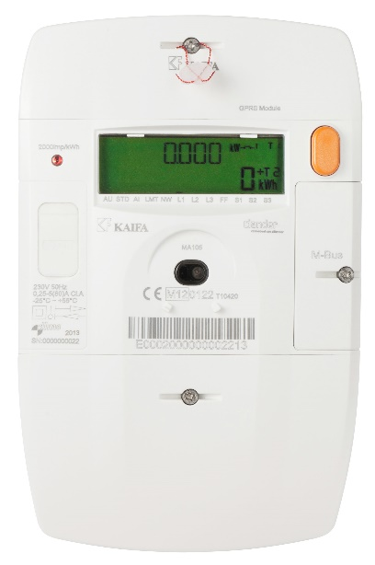
- Yes
- No
- I don’t know

- [If no]. You indicate that you do not have a smart meter at home. Has it been offered to you by your network operator?
- No
- Yes but I did not accept their offer
- Ja, and I am waiting for the smart meter to be installed
- I don’t know

- [If yes, but declined]. You indicate that you have not accepted your grid operator's offer for a smart meter. Why not? (multiple answers possible)
- I do not want my consumption data to fall into the hands of my energy provider
- I am afraid that my data could fall into the hands of malicious parties
- I have doubts about the reliability of smart meters
- Other, namely…

- [Everyone] Do you have a consumption manager at home?
A consumption manager is an app for your mobile or computer, or a screen on the wall that shows you how much electricity and natural gas you use on a day, at a specific hour, whether or not compared to previous years or comparable households. An energy consumption manager provides much more information than the energy meter in the meter fuse box. Examples are Toon and Oxxio.
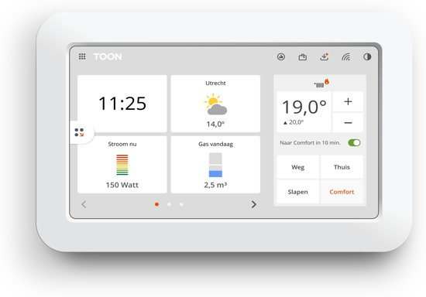
- No
- Yes, but I rarely, if ever, look at this
- Yes, and check this monthly
- Yes, and check this weekly
- Yes, and check this daily
- I don’t know

Smart meter - Water

- In addition to smart meters and in-home display’s for energy, these also exist for water use.
A smart water meter is a digital meter that looks like a smart energy meter. A smart water meter measures your water consumption remotely and can be read by your drinking water company. With a smart water meter you never have to report your meter readings yourself. In addition, it always gives you insight into your water consumption and can help you save water. Finally, a smart water meter helps to check that there are no leakages.
Suppose you receive an offer from your drinking water utility for the free installation of a smart water meter coupled with a in-home display for your water consumption. On a scale of 0 to 10, how likely is it that you would accept such an offer?
0 very unlikely) to 10 (very likely)

- [If score is 10, 9, 8 or 7]. Why do you think it is likely that you would accept such an offer? (multiple answers possible)
- I see (many) advantages for a smart water meter
- I see little or no advantages for a smart water meter, but I have no objection either
- other, please specify

- [if you advantages are perceived]. You indicate that you see advantages for a smart water meter coupled with a in-home display for your water consumption? Can you indicate how important or insignificant the benefits below are to you?
- I never have to report my meter readings myself
- At any time and anywhere access to my water consumption information
- Lower water bill because the smart meter helps to save water
- Makes it possible to quickly address to deviations / leaks
- Positive impact for the environment because the smart meter helps to save water
- Makes it possible to receive personal tips for saving water
- Other, please specify

Answer categories for a to g.
  - Very important
  - Important
  - Not important
  - not important at all

- [If score is 0, 1, 2, 3 or 4]. Why do you consider it unlikely that you would accept such an offer? (multiple answers possible)
- I think there are little or no advantages of installing a smart water meter
- Information is lacking
- I do not want my consumption data to fall into the hands of my drinking water utility
- I am afraid that my consumption data could fall into the hands of malicious parties
- I have doubts about the reliability of smart water meters
- Other, please specify

- [If score is 10, 9, 8 or 7]. Would you also be interested in a smart water meter linked to a consumption manager if it were not offered free of charge by your drinking water utlity?
The recommended price of a smart water meter: +/- € 275, -
- Yes
- Yes, under certain conditions
- No

- [If yes, under certain conditions] You indicate that you are interested in a smart water meter linked to in-home display under certain conditions, even if you have to pay for it yourself. Under what conditions are you interested? Multiple answers possible
- If my drinking water utility provides an interesting offer for financing (e.g. subscription or payment in 24 months without additional costs)
- If I am given the option not to automatically share my consumption data with my drinking water utlity
- Other, please specify

Tap water perspectives

16) Which of the following options for saving tap water do you have in your home? Multiple answers possible
- Water-saving shower head
- Water saver in the kitchen tap
- An efficient washing machine
- Other, please specify
- I do not know
- None
17) [IF AT LEAST ONE OPTION IS SELECTED] You indicate that you have one or more applications at home to save water. Have you installed/payed for at least one of these facilities yourself?
- Yes
- No, these are provided by my landlord
- No, these are provided by the previous owner
18) [IF YES] You indicate that you have installed/payed for at least one application yourself in order to save water. Can you indicate how important or unimportant the motivations below are for doing this?
- Environment / sustainability
- Lower water bill
- Other, please specify
Answer categories:
- Very important
- Important
- Not important
- Not important at all
19) [IF NOT ANY WATER-SAVING APPLICATION AT HOME] You indicate that you do not have any applications to save water at home. What is the main reason for this?
- Not interested
- I live in a rented house
- I think the costs are too high (purchase and maintenance)
- I lack information
- I dread the hassle / not getting to it
- Do not know
20) To what extent do you agree or disagree with the following statements?
- I do my best to use as little water as possible
- I want to live as sustainably as possible, even if I have to compromise on comfort
- Saving water is pointless if not everyone participates
- I would like more information on how I can save water by using water differently at home
- The current focus on climate change has been greatly exaggerated
- There is enough water in my country, we do not have to be economical with water for the next 25 years
- I think it is a good idea that my drinking water utiity invests in smart water meters to make people more aware of how to use water
- I would like to save (even) more tap water at home.
- I would like more information about the benefits of a smart water meter
- I would like more information about equipment that can save water (e.g. water-saving shower heads or water-efficient washing machines)
Answer categories:
- Fully agree
- Agree
- Do not agree or disagree
- Disagree
- Fully disagree
- Do not know

21) To what extent are you concerned about the following topics regarding tap water in your country?
- Sufficient availability of tap water
- The quality of my tap water
- Increase in the number of service interruptions
- Price increases which make tap water unaffordable
- Other, please specify

Answer categories:
- Lots of worries
- Some concerns
- Do not worry so much
- Do not worry at all
- Do not know

