Appendix
Table A1. Planning districts in Philadelphia and their corresponding abbreviations.
Planning District | Abbreviation
Central Northeast | CNE
Central | CTR
Lower Far Northeast | LFNE
Lower Northeast | LNE
Lower North | LNO
Lower Northwest | LNW
Lower South | LS
Lower Southwest | LSW
North Delaware | NDEL
North | NOR
River Wards | RW
South | STH
Upper Far Northeast | UFNE
Upper North | UNO
Upper Northwest | UNW
University Southwest | USW
West Park | WP
West | WST

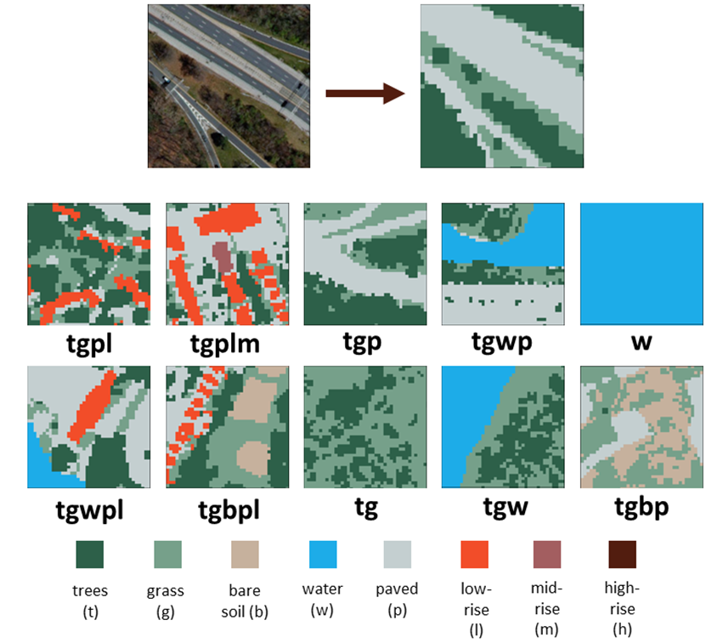

Figure A1. Examples of pixels of common STURLA classes symbolized on a land cover/building height data raster. Each color within a STURLA cell indicates the presence of a different urban structure component: trees (t), grass (g), bare soil (b), water (w), pavement (p), low-rise buildings (1 – 3 stories) (l), mid-rise buildings (4 – 9 stories) (m), and high-rise buildings (9+ stories) (h).

Figure A2. The two routes traveled during the data collection campaign. Each route is approximately ~150 km long.

Table A2. Information on instrumentation used for mobile monitoring campaign.
Instrument | Variables Measured | Units of Measurement | Measuring Range/Uncertainty | Detection Limit | Time Resolution
Trimble Juno 3B with R1 Receiver | latitude | decimal degrees | 1 – 3 m | - | 1 second
 | longitude
Microaeth MA200 | black carbon | µg/m³ | ± 0.1 µg/m³ | 0.03 µg/m³ | 5 seconds
Grimm Portable Laser Aerosol Spectrometer, Model 11-C | particulate matter (mass concentrations) | µg/m³ | ± 5% | 0.1 µg/m³ | 6 seconds

Table A3. Daily weather information for each day of sampling, including average temperature, range of relative humidity, start and end times, and sampling duration.
Date | Route | Weather | Average Temperature (°F/°C) | Relative Humidity Range | Start time | End time | Sampling duration
6/27/2019 | 2 | Partly / Mostly Cloudy | 83.0 / 28.3 | 29 – 66% | 7:16 AM | 5:22 PM | 10 hr. 6 min.
7/1/2019 | 1 | Fair / Partly Cloudy | 75.6 / 24.2 | 37 – 61% | 7:02 AM | 5:33 PM | 10 hr. 31 min.
7/3/2019 | 2 | Mostly Cloudy | 80.3 / 26.8 | 48 – 79% | 7:02 AM | 5:04 PM | 10 hr. 2 min.
7/5/2019 | 2 | Cloudy | 79.3 / 26.3 | 48 – 81% | 7:06 AM | 3:07 PM | 8 hr. 3 min.
7/9/2019 | 1 | Fair | 78.0 / 25.6 | 49 – 81% | 6:36 AM | 4:40 PM | 10 hr. 4 min.
7/10/2019 | 1 | Mostly Cloudy | 80.3 / 26.8 | 43 – 79% | 7:24 AM | 5:11 PM | 9 hr. 47 min.
7/12/2019 | 2 | Partly Cloudy | 78.4 / 25.8 | 42 – 91% | 6:42 AM | 4:14 PM | 9 hr. 32 min.
7/15/2019 | 1 | Partly Cloudy | 79.8 / 26.6 | 36 – 59% | 6:49 AM | 4:11 PM | 9 hr. 22 min.
7/16/2019 | 2 | Partly Cloudy | 81.6 / 27.6 | 43 – 81% | 7:09 AM | 3:51 PM | 8 hr. 42 min.
7/24/2019 | 1 | Partly / Mostly Cloudy | 74.7 / 23.7 | 34 – 87% | 6:57 AM | 3:39 PM | 8 hr. 42 min.
7/26/2019 | 1 | Fair / Partly Cloudy | 79.0 / 26.1 | 34 – 68% | 6:28 AM | 5:01 PM | 10 hr. 33 min.
7/29/2019 | 2 | Fair | 83.8 / 28.8 | 41 – 79% | 7:04 AM | 3:09 PM | 8 hr. 5 min.

Figure A3. Results of pairwise permutational t-tests between STURLA classes comparing average daily pollutant concentrations for BC (left) and PM_{2.5} (right). Black cells indicate significant differences in pollutant concentrations between classes.
Figure A4:
A. Barplot of PM_{2.5} model error separated by STURLA class, with bar colors indicating underpredictions (blue) and overpredictions (red). B. Map of PM_{2.5} model validation error throughout Philadelphia. C. Barplot of BC model error separated by STURLA class, with bar colors indicating underpredictions (blue) and overpredictions (red). D. Map of BC model validation error.

Table A4. Summary of measured pollutants, modeled pollutants, and model error by STURLA class.
STURLA | PM_{2.5} (µg/m³) Predicted | PM_{2.5} (µg/m³) Measured | Difference (µg/m³) | BC (µg/m³) Predicted | BC (µg/m³) Measured | Difference (µg/m³)
bpl | 10.60 | 14.28 | 3.68 | 2.28 | 2.26 | -0.02
gbp | 18.12 | 15.29 | -2.84 | 1.86 | 1.90 | 0.04
gbpl | 13.63 | 14.50 | 0.87 | 1.87 | 1.88 | 0.01
gbpm | 14.13 | 11.54 | -2.60 | 4.61 | 1.89 | -2.73
gp | 15.15 | 13.83 | -1.33 | 2.11 | 1.90 | -0.21
gpl | 16.60 | 14.57 | -2.03 | 2.06 | 2.11 | 0.05
gplm | 13.31 | 12.39 | -0.92 | 1.64 | 1.75 | 0.10
gpm | 12.19 | 10.59 | -1.60 | 2.01 | 1.86 | -0.15
gwp | 7.59 | 10.12 | 2.54 | 2.07 | 2.23 | 0.17
gwpl | 17.80 | 14.47 | -3.33 | 1.76 | 1.93 | 0.17
gwpm | 13.02 | 11.85 | -1.17 | 1.99 | 2.08 | 0.08
p | 14.13 | 10.60 | -3.54 | 1.55 | 2.15 | 0.60
pl | 12.19 | 12.22 | 0.04 | 0.95 | 2.16 | 1.20
pm | 5.40 | 8.77 | 3.37 | 0.85 | 1.71 | 0.86
tg | 15.20 | 14.46 | -0.74 | 0.90 | 1.42 | 0.53
tgbp | 14.25 | 13.85 | -0.40 | 1.67 | 1.71 | 0.04
tgbph | 13.67 | 14.26 | 0.58 | 0.92 | 1.26 | 0.34
tgbpl | 22.21 | 13.64 | -8.57 | 1.73 | 1.72 | -0.01
tgbplh | 14.00 | 14.16 | 0.17 | 1.31 | 1.35 | 0.04
tgbplm | 12.40 | 12.61 | 0.21 | 1.25 | 1.42 | 0.17
tgbplmh | 11.47 | 12.02 | 0.55 | 1.37 | 1.60 | 0.23
tgbpm | 10.98 | 11.55 | 0.58 | 1.50 | 1.52 | 0.03
tgbwp | 12.06 | 12.70 | 0.63 | 2.31 | 1.96 | -0.35
tgbwpl | 14.42 | 14.20 | -0.23 | 2.04 | 1.71 | -0.33
tgp | 15.67 | 14.58 | -1.10 | 1.62 | 1.65 | 0.03
tgph | 13.43 | 13.74 | 0.31 | 1.09 | 1.39 | 0.30
tgpl | 11.68 | 13.32 | 1.64 | 1.58 | 1.65 | 0.07
tgplh | 14.17 | 13.75 | -0.42 | 1.48 | 1.39 | -0.09
tgplm | 12.00 | 13.43 | 1.43 | 1.43 | 1.47 | 0.03
tgplmh | 12.36 | 12.15 | -0.20 | 1.31 | 1.34 | 0.02
tgpm | 11.58 | 11.65 | 0.07 | 1.52 | 1.61 | 0.09
tgpmh | 12.20 | 12.48 | 0.28 | 1.62 | 1.53 | -0.09
tgwp | 12.95 | 12.54 | -0.41 | 1.58 | 1.77 | 0.19
tgwph | 12.94 | 13.06 | 0.12 | 0.89 | 1.41 | 0.51
tgwpl | 6.85 | 8.93 | 2.08 | 1.65 | 1.69 | 0.04
tgwplh | 14.12 | 13.64 | -0.48 | 1.90 | 1.58 | -0.33
tgwplm | 18.30 | 12.88 | -5.42 | 1.06 | 1.37 | 0.31
tgwpm | 9.80 | 10.97 | 1.17 | 2.00 | 1.81 | -0.19
tp | 12.42 | 10.98 | -1.44 | 3.22 | 2.68 | -0.55
tpl | 14.98 | 12.91 | -2.07 | 5.45 | 3.76 | -1.69
tplm | 15.49 | 14.08 | -1.41 | 2.63 | 1.60 | -1.02
tpm | 13.03 | 11.27 | -1.76 | 1.27 | 1.61 | 0.34
twp | 13.31 | 11.20 | -2.11 | 3.74 | 2.19 | -1.56
twpl | 13.79 | 12.20 | -1.59 | 1.87 | 2.30 | 0.42
twpm | 12.70 | 12.82 | 0.13 | 2.82 | 2.41 | -0.41
wp | 14.07 | 11.03 | -3.05 | 1.88 | 2.29 | 0.41

Table A5. Summary of measured pollutant concentrations, predicted pollutant concentrations, differences between predicted and measured, and validation error by Philadelphia planning district.

Planning District | Mean Predicted PM_{2.5} | Mean Measured PM_{2.5} | P – M  (PM_{2.5}) | Validation Error (P/M) | Mean Predicted BC | Mean Measured BC | P – M  (BC) | Validation Error (P/M)
Central | 12.62 | 12.74 | -0.12 | 0.994 | 1.54 | 1.49 | 0.05 | 1.040
Central Northeast | 13.60 | 13.88 | -0.28 | 0.981 | 1.65 | 1.57 | 0.08 | 1.062
Lower Far Northeast | 13.74 | 14.11 | -0.37 | 0.975 | 1.68 | 1.63 | 0.05 | 1.046
Lower North | 13.40 | 13.55 | -0.15 | 0.991 | 1.62 | 1.56 | 0.06 | 1.040
Lower Northeast | 13.71 | 14.03 | -0.32 | 0.978 | 1.65 | 1.59 | 0.06 | 1.040
Lower Northwest | 13.59 | 13.83 | -0.24 | 0.984 | 1.64 | 1.55 | 0.09 | 1.078
Lower South | 12.83 | 12.85 | 0.02 | 1.036 | 1.78 | 1.66 | 0.12 | 1.134
Lower Southwest | 13.59 | 13.84 | -0.25 | 0.988 | 1.72 | 1.65 | 0.07 | 1.069
North | 13.54 | 13.75 | -0.21 | 0.986 | 1.64 | 1.59 | 0.05 | 1.036
North Delaware | 13.73 | 14.01 | -0.28 | 0.983 | 1.70 | 1.65 | 0.05 | 1.038
River Wards | 13.63 | 13.85 | -0.22 | 0.988 | 1.71 | 1.66 | 0.05 | 1.052
South | 13.56 | 13.94 | -0.38 | 0.975 | 1.68 | 1.62 | 0.06 | 1.043
University Southwest | 13.20 | 13.38 | -0.18 | 0.989 | 1.61 | 1.56 | 0.05 | 1.037
Upper Far Northeast | 13.74 | 14.09 | -0.35 | 0.976 | 1.66 | 1.60 | 0.06 | 1.047
Upper North | 13.62 | 13.95 | -0.33 | 0.976 | 1.65 | 1.58 | 0.07 | 1.044
Upper Northwest | 13.55 | 13.85 | -0.30 | 0.979 | 1.64 | 1.57 | 0.07 | 1.049
West | 13.58 | 13.88 | -0.30 | 0.979 | 1.64 | 1.57 | 0.07 | 1.040
West Park | 13.53 | 13.60 | -0.07 | 0.997 | 1.67 | 1.59 | 0.08 | 1.057

