Supplementary Materials

Word count: 242 words
Tables: 4
Figure: 1

Table S1
Emotion Terms, Definitions, and Example Situations

 | English | Dutch | Chinese
Emotion term
Anger | Anger | Boosheid | 气愤
Disgust | Disgust | Walging | 厌恶/恶心
Definition
Anger | A feeling of displeasure resulting from injury, mistreatment, opposition, usually showing itself in a desire to fight back at the supposed cause of this feeling. | Een gevoel van ongenoegen ontstaan door letsel, mishandeling, verzet dat zich vaak uit in een verlangen om terug te vechten tegen de veroorzaker van de boosheid. | 这是一种不愉快的体验，可能来源于受到伤害，遭受不公平对待，或者遭到别人反对。通常这种情绪会伴随想要反击的欲望。
Disgust | A sickening distaste, or dislike. | Een misselijkmakende tegenzin, of afkeer. | 令人反胃的，恶心的，不喜欢的。
Example
Anger | A person received insulting words from others. | Een persoon wordt door iemand anders beledigd. | 一个人正在经受别人对他/她的羞辱。
Disgust | A person touched dog feces accidently. | Een persoon raakt per ongeluk een hondendrol aan. | 一个人的手一不小心碰到了狗屎。

Note. These emotion terms, definitions, and examples were extracted from the Display Rule Inventory (Ekman & Cordaro, 2011; Matsumoto, Yoo, Hirayama, & Petrova, 2005).

Eliciting Spontaneous Emotional Facial Expressions
In the spontaneous condition, we used a cover story telling participants that they were going to help to develop an emotional robot that can understand human emotions. In order to do so, participants were instructed to recall a past life event involving a specific emotion and tell the experience in detail to the robot. In order to make the cover story more believable, we first presented participants with general information about the robot (e.g., functions and possible applications). In order to make the robot more human-like, an animation was presented to participants following the introduction, in which a virtual robot appeared on the screen, waving her hand and talking to participants like a friend (“Hello, I am Eva. Nice to meet you. I am glad you are willing to chat with me. I would like to know you, listen to your experience, and understand how you feel. I hope I can become one of your best friends. In a moment, I will pick a random emotion term, and you need to recall an experience relating to this emotion experience. Once you come up with something, please tell it to me, the more detailed the better.”). Then participants proceeded to the formal testing phase, where Eva told participants to recall a particular emotional event. Similar to the posed condition, for each emotion, participants received an emotion label, a definition of the emotion term, and a one-sentence emotion story.
Table S2
Emotion (Anger vs. Disgust) × Culture (Chinese vs. Dutch) × Spontaneity (Posed vs. Spontaneous) Mixed-Design Analysis of Variance for Self-Reported Expression Intensity, Clarity, Difficulty, and Comfortableness

Effect | Clarity |  |  |  | Intensity |  |  |  | Difficulty |  |  |  | Comfortableness
 | df | F | p | $$η_{p}^{2}$$ | df | F | p | $$η_{p}^{2}$$ | df | F | p | $$η_{p}^{2}$$ | df | F | p | $$η_{p}^{2}$$
Emotion (E) | (1, 160) | 14.95 | < .001 | .085 | (1, 160) | 4.64 | .033 | .028 | (1, 92) | 3.34 | .071 | .035 | (1, 68) | 2.74 | .103 | .039
Culture (C) | (1, 160) | 5.99 | .015 | .036 | (1, 160) | 11.32 | .001 | .192 | (1, 92) | 0.53 | .467 | .006 | (1, 68) | 4.93 | .030 | .068
Spontaneity (S) | (1, 160) | 1.22 | .271 | .008 | (1, 160) | 1.71 | .192 | .011
E × C | (1, 160) | 1.23 | .270 | .008 | (1, 160) | 0.40 | .529 | .002 | (1, 92) | 0.13 | .720 | .001 | (1, 68) | 0.06 | .814 | .001
E × S | (1, 160) | 1.17 | .281 | .007 | (1, 160) | 5.57 | .020 | .034
C × S | (1, 160) | 2.50 | .116 | .015 | (1, 160) | 7.29 | .008 | .044
E × C × S | (1, 160) | 1.50 | .222 | .009 | (1, 160) | 0.09 | .760 | .001

Table S3
Means and Standard Deviations of Emotional Experience Ratings in Each Condition
Condition | Emotion scale | Chinese |  | Dutch
 |  | M | SD | M | SD
Posed anger | Anger | 6.84 | 2.49 | 5.61 | 2.17
 | Disgust | 3.93* | 2.90 | 2.33 | 2.36
 | Fear | 1.73 | 2.41 | 1.12 | 1.33
 | Sadness | 2.98* | 2.90 | 1.39 | 1.92
 | Happiness | 0.62 | 1.19 | 1.02 | 1.89
Posed disgust | Anger | 2.51* | 2.52 | 1.31 | 1.83
 | Disgust | 7.33 | 2.24 | 6.12 | 2.35
 | Fear | 1.80 | 2.13 | 1.08 | 1.63
 | Sadness | 2.02* | 2.24 | 0.69 | 1.25
 | Happiness | 0.64 | 1.13 | 1.08 | 1.85
Spontaneous anger | Anger | 7.17 | 1.98 | 5.86 | 2.17
 | Disgust | 5.37* | 2.95 | 3.54 | 2.55
 | Fear | 1.31 | 2.14 | 1.54 | 1.95
 | Sadness | 3.63 | 2.87 | 2.51 | 2.33
 | Happiness | 0.46 | 1.09 | 0.97 | 1.15
Spontaneous disgust | Anger | 3.97 | 2.97 | 2.66 | 2.59
 | Disgust | 7.57 | 1.88 | 6.54 | 2.39
 | Fear | 1.69 | 2.40 | 1.63 | 1.91
 | Sadness | 2.00 | 2.28 | 1.26 | 1.84
 | Happiness | 0.89 | 1.88 | 1.91 | 1.82

Note. The underlined numbers indicate the highest means within a column for each condition; Asterisks denote that a mean is significantly higher than the other mean (representing the other cultural group) in the same row (p values adjusted for multiple comparisons).

Table S4
Emotion (Anger vs. Disgust) × Culture (Chinese vs. Dutch) × Spontaneity (Posed vs. Spontaneous) × Emotion Ratings (Target vs. Nontarget) Mixed-Design Analysis of Variance for Subjective Emotional Experience

Effect | df | F | p | $$η_{p}^{2}$$
Emotion (E) | (1, 160) | 4.52 | .035 | .027
Culture (C) | (1, 160) | 23.58 | < .001 | .128
Spontaneity (S) | (1, 160) | 9.17 | .003 | .054
Emotion Ratings (R) | (1, 160) | 440.97 | < .001 | .734
E × C | (1, 160) | 0.97 | .327 | .006
E × S | (1, 160) | 0.04 | .845 | < .001
E × R | (1, 160) | 41.63 | < .001 | .206
C × S | (1, 160) | 0.01 | .917 | < .001
C × R | (1, 160) | 0.80 | .372 | .005
S × R | (1, 160) | 10.51 | < .001 | .062
E × C × S | (1, 160) | 0.09 | .762 | .001
E × C × R | (1, 160) | 0.33 | .565 | .002
C × S × R | (1, 160) | 0.11 | .742 | .001
E × C × S × R | (1, 160) | 0.02 | .886 | < .001

Note. The target emotion refers to the emotion that participants were asked to pose or share; the nontarget emotion refers to the emotion that has been found to be most confusable with the intended one (i.e., ratings of anger for disgust and ratings of disgust for anger).

Figure S1
﻿Mutual Information between Each of the 18 frequent AUs and Emotion Categories (Anger or Disgust) for Culture by Spontaneity

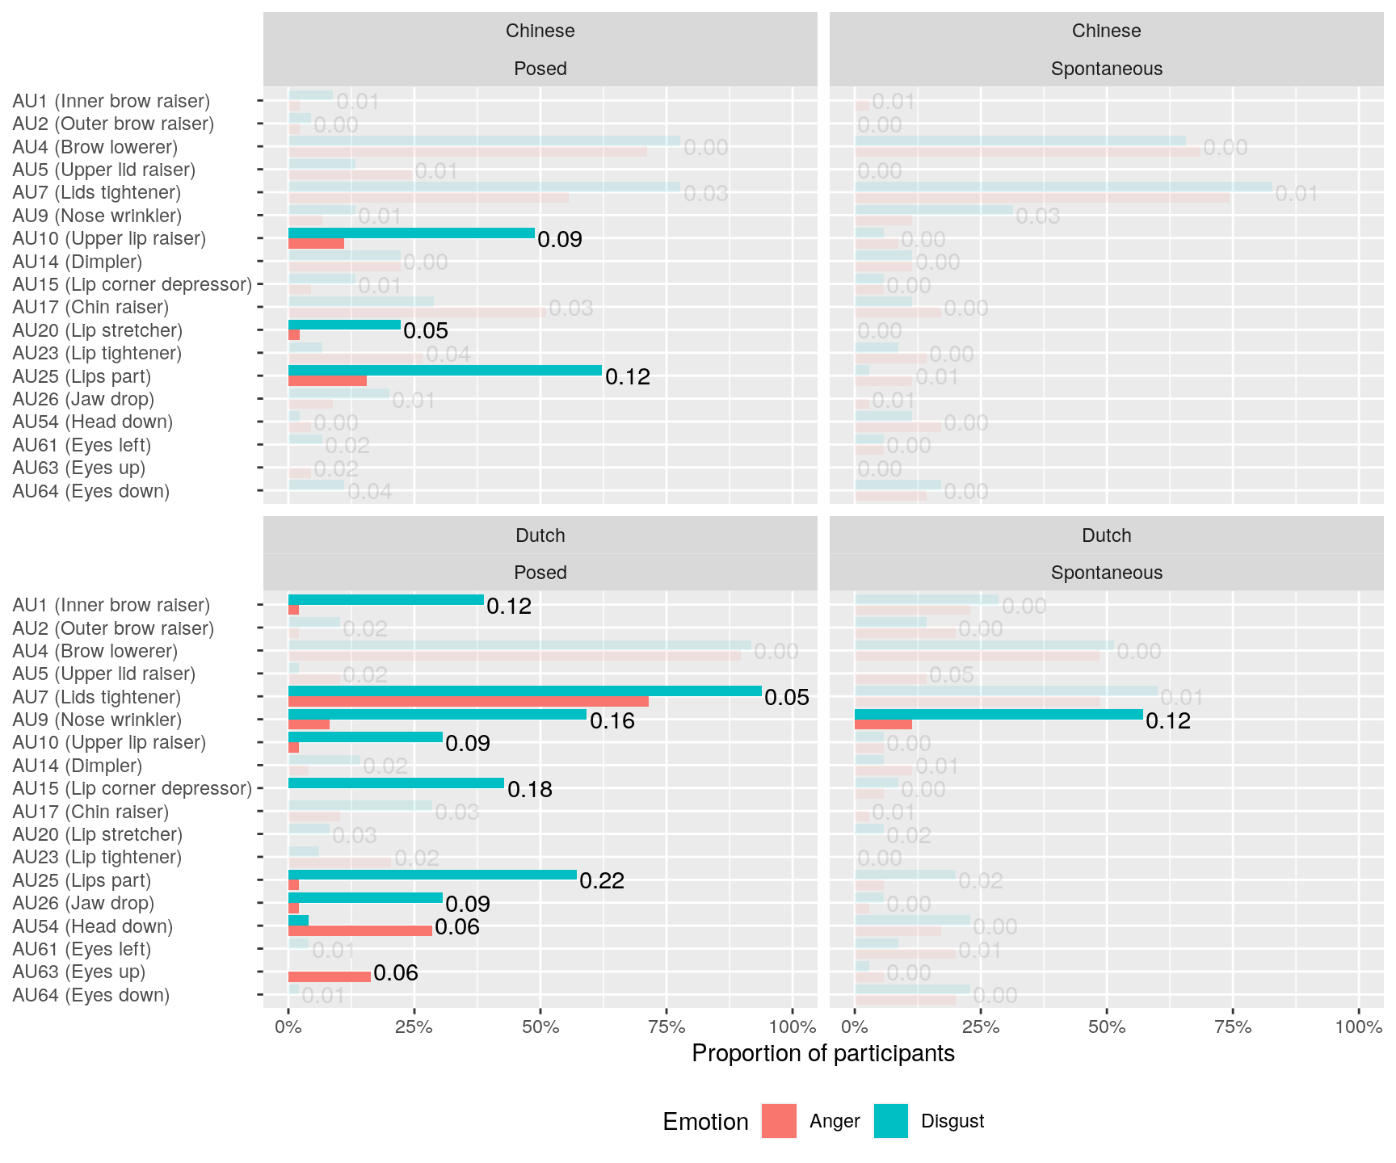

Note. Opaque bars indicate specific AUs (with significant MI values, p < .005); transparent bars indicate non-specific AUs (with non-significant MI values, p > .005). Higher MI values indicate more “knowledge” one can gain of emotion categories (anger versus disgust) by knowing the other variable (the absence versus presence of a given AU).

