Table 1 SM. Preparation of binary mixtures of peanut in spelt wheat flours.
Mixture | Peanut (g) | Wheat (g) | % | mg/kg
S1 | 10 | 90 | 10 | 100.000
S2 | 10 | 90 | 1 | 10.000
S3 | 10 | 90 | 0,1 | 1.000
S4 | 50 | 50 | 0,05 | 500
S5 | 20 | 80 | 0,01 | 100
S6 | 50 | 50 | 0,005 | 50
S7 | 20 | 80 | 0,001 | 10
S8 | 10 | 90 | 0,0001 | 1
S9 | 50 | 50 | 0,00005 | 0.5
S10 | 20 | 80 | 0.0001 | 0.1

Table 2 SM. Primers used for sequencing purposes.
Oligo | Sequence 5’ 3’ | Amplicon size
trnH-psbA fw | ACATCCGCCCAAAGGAGAAAT | 414
trnH-psbA rev | TCTGGTTTACCGCGTTAGGT
rpl 16 fw | GCGATGGGAACGACGAAAAC | 493
rpl 16 rev | ACGGCTCCTCGCGAATAAAA
mat k fw | TGGACTCGCCTCTGGTCAT | 392
mat k rev | CCAGATGGATAGGATAGGGTATTCG
Ara h 6 fw | AGTACTCGATCCTCCGACCA | 392
Ara h rev | AAGCCATAAGAGCACACCGAA

Figure 1SM. Sequence alignment of two clones of partial Ara h 6-allergen coding gene. Primers and probe designed for real-time PCR experiment are squared in red and green respectively.

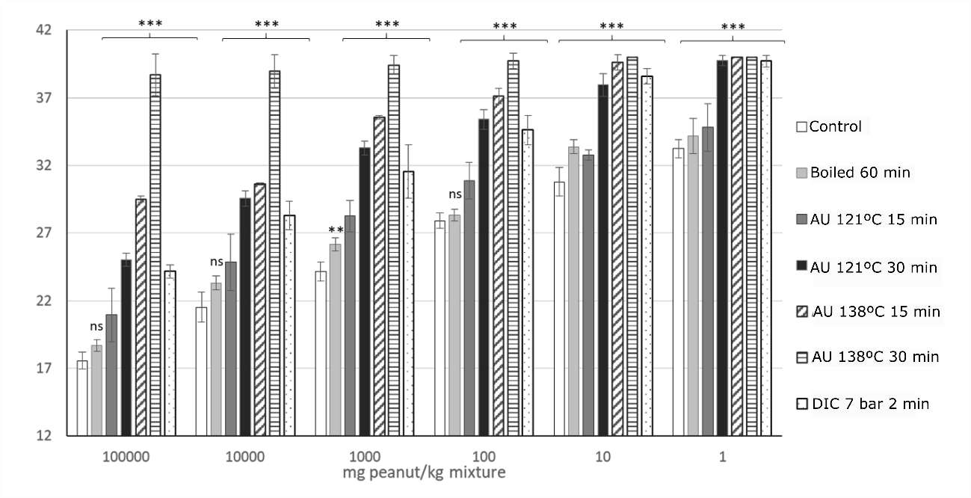

Figure 2SM. Amplification of mat K marker in treated and untreated binary mixtures. Amplification of mat K target in samples from binary mixtures builts with known quantity (10000 to 1mg/kg) of untreated (control) and treated (boiled, autoclaved and despressurised) peanut flour in wheat flour. DNA from all samples was obtained with Dneasy Plant Pro Kit. Mean and standard deviation is shown. Significant differences were found between Ct obtained in untreated and treated samples, for the same spiked level (p < 0.05, by t-student test).

