List of Supplementary files:
S1: Line separated sequences of P-gp proteins from 96 organisms saved in text file format and used as an input file for multiple sequence alignment done through Clustal omega.
S2: Sequences of P-gp aligned in nexus file format and further used as an input file for Phylogenetic tree construction through MrBayes.
S3: Line separated sequences of P4ATPase proteins from 207 organisms saved in text file format and used as an input file for multiple sequence alignment done through Clustal omega.
S4: Sequences of P4ATPase aligned in nexus file format and further used as an input file for Phylogenetic tree construction through MrBayes.
S5: Line separated sequences of CDC50 proteins from 189 organisms saved in text file format and used as an input file for multiple sequence alignment done through Clustal omega.
S6: Sequences of CDC50 aligned in nexus file format and further used as an input file for Phylogenetic tree construction through MrBayes.

Supplementary Figures:
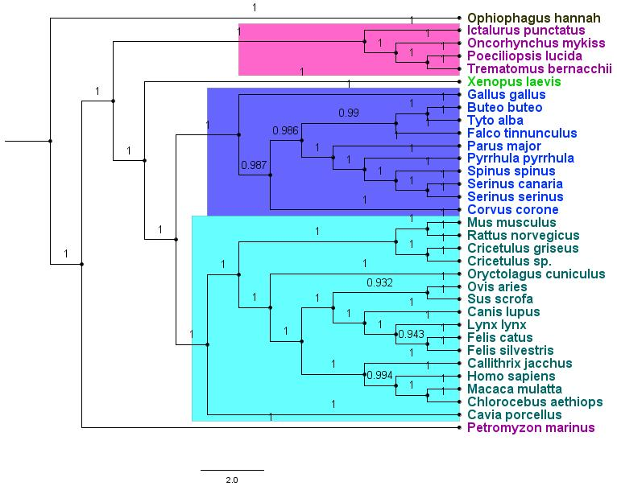Fig S1: Phylogenetic subtree of P-gp amongst 33 chordates. Purple – Fishes; Light Green – Amphibia; Dark Green – Reptilia; Blue - Aves and Cyan – Mammals.
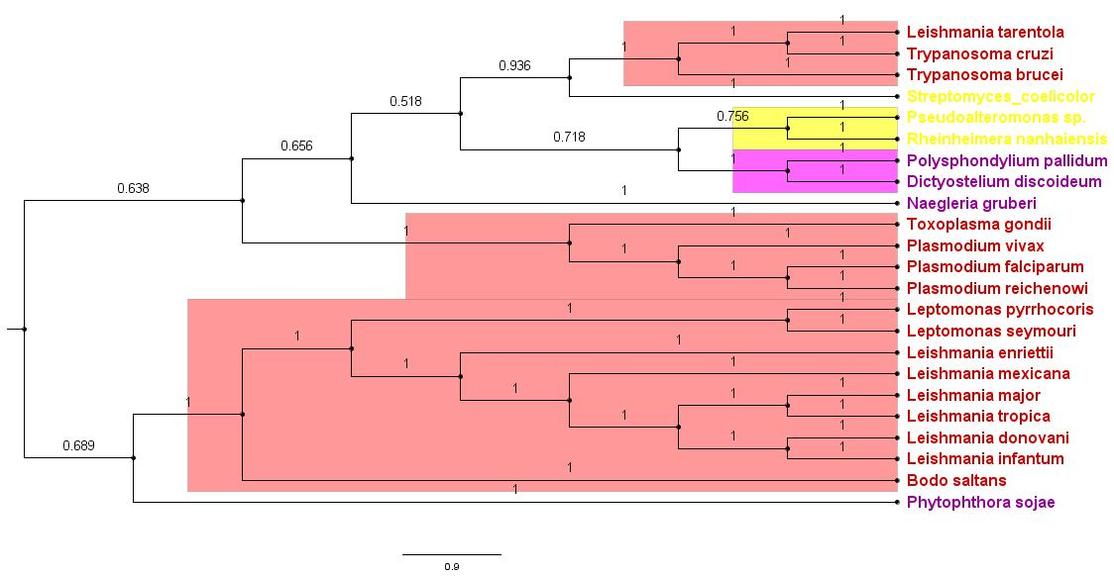Fig S2: Phylogenetic subtree of P-gp consisting of Protozoa - Red, Protista - Purple and Bacteria - Yellow.
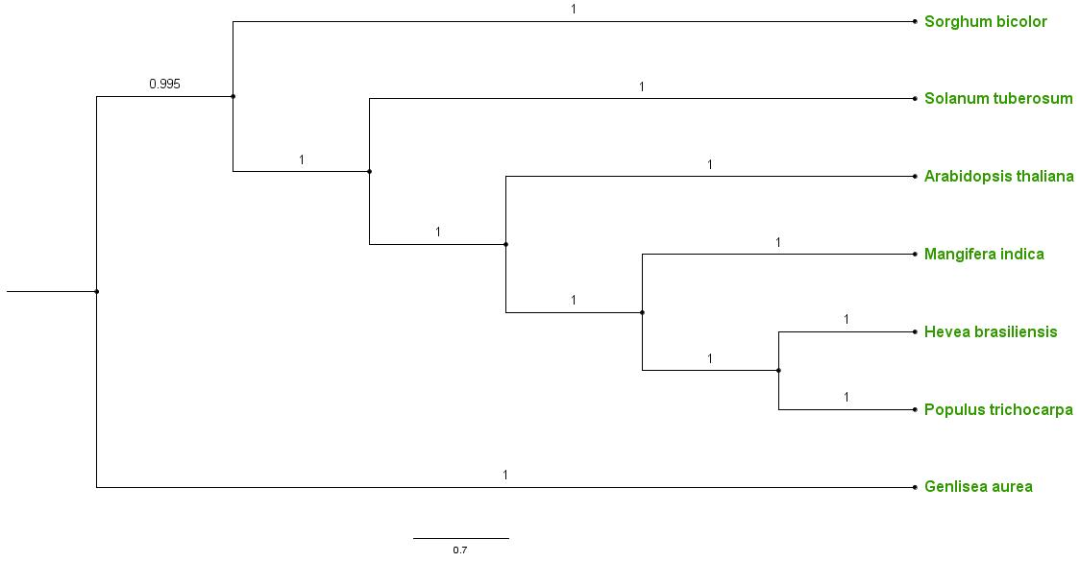Fig S3: Phylogenetic subtree of P-gp in Plants.
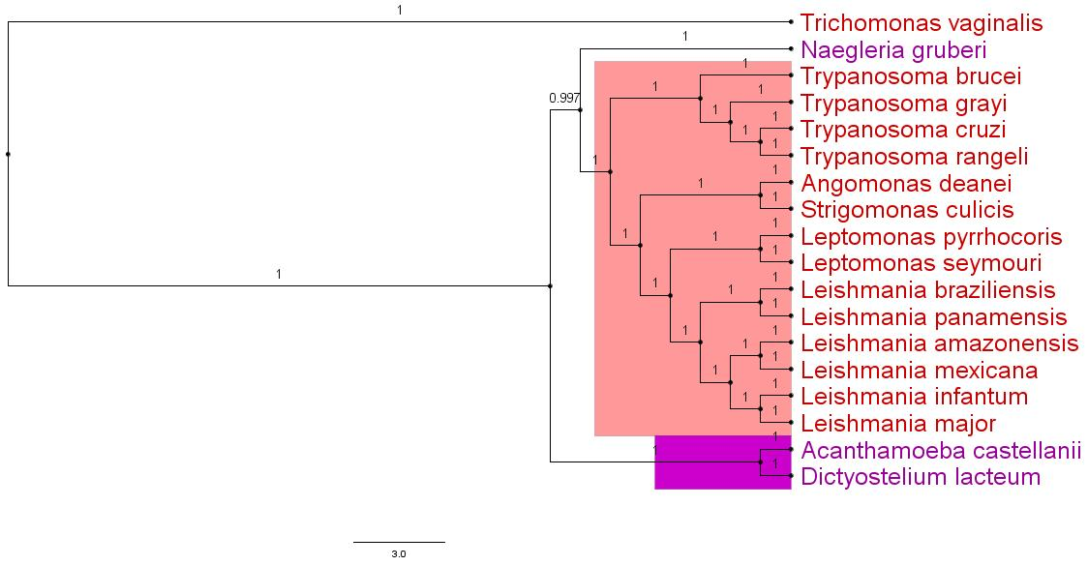Fig S4: Phylogenetic subtree of P4ATPase consisting of Protozoa - Red and Protista - Purple.
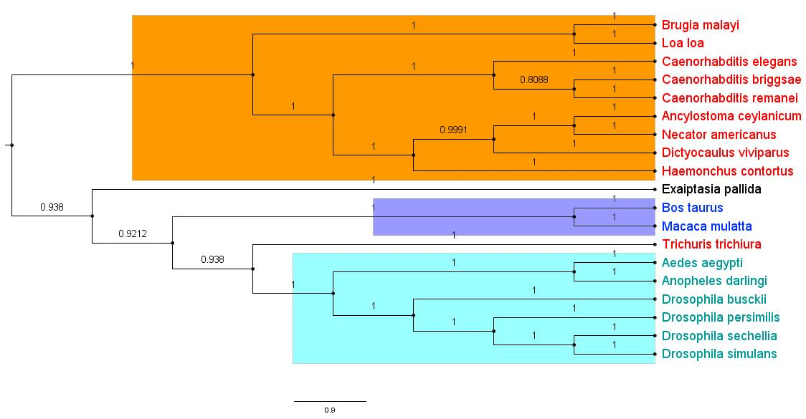Fig S5: Phylogenetic subtree of P4ATPase consisting of Nematodes - Orange, Arthropods - Cyan and Chordates - Blue.
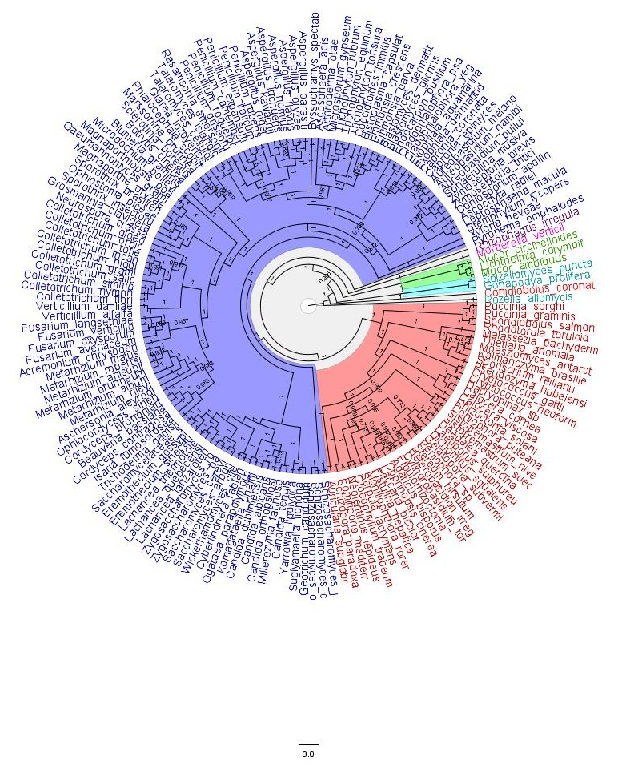Fig S6: Phylogenetic subtree of P4ATPase in Fungi. Blue: Ascomycota; Red: Basidiomycota; Green: Zygomycota; Cyan: Chytridiomycota; Orange: Entomophthoromycota; Pink: Mucoromycota and Purple: Glomeromycota.
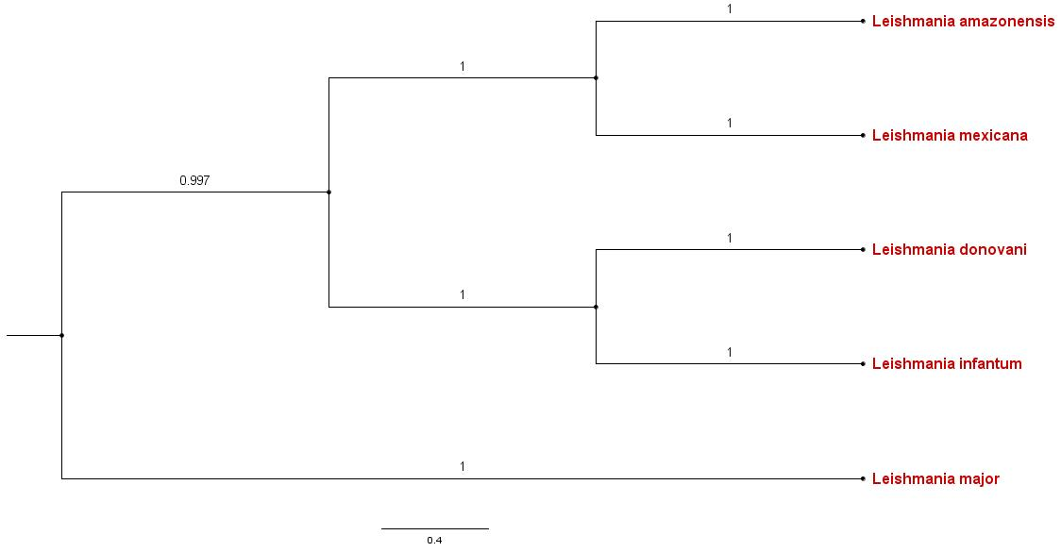
Fig S7: Phylogenetic subtree of CDC50 in Leishmania species.
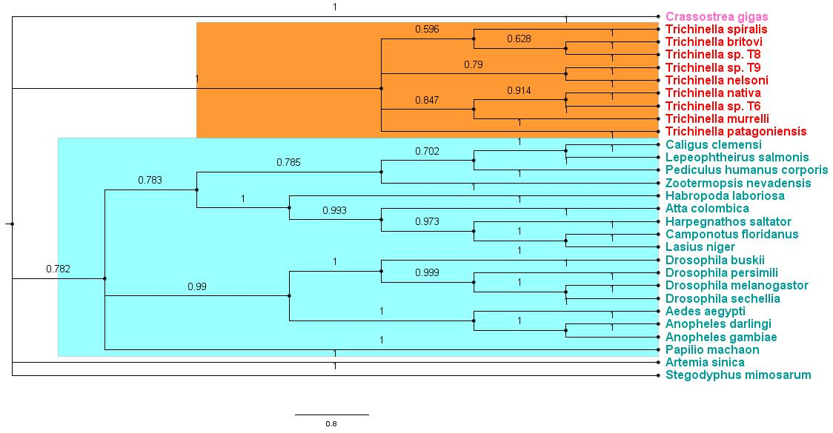
Fig S8: Phylogenetic subtree of CDC50 consisting of Nematodes - Orange, Arthropods - Cyan and Molluscs - Pink.
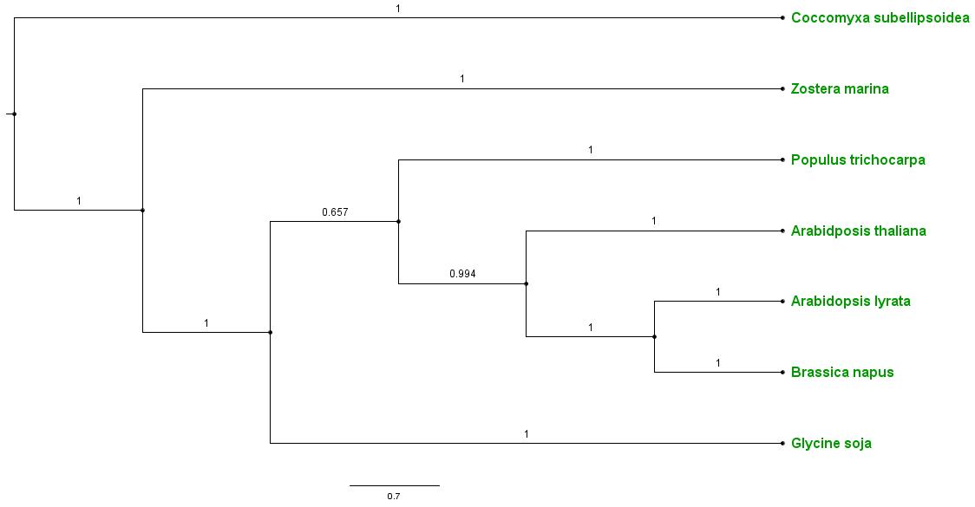
Fig S9: Phylogenetic subtree of CDC50 in Plants.
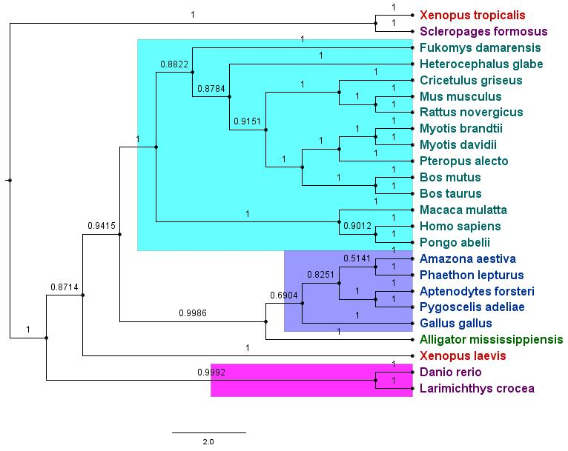
Fig S10: Phylogenetic subtree of CDC50 amongst 24 Chordates. Purple – Fishes; Red – Amphibia; Green – Reptilia; Blue - Aves and Cyan – Mammals.
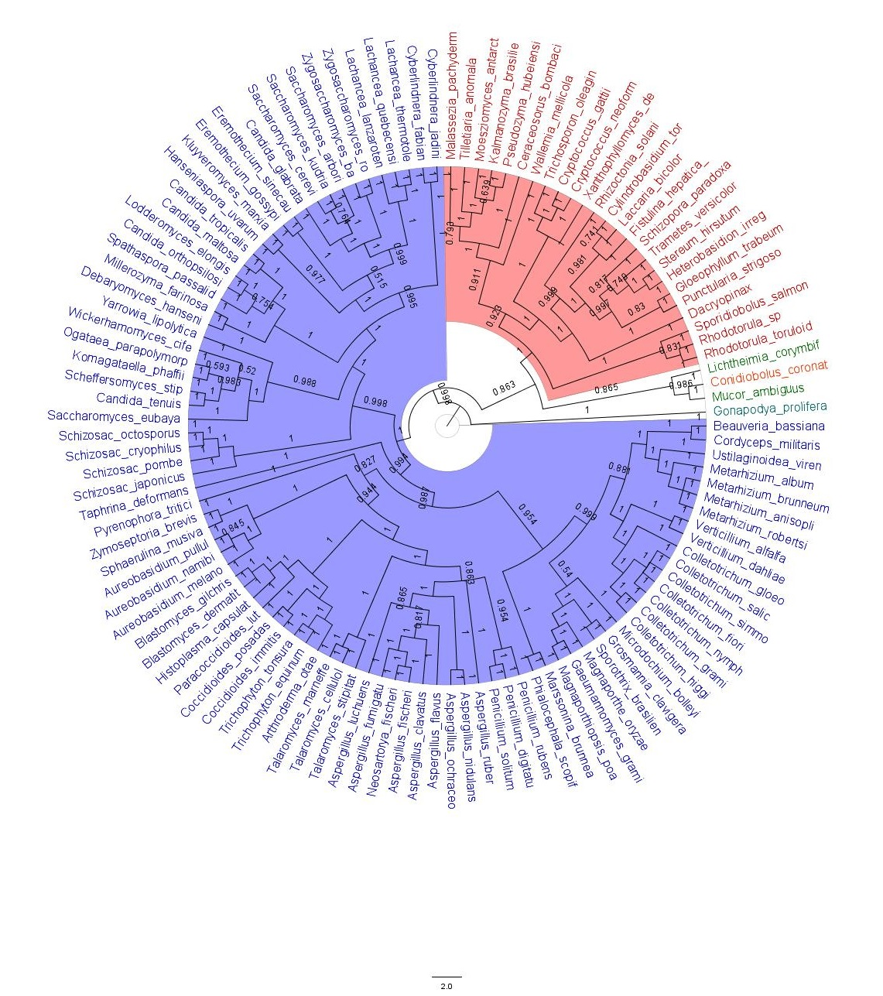
Fig S11: Phylogenetic subtree of CDC50 protein in Fungi. Blue: Ascomycota; Red: Basidiomycota; Green: Zygomycota; Cyan: Chytridiomycota and Orange: Entomophthoromycota.

