Supplementary Information
Room Temperature syntheses of ZnO and its structure
Domenica Tommasa Donia¹, Elvira Maria Bauer², Mauro Missori³ Ludovica Roselli⁴, Daniele Cecchetti⁴, Pietro Tagliatesta⁴, Lorenzo Gontrani^{5,}*, Marilena Carbone^{2,4}*
¹ Department of Surgical Science, University of Rome Tor Vergata, Via Montpellier 1, 00133, Rome, Italy
² Italian National Research Council – Institute of Structure of Matter (CNR-ISM), Via Salaria km 29.3, 00015 Monterotondo, RM, Italy
³ Istituto dei Sistemi Complessi, Consiglio Nazionale delle Ricerche, Unit “Sapienza”, Piazzale Aldo Moro 5, 00185 Rome, Italy
⁴ Department of Chemical Science and Technologies, University of Rome Tor Vergata, Via della Ricerca Scientifica 1 – 00133 Rome, Italy
⁵ Department of Chemistry, Sapienza University of Rome, P.le A. Moro 2, Rome, 00185, Italy

* Correspondence MC: Carbone@uniroma2.it
and
* Correspondence LG: Lorenzo.Gontrani@uniroma1.it
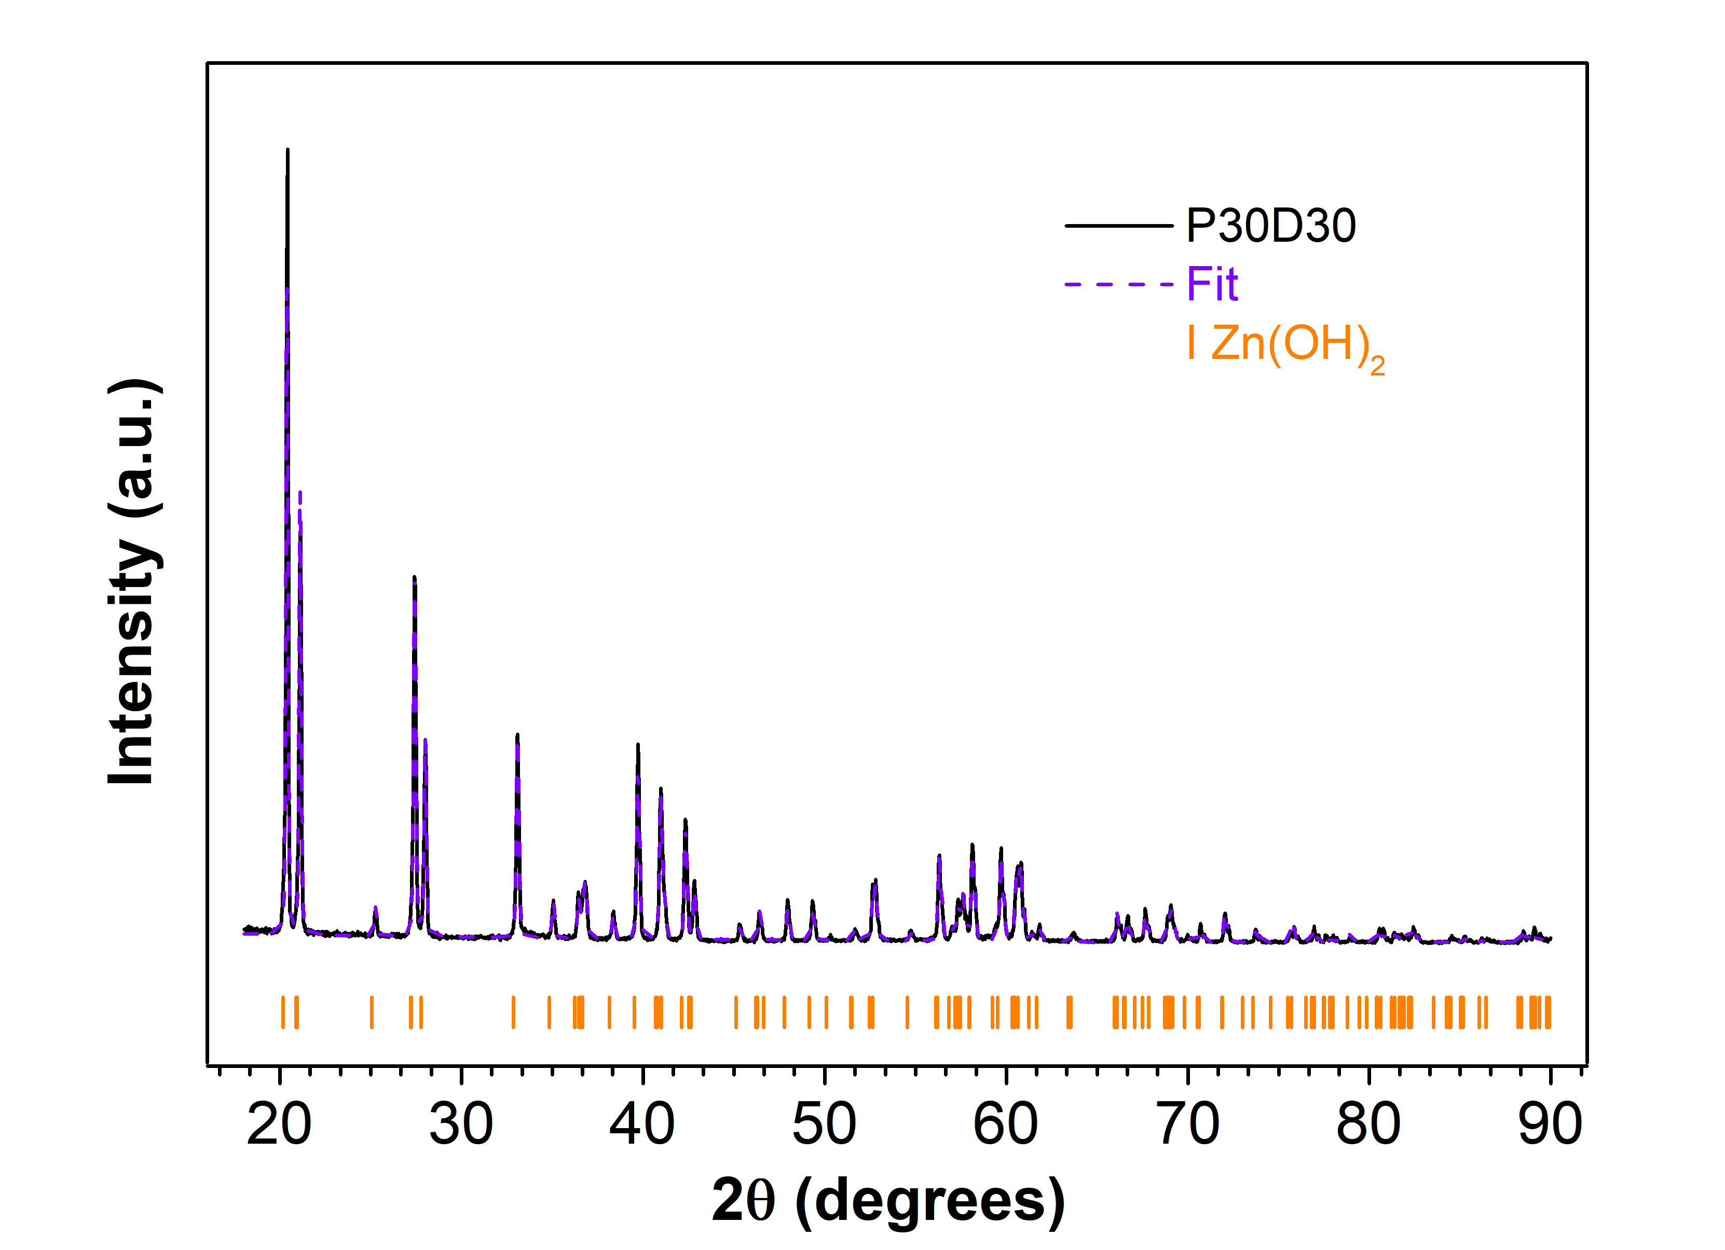
Figure SI1. XRD patterns of the sample P30D30 and associated Rietveld fit.

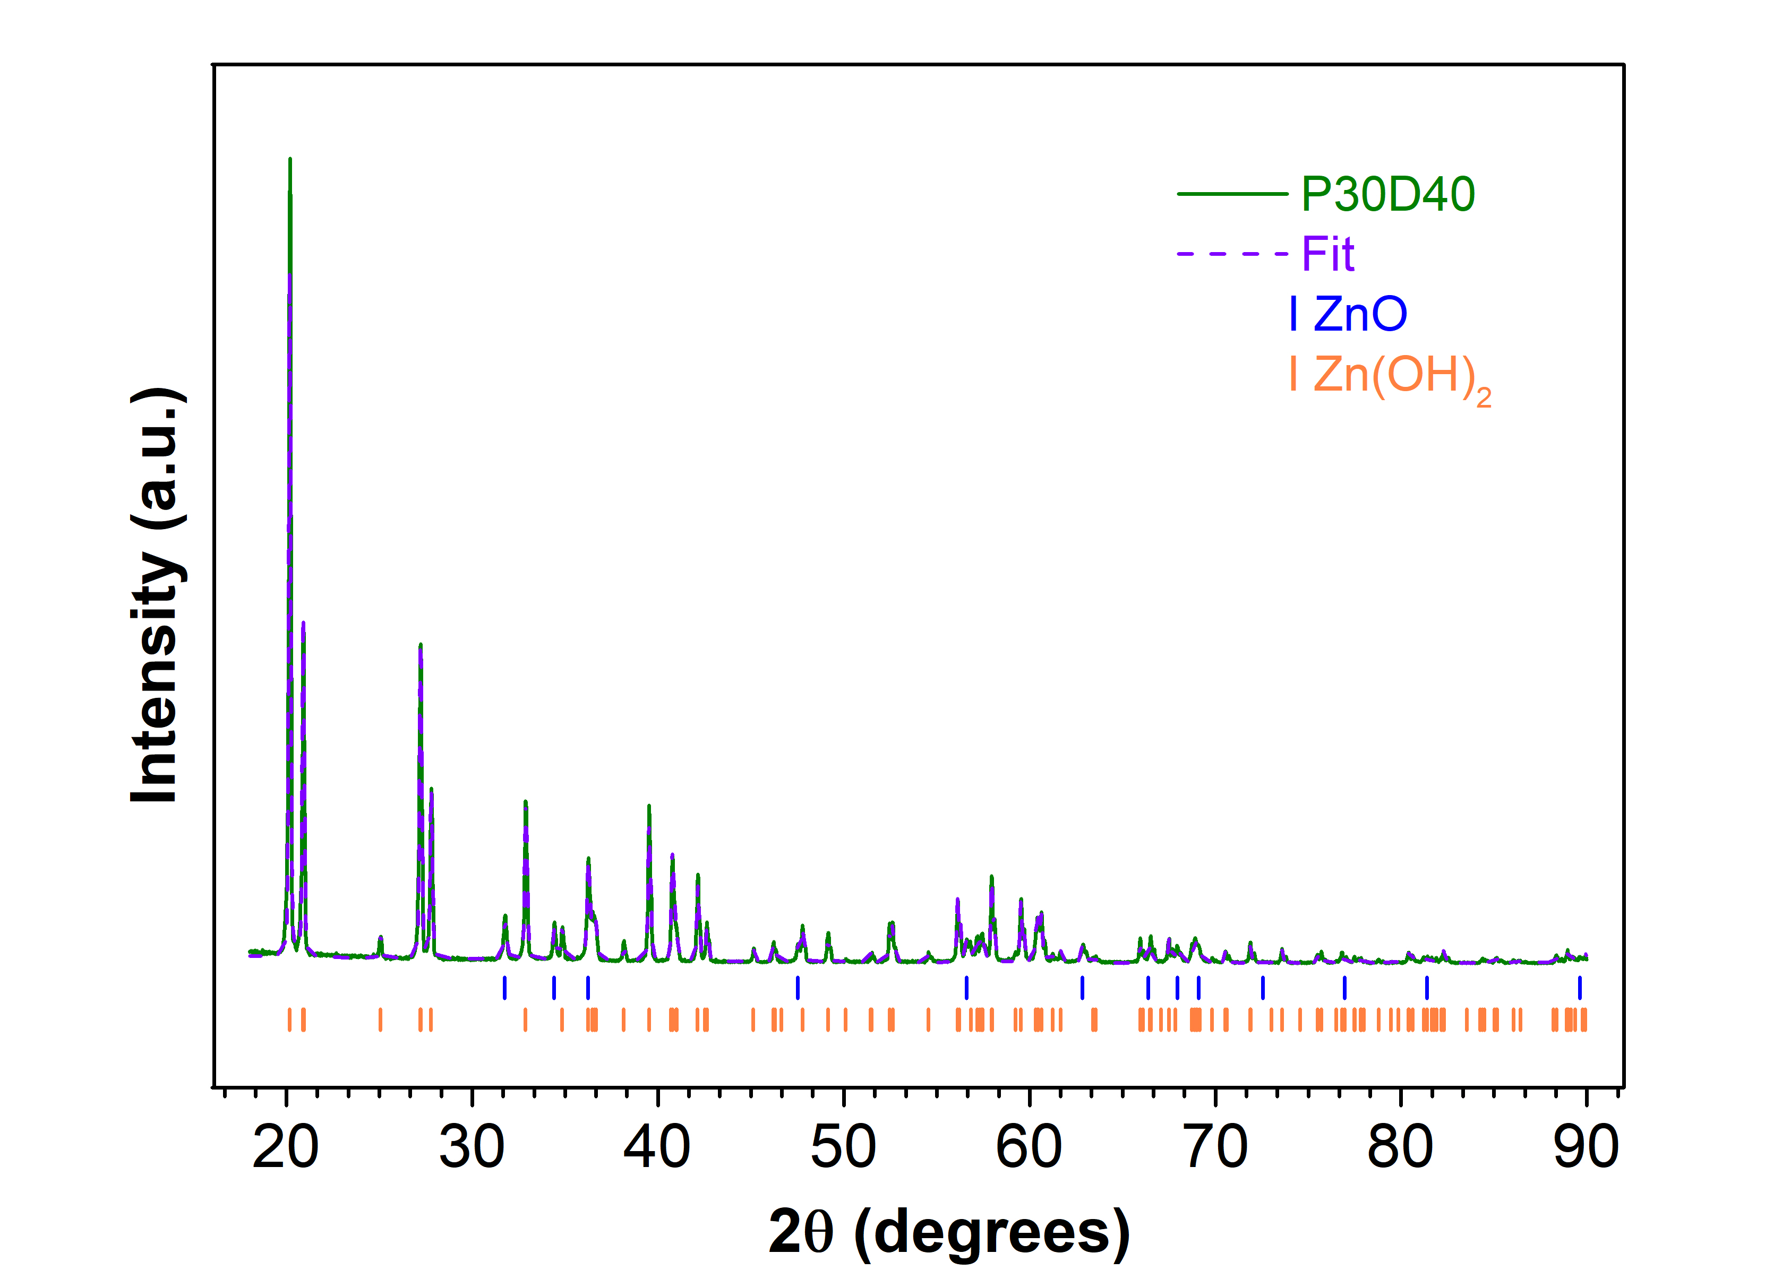
Figure SI2. XRD patterns of the sample P30D40 and associated Rietveld fit.
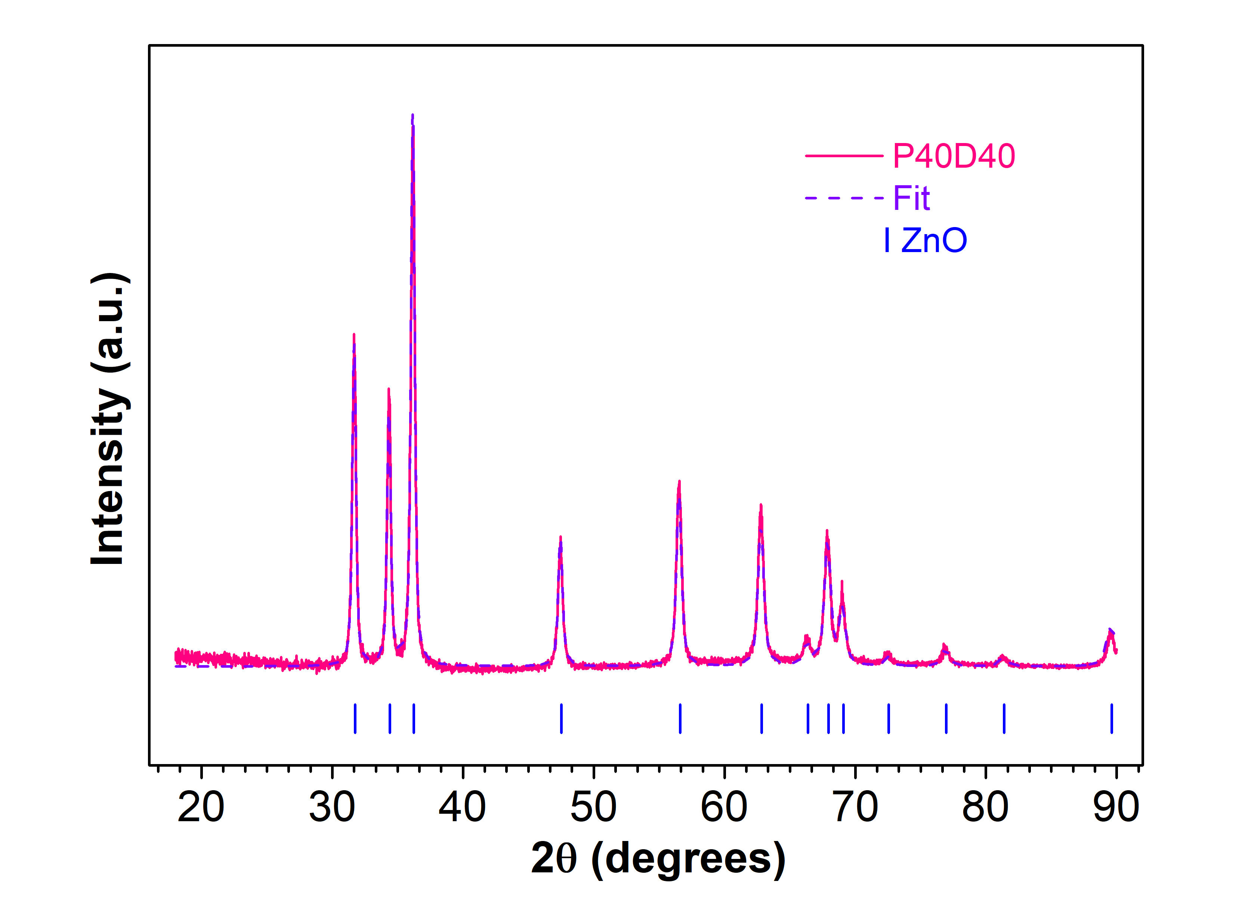
Figure SI3. XRD patterns of the sample P40D40 and associated Rietveld fit.

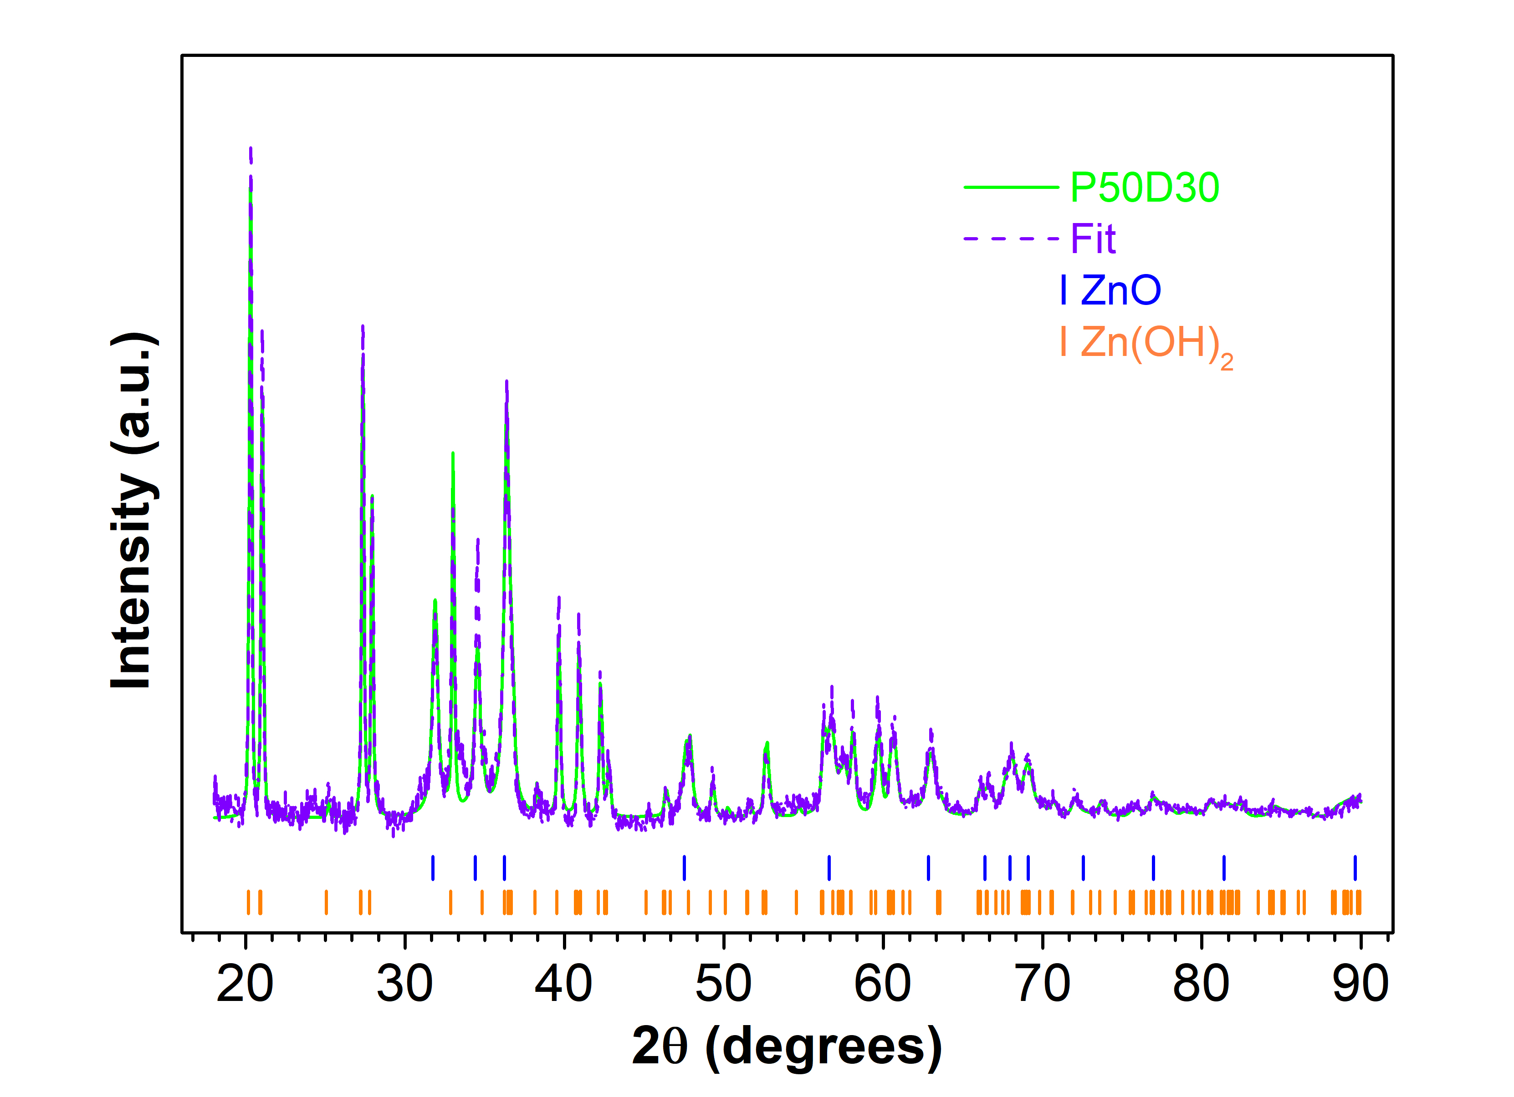
Figure SI4. XRD patterns of the sample P50D30 and associated Rietveld fit.
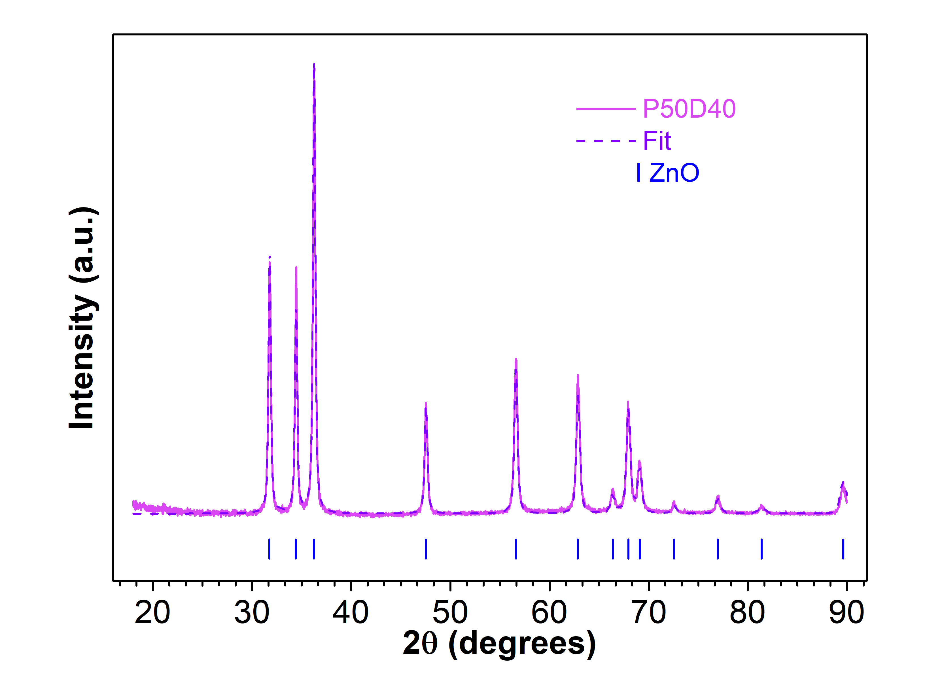
Figure SI5. XRD patterns of the sample P50D40 and associated Rietveld fit.

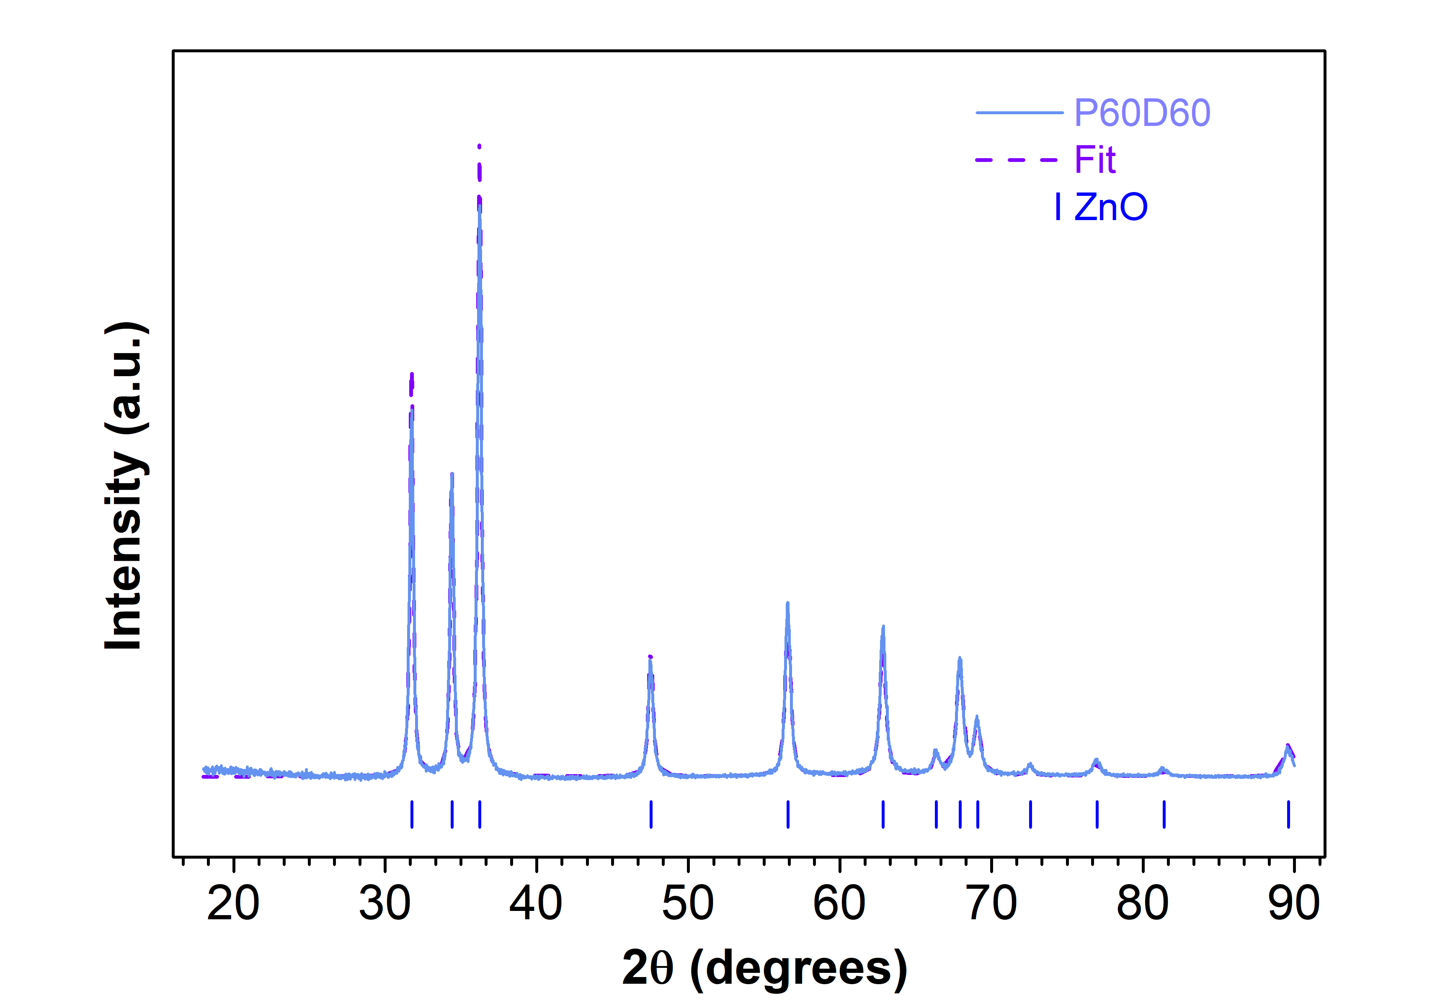
Figure SI6. XRD patterns of the sample P60D60 and associated Rietveld fit.

